FOR NWMOA

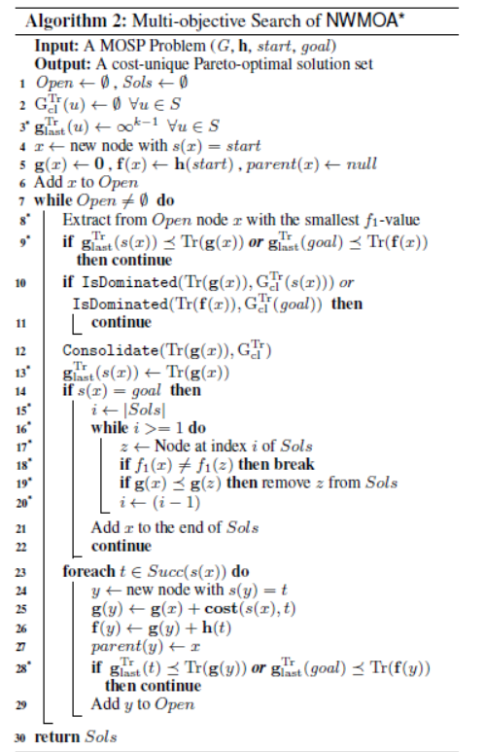
In NWMOA(graph *G, graph *G_rev, experiment exp)
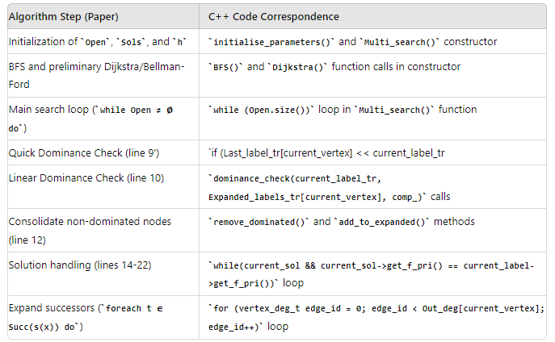

To be done

Change experient , constrain from Uint32 to a table of min max

