HW7

# Question 2

**Code Output**

Normal Equation Solution:

[[ 2.2803765]

[ 1.4560753]]

CVX Optimal value: 4.187673

CVX Optimal x:

[[ 2.2812872 ]

[ 1.45790064]]

# Question 3

## Part A

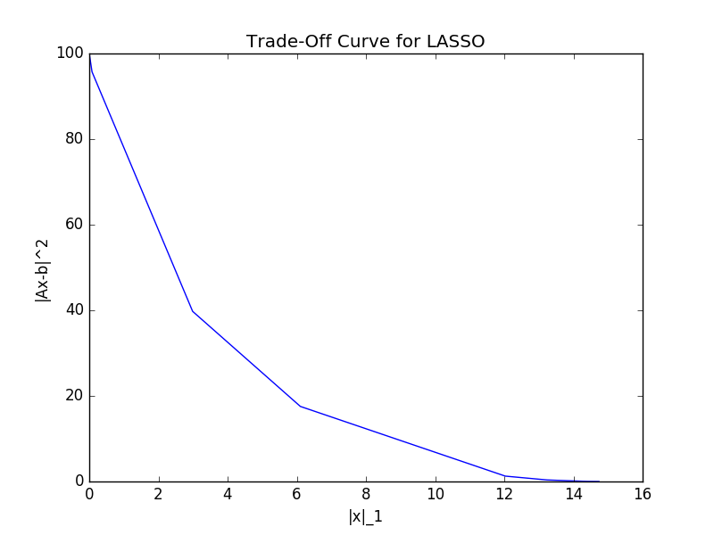

This plot shows that as the L1 norm increases, there is a corresponding decrease in the residual squared value. This means that the residual squared term is prioritized more as the L1 norm of x increases. Correspondingly, as the residual value increases, the L1 norm term is prioritized more, and therefore decreases.

## Part B

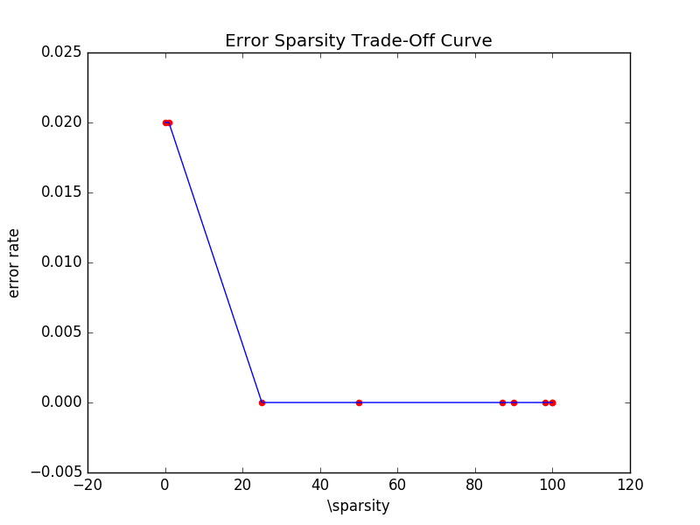

## Part C

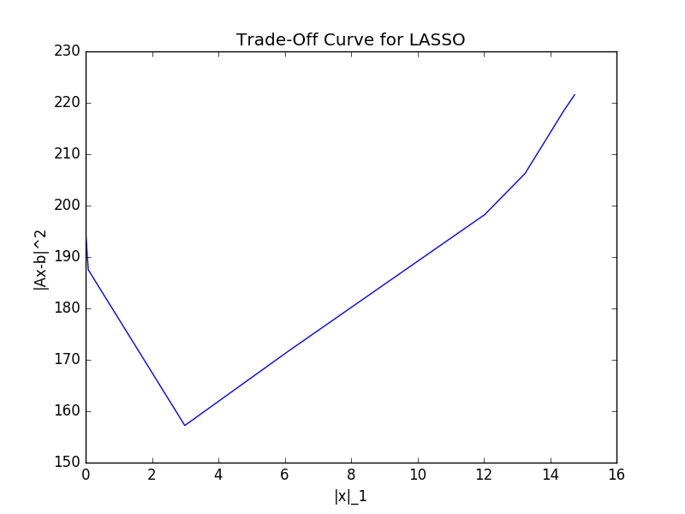

This plot shows that after a certain amount of sparsity is reached, the residual error on the validation set begins to increase. This means that after a certain amount of sparsity in the solution is reached, decreasing the sparsity further (by lowering lambda and increasing the L1 norm) increases the residual error.

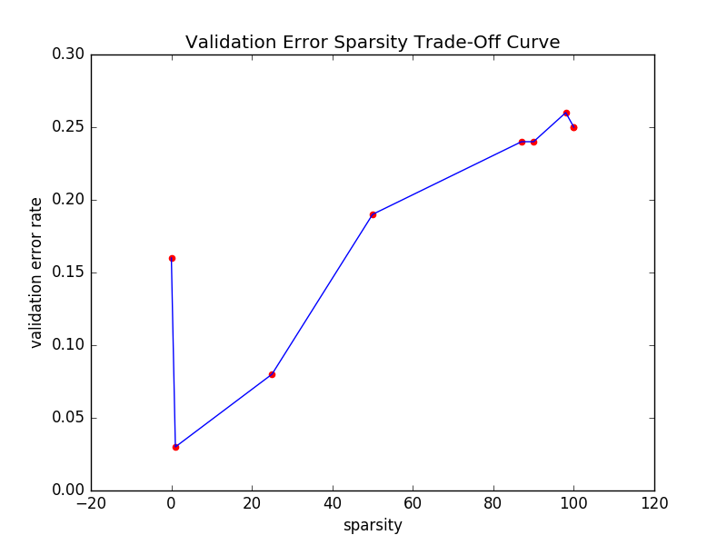

This plot shows that as the number of non-zeros in the solution increases, the validation error increases. This seems to imply that solutions with more zero entries tend to generalize better than solutions that have very few 0 entries.

## Part D

**Code Output:**

Runing q3 partd, section i

Runing q3 partd, section ii

Solving lambda: 0.000100

Solving lambda: 0.001000

Solving lambda: 0.010000

Solving lambda: 0.100000

Solving lambda: 0.500000

Solving lambda: 1.000000

Solving lambda: 5.000000

Solving lambda: 10.000000

Solving lambda: 50.000000

Solving lambda: 100.000000

Solving lambda: 0.000100

Solving lambda: 0.001000

Solving lambda: 0.010000

Solving lambda: 0.100000

Solving lambda: 0.500000

Solving lambda: 1.000000

Solving lambda: 5.000000

Solving lambda: 10.000000

Solving lambda: 50.000000

Solving lambda: 100.000000

Runing q3 partd, section iii

Runing q3 partd, section iv

Ridge test accuracy: 0.933333

LASSO test accuracy: 1.000000

**Analysis of Results**

As seen above, the LASSO's accuracy on the test set was much better than the Ridge accuracy on the test set. On average, the LASSO classifier has a lower test accuracy than the Ridge classifier.

# Code