David Corcoran

DSAN 6300

November 27, 2024

Report for FAA Flight Data During April 2022

The Bureau of Transportation and Statistics (BTS) is a division within the Department of Transportation (DOT) responsible for collecting, analyzing, and publishing comprehensive and credible data on American transport. The BTS focuses on a wide range of transportation subjects, including commercial aviation, multimodal freight activity, transportation economics, passenger travel, demographics, energy consumption, environmental impact, and transportation safety. This report specifically examines flight data for April 2022 sourced from “The Bureau of Transportation Statistics (BTS) Reporting Carrier On-Time Performance (1987-Present)” database. The data in the data tables are sourced directly from certified air carriers in the United States that contribute to at least one percent of domestic scheduled passenger revenues. The data includes key flight metrics, such as:

* Carrier Codes and Flight Numbers
* Origin and Destination Airport Codes
* Scheduled and Actual Departure and Arrival Times
* Departure and Arrival Delays
* Reasons for Delays
* Cancellation Status and Reasons for Cancellation
* Flight Dates

This report will analyze the given FAA flight data, concentrating on departure and arrival delays by airline and airport, the distribution of flights within the month, and flight cancellations, and reasons for cancellation. Data from the database was queried using structured query language (SQL) and each subsequent plot was created using ggplot2 in R.

Airline performance is judged by many factors, but one that most people experience and get frustrated with repeatedly is flight delays. Most flight delays last no more than an hour, but in extreme cases, passengers can be stuck in the airport for days on end. The first query focuses on determining the maximum departure delay in minutes for each airline. Understanding maximum departure delays is significant for assessing the performance and operational efficiency of airlines, as this metric highlights the worst-case delays faced by passengers. Figure 1 depicts the maximum departure delay an airplane belonging to each airline experienced. The airlines in the plot are sorted from those with the smallest to the largest maximum delay. The airline with the smallest maximum departure was Horizon Air with a delay of 364 minutes (6.06 hours) and the airline with the largest maximum delay was SkyWest Airlines with a delay of 2366 minutes (39.43 hours).

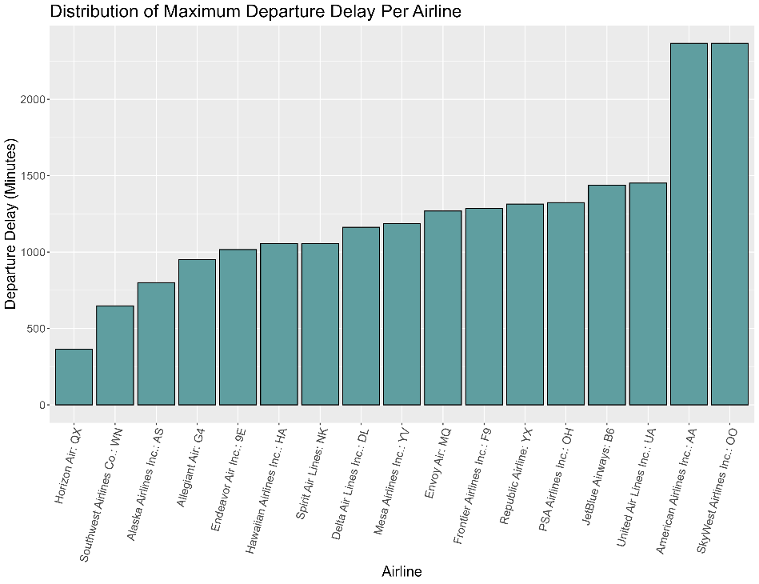

Figure 1: Distribution of Maximum Departure Delay Per Airline

Flight departure delays aren’t solely linked to individual airlines, so it’s important to look at other factors that may also have a correlation with these delays. The next queries identify the airport that has the highest average departure delay among all airports, as well as each airline’s highest average departure delay and the subsequent airport where their highest average delay occurs. Upon querying, the airport with the highest average departure delay time regardless of airline is Lea County Regional in Hobbs, NM, with an average departure delay time of 445 minutes (7.41 hours). Figure 2 plots the results of the second query and depicts each airline’s maximal average departure delay by airport, along with the airport in which that delay occurred. From the results of the query, in April 2022, PSA Airlines had the largest maximum average departure delay time of 1130 minutes (18.83 hours) at Southwest Florida International in Fort Myers, Florida. In other words, PSA Airlines airplanes average a delay time of 1130 minutes whenever departing from Southwest Florida Internal airport, and that average departure delay time is higher than any other airline-airport combination’s average departure delay time in the BTS database.

An early departure is another important factor that impacts airline performance, but one that mostly indicates positive operational efficiency. Figure 3 visualizes the maximum early departure in minutes for each airline, sorted from smallest maximum early departure to largest maximum early departure. This plot lets us observe how often airlines manage to depart earlier than scheduled, as well as how extreme those early departures can be. In April 2022, Endeavor Air had the lowest maximum early departure at 20 minutes before scheduled takeoff, while SkyWest Airlines had the largest maximum early departure at 39 minutes. The range of maximum early departures (19 minutes) was relatively low compared to the airline’s maximum departure delays (2002 minutes), indicating that departure delays are much more frequent and substantial challenge than early departures.

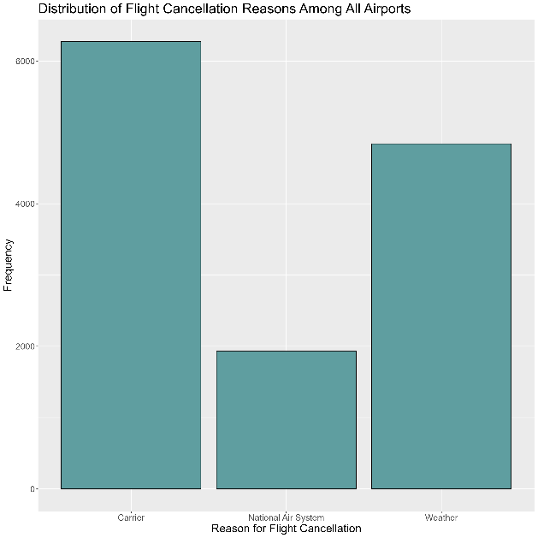

Figure 4: Distribution of Flight Cancellation Reasons Among All Airports

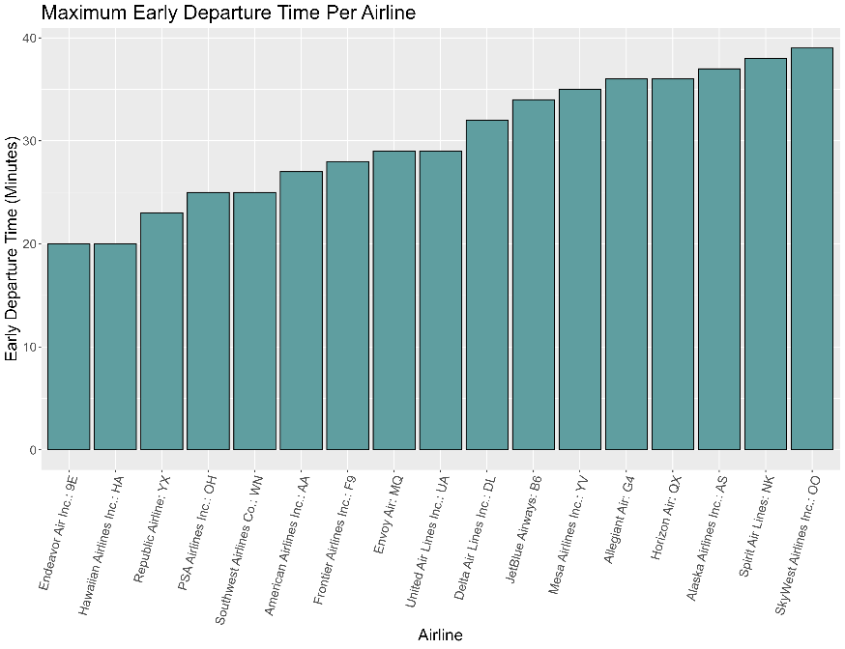

Figure 3: Maximum Early Departure Time Per Airline

Figure 2: Scatter Plot of Maximal Average Delay by Airline and Airport

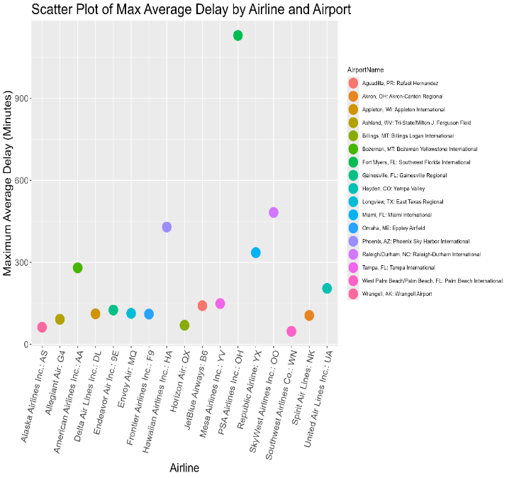

Cancellations also have a severe effect on passenger satisfaction and overall airline operations. Understanding the primary reasons for flight cancellations could provide valuable insights into areas where improvements can mitigate these challenges and enhance airline performance. Figure 4 highlights the distribution of flight cancellations across three cancellation reason categories: carrier, National Air System, and weather. The data illustrates that carrier-related issues and weather are easily the top two reasons why a flight would get delayed, with 6272 cancellations and 4841 cancellations, respectively. The National Air System lags severely behind these two causes, with over a 2000 canceled flight difference between the next highest category. This emphasizes the enlarged role that airline-specific issues and weather conditions play when it comes to flight cancellations.

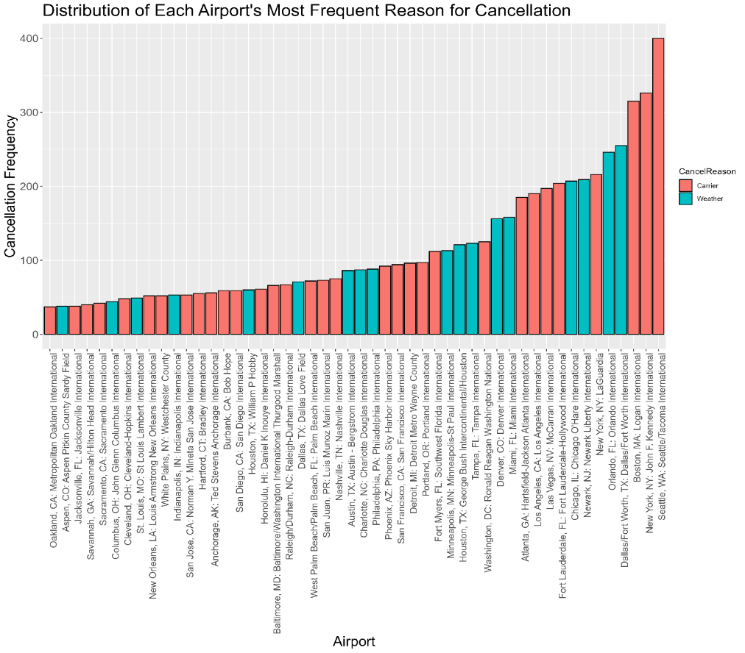

Figure 3: Distribution of Each Airport's Most Frequent Reason for Cancellation

A similar analysis continues in Figure 5, which depicts the most frequent reasons for cancellation in 50 airports. These airports were selected based on having the highest count of cancellations attributed to a single category among all 300 airports in the database. The plot further emphasizes the dominance that carrier-related activities have in cancelling flights, with weather being a close second and the National Air System being completely absent. Another observation that can be made is that most airports in the figure are international airports. International airports serve a broader range of people by serving both domestic and international customers, so this graph possibly reflects their larger volume of departing flights and higher likelihood of encountering flight obstacles.

Temporal flights patterns can also be observed when working with flight date and frequency data. Airlines and airports can use this information to plan flight schedules for peak travel times and adjust their ticket pricing strategies. Figures 6 and 7 explore these trends by providing insights into the distribution of flights over time and highlighting patterns in air travel demand. Figure 6 displays the moving average in flight counts for a window of three days prior to the selected date. The plot reveals a distinct weekly fluctuation, in which there is a trough in flight activity at the start of the week and increased travel demand on the weekend. This pattern is likely the result of airline passengers being available to travel during the weekend and stuck with work commitments during the middle of the week. Figure 7 shows a similar trend and supports the conclusion from figure 7 by displaying total flight count by weekday through the month. The plot shows that Thursday, Friday, and Saturday represent peak travel time, highlighting their contribution to the previously discovered weekly travel cycle. Meanwhile, midweek days like Tuesday and Wednesday experience a slightly lower monthly flight count.

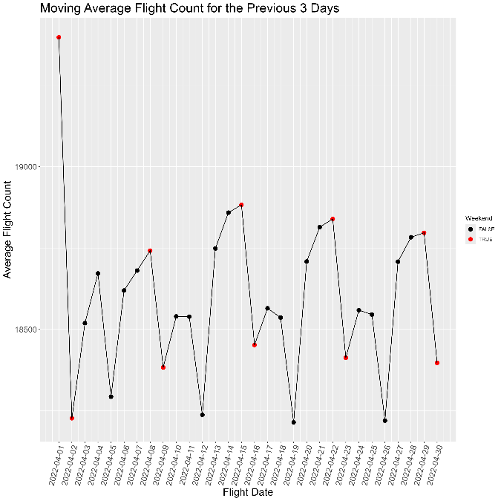

Figure 6: Moving Average Flight Count for the Previous 3 Days

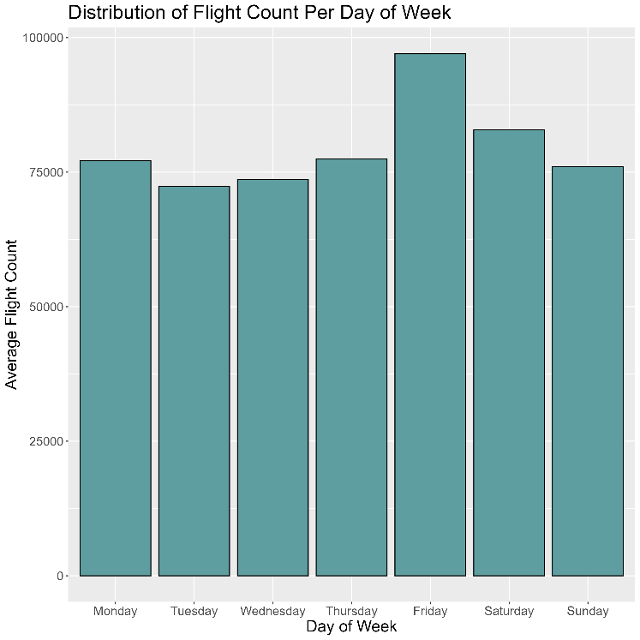

Figure 7: Distribution of Flight Count Per Day of Week

This report provides an examination of FAA flight data from April 2022, revealing trends and patterns for operational metrics. The analysis highlights a stark contrast between maximum departure delays and early departures, the critical role that carrier-specific issues and weather play in flight cancellations, and the distribution of these reasons across all airports in the dataset. The report also uncovers weekly patterns in flight demand, with weekend peaks emphasizing the dynamic nature of air travel. These insights offer valuable perspectives for airlines and airports to improve operational efficiency, address delay and cancellation issues, and optimize flight scheduling. The queries, and their results illustrated in this report, can aid in improving passenger experience, as well as the aviation industry's growth.