MPO Project Management Tool

Software Configuration Management Plan

Version <1.0>

Document Control

Approval

The Guidance Team and the customer shall approve this document.

Document Change Control

|  |  |
| --- | --- |
| Initial Release: | 1.0 |
| Current Release: | 1.0 |
| Indicator of Last Page in Document: | [END OF DOCUMENT] |
| Date of Last Review: | 2/1/2016 |
| Date of Next Review: | 2/3/2016 |
| Target Date for Next Update: | TBD |

Distribution List

This following list of people shall receive a copy of this document every time a new version of this document becomes available:

Guidance Team Members:

Salamah Salamah

Customer:

Mr. Roger Williams

Software Team Members:

Daniel Coronel

Brian Espinosa

Ricardo Garcia

Jose Herrera

Ryan Martinez

Change Summary

The following table details changes made between versions of this document

|  |  |  |  |
| --- | --- | --- | --- |
| Version | Date | Modifier | Description |
| 1.0 | 1/31/2016 | Daniel  Brian  Jose  Ricky  Ryan | Completed sections 3,4,5  Reviewed Document  Composed introduction  Reviewed Document  Completed section 2 |
| 2.1 | 2/6/2016 | Daniel | Updated sections 3,4,5 based on feedback |
| 2.2 | 2/8/2016 | Ryan | Revised section 2 based on feedback. |

Table of Contents

Document Control ii

Approval ii

Document Change Control ii

Distribution List ii

Change Summary ii

1. Introduction 1

1.1. References 1

2. Software Configuration Identification 2

2.1. Software Configuration Item Identification 2

2.2. Software Configuration Item Organization 2

3. Software Configuration Control 3

3.1. Documentation 3

3.2. Configuration Control Board 4

3.3. Procedures 4

4. Software Configuration Auditing 6

5. Appendix 7

# Introduction

This section gives a general summary of what the project in development consists of. It also provides a description of the purpose of this document, its contents, intended audience, and a brief description of the sections it contains.

The project of interest that the software team is currently developing is an information management system for the Metropolitan Planning Organization (MPO) of El Paso. The system involves a front-end web interface that users will interact with, as well as a back-end database that will hold various data regarding transportation projects being developed in the region. There are different users of the system looking for different functionalities. The municipalities will use the system to submit proposals for transportation projects. MPO staff will add and update project information through the system, and the administrator will manage the users of the system. Overall, the system will help facilitate the daily operations of the organization, and will aid in making the process of project tracking and approvals more efficient.

The purpose of this document is to provide a detailed plan of the procedures to follow when dealing with changes in the software development cycle of the system. This will help the software team have an organized method of carrying out necessary changes to the project, as well as serve as a way to justify changes and filter out potentially detrimental ones. It will allow the team to control changes being made to important artifacts related to the project and provide a history of changes made. This document contains four sections including this introduction, and it is intended as a guidance tool for Diamond Dogs, as well as a reference for the guidance team to look at when inquiring about the processes followed by the software team. It also helps new team members gain an understanding of the project, and the procedures to follow to perform changes. The sections will be described below.

The Software Configuration Identification section is used to list the relevant items in this process that are prone to change and that the software team must make note of when carrying out changes in the project. It also provides detailed criteria for assigning different labels to baselines, updates, and variants of these items. The Software Configuration Control section contains the documents and procedures that will be used to formally request, review, and carry out changes to project artifacts when needed. It establishes the team members that will review the requested changes, and the overall rules to follow to control changes after being approved. The last section, Software Configuration Auditing, contains the processes needed to check how the current state of the project matches the requirements detailed in the SRS, as well as determine how changes affect the capability of configuration items to meet requirements. This last section serves as a verification and validation tool that determines if the software team has been following the processes outlined in this document correctly.

## References

There are currently no external references used for the creation of the document.

# Software Configuration Identification

This section describes the items of interest that are expected to change through the project’s lifecycle, as well as the guidelines for labeling baselines and ensuing updates to these items. It also details the directory structure of the team repository, and how project backups will be handled.

## Software Configuration Item Identification

The following section will identify the elements that will be contained in the life cycle of the project. These elements will be artifacts, which will be of high importance to the project. Examples of artifacts of high importance are artifacts that may change throughout the life cycle of the project or artifacts that contain the basis of the project such as the SRS. The following list contains an artifact along with a brief description of the importance of the artifact:

* Software Requirement Specification
  + The SRS serves as an agreement between the customer and the development team to ensure that system will perform exactly how it is specified in the document.
* Source Code
  + Source code is the final product of the project and will be undergoing change throughout the lifecycle of the project.
* Test suites
  + Test suites are test cases that ensure that the system works and that the source code is working as intended.

## Software Configuration Item Organization

The following section will explain the formal identification and classification of important documents via labels. This section will map out the complete directory structure the team will be using to organize documents and source code. It will also cover how the directory structure will be stored, as well as what approaches will be taken to back up and recover the files. The section will be divided into three parts: Naming conventions of the files, directory structure, and file management.

The naming convention of files will differ between code and documents created by Team 9. Documents will have different variations before updating into an official new version. For example, document1-0.docx will be the first official version of the document. Document1-1.docx will contain any updates to the current document and this applies to document1-n.docx, where n is the latest update. Each variation of the document will be noted in the document control and will provide an explanation what was updated and who updated it. The document will be updated to a new version when a variation of the document has been approved by the guidance team.

Source code standard will vary than the standards of documents. When an individual works on a specific piece of code, they will save a copy of the code locally. This will ensure any changes that affect the system as a whole can be quickly assessed. Copies of the previous version of the code that were saved locally will be saved as codePrevious.extenstion.

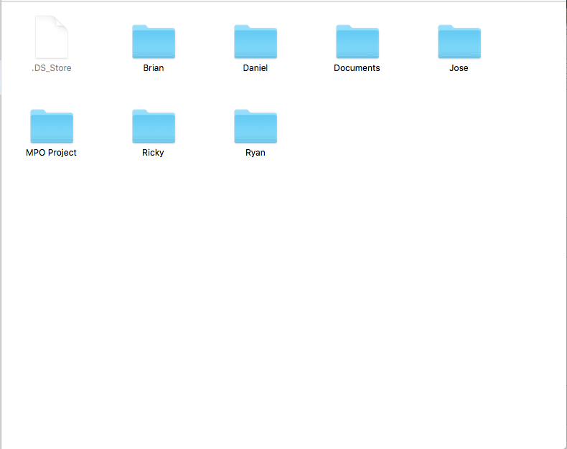

Figure : Directory Structure

The directory structure as seen in Figure 1: Directory Structure will be composed of the following folders: Documents, MPO Project, and an individual folder for each team member. The document folder will contain assignments that the guidance team has given to Team 9. Each assignment will have a folder labeled with the name of the document. Each time there is a new version of a document that version of the document will receive a subfolder. The subfolder will contain the variations of that document version that Team 9 has created. The MPO Project folder will contain all code that Team 9 has produced for the final product. Each team member will have an assigned folder where they will organize their contributions to the document and code that they have produced.

Team 9 will use GitHub to organize and save the files. Each member will save a copy of the directory locally to their own personal computers and the remaining directory will be stored on GitHub. Every member will be able to commit changes to code and documents. Each member will be able fetch the files and update their files when needed.

# Software Configuration Control

This section contains and describes the mechanisms that will be used when making a change in artifacts.

These mechanisms will ensure that changes are documented, assessed, approved, and ensure accountability is enforced along the development process.

## Documentation

The following documents will serve to facilitate change management and auditing. Below is a list of documents with a short description of their purpose.

Change Request Form- This form will be used by the requester of the change describing the reason for change and providing a short outline of the changes made.

Board Meeting Form-This form will be used to outline the purpose of the board meeting, provide an agenda, and serve as a log of meetings.

Board Voting Form-This form will be used for decision making upon a matter needing board approval.

Change Configuration Form-This form will be used to document the deadline of changes, impact of change, and more details of the accepted change.

Baseline Form-This form will be used for the updating of Baselines, logging any and all changes made, version number, and more details necessary for auditing purposes.

Audit Form-This form will be used to determine if all procedures have been followed and are used in official requests.

## Configuration Control Board

The Configuration Control Board will be composed of all five members of Team 9: Daniel Coronel, Brian Espinosa, Ricardo Garcia, Jose Herrera, and Ryan Martinez.

The approval of changes will have to be agreed upon by the vast majority of the control board (3 members) in a formal board meeting. If a change only receives two or less approvals, then the approval request will be dismissed. Upon a board meeting being called and all board members being present, each board member will carry a vote of equal point value. In the case where a board meeting is held and a member is not able to attend then the lead of the artifact in question will carry an additional vote for the member that is missing. If the lead of the project cannot attend the board meeting, then the lead shall appoint a member of the board as temporary lead. At any given point in time where a meeting must be held and no more than three members can attend, the meeting will be postponed.

With the V&V (Brian Espinosa) being in charge of finding discrepancies in artifacts and code there will be a set of procedures and documents that will need to follow in order to document the process and ensure accountability in the correction of items. The V&V will follow the Error Reporting procedures defined below.

## Procedures

This section defines various procedures that will be used when in need of modifying documents, requesting modification, or reporting errors in artifacts. These procedures shall be followed at all times and if not done so can result in disciplinary action by the guidance team upon auditing procedures and artifacts.

The Change Configuration Management procedures are defined as follows:

1. The requester will submit a copy of the Change Request Form via email to all board members.
2. The board members will agree on a meeting time.
3. The requester will create a calendar entry and include all board members.
4. The board members will make an official decision using the Board Meeting procedures.
5. Based on the decision, the change may or may not be applied.

The Board Meeting procedures are defined as follows:

1. The board will meet at a pre-defined destination and time.
2. The meeting requester will present their proposed change.
3. After the presentation a discussion session will be held.
4. After the discussion session, board members will vote using the Board Voting Form.
5. The votes will be reviewed and the Change Configuration Form will be filled and the Change Configuration procedures will be followed if the change request is approved.
6. If the change request is rejected the meeting will adjourn.

The Change Configuration procedures are defined as follows:

1. The lead for the artifact that requires changes will have a time frame to complete the requested changes as stated in the Change Request Form.
2. A board meeting will be held to test and discuss the changes made on the due date.
3. If the requested change is incomplete, the Extension procedure will be followed.
4. If the requested change is satisfactory then the New Baseline procedures are followed.

The Extension procedures are defined as follows:

1. The lead for the artifact that is being changed will provide an update as to where the modifications are and provide an estimated time of completion.
2. The board members will vote using the Board Voting Forms on whether or not to approve the extension.
3. If the board members approve the extension the meeting is adjourned and the board will not meet in regards to this change until the due date.
4. If the board members reject the extension, the meeting will adjourn and all changes will be reverted to the baseline.

The New Baseline procedures are defined as follows:

1. The board members will fill out the Baseline Form
2. The Baseline will be updated to the new modified artifact.

The Error Reporting procedures for V&V are defined as follows:

1. The V&V shall document the error area and what testing procedures were followed.
2. The document will be distributed to all members via email.
3. The V&V will schedule a meeting for the board to meet.
4. The board will meet and follow Board Meeting procedures.

# Software Configuration Auditing

The audit process will consist of ensuring that all software and document changes are logged, that procedures are followed, and that all changes are competed in a timely manner. All the forms that are used in the procedures section above will serve as logs for auditing purposes. With the ability to track board meetings and change requests, this will allow for auditing to be simple, fast, and effective. Along with this, the use of the forms referenced in section 3 will allow the auditing of not only changes but accountability with logs of who made requests and why. Upon the auditing process being required as an official document, the following auditing forms will be used depending on the audit type:

* Software Configuration Audit Form
* Accountability Audit Form
* Procedure Audit Form

# Appendix

Change Request Form- This form will be used by the requester of the change describing the reason for change and providing a short outline of the changes requested.

**Change Request Form**

**Requester Details**:

First Name

Last Name

Position

**Change Information:**

Requested Change (Provide a description of the requested change)

Importance Level (Provide an impact level from a scale of 1-10)

Impacted Artifacts (List the artifacts impacted by this change request)

Estimated Time of Completion (Provide an estimated completion date for the proposed changes)

Signature Date

Board Meeting Form-This form will be used to outline the purpose of the board meeting, provide an agenda, and serve as a log of meetings. The main purpose of this form is for logging/administrative purposes which can be utilized for audits and serve as an accountability sheet.

**Board Meeting Form**

Board Meeting # Date

**Purpose: (Provide a short description of the meeting purpose)**

**Agenda: (List items that will be discussed in this meeting)**

* Item 1
* Item 2
* Item 3
* Item 4

**Members Present: (List all members who attended the meeting)**

**Decisions: (Provide a description of major decisions/actions of this meeting)**

Board Voting Form-This form will be used for decision making upon a matter needing board approval.

The main purpose of this form is to log the votes for auditing purposes.

**Board Voting Form**

**Voting Details:**

Voting Matter (Provide a short description of the item being voted on)

**Board Member Details:**

First Name

Last Name

Position

* **Approve Change Request**
* **Deny Change Request**

Signature Date

Change Configuration Form-This form will be used to document the deadline of changes, impact of change, and details of the accepted change.

**Change Configuration Form**

ChangeConfig# Date

**Approved Change: (Provide a description of the approved change request)**

**Purpose for Change: (Provide the purpose for the proposed change)**

**Steps to be taken: (Provide a list of steps to be taken in order to accomplish the change)**

**Impact of Change: (Provide a description of the overall impact that the change will cause in the system)**

**Due Date:**

**Signatures:**

Daniel Coronel Ricardo Garcia

Brian Espinosa Jose Herrera

Ryan Martinez

Baseline Form-This form will be used for the updating of Baselines, logging any and all changes made, version number, and details necessary for auditing purposes.

**Baseline Form**

Date

**Current Version Number: (Provide the current baseline version)**

**Baseline Change Details: (Provide a short description of major changes to the baseline)**

**Baseline Checklist:**

* Previous functionality remains intact
* All changes have passed testing
* Changes made increase or correct functionality
* Board Approval of Baseline Update

**Updated Version Number: (Provide the baseline a new baseline version number)**

**Further Development Plans: (Provide a list of future changes planned for the new baseline)**

**Signatures:**

Daniel Coronel Ricardo Garcia

Brian Espinosa Jose Herrera

Ryan Martinez

**Software Configuration Audit Form**

Date

**Configuration #**

**Audit Results/Comments:**

Signature (Auditor) Date

[END OF DOCUMENT]