**DATABASE**

Creating a database pylogin with table account1 and connecting it with server.

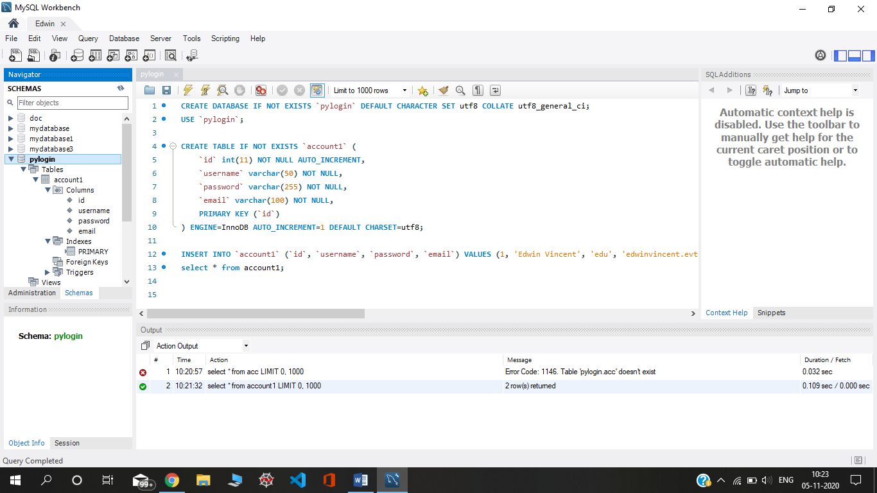

**APP.PY**

Importing important packages. Secret key is for extra protection. Fill in the details of MySQL connection and connect to MySQL database.

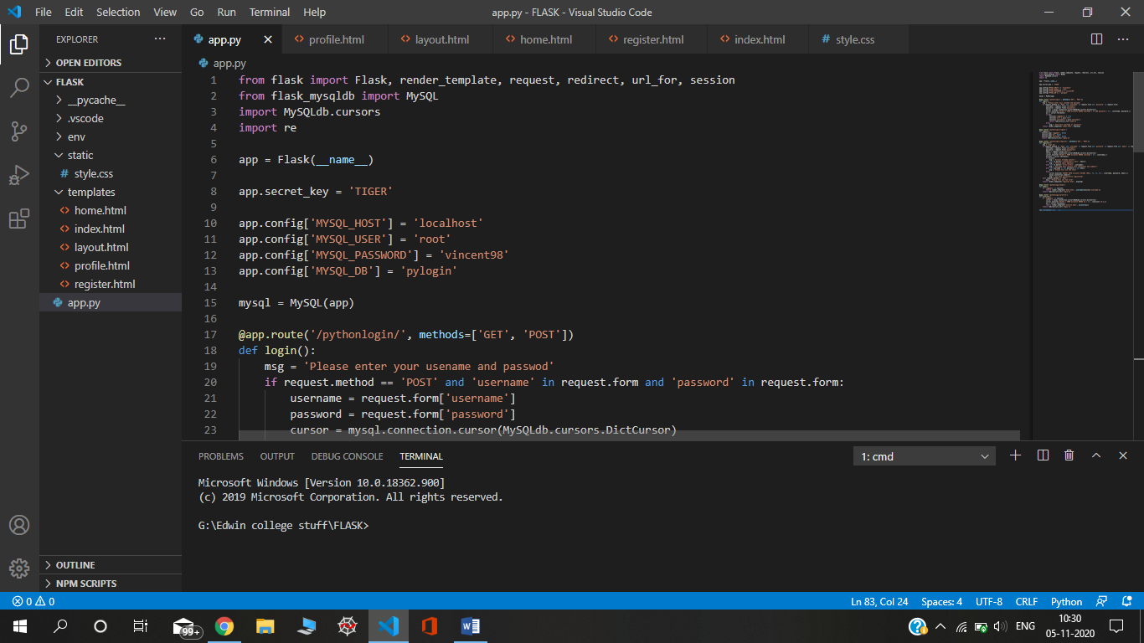

**Login():**

we use an if statement to check if the requested method is POST and check if the username and password exist in the form request, if they both exist the username and password variables will be created. If it does we create new session variables, these session variables will be remembered for the user, we can use them to determine if the user is logged in or not.

Session variables act like cookies, they will be remembered on the server instead of the user's browser, only the session ID will be stored as a browser cookie.

If the account doesn't exist we can simply show an error on the login form.

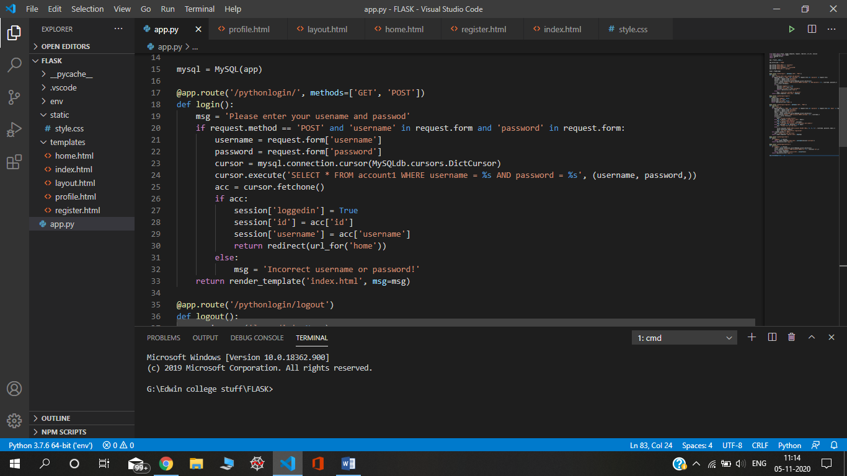

**Logout():**

For a user to log out remove the session variables that were created when the user logs in.

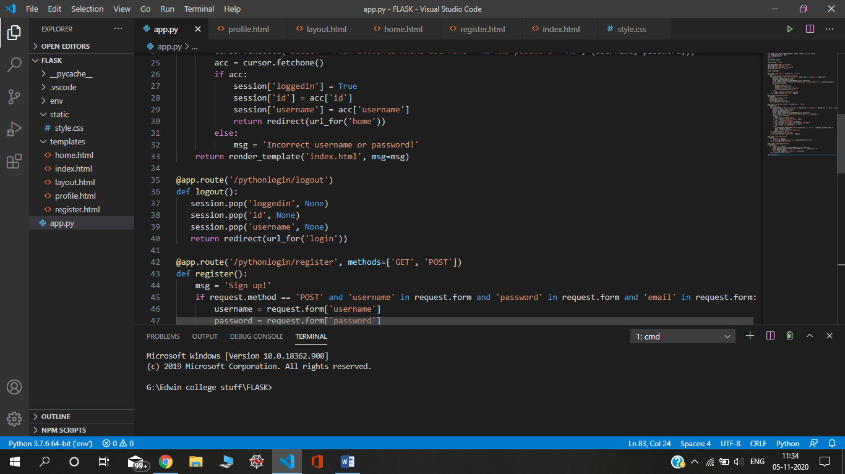

**Register():**

Register will handle the POST request and insert a new account into our account1 table, only if the submitted fields are valid that is.

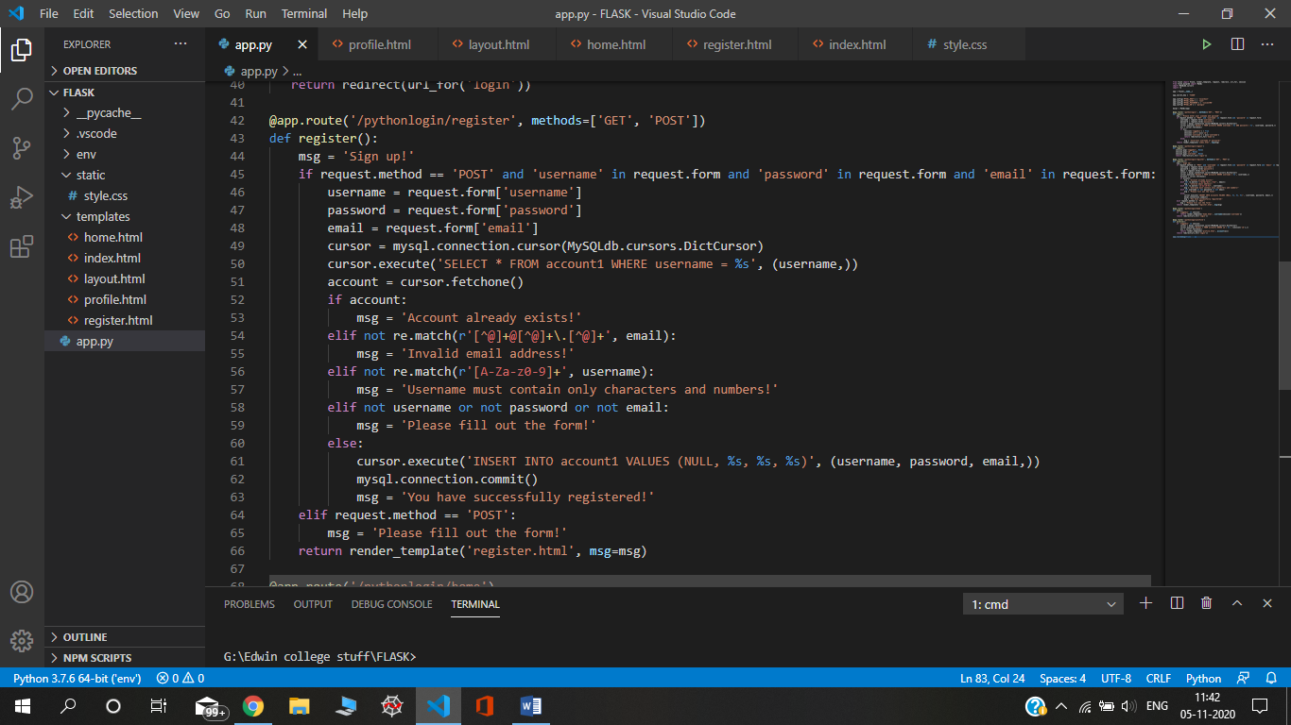

**Home() and Profile():**

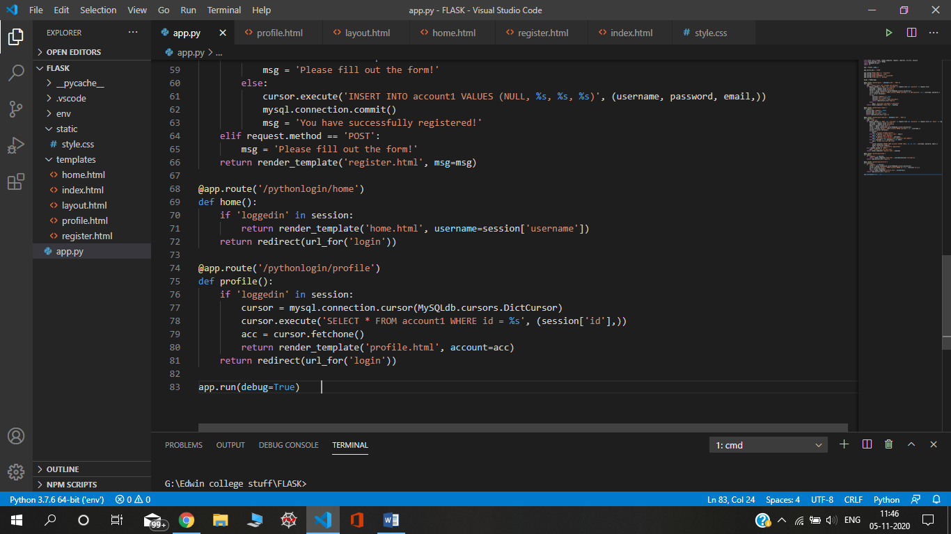

**TEMPLATES-**

**Index.html:**

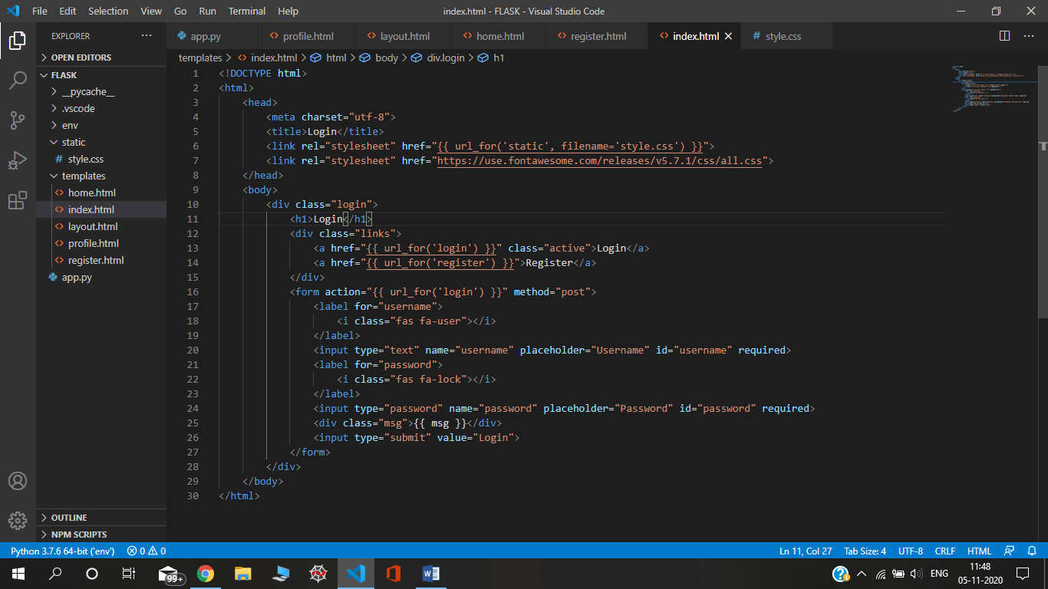

**register.html:**

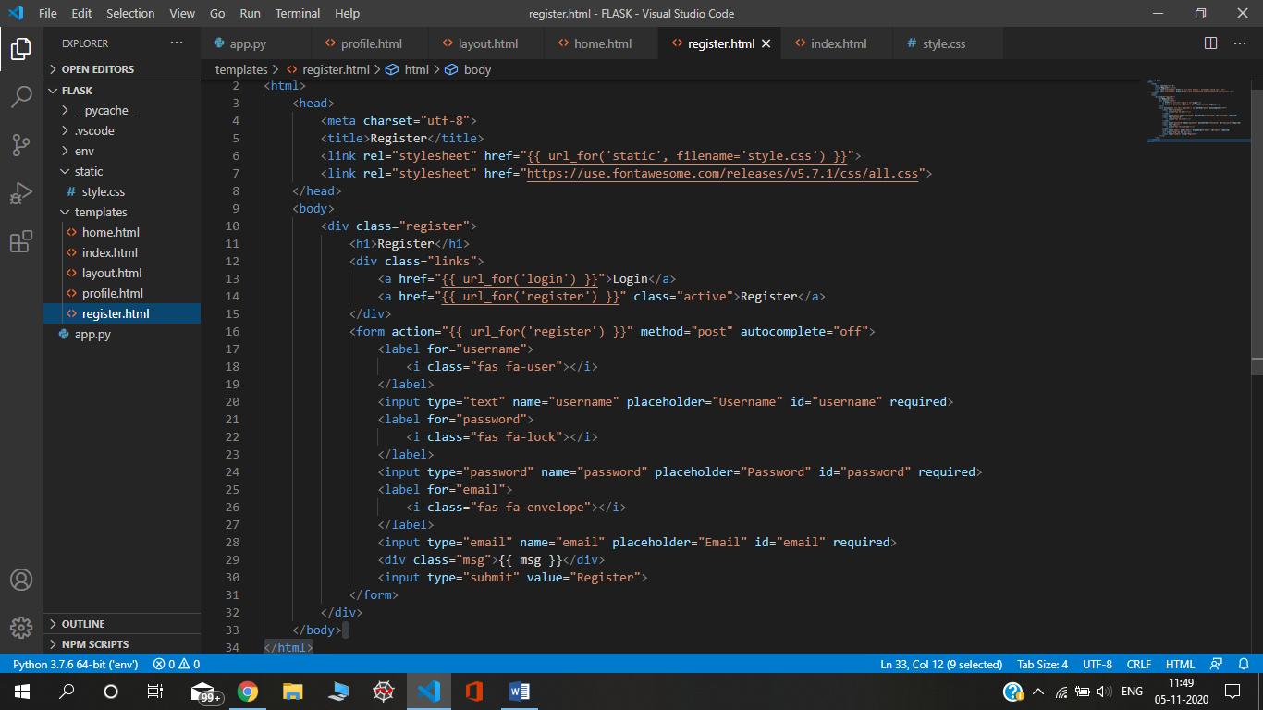

**home.html:**

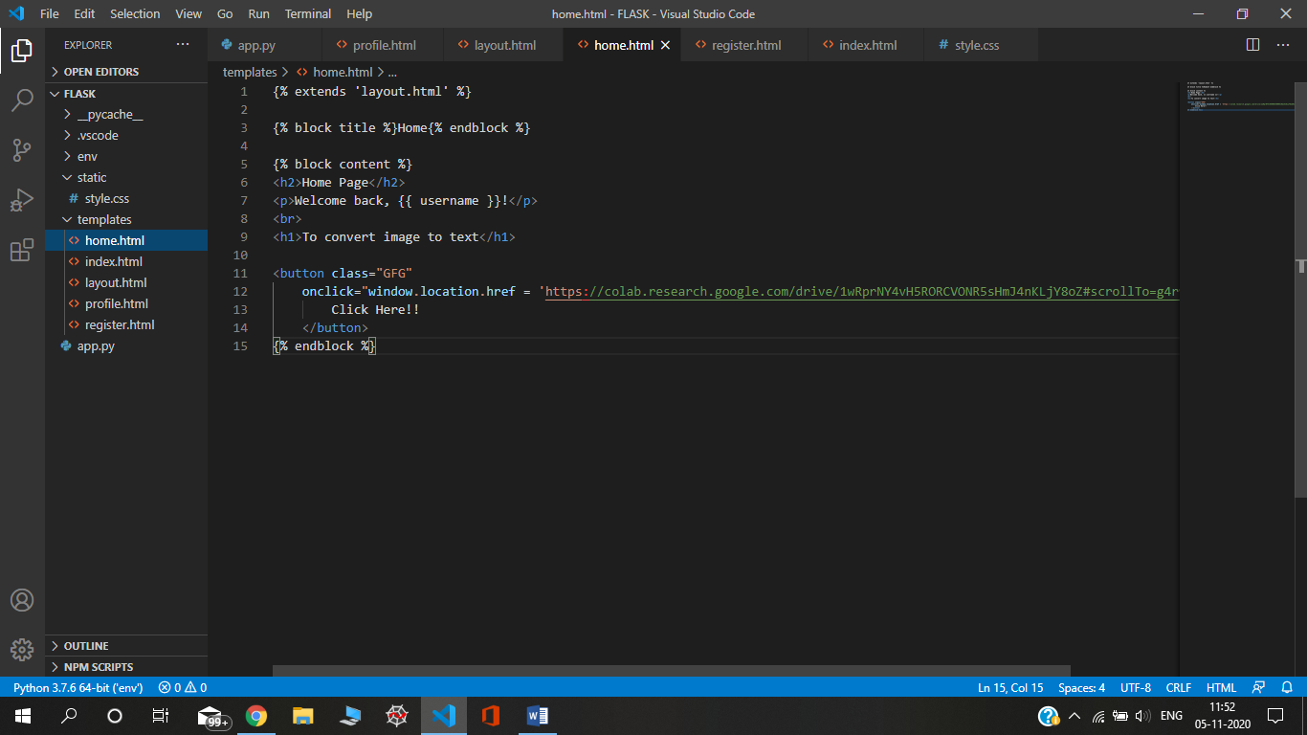

**Pofile.html**

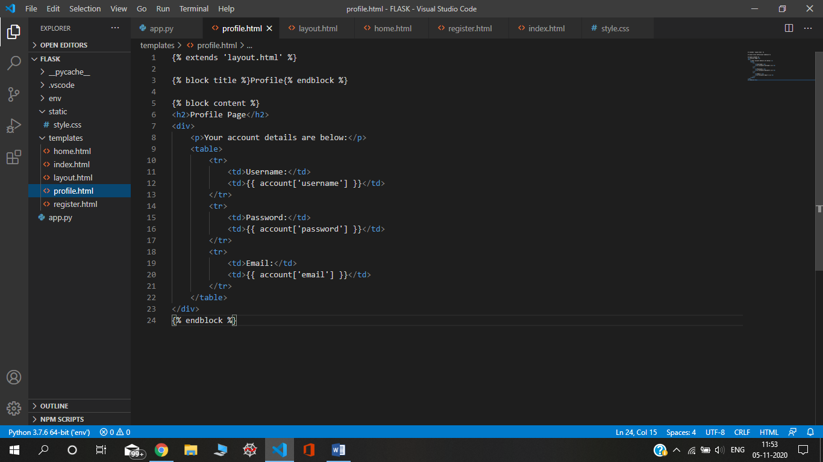

**Layout.html**

