Iterative reasoning using the group chat pattern
This chapter covers
- Understanding the GroupChat pattern
- Building a custom termination manager on top of a group chat manager
- Using human-in-the-loop in a group chat orchestrator
- Selecting the next specialist with a custom manager and explicit state
In the previous chapter, Robby's sequential pipeline ran through safety assessment and motor execution in a strict order. Every step finished before the next one started, and each agent's output flowed directly into the next agent's input. That works well when each step depends on the previous one.
But what happens when two agents need to negotiate, talking back and forth until they reach an agreement? Imagine Robby's MotorsAgent proposing a route and a NavigatorAgent reviewing it. The navigator can reject the first proposal, the motors agent revises it, the navigator reviews again, and the cycle continues until the navigator approves, or until a maximum number of rounds is reached, to prevent infinite loop. There is no single predetermined number of steps. The workflow terminates when a condition is satisfied, not when a fixed chain is exhausted.
I hit this wall early in Robby's development. My first instinct was to hard-code the negotiation as a longer pipeline: propose, review, revise, review again. It worked until the second review came back DENIED and the pipeline had no third review to offer. Adding more stages just moved the problem one round further down the chain. What I needed was not a longer pipeline but a loop with an exit condition, and that is exactly what the GroupChat orchestration pattern provides: a structured multi-agent conversation where participants take turns and a manager decides when the conversation is over.
  - Understanding Group Chat Orchestration
GroupChat is a managed conversation. Participants contribute messages, while a manager chooses who speaks next and when to stop. Round-robin is one scheduling policy, not the definition of the pattern. Likewise, a participant can use an LLM, conventional code, or a human response behind the same AIAgent contract.
Think of it as a moderated committee meeting:
- The chairperson (the group chat manager) chooses the next speaker and applies the rules for ending the meeting.
- The specialists (the participants) contribute different capabilities; membership does not require the same kind of expertise or implementation.
- The minutes (the conversation history) preserve previous contributions so the group can revise its conclusions.
- The adjournment rule (termination) ends the discussion when the required outcome has been reached.
- The meeting budget (MaximumIterationCount) limits the number of turns even when the discussion has not reached a useful outcome.
Agent Framework models this with two components:
- AgentWorkflowBuilder.CreateGroupChatBuilderWith builds the group chat workflow. It accepts a factory delegate that receives the participant list and returns the manager instance.
- RoundRobinGroupChatManager calls the participants in round-robin order, in the exact order they were added, and delegates the termination decision to a pluggable shouldTerminateFunc delegate.
The builder shape is short enough to memorize:
var workflow = AgentWorkflowBuilder
.CreateGroupChatBuilderWith(agents => /* create the manager */)
.AddParticipants(/* agents, in speaking order */)
.Build();
Figure 13.1 shows the topology this builder produces, and it holds the first surprise of the pattern.
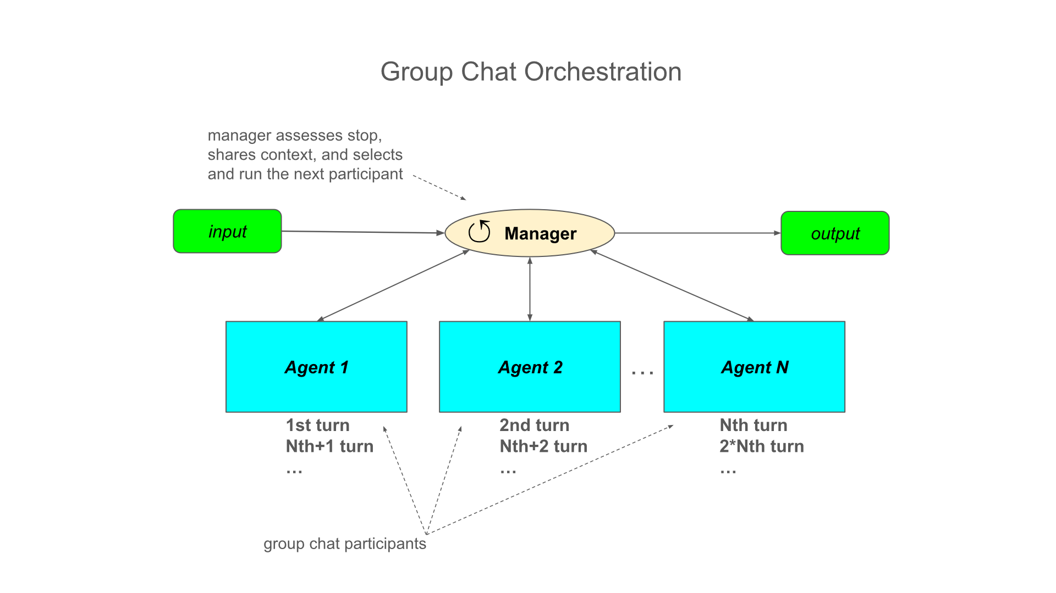
Figure 13.1 The Group Chat pattern is a star, not a ring: the host coordinates message delivery while the manager selects speakers and evaluates termination, so participants do not call each other directly.
A turn is one scheduled interaction with one participant. A round is our informal name for a complete rotation. Ten turns are not ten rounds, and a tool-calling turn can contain several model requests and tool calls. Human turns also count toward the same ceiling.
Let's walk through one full round:
- The mission command enters the manager, which appends it to the shared conversation history.
- The manager hands the full history to the first participant, which produces a response.
- The response returns to the manager, which appends it to the history and increments the iteration counter.
- The manager evaluates the termination condition. If it returns true, the workflow emits its output and stops.
- Otherwise, the manager hands the deltas history to the next participant in the rotation, and the cycle repeats.
The star shape is not an implementation detail; it is the reason the pattern works. Because agents never exchange messages directly, the manager is the single point where the iteration counts, the termination decision, and the observability of the whole conversation live. When something goes wrong in a group chat, there is exactly one place to look.
Each GroupChat participant has its own session. The manager broadcasts new messages instead of passing the entire accumulated transcript into every invocation. Those messages build up in participant context over time. Shared conversational context therefore does not mean that all participants share one AgentSession object. In figure 13.2 we show how the GroupChatManager handles the agent’s individual sessions.
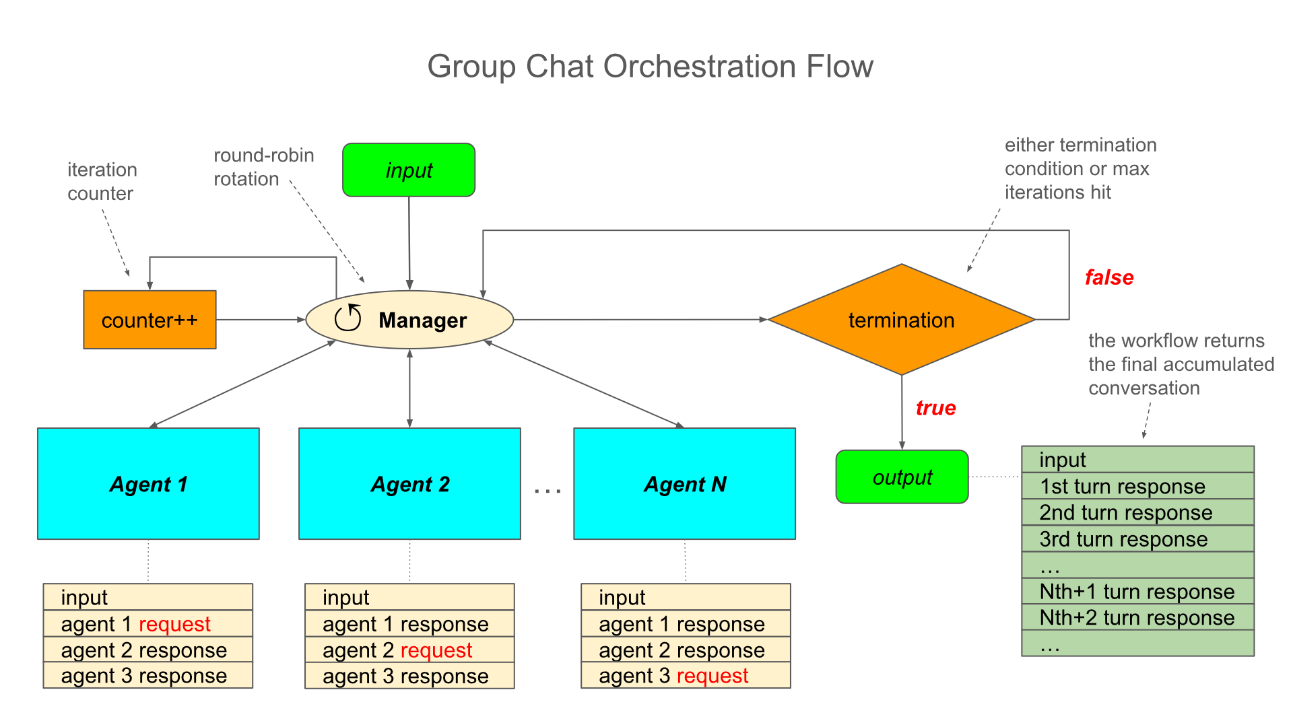
Figure 13.2. Round-robin conversation flow shows the host coordinating successive turns and distributing new message batches while each participant retains its own context.
Read the center as the selection-and-termination loop and the participant-side message lists as accumulated context. The counter marks scheduled participant interactions; it is not a count of broadcast deliveries or tool calls. The transcript output shown is the default host output, which an explicit output designation can replace.
Warning Accumulated context can make total input tokens grow approximately quadratically when each turn adds similar text and prior context remains in requests. Broadcasting deltas does not make that context free. Set a turn ceiling for MaximumIterationCount (default is 40) and measure model requests, token use, and elapsed time separately.
Best use cases: iterative approval loops, negotiation, plan review, critique-and-revise cycles, and any multi-turn exchange where the number of rounds is not known in advance.
Important Choose round-robin manager (RoundRobinGroupChatManager) when each participant should contribute in a predictable order. Choose a custom manager (implement an abstract GroupChatManager) when the next useful turn depends on completed work.
    - Group Chat Orchestration in Action
Robby's first group chat has two participants. MotorsAgent proposes a movement sequence for the mission. NavigatorAgent evaluates the proposal and either approves it or sends it back with concrete feedback. The optimality rule is deliberately concrete so the navigator can apply it consistently: turning angles of 30°, 45°, or 60° are preferred for efficient pathing, and 90° turns are acceptable only when the geometry requires them.
The mission is the same tree-avoidance trip from previous examples, with one addition: the distance to the tree is 50 meters. That distance matters, because a 45° diagonal detour around a distant obstacle is measurably shorter than the 90° detour, and the navigator knows it.
Figure 13.3 shows the negotiation loop the two agents run inside the group chat:
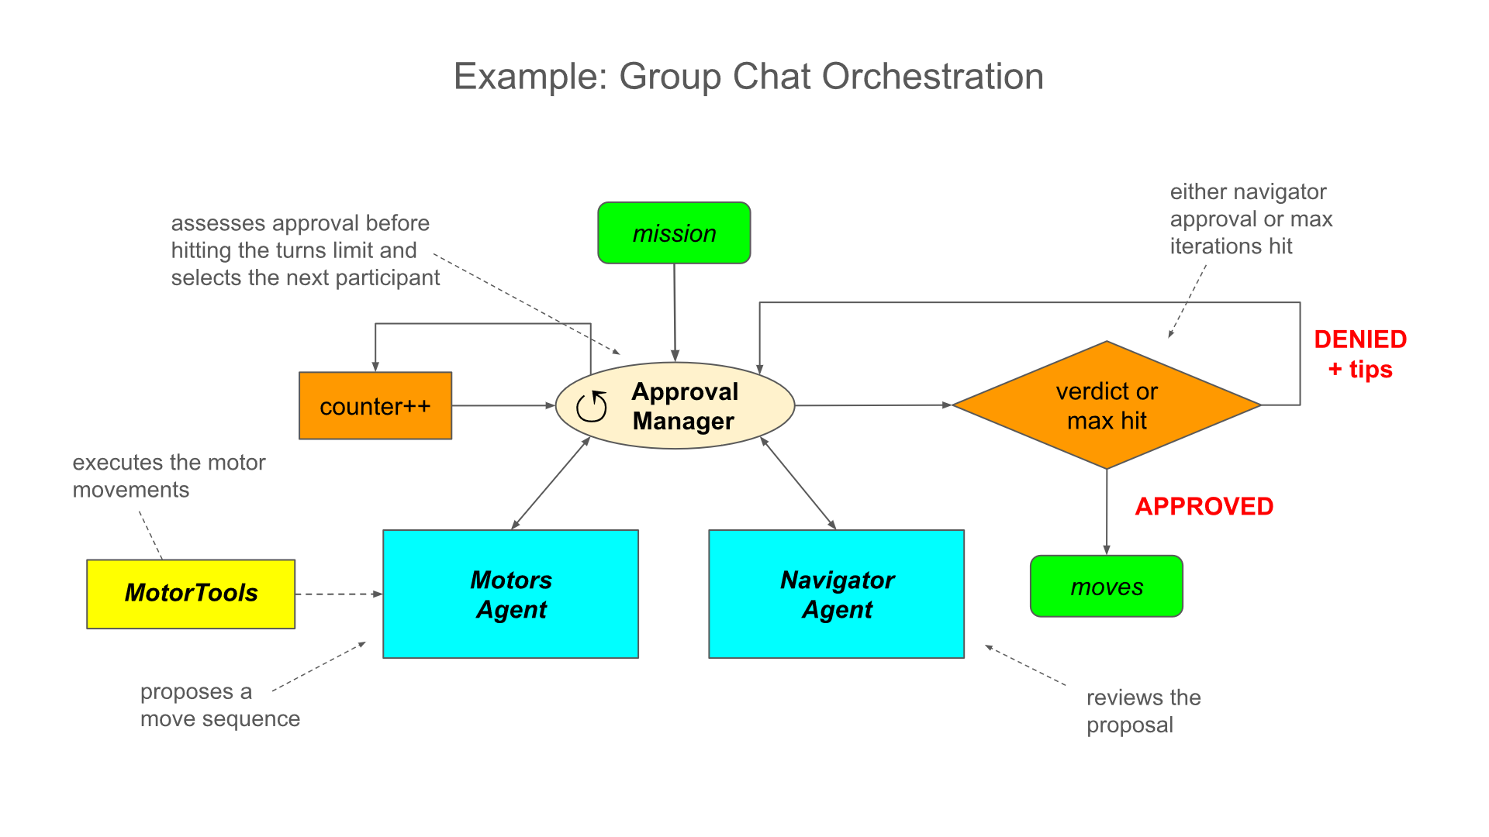
Figure 13.3 The approval loop inside the group chat. MotorsAgent proposes, NavigatorAgent reviews, and a DENIED verdict sends the proposal back for revision. Only an APPROVED verdict lets MotorsAgent execute the sequence and confirm with EXECUTED, which terminates the chat. The iteration ceiling guards the whole loop.
One round of this loop is two turns: a proposal and a verdict. A DENIED verdict costs one more round; an APPROVED verdict triggers execution and the terminating EXECUTED confirmation. The number of rounds depends entirely on how good the first proposal is, which is precisely why a fixed pipeline cannot express this workflow.

Practical Example
Before writing any agent, we need to settle a question that looks trivial and is not: how does the code recognize a verdict? My first version of this sample used raw string comparisons, Contains("APPROVED"), sprinkled across the termination logic. It worked in the demo and fell apart the first time the model produced ambiguous text like Previously DENIED, now APPROVED, which fired the guard on the wrong message. Worse, the same magic string lived in three places: the termination check, the navigator's instructions, and the motors agent's constraints. When I reworded one prompt, the other two silently stopped matching.
The clean solution is an ApprovalState enum (see listing 13.1) that captures every verdict as a named constant. Code references the tokens through nameof, so the compiler guarantees that the termination manager, the agents' instructions, and any future logging all agree on the exact spelling.
Code path: /GroupChatOrchestration/ExecutionDecision.cs
Listing 13.1 — ApprovalState enum
public enum ExecutionDecision
{
APPROVED, //❶
DENIED, //❷
EXECUTED //❸
}
❶ the reviewer's positive verdict token
❷ the reviewer's negative verdict token
❸ the executor's confirmation token after the sequence has run
The uppercase members are deliberate. These are the same tokens the agents write into the chat, so nameof(ApprovalState.APPROVED) returns exactly the string APPROVED that appears in the conversation. The enum lives in its own file and becomes the single source of truth shared by the termination manager and, conceptually, by the prompts.
Next, the termination logic. Rather than passing raw lambda, we encapsulate it in a dedicated manager class. This keeps the code focused on wiring, makes the termination rule independently reviewable, and gives the delegate access to the manager's own state, the iteration count and its ceiling, without closing over external variables (see listing 13.2).
Code path: /GroupChatOrchestration/ApprovedTerminationManager.cs
Listing 13.2 — ApprovedTerminationManager
using Microsoft.Agents.AI;
using Microsoft.Agents.AI.Workflows;
public class ApprovedTerminationManager(IReadOnlyList<AIAgent> agents)
: RoundRobinGroupChatManager(agents, (chatManager, messages, _) =>
{
if (chatManager.IterationCount >= chatManager.MaximumIterationCount)
return ValueTask.FromResult(true); //❶

return ValueTask.FromResult(
(messages.LastOrDefault()?.Text ?? string.Empty)
.Contains(nameof(ApprovalState.EXECUTED)) && //❷
messages.Any(m => m.Text != null
&& m.Text.Contains(nameof(ApprovalState.APPROVED))
&& !m.Text.Contains(nameof(ApprovalState.DENIED)))); //❸
});
❶ stops the chat when the iteration ceiling is reached, regardless of outcome
❷ requires the last message to be the execution confirmation
❸ requires an approval message that does not also contain a denial
The success condition has two parts, and both are load-bearing. The last message must contain EXECUTED, proof that the executor acted, and some earlier message must contain APPROVED without DENIED, proof that permission was granted. Anchoring EXECUTED to the last message prevents the chat from terminating on a stale mention of the token from an earlier round, and the !Contains(DENIED) guard rejects hedged messages that carry both tokens at once.
Robby's negotiation loop needs two agents (see listing 13.3). MotorsAgent proposes and, on approval, executes. NavigatorAgent reviews. There is one ordering rule to respect: the first agent added in AddParticipants sends the opening message. That must be MotorsAgent because it proposes. If NavigatorAgent spoke first, it would try to evaluate a proposal that has not been made yet. The optimality rule is concrete enough that the navigator can apply it deterministically: only turning angles of 30°, 45°, or 60° are acceptable. A 90° turn is rejected unless it is optimal.
Requirements (NuGet packages):
dotnet add package Microsoft.Agents.AI
dotnet add package Microsoft.Agents.AI.OpenAI
dotnet add package Microsoft.Agents.AI.Workflows
dotnet add package Microsoft.Extensions.Configuration.UserSecrets
Code path: /GroupChatOrchestration/Program.cs
Listing 13.3 Group chat participants (agents) definition
// 'usings' and API key fetching omitted for brevity

var navigatorAgent = new OpenAIClient(apiKey)
.GetChatClient(model)
.AsAIAgent("""
# PERSONA
You are the NavigatorAgent that approves or denies proposed move sequences.

# ACTIONS
Prefer turning angles of 30°, 45°, or 60° for efficient pathing.
90° turns are allowed but only when geometry requires it.
Respond APPROVED if the sequence is optimal;
otherwise respond DENIED with concrete angle or path improvements.

# OUTPUT TEMPLATE
APPROVED or DENIED: <optimality tips>
""",
"NavigatorAgent"
); //❶

var motorsAgent = new OpenAIClient(apiKey)
.GetChatClient(model)
.AsAIAgent("""
# PERSONA
You are the MotorsAgent.
Permitted moves: forward, backward, turn left, turn right, stop.

# ACTIONS
Break the mission into a move sequence and submit it to NavigatorAgent
for approval, then end your turn.
NavigatorAgent's verdict is the ONLY one that matters for execution:
If DENIED, revise based on feedback and resubmit.
If APPROVED, execute the sequence using MotorTools, then respond with:
EXECUTED: <one-line summary>.

# CONSTRAINTS
- NEVER execute a sequence you proposed, revised, or assume approval for,
only if NavigatorAgent's message literally contains "APPROVED".
- NEVER execute a DENIED sequence.
""",
"MotorsAgent",
tools: [.. MotorTools.AsAITools()]
); //❷
❶ defines the reviewer: no tools, only judgment and an exact output template
❷ defines the proposer-executor with movement tools and token constraints

Look closely at the CONSTRAINTS block in agent’s instructions, because it encodes a lesson that cost me an afternoon of debugging. The NEVER response with APPROVED rule is not cosmetic. Without it, an LLM happily echoes the approval back in its own confirmation, something like Sequence APPROVED by NavigatorAgent — executing now, and suddenly the approval token appears in a message written by the wrong agent. The termination logic scans messages, not authors, so each agent must be restricted to producing only the verdict tokens it owns: NavigatorAgent owns APPROVED and DENIED, MotorsAgent owns EXECUTED.
At this point we have defined agents, not started a conversation. With the enum, the manager, and the agents defined, the workflow wires together in a handful of lines. The factory creates a manager for the group chat run, and MaximumIterationCount = 10 leaves room for revisions without an open-ended conversation (see listing 13.4).
Code path (code continuation): /GroupChatOrchestration/Program.cs
Listing 13.4 Group chat workflow and run
var prompt = """
# MISSION COMMAND: Exploration Trip

"There is a tree directly in front of the car. Avoid it and then come back to the original path. The distance to the tree is 50 meters."
""";

var workflow = AgentWorkflowBuilder.CreateGroupChatBuilderWith(agents =>
new ApprovedTerminationManager(agents) { MaximumIterationCount = 10 }) //❶
.AddParticipants(motorsAgent, navigatorAgent) //❷
.WithOutputFrom(motorsAgent) //❸
.WithName("RefinedExecution")
.Build();

// Use this for streaming execution to see the events as they happen (observability)
await using StreamingRun run = await InProcessExecution.RunStreamingAsync(workflow, input: prompt);
await run.TrySendMessageAsync(new TurnToken(emitEvents: true)); //❹

await PrintAsync(run);

static async Task PrintAsync(StreamingRun run)
{
await foreach (WorkflowEvent evt in run.WatchStreamAsync())
{
switch (evt)
{
case ExecutorCompletedEvent completed:
Console.WriteLine($"[EXECUTOR] {completed.ExecutorId} completed.");
break;

case AgentResponseEvent response:
Console.WriteLine(response.Response.Text);
break;

case AgentResponseUpdateEvent update:
Console.Write(update.Update.Text);
break;

case WorkflowOutputEvent output:
string? summary = output
.As<List<Microsoft.Extensions.AI.ChatMessage>>()?
.LastOrDefault(m => !string.IsNullOrWhiteSpace(m.Text))?.Text; //❺
Console.WriteLine($"\n[WORKFLOW OUTPUT] {summary}");
break;

case WorkflowErrorEvent error:
Console.WriteLine($"\n[WORKFLOW ERROR] {error.Exception?.InnerException?.Message ?? error.Exception?.Message ?? "unknown"}");
break;

case ExecutorFailedEvent failed:
Console.Error.WriteLine($"\n[EXECUTOR FAILED] {failed.Data?.Message}");
break;
}
}
}
❶ creates the manager with an iteration ceiling of ten turns
❷ adds the participants in speaking order: the proposer first
❸ emits workflow output only from MotorsAgent's messages
❹ runs in streaming mode and sends the turn token to start execution
❺ extracts the last non-empty message as the mission result
Two details are new compared to chapter 12. WithOutputFrom(motorsAgent) filters the workflow output down to MotorsAgent's messages, so the mission result is the EXECUTED confirmation rather than the entire negotiation transcript. And the manager factory delegate receives the participant list when the host creates the manager for the run, normally on the first turn, which is how ApprovedTerminationManager gets its agents without any global state.
NOTE WithOutputFrom is an output designation, not a final-summary generator or a filter over every console event. In this version it replaces the default host output designation; a missing [WORKFLOW OUTPUT] transcript line is expected in these selected-participant runs. Streamed agent text remains observable and must not be mistaken for a failed workflow.
Code output:
[EXECUTOR] MotorsAgent_46e89e5600224e3c9ce5c18bfe678c43 completed.
Proposed sequence: forward 49m, turn right 90°, forward 2m,
turn left 90°, forward 2m, turn left 90°, forward 2m,
turn right 90° — resume original path.
[EXECUTOR] NavigatorAgent_eb7ee09954344003974895e3d2ea224b completed.
DENIED: 90° turns are not required by this geometry. With 50 meters
of approach, use 45° diagonals: turn left 45° before the tree,
clear it, then mirror the maneuver to rejoin the original path.
[EXECUTOR] MotorsAgent_46e89e5600224e3c9ce5c18bfe678c43 completed.
Revised sequence: forward 47m, turn left 45°, forward 3m,
turn right 45°, forward 2m, turn right 45°, forward 3m,
turn left 45° — back on the original path.
[EXECUTOR] NavigatorAgent_eb7ee09954344003974895e3d2ea224b completed.
APPROVED: the 45° diagonals produce a shorter detour and a smooth
rejoin. Proceed.
[10:22:41:118] MOTORS: Forward: 47m
[10:22:42:944] MOTORS: TurnLeft: 45°
[10:22:44:702] MOTORS: Forward: 3m
[10:22:46:513] MOTORS: TurnRight: 45°
[10:22:48:301] MOTORS: Forward: 2m
[10:22:50:119] MOTORS: TurnRight: 45°
[10:22:51:925] MOTORS: Forward: 3m
[10:22:53:731] MOTORS: TurnLeft: 45°
[EXECUTOR] MotorsAgent_46e89e5600224e3c9ce5c18bfe678c43 completed.
EXECUTED: avoided the tree with 45° diagonals and rejoined the
original path.

[WORKFLOW OUTPUT] EXECUTED: avoided the tree with 45° diagonals and
rejoined the original path.
The negotiation took two rounds. MotorsAgent's first proposal used the boxy 90° detour, NavigatorAgent denied it with specific feedback, the revision switched to 45° diagonals, and the second review approved. Only then did the MOTORS tool lines appear, followed by the EXECUTED confirmation that satisfied the termination condition. Try running it a few times: sometimes MotorsAgent proposes 45° turns on the first attempt and the chat converges in a single round; sometimes it takes three. The rotation is deterministic; the convergence is not.

Exercise
Let's tighten NavigatorAgent's review policy. Extend its instructions with a second optimality rule: the total forward distance of the detour must not exceed the straight-line mission distance by more than 10 meters. Run the workflow several times and observe how many rounds the negotiation now takes. Bonus: capture the manager instance created in the factory delegate, and after the run print its IterationCount; flag any run that ended by hitting the ceiling rather than by approval. You will need exactly this distinction in the hardening section.
  - Group Chat with Human in the Loop
While traveling along its route, Robby’s proximity sensors detect an obstacle that is not included in the pre-mapped path. Robby cannot continue as planned and must identify an alternative route without colliding with shelving or crossing the floor-marked safe zone.
Because this unplanned maneuver occurs near infrastructure and possibly people, it is classified as high risk. Before Robby moves, a human supervisor must review and personally authorize the proposed detour.
We call such supervision human-in-the-loop (HITL) where we can involve people in two fundamentally different ways:
- Tool-level approval: The agent proposes invoking a tool—for example, sending a message, updating a record, controlling a device, or calling an external API—and the system pauses before execution. A human approves or rejects that specific tool invocation. The human controls whether the action occurs but does not necessarily participate in the agent’s wider reasoning process.
- Human-agent participation: The human is represented as an active agent in the workflow and is assigned an explicit turn in the conversation. Rather than merely approving a tool call, the human can assess the situation, approve or reject a plan, introduce new constraints, request a different approach, or provide feedback that shapes the agent’s next proposal.
Tool-level approval protects individual side effects. Human-agent participation adds human judgment to planning, coordination, and decision-making. Production systems often need both: a human agent to guide the workflow and tool-approval gates to prevent unapproved external actions.
The negotiation loop from the previous section is exactly the right conversation for this decision. MotorsAgent still proposes and NavigatorAgent still reviews. What must change is the authority: the verdict that gates execution has to move from an LLM to a person. Which raises a practical question: how does a human join a group chat built for AI agents?
The answer is one of my favorite design moments in Agent Framework: everything at the table is an AIAgent, so we seat the human as one. We write a custom agent whose purpose is a console prompt.
The model-backed participants in these examples are ChatClientAgent instances created through AsAIAgent, a class built on top of IChatClient, which means every response ultimately comes from an LLM. But AIAgent itself is an abstract base class with no opinion about where responses come from. By inheriting from AIAgent directly, we can produce responses deterministically, from conventional code: no model, no tokens, no non-determinism. That is precisely what we need here, because the human's decision must be relayed verbatim, not generated by a model. Let’s see the diagram of class inheritance in figure 13.4.
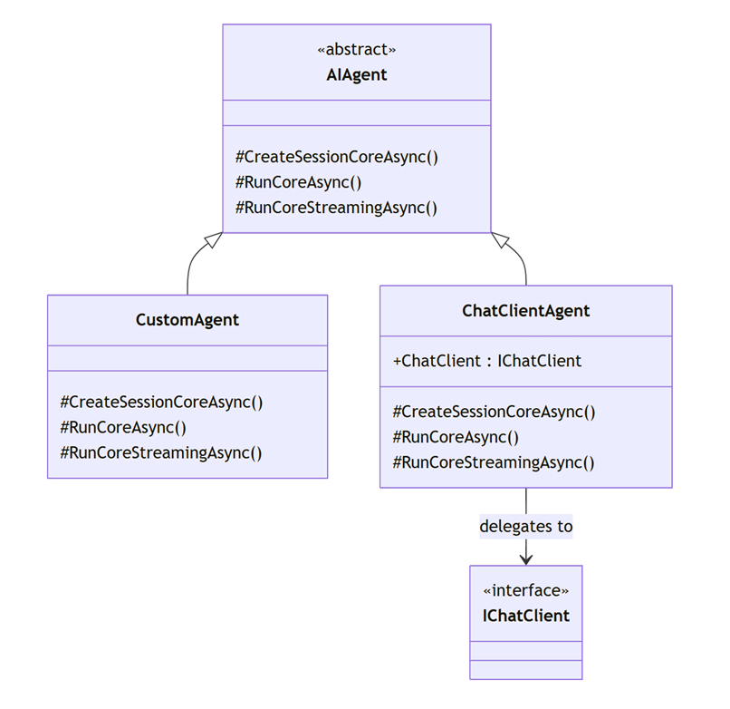
Figure 13.4 ChatClientAgent and a custom agent derive from AIAgent; ChatClientAgent delegates to IChatClient, while CustomAgent implements the custom-agent branch without a model.
It's like a driving lesson in a car with dual control:
- The student driver (MotorsAgent) participant operates the pedals and proposes every maneuver.
- The GPS (NavigatorAgent) participant suggests better routes, but it cannot stop the car; its advice is exactly that advice.
- The instructor's (HumanAgent) participant accepts or rejects the proposal before the student proceeds.
This distinction lets us teach human participation, but we may replace the human agent with conventional code agent. Opposing to human agent, conventional code agent allows us to automate the workflow (see figure 13.5).
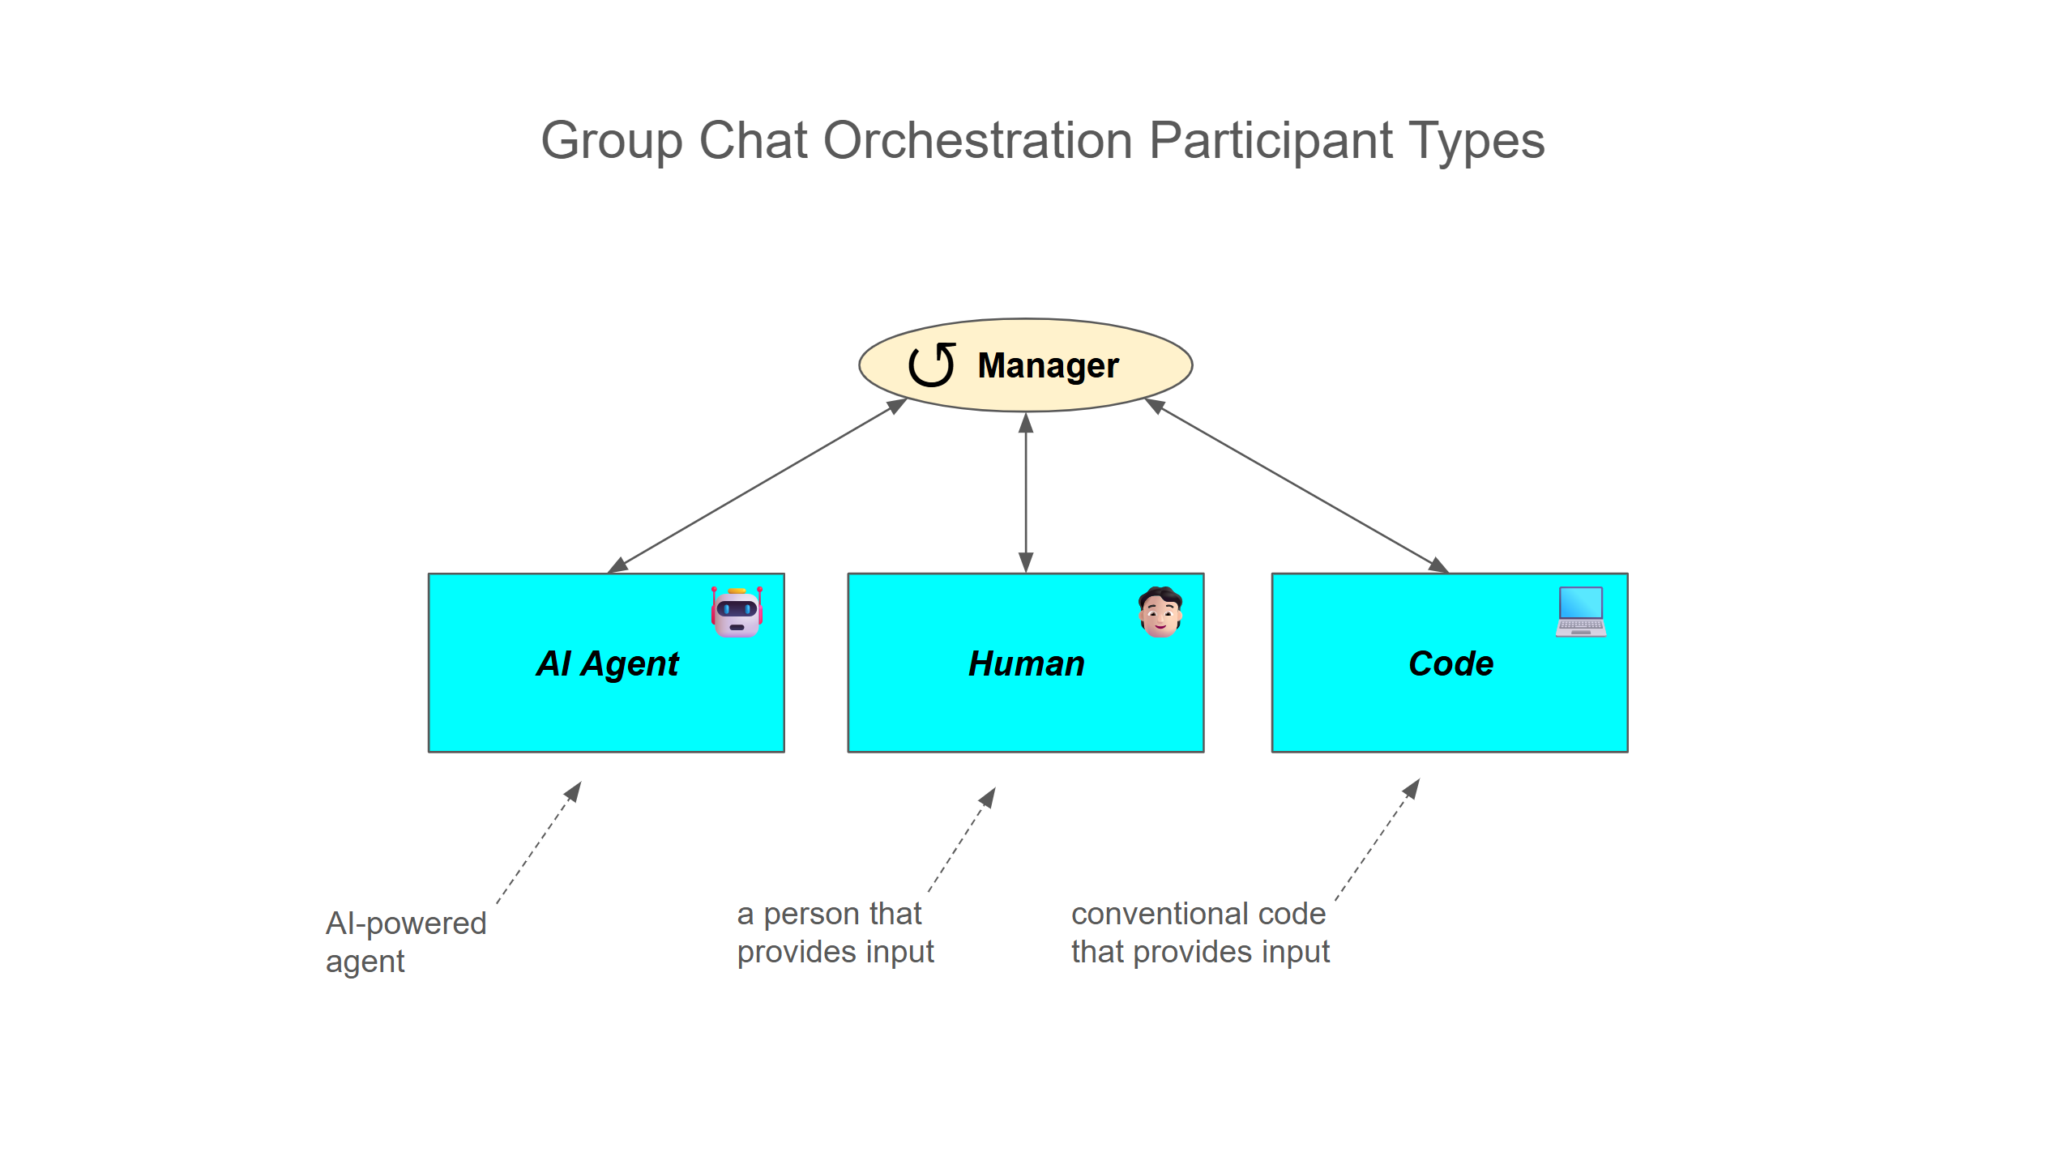
Figure 13.5 Group-chat participants can be model-backed, human-backed, or code-backed because the manager schedules the agent contract rather than a particular response-generation mechanism.
Any branch goes back to the manager: each participant contributes a message through the same workflow. HumanAgent is the implemented non-model example here; the conventional-code branch illustrates another possible implementation, not an extra project. No additional model call is needed merely to relay the operator's answer.
Effective orchestration brings together AI-powered, human-backed, and code-backed participants, applying each where its particular strengths deliver the best outcome (see table 13.3).
Table 13.3 Participant implementation strategies: AI-powered, human-backed, and code-backed.
AI agent type | Decision maker | Example role
AI-powered | AI model | Generate / critique
Human-backed | Person | Approval / advice
Code-backed | Rules / code | Validate / calculate
Together, these implementations support flexible automation with human judgment (human-backed) and deterministic validation (code-backed) where needed.
    - Group Chat with Human in the Loop in Action
The workflow now has three participants:
- MotorsAgent, the executor. It plans a move sequence and is instructed to invoke the simulated MotorTools only after human approval, then report EXECUTED.
- NavigatorAgent, the advisory reviewer. It evaluates the path for efficiency and returns an APPROVED or DENIED verdict with tips, but its verdict is non-blocking.
- HumanAgent, the participant that relays the operator's APPROVED or DENIED decision, which MotorsAgent's instructions designate as authoritative.
Figure 13.6 show the flow with the human in the loop agent.
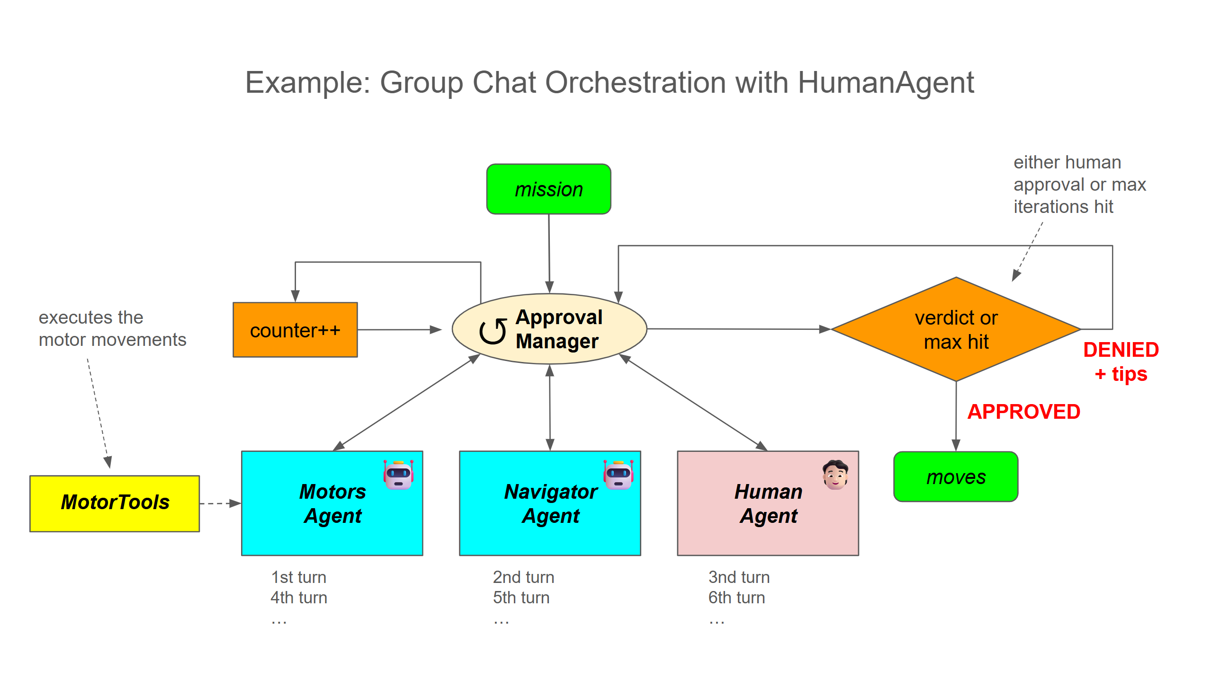
Figure 13.6 The HITL group chat rotation: the proposer speaks first, the advisor second, and the human authority last, so every human decision is made with both the proposal and the expert review on the table. Only the human verdict gates execution.
The rotation order is a design decision, not an accident. The human speaks last in each round, after seeing both the proposed sequence and the navigator's expert opinion, the same way a supervisor reads the report and the specialist's assessment before signing off. One round is now three turns instead of two.
Notice what we do not change: ApprovedTerminationManager is reused as is. The termination condition cares about tokens, not authors: permission granted plus proof of execution. Since MotorsAgent's new instructions only let it execute after the human's APPROVED, the same manager now enforces human authority for free. The entire authority shift lives in the prompts and in one new class.

Practical Example
The only genuinely new code is the human participant. HumanAgent inherits AIAgent directly and implements the small contract the runtime needs: session management plus the non-streaming and streaming run methods.
Participants:
- MotorsAgent — the executor. It plans a move sequence (forward, backward, turn left/right, stop) and, once approved, invokes MotorTools to physically carry it out, then it responds with EXECUTED.
- NavigatorAgent — an advisory reviewer. It evaluates the proposed path for efficiency (preferring 30°/45°/60° turns over 90°) and returns an APPROVED/DENIED verdict with tips — but its verdict is non-blocking.
- HumanAgent — the human participant, whose APPROVED/DENIED decision is the only one that gates execution.
- Orchestration mechanics: AgentWorkflowBuilder.CreateGroupChatBuilderWith builds a round-robin-style group chat, governed by a custom ApprovedTerminationManager that ends the conversation once the human approves and the motors agent executes (capped at 10 iterations to prevent infinite loops).
In listing 13.5 we define the HumanAgent.
Requirements (NuGet):
dotnet add package Microsoft.Agents.AI
dotnet add package Microsoft.Agents.AI.OpenAI
dotnet add package Microsoft.Agents.AI.Workflows
dotnet add package Microsoft.Extensions.Configuration.UserSecrets
Code path: /GroupChatOrchestrationWithHitl/HumanAgent.cs
Listing 13.5 Human Agent, a custom AIAgent around a console prompt
public sealed class HumanAgent : AIAgent
{
public override string Name { get; } = "HumanAgent";

protected override ValueTask<AgentSession> CreateSessionCoreAsync(
CancellationToken cancellationToken = default)
=> new(new HumanAgentSession()); //❶

protected override ValueTask<JsonElement> SerializeSessionCoreAsync(
AgentSession session,
JsonSerializerOptions? jsonSerializerOptions = null,
CancellationToken cancellationToken = default)
=> new(JsonSerializer.SerializeToElement(new { }));

protected override ValueTask<AgentSession> DeserializeSessionCoreAsync(
JsonElement serializedState,
JsonSerializerOptions? jsonSerializerOptions = null,
CancellationToken cancellationToken = default)
=> new(new HumanAgentSession());

protected override Task<AgentResponse> RunCoreAsync(
IEnumerable<ChatMessage> messages,
AgentSession? session = null,
AgentRunOptions? options = null,
CancellationToken cancellationToken = default)
=> Task.FromResult(new
AgentResponse(CreateApprovalDecisionMessage(messages))); //❷

protected override async IAsyncEnumerable<AgentResponseUpdate>
RunCoreStreamingAsync(
IEnumerable<ChatMessage> messages,
AgentSession? session = null,
AgentRunOptions? options = null,
[EnumeratorCancellation] CancellationToken cancellationToken = default)
{
ChatMessage responseMessage = CreateApprovalDecisionMessage(messages);
yield return new AgentResponseUpdate(responseMessage.Role,
responseMessage.Contents)
{
AuthorName = responseMessage.AuthorName,
MessageId = responseMessage.MessageId,
}; //❸
await Task.CompletedTask;
}

private static ChatMessage
CreateApprovalDecisionMessage(IEnumerable<ChatMessage> messages)
{
if (messages.Any(message => message.Text?
.Contains(nameof(ApprovalState.EXECUTED), StringComparison.Ordinal)
== true))
{
return new ChatMessage(ChatRole.Assistant,
"Sequence approved already!"); //❹
}

Console.Write("HUMAN: Approve? [y/n]: ");
var input = Console.ReadLine();

if (string.Equals(input, "y", StringComparison.OrdinalIgnoreCase))
{
return new ChatMessage(ChatRole.Assistant,
$"HUMAN {nameof(ApprovalState.APPROVED)}: "
+ "the proposed move sequence looks good. Execute it now."); //❺
}

return new ChatMessage(ChatRole.Assistant,
$"HUMAN {nameof(ApprovalState.DENIED)}: "
+ "please revise the proposed move sequence.");
}

private sealed class HumanAgentSession : AgentSession;
}
❶ minimal session plumbing: the human has no state worth persisting
❷ non-streaming path: the decision is returned as a normal AgentResponse
❸ streaming path: yields the same message as a single update
❹ short-circuits when the sequence has already been executed
❺ maps console input to the shared ApprovalState tokens
Why implement AIAgent directly instead of, say, wrapping a nested workflow or faking an IChatClient? Because a direct AIAgent responds with a plain ChatMessage that flows through the group chat like any other participant's message, with no extra propagation layer that can silently drop or misattribute the output. The session methods are the minimum the runtime requires: HumanAgentSession is an empty class, and serialization returns a default JsonElement because there is nothing to save.
Code output:
HUMAN: Approve? [y/n]: n
HUMAN DENIED: please revise the proposed move sequence.
Only y, ignoring case, maps to APPROVED. Other input, including an empty line, maps to DENIED. The EXECUTED check is a defensive shortcut when that marker appears in the incoming messages; it is not independent verification that a movement occurred. Under normal termination, a final execution report ends the chat before another human turn is scheduled.
Important Console.ReadLine blocks the workflow until a person types an answer, which is fine for a console demonstration and wrong for production. In real deployment, human approval is an asynchronous external event: an approval queue, a web endpoint, a messaging system. Pair it with the checkpointing from chapter 12 so the workflow can persist its state at the approval boundary and resume hours or days later when the decision arrives.
The agent definitions change less than you might expect. NavigatorAgent keeps its persona; its verdict simply becomes advisory. MotorsAgent's instructions are re-anchored so that only the human verdict authorizes execution.
Let’s initialize the agent in listing 13.6.
Requirements (NuGet packages):
dotnet add package Microsoft.Agents.AI
dotnet add package Microsoft.Agents.AI.OpenAI
dotnet add package Microsoft.Agents.AI.Workflows
dotnet add package Microsoft.Extensions.Configuration.UserSecrets
Code path: /GroupChatOrchestrationWithHitl/Program.cs
Listing 13.6 Group chat agents definition with a human approver
// 'usings' and API key fetching omitted for brevity

var navigatorAgent = new OpenAIClient(apiKey)
.GetChatClient(model)
.AsAIAgent("""
# PERSONA
You are the NavigatorAgent that approves or denies proposed move sequences.

# ACTIONS
Prefer turning angles of 30°, 45°, or 60° for efficient pathing. 90° turns are allowed but only when geometry requires it.
Respond APPROVED if the sequence is optimal; otherwise respond DENIED with concrete angle or path improvements.

# OUTPUT TEMPLATE
APPROVED or DENIED: <optimality tips>
""",
"NavigatorAgent"
); //❶

var motorsAgent = new OpenAIClient(apiKey)
.GetChatClient(model)
.AsAIAgent("""
# PERSONA
You are the MotorsAgent. Permitted moves: forward, backward, turn left, turn right, stop.

# ACTIONS
Break the mission into a move sequence and state it clearly.
NavigatorAgent will offer advisory feedback (APPROVED or DENIED with tips) that you may use to improve future proposals, but it never blocks execution.
HumanAgent's verdict is the ONLY one that matters for execution:
If DENIED, revise based on feedback and resubmit.
If APPROVED, execute the sequence using MotorTools, then respond with: EXECUTED: <one-line summary>.

# CONSTRAINTS
- NEVER execute a sequence unless HumanAgent's most recent message says APPROVED.
- NavigatorAgent's verdict NEVER overrides or delays a HumanAgent APPROVED.
""",
"MotorsAgent",
tools: [.. MotorTools.AsAITools()]
); //❷

AIAgent humanApprover = new HumanAgent(); //❸
❶ the reviewer keeps its persona; its verdict is now explicitly advisory
❷ execution is re-anchored on the human's verdict, not the navigator's
❸ the human joins the chat as just another AIAgent

Compare MotorsAgent's ACTIONS blocks with listing 13.3 and you can see the entire authority shift expressed in prose: it never blocks execution for the NavigatorAgent, HumanAgent's verdict is the ONLY one that matters for the MotorsAgent. In a group chat, governance lives in the instructions.
In listing 13.7 we build the group chat with human in the loop workflow.
Code path (continuation): /GroupChatOrchestrationWithHitl/Program.cs
Listing 13.7 Group chat workflow with human-in-the-loop and run
var prompt = """
# MISSION COMMAND: Exploration Trip

"There is a tree directly in front of the car. Avoid it and then come back to the original path. The distance to the tree is 50 meters."
""";

var workflow = AgentWorkflowBuilder.CreateGroupChatBuilderWith(agents =>
new ApprovedTerminationManager(agents) { MaximumIterationCount = 10 }) //❶
.AddParticipants(motorsAgent, navigatorAgent, humanApprover) //❷
.Build();

await WorkflowsHelper.PrintToMarkdownAsync(workflow);

await using StreamingRun run = await InProcessExecution.RunStreamingAsync(workflow, input: prompt);
await run.TrySendMessageAsync(new TurnToken(emitEvents: true));

await foreach (WorkflowEvent evt in run.WatchStreamAsync())
{
switch (evt)
{
case ExecutorCompletedEvent completed:
Console.WriteLine($"[EXECUTOR] {completed.ExecutorId} completed.");
break;

case AgentResponseEvent response:
Console.WriteLine(response.Response.Text);
break;

case AgentResponseUpdateEvent update:
Console.Write(update.Update.Text);
break;

case WorkflowOutputEvent output:
string? summary = output
.As<List<Microsoft.Extensions.AI.ChatMessage>>()?
.LastOrDefault(m => !string.IsNullOrWhiteSpace(m.Text))?.Text;
Console.WriteLine($"\n[WORKFLOW OUTPUT] {summary}");
break;

case WorkflowErrorEvent error:
Console.WriteLine($"\n[WORKFLOW ERROR] {error.Exception?.InnerException?.Message ?? error.Exception?.Message ?? "unknown"}");
break;

case ExecutorFailedEvent failed:
Console.Error.WriteLine($"\n[EXECUTOR FAILED] {failed.Data?.Message}");
break;
}
}
❶ the same termination manager is reused unchanged
❷ speaking order: proposer, advisor, then the human authority
This time we do not call WithOutputFrom, so the workflow output is the full transcript, and the WorkflowOutputEvent handler picks the last non-empty message, which is MotorsAgent's EXECUTED confirmation. Let's run it, and this time, let's be a difficult supervisor.
Code output:
[EXECUTOR] MotorsAgent_cccea5d3987649f4a6a01c72325eb0db completed.
Proposed sequence: forward 47m, turn left 45°, forward 3m,
turn right 45°, forward 2m, turn right 45°, forward 3m,
turn left 45° — rejoins the original path.
[EXECUTOR] NavigatorAgent_888fa864d5b94d0ab2a7ba20f54c7891 completed.
APPROVED: efficient 45° diagonals with a smooth rejoin.
HUMAN: Approve? [y/n]: n
[EXECUTOR] Human_dae24ea4ec014fbfa9a34a024e835493 completed.
HUMAN DENIED: please revise the proposed move sequence.
[EXECUTOR] MotorsAgent_cccea5d3987649f4a6a01c72325eb0db completed.
Revised sequence: forward 45m, turn left 45°, forward 4m,
turn right 45°, forward 4m, turn right 45°, forward 4m,
turn left 45° — wider clearance around the tree, rejoins the
original path.
[EXECUTOR] NavigatorAgent_888fa864d5b94d0ab2a7ba20f54c7891 completed.
APPROVED: still optimal, with a larger safety margin around the
obstacle.
HUMAN: Approve? [y/n]: y
[EXECUTOR] Human_dae24ea4ec014fbfa9a34a024e835493 completed.
HUMAN APPROVED: the proposed move sequence looks good. Execute it now.
[11:03:12:207] MOTORS: Forward: 45m
[11:03:14:031] MOTORS: TurnLeft: 45°
[11:03:15:842] MOTORS: Forward: 4m
[11:03:17:655] MOTORS: TurnRight: 45°
[11:03:19:470] MOTORS: Forward: 4m
[11:03:21:288] MOTORS: TurnRight: 45°
[11:03:23:094] MOTORS: Forward: 4m
[11:03:24:902] MOTORS: TurnLeft: 45°
[EXECUTOR] MotorsAgent_cccea5d3987649f4a6a01c72325eb0db completed.
EXECUTED: wider 45° detour around the tree completed; back on the
original path.

[WORKFLOW OUTPUT] EXECUTED: wider 45° detour around the tree
completed; back on the original path.
The first round is the interesting one. NavigatorAgent approved the proposal, and Robby did not move a single motor, because the human typed n. The advisory verdict and the authoritative verdict pointed in opposite directions, and the authoritative one won, exactly as designed. MotorsAgent treated human denial as actionable feedback, widened the clearance, and only after the human's y did the MOTORS tool lines appear.
A human turn and human-driven tool approval solve different problems, and we have to chose carefully when to use each (see table 13.1).
Table 13.1 Human participant versus human tool approval
Aspect | Human participant | Human-driven tool approval
Intervention point | A scheduled conversation turn | A proposed function invocation
Scope of judgment | A proposal, plan, or revision | A specific tool call and arguments
Response handling | A normal agent message | The tool-approval response protocol
Main lesson | A participant need not be model-backed | Permission can be checked at a tool boundary
Choose a human participant when the person should contribute to reasoning and revision as a member of the group. Choose tool approval when permission is required for a specific pending invocation. Otherwise, start with ordinary review; the mechanisms can also be combined when a conversation and an execution boundary both need human involvement.
Important Although we introduced human-backed AI agents in the context of GroupChat orchestration, this capability is not limited to GroupChat. All orchestration patterns operate on the AIAgent type and can therefore work with agents backed by a human participant or by conventional application code.

Exercise
Extend HumanAgent so a denial can include a short reason, then show that reason in the next proposal. Bonus: sketch an asynchronous approval response with a proposal identifier and a 30-second deadline that defaults to denial. Explain why cancelling a Task around Console.ReadLine does not cancel the underlying console read.
  - Next Participant with Custom Manager
A fixed rotation (round-robin) worked for the proposal, review, and human decision. It is less useful when some specialists should run only after evidence is available. Robby's sensors give us a concrete case: collect readings, ask for an independent observation when needed, calibrate only on the appropriate path, and let a safety reviewer make the decision.
    - Next Participant with Custom Manager in Action
Calling MaintenanceAgent on every rotation would spend time calibrating before the reviewer had established whether the investigation should continue. We do not need more participants or a different orchestration pattern. We need a different speaker-selection policy inside the same group chat.
Think of a diagnostic checklist:
- The technician (EnvironmentAgent) supplies measurements rather than diagnosis.
- The reviewer (SafetyAgent) interprets evidence and asks for more work when it is insufficient.
- The service specialist (MaintenanceAgent) performs the requested calibration.
- The checklist coordinator (InvestigationManager) records completed steps and chooses the next specialist.
The coordinator is pure C# code, not another LLM conversation. It can make reliable scheduling decisions from a count and a flag, while the reviewer remains responsible for interpreting the readings. The important boundary is who owns facts about execution and who reasons about the domain.
In figure 13.7 we use a custom manager to coordinate the participants in a GroupChat workflow. Rather than following a fixed turn order, the manager evaluates the participants’ responses and selects the next agent based on the current state of the conversation.
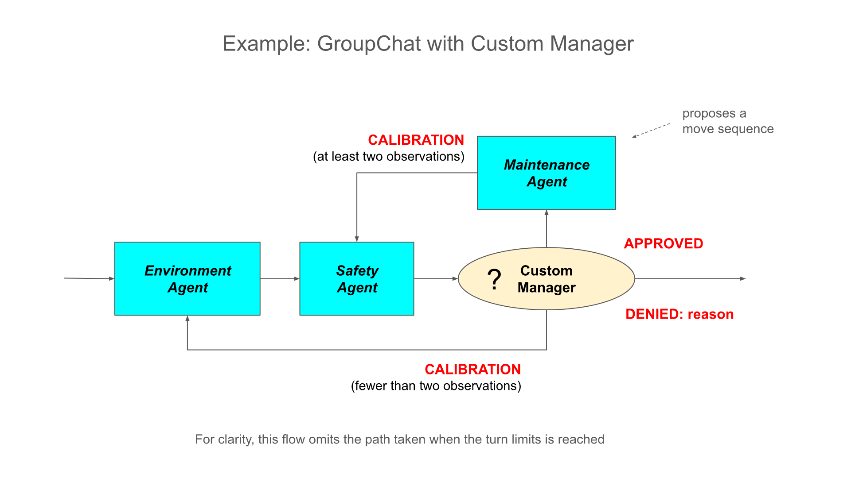
Figure 13.7 A custom GroupChat manager dynamically selects the next participant based on agent responses and workflow-specific rules.
This approach supports workflows whose next step depends on the content and state of prior participant responses, rather than on a predetermined sequence.

Practical Example
Robby is investigating whether its sensors are reporting safe environmental conditions. It begins by collecting a temperature and humidity reading, but the investigation may require more than one observation. Depending on the evidence, Robby may need to collect another reading, calibrate its sensors, or stop because the conditions are unsafe.
This example uses a GroupChat workflow with four participants:
- EnvironmentAgent collects Robby’s temperature and humidity readings.
- SafetyAgent evaluates the observations and returns a verdict.
- MaintenanceAgent calibrates Robby’s sensors when requested.
- InvestigationManager tracks the investigation and selects the next participant.
The participants have deliberately narrow responsibilities. EnvironmentAgent uses sensor tools but reports only one temperature/humidity pair per turn. That pair counts as one observation; multiple tool results from the same turn or repeated readings in later messages do not create additional observations.
MaintenanceAgent receives only the calibration tool and can report success only when the tool confirms it. SafetyAgent has no tools and evaluates the recorded observations and the manager’s state. InvestigationManager does not call a model or tool; it applies custom routing logic to choose the next participant.
CALIBRATION means that more work is required; it does not mean that calibration has already happened. The manager uses its current state to determine whether the next step is another observation or sensor calibration.

A typical approval route is:
EnvironmentAgent → SafetyAgent → EnvironmentAgent → SafetyAgent
→ MaintenanceAgent → SafetyAgent
If Robby detects an unsafe reading, the investigation can end with a denial before the remaining steps occur. The behavioral diagram shows these conditional routes, while the generated workflow graph shows the static participant topology. Together, they explain both who can participate and how the manager chooses the next step at runtime.
Listing 13.8 creates observation and maintenance specialists. Sharing a chat client does not merge their instructions or sessions; each AsAIAgent call creates a separately configured participant.
Requirements (NuGet packages):
dotnet add package Microsoft.Agents.AI.OpenAI
dotnet add package Microsoft.Extensions.Configuration.UserSecrets
Code path: /GroupChatOrchestrationWithCustomManager/Program.cs
Listing 13.8 Collecting observations and calibrating through existing tools
using AITools;
using GroupChatOrchestrationWithCustomManager;
using Helpers;
using Microsoft.Agents.AI.Workflows;
using Microsoft.Extensions.AI;
using Microsoft.Extensions.Configuration;
using OpenAI;
using OpenAI.Chat;
using ChatMessage = Microsoft.Extensions.AI.ChatMessage;

var configuration = new ConfigurationBuilder().AddUserSecrets<Program>().Build();
var model = configuration["OpenAI:ModelId"];
var apiKey = configuration["OpenAI:ApiKey"];

var chatClient = new OpenAIClient(apiKey).GetChatClient(model); //❶

var environmentAgent = chatClient.AsAIAgent("""
# PERSONA
You are EnvironmentAgent. You collect Robby's environmental readings.

# ACTIONS
On every turn, read the temperature and humidity using each tool exactly once.
The two measurements together form one observation, not two observations.
Report only this turn's observation. Do not repeat earlier readings or assess safety.

# OUTPUT TEMPLATE
Observation: temperature = <value> Celsius; humidity = <value>%.
""",
"EnvironmentAgent", //❷
tools: [.. SensorTools.AsAITools()]);

var maintenanceAgent = chatClient.AsAIAgent("""
# PERSONA
You are MaintenanceAgent. You maintain Robby's sensors.

# ACTIONS
Call your calibration tool and wait for its result.
Confirm that calibration is complete only if the tool reports success.
If the tool fails, report the failure instead of claiming calibration is complete.
Do not include or repeat any sensor readings.
""",
"MaintenanceAgent", //❸
tools: [AIFunctionFactory.Create(MaintenanceTools.CalibrateSensorsAsync)]); //❹
❶ Shares the provider client while creating separate agent instances.
❷ Defines one observation per turn and forbids repeating earlier evidence.
❸ Requires successful tool evidence before reporting calibration.
❹ Exposes only the calibration action, keeping the maintenance evidence check unambiguous in this sample.
Code output:
Excerpt from a recorded run, with timestamps removed and line breaks added. The workflow wiring in listing 13.9 causes the participant to run; definitions alone make no model or tool call.
SENSORS: READING Temperature: -9 Celsius degrees.
SENSORS: READING Humidity: 0 %
Observation: temperature = -9 Celsius; humidity = 0%.
The shared sensors return random readings. CalibrateSensorsAsync simulates work and returns a confirmation string; it does not change that random-number generation or repair earlier measurements. This keeps the book sample reusable, but it also means that a second observation is another sampled pair, not a validated physical sensor experiment.
Next, define the reviewer. The earlier version of this workflow exposed a reasoning problem: the conversation contained measurements, repeated explanations, and requests for calibration, but those are not interchangeable facts. The corrected prompt explicitly distinguishes observations, tool results, earlier decisions, and manager state. Its ordered rules are shown in full because their order is part of the behavior.
Requirements (NuGet packages):
dotnet add package Microsoft.Agents.AI.OpenAI
Code path: /GroupChatOrchestrationWithCustomManager/Program.cs
Listing 13.9 Participants instructions
var safetyAgent = chatClient.AsAIAgent("""
# PERSONA
You are SafetyAgent. You decide whether Robby's readings are safe.

# EVIDENCE
One observation is one EnvironmentAgent report containing a temperature/humidity pair.
Tool results and repeated mentions of the same readings are not additional observations.
Use the latest InvestigationManager state for the completed observation count and calibration status.
Your previous decisions are not measurements or evidence that a tool ran.
CALIBRATION always requests more work; it never confirms that calibration happened.

# ACTIONS
Apply these rules in order, using the actual readings from all completed observations:
1. If any temperature is greater than 90 Celsius or any humidity is greater than 95%, respond with DENIED.
2. If there are at least two observations and any temperature is greater than 60 Celsius
or any humidity is greater than 80%, respond with DENIED. Check both observations, not just the latest.
Apply these lower limits only when the completed observation count is at least two.
3. If there is only one observation, respond with CALIBRATION and request a second observation.
4. If calibration is not complete, respond with CALIBRATION and request sensor calibration.
5. Otherwise, respond with APPROVED only when the manager's state confirms calibration is complete
and MaintenanceAgent has actually reported successful calibration.

Values equal to a limit do not exceed it. Verify each numeric comparison before choosing a decision.
For DENIED, cite an actual offending measurement and its limit. Never invent readings or calibration evidence.

# OUTPUT TEMPLATE
Return exactly one line using one of these formats:
APPROVED: <reason>
DENIED: <reason>
CALIBRATION: <reason>
""",
"SafetyAgent"); //❶
❶ Creates a tool-free reviewer with explicit evidence, ordered rules, and a one-line decision template.
Code output:
Recorded response after the first (-9°C, 0%) observation. The request keeps the investigation open; it is not evidence that the maintenance tool ran.
CALIBRATION: Only one observation is complete; request a second observation.
The prompt cannot know that a second observation was completed unless the conversation makes that fact unambiguous. InvestigationManager therefore owns three small pieces of state: the completed observation count, a calibration flag, and the last selected participant. These are orchestration facts, not conclusions the reviewer should reconstruct by counting sentences.
The manager extends GroupChatManager directly because speaker selection must change. It implements three hooks: ShouldTerminateAsync decides whether to continue, UpdateHistoryAsync updates the continuing turn's state and broadcast, and SelectNextAgentAsync chooses the next participant.
Listing 13.10 combines the two short source files under their shared namespace.
Requirements (NuGet packages):
Code path: /GroupChatOrchestrationWithCustomManager/SafetyDecision.cs
Listing 13.10 Implementing state-based routing and termination
using Microsoft.Agents.AI;
using Microsoft.Agents.AI.Workflows;
using Microsoft.Extensions.AI;

namespace GroupChatOrchestrationWithCustomManager;

public enum SafetyDecision
{
APPROVED,
DENIED,
CALIBRATION
}

In listing 13.11 we have the investigation manager which implements the GroupChatManager abstraction.
Code path: /GroupChatOrchestrationWithCustomManager/InvestigationManager.cs
Listing 13.11 Implementing state-based routing and termination
using Microsoft.Agents.AI;
using Microsoft.Agents.AI.Workflows;
using Microsoft.Extensions.AI;

namespace GroupChatOrchestrationWithCustomManager;

public sealed class InvestigationManager(AIAgent EnvironmentAgent, AIAgent MaintenanceAgent, AIAgent SafetyAgent)
: GroupChatManager
{
private bool _calibrated; //❶
private int _observationCount;
private AIAgent? _lastAgent;

protected override ValueTask<bool> ShouldTerminateAsync(
IReadOnlyList<ChatMessage> history,
CancellationToken cancellationToken = default)
{
var lastDecision = (history.LastOrDefault()?.Text ?? string.Empty).Split(':', 2)[0].Trim(); //❷

return ValueTask.FromResult(
IterationCount >= MaximumIterationCount || //❸
(_lastAgent == SafetyAgent &&
(lastDecision.Equals(nameof(SafetyDecision.DENIED), StringComparison.OrdinalIgnoreCase) ||
(_calibrated && lastDecision.Equals(nameof(SafetyDecision.APPROVED), StringComparison.OrdinalIgnoreCase)))));
}

protected override ValueTask<IEnumerable<ChatMessage>> UpdateHistoryAsync( //❹
IReadOnlyList<ChatMessage> history,
CancellationToken cancellationToken = default)
{
if (_lastAgent == EnvironmentAgent)
_observationCount++;
else if (_lastAgent == MaintenanceAgent)
_calibrated = history.SelectMany(message => message.Contents)
.OfType<FunctionResultContent>()
.Any(result => result.Exception is null && result.Result is not null);

ChatMessage state = new(ChatRole.User, $"""
InvestigationManager state:
Completed observations: {_observationCount}
Calibration completed: {_calibrated}
""") { AuthorName = nameof(InvestigationManager) }; //❺

return ValueTask.FromResult<IEnumerable<ChatMessage>>([.. history, state]);
}

protected override ValueTask<AIAgent> SelectNextAgentAsync(
IReadOnlyList<ChatMessage> history,
CancellationToken cancellationToken = default)
{
AIAgent nextAgent; //❻
if (_lastAgent is null)
nextAgent = EnvironmentAgent;
else if (_lastAgent == EnvironmentAgent || _lastAgent == MaintenanceAgent)
nextAgent = SafetyAgent;
else if (_observationCount < 2)
nextAgent = EnvironmentAgent;
else if (!_calibrated)
nextAgent = MaintenanceAgent;
else
nextAgent = EnvironmentAgent;

_lastAgent = nextAgent;
return ValueTask.FromResult(nextAgent);
}
}
❶ Keeps calibration, observation count, and speaker identity in ordinary C# state.
❷ Reads the leading token before the colon rather than searching the whole explanation.
❸ Keeps the turn ceiling explicit alongside the terminal-decision checks.
❹ Processes the latest message batch to record completed observation or maintenance work.
❺ Appends an explicit state message to the broadcast seen by the next participants.
❻ Selects the next specialist from the previous participant and current state.
Code output:
Example of the injected message after the first EnvironmentAgent turn. This is participant context, not an extra console line printed by the sample.
InvestigationManager state:
Completed observations: 1
Calibration completed: False
Notice what the code does not do. It does not count temperature and humidity as two observations, infer successful maintenance from the word CALIBRATION, or ask another LLM to select a speaker. After an EnvironmentAgent turn, the counter increases once. After a MaintenanceAgent turn, the flag comes from a non-null, exception-free FunctionResultContent in that turn's message batch.
That last check is intentionally narrow. MaintenanceAgent has only one tool, and the shared calibration tool returns its confirmation on success. If we later give that agent several tools, or a tool can return a failure payload without an exception, the same Any check is no longer enough. We would need to identify the calibration call and validate its result explicitly.
IMPORTANT The observation counter assumes EnvironmentAgent followed its one-pair-per-turn contract; it does not parse or validate the measurements. Similarly, the manager does not recheck the reviewer's numeric verdict. Explicit state removes one source of ambiguity without turning the whole investigation into deterministic validation.
EnvironmentAgent and MaintenanceAgent always give the next turn to SafetyAgent. After a nonterminal safety reply, the manager first checks whether two observations exist, then whether calibration is complete. It can skip maintenance entirely when SafetyAgent rejects the evidence.
Termination also differs from the first manager. The code requires the last selected participant to be SafetyAgent and recognizes only the leading APPROVED or DENIED token. CALIBRATION: approval is pending does not terminate just because its explanation discusses approval. DENIED can stop immediately. Neither branch validates the model's arithmetic, and malformed replies have no dedicated rejection branch in this educational implementation
AddParticipants registers the three members, but their registration order no longer expresses the route: the explicit manager selects them. WithOutputFrom(safetyAgent) expresses the chosen output source without changing which participants run or what evidence the manager maintains (see listing 13.12).
Requirements (NuGet packages):
dotnet add package Microsoft.Agents.AI.Workflows
Code path: /GroupChatOrchestrationWithCustomManager/Program.cs
Listing 13.12 Building and observing the custom-manager workflow
var agents = new[] { environmentAgent, maintenanceAgent, safetyAgent };
var workflow = AgentWorkflowBuilder.CreateGroupChatBuilderWith(_ =>
new InvestigationManager(environmentAgent, maintenanceAgent, safetyAgent) { MaximumIterationCount = 10 }) //❶
.AddParticipants(agents) //❷
.WithOutputFrom(safetyAgent) //❸
.WithName("SensorInvestigation")
.Build();

await WorkflowsHelper.PrintToMarkdownAsync(workflow); //❹

const string prompt = "Check Robby's environment and decide whether it is safe.";
await using StreamingRun run = await InProcessExecution.RunStreamingAsync(workflow, input: prompt);
await run.TrySendMessageAsync(new TurnToken(emitEvents: true));

await foreach (WorkflowEvent evt in run.WatchStreamAsync())
{
switch (evt)
{
case AgentResponseUpdateEvent update: //❺
ColorHelper.PrintColored(update.Update.Text, ConsoleColor.Green);
break;

case WorkflowOutputEvent output:
string? result = output
.As<List<ChatMessage>>()?
.LastOrDefault(message => !string.IsNullOrWhiteSpace(message.Text))?.Text;
ColorHelper.PrintColoredLine($"\n[WORKFLOW OUTPUT] {result}", ConsoleColor.Yellow);
break;

case WorkflowErrorEvent error:
ColorHelper.PrintColoredLine($"\n[WORKFLOW ERROR] {error.Exception?.InnerException?.Message ?? error.Exception?.Message ?? "unknown"}", ConsoleColor.Red);
break;

case ExecutorFailedEvent failed:
ColorHelper.PrintColoredLine($"\n[EXECUTOR FAILED] {failed.Data?.Message}", ConsoleColor.Red);
break;
}
}
❶ Creates a fresh stateful manager with a bounded number of turns.
❷ Registers membership; the manager, not registration order, controls this route.
❸ Designates SafetyAgent for output, independently of routing and termination.
❹ Writes the static workflow graph to workflow.md for inspection.
❺ Prints streamed responses, including intermediate requests for more work.
Code output:
SENSORS: READING Temperature: -9 Celsius degrees.
SENSORS: READING Humidity: 0 %
Observation: temperature = -9 Celsius; humidity = 0%.
CALIBRATION: Only one observation is complete;
request a second observation.
SENSORS: READING Temperature: 3 Celsius degrees.
SENSORS: READING Humidity: 22 %
Observation: temperature = 3 Celsius; humidity = 22%.
CALIBRATION: Calibration is not complete;
request sensor calibration.
MAINTENANCE: CALIBRATING sensors...
Calibration complete.
APPROVED: Two observations are within denial limits,
and calibration is complete with MaintenanceAgent
reporting successful calibration.
The first CALIBRATION requests an observation, while the second requests maintenance. The manager makes that distinction from its count and calibration flag. The calibration tool line appears only after two observation turns and before the final approval. Six participant turns, but not six model requests: sensor and calibration tool calls can each involve additional model round trips.
Another recorded run stopped earlier:
Code output:
SENSORS: READING Temperature: 94 Celsius degrees.
SENSORS: READING Humidity: 45 %
Observation: temperature = 94 Celsius; humidity = 45%.
DENIED: temperature 94 Celsius exceeds the 90 Celsius limit.
This is successful rejection, not a workflow failure. The extreme first observation justified denial after two turns. No calibration was needed. A separate run with (0°C, 94%) followed by (72°C, 74%) correctly requested a second observation first, then denied after the fourth turn; the normal thresholds now applied to both observations.
Choose conditional selection when these branches represent meaningful work dependencies. Otherwise, start with round-robin: if every specialist always needs to speak in the same order, a custom state machine adds code without improving the flow.

Exercise
Use chapter 11 evaluation approach to record each observation, intermediate decision, tool call, and final decision. Include boundary cases of 60°C versus 61°C and 80% versus 81%, and a case where the first observation violates a normal limit but the second does not. Bonus: make a test response mention APPROVED inside a CALIBRATION reason and verify that it remains nonterminal; keep these cases in tests rather than embedding them into the shared sensor models
  - Conclusions
Group chat adds a conversational pattern to the sequential and concurrent patterns from chapter 12. Table 13.2 compares the three patterns covered so far. Within group chat, our projects change termination, participation, and conditional selection independently.
Table 13.2 Choosing between the three built-in orchestration patterns
Aspect | Sequential | Concurrent | Group chat
Topology | Pipeline | Fan-out / fan-in | Star with a manager hub
Number of steps | Fixed | Fixed | Open-ended, condition-driven
Termination | Last stage completes | All branches complete | Termination function or iteration ceiling
Best for | Dependent stages | Independent parallel checks | Negotiation and approval loops
The decision rule:
- Choose group chat when the number of rounds is unknown in advance and agents must react to each other's messages: approval loops, critique-and-revise cycles, negotiation.
- Choose group chat with a human participant when the loop gates a real-world action that policy or safety requires a person to authorize.
- Otherwise, start with the sequential or concurrent patterns from chapter 12: fixed topologies are cheaper, faster, and easier to reason about.
One constraint remains. The round-robin rotation is still a fixed schedule: every participant speaks in every round, whether or not it has anything useful to say. In the next chapter we remove that constraint too: the handoff pattern lets the current agent decide who speaks next, turning turn-taking itself into a routed decision.

Summary
- Group chat orchestration is a managed multi-turn conversation: participants take turns over a shared history, and a manager decides when the conversation is over.
- The pattern's topology is a star: every message flows through the group chat manager, which is the single place where history, iteration counting, and termination live.
- RoundRobinGroupChatManager rotates through participants in the order they were added, and the first participant added to AddParticipants speaks first, so the proposer must precede the evaluator.
- Termination is a pluggable decision: shouldTerminateFunc delegate receives the manager’s state and the full history, and MaximumIterationCount must always guard against endless loops.
- Verdict tokens belong in an enum referenced through nameof, giving the termination manager, the prompts, and the logs a single source of truth.
- A robust termination condition combines proof of permission with proof of execution and checks the absence of the negative token to survive hedged LLM responses.
- Agent instructions must restrict each agent to the verdict tokens it owns, because termination logic scans messages, not authors.
- A custom agent that inherits AIAgent directly can produce deterministic, non-LLM responses, which is how a human takes a seat in the group chat as an ordinary participant.
- Human-in-the-loop orchestration separates advisory AI feedback from authoritative human control: only the human verdict gates real-world actuation.
- Token cost grows roughly quadratically with the number of rounds, and a ceiling-triggered exit is a failure to agree, so it must be logged and alerted as a failure, never as a success.

