… Describe the problem/overview …

Theses objects are described by the following specification and drawings, in which:

Figure 1 is a perspective view of the saw guide in typical use,
Figure 2 is a perspective view of the saw guide shown without a saw or guide track.
Figure 3 is a perspective view showing the adjustable manner in which the guide is attached to a saw,
Figure 4 is a perspective view showing how the guide adjusts to accommodate tracks of a variety of widths,
Figure 5 is a top view of the guide
Figure 6 is a section view along line E-E of figure 5
Figure 7 is a section view along line F-F of figure 5

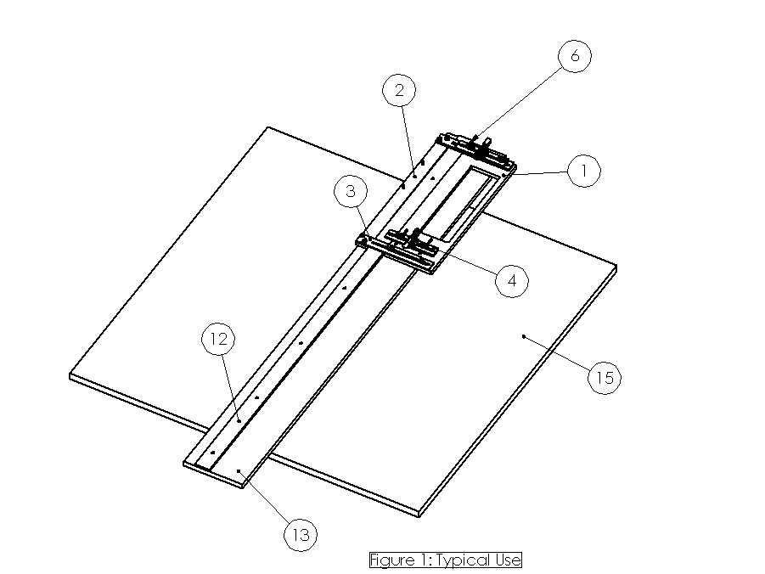

Referring now to the figures, the saw guide is shown in its typical use in Figure 1. Saw guide 6 is attached to a rotary saw for the purposes of making a straight cut in material 15. Material 15 is typically a large wood or medium density fiberboard panel, but can also be other materials suitable for cutting with a rotary saw, including lumber of other dimensions. The typical use to cut a large panel is shown, but those experienced in the art will recognize that other materials can be cut with precision, including dimensional lumber.

The saw guide is composed of several pieces which allow it to slide along track 12 to provide a straight, accurate cut along the edge of track support piece 13. Track 12 can be made of a variety of materials that provide an accurate, straight edge. In the typical embodiment, track 12 is aluminum extrusion having a thickness of 0.1875 and 0.3” in thickness and 1.5-2.5” in width. The length of the track is based on the material to be cut. Tracks of various widths, length, thickness, and profile can be used .

In the typical use, a suitable track 12 is attached to support board 13, and the rotary saw is attached to the saw guide 6, and the saw guide 6 is adjusted to fit the width of track 12. Then, the rotary saw is used to trim the width of support board 13 such that the outer edge is flush with the blade kerf. This allows the outer edge of support board 13 to indicate where the work material will be cut when the saw is moved along track 12. Those experienced in the art will recognize that there are many ways to assemble the track 12 and support board 13 such that the saw guide will slide along the track.

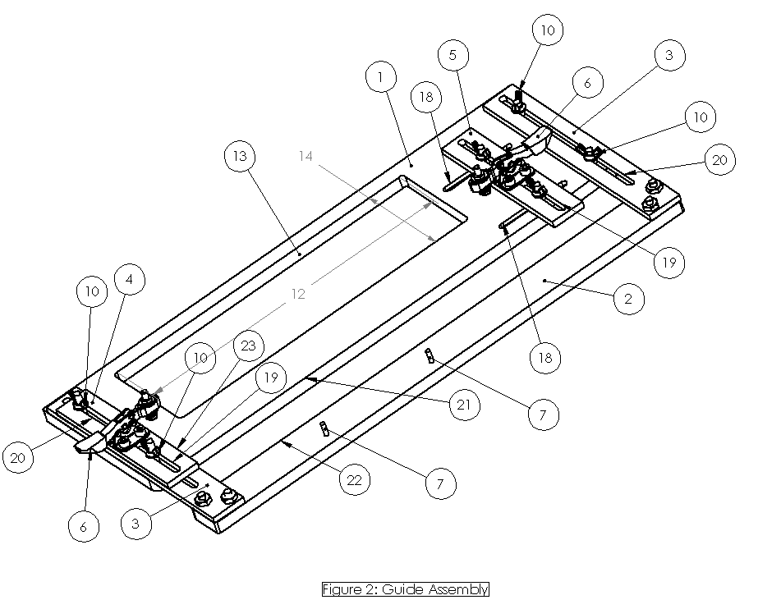
Figure 2 shows the saw guide, which attaches to suitable rotary saws without requiring modification of any kind to the saws. Base plate 1 and outer arm 2 form the base of the guide, and ride along either side of the track. Suitable materials for these parts are inexpensive to manufacture, lightweight, durable, and have a low coefficient of friction. In the preferred embodiment, HDPE plastic is used for its low cost and low coefficient of friction, but those experienced in the art will recognize that a variety of materials and techniques may be used to allow base 1 and arm 2 to slide easily and accurately along the track. Other alternatives may include the use of bearings, lubricants, or the use of special materials along the edges of the base 1 and outer arm 2 where it contacts the track. All of these alternatives are within the spirit and scope of the invention.

Base part 1 is designed to accommodate a wide variety of commonly available rotary saws ( “circular saws”) as possible. Clearance hole 13 allows the blade and blade guard of suitable saws to fit inside the base part. The slot length 12 and width 14 are sized to accommodate the blade guards of the compatible saws, so that the blade guard of the saw will extend properly. This is important for safety, as well as to allow the saw to be placed onto the ground or a work surface immediately after a cut, since the blade is typically still spinning immediately after the cut.

The Front Clamp assembly 4 grasps the base plate of a saw. Slots 18 in base plate 1 allow rear clamp assembly 5 to adjust parallel to the track. Slots 19 in front and rear clamp assemblies allow the locations of the clamps to be adjusted in a direction perpendicular to the track. Together, these adjustments make it possible to secure a wide variety of circular saws. Other similar adjustment means may be used to provide flexibility to attach to varied saws without need for modification.

Outer arm 2 is attached to base part 1 using slide arms 3. Slide arms 3 contain slots 20 which allow the spacing between edge 21 of base part 1 and edge 22 of outer arm 2 to be a variable distance apart, to accommodate a wide variety of track widths. Locating pins 7, combined with edge 23 of front clamp assembly 4, provide a positive location points for the saw base plate. These locating points allow the saw to be removed and subsequently re-installed to the guide without the need to re-adjust the guide or re-cut the support board.

Clamp assemblies 4 and 5, and slide arms 3 are secured to base part 1 using fasteners that can be loosened and tightened without the use of any tools. Wing nuts are one suitable fastener, but those experienced in the art will recognize that there are a variety of fastening techniques suitable, including rivets, bolts, and quick-release clamps. Clamp 6assemblies 4 and 5 are constructed so that they can be loosened and re-righted quickly, so that the saw can be easily and quickly removed.

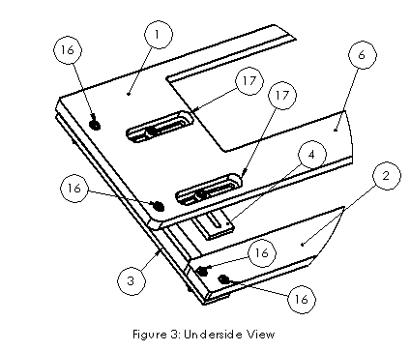

Figure 3 shows the underside of base part 1. Slots 17 and holes 16 allow the fasteners attaching rear clamp assembly 4 and slide arm 3 to remain below surface 6 of base part 1, allowing it to ride smoothly over the work surface. In the typical embodiment, the fasteners are socket head cap screws and base part is counter-bored . Other fastener types such as clamps, rivets, cast-in bolts, or self-tapping screws may also be used to maintain the smooth lower surface..

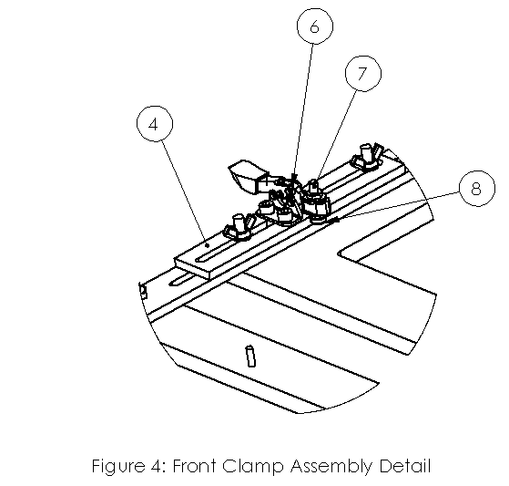

Figure 4 shows the front clamp assembly in more detail. Toggle clamp 6 is placed such that it will secure the front edge of the saw. The clamp includes a fastener 7, which can be adjusted to contact the base plate of the saw securely. The tip 8 of the fastener is a material chosen to prevent it from slipping on the base plate of the saw, and also to prevent damage to the saw plate. The preferred material will be rubber or plastic, but many other materials may be suitable.

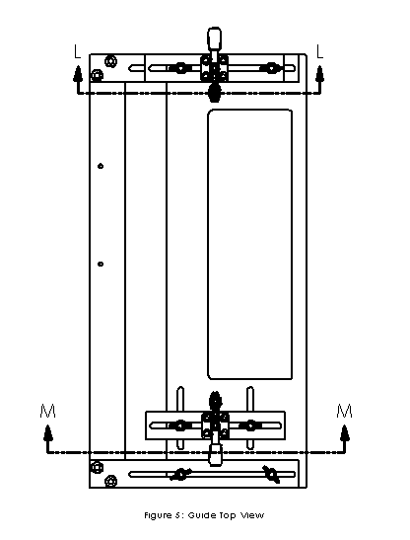

Figure 5 shows a top view of the guide, with two cross-section views L and M defined.

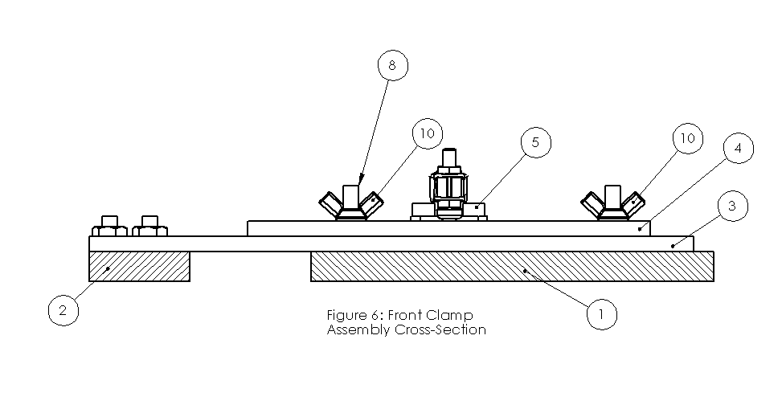

Figure 6 shows section L-L, from Figure 5, and shows another view of the front clamp assembly. Base plate 1 and outer arm 2 are shown in cross-section. Clamp mounting plate 4 is slides upon and is mounted on top of slider arm 3. Clamp 5 is affixed to clamp mounting plate 5. Outer arm 2 can move relative to base plate by first loosening wing nuts 10, and then sliding slide arm 3. Clamp 5 can also be moved perpendicular to the track. When adjustment is complete, the wing nuts can be tightened.

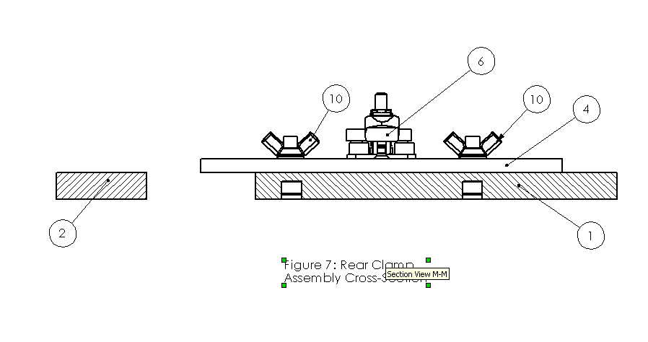

Figure 7 shows partial section M-M from Figure 5, and shows another view of the rear clamp assembly. Wing nuts 10 can be loosened, then allowing clamp 6 to move both parallel and perpendicular to the track due to slots in the base plate and in the clamp mounting plate. Other geometries of hardware may be possible to provide the two-dimensional adjustability of the clamp location relative to the track. Adjustment of the clamps in a direction along the axis of the fastening screws is not necessary in the preferred embodiment, since the base plates of most saws are fairly uniform, but such adjustment would be in included in the spirit and scope of the invention.

Although the present invention has been described with reference to preferred embodiments, workers skilled in the art will recognize that changes may be made in form and detail without departing from the spirit and scope of the invention.

We claim:
- A saw guide which assists in using a rotary power (“circular” ) saw in making accurate and straight cuts,
- A method of attaching the guide to the saw such that:
- A wide variety of saws are accommodated,
- No modifications of any kind are required to the saw,
- The guide can be removed and re-attached to the saw very quickly without any re-adjustment or the need for any tools.
- The blade guard of all suitable saws remains functional, so that the saw is still safe to operate and can be placed onto the ground or a work surface immediately after a cut.
- A method of adjusting a saw guide to accommodate a variety of rail shapes, without any modification to the saw or the guide.

