1. Created HeroFactory

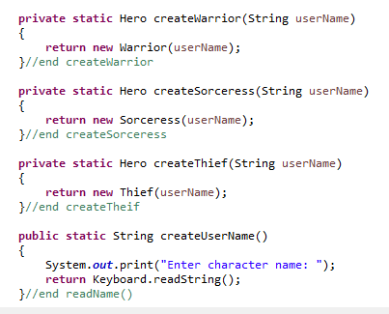

Created to handle the creation of heroes and limit outside visibility

2. Created MonsterFactory

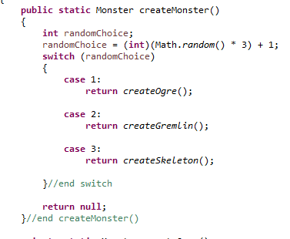

Created to handle the creation of monsters and limit outside visibility

3. Created SpecialAblity Interface

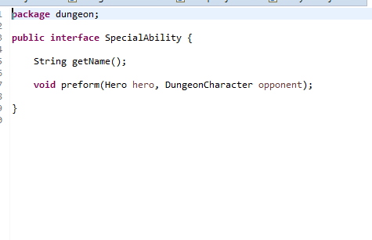

Allowed for the moving of the battle choice to the hero class to remove duplicate code from the subclasses

4. Created Weapon Interface

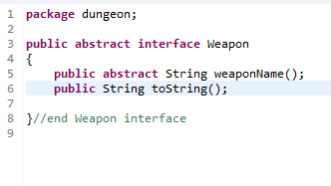

Allowed for the moving of attack to the dungeon character class to remove duplicate code from the subclasses. Also, allowed for the cleaning of the Attack method.

5. Cleaned up un-needed comments.

6. Updated attack method, only DungeonCharcter has one now

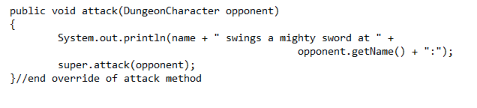

OLD from Warrior

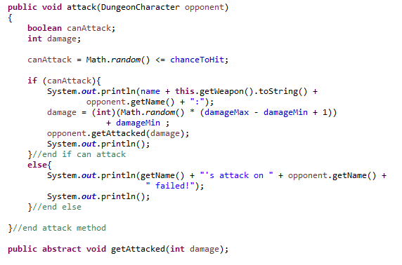

NEW

As stated above we created the weapon class to allow for this clean up. We were able to move this method to the Super class and remove Overridden methods in the sub classes.

7. Changed visibility on classes and fields to package and private

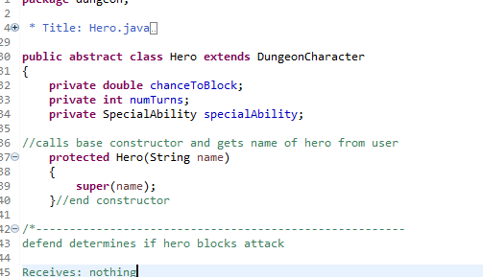

Changed all fields to private and created getters and setters as needed. We also changed constructors to package or protected visibility as made sense

8. Changed methods in Hero/Monster classes to have a more intent revealing name

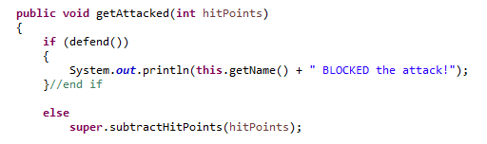

Changed SubtractHitpoints in the child classes to getAttacked, also created the method as an abstract method in the parent class to ensure future classes will have this field. Named fields with names that reveal intent. Simplified the constructors by only passing in a name.

9. Remove comparable & compareTo from DungeonCharacter

Removed unimplemented code and dead code