David C. Petty
04.535 / 2010-T1 Combinatorics
Mathematics for Teachers II / Final Project

Abstract

Combinatorics is the branch of discrete mathematics concerned with counting. Combinatorial techniques allow counting elements of sets under various conditions. Elements of sets can be counted ordered or unordered and with and without repeated elements. Understanding combinatorics requires understanding basic properties of set theory. Combinatorics can be used as a basis for probability, because the probability an event happens is the ratio of the number of ways an event can happen to the total number of possible events, both of which must be counted. Combinatorial reasoning is used in solving a wide variety of problems. After a brief introduction to set theory, this paper discusses the five principles of combinatorics, the four categories of counting problems, and the uses of combinatorial techniques in solving related problems.

Introduction

Combinatorics is the branch of discrete mathematics concerned with counting. Counting is useful in solving problems in pure mathematics like probability, (polynomial) algebra, graph theory, partitions, geometry, and in applied mathematics like optimization in computer science. Counting is the first sense of numbers that children are exposed to and yet counting problems can be fiendishly complicated. Counting principles are simple, involving mostly the four basic arithmetic operations, but can easily be misapplied resulting in undercounting or overcounting. Counting problems can be direct analogs while appearing completely unrelated.

History

Counting has been of interest throughout the world for thousands of years. Hubbard (2008) cites ancient problems involving menus, rhythm and meter, and polynomial expansion in India, the Middle East, and China in the 15 centuries before 1200 CE. In Europe, combinatorial principles were introduced by Fibonacci, Pascal, De Moivre, and Euler (and others) in the six centuries after 1200 CE.

Devlin (2008) describes correspondence between Pascal and Fermat in 1654 that formalized probability theory through 'combinations' (p. 10) — that is, counting possible outcomes. And it is Pascal whose name is attached to the combinatorial triangle of binomial coefficients.

Once counting was well understood and used to develop new branches of mathematics (especially probability as used to solve gambling problems), combinatorics took its place among the branches of mathematics.

Set theory

The theory of sets of discrete elements is sometimes called naïve set theory, since it is defined informally, but it is nonetheless useful when describing relationships between sets and their discrete elements. There are set theories that cover sets with an infinite number of elements, but combinatorics as described in this paper will only cover finite sets.

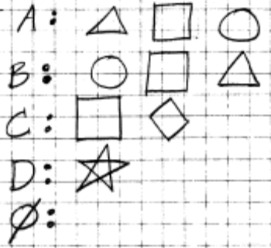
Sets A, B, C, D, and E are five examples. Interesting properties of these sets are:

- Sets A and B have exactly the same elements, but in a different order.
- Set C has one of the same elements as sets A and B, but one element unique to it.
- Set D has no elements in common with the other sets.
- Set has no elements.

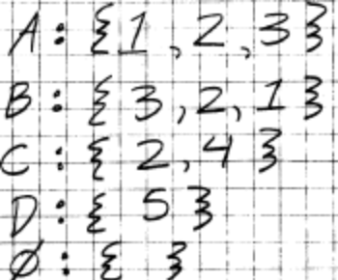
Sets A, B, C, D, and E are five more examples. These sets use numbers for elements. These sets have the same interesting properties as the first group. A common way to denote sets is to enclose the elements in 'curly brackets' and separate them with commas.

Sets A and B have the same elements (and are said to be equal), so the order of the elements does not matter, but if elements of a set have a natural ordering (e.g. ), then it is conventional to write the elements in that order (as in set A).

Definitions

Set theory has important definitions that will be used in defining the tenets of combinatorics. (These definitions assume prior knowledge of the symbols , , , and ):

- Sets are collections of zero or more distinct objects called elements (a) without duplicates and (b) without order.
- Two sets are equal if and only if they have the same elements. For any sets A and B, .
- Set A is a subset of a set B if and only if everything in A is also in B. If denotes 'A is a subset of B', then for any sets A and B, .
- The empty set (denoted ) is a set with no elements, or . is a subset of any set.
- A set which has all the elements in the universe of discourse is called a universal set (denoted ), or .
- A set which is the complement of another set has all the elements not in that set. If all denote 'the complement of A', then .
- The cardinality of set A, usually denoted |A|, is (in the case of finite sets) the number of elements in the set.
- The power set of a set A, denoted , is the set of all subsets of A, including and A. The power set notation stems from the fact that . (This set is not strictly necessary for combinatorics, but it helps to illustrate interesting properties of combinatorics.)

Simply stated, combinatorics is concerned with finding the cardinality of finite sets. Though these definitions are simple, the implications of these definitions are manifold. A natural way to understand these implications is graphically through Venn diagrams.

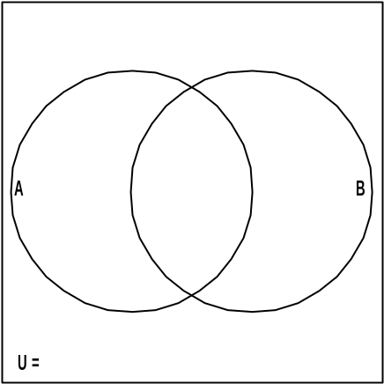
Venn diagrams

Venn diagrams are used to graphically represent set and subset relationships where elements are in more then one overlapping set. A typical Venn diagram of two sets A and B is shown as overlapping circles on the right. The circle labeled A encloses the elements of A. The circle labeled B encloses the elements of B. The area outside the circles, but inside the rectangle, encloses the elements in that are not in A or B.

Shading is sometimes used to identify relationships between sets. Set A would be represented as: 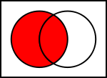, and set B would be represented as: 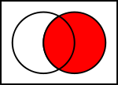.

Venn diagrams are used to see relationships between elements of sets. Consider the following sets:

= { "prime factors of 210" } = { 2, 3, 5, 7 }
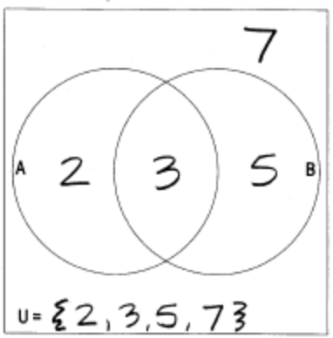
A = { "prime factors of 6" } = { 2, 3 }
B = { "prime factors of 15" } = { 3, 5 }

The Venn diagram makes it obvious that:

- A and B have only one element in common.
- |A| = |B| = 2
- B' = { 2, 7 }

Consider another example:

= { "letters of the English alphabet" } = { A, B, …, Z }
A = { "letters in the word 'soccer'" } = { C, E, O, R, S }
B = { "letters in the word 'football'" } = { A, B, F, L, O, T }
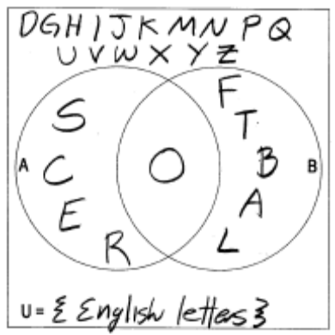
The Venn diagram makes it obvious that:

- Though the words have repeated letters, the sets do not.
- A and B have only one element in common.
- A' = { A, B, D, F, G, H, I, J, K, L, M, N, P, Q, T, U, V, W, X, Y, Z }
- |B| = 6

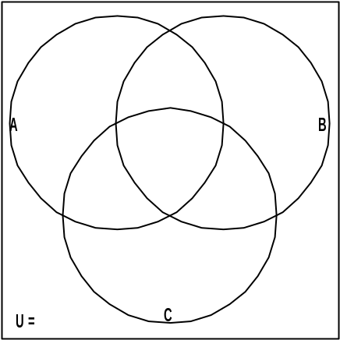
A Venn diagram of 2 sets has 4 = 2² distinct regions. A Venn diagram of 3 sets (shown at right) has 8 = 2³ distinct regions. A Venn diagram of n sets has 2^{n} distinct regions.

In order to describe and work with those regions, we will have to use operations from logic and Boolean algebra.

Intersection / 'and' / / conjunction

The intersection of sets A and B, denoted , is the set of elements in A and in B. It is defined graphically on a Venn diagram as: 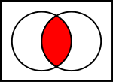.
Misconception alert!

The word and connotes addition and so elements in A and B can be construed as combining all the elements of A and B together — that is the union.

This use of the word and comes from logic, where combining the truth values of two statements with and — as in 'the statement is true if statement₁ is true and statement₂ is true' — is called conjunction. The conjunction of two truth values is true if both are true.

Union / 'or' / / disjunction
Misconception alert!

The word or as used in set theory is called inclusive or, but what is usually meant in the vernacular use of or is exclusive or, whose Venn diagram is:
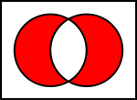

Most people when hearing someone is a sumo wrestler or a cheerleader think she can be one or the other, but not both.
The union of sets A and B, denoted , is the set of elements in A or in B. It is defined graphically on a Venn diagram as: 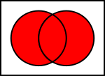.

This use of the word or comes from logic, where combining the truth values of two statements with or — as in 'the statement is true if statement₁ is true or statement₂ is true' — is called disjunction. The disjunction of two truth values is true if either is true.

The addition principle

In a class of 18 girls and 12 boys, answering the question, how many boys and girls are there in the class is easy: simply count the number of boys and add it to the number of girls. This approach works when there is no overlap between boys and girls (a good assumption).

In a group of 6 athletes (initials A, B, C, D, E, F) there are 3 hockey players and 3 soccer players, so following the pattern above it might seem that there are 6 hockey players and soccer players in the group. However the sets are defined as follows:

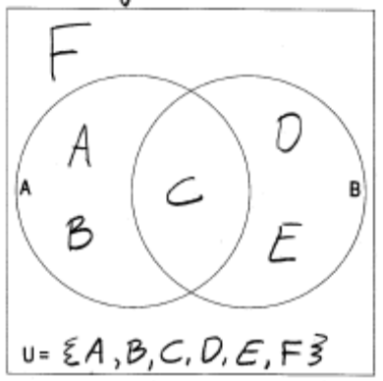
= { A, B, C, D, E, F }
A = { "3 hockey players" } = { A, B, C }
B = { "3 soccer players" } = { C, D, E }

In this case, there is overlap between hockey players and soccer players (C plays both sports), so it is not true that counting the number of hockey players and adding it to the number of soccer players yields the number of hockey players and soccer players in the group.

A way to describe two groups with no overlap is to describe two sets whose intersection is empty. Two sets A and B are disjoint if .

We can now state the addition principle: The number of ways to select elements from disjoint sets is the sum of the numbers of elements in the sets. — Tucker (2006).

The multiplication principle

How many numbers are there between 1 and 100? The easy answer to that is, 'count them!' 1, 2, 3, …, 100. That is, use the addition principle.

Another way to think about that question is to ask, how many non negative two-digit numbers (including leading zeros) are there? There are 10 possible numerals that can appear in the tens place (0, 1, 2, …, 9) and for each of those there are 10 possible numerals that can appear in the ones place, so repeatedly add 10, 10 times, or .

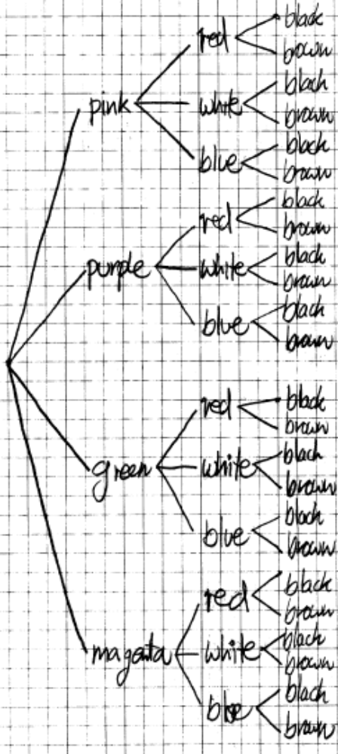
If I have pink, purple, green, and magenta shirts, red, white, and blue pants, and black and brown shoes, how many distinct ways can I dress myself? (The words distinct and distinguishable mean I can tell the difference between two things by observation.)

The tree at the right shows the possibilities graphically. For each of my 4 different colored shirts, I have 3 different colored pants, and 2 different colored shoes. Counting the number of paths from the root of the tree to its leaves (which is the same as the number of leaves) yields the number of distinct ways can I dress myself (albeit hideously!).

Furthermore, shirts are not pants or shoes and pants are not shoes, so choosing a certain shirt is independent of what pants or shoes I choose.

We can now state the multiplication principle: If the composite outcomes of the successive ordered stages of a procedure are all distinct and the number of outcomes at each stage is independent of the previous stage, then the number of composite outcomes is the product of the numbers of outcomes of the stages. — Tucker (2006).

License plates

How many distinguishable three-character license plates can be formed from the letters A, B, or C? The easy answer to that is, 'enumerate them!' In license-plate problems the order of the characters matters (since ABC is distinguishable from CBA) and repeats are allowed (since AAA is a valid license plate). In this case, the first letter can be A, B, or C, the second letter can be A, B, or C, and the third letter can be A, B, or C. Here they are:











There are 3 positions and 3 letters for each position, so the total is: .

How many six-character license plates are there using 10 numerals and 26 letters? There are 6 positions and 36 characters for each position, so the total is: .

License Plate — order matters / with repeats allowed

Counting license plates of r positions using an alphabet of n characters, use the multiplication principle:

Examples

1) How many 6-character license plates are there with all vowels?



A) There are 5 English vowels for each V on the license plate, so use the multiplication principle: .

2) How many 6-character license plates are there with 1 vowel?

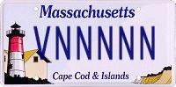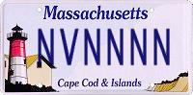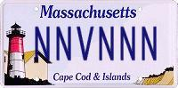
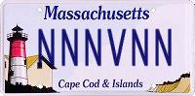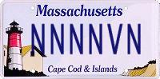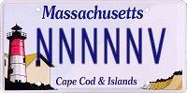

A) There are 5 English vowels for each V on each license plate and 31 non-vowel characters for each N on each license plate, so use the addition principle to add the 6 distinct cases of one vowel: .

Horse races

How many distinguishable ways are there for 3 horses to finish a race? The easy answer to that is, 'enumerate the possibilities!' In horse-race problems the order of the horses matters (that is the point of a horse race) and repeats are not allowed (since horse #1 cannot both win the race and lose the race). In this case, any of the 3 horses (#1, #2, or #3) can come in first:

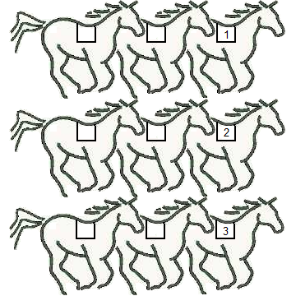

In each of those 3 cases, either of the other 2 horses can place second:

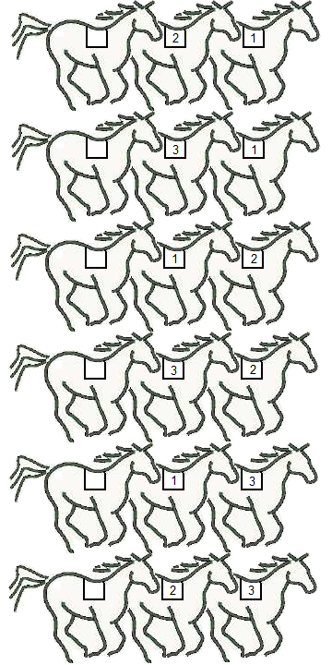

In each of those 6 cases, the remaining horse must place third:

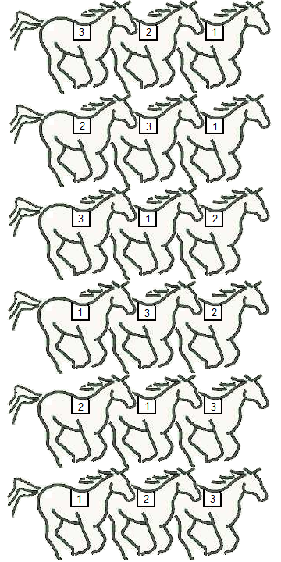

Given a 3-horse race, there are 3 ways for one of the horses to place first, 2 ways for one of the remaining horses to place second, and 1 way for the remaining horse to place third, so the total number of distinguishable 3-horse races is .

The process of repeated multiplication of decreasing positive integers is so useful in mathematics (not just for horse-race problems) that it has its own name and notation.

The factorial of a positive integer n, denoted by n!, is the product of all positive integers less than or equal to n.
Misconception alert!

Students will want to 'simplify' factorial fractions like: 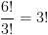, when actually 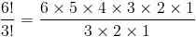.

There are factorial identities that can be used to 'simplify' factorial expressions, but it is always safe to use the definition and then factor out factors of 1 (as above).

For example, . It is obvious that 1! = 1 (how many distinguishable horse races are there with one horse?). It is true, though less obvious, that 0! = 1 (how many distinguishable horse races are there with no horses?).

How many distinguishable ways are there for 4 horses to place first, second, and third in a race? There are 4 ways for one of the horses to place first:

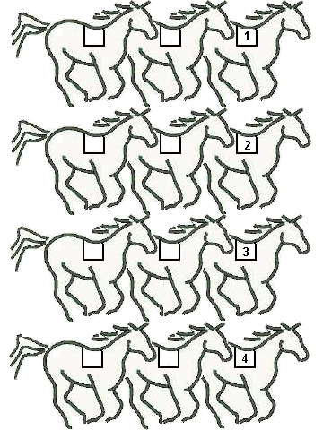

In each of those 4 cases, any of the remaining 3 horses can place second:

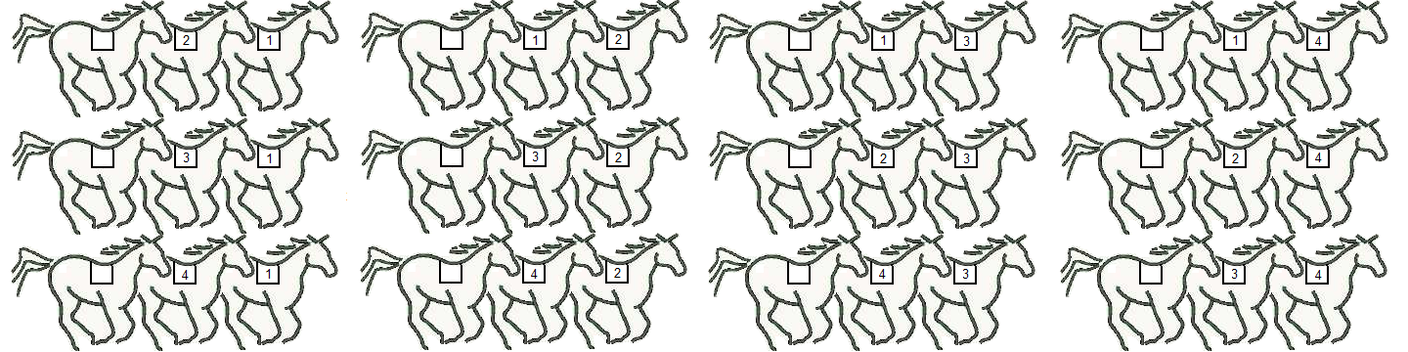

In each of those 12 cases, either of the remaining 2 horses can place third:

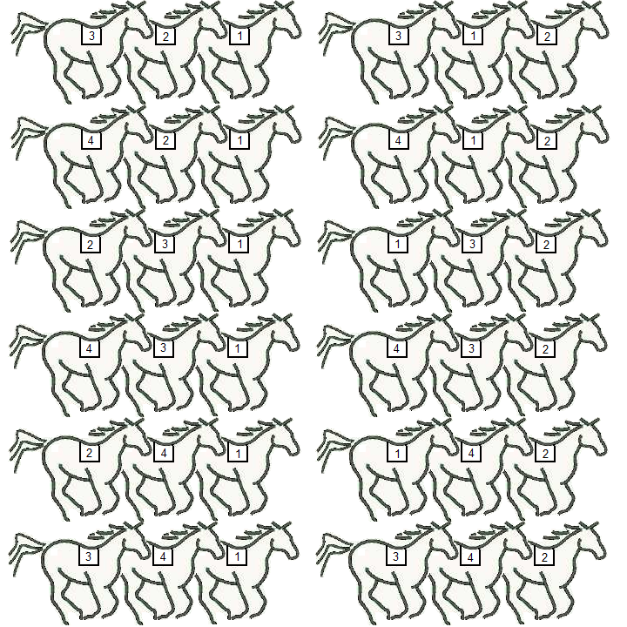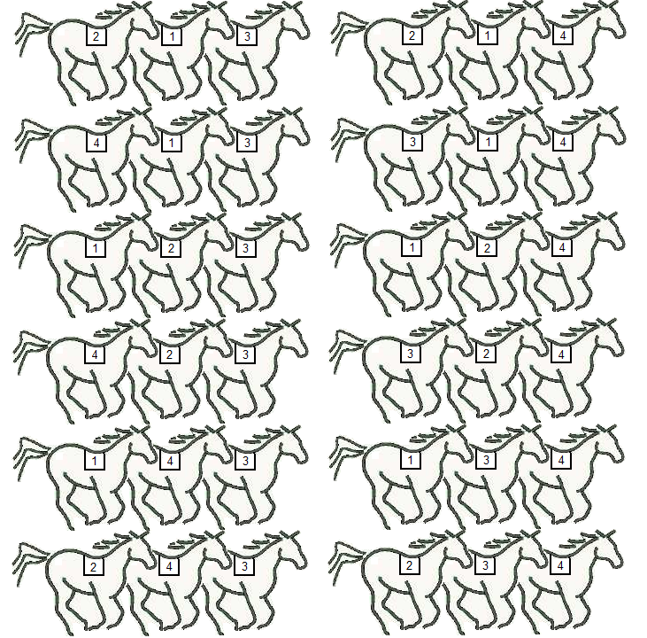

Given a 4-horse race, there are 4 ways for one of the horses to place first, 3 ways for one of the remaining horses to place second, and 2 ways for one of the remaining horses to place third, so the total number of distinguishable 4-horse races is , or in factorial notation: 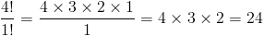.

Horse Race — order matters / no repeats allowed
It would probably be better to use a 5-horse example…

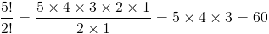

That would be 60 diagrams, however!

Counting horse races of n horses and selecting r places, use a permutation of n things, selecting r of them:

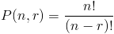

Examples

1) How many distinguishable arrangements of the letters of the word FACETIOUS are there?

A) There are 9 non-repeating letters in the word FACETIOUS, so there are distinguishable arrangements of 9 letters.

2) How many distinguishable 3-letter arrangements of the letters of the word FACETIOUS are there?

A) There are 9 non-repeating letters in the word FACETIOUS, so there are 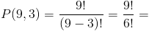 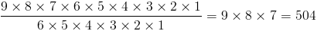 distinguishable 3-letter arrangements of 9 letters.

Sheep-counting principle (shepherd's law)

How many distinguishable arrangements of the letters of the word BOOK are there? It is not simply a 4-horse race, because 2 of the 'horses' (Os) are indistinguishable. If they were distinguishable, then the arrangements would be:

BOOK BOKO BKOO BKOO BOOK BOKO
OBOK OBKO OKBO OKOB OOBK OOKB
OBOK OBKO OOBK OOKB OKBO OKOB
KBOO KBOO KOBO KOOB KOBO KOOB

Since the Os are actually indistinguishable, exactly of the arrangements are indistinguishable, corresponding to the 2 indistinguishable Os.

We can now state the shepherd's law: "To count sheep, count the legs and divide by four." — Over-counting by a uniform multiplicative factor can be corrected by dividing by this factor.

Examples

1) How many distinguishable arrangements of the letters of the word BOOKKEEPING are there?

A) There are 11 letters in the word BOOKKEEPING, with 3 double letters, so there are distinguishable arrangements of 11 letters where 3 are doubled. There are 2!s in the denominator, because there are 2! = 2 distinguishable arrangements of 2 letters.

1) How many distinguishable arrangements of the letters of the word MISSISSIPPI are there?

A) Shepherd's law is sometimes called the 'Mississippi rule.' There are 11 letters in the word MISSISSIPPI, with 1 double letter and 2 quadruple letters, so there are 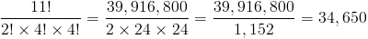 distinguishable arrangements of 11 letters where 1 is doubled and 2 are quadrupled.

Committees


How many distinguishable ways are there to choose 3 people for a committee from a group of 7? In committee problems the order of the committee does not matter (a committee is the same no matter which order it is chosen) and repeats are not allowed (since a committee member cannot be on a committee twice).

For a group of 7 people (initials A, B, C, D, E, F, G), enumerating 3-person committees is as follows:

ABC, ABD, ABE, ABF, ABG, ACD, ACE, ACF, ACG, ADE, ADF, ADG, AEF, AEG, AFG
BCD, BCE, BCF, BCG, BDE, BDF, BDG, BEF, BEG, BFG
CDE, CDF, CDG, CEF, CEG, CFG
DEF, DEG, DFG
EFG

In this case, enumerating the committees (35) does not necessarily reveal a pattern. Another way to think about it is as 3-place horse races of 7 horses and use shepherd's law to divide out the 3! finishes that, for example, involve A, B, & C (ABC, ACB, BAC, BCA, CAB, CBA), because they are indistinguishable committees.

There are 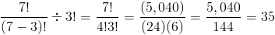 ways to choose 3 people for a committee from a group of 7.

Committee — order does not matter / no repeats allowed

Counting committees of r individuals selected from a set of n, use a combination of n things, selecting r of them:

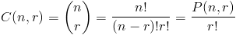

Examples

1) How many 5-person committees can be chosen from a group of 9 people?

A) 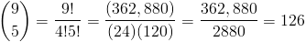.

2) How many distinguishable arrangements of the letters of the word FACETIOUS are there where the vowels are in alphabetical order?

A) This is a related problem. Imagine there are 9 'slots' for letters:

1 2 3 4 5 6 7 8 9

Then choose 5 for the vowels (as an example from the word itself:

1 2 A 3 4 E 5 6 I 7 O 8 U 9

We now have a 'committee' of slots for the vowels (for example, slots 2, 4, 6, 7, 8) chosen from the 9 (see example 1) and can always place the vowels in those slots in alphabetical order (A, E, I, O, U). Next use the multiplication principle with a 4-horse 'horse race' of the remaining letters (F, C, T, S), which yields: .

Donuts

How many distinguishable ways are there to select a dozen donuts of 4 varieties: chocolate, glazed, jelly, and old fashioned. Donut problems assume there are as many indistinguishable donuts of each variety as necessary, so that order does not matter and repeats are allowed. A solution to this problem is with a donut box that has slots for donuts or dividers.

Example 0.

Use dividers to divide the box 4 regions, then fill in the appropriate donuts (C, G, J, O) in the empty slots. Always use the same order for the empty regions (not for the donuts, whose order in the box does not matter!).

Consider the following example ways to select a dozen donuts of 4 varieties:


Example 1: 3 of each C, G, J, O.


Example 2: 1 C, 2 G, 3 J, 6 O.


Example 3: 4 C, 4 G, 4 J, 0 O.


Example 4: all jelly (0 C, 0 G, 12 J, 0 O).

Interesting properties of these examples are:

- Dividing a box of donuts into 4 regions requires 3 dividers. Dividing a box of donuts into r regions requires r - 1 dividers.
- To select 0 of the k^{th} variety, simply put the k^{th} divider (or right wall of the box, if k = r) immediately to the right of the previous divider (or left wall of the box, if k = 0). As illustration, example 3 has 0 old fashioned and example 4 has 0 chocolate, 0 glazed, and 0 old fashioned.
- There are 12 donuts and 3 dividers, so the box must have 15 places to put donuts and dividers.

Donut — order does not matter / with repeats allowed

Counting combinations of n donuts from r different varieties:

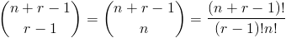

Examples

1) How many ways are there to choose 10 coins from $3 each worth of pennies, nickels, dimes, and quarters?

A) There are 10 coins from (enough) of 4 varieties. 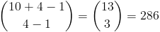.

Complement (subtraction) principle

How many distinguishable arrangements of the letters of the word FACETIOUS are there where the vowels are not in alphabetical order? Sometimes it is easier to count when an event does not occur and subtract it from the number of total possible events. In this example, use two prior results:

Distinguishable arrangements of the letters of the word FACETIOUS?

Distinguishable arrangements of the letters of the word FACETIOUS where the vowels in alphabetical order? | 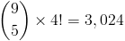
Distinguishable arrangements of the letters of the word FACETIOUS where the vowels not in alphabetical order?

We can now state the complement principle: The difference between the total number of possible outcomes and the number outcomes that happen is the number of outcomes that do not happen.

Applications

Combinatorics is useful for a variety of other problems from other branches of mathematics.

Probability

Define the probability that an event occurs as the ratio of the number of ways an event can occur to the number of possible events.

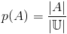

That's it! For example: what is the probability of being dealt a full house (2-of-a-kind with 3-of-a-kind) as a 5-card poker hand?

Number of full houses: 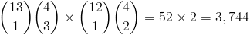
Number of poker hands: 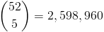
Probability: 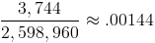

Other

Other interesting problems from other branches of mathematics include:

- Binomial coefficients
- Graph theory
- Partitions

Conclusion

Counting is the first sense of numbers that children are exposed to and yet combinatorics provides techniques for understanding deep mathematical questions.

Appendix

Counting falls into four distinct categories along two axes: ordered / unordered and with / without repeats. This table describes the categories and the formulas associated with them.

License Plate — order matters / with repeats  Counting license plates of r positions using an alphabet of n characters, use the multiplication principle:  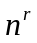 | Donut — order does not matter / with repeats  Counting combinations of n donuts from r different varieties:  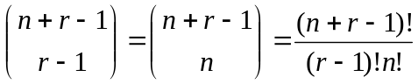
Horse Race — order matters / no repeats  Counting horse races of n horses and selecting r places, use a permutation of n things, selecting r of them:  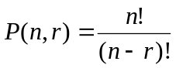  http://en.wikipedia.org/wiki/Permutation "A permutation is an ordered sequence of elements selected from a given finite set, without repetitions, and not necessarily using all elements of the given set." | Committee — order does not matter / no repeats  Counting committees of r individuals selected from a set of n, use a combination of n things, selecting r of them:  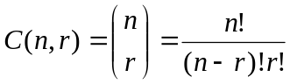  http://en.wikipedia.org/wiki/Combination "A combination is an un-ordered collection of distinct elements taken from a given set; a subset."

This table summarizes combinatorial principles and identities.

Principles:  - Addition Principle — The number of ways to select elements from disjoint sets is the sum of the numbers of elements in the sets.  - Multiplication Principle — If the composite outcomes of the successive ordered stages of a procedure are all distinct and the number of outcomes at each stage is independent of the previous stage, then the number of composite outcomes is the product of the numbers of outcomes of the stages.  - Subtraction / Complement Principle — The difference between the total number of possible outcomes and the number outcomes that happen is the number of outcomes that do not happen.  - Sheep Counting Principle (Shepherd’s Law): "To count sheep, count the legs and divide by four." — Over-counting by a uniform multiplicative factor can be corrected by dividing by this factor.  - Pigeon Hole Principle — Given two natural numbers n and m with n > m, if n items are put into m pigeonholes, then at least one pigeonhole must contain more than one item. | Identities:  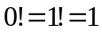  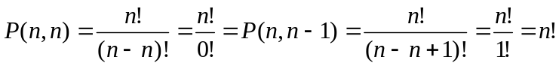  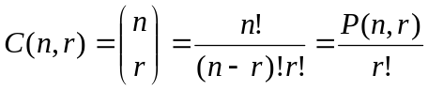  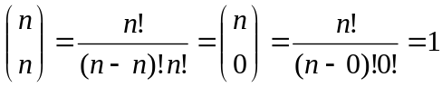  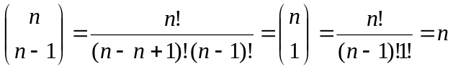  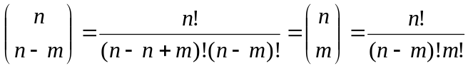  Note: 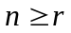 and 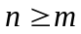

LaTeX

Some of the mathematical examples in this paper were prepared by the Online LaTeX Equation Editor. The source text for many of them is below.

- A=B \; \leftrightarrow \; \forall x : \; x \in A \leftrightarrow x \in B
- A \subseteq B \; \leftrightarrow \; \forall x : \; x \in A \rightarrow x \in B
- \forall x \; : \; x \notin \varnothing
- \forall x \; : \; x \in \mathbb{U}
- A', \; A^{c}, \; \overline{A}
- \forall x \; : \;x \in A' \leftrightarrow x \notin A
- P(n,r) = \frac{n!}{(n-r)!}
- C(n,r) = \binom{n}{r} = \frac{n!}{(n-r)!r!} = \frac{P(n,r)}{r!}
- \binom{n+r-1}{r-1} = \binom{n+r-1}{n} =\frac{(n+r-1)!}{(r-1)!n!}

References

Tucker, A. (2006). Applied combinatorics. Hoboken: John Wiley & Sons.
Devlin, K. (2008).The unfinished game: Pascal, Fermat, and the seventeenth-century letter that made the world modern. New York: Basic Books.
Combinatorics. (2010, June 19). In Wikipedia, The Free Encyclopedia. Retrieved 13:24, June 26, 2010, from http://en.wikipedia.org/w/index.php?title=Combinatorics&oldid=368950754
Naive set theory. (2010, March 14). In Wikipedia, The Free Encyclopedia. Retrieved 13:25, June 26, 2010, from http://en.wikipedia.org/w/index.php?title=Naive_set_theory&oldid=349876875
Empty set. (2010, June 21). In Wikipedia, The Free Encyclopedia. Retrieved 13:26, June 26, 2010, from http://en.wikipedia.org/w/index.php?title=Empty_set&oldid=369366539
Venn diagram. (2010, June 26). In Wikipedia, The Free Encyclopedia. Retrieved 13:29, June 26, 2010, from http://en.wikipedia.org/w/index.php?title=Venn_diagram&oldid=370254124
Boolean algebra (logic). (2010, June 26). In Wikipedia, The Free Encyclopedia. Retrieved 20:16, June 26, 2010, from http://en.wikipedia.org/w/index.php?title=Boolean_algebra_(logic)&oldid=370353594
Permutation. (2010, June 7). In Wikipedia, The Free Encyclopedia. Retrieved 13:31, June 26, 2010, from http://en.wikipedia.org/w/index.php?title=Permutation&oldid=366563313
Combination. (2010, June 14). In Wikipedia, The Free Encyclopedia. Retrieved 13:35, June 27, 2010, from http://en.wikipedia.org/w/index.php?title=Combination&oldid=367895591
Hubbard, M., & Roby, T. (2008). History. Retrieved 17:32, June 27, 2010, from http://binomial.csueastbay.edu/History.html
Bateman, W., & Mayer, S. (2010). The Online LaTeX Equation Editor (version 2.98). http://www.codecogs.com/components/equationeditor/equationeditor.php
Poskanzer, J. Acme license maker. http://www.acme.com/licensemaker/

