####----------------------------------------####

#DAN CRISP, EXTRA CREDIT QUIZ

####----------------------------------------####

#QUESTION 1:

####----------------------------------------####

syms x

f = x^2 - 5\*x+6

diffx = diff(f,x)

diffx = 2\*x - 5

slope = subs(diffx,x,3)

slope = 1

offset = slope\*(3) - subs(f,x,3)

offset = 3

tangent = slope\*x - offset

ezplot(f); hold on; ezplot(tangent)

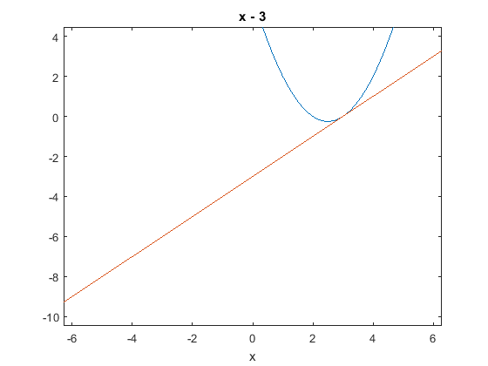

####----------------------------------------####

#QUESTION 2:

####----------------------------------------####

syms t

dist = 20\*sin((pi\*(t - 10))/20) + 20

distance = subs(dist,t,10)

distance = 20

spd = diff(dist,t)

spd = pi\*cos((pi\*(t - 10))/20)

speed = subs(spd,t,10)

speed = pi

accl = diff(spd,t)

accl = -(pi^2\*sin((pi\*(t - 10))/20))/20

acceleration = subs(accl,t,10)

acceleration = 0

PLOTTING:

mupad

plot(20\*sin((pi\*(x - 10))/20) + 20,pi\*cos((pi\*(x - 10))/20),-(pi^2\*sin((pi\*(x - 10))/20))/20)

