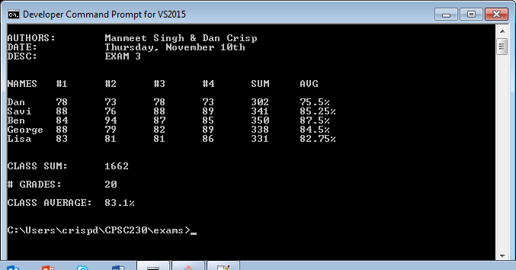

//AUTHOR: Manmeet Singh & Dan Crisp

//DATE: 10Nov2016

//FILE: Exam3.cpp

/* Report Card*/

#include<iostream>

#include<fstream>

#include<cstring>

#include<cstdlib>

#include<cmath>

#include<ctime>

using namespace std;

const int NUMBER_OF_STUDENTS = 5, NUMBER_OF_GRADE_VALUES = 4;

int main() {

// Clear Screen

system("cls");

// Create arrays for storing student names, grades, totals, and the class average

string student[NUMBER_OF_STUDENTS] = {"Dan", "Savi", "Ben", "George", "Lisa"};

int scores [NUMBER_OF_STUDENTS][NUMBER_OF_GRADE_VALUES];

double sum [NUMBER_OF_STUDENTS], avg[NUMBER_OF_STUDENTS], classAvg(0);

// Seed random value using time

srand(time(NULL));

// Display Desc and Table Header

cout << "\nAUTHORS:\tManmeet Singh & Dan Crisp\n"

<< "DATE:\t\tThursday, November 10th\n"

<< "DESC:\t\tEXAM 3\n\n";

cout << "\nNAMES\t#1\t#2\t#3\t#4\tSUM\tAVG\n\n";

for (int i=0;i<NUMBER_OF_STUDENTS;++i) {

// cout does not print out type string, though it does output c_str (w/ '/0' char ending).

// creating char pointer strcopied, pointing to new char variable with length +1 of string for needed '/0' c_str ending.

char *strcopied = new char[student[i].length() + 1];

// Copying c_str casted student name to pointer strcopied.

strcpy(strcopied, student[i].c_str());

// Using new c_str to console output

cout << strcopied << "\t";

// Fill 2-dim array with random numbers.

for (int j=0;j<NUMBER_OF_GRADE_VALUES;++j) {

scores[i][j] = rand() % (95-70) + 70;

sum[i] += scores[i][j];

cout << scores[i][j] << "\t";

}

avg[i] = sum[i]/NUMBER_OF_GRADE_VALUES;

cout << sum[i] << "\t" << avg[i] << "%\n";

// Having classAvg do double duty, holding aggregated sum for each student.

classAvg += sum[i];

}

cout << "\n\nCLASS SUM:\t" << classAvg << "\n";

cout << "\n# GRADES:\t" << ((NUMBER_OF_STUDENTS)*(NUMBER_OF_GRADE_VALUES)) << "\n";

classAvg = classAvg/((NUMBER_OF_STUDENTS)*(NUMBER_OF_GRADE_VALUES));

cout << "\nCLASS AVERAGE:\t" << classAvg << "%\n\n";

return 0;

}