02/14/2017 Homework #4 PHY431-Optics

1a) Plot[exp(-(1\*y-1\*t)^2),{t,0,10},{y,0,10}] *assuming a = b =1*

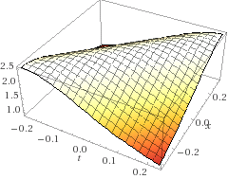

1b) -5\*E/((3\*x+4\*t-6)^2+2) *assuming E = 1*

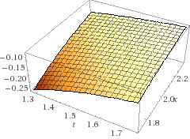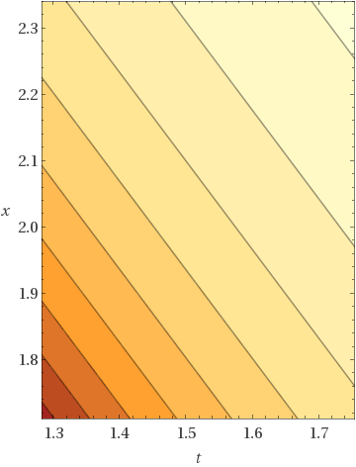

1c) Plot[1\*sin(2\*Pi\*(x/1+t/1)),{t,0,4},{x,0,4}] *assuming A = a = b = 1*

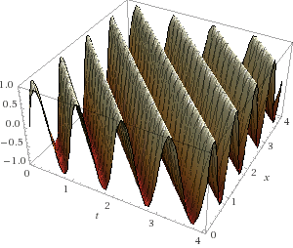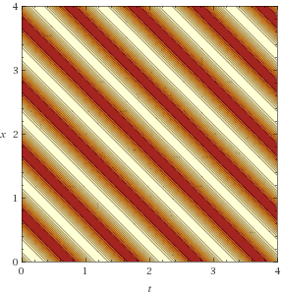

1d) Plot[1\*cos(2\*Pi\*(t-x))^2,{t,0,1.5},{x,0,1.5}] *assuming A = 1*

