**Abstract:**

**Introduction:**

**Analysis and Discussion:**

Power Value 1

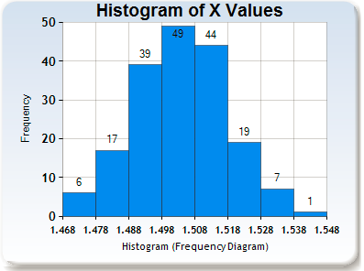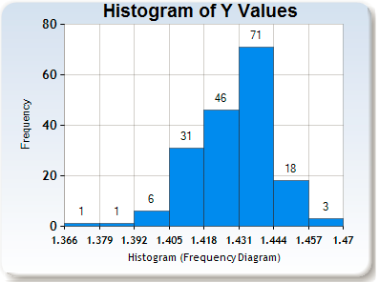

|  |  |
| --- | --- |
| **X Variance** | **Y Variance** |
| 0.000199 | 0.056268 |

Power Value 2

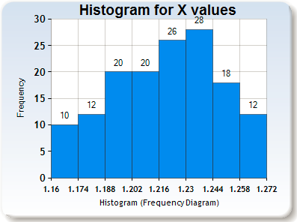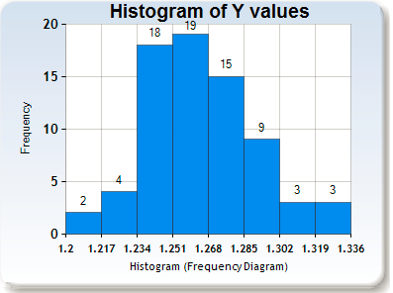

|  |  |
| --- | --- |
| **X Variance** | **Y Variance** |
| 0.000695 | 0.000622 |

Power Value 3

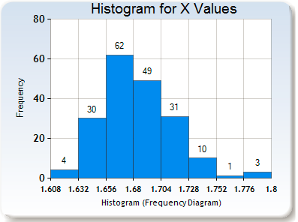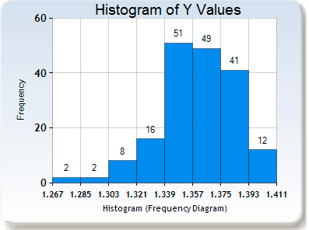

|  |  |
| --- | --- |
| **X Variance** | **Y Variance** |
| 0.000976 | 0.000586 |

**Q1:** The oil has a very similar index of refraction to the glass, this is why glass disappears in in oil. The oil between the aperture and the slide stops any additional diffraction occurring in the air between the objects.

**Q2:** The beads move down, gravity pulls them and the medium that they are in that way.

**Q3:** The slope tells us that as the power of the laser increases, so does the height of the walls of the potential well it creates. Essentially, the more powerful the laser, the stronger the trap.