**Experiment 10: Laser Tweezers**

D. Crisp, J. Priest, J. Abagail, J. Sanders

**Abstract**

Laser Tweezers, Optical Tweezers, or ‘single-beam gradient force traps’ generate a net force oriented centrally at its point of greatest intensity. Though there are radiative effects, they are negligent compared to the thermal effects of the suspension fluid and the forces reacting to momentum changes of refracted and reflected light when the light is intensely focused. This lab was an exploration into what it takes to operate and set up such a tool. Several hundred images were taken and analyzed to catalogue and measure the trapping force exerted by optical tweezers.

**Introduction**

Our laser tweezer setup was arranged using an optical breadboard for securing each element in place. Red laser light was reflected off an Al mirror at 45 degrees, passed through an adjustable polarizer used later for adjusting intensity, focused by a lens with a 200mm focal length, reflected off a Dichroic Mirror at 45 degrees, then put through a 100x objective for focusing at the position we place our slide sample. The lens between the polarizer and Dichroic Mirror is positioned on the breadboard with a rail allowing for pre-focusing of the laser before it enters the 100x objective. A lamp is used to shine white light into the slide in the opposite direction as the laser. The white light passes through the sample, the 100x objective lens, allowed to pass straight through the Dichroic mirror to illuminate our sample in the eye of a camera we used to measure the effects of our tweezer.

A Dichroic Mirror is a mirror which reflects and/or transmits light in different amounts based on the light’s wavelength.

In this lab, water with a mixed concentration of 1.2 micrometer sized plastic beads gets placed in a stage were a 100x objective focuses the laser. Note that the diameter of these beads are much bigger than the wavelength of the light.

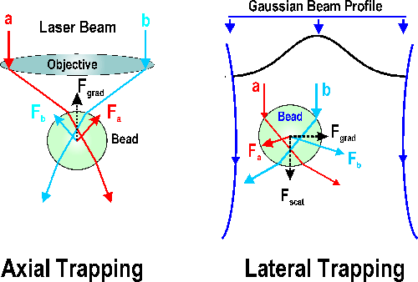Figure 1: Diagram indicating forces involved in trapping a micrometer sized bead with a laser (estimated to be ~3mW)

As a bead slides by the point of focus, an interaction with the laser light generates an effective potential well seen by said bead. The force generating the potential is only observed when it is big enough to overcome already present thermal/kinetic motion inherent in liquids.

Using $k_{B}$ for the Boltzmann’s constant, T for temperature, and $<x^{2}>$ ­­ for the 1-D variance of the displacement within the trap, this equation equates variance to temperature and the 1-D restorative constant $k_{x}$.

$$\frac{1}{2}k_{x}<x^{2}> =\frac{1}{2}k_{B} T$$

These beads interact with the light as seen in Figure 1. Here, forces in different directions are exerted by incident light being reflected or refracted at the bead’s surface. The sum of these forces exerts a central net force that holds the bead.

**Analysis & Discussion**

Samples with a concentration of 1.2 micrometer sized beads were made. A few drops of more highly concentrated solution was added to a vile of de-ionized water and mixed—a diluted concentration was made, and a few drops of it was transferred to a small glass slide typical in microscopic setups. An even smaller, thinner slide is placed on top, sandwiching our sample between the two pieces of glass. Once made, the slide sample was put into a slide holder—right up against the business end of the objective lens so that the coverslip faced the lens. The slide holder allowed us to adjust the position and orientation of the sample along x, y, and z directions. Once oriented and close enough to the objective, a small amount of immersion oil was carefully placed between the two. As the oil was held in place by surface tension experienced in its close quarters, care had to be taken not to allow much space between the two.

**Q1** Immersion Oil is helpful to reduce the degree of refraction that happens as light travels from one media to the next. In our case, it helps keep the light from becoming obscured as it travels from the objective lens to the sample slide.

The white light lamp was then turned on to illuminate our set up for viewing with the camera. An aperture immediately after the lamp was closed slightly to decrease its intensity for optimal intensity resolution of the cameras digital image. The stage holding our slide is then adjusted so that the 1.2 micrometer beads came into focus on the camera as they traveled across the viewing area. **Q2** Beads were observed to be traveling with gravity in the downward direction.

Although all optical elements of this setup were already in place when we began, their positions and orientations were adjusted to verify its optimization and to get a feel for the setup. The 200mm lens wanted to be placed closer towards the Dichroic Mirror, increasing the lasers focus at the position of our slide—decreasing the beam size at the slide and increasing the lasers effective power there. Some adjustment was also needed for each of the two mirrors, and more-so after having shifted the central lens. Changes to these mirrors was done based on the quality of the hourglass shaped diffraction pattern made with the laser light. At this point we had expected to be able to observe the beads within our sample get trapped by our tightly focused laser light. However, after much effort, we were not able to achieve this on our setup within the allotted time.

*The rest of this lab was done based on work on an analogous setup prepared by a neighboring group. Though we made independent observations, ultimately our data was also given to us by a member of this other group, S. Fromm.*

*Items that likely contributed to our difficulty in optimizing our set up are taking for granted both the beam trajectory into the objective lens and the beam collimation throughout. Wording from here on out will be as if we had gotten the data ourselves.*

Trapping of 1.2 micrometer beads was observed. Adjusting the orientation of the polarizer, located in the beams path upstream, the laser’s intensity and effective power was decreased to minimize the chances of trapping a distracting number of beads. When moving the slide’s position, the already trapped bead did dislodged from the potential well generated by the focused beam. A red-light filter was added before the camera to keep from saturating our image with red light from the laser, having a spot of concentrated red light in our camera images was thought to be a potential issue later.

Image data from the camera was taken with a computer at a rate of 50ms for 100 image bursts, or over a time span of 5 seconds. Three sets of images were taken, one with the polarizer oriented to transmit 100% of the laser intensity, one which transmitted 75%, and one for 25%.

A software utility ImageJ was used to perform an offline analysis of each images x-y profile. These profiles were found after having chosen a static region of interest to be used in all images of a given image set. The position values for x and y that we ultimately ended up analyzing were defined internally by ImageJ from its x-y profiles.

The X and Y data for each image set was plotted in separate histograms. Width of binning was between 0.01 and 0.3 micrometers. Sample variance of data subsets (X or Y at that beam power), is also added for reference. Though some data did not end up in the histogram plot, all did get used in variance calculation.

|  |  |  |  |
| --- | --- | --- | --- |
| *X Positions* | *Frequency* | *Y-Positions* | *Frequency* |
| 1.468 | 1 | 1.366 | 1 |
| 1.478 | 8 | 1.379 | 0 |
| 1.488 | 19 | 1.392 | 1 |
| 1.498 | 40 | 1.405 | 7 |
| 1.508 | 49 | 1.418 | 30 |
| 1.518 | 39 | 1.431 | 53 |
| 1.528 | 18 | 1.444 | 66 |
| 1.538 | 7 | 1.457 | 17 |
| 1.548 | 1 | 1.47 | 2 |
| More | 17 | More | 22 |
|  |  |  |  |
| X Data Variance | 0.001554 | Y Data Variance | 0.0017796 |

Table 1: X-Y Position histogram data for bead trapped at 100% power. 199 images in set.

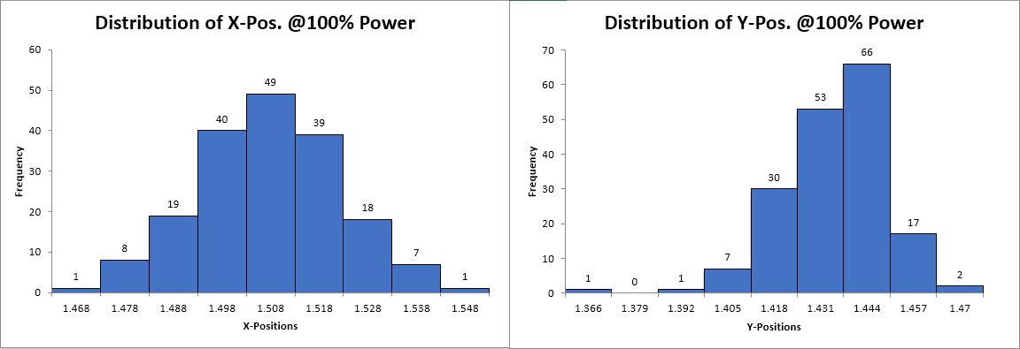

Figure 2: Trapped bead position distributions with 100% power

|  |  |  |  |
| --- | --- | --- | --- |
| *X-Positions* | *Frequency* | *Y-Positions* | *Frequency* |
| 1.16 | 1 | 1.2 | 1 |
| 1.174 | 4 | 1.217 | 1 |
| 1.188 | 6 | 1.234 | 4 |
| 1.202 | 10 | 1.251 | 19 |
| 1.216 | 11 | 1.268 | 19 |
| 1.23 | 13 | 1.285 | 14 |
| 1.244 | 14 | 1.302 | 9 |
| 1.258 | 9 | 1.319 | 4 |
| 1.272 | 5 | 1.336 | 2 |
| More | 0 | More | 0 |
|  |  |  |  |
| X Data Variance | 0.000732123 | Y Data Variance | 0.000640305 |

Table 2: X-Y Position histogram data for bead trapped at 75% power. 73 images in set.

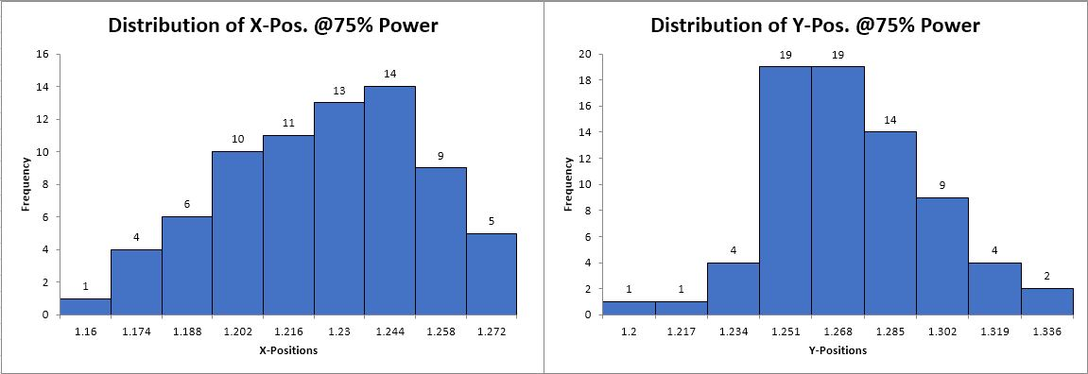

Figure 3:Bead position distributions with 75% power

|  |  |  |  |
| --- | --- | --- | --- |
| *X-Positions* | *Frequency* | *Y-Positions* | *Frequency* |
| 1.608 | 1 | 1.267 | 9 |
| 1.632 | 3 | 1.285 | 1 |
| 1.656 | 30 | 1.303 | 2 |
| 1.68 | 67 | 1.321 | 9 |
| 1.704 | 48 | 1.339 | 19 |
| 1.728 | 28 | 1.357 | 51 |
| 1.752 | 9 | 1.375 | 48 |
| 1.776 | 1 | 1.393 | 41 |
| 1.8 | 3 | 1.411 | 11 |
| More | 9 | More | 8 |
|  |  |  |  |
| X Data Variance | 0.002951196 | Y Data Variance | 0.003097873 |

Table 3: X-Y Position histogram data for bead trapped at 25% power. 199 images in set.

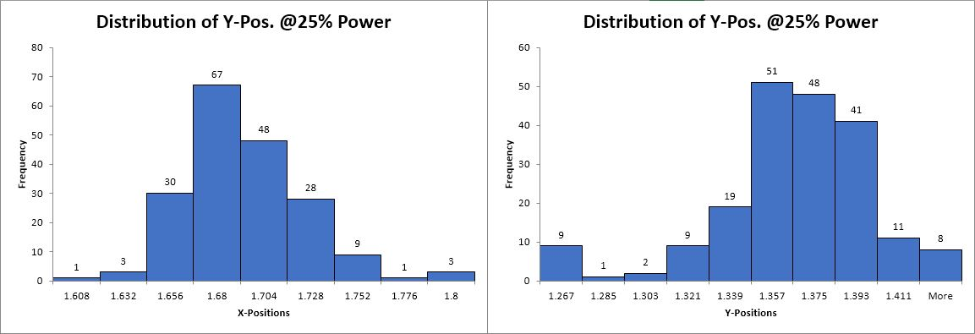

Figure 4:Bead position distributions with 25% power

Variance of the data from its mean was plotted verses 1/P – the inverse power of the laser. It was expected that as power increased—thus the inverse of P decreased—the variance would increase. This expectation is based on the idea that there are thermal(kinetic) forces constantly bombarding these beads, and that these forces would win out over the restorative ones exerted by our laser if it wasn’t strong enough. Our second data set, taken at 75% beam power, ended up being so much smaller that our plot in figure 5 is clearly skewed at center.

Figure 5: Plot of calculated sample variance in bead position data vs the inverse of power of laser. (note – We never measured laser power absolutely, P used here is minimizing factor between 0 and 1 given to us with image data)

**Conclusion**

Even though the lab was prepared and verified before class, the complexity of the system used here for the study of laser tweezers turned out to be more than what was surmountable in our group’s 3-hour time allotment.

However, the process of troubleshooting the more complicated set-up was instructive as a trial in perseverance, adding to the lab an amount of realistic struggle one can expect to experience if lab employed. This aspect may have solidified what I did learn that day into a longer-term memory than if it all had gone ‘as planned’ while sparking more genuine interest in the subject.

It was apparent from what we could observe that the supplied laser was fully capable of trapping 1.2 micrometer beads, even several at a time.

Gaussian-like distributions were found to describe the tendency of a trapped beam to remain trapped. This does agree with the description of the optical tweezer force as an isotropic potential well whose force is defined with this equation $F\left(r\right)= α I_{0}ω^{2} 4 π e^{-\left(a^{2}+u^{2}\right)/2}[a u \cosh\left(au\right)-\sinh{(au)}]$ [4] where a=R/omega and u = r/omega are the normalized radius and coordinate respectively.

**References** (Image & ImageJ Credit)

1. A. Ashkin, J. M. Dziedic, J. E. Bjorkholm and S. Chu, Opt. Lett. **11**, 288 (1986).
2. A. Ashkin, J. M. Dziedic and T. Yamane, Nature **330**, 769 (1987).
3. Schneider, C. A.; Rasband, W. S. & Eliceiri, K. W. (2012), "[NIH Image to ImageJ: 25 years of image analysis](http://www.nature.com/nmeth/journal/v9/n7/full/nmeth.2089.html)", *Nature methods* **9(7)**: 671-675, [PMID 22930834](https://www.ncbi.nlm.nih.gov/pubmed/22930834?dopt=Abstract)
4. Tlusty T, Meller A, Bar-Ziv R. Phys Rev Lett, 81 (8), 1738 (1998)