**Experiment II: Thin Divergent Lens**

D.Crisp, H.Allele

**Abstract**

The goals of this experiment are to investigate the properties of not only a thin divergent lens, but the way that it can be used as a piece of multi-lens optical set-ups. Measurements made with rulers and spherometers were used in calculations to derive focal lengths of -307.17mm and 269.686mm for defocusing, and converging lenses respectively. These properties were verified somewhat by combining the two in a linear optical arrangement, and slightly adjusting their positions. By replacing the light source with a laser, and trying reverse orders of the lenses, the methods of expanding and reducing of collimated beam radii were compared. Whether expanding, or reducing, the distance between the two lenses needed to be equal to the sum of their focal lengths to ensure the beam exited the set-up in a collimated fashion.

**Introduction & Analysis**

For this lab we used two thin lenses: one convergent, and one divergent. Each lens is secured inside a housing which can be screwed into clamps. These clamps, in conjunction with a long metal rail secured to a lab bench, allowed us to secure the lenses in a variety of linear arrangements.

The radii of curvature for our lenses was calculated using measurements made with a spherometer—a device which allows for measuring how far the vertex of a given spherical surface is from an imaginary plane made by the device’s circular base. These measurements are represented by the value $h$ in the spherometer equation. This circular base is made of a hard material about 2mm thick, where half of the inner diameter is 12 +- 0.1mm and half of the outer diameter is 14 +- 0.1mm—these are the values used for $b_{inner}$ and $b_{outer}$ respectively.

Using the spherometer, values for $h$ were measured for both sides of each lens: the sides of the convergent lens were found to be 0.4775mm and 0.00mm, and those of the divergent lens were 0.21mm and 0.36mm. As the device’s smallest level of discritization was 0.01mm, we assume an error of +-0.001mm for these values. Inserting these values into the spherometer equation gives us our radii of curvature.

$R_{div,1}={\frac{b}{2h}}^{2}+\frac{h}{2}=\frac{{14.00}^{2}}{2∙0.21}+\frac{0.21}{2}$, $R_{div,1}=466.771mm$

$R_{div,2}={\frac{b}{2h}}^{2}+\frac{h}{2}=\frac{{14.00}^{2}}{2∙0.36}+\frac{0.36}{2}$, $R_{div,2}=272.402mm$

$R_{conv,1}={\frac{b}{2h}}^{2}+\frac{h}{2}=\frac{{12.00}^{2}}{2∙0.4775}+\frac{0.4775}{2}$, $R_{conv,1}=151.024mm$

$$R_{conv,2}=0.00mm (flat)$$

The overall error in our calculation of R, based on curvature with the largest error, is found with assumed measurement errors of $σ_{b}=0.1mm$ and $σ_{h}=0.001mm$. (by measurement error we assume 1/10th of the smallest discretization of our device, 0.1mm for a ruler and 0.001mm for a spherometer)

$${σ_{b}}^{2}{\left(\frac{∂R}{∂b}\right)}^{2}={\left(σ_{b}\right)}^{2}{\left(\frac{b}{h}\right)}^{2}=0.01{\left(\frac{14}{0.21}\right)}^{2}=44.444mm$$

$${σ_{h}}^{2}{\left(\frac{∂R}{∂h}\right)}^{2}={σ_{h}}^{2}{\left(\frac{b^{2}}{2}\log{h}+\frac{1}{2}\right)}^{2}={10}^{-6}{\left(\frac{{14}^{2}}{2}\log{0.21}+\frac{1}{2}\right)}^{2}=0.0232mm$$

$$σ_{R}=\sqrt{{σ_{h}}^{2}{\left(\frac{∂R}{∂h}\right)}^{2}+{σ_{b}}^{2}{\left(\frac{∂R}{∂b}\right)}^{2}}=6.668mm$$

Using these values for radii of curvature in the Lens Equation below, along with 1.56 for the index of refraction, its estimated that the focal length for the divergent lens is -30.717cm, and that of the convergent lens is 26.968cm.

$\frac{1}{f}=\left(n-1\right)\left(\frac{1}{R_{1}}-\frac{1}{R_{2}}\right)$, $\frac{1}{f}=\left(1.56-1\right)\left(\frac{1}{-466.771}-\frac{1}{272.402}\right)$, $f=-307.17mm$

$\frac{1}{f}=\left(1.56-1\right)\left(\frac{1}{151.024}-\frac{1}{Inf}\right)=1/269.686mm$, $f$ =269.686mm

To measure the focal length of the convergent lens directly, the convergent lens and a screen were secured onto the rail with a lamp positioned to shine through the lens onto the screen. This arrangement was measured to have an object distance of 28.9 +- 0.1cm, and an image distance of 75.2+-0.1cm. Putting these values into the lens equation returns a focal length of 20.87cm, or 22.6% below our calculated value.

The divergent lens was then secured at several locations between the convergent lens and the screen where an image was focused. The object distance coming into the first lens was held at 75.2cm in every case.

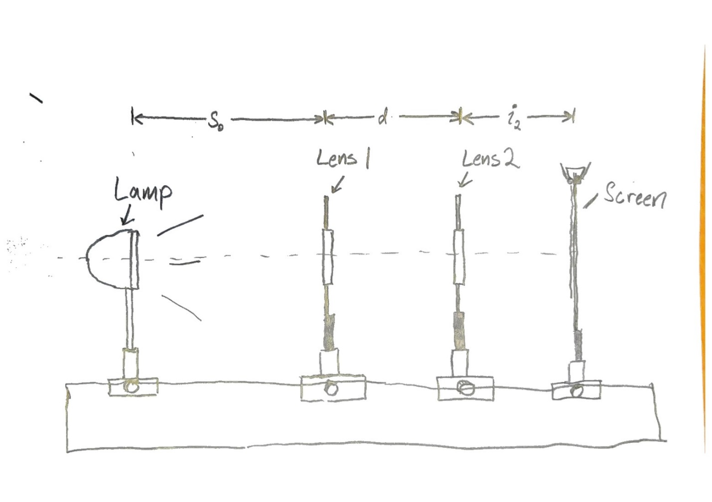

|  |  |  |
| --- | --- | --- |
| I2(cm) | D(cm) | F2(cm) |
| 76.3 | 50.15 | -37.294 |
| 12.5 | 65.5 | -43.303 |
| 24 | 62 | -29.333 |
| 29.6 | 59.6 | -32.983 |
| 49 | 56 | -31.570 |

$$f=\frac{1}{\frac{1}{i2}+\frac{1}{d-i1}}$$

The equation above is what gets us the second focal length in the third column, these values have an average of -34.89cm, or 13.6% farther than what was previously calculated.

Use of the Lens Makers equation returns an approximate value for the index of refraction, 1.55, which is only 3.5% away from the previous lab’s value of 1.495.

$$n=\frac{1}{f\left(\frac{1}{R_{1}}-\frac{1}{R_{2}}\right)}+1=\frac{-1}{30.717\left(\frac{1}{-46.677}-\frac{1}{27.24}\right)}+1=1.55$$

Then, a laser was used in place of the lamp. Removing the lenses, and letting the laser hit the wall past the metal rail created a beam spot of radius 6.4mm. This is compared to a 1mm beam spot at the exit of the laser. Taking the distance from the laser to the wall as 3 meters, and the radius of 3.2mm, the tangent of (3.2/300) returns an angle of 0.01066 radians, or 0.61degrees.

The lenses were re-secured to the railing such that the laser beam hits the center of the convergent lens, then the divergent lens and finally the screen. By setting up the optics this way the beam is made smaller, then re-collimated to a beamlet of light thinner than it was before entering the first lens.

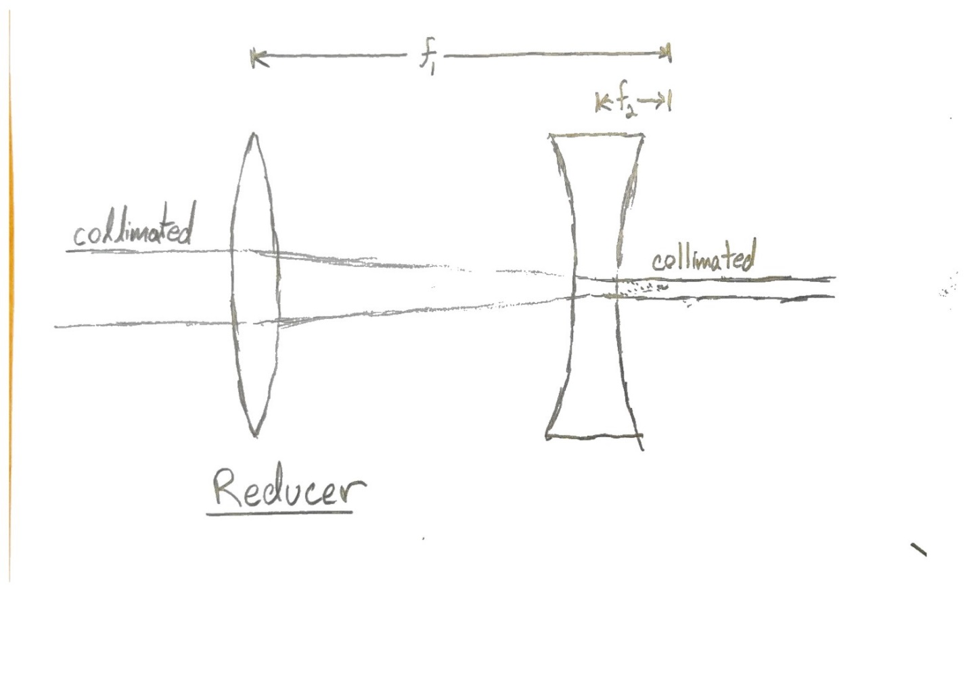

By switching the order of the lenses, the opposite occurs, where the radius of the collimated beam is expanded and re-collimated by the convergent lens.

It can be seen from the below equation that when the lenses are separated by a distance equal to the sum of their focal lengths, the object and image distances go to infinity. This answer represents a collimated beam coming in and out of our optic. This is exactly what was seen by placing a sheet of paper at various locations in the beams path, it was noted that the beam’s radius did not grow or decrease any noticeable amount.

$$s_{i}=\frac{f_{2}d-\frac{f_{2}s_{o}f_{1}}{s_{o}-f_{1}}}{d-f_{2}-\frac{s_{o}f_{1}}{s_{o}-f_{1}}}$$

The magnification is equal to the ratio of the focal lengths. In our case, it becomes either $\frac{f_{1}}{f_{2}}=$ 1.13, or the inverse—0.878. Changing d from these two points creates a non-collimated beam which either focuses or defocuses onto a plane defined by $s_{i}$ in the equation above.

**Discussion**

**Q1:** The best value for f is an average of the set, -34.89cm. This value is 13.6% longer than what was previously calculated, the error is likely due to difficulty in making accurate measurements, and the difficulty resolving precise location of the focal plane.

**Q2:** The beam spot is not of uniform brightness, it is most likely gaussian in nature, and difficult to measure the border of. An error on the reading of beam spot could be as far off as +-1mm, or 31%.

**Q3:** Divergence of the beam is not observed unless the distance between the two lenses decreases.

**Q4:** Magnification is equal to the ratio of the focal lengths. In our case, it becomes either $\frac{f_{1}}{f_{2}}=$ 1.13, or the inverse—0.878. Changing d from these two points creates a non-collimated beam which either focuses or defocuses onto a plane defined by $s_{i}$ in the equation above.

**Conclusion**

The focal lengths for the converging and diverging lenses were found to be 29.696cm and -30.717cm respectively. As the R values had an error of about 0.066cm, these calculations may not be far off, however it is clear from the average focal lengths (-34.89cm) derived from measurements from the optical bench were still about 13.6% larger than the calculated values. Though measurements done with the meter long ruler were not very accurate (0.1mm), the larger source of error is likely due to the difficulty involved in defining the focal point by eye when using lenses with large focal lengths—it was very hard to tell within sometimes 5 cm from the image plane.