**Experiment 6: Interference Fringes and Newton’s Rings**

D. Crisp, J. Sanders

**Abstract**

Interference patterns are observed when coherent light is split and a portion is forced to travel a different distance such that it re-converges at a relative phase difference. Using this fact, and a set of optical flats, which are separated by a strand of hair, we determine that the width of a hair is 14.84 micrometers. The radius of a glass surface is also calculated to be 1962.4km from measurements taken to characterize interference observed as newton rings.

**Introduction**

The electric and magnetic field oscillations that light waves are made of undergo one full oscillation at a distance known as its wavelength. This characteristic distance is what makes one color different from another, and it plays a role in understanding interference patterns.

When waves, or their wave-fronts, cross paths, the field strength at any position where they both exist is described as the sum of their constituent fields—a concept known as superposition. In this way, waves interfere with each other: when they negate each other, they are said to be in destructive interference, and when their strengths build on each other it is said to be constructive. It’s necessary to note that these kinds of measurements require the waves to be coherent with each other, their relative phases do not shift for reasons other than a difference in path. If their fields are oscillating at different frequencies—their wavelengths differ—then the phase of one will slip relative to another and their interference will evolve differently.

Optical flats are blocks of glass with reflective surfaces being smooth to about $λ/4$, where lambda is the wavelength. Because they are not perfectly flat, a narrow wedge of air rests between the two surfaces and an interference pattern can be observed. As light travels through the top flat, a portion gets reflected upwards while the remaining continues across the airgap only to get reflected itself before making the trip back up then along-side the first portion. Of the two light waves, the second travels an extra distance of $d=n\frac{λ}{2}+C$. Where C is a constant due to a pi shift or dust on either surface, and 2d is the extra distance traveled through the air gap.

In this lab, we use this concept to measure the thickness of a strand of hair which is placed in-between two flats such that its thickness equals the height of the wedge opposite the angle of contact between the plates.

Newton Rings are a special kind of interference pattern we observe in the lab by placing a piece of glass, with a rounded bottom with a radius of curvature R, on top of a flat. They appear as a repeated and concentric circular pattern centered at the point of contact between the two. Where the radius of the nth fringe () is defined by the equation: . Again, C represents a constant for a pi shift at reflection and imperfections introduced by things like dust.

To make an analysis of these patterns the program ‘ImageJ’ was downloaded from <https://imagej.nih.gov/ij/download.html>. The version used was for 64bit Windows OS, and Java 1.8. We used the software’s abilities to set a scale factor from pixels to distance, and to plot a projected profile along lines defined by the user.

We used a Sodium [Na] lamp to perform these observations. Sodium has an emission spectra with two distinct wavelengths. As the emission of wavelength 589.2nm is far more dominant, it is the one used in our calculations. The glass plates were placed inside a box, as the light was diffused through the back of this observation box.

**Analysis & Discussion**

Initially observed the resulting interference pattern from two optical plates stacked one on top of the other. The pattern that results tells us something about the flatness of these plates, as if they were perfectly flat, we’d not expect to see such an easily observed pattern.

The image below was taken at approximately 36.85cm+- 1cm from the top of the flat. Windows from ImageJ are included here as extra description, and to give a more easily understandable profile plot.

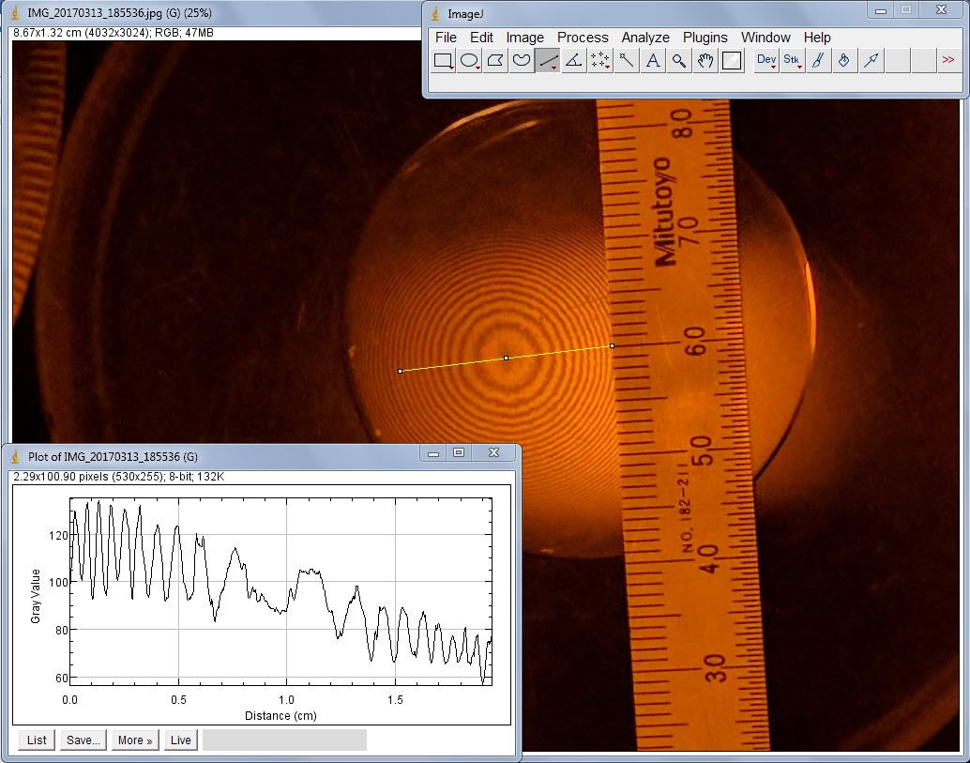

Figure :Interference from imperfect Flats

When playing with the angle of this line of analysis, the interference pattern was no longer distinguishable when going a distance 1.07cm from the 0th order fringe [the center]. Therefore, the angle that spans an area of clarity in this case equals: . Regardless of this resolution, these plates are not flat. Plugging the fact that our highest differentiable fringe is of order 24, and our wavelength of 589.2nm into our equation for d, the spacing between the two plates comes out to be about 24*(589.2nm)/2 = 12=7070nm. This is decidedly worse than expected, and leads to the conclusion that this was not actually a flat, but a curved piece of glass meant for the observation of a newton ring.

When replacing the sodium lamp with white light, it is still possible to see very low order fringes but the interference then becomes very hard to discern. This is because white light is comprised of light of various wavelengths such that the point of constructive interference for one light fills in the gaps that would have been destructive interference for a different light.

The thickness of a strand of hair was found by measuring the interference pattern introduced by placing a hair in-between two glass flats. First we determined a portion of the pattern that has similarly spaced oscillations and measured the distance from peak to peak to be 0.08cm. For the distance from the plates’ point of contact to the hair we measured 4.03cm. These values were entered into a combination of equations from the introduction to give us 14.84 micrometers.

This conclusion does not tell me anything about the roughness of the flats as the hair is about 28 times as thick as a single wavelength. If the previous image for optical flats were in fact flats, this would mean they are rough to about the scale of hair thickness.

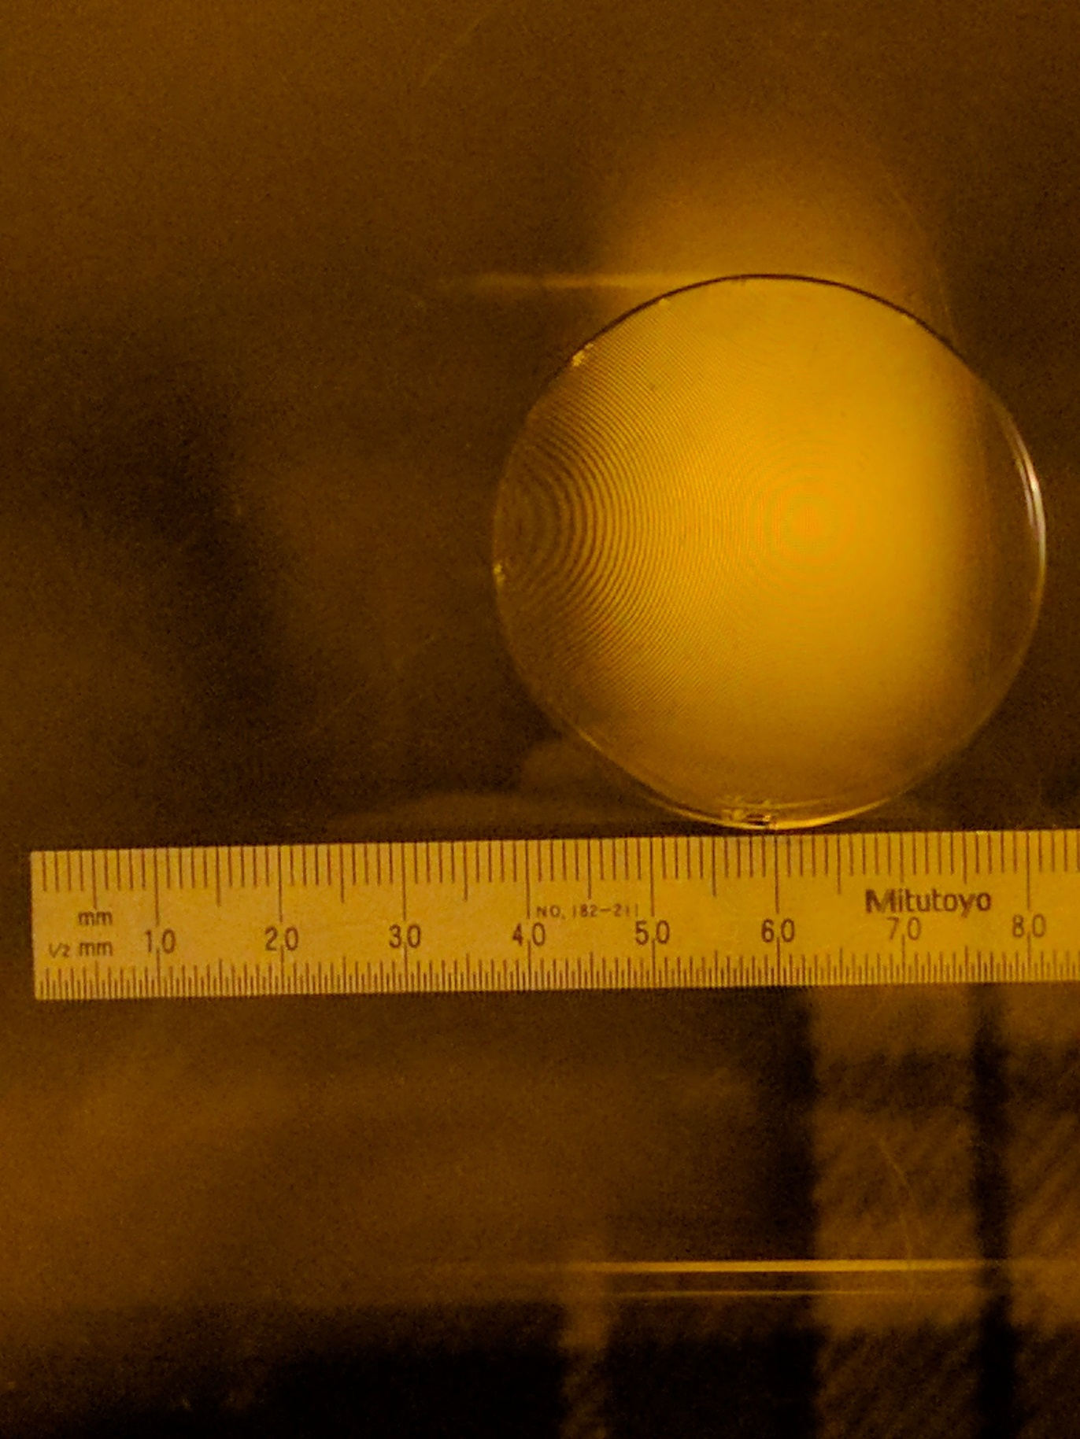

Figure :Thickness of Hair

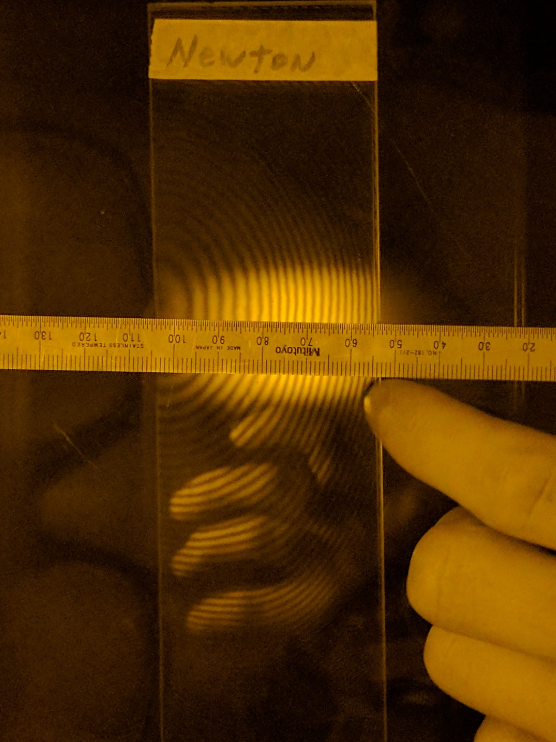

Figure : Newton Rings

Circular fringes [Newton’s Rings] were then observed with the curved side of a piece of glass face down on top of another flat. The diameter of each ring should grow as the square root of its order as can be seen in the image and the equation from the introduction.

Figure : The radius of concentric circles in a newton ring interference pattern grow with sqrt(n)

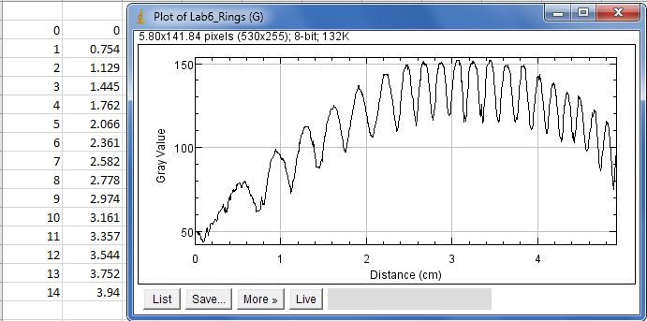

Figure : The profile of the image in figure 3 is plotted using ImageJ

Note that the raw data in figure 5 is not squared, yet the square of this data is what was used in the plot from Figure 4.

You can see that a linear plot fits very well to the data giving an R-Squared value of 0.9953. Associating the slope to , and knowing that the wavelength is 589.2nm it can be concluded that we’ve measured the radius of curvature for the curved glass to be 1.1563/589.2nm = 1962.5 km. This radius seems difficult to believe.

**Conclusion**

We measured the angle of clarity that could be seen when looking at interference observed from two optical flats to be 1.66 degrees. This is the angle made from our eye and spanning the zeroth order to the last discernable fringe.

The smoothness of the initial two flats was measured to be in the order of 12 times the wavelength: 7.07 micrometers. This is far higher than the expected factor of 1-4. It is very likely that these plates were not normal flats and an opportunity to verify this is needed.

Measuring the thickness of something in the order of a strand of hair is quite effective from observations of resulting interference patterns. The thickness of thin blonde hair was calculated to be 14.84 micrometers and very nicely agrees with the known values thicknesses of hair referred to as ‘Flaxen’.

Measuring the differences in trough to trough distances in newton ring interference patterns gives us a radius of curvature for the curved glass plate. However, a calculated radius of 1962.5km seems curiously high. It is very likely that this could be improved by taking more care to image the plate such that more data could be taken.