**Experiment 8: Diffraction Patterns and Gratings**

D. Crisp, S. Fromm

**Abstract**

Using a laser light source with wavelength of 651nm, diffraction patterns due to single slits, double slits, and hexagonal orientations were studied. Using equations derived from Huygen’s principle the single slit widths were verified to within about 20%. Measured data from double slit patterns indicates fringe spacing is consistent when slit width is, and that slit separation only serves to affect the less prominent fringes. Components of white light are diffracted at different angles using a grating, separation of colors like blue, red, and green were observed. Other shapes only diffract constructively in planes perpendicular to flat edges of the mask shape.

**Introduction**

In this lab we study diffraction patterns resulting from the way light diffracts as it passes through masked holes of varying geometries. The pattern itself is an observation of interference due to the superposition of field vectors comprising the incident light, where relative phase differences govern whether it is constructive or destructive. A laser light of wavelength 651 nm was shined through several different masks then projected onto a screen far enough downstream that we can consider the diffraction to be ‘far-field’ and utilize handy approximations of small angles. Frauenhofer Diffraction is what we call this type of diffraction where the mask and screen are separated at distance much greater than that of individual slits in the mask.

A metal rail support system was utilized to set up our optical arrangements. Elements like the rotating masks, the laser, and the screen for projecting patterns downstream can all be screwed into clamps which secure these elements to the support rail in optical alignment.

Huygens’s Principle says to treat each point on a wavefront as an independent light source. As these intermediate sources radiate, one considers the line tangent to each of their wavefronts as the wavefront to the light as a whole. By drawing this tangent line one sees how the geometry works out to find respective optical path differences resulting in destructive interference:

**Analysis & Discussion**

The first mask geometries studied were single slit, but with four different widths: 0.04 mm, 0.08 mm, and 0.16 mm. The mask for each was rotated into the path of the laser one at a time. For each slit, the spacing of the fringes in the resulting pattern were marked on the screen downstream, measured, and logged.

Using the angle made between the line going from slit center to position of a dark fringe, and that of the optical axis, one can correlate transverse displacement on the screen (y) with the distance of the screen from the mask (L):

The equation in the introduction correlating slit width (b) with wavelength lambda and theta can be substituted into the one above given that theta is the same in this case and that with small angles one can approximate sin(theta) = tan(theta). In doing so, an equation for slit width (b) can be found and shown to verify the slit width. Length L from the mask to the screen was measured to be 24.5 +/- 1cm.

|  |  |  |
| --- | --- | --- |
| Slit 1: 0.02 mm | Slit 2: 0.04 mm | Slit 3: 0.08 mm |
| 8.0 | 3.5 | 1.5 |
| 16.5 | 7.5 | 3.5 |
| 24.5 | 11.0 | 5.5 |
| 33.5 | 29.0 | 7.5 |

Table 1: Distances measured from center of patterns to nth order destructive fringes. (1st, 2nd, 3rd, & 4th)

Using the distance from center to the first destructive fringe alone for y (row 1 in table 1) we calculated these values for slit widths, which match much better for the 0.002mm slit than they do for the 0.08mm. The error is likely due to the difficulty of measuring increasingly fine distances.

|  |  |  |
| --- | --- | --- |
| Slit 1 | Slit 2 | Slit 3 |
| 0.00199 mm (.5%Error) | 0.00456 mm (8.8%Error) | 0.0106 mm (32.5%Error) |

**Q1** It’s clear from the data above that the width of the central constructive interference grows larger as the slit width decreases. This is a neat result as it would seem counterintuitive, however referring to huygen’s concept of a wavefront emitting from separate and intermediary point sources helps us. As the width of sources (the width of the slit) decreases, the wavelength and the factor of ½ stays constant, meaning the angle in sin(theta) must grow and the transverse distance y must as well.

We then tried masks with double slits. There were two with slit width (we’ll call width ‘a’) 0.04 mm: one had a slit spacing (we’ll call spacing ‘d’) of 0.25 mm, the other 0.5 mm. And there were two with an ‘a’ of 0.08mm and one with a ‘d’ of 0.25mm and the other with 0.5mm.

|  |  |  |  |
| --- | --- | --- | --- |
| Slits 1: a=0.04mm, d=0.5mm | Slits 2: a=0.04mm, d=0.25mm | Slits 3: a=0.08mm, d=0.25mm | Slits 4: a=0.08, d=0.5mm |
| 4.0mm | 4.0mm | 1.5mm | 2.0mm |
| 8.0mm | 7.5mm | 3.5mm | 4.0mm |
| 11.5mm | 11.5mm | 5.5mm | 5.5mm |
| 16.0mm | 15.5mm | 7.0mm | 7.0mm |

What is new about these patterns compared to the ones made by single slits, is that there are more prominent destructive fringes in addition to the smaller less prominent ones. **Q2** The distance ‘d’ between the slits does not affect the prominent fringes. Only the ‘micro-fringes’ are affected by this parameter.

A mask with 5 separated slits was then used, and it’s diffraction pattern projected.

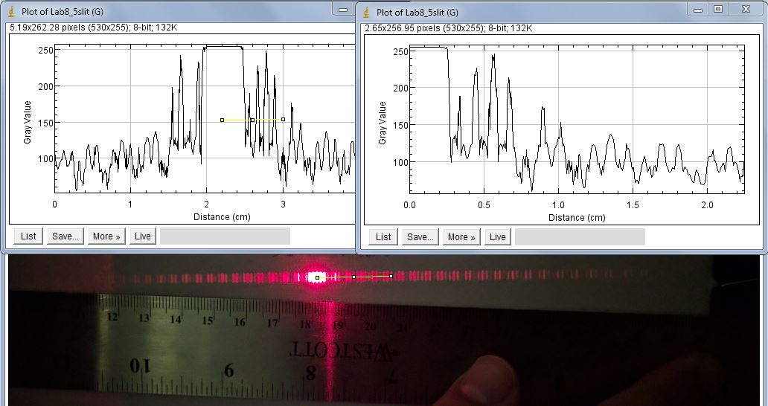

Figure 1: Image of diffraction pattern from 5 slit mask separated by 0.125, and with slit width of 0.04. Intensity profile plots made with ImageJ software.

In the intensity profile, one can see that there are larger destructive fringes, and smaller ones. **Q3** It appears we do not have detail fine enough to calculate the separation between slits as one cannot definitively measure the number of maxima or minima within the more prominent single and double slit patterns. If we had, the calculation would be much as it was before.

A square aperture was then used as a mask. **Q4** diffraction patterns only appeared in planes perpendicular to the aperture’s flat edges. This is not because there aren’t other planes of diffraction, but because the other ones cancel each other out. All planes perpendicular to these edges are the same as the ones parallel to them thus increasing intensity.

Then, a steel ruler was used as a diffraction grating by reflecting light off the edge with tick marks. Only the light hitting between the tick marks gets reflected. Please see the image below of the set up. It can be seen in the image of our set up that there are two much brighter spots. One of these is at a location unaffected by the ruler, and the other is the 0th order of our reflection—where the light would end up if we had used a smooth mirror instead of the grating of the ruler.

What cannot be seen in this image is that there are less bright spots which appear on either side of the reflected spot. These are our 1st, 2nd, 3rd, etc. order constructive fringes, and their spacing is related to the spacing of the grating which we know (it’s a ruler), and the wavelength of the laser along with the distance from the point of reflection to the screen.

If we say that the angle between the two bright spots is split into two equal angles, alpha and beta, where beta is the center of that space to the reflected bright spot, then consecutive fringes can be defined with changing beta (with alpha constant) in the following equation:

Where a is the distance between gratings, with this ruler a is 1.0 mm. We measured the distance of several reflected points from the zeroth order: from 0-1, 82mm; from 1-2, 18mm; from 2-3, 10mm. I’ll say that it seems strange we have such a large relative distance between the first two

fringes compared to the spacing between other consecutive measurements. As such, I believe that the numbers measured are likely incorrect as they were done from the un-reflected bright spot to the first right hand fringe on that side. This would be incorrect. Using our current data however, I will assume that 0-1 is the distance spanned by alpha+beta, and continue with the assumption that consecutive measurements are for increasing order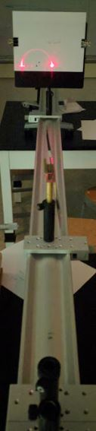. As such, the initial angles would be equal to ½*arctan(8.2cm/86.3cm)=2.7degrees. The beta for the first order constructive fringe is then arctan(10cm/86.3cm)-2.7deg=3.91deg. Entering into our equation for grating fringes, 0.001*(cos(3.91)-cos(2.7))=lambda=1.217um, or correlating to a 1217nm wavelength. This calculation is off by (1217-651)/651=87%, almost a factor of 2. Either a fringe was missed, and this is a second order, or the distances we’re using are incorrect.

A grating with 100 lines/mm was then used. Here the separations were easily seen. The distance from center constructive fringe to first order was 7.5mm. However, we forgot to log the distance between our grating and the screen.



A 1000ln per mm grating was also used with white light. Light of different wavelengths was diffracted at different angles. Blue light was found to be off by 5cm from the center and red light 8cm.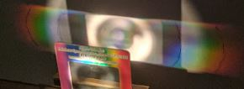

**Conclusion**

It was found that for producing diffraction patterns, the slit widths affect what is the single slit diffraction pattern, and that adding multiple slits does not affect this envelope in the resulting pattern. However, adding slits does affect the characteristics of the micro-fringes in the resulting pattern.

Also, though there may be light coming out in different planes, the only ones which add up to something visible are those which are alongside many others with nearly identical patterns, a conclusion derived from seeing the patterns from square aperture gratings.

By viewing a diffraction grating with very dense lines, the single slit envelope seems to disappear from the pattern and a very fine, consistently bright pattern emerges.

These fine gratings diffract light at different wavelengths.