**Experiment 4: Lens Aberrations**

D. Crisp, M. Arielle

**Abstract**

Spherical Aberrations are studied using apertures and colored film. By defining the radial height which light passes through a large diameter lens, focal lengths were found to decrease with increasing heights. The effect of chromatic aberration was observed to be that the focal power of a lens is effectively increased when the wavelength of that light is shorter.

**Introduction**

One can determine the focal length of a lens by using its radii of curvature and index of refraction in the Lensmakers Equation (1). If the radii are unknown, they can be calculated with the Spherometer Equation (2)—essentially Pythagoreans—using values obtained using a device with the same name.

Spherical aberration is one of several types of lens aberrations, and is where the focal length is dependent on the radial distance incoming rays enter a lens. This variation of focal lengths is because the effective focal power of the lens changes as you go farther from the optical axis (go through different meridians). Light passing close enough to the optical center of the lens will get focused at a distance approximately equal to the focus of the paraxial position—the position that can be calculated using the simple Lens Equation (3). Circular apertures can then be used to define the median at which light will pass through the lens: doing so will allow probing of focal powers at defined radial distances (meridians). As an extra note, when the varying focal lengths lie on the shorter side of the paraxial position the aberration is called undercorrected, or negative. Traditionally the relationship between the longitudinal shift of focus from the paraxial position is graphed against the radial height of the circular aperture.

Axial chromatic aberration is where the focal length varies with a light’s wavelength. Indices of refraction are greater for short wavelengths than they are for long, meaning that light with shorter wavelengths will be more strongly focused and have closer focal lengths compared to light with longer wavelengths through a convergent lens. For instance, an image made with blue light will be closer than one made with red. Indices of refraction assumed to pertain to the lens used in this lab are tabulated below for the different wavelengths of visible light used.

|  |  |  |
| --- | --- | --- |
| *Color* |  | *n* |
| Violet | 420 | 1.5318 |
| Blue | 460 | 1.5265 |
| Cyan | 485 | 1.5240 |
| Green | 540 | 1.5196 |
| Yellow | 580 | 1.5172 |
| Red | 640 | 1.5145 |

The arrangements set up in this lab relied on the use of a long metal rail secured to large tables in the room. Each optical element, the lens, aperture, lamp head, and image screen could be screwed into a metal clamp which clamped onto the rail. These clamps could be loosened and slid longitudinally along the rail, making it relatively easy to make the adjustments needed for successive measurements while maintaining the transverse alignment of the elements with the optical axis.

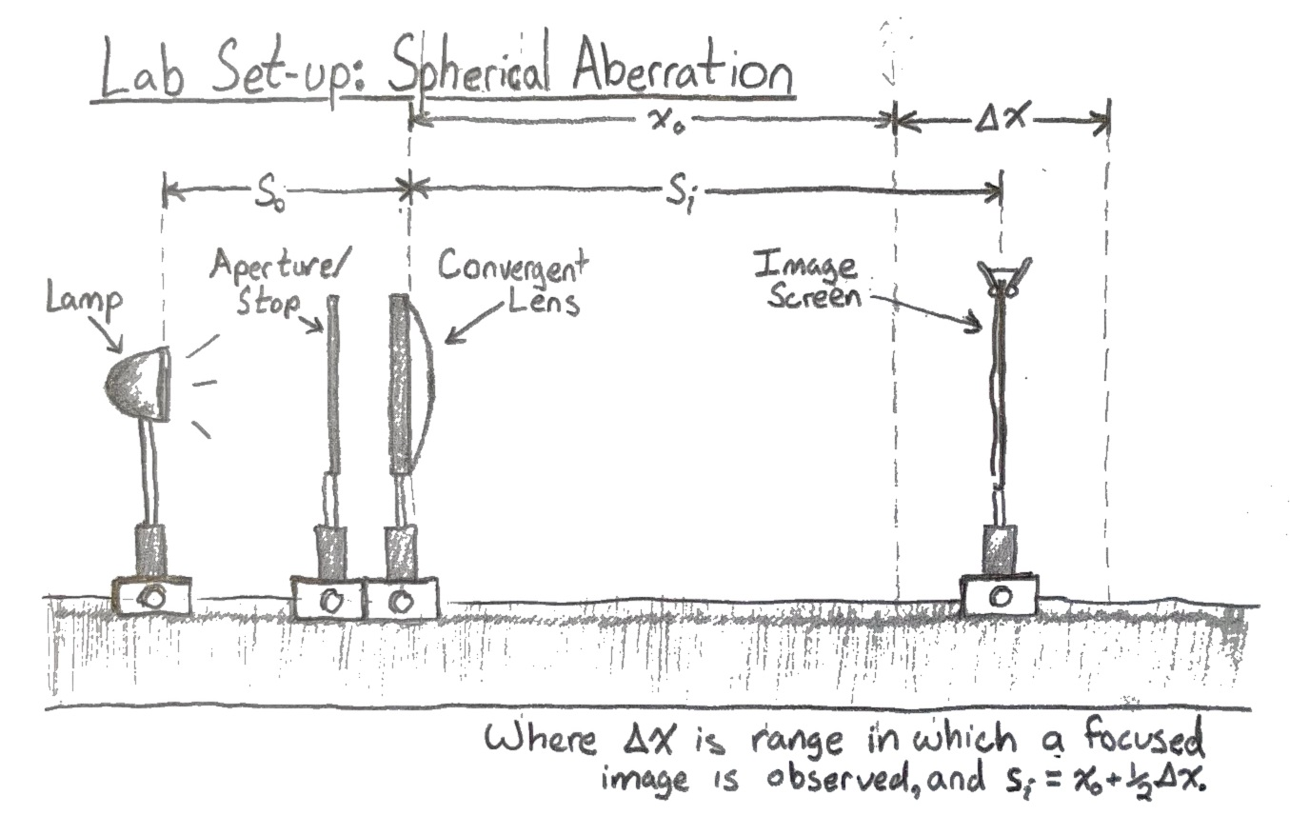

**Analysis & Discussion**

A large diameter lens was used and its properties calculated using a Spherometer and equations (1) & (2). As our lens was planar on one side, the second radii of curvature is infinite and the additional term from equation (1) goes to zero. Note that the focal length calculated the day of the lab was erroneously calculated to be 15.20cm due to mistaking the lens’ index of refraction to be 1.56 rather than the correct value of 1.52.

Where the error in R is found using , and in the below equations: . The error is so large due to the measurement of the Spherometers base being so rough. By the same method, the calculated error for the focal length is 383.1mm.

Using a lamp as an object, the lens was secured on the rail in line between the object and screen, and the screen was moved to the location of a focused image. This object distance was measured at , and the image distance . Inserting these distances into the Lens Equation (3) results in a focal length of 15.97cm. Though it wasn’t acknowledged at the time, this value turned out to be closer to the expected focal length of the lens than 15.20cm.

The lens was placed a distance 1.25f away from the object, which based on our calculation at the time meant that the object distance was set to 19cm. Though the lens was rotated later, it was always immediately re-positioned to maintain this distance of 19cm.

With the planar side of the lens facing the object, a aperture—the smallest on hand—was placed immediately before the lens so that a more accurate paraxial position of the focal length could be determined, and serve as our initial data point. After logging measurements for the image distance, the aperture was replaced with one circular aperture after another, each one defining a median of larger radii than the one before it. The measurements for image distance and aperture radii are seen in a table below. Note that the radial value h(cm) is found by taking half of the average of inner and outer diameters: see image below.

It was quickly noted that the difficulty in determining the exact location of the focused image was substantial. Throughout the lab there were relatively large ranges where the sharpness of an image was arguably equally optimal, so a decision was made to log the limits of this optimal range in every measurement and to assume the midpoint of the range reasonably accurate for input into later calculations. Though this is less than ideal, the error induced on each measurement should be fairly consent and a comparison of deltas between them was expected to be far more accurate than if we’d used single points with large and random error.

|  |  |  |  |  |  |  |  |  |  |
| --- | --- | --- | --- | --- | --- | --- | --- | --- | --- |
| Stops | ID*(cm)* | OD*(cm)* | h*(cm)* | ∆x*(cm)* | *(cm)* | Si*(cm)* | Error |  |  |
| open |  | 0.5 | 0-.25 | 40 | 75.5 | 95.5 | 20 | 0.010471 |  |
| #1 | 1.5 | 2 | 0.875 | 11.5 | 88.8 | 94.6 | 5.8 | 0.010571 |  |
| #2 | 2.5 | 3 | 1.375 | 5 | 85.6 | 88.1 | 2.5 | 0.011351 | -0.00078 |
| #3 | 3.7 | 4.4 | 2.025 | 6 | 77.1 | 80.1 | 3 | 0.012484 | -0.00191 |
| #4 | 4.7 | 5.2 | 2.475 | 8.5 | 69.7 | 73.95 | 4.25 | 0.013523 | -0.00295 |
| #5 | 5.7 | 6.2 | 2.975 | 4 | 60.6 | 62.6 | 2 | 0.015974 | -0.0054 |
| #6 | 6.7 | 7.2 | 3.475 | 3.2 | 51.3 | 52.9 | 1.6 | 0.018904 | -0.00833 |

Error in all aperture diameter measurements is , meaning an error in h of .

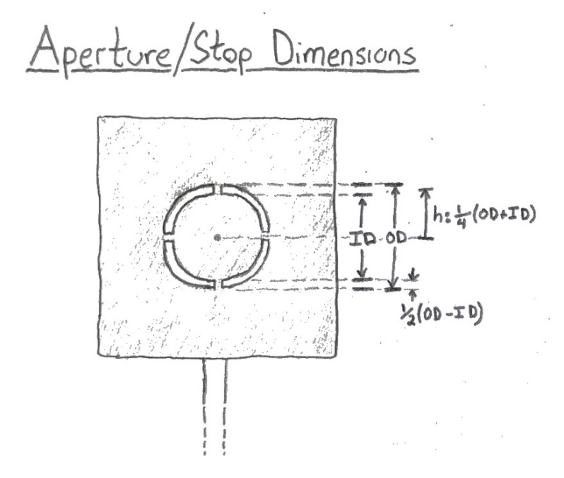

At this point the lens was rotated 180 degrees and shifted such that it’s object distance was maintained and the curved surface faced the object. With this configuration, all measurements seen in the previous table were re-taken except for the ID and OD of the apertures which remained the same.

|  |  |  |  |  |  |  |  |
| --- | --- | --- | --- | --- | --- | --- | --- |
| Stops | h*(cm)* | ∆x*(cm)* | *(cm)* | Si*(cm)* | Error |  |  |
| open | 0-.25 | 39.8 | 130.2 | 151.1 | 19.9 | 0.006618 |  |
| #1 | 0.875 | 26.2 | 130.9 | 144 | 13.1 | 0.006944 |  |
| #2 | 1.375 | 26.7 | 127.8 | 141.2 | 13.35 | 0.007082 | -0.00014 |
| #3 | 2.025 | 22.3 | 111.9 | 123.05 | 11.15 | 0.008127 | -0.00118 |
| #4 | 2.475 | 15 | 92.4 | 99.9 | 7.5 | 0.01001 | -0.00307 |
| #5 | 2.975 | 12.6 | 79.2 | 85.5 | 6.3 | 0.011696 | -0.00475 |
| #6 | 3.475 | 7.5 | 61.7 | 65.5 | 3.75 | 0.015267 | -0.00832 |

Then the data for each case, planar to curved and curved to planar is graphed and fitted. **Q1**To determine the quality of the fit we use the R-Squared value, or the proportion of variance in dependent variable expected from the independent variable. With an R-Squared value of 1 being a perfect fit, the values of 0.9983 and 0.9941 are relatively good.

As might be gathered from these results, there is a parabolic equation which defines contributions of aberration.

Where: .

Inserting values for , f^3, and h^2, S was found to be between -1.57 and -1.88 as h went from 0.875 to 3.475.

|  |  |  |  |
| --- | --- | --- | --- |
|  |  |  | S |
| -0.00078 | 3817.86 | 1.89 | -1.575 |
| -0.00191 | 3621.91 | 4.10 | -1.69 |
| -0.00295 | 3454.04 | 6.126 | -1.66 |
| -0.0054 | 3096.80 | 8.85 | -1.89 |
| -0.00833 | 2731.75 | 12.076 | -1.885 |

**Q2**The term in our trendlines which looks to fit this the best is the quadratic term equal to -0.0015. It’s possible that there was a mistake in one of our variables as the difference is the same factor difference between cm and mm, however other than this it seems to match quite nicely. **Q3**There are no values in these graphs which are deviate substantially from their fits. However it should be noted that the likely culprit of error here is due to the very small angle between focused light and that of the optical axis, meaning that any transverse shift in image (leading to decrease of clarity) is very small for the longitudinal shift in the screen. These small angles of focus induce larger error for light passing through closer to the optical axis. The same reason could be used for why the margins of error in determining focal length decrease as we go through regions of the lens with greater focal power.

Next, we perform the same series of measurements but while changing the color of light with a colored film. The open and aberration free aperture is used in each of these measurements and the values found are tabulated below. The assumed error in these measurements are the same as they were previously.

|  |  |  |  |  |
| --- | --- | --- | --- | --- |
| *colors* |  |  |  | *n* |
| Blue | 86.95 | 19 | 0.06413244 | 1.5265 |
| Cyan | 92.95 | 19 | 0.06339005 | 1.524 |
| Green | 91.9 | 19 | 0.06351297 | 1.5196 |
| Yellow | 100.9 | 19 | 0.06254238 | 1.5172 |
| Red | 103.1 | 19 | 0.0623309 | 1.5145 |

**Q4**In the fit for this graph, the slope should be equal to the inverse of the radii of curvature. The inverse of 6.0969 is 0.164, a value which is again off by what appears to be a factor of 100 from the previously calculated 16.3cm. It’s likely that again, there is confusion regarding units as this is the difference between mm and cm. If the value in this fit was the right order of magnitude, it would be more believable, so the one calculated with the help of measurements done with the spherometer is considered better.

**Conclusion**

The parabolical longitudinal shift in focal lengths was seen to be negative when light passed through increasing radial displacements of the lens. The fit of the data was very good with R-Squared values of 0.9941 when the planar side of the lens faced the object, and 0.9983 for when the lenses’ orientation was reversed. However, the fitting parameters seemed to be a factor of 1000 off from the calculated value of S, where the second order factor of the fit was -0.0015 and S was about -1.6. It’s curious that the value for S was found to change between each change in height h.

A linear shift of the same sign was seen when decreasing the wavelength of light that passed through the lens. The fit of this data was poor relative to the other fits in this lab with an R-Squared value of 0.8492. One factor likely plays a large roll in this error: the aperture used was very small and at the center of the lens, this means that the angle at which the focused light met with the optical axis is very small and meaning the change in clarity for the image with longitudinal shifts of the screen was also very small. However, the inverse slope of the fit (0.164) would match very nicely with the radii of curvature calculated from measurements made with the spherometer (16.3cm).