**Experiment 3: Periscope, Telescope, Microscope**

D. Crisp, A. Johnson, S. Frounn

**Abstract**

A pair of converging lenses are arranged in Periscopic, Telescopic, and Microscopic orientations. In all orientations, the objective lens acts to gather incoming light and focus it into the system. The placement of the objective with respect to the object determines the magnification of an intermediate image, and the placement of the second lens—or eyepiece—effects how that image as an object is projected into a final image.

In a Periscopic orientation, the final image is real, upright, and has a magnification of 1. It can help to limit portions of traveling light with high transverse displacement by introducing an aperture. Placing it somewhat closer to the first lens will make the final image clearer.

Moving the second lens upstream can turn the periscopic into telescopic, and serve to magnify the image. This system allows one to project light from a large collecting lens onto a human eye.

A Microscopic orientation allows for a small image to appear not just closer but more clear. Decreasing the distance between the objective lens and the object--towards a distance equal to its focal length--increases the magnification significantly, thus increasing the viewing angle and resolution seen by the user. In this orientation, the lenses can be made to perform as apertures for increasing clarity of image, executed experimentally by decreasing the magnification of the system.

**Introduction**

One can determine the focal length of a lens experimentally by arranging it in-between an object and screen such that an image is focused onto the screen, then measure the resulting distances and entering them into the Lens Equation.

A Telescopic system can be created by arranging one lens, an aperture, and a second lens in-between an object and screen such that an image is focused at the screen. Generally, the first lens in a telescopic system, the objective, serves as a collector of incoming rays. The eyepiece then serves to re-collimate the image to a diameter suitable for a pupil.

To make the system Periscopic the distances used between the elements on either side of the first lens is and for either side of the second as seen in the image below. This makes the simplified values relevant in following equations: , , and . In our Periscopic system, the image becomes flipped in the intermediate image, then reverted back to the original orientation on the final screen. The goal of a periscope isn’t to magnify an image but allow it to travel some distance, as is done in submarine periscopes so views from above the surface can be seen by someone below.

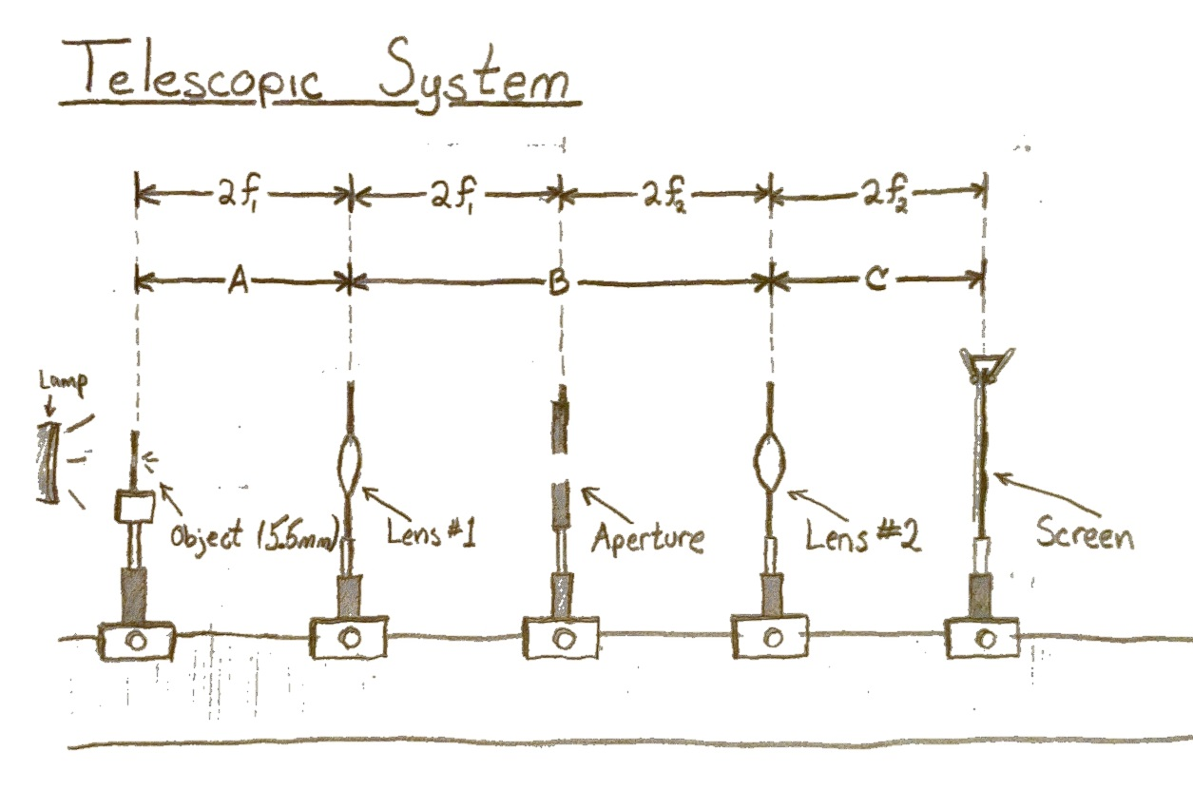

Our microscopic optical arrangement has the same order of optical elements as the Periscopic but with different distances and no aperture. The first lens in a microscope is called the objective. It generates a real, inverted, and magnified intermediate image. This image is then magnified again, except into a virtual image, by the second lens. Using the Lens Equation in a compound fashion, we can describe the system and its magnification. Note that is the distance to the image plane from the second lens, and that a human eye—itself containing a lens—requires a different focus.

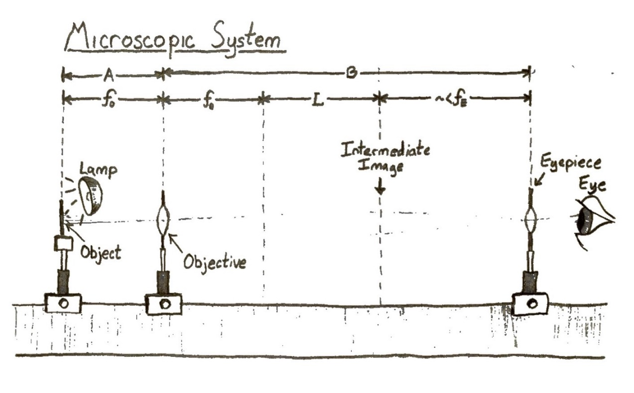

**Analysis & Discussion**

The focal length of each lens used was calculated using the Lens Equation and measured distances from the lens to the object on one side, and to a focused image on the other. Error analysis was done as seen below, and results tabulated below that.

|  |  |  |  |  |
| --- | --- | --- | --- | --- |
| Lenses |  |  |  |  |
| #2 |  |  | 20.46 |  |
| #1 |  |  | 15.36 |  |

The Periscopic System was arranged with the 15.36cm focal length lens first, and lens (2) second: resulting in distances of and . It was found that some extra adjustment from an initial setting of was required to get a sharp image at C. Entering these values into equation (3) returns a Magnification

. Which exactly matches the observed ratio in heights of our object to our image: both being 5.5mm—in other words, an agreeable magnification of 1.

Closing the aperture upstream from Lens #2 did decrease some blurring, but it seemed to mostly dim the image rather than sharpen it. Not until moving the aperture upstream farther still did we see any sharpening of the image. It was determined this ‘first order blurring effect’ is most likely due to the way transmitted light is effected by traveling through the edges of the first lens, and that this light can be limited by the aperture as it continues to travel along the optical axis with largest transverse distance relative to the other rays.

Our periscopic system was then made more telescopic by shifting Lens #2 upstream towards a distance from the intermediate image. Once at that distance, the exiting light would be fully collimated. If the distance is made shorter still, the light would begin to diverge.

By decreasing the distance of Lens#2 from the intermediate image, from 39.5cm to 22cm (). The Magnification became approximately 25 times larger, it appeared to be 13.75mm tall rather than 5.5mm.

The distance of the objective lens, Lens #1, from the object makes a big difference in the apparent size, or viewing angle of the arrangement. As the distance becomes 1.25 times, and then 1.75 times the objective’s focal length, the image magnification decreases. This makes sense when you look at the equations as the magnification of the first lens goes like , note the first term of equation (3). Which means that the size of the intermediate image is decreased.

When holding the position of the objective lens from the object steady at and using the second lens to focus, it was clear there was a trade-off between creating a large or a clear image. With a smaller magnification, the image was clearer.

Below are two images: the first one is with a smaller, clearer, image; the second is with a more magnified, yet more blurry one.

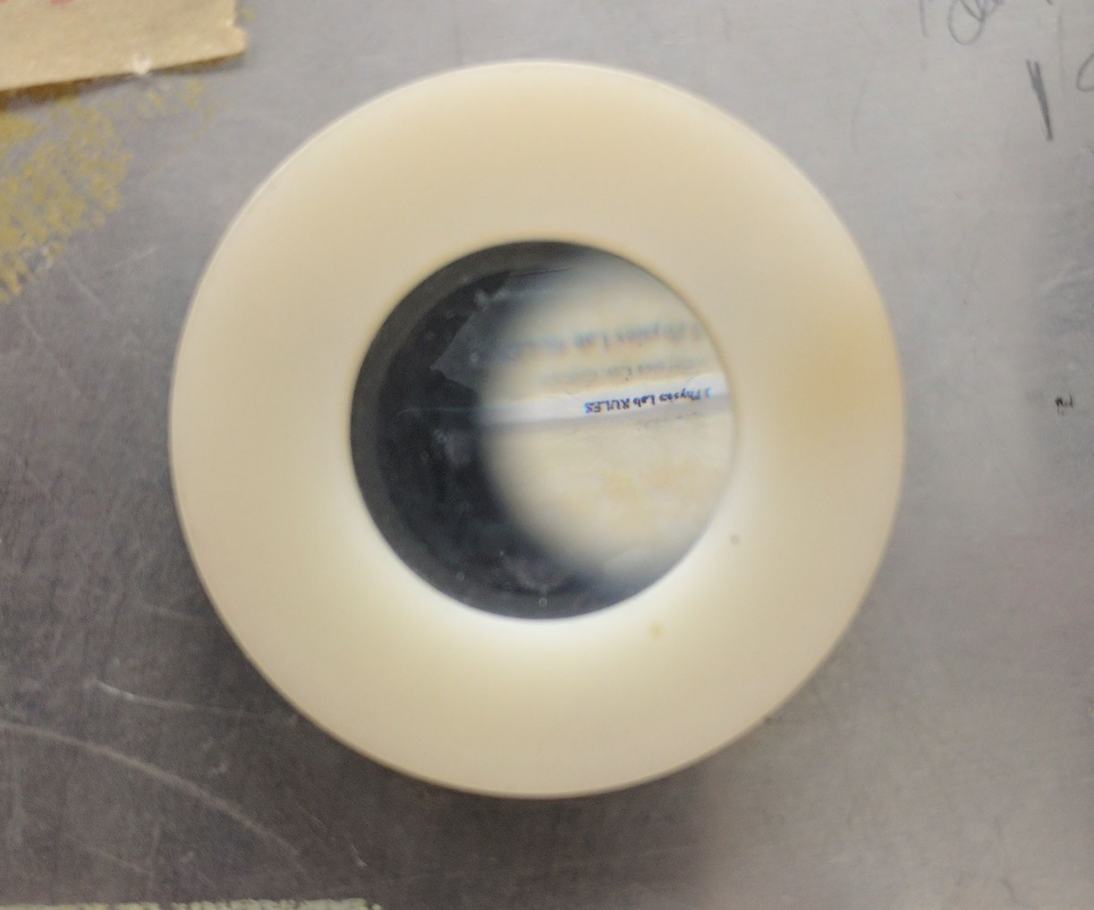

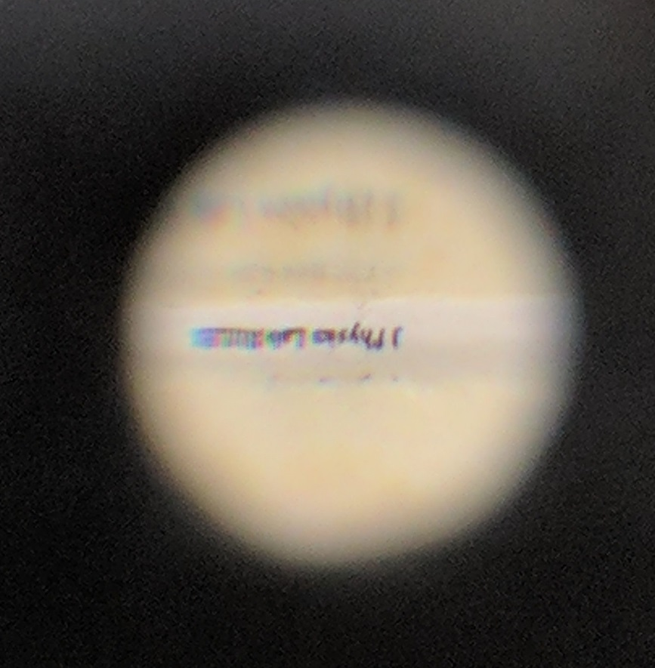

Q1) The Closing of the aperture, or field stop, at a distance past lens #1 does decrease some blurring of the image. This is likely due to it excluding light which is getting around the lens in the first place. However, it was noted experimentally that by shifting this aperature further upstream, the image did get clearer. This was assumed to mean that rays coming in at greater , or transverse position, are blurring the image.

Q2) It was clear that moving the aperture closer to the objective lens that the image became sharper, implying that lens is the culprit for a lousy image.

Q3) Though there was some debate within our group about what was sharper rather than just less bright, I was left with the distinct impression that the field stop positioned closer to Lens #1 was optimal. This may be because it then limits not just stray incoming light, but also any aberrations due to light coming through at the edges of the lens, as the locations of our images do not change. These issues would otherwise have passed through the aperture if it was instead closer to Lens #2.

Q4) It was necessary to shift L2 because the human eye either cannot, or struggles greatly, to see anything under the near point position of 25cm. By shifting L2 such that it’s distance from the intermediate image is decreased from , the light exiting the other side will become increasingly collimated as it reaches the distance . The source of most light we see with our eyes is at a very far (nearly infinite) distance.

Q5) The discrepancy between M and , after moving Lens#2 upstream, was quite large by about a factor of 2. Entering the distances into compound magnification equation (3) returned a magnification of 42.5 times, which varied quite a bit from our observed 25 times magnification. The discrepancy is likely due to the optical transformation of the image performed by our eyes, as well as the difficulty in measuring such an angle. Instead of measuring an actual angle, relative sizes were made using a ruler put next to the eyepiece lens where we saw the image coming from.

Q6) The magnification of the images decreases as the distance from the object to the objective lens increases. This makes sense when looking at the Lens Equation (1) as the focal length is intrinsic to the lens and does not change (at least it doesn’t in our simple, one-lens collector, where it is not made of a system of variably placed lenses).

Q7 & Q8) The image was made clearer by decreasing the final images magnification. This result may be because portions of the beam with a high transverse displacement--with respect to the optical axis--are effectively excluded when increasing the distance of the second lens from the intermediate image. Alternatively, its likely much more light makes it through the system when configured to have a higher magnification. In the Periscopic system, an aperture was used to do essentially this, however in a microscopic system the intermediate image is already magnified. It is easier to use an aperture where your beam has a waist.

**Conclusion**

We found the focal lengths of each lenses used to be and for Lens #1 and Lens #2 respectively. Arranging the lenses in a Periscopic orientation resulted in a real, upright image with +1 magnification. The calculation of this result matched with what was seen in the lab. An aperture placed in-between the two lenses could help sharpen the final image, but even more so when shifted upstream towards the first lens.

Turning the Periscopic system into a Telescopic one required using the second lens as an eyepiece and using our own eyes in place of the screen. To view the image, the second lens also had to be shifted upstream to accommodate the inclusion of our eyes in the system of optics. Doing so induced some magnification which was hard to determine but roughly measured to about 25 times that of the object.

The effect of changing the objective lens in the microscopic system effects the magnification. Increasing the distance of the objective from the object greater than that of its focal length reduces the magnification. A trade-off between the final image’s size and clarity can be made by adjusting the second lens and the position of the experimenter’s eye. It was seen that a clearer image could be had at smaller multiples of magnification, which was determined to be the result of the lenses acting as apertures—something that was not seen when working with less magnified images.

Some improvements that would help greatly would be to have better methods of measuring distances. Using a ruler between two elements, and then another two elements separately does not improve margins of error. But the error in this lab is not so serious as in previous as the results are largely qualitative.