Sentiment Classification on GoEmotions: A Comparative Study of TF-IDF + Logistic Regression and DistilBERT
Anuruddha Ekanayake | Arian Alai | Daniel Crow
School of Computing | School of Computing | School of Computing
University of Nebraska-Lincoln | University of Nebraska-Lincoln | University of Nebraska-Lincoln
Lincoln, USA | Lincoln, USA | Lincoln, USA
aekanayake2@huskers.unl.edu | aalai2@huskers.unl.edu | dcrow2@huskers.unl.edu
Abstract—We map the fine-grained emotions in the GoEmotions dataset to four coarse sentiment categories: positive, negative, neutral, and ambiguous. We train and compare two classification models: a TF-IDF feature pipeline with a Logistic Regression classifier, and a fine-tuned DistilBERT transformer. Our experimental results show that the TF-IDF + Logistic Regression baseline achieves a classification accuracy of 0.636 (95% CI [0.622, 0.650]) and macro-F1 of 0.601 (95% CI [0.585, 0.616]). Fine-tuning DistilBERT on the full training dataset yields a test accuracy of 0.715 (95% CI [0.703, 0.728]) and macro-F1 of 0.684 (95% CI [0.669, 0.699]). Since the 95% confidence intervals for accuracy do not overlap, we conclude that the transformer-based model provides a statistically significant improvement over the linear baseline.

Introduction
Emotion and sentiment analysis of natural language text is a fundamental task in Natural Language Processing (NLP) with applications in customer service, social media analysis, and public opinion monitoring. The advent of modern social media platforms has led to a massive influx of informal text, which is often characterized by noisy writing, slang, and complex emotional expressions. Standard sentiment analysis (classifying text into positive, negative, or neutral) is often insufficient for capturing the rich emotional cues present in these comments.
The GoEmotions dataset [@demszky-etal-2020-goemotions] is a large, human-annotated corpus of 58k Reddit comments labeled with 28 fine-grained emotion categories. In this project, we address a simplified variant of the task: 4-way single-label sentiment classification. We filter the comments to keep only those with exactly one emotion label, and map that label to one of four sentiment classes: positive, negative, neutral, or ambiguous.
To solve this problem, we implement and compare two different modeling approaches: 1. A baseline model consisting of a TF-IDF vectorizer (using word and character n-grams) combined with a Logistic Regression classifier. 2. A deep learning approach using a pre-trained DistilBERT transformer fine-tuned on the training data.
We evaluate both models on the test split, report their classification accuracy and macro-F1 scores along with 95% bootstrap confidence intervals, and analyze their per-class performance to justify the selection of the best-performing model.

Problem Description
The sentiment classification task is framed as a supervised single-label classification problem.
Inputs: The input is a raw text string $x∈X$, representing a single Reddit comment. The text is preprocessed by collapsing whitespace, removing newlines, and striping leading/trailing whitespace.
Outputs: The output is a categorical label $y∈Y$, where:
$$Y=\{\text{negative},\text{neutral},\text{positive},\text{ambiguous}\}$$

Sentiment Mapping
We map the original 28 GoEmotions categories to our target categories as follows: * Positive: admiration, amusement, approval, caring, desire, excitement, gratitude, joy, love, optimism, pride, relief. * Negative: anger, annoyance, disappointment, disapproval, disgust, embarrassment, fear, grief, nervousness, remorse, sadness. * Ambiguous: confusion, curiosity, realization, surprise. * Neutral: neutral.
To handle multi-label comments, we restrict the dataset to comments that have exactly one active emotion label. The preprocessed splits contain the following class counts: * Train Set: 36,308 samples (12,920 positive, 12,823 neutral, 7,012 negative, 3,553 ambiguous). * Validation Set: 4,548 samples. * Test Set: 4,590 samples (1,606 neutral, 1,603 positive, 932 negative, 449 ambiguous).

Models Used
We utilize two models representing different levels of model complexity and linguistic representations.

Model 1: TF-IDF + Logistic Regression (Baseline)
Our baseline model utilizes a standard bag-of-words approach: 1. Feature Extraction: A TfidfVectorizer computes tf-idf features using word and character n-grams in the range $\left(1,2\right)$. We restrict the vocabulary to the top 50,000 features, apply sublinear term-frequency scaling ($\text{tf}←1+log\left(\text{tf}\right)$), and filter out features appearing in only one document. 2. Classification: A LogisticRegression classifier is trained on the TF-IDF representations. To handle class imbalance, we use balanced class weights, which scales the loss inversely proportional to class frequencies. The inverse regularization parameter is set to $C=1.0$, and the model is trained using the L-BFGS solver.

Model 2: Fine-Tuned DistilBERT (Transformer)
DistilBERT [@sanh2019distilbert] is a distilled, light version of the Bidirectional Encoder Representations from Transformers (BERT) model. It uses 40% fewer parameters (66 million compared to BERT’s 110 million) and is 60% faster, while retaining 97% of BERT’s language understanding capabilities. 1. Tokenization: Text is tokenized using the WordPiece tokenizer with a maximum sequence length of 64 tokens. 2. Architecture: A classification head (a linear layer mapping the 768-dimensional CLS token representation to the 4 classes) is added on top of the pre-trained DistilBERT layers. 3. Fine-Tuning: We fine-tune the model for 2 epochs using the AdamW optimizer with a learning rate of $2×{10}^{−5}$ and batch size of 16 on the full training dataset of 36,308 examples.

Performance Comparison
We evaluate both models on the test set of 4,590 samples. To measure statistical significance, we estimate the 95% confidence intervals (CI) for both accuracy and macro-F1 using bootstrapping with $N=1,000$ resamples.

Overall Performance
Table 1 summarizes the overall performance of the two models on the test set.
Overall test performance of the classification models.
Model | Accuracy (95% CI) | Macro-F1 (95% CI)
TF-IDF + Logistic Regression | 0.636 [0.622, 0.650] | 0.601 [0.585, 0.616]
Fine-Tuned DistilBERT | 0.715 [0.703, 0.728] | 0.684 [0.669, 0.699]

Per-Class F1 Analysis
Table 2 breaks down the performance by sentiment class using the F1-score indicator.
Per-class F1-scores on the test set.
Class | TF-IDF + Logistic Regression | Fine-Tuned DistilBERT | Improvement
negative | 0.576 | 0.674 | +0.098
neutral | 0.629 | 0.679 | +0.050
positive | 0.747 | 0.818 | +0.071
ambiguous | 0.452 | 0.566 | +0.114

Visualizations
The performance comparisons are illustrated in the figures below. Figure 1 shows the test accuracy along with the 95% confidence intervals. Figure 2 shows the per-class F1-scores, illustrating that DistilBERT consistently outperforms the baseline across all classes.
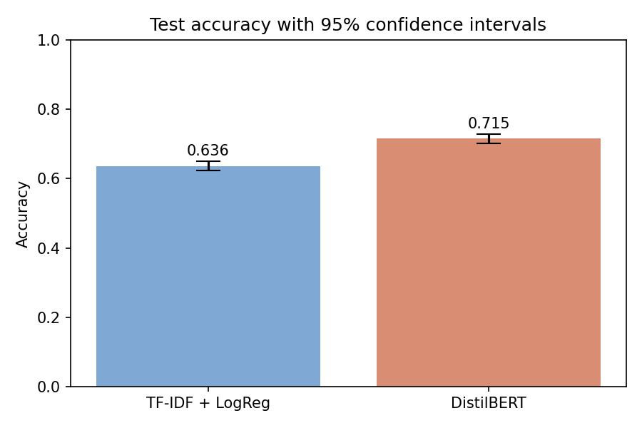
Figure 1: Test Accuracy with 95% Confidence Intervals

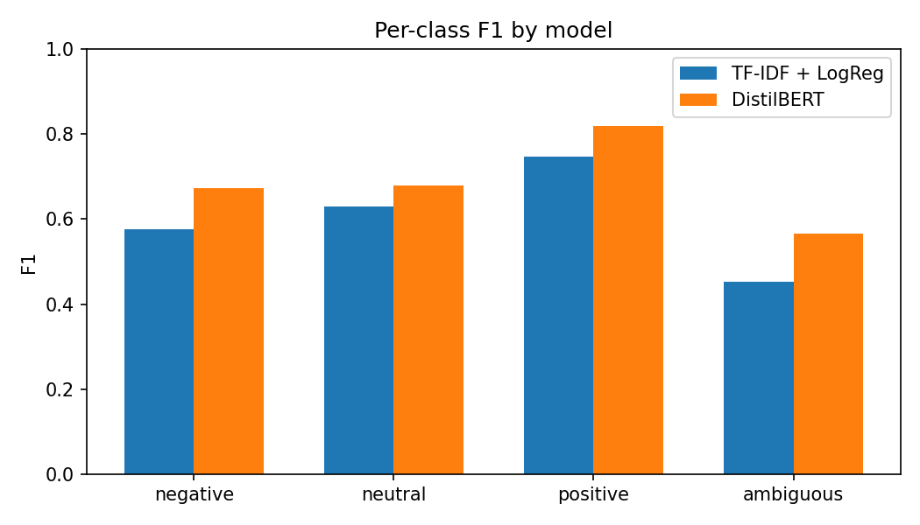
Figure 2: Per-Class F1 Score Comparison by Model
Figure 3 displays the normalized confusion matrices for both models. The diagonal values represent the recalls for each class.
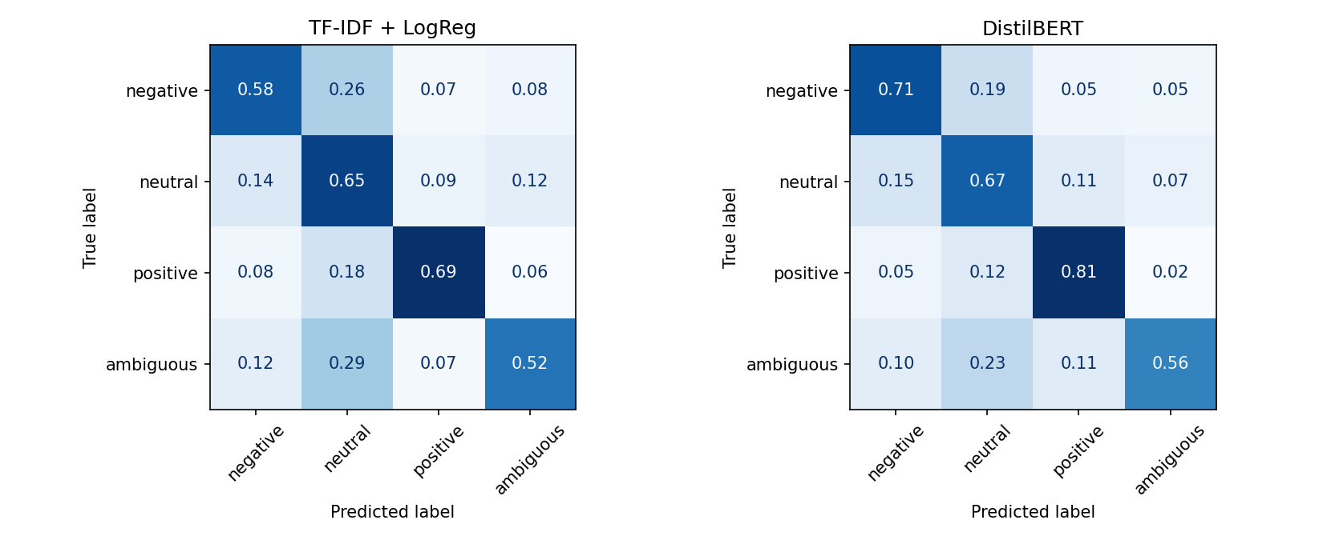
Figure 3: Normalized Confusion Matrices for Baseline and DistilBERT

Justification of the Best Model
Based on the empirical results, the Fine-Tuned DistilBERT model is the superior model: 1. Statistical Significance: The 95% confidence interval for DistilBERT’s accuracy ($\left[0.703,0.728\right]$) does not overlap with the baseline’s accuracy confidence interval ($\left[0.622,0.650\right]$). The lower bound of DistilBERT is strictly greater than the upper bound of the baseline, which proves that the performance improvement is statistically significant. 2. Consistent Class Improvements: DistilBERT outperforms the baseline on all classes. The most significant improvement occurs in the minority “ambiguous” class, where the F1-score increases from 0.452 to 0.566 (+0.114 improvement), and the “negative” class, where the F1-score increases from 0.576 to 0.674 (+0.098 improvement), demonstrating that the contextual transformer is better equipped to handle subtle, complex, and negative emotional expressions.

Pros and Cons of the Approach

TF-IDF + Logistic Regression
- Pros:
  - Efficiency: Training takes less than 30 seconds and requires minimal memory and CPU resources.
  - Interpretability: The linear model weights are directly inspectable, allowing us to find the most indicative n-grams for each sentiment.
  - Simplicity: No hyperparameter tuning or deep learning infrastructure is required.
- Cons:
  - Lack of Context: By relying on bag-of-words, the model ignores word order, meaning sentences like “not positive” and “positive, not” have identical feature representations.
  - Out-of-Vocabulary (OOV): The model cannot handle words unseen during training.

Fine-Tuned DistilBERT
- Pros:
  - Contextual Representation: Captures complex syntactic patterns, semantic dependencies, and word order.
  - Transfer Learning: Leverages massive pre-training on general English corpora, allowing it to adapt to social media text with very few training epochs (e.g., fine-tuned on the full 36k examples for only 2 epochs).
  - Robustness: Handles spelling mistakes, subwords, and abbreviations via WordPiece tokenization.
- Cons:
  - Resource Intensive: Requires significant compute time (took ~10 minutes on CPU for a single epoch) and memory.
  - Black Box: High-dimensional attention maps and weights make model predictions hard to interpret.

Conclusion
We compared a traditional linear baseline with a transformer model on a 4-way sentiment classification task using the GoEmotions dataset. Our evaluation demonstrates that a fine-tuned DistilBERT transformer significantly outperforms a TF-IDF + Logistic Regression baseline trained on the same data. The accuracy improvement (0.715 vs. 0.636) is statistically significant as verified by non-overlapping bootstrap confidence intervals. The transformer’s ability to represent word order and contextual nuances is particularly beneficial for noisy social media comments, justifying the additional computational cost.

