敦煌莫高窟：千年丝路的艺术圣殿
Dunhuang Mogao Caves: The Art Sanctuary of the Millennial Silk Road

一、历史与地理背景
敦煌莫高窟，1987年被联合国教科文组织列为世界文化遗产，位于中国甘肃省敦煌市东南25公里的鸣沙山东麓崖壁上。作为古代丝绸之路的咽喉要道，敦煌是连接中原、西域、印度乃至欧洲的文化与宗教枢纽。莫高窟始凿于前秦建元二年（公元366年），由僧人乐僔开凿第一个洞窟，此后历经北凉、北魏、隋、唐、五代、宋、西夏、元等十个朝代，持续营建千年。现存洞窟492个，南北绵延1680米，保存彩塑造像2000余身、壁画4.5万平方米，构成世界上规模最大、延续时间最长的佛教艺术宝库。

1. History & Geography
Located 25 km southeast of Dunhuang, Gansu, China, the Mogao Caves (UNESCO World Heritage, 1987) were carved into the cliffs of Mingsha Mountain. As a Silk Road hub, Dunhuang bridged China, Central Asia, and Europe. Founded in 366 CE by monk Lezun, the caves were expanded over 10 dynasties for 1,000 years. Today, 492 caves remain, housing 2,000 painted sculptures and 45,000㎡ of murals—the world’s largest Buddhist art treasury.
二、建筑与艺术特色
Architectural and Artistic Features

- 洞窟形制演变
- Evolution of Cave Structures

莫高窟的洞窟结构随佛教传播与时代需求不断演进：
The Mogao Caves' architecture evolved with Buddhist traditions and historical needs:

- 中心塔柱窟（早期）：以北魏第259窟为代表，模仿印度支提窟形制，中央设塔柱供信徒绕行礼拜，塔柱四面开龛塑像，壁画与雕塑融为一体。
Central Pillar Caves (Early Period): Exemplified by Northern Wei Cave 259, modeled after Indian chaitya caves. A central pillar allowed ritual circumambulation, with sculpted niches and murals fused into a unified sacred space.
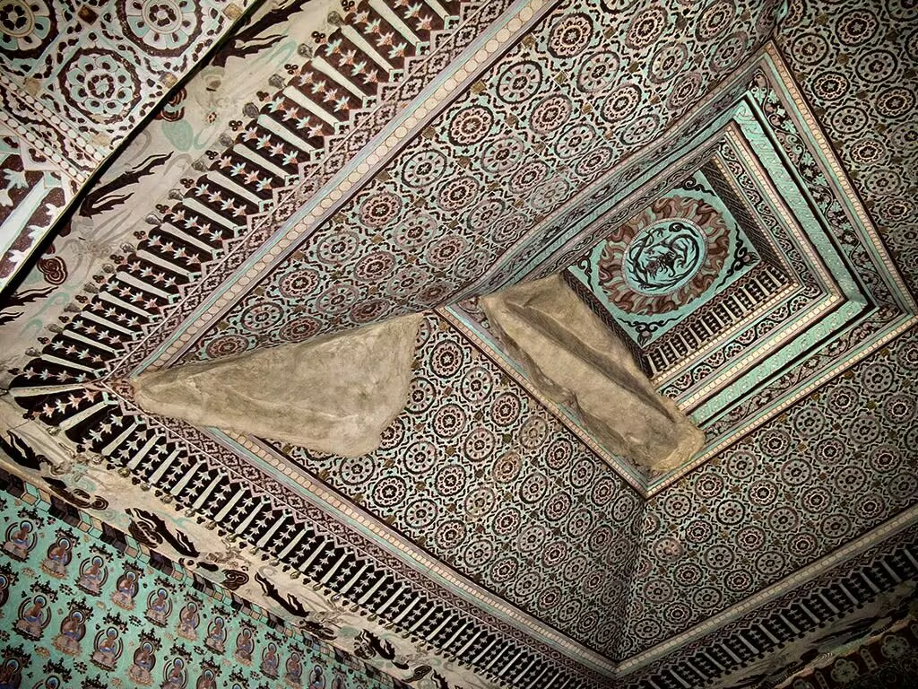
259窟
- 覆斗顶窟（中后期）：如唐代第45窟，顶部呈倒斗形，扩大墙面空间以绘制巨幅壁画，并容纳大型群塑。
Ceiling Caves (Mid-Late Period): Tang-era Cave 45 features an inverted-funnel-shaped ceiling, maximizing wall space for monumental murals and housing elaborate group sculptures.
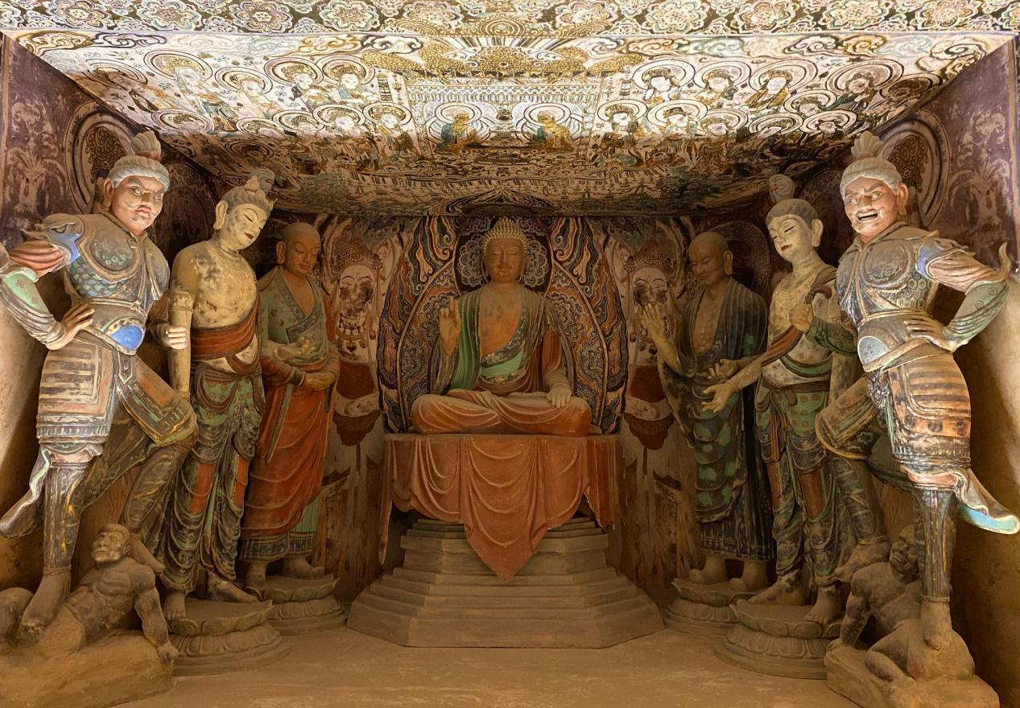
45窟
- 大佛窟：以初唐第96窟的“北大像”（33米弥勒坐佛）与盛唐第148窟的涅槃佛像（全长14.4米）最为宏伟，彰显皇家崇佛的恢弘气象。
Colossal Buddha Caves: The 33-meter seated Maitreya ("Northern Colossal Statue") in Early Tang Cave 96 and the14.4-meter reclining Nirvana Buddha in High Tang Cave 148 epitomize imperial Buddhist grandeur.
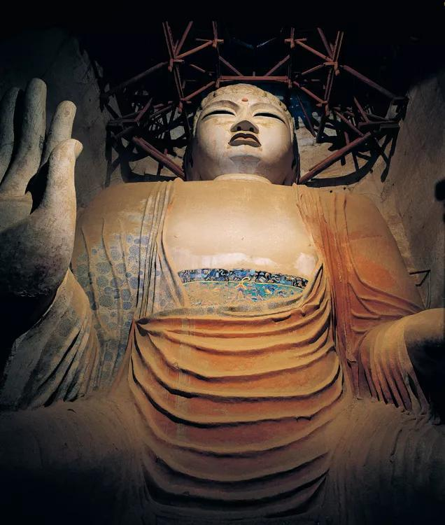
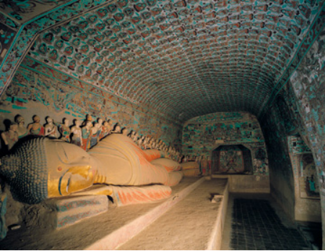
- 彩塑风格分期
2.Stylistic Phases of Painted Sculptures

- 早期（北凉-北周）：融合印度犍陀罗风格与中国本土审美。如北凉第275窟的交脚弥勒菩萨，肩宽腰细，面容方圆丰润，神情恬淡，体现北方游牧民族的雄健气质。
Early Period (Northern Liang–Northern Zhou):A fusion of Gandharan and Chinese aesthetics. Example: The cross-ankled Maitreya Bodhisattva in Northern Liang Cave 275—broad shoulders, slender waist, full rounded face, and serene composure—embodying the robust vigor of northern nomadic traditions.
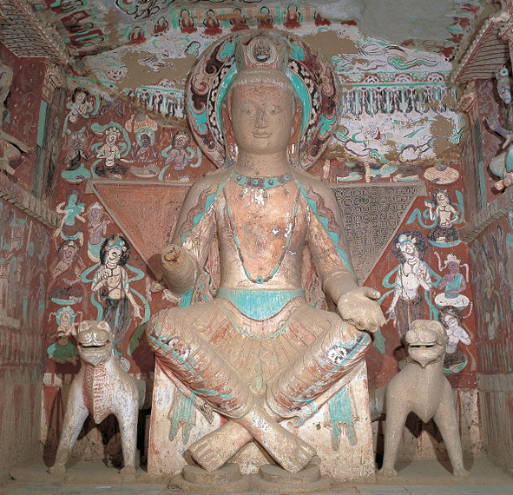

- 中期（隋-唐）：唐代彩塑达到艺术巅峰。第45窟的菩萨塑像面如满月，体态丰腴，璎珞华美，衣纹流畅，展现盛唐以丰腴为美的审美观；第148窟的涅槃群塑以73身人物环绕释迦牟尼佛，悲欣交集的神态刻画入微。
Mid Period (Sui-Tang):Tang painted sculptures reached their zenith. Cave 45’s Bodhisattva—moon-faced, full-figured, adorned with jewels and fluid drapery—embodies High Tang’s ideal of opulent beauty. Cave 158’s Nirvana scene features 73 figures encircling Sakyamuni Buddha, their expressions poignantly blending sorrow and transcendence.
45窟
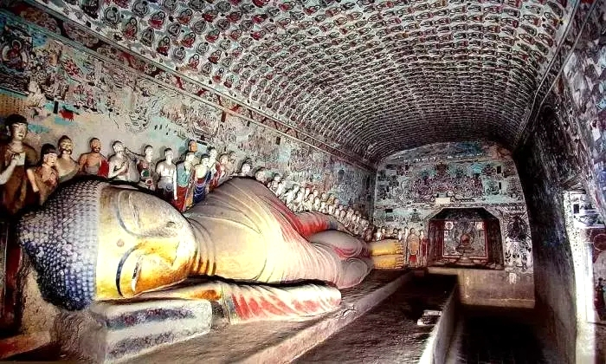
148窟

- 晚期（五代-元）：宋代造像继承唐风但趋于程式化，西夏第465窟的天女像虽遵循唐宋模式，但面容圆润、服饰简朴，折射党项族审美特色。
Late Period (Five Dynasties-Yuan):Song sculptures retained Tang influences but grew formulaic. Tangut-era Cave 465’s celestial maidens, while following Tang-Song conventions, reveal distinct Tangut aesthetics: rounded faces and simplified attire reflecting steppe minimalism.

3. 壁画：百科全书式艺术
3. Murals: An Encyclopedic Art

莫高窟壁画涵盖佛教宇宙观、世俗生活与跨文化交融：
The Mogao murals encompass Buddhist cosmology, secular life, and cultural fusion:

- 佛像画：如第3窟的千手千眼观音，十一面四十臂，以“凹凸法”渲染立体感，展现密教艺术的繁复瑰丽。
Buddhist Paintings: Cave 3’s 11-faced, 40-armed Guanyin, rendered with three-dimensional shading (aotu technique), exemplifies Esoteric Buddhism’s ornate brilliance.
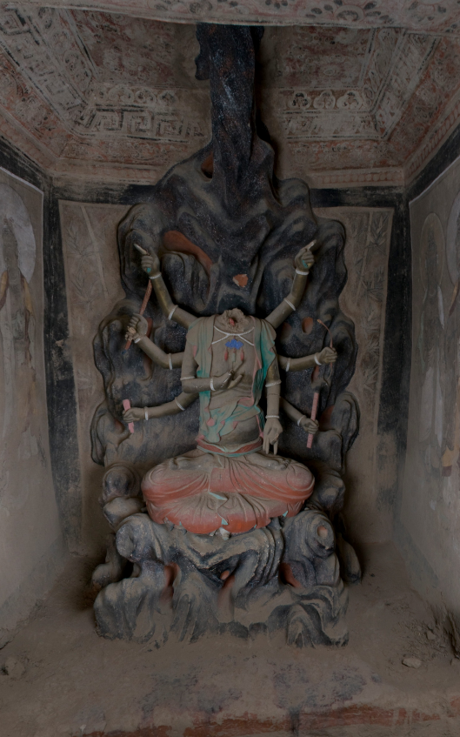
3窟

- 经变画：将佛经文本转化为视觉叙事，如第61窟的《五台山图》以鸟瞰视角描绘五台山全景，融合地理与信仰。
Sutra Illustrations: Cave 61’s Mount Wutai Painting transforms Buddhist texts into visual storytelling, using a bird’s-eye view to map the sacred mountain’s landscape while weaving spiritual devotion into geography.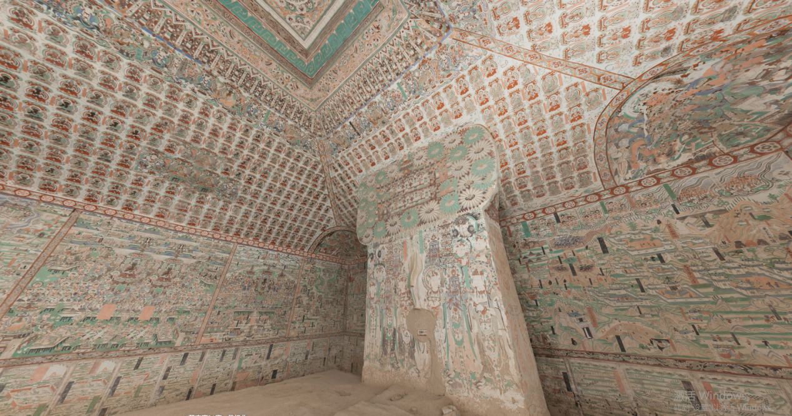
61窟

- 世俗题材：第296窟的商队图、第445窟的婚礼图记录丝路贸易与民间生活；第61窟的曹氏家族供养人画像，服饰华贵，凸显归义军时期的权贵风貌。
Secular Themes:Cave 296’s caravan scenes and Cave 445’s wedding rituals document Silk Road trade and folk life; Cave 61’s Cao family donor portraits, clad in lavish attire, epitomize Guiyi Jun era elite culture.
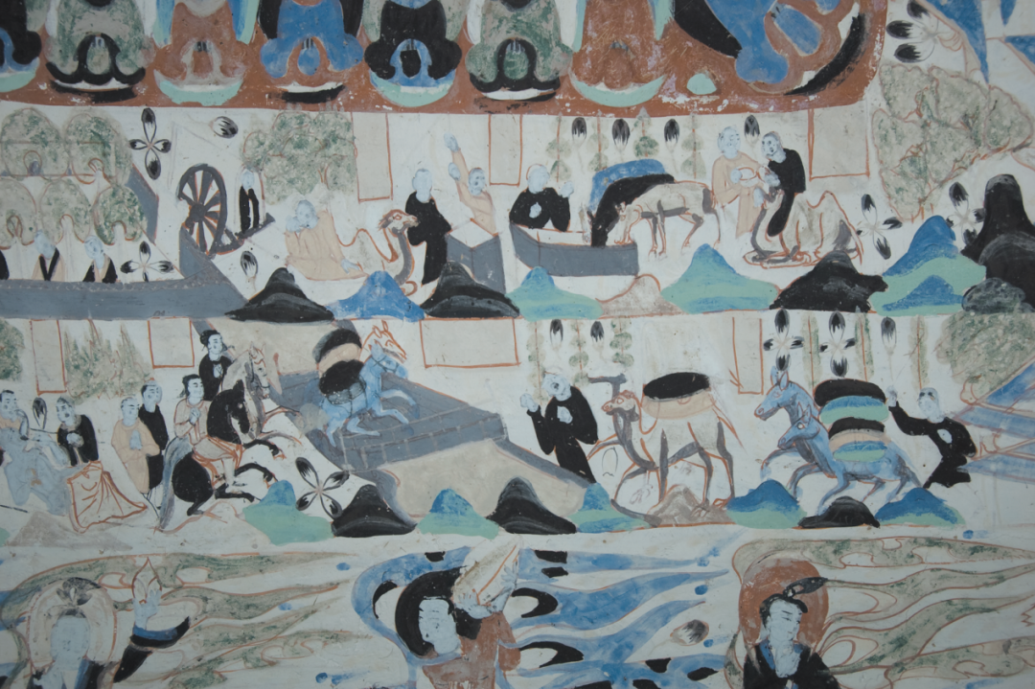
296窟
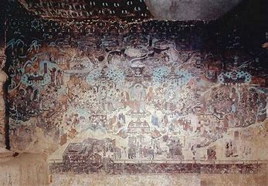
445窟
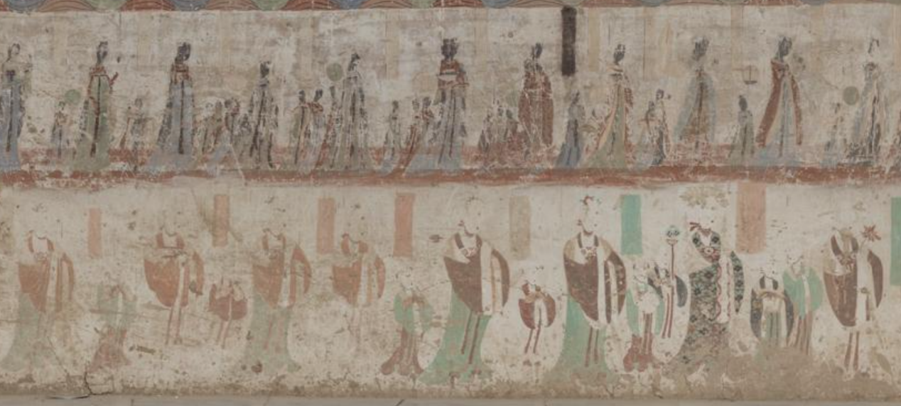
61窟“女性供养人”
Female Donors in Cave 61
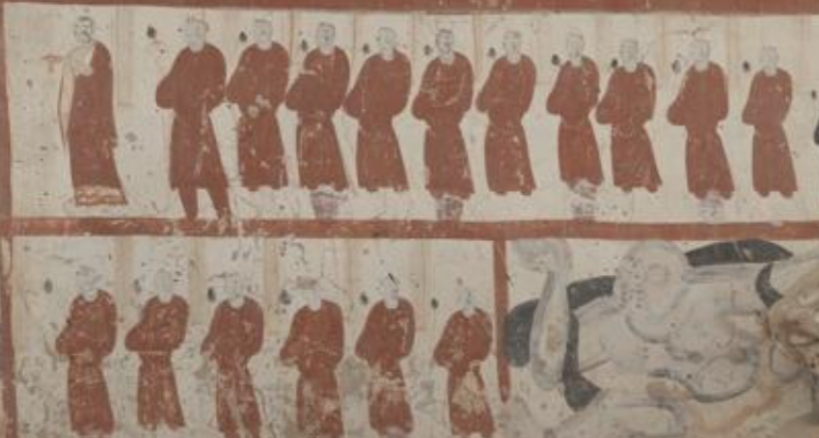
61窟“男性供养人”
Male Donors in Cave 61
- 飞天演变：早期飞天身形短拙（如北凉第272窟），隋唐后逐渐轻盈曼妙（如初唐第321窟的双飞天），飘带飞扬，尽显“天衣飞扬，满壁风动”的韵律之美。
The Evolution of Flying Deities: Early depictions featured sturdy and compact forms (for example., Cave 272, Northern Liang Dynasty), while post-Sui and Tang dynasties saw increasingly graceful and ethereal figures (like the paired flying deities in Cave 321 of the early Tang). Their fluttering ribbons embody the poetic rhythm of "celestial garments
Dancing in wind, walls alive with motion.”

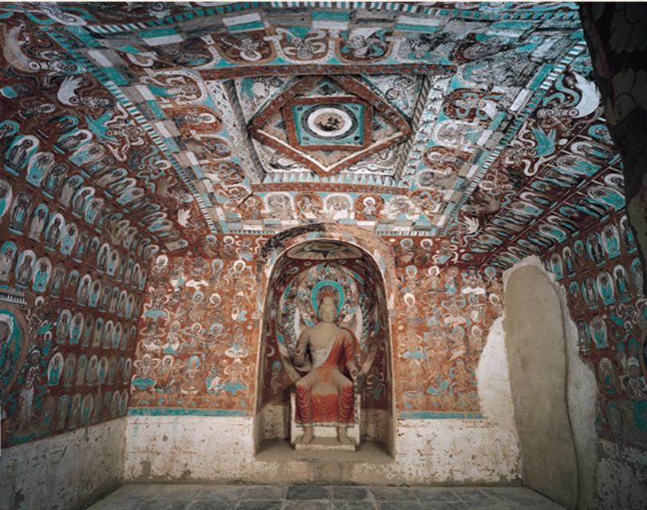
272窟
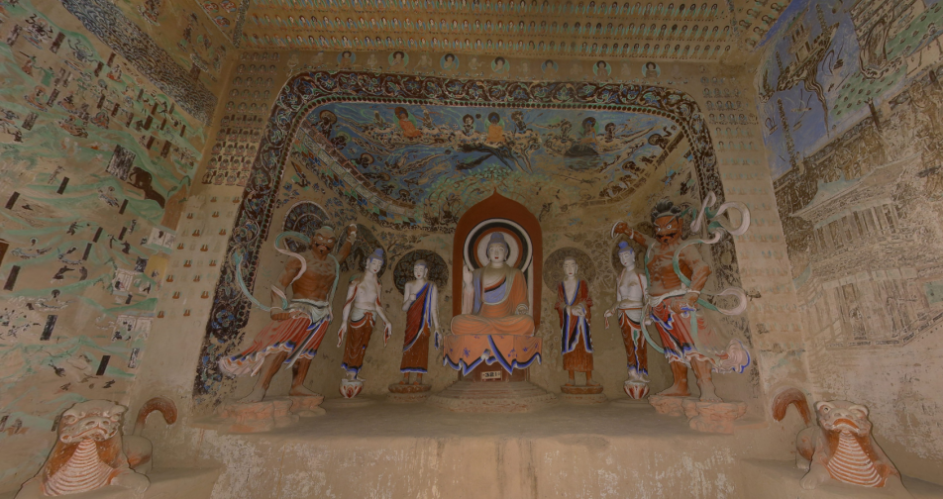
321窟
- 文化融合与全球意义
Cultural Fusion and Global Significance

莫高窟是佛教中国化的缩影。早期壁画受西域“凹凸晕染法”影响（如北魏第254窟《萨埵太子舍身饲虎》），至唐代发展为“吴带当风”的线描技法（如第103窟《维摩诘经变》），融合印度、波斯与中原艺术精髓。
The Mogao Caves epitomize Buddhism’s Sinicization. Early murals, like the Sattva Prince Offering His Body to a Tiger in Northern Wei Cave 254, adopted Central Asian "aotu" shading techniques. By the Tang era, these evolved into the "Wu-style ‘wind-blown robes’ brushwork" seen in Cave 103’s Vimalakirti Sutra Illustration—synthesizing Indian, Persian, and Chinese artistic genius.
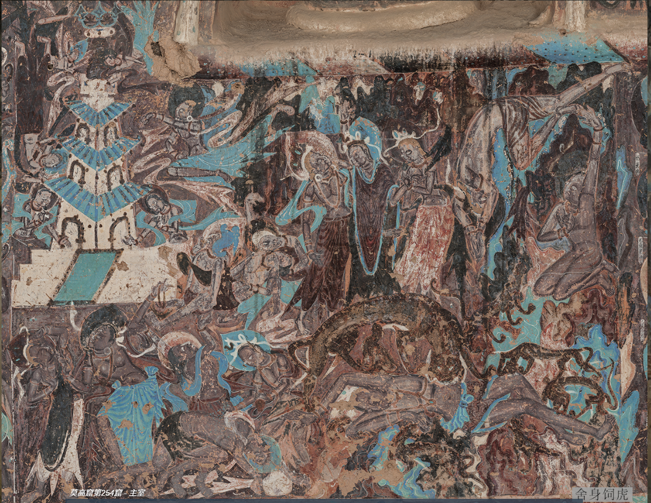
254窟“舍身饲虎”
Cave 254: "Prince Mahasattva’s Self-Sacrifice to a Tiger"
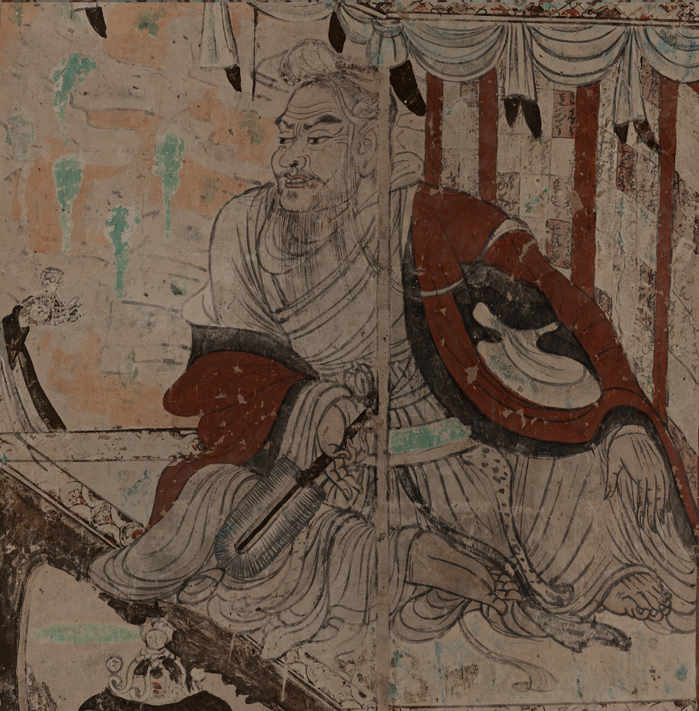
103窟
藏经洞（第17窟）的发现（1900年王道士偶然开启）揭开文化宝库：5万余件4-11世纪的写本文物，涵盖汉、藏、梵、回鹘等文字，内容从佛经到户籍、契约，堪称中古社会的“时间胶囊”。然而，斯坦因、伯希和等探险家以低价掠走大量文物，导致敦煌文献流散全球，成为中国近代文化创伤的象征。
The Library Cave (Cave 17): Discovered in 1900 by Taoist monk Wang Yuanlu, this trove held over 50,000 manuscripts spanning the 4th–11th centuries—Buddhist texts, household registers, contracts, and multilingual documents in Chinese, Tibetan, Sanskrit, and Uighur. A "time capsule" of medieval Eurasia. Yet explorers like Aurel Stein and Paul Pelliot acquired vast quantities at minimal cost, scattering the artifacts globally—a symbol of modern China’s cultural dispossession.
---

- 保护与挑战
Preservation and Challenges

莫高窟面临自然风化、游客压力与颜料褪色的威胁。敦煌研究院通过数字化工程（如“数字敦煌”项目）对壁画进行高精度扫描与虚拟复原，并严格控制洞窟开放数量。学界如荣新江、方广锠等学者持续破解藏经洞封闭之谜，揭示其与西夏入侵、黑汗王朝东进等历史事件的关联。
The Mogao Caves face threats from natural weathering, visitor pressure, and pigment fading. The Dunhuang Academy combats these through digitalization (for example, the Digital Dunhuang project), using high-precision scans and virtual restoration, while limiting open cave access. Scholars like Rong Xinjiang and Fang Guangchang investigate why the Library Cave was sealed, linking it to historical crises like Tangut invasions and the Kara-Khanid Khanate’s eastward expansion.
---

结语
Epilogue

敦煌莫高窟不仅是艺术殿堂，更是文明对话的见证。它凝聚了丝路商旅的足迹、僧侣的虔诚、画工的匠心，以及千年历史的悲欢离合。保护这一遗产，不仅是守护过去的辉煌，更是为人类共同的文化记忆赋予未来。
The Mogao Caves are not just an artistic sanctuary but a testament to civilizational exchange. They immortalize the footsteps of Silk Road traders, the devotion of monks, the ingenuity of artisans, and the joys and sorrows of a millennium. To protect this legacy is to honor humanity’s shared memory—and ensure its light endures for ages to come.

