Samson_HW5
Danielle Samson
2025-12-01

Choose a city to work with
In the following chunk, I read in the data, looked through the list of potential cities then decided to work with Denver. I then filtered the dataset to include only the data from Denver and used the provided coordinates to turn the dataframe into a simple feature object. Finally, I generated the plot to help visualize where I am and where I need to go with my code
library(tidyverse)
library(sf)
library(tigris)
library(ggthemes)
#read in the data
homicides <- read.csv("homicide-data.csv")
#choose a city
print(unique(homicides$city))
## [1] "Albuquerque" "Atlanta" "Baltimore" "Baton Rouge"
## [5] "Birmingham" "Boston" "Buffalo" "Charlotte"
## [9] "Chicago" "Cincinnati" "Columbus" "Dallas"
## [13] "Denver" "Detroit" "Durham" "Fort Worth"
## [17] "Fresno" "Houston" "Indianapolis" "Jacksonville"
## [21] "Kansas City" "Las Vegas" "Long Beach" "Los Angeles"
## [25] "Louisville" "Memphis" "Miami" "Milwaukee"
## [29] "Minneapolis" "Nashville" "New Orleans" "New York"
## [33] "Oakland" "Oklahoma City" "Omaha" "Philadelphia"
## [37] "Phoenix" "Pittsburgh" "Richmond" "San Antonio"
## [41] "Sacramento" "Savannah" "San Bernardino" "San Diego"
## [45] "San Francisco" "St. Louis" "Stockton" "Tampa"
## [49] "Tulsa" "Washington"
denver_homicides <- homicides %>%
filter(city == 'Denver') %>%
st_as_sf(coords = c("lon", "lat"),
crs = 4269)
#evaluate the current plot
denver_homicides %>%
ggplot() +
geom_sf()
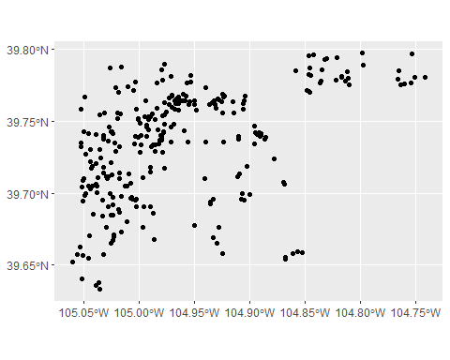

Input city boundaries
In this chunk, I took the Colorado geometry from the tigris package and then filtered the data to include only Denver. Looking back, I think I could have done this in one step by immediately filtering by the NAME column. Again, I checked in on the plot
#extract denver boundaries from tigris
places <- tigris::places(state = "CO",
cb = FALSE,
year = "2024")
denver_boundaries <- places %>%
filter(NAME == "Denver")
denver_boundaries %>%
ggplot() +
geom_sf()
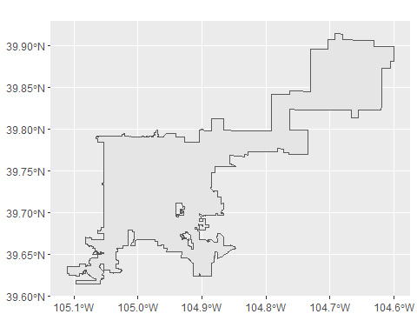

Align Geometries
In this chunk, I ensure that my geometries align before continuing to manipulate my dataset
ggplot() +
geom_sf(data = denver_boundaries) +
geom_sf(data = denver_homicides)
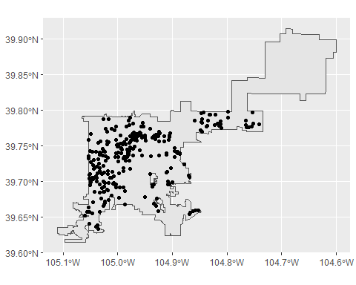

Factor Lump to Most Murdered Races
In this chunk, I convert the victim_race column to a factor to be used with the fct_lump function to highlight the races with the most murders. I then visualize the status of the plot
denver_victim_races <- denver_homicides %>%
mutate(victim_race = as.factor(victim_race)) %>%
mutate(victim_race = fct_lump(victim_race, n = 3))
ggplot() +
geom_sf(data = denver_boundaries) +
geom_sf(data = denver_victim_races, aes(color = victim_race))
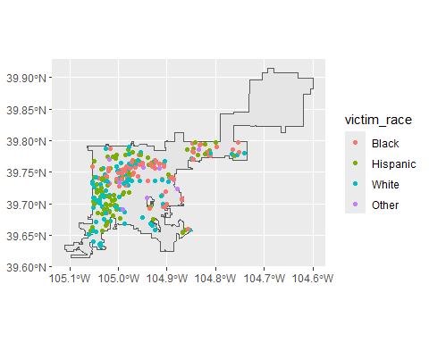

Unsolved cases
In this chunk, I create a new column to sort the cases by solved vs unsolved
#solved vs unsolved columns
case_status <- denver_victim_races %>%
mutate(solved = ifelse(disposition %in% c("Closed without arrest", "Closed by arrest"), "Solved", "Unsolved"))

Final Plot
This chunk generates the final plot with maps separated by solved and unsolved cases
ggplot() +
geom_sf(data = denver_boundaries) +
geom_sf(data = case_status, aes(color = victim_race), alpha = 0.5) +
facet_wrap("solved") +
theme_stata() +
labs(
title = "Denver Homicides by Race",
color = "Victim Race"
)
