- Database sync

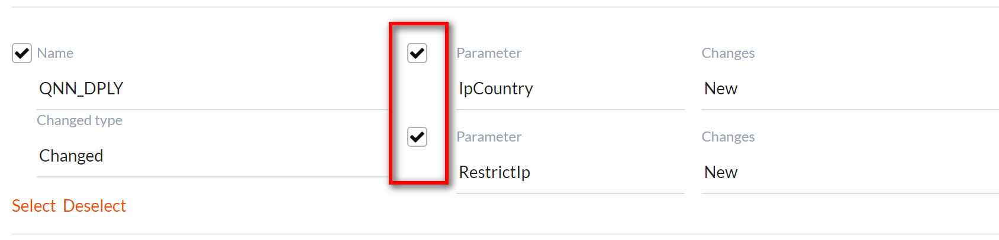
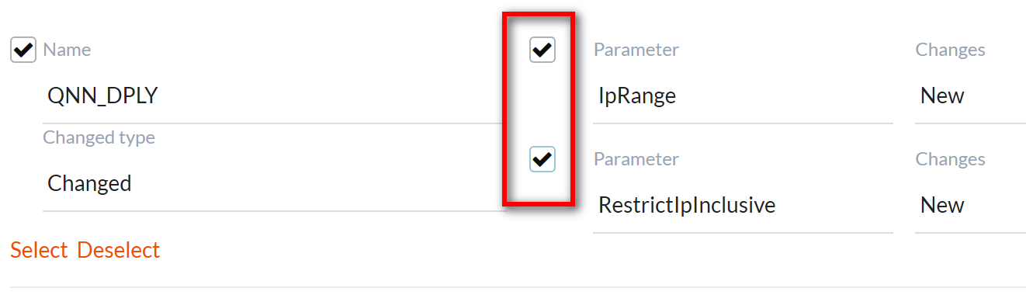
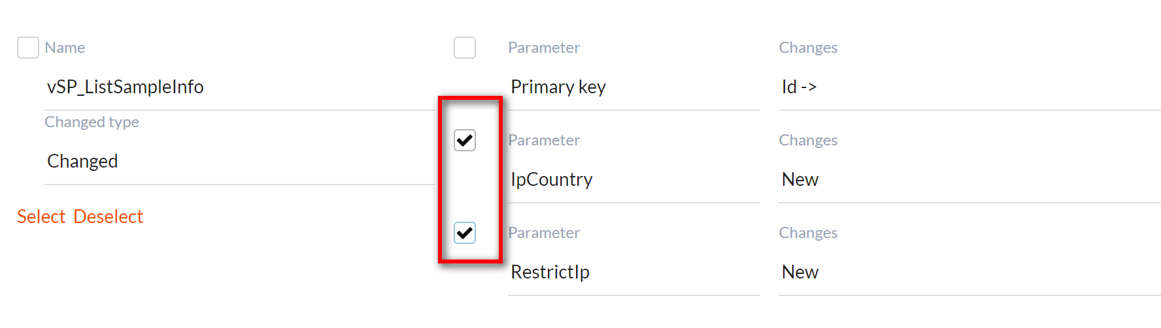

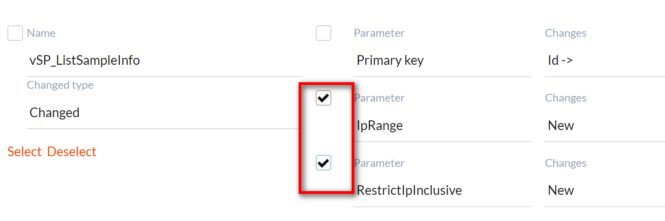

- Edit Qnn_Dply form to add (for your info only. It has been done when execute the sql file)
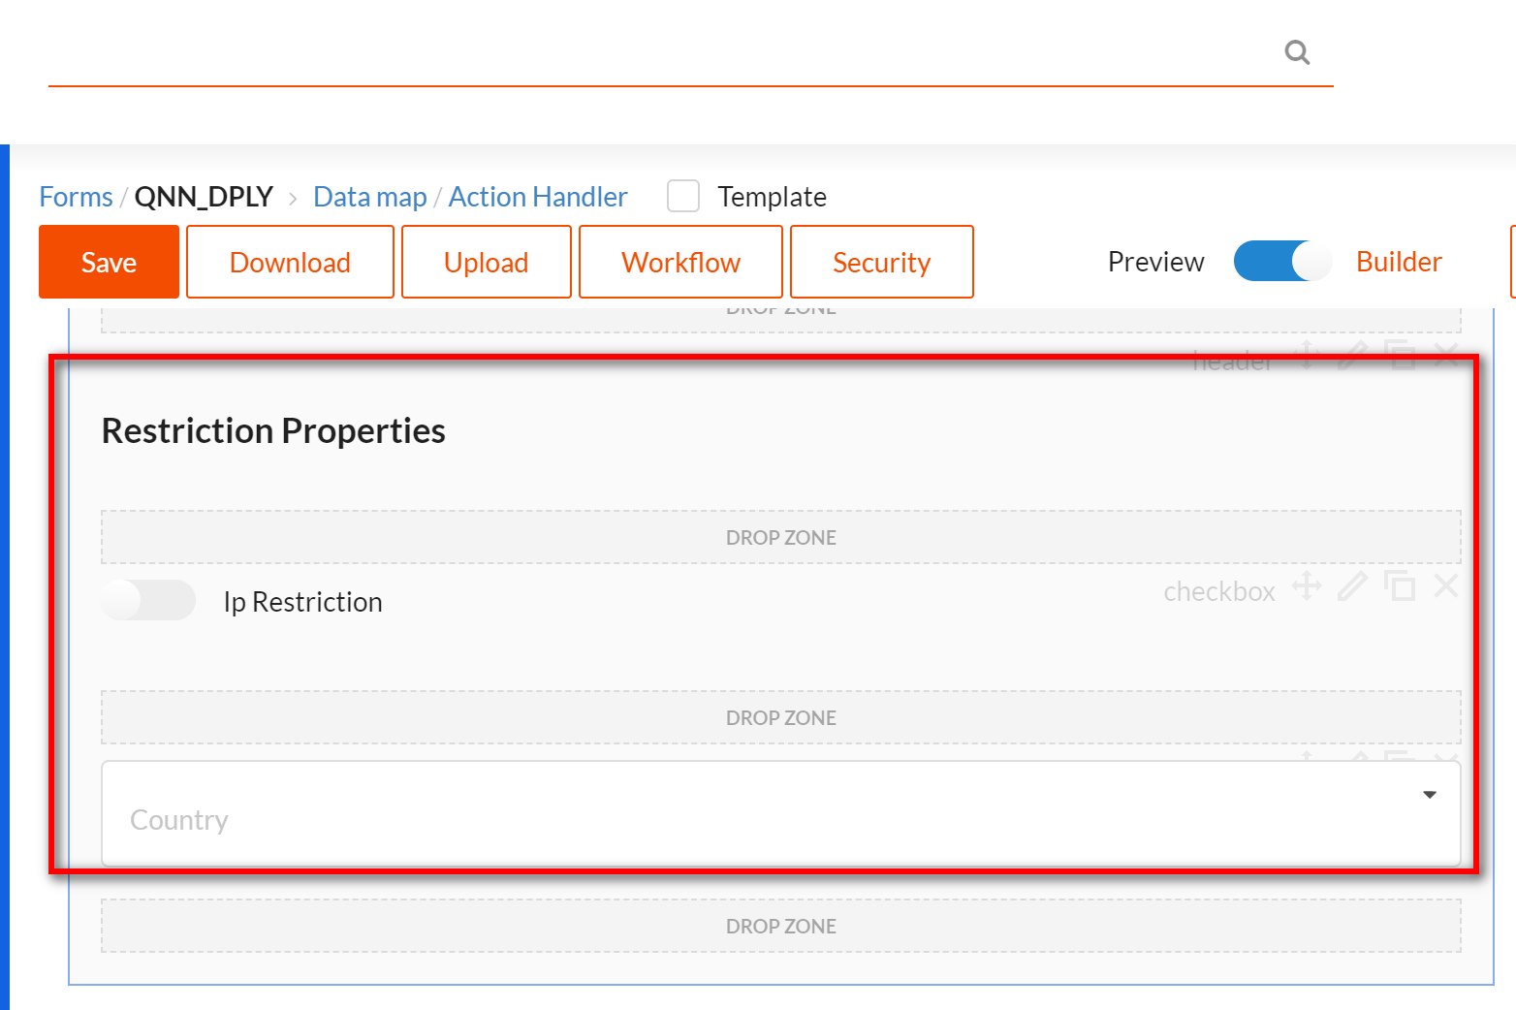

- Mapping Data Model for QNN_DPLY form
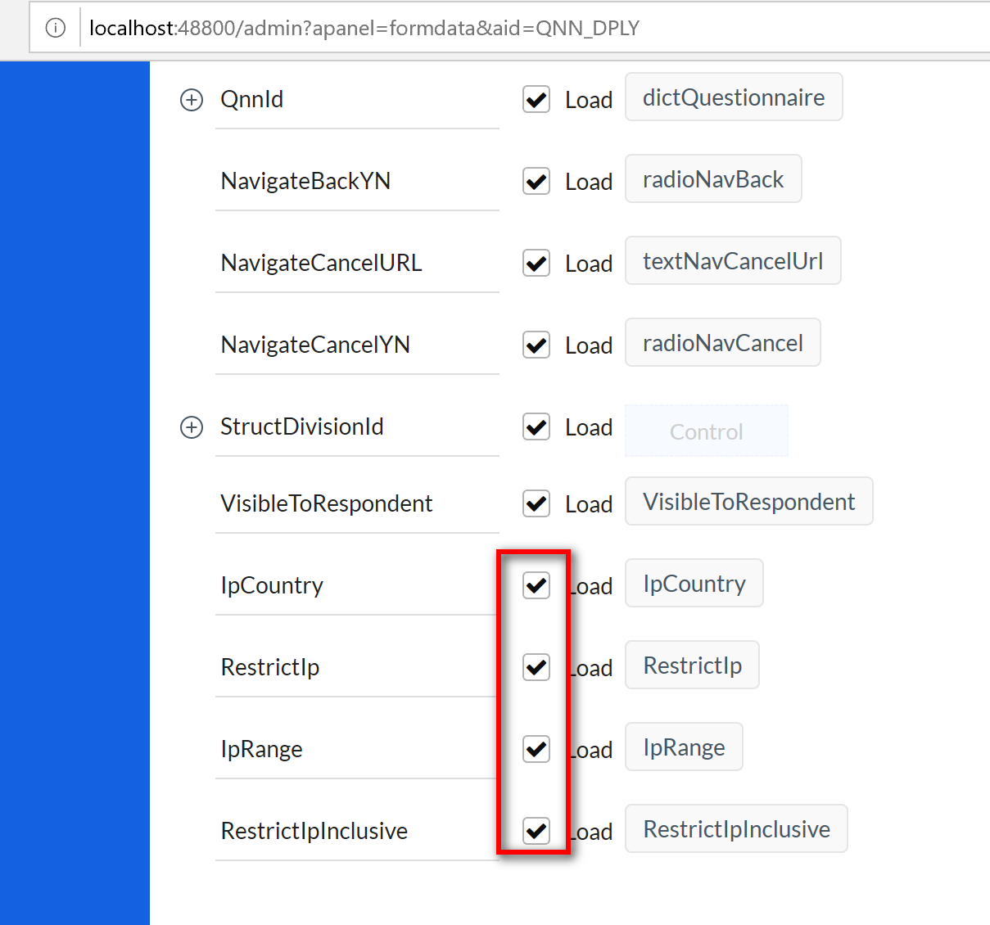

- Mapping Data Model for respdashboard form, untick IpCountry, RestrictIp, IpRange and RestrictIpInclusive for both grid and gridview collections and save the mapping.
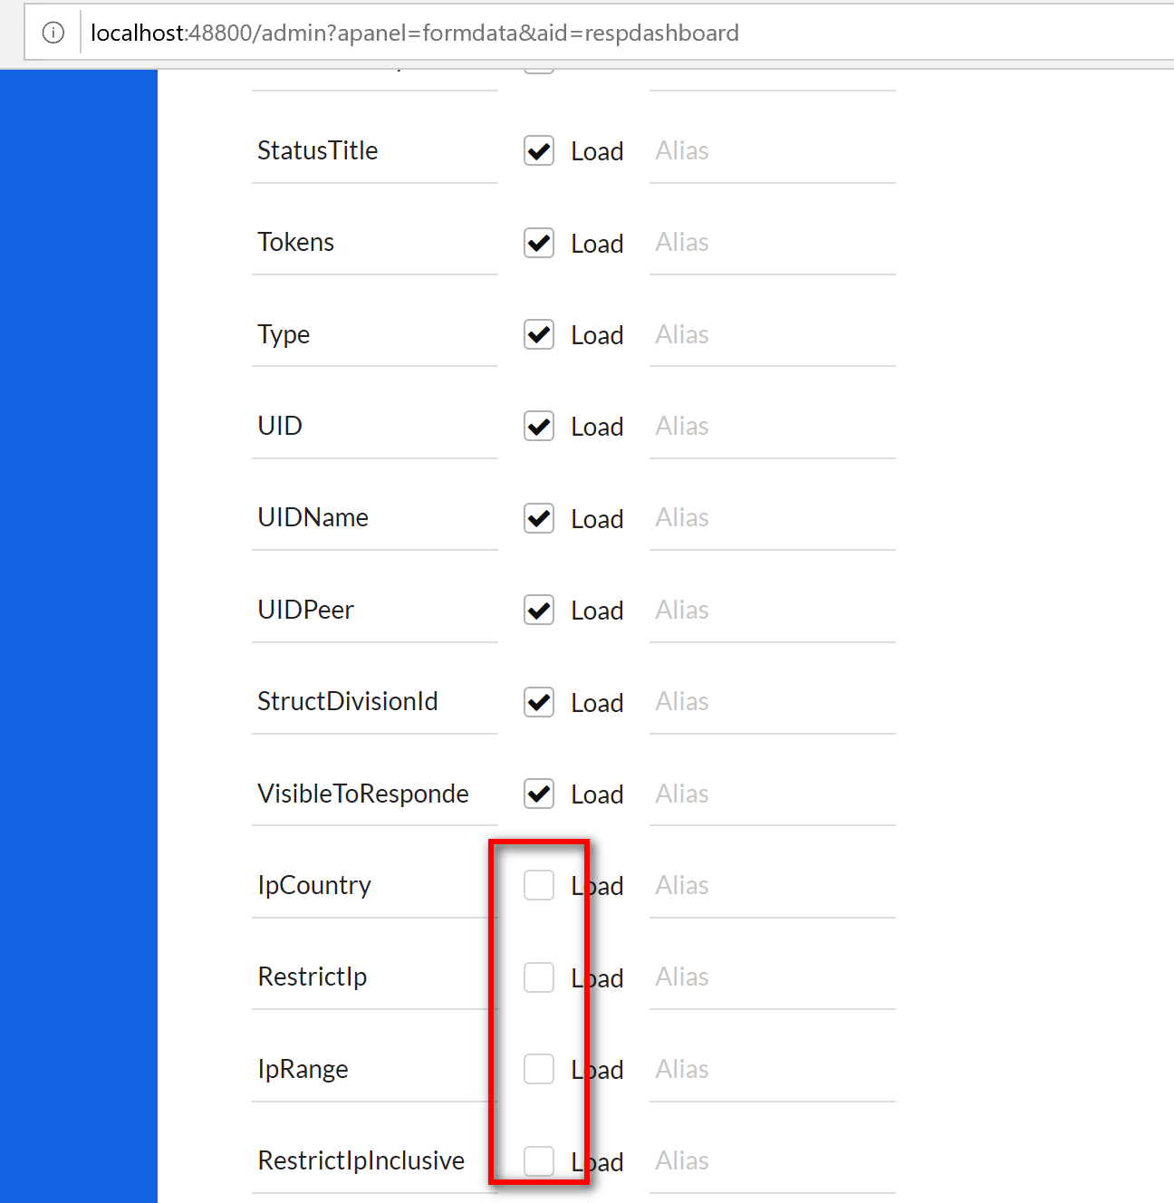

- Tick IpCountry, RestrictIp, IpRange and RestrictIpInclusive for both grid and gridview collections and save the mapping. These two steps are for remapping purpose, to update/sync the attribute ids

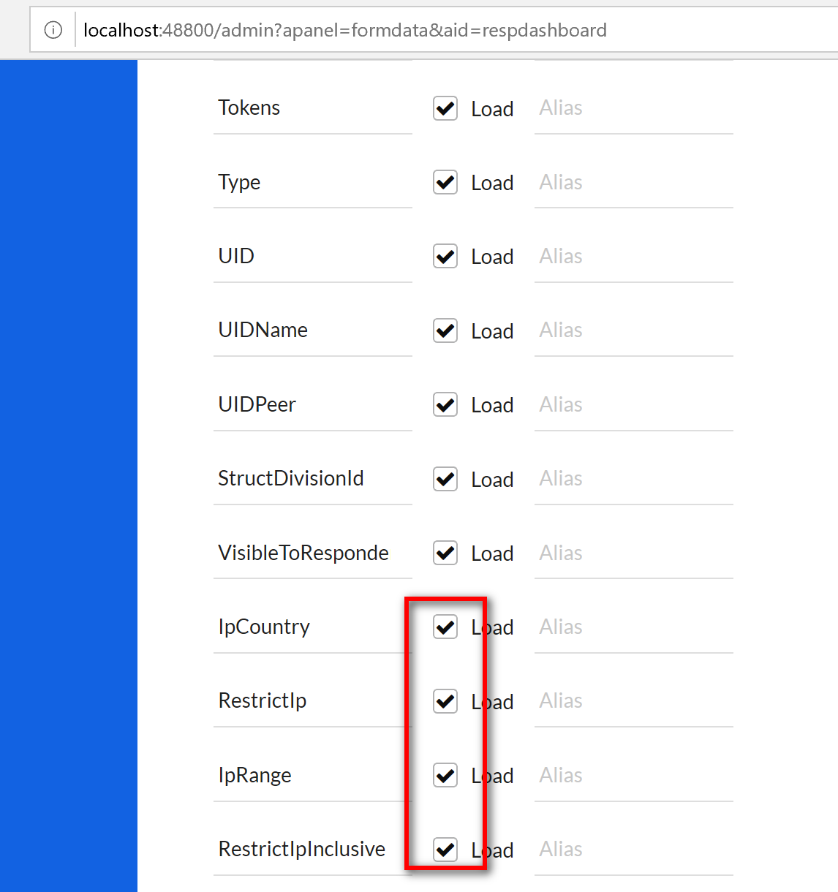

- Reset app cache

