**ALM**   
  
**What is ALM?**

ALM (Application LifeCycle Management) is a test management tool and now is developed by HP. ALM supports various stages of system development lifecycle(project planning, testing, requirements gathering), allows integration with HP UFT and helps in development, maintaining and tracking of project.

**ALM Arhitecture**

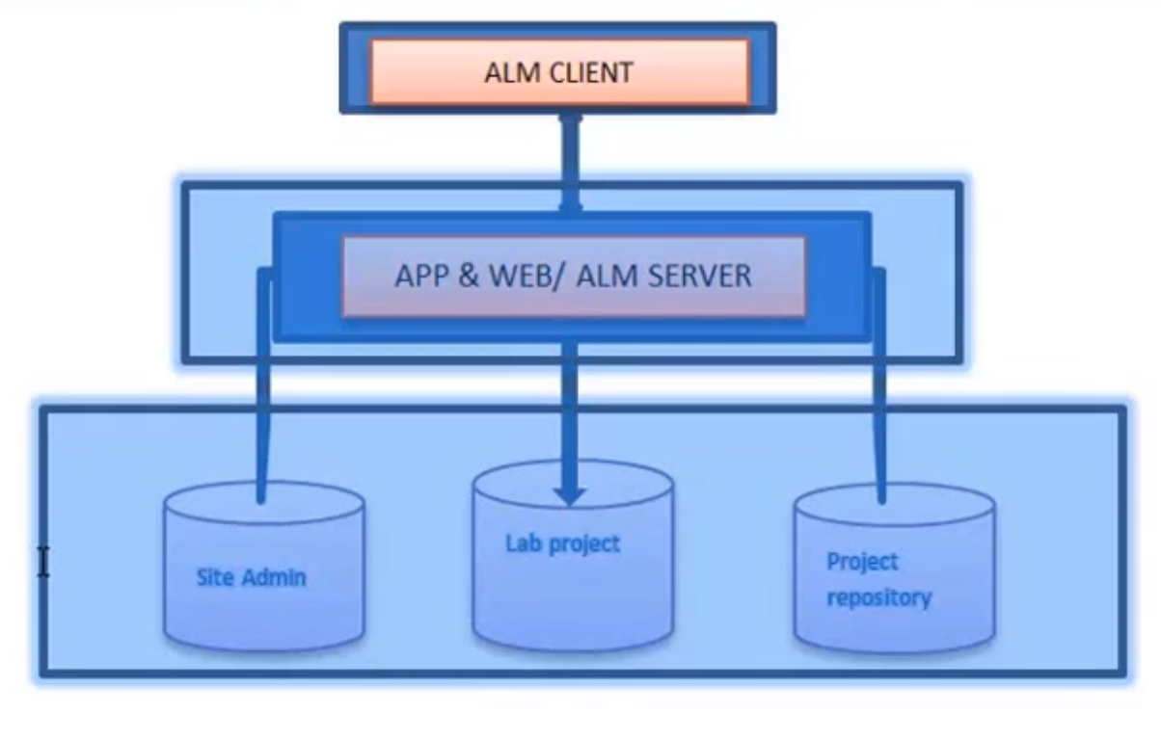ALM has 2 components:

1. **ALM Client**
2. **ALM Server / Application server** is split in three different databases:  
    - **Site Admin** stores information related to domains, users.  
    - **Lab project** stores lab information related to functional and Performance Testing on remote hosts.

- **Project repository** stores project information. A project has its own database and it is created on the same database server as the Site Admin.

**Installing ALM**

Create an account on <https://software.microfocus.com/signup>

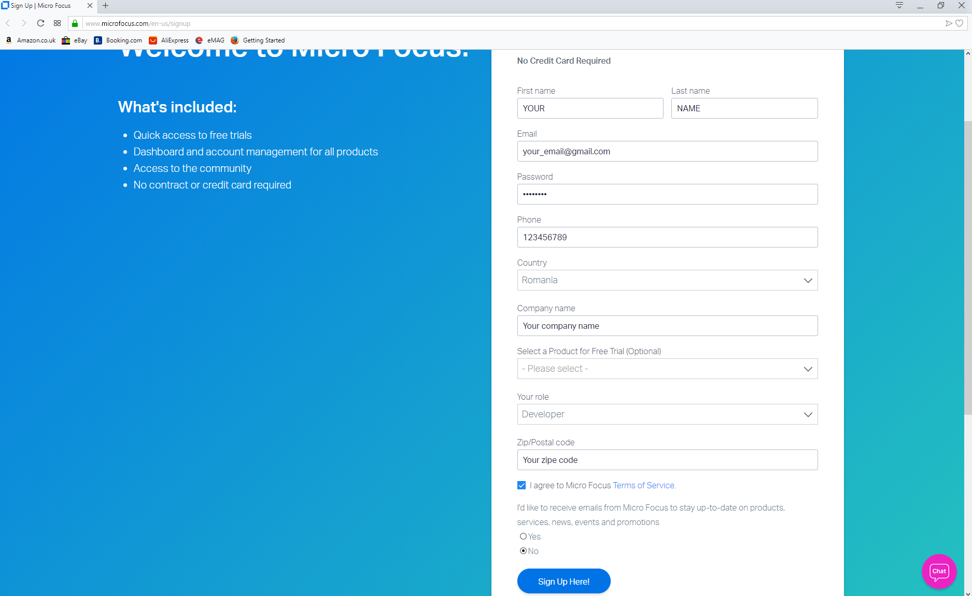

Check your inbox and confirm your email address.

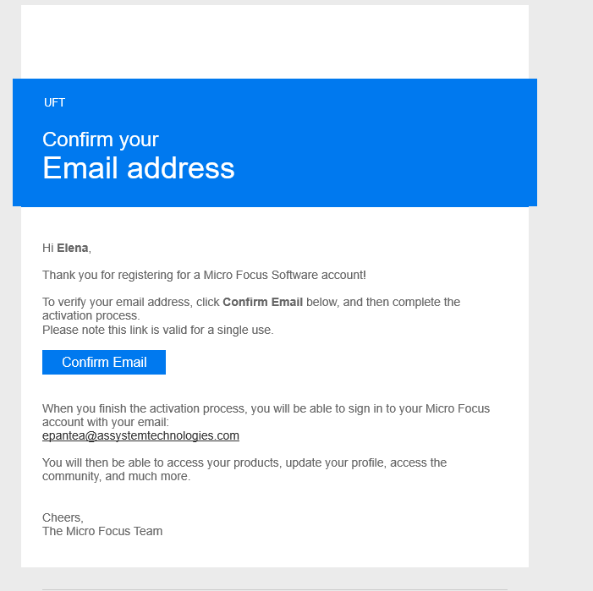

Click Continue



Enter your password and click “Sign in”  
  
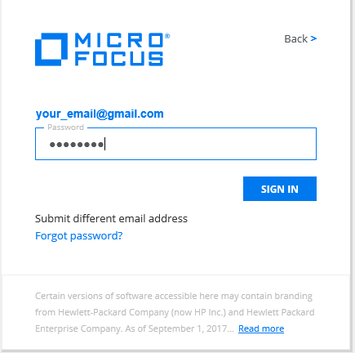

There are two ways to access ALM:

1. **Cloud ALM** (without installation) - Don’t need an installation and ALM Admin can’t be accessed.

**ALM Client Launcher(Supports only Internet Explorer Browser)**

ALM Client Launcher is a lightweight, portable, and flexible tool that enables you to run an ALM client on any Windows machine without the need of downloading it from an ALM server and without Windows administrator permissions.

As an administrator you can package and store the ALM client on USB devices, local or remote storage, shared folders, etc.

**Step 1**: create an account

Link:  <https://software.microfocus.com/en-us/signup>

**Step 2**: login to account

**Step 3**: open new browser tab  
**Step 4**: open <https://www.microfocus.com/en-us/products/application-lifecycle-management/free-trial>

The user will receive an email when ALM is ready to use.

In your account you will click on **‘LAUNCH’** option.

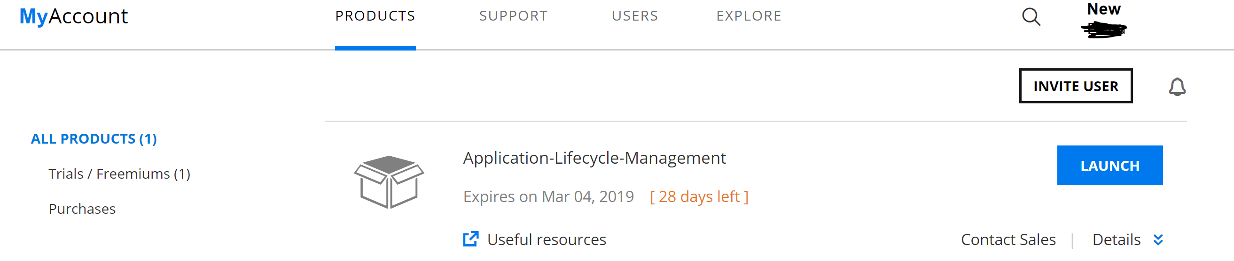

Click **Yes** on **Security Warning** pop-ups.

Select **ALM Desktop Client**

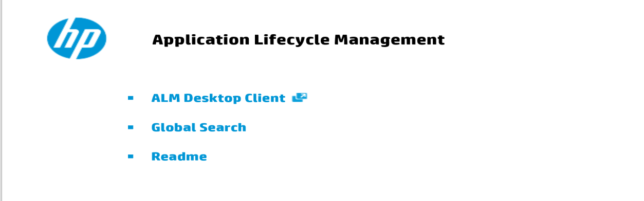

Select **Connect to project**

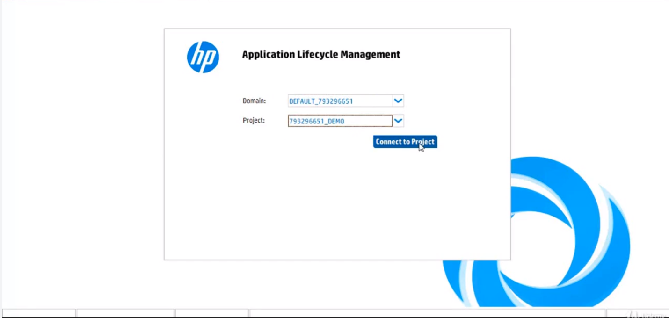

1. **Full installation** – Can access ALM Admin and ALM Client.

For full installation we need to install a Sql server and an ALM setup file.

**Integration of UFT(QTP) with ALM (Quality Center)**

ALM allows integration with other HP products such as HP UFT..

**Connectiong UFT and ALM**

In UFT is a tab ALM. Click on it and the select ALM Connection. When ALM Connection dialog opens ALM server url, the UserName and the Password and click ‘Connect’. If the authentication is OK, the ALM files will be downloaded if the connection between ALM and UFT is for the first time. Also in the ALM Connection dialog the user has to selet the domain, the project and click ‘Login’. If the status is ‘Connected’ and ‘Logged in’, click ‘Close’.

UFT scripts can be saved and executed in ALM. Also UFT scripts can be created from ALM.

**ALM Workflow**

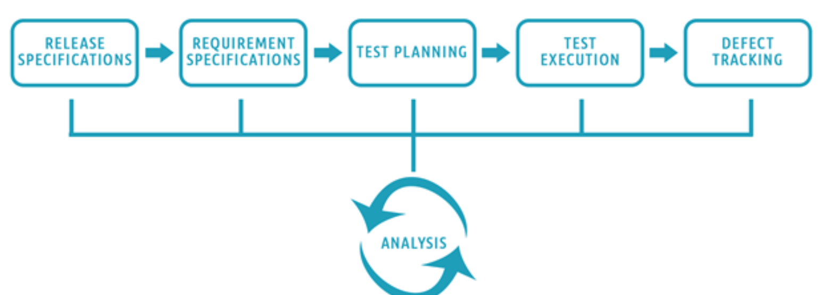

* For a given Release and Cycle, we draft the Requirements Specifications.
* Based on the requirements, Test plans and test cases are created.
* Next stage is executing the created tests plan
* Next stage in this test processes is tracking and fixing the defects detected in the execution stage
* During all stages, analysis is done, and reports and graphs are generated for test metric generation.

**Note:**

UFT standalone is not compatible with ALM Cloud(ALM Trial).