**Table 1**: The 20 wetlands included in the study and their respective area, perimeter, and the number of minnow traps deployed per wetland. Area and perimeter values were taken from GIS layer data.

|  |  |  |  |  |
| --- | --- | --- | --- | --- |
| **Wetland** | **Wetland ID** | **Area(ha)** | **Perimeter(m)** | **Trap Totals** |
| **Sampling group A** |  |  |  | **90** |
| Bay12 | 7 | 0.91 | 533.123 | 10 |
| Dry Bay | 20 | 7.27 | 1038.471 | 30 |
| Ellenton Bay | 12 | 12.14 | 1117.283 | 30 |
| Ginger’s Bay | 9 | 1.99 | 316.412 | 10 |
| Squirrel Bay | 14 | 1.33 | 372.635 | 10 |
| **Sampling group B** |  |  |  | **80** |
| Bay128 | 2 | 1.91 | 347.799 | 10 |
| Castor Bay | 18 | 5.1 | 1043.131 | 20 |
| Flamingo Bay | 19 | 11.15 | 1290.885 | 30 |
| Linda’s Pond | 5 | 0.9 | 254.865 | 10 |
| Rainbow Bay | 4 | 1.21 | 315.424 | 10 |
| **Sampling group C** |  |  |  | **90** |
| Bay 92 | 3 | 5.54 | 748.733 | 20 |
| Bay 93 | 13 | 4.25 | 796.458 | 20 |
| Bay 100 | 16 | 6.26 | 916.859 | 20 |
| Bay 120 | 8 | 1.19 | 419.059 | 10 |
| Thunder Bay | 17 | 8.64 | 902.758 | 20 |
| **Sampling group D** |  |  |  | **90** |
| Bay 52 | 11 | 3.71 | 708.715 | 20 |
| Bay 5144 | 6 | 1.46 | 411.932 | 10 |
| Bay 5179 | 1 | 1.53 | 550.667 | 10 |
| Mona Bay | 10 | 11.65 | 1247.99 | 30 |
| Sarracenia Bay | 15 | 4.48 | 793.649 | 20 |

**Table 2.** List of the hyper parameters and values used in the overall RV prevalence BRT model.

|  |  |
| --- | --- |
| **RV Prevalence BRT Model Hyperparameters** | **Hyperparameter Values** |
| Tree complexity | 3 |
| Learning rate | 0.01 |
| Bag fraction | 0.7 |
| Total models | 1500 |

**Table 3**. Hyper parameters and values used in the focal species RV BRT Model.

|  |  |
| --- | --- |
| **RV focal species BRT model hyperparameters** | **Hyperparameter values** |
| Tree complexity | 3 |
| Learning rate | 0.003 |
| Bag fraction | 0.75 |
| Total models | 1700 |

**Table 4**. List of predicting variables applied to the RV prevalence BRT. Sample level indicates the resolution of the predictor. Percent missing data was calculated by the number of empty values for each observation.

|  |  |  |  |
| --- | --- | --- | --- |
| **Model Predictor** | **Description** | **Sample Level** | **%Missing** |
| RV.Status | Binary response | Individual | 0 |
| SQMean(viral load) | Numeric Response | Individual | 0 |
| Prevalence | Percent | Site | 0 |
| Vegetation | Vegetation descriptions | Site | 0 |
| SoilType | Dominant soil type for each wetland | Site | 0 |
| Stage | Developmental stage for the individual | Individual | 0 |
| AvgTemp | Mean daily ambient air temp | Daily Site | 18.7 |
| MinTemp | Minimum daily water temp | Daily Site | 18.7 |
| MaxTemp | Maximum daily water temp | Daily Site | 18.7 |
| MeanTemp | Mean daily water temp | Daily Site | 18.7 |
| DryingScore | Overall percent of 0’s and 1’s | Site | 0 |
| CumRich | Cumulative species richness | Monthly Site | 0 |
| CanopyCover | Percent canopy cover | Site | 0 |
| Area | Wetland area | Site | 0 |
| Perimeter | Wetland perimeter | Site | 0 |
| H | Shannon's Diversity index | Monthly Site | 0 |
| S | Observed species richness | Monthly Site | 0 |
| J | Peilou's evenness | Monthly Site | 0 |
| SVL | Snout-Vent Length | Individual | 0 |
| WetAltID.1 | Wetland Dummy | Individual | 0 |
| WetAltID.2 | Wetland Dummy | Individual | 0 |
| WetAltID.3 | Wetland Dummy | Individual | 0 |
| WetAltID.4 | Wetland Dummy | Individual | 0 |
| WetAltID.5 | Wetland Dummy | Individual | 0 |
| WetAltID.6 | Wetland Dummy | Individual | 0 |
| WetAltID.7 | Wetland Dummy | Individual | 0 |
| WetAltID.8 | Wetland Dummy | Individual | 0 |
| WetAltID.9 | Wetland Dummy | Individual | 0 |
| WetAltID.10 | Wetland Dummy | Individual | 0 |
| WetAltID.11 | Wetland Dummy | Individual | 0 |
| WetAltID.12 | Wetland Dummy | Individual | 0 |
| WetAltID.13 | Wetland Dummy | Individual | 0 |
| WetAltID.14 | Wetland Dummy | Individual | 0 |
| WetAltID.15 | Wetland Dummy | Individual | 0 |
| WetAltID.16 | Wetland Dummy | Individual | 0 |
| WetAltID.17 | Wetland Dummy | Individual | 0 |
| WetAltID.18 | Wetland Dummy | Individual | 0 |
| WetAltID.19 | Wetland Dummy | Individual | 0 |
| WetAltID.20 | Wetland Dummy | Individual | 0 |
| Month.Apr | Month Dummy | Individual | 0 |
| Month.Feb | Month Dummy | Individual | 0 |
| Month.Jul | Month Dummy | Individual | 0 |
| Month.Jun | Month Dummy | Individual | 0 |
| Month.Mar | Month Dummy | Individual | 0 |
| Month.May | Month Dummy | Individual | 0 |
| Species.4 | Species Dummy | Individual | 0 |
| Species.9 | Species Dummy | Individual | 0 |
| Species.20 | Species Dummy | Individual | 0 |
| Species.21 | Species Dummy | Individual | 0 |
| Species.24 | Species Dummy | Individual | 0 |
| Species.26 | Species Dummy | Individual | 0 |
| Species.27 | Species Dummy | Individual | 0 |
| Species.28 | Species Dummy | Individual | 0 |
| Species.29 | Species Dummy | Individual | 0 |
| Species.31 | Species Dummy | Individual | 0 |
| Species.32 | Species Dummy | Individual | 0 |
| Species.34 | Species Dummy | Individual | 0 |
| Species.35 | Species Dummy | Individual | 0 |
| Species.38 | Species Dummy | Individual | 0 |
| Species.39 | Species Dummy | Individual | 0 |
| Species.41 | Species Dummy | Individual | 0 |
| Species.42 | Species Dummy | Individual | 0 |
| PA2 | Presence/Absence of species 2 | Individual | 0 |
| PA3 | Presence/Absence of species 3 | Individual | 0 |
| PA4 | Presence/Absence of species 4 | Individual | 0 |
| PA5 | Presence/Absence of species 5 | Individual | 0 |
| PA6 | Presence/Absence of species 6 | Individual | 0 |
| PA8 | Presence/Absence of species 8 | Individual | 0 |
| PA9 | Presence/Absence of species 9 | Individual | 0 |
| PA20 | Presence/Absence of species 20 | Individual | 0 |
| PA21 | Presence/Absence of species 21 | Individual | 0 |
| PA24 | Presence/Absence of species 24 | Individual | 0 |
| PA26 | Presence/Absence of species 26 | Individual | 0 |
| PA27 | Presence/Absence of species 27 | Individual | 0 |
| PA28 | Presence/Absence of species 28 | Individual | 0 |
| PA29 | Presence/Absence of species 29 | Individual | 0 |
| PA31 | Presence/Absence of species 31 | Individual | 0 |
| PA34 | Presence/Absence of species 34 | Individual | 0 |
| PA35 | Presence/Absence of species 35 | Individual | 0 |
| PA38 | Presence/Absence of species 38 | Individual | 0 |
| PA39 | Presence/Absence of species 39 | Individual | 0 |
| PA41 | Presence/Absence of species 41 | Individual | 0 |
| PA42 | Presence/Absence of species 42 | Individual | 0 |
| AB2 | Absolute abundance of species 2 | Monthly Site | 0 |
| AB3 | Absolute abundance of species 3 | Monthly Site | 0 |
| AB4 | Absolute abundance of species 4 | Monthly Site | 0 |
| AB5 | Absolute abundance of species 5 | Monthly Site | 0 |
| AB6 | Absolute abundance of species 6 | Monthly Site | 0 |
| AB8 | Absolute abundance of species 8 | Monthly Site | 0 |
| AB9 | Absolute abundance of species 9 | Monthly Site | 0 |
| AB20 | Absolute abundance of species 20 | Monthly Site | 0 |
| AB21 | Absolute abundance of species 21 | Monthly Site | 0 |
| AB24 | Absolute abundance of species 24 | Monthly Site | 0 |
| AB26 | Absolute abundance of species 26 | Monthly Site | 0 |
| AB27 | Absolute abundance of species 27 | Monthly Site | 0 |
| AB28 | Absolute abundance of species 28 | Monthly Site | 0 |
| AB29 | Absolute abundance of species 29 | Monthly Site | 0 |
| AB31 | Absolute abundance of species 31 | Monthly Site | 0 |
| AB34 | Absolute abundance of species 34 | Monthly Site | 0 |
| AB35 | Absolute abundance of species 35 | Monthly Site | 0 |
| AB38 | Absolute abundance of species 38 | Monthly Site | 0 |
| AB39 | Absolute abundance of species 39 | Monthly Site | 0 |
| AB41 | Absolute abundance of species 41 | Monthly Site | 0 |
| AB42 | Absolute abundance of species 42 | Monthly Site | 0 |
| RA2 | Relative abundance of species 2 | Monthly Site | 0 |
| RA3 | Relative abundance of species 3 | Monthly Site | 0 |
| RA4 | Relative abundance of species 4 | Monthly Site | 0 |
| RA5 | Relative abundance of species 5 | Monthly Site | 0 |
| RA6 | Relative abundance of species 6 | Monthly Site | 0 |
| RA8 | Relative abundance of species 8 | Monthly Site | 0 |
| RA9 | Relative abundance of species 9 | Monthly Site | 0 |
| RA20 | Relative abundance of species 20 | Monthly Site | 0 |
| RA21 | Relative abundance of species 21 | Monthly Site | 0 |
| RA24 | Relative abundance of species 24 | Monthly Site | 0 |
| RA26 | Relative abundance of species 26 | Monthly Site | 0 |
| RA27 | Relative abundance of species 27 | Monthly Site | 0 |
| RA28 | Relative abundance of species 28 | Monthly Site | 0 |
| RA29 | Relative abundance of species 29 | Monthly Site | 0 |
| RA31 | Relative abundance of species 31 | Monthly Site | 0 |
| RA34 | Relative abundance of species 34 | Monthly Site | 0 |
| RA35 | Relative abundance of species 35 | Monthly Site | 0 |
| RA38 | Relative abundance of species 38 | Monthly Site | 0 |
| RA39 | Relative abundance of species 39 | Monthly Site | 0 |
| RA41 | Relative abundance of species 41 | Monthly Site | 0 |
| RA42 | Relative abundance of species 42 | Monthly Site | 0 |

**Table 5.** List of predicting variables applied to the focal species (*Lithobates sphenocaphalus*) RV prevalence BRT. Sample Level indicates the resolution of the predictor. Percent missing data was calculated by the number of empty values for each observation.

|  |  |  |  |
| --- | --- | --- | --- |
| **Model Predictor** | **Description** | **Sample Level** | **%Missing** |
| RV.Status | Binary response | Individual | 0 |
| Prevalence | Percent | Site | 0 |
| Vegetation | Vegetation descriptions | Site | 0 |
| SoilType | Dominant soil type for each wetland | Site | 0 |
| Stage | Developmental stage for the individual | Individual | 0 |
| AvgTemp | Mean daily ambient air temp | Daily Site | 18.7 |
| MinTemp | Minimum daily water temp | Daily Site | 18.7 |
| MaxTemp | Maximum daily water temp | Daily Site | 18.7 |
| MeanTemp | Mean daily water temp | Daily Site | 18.7 |
| DryingScore | Overall percent of 0’s and 1’s | Site | 0 |
| CumRich | Cumulative species richness | Monthly Site | 0 |
| CanopyCover | Percent canopy cover | Site | 0 |
| Area | Wetland area | Site | 0 |
| Perimeter | Wetland perimeter | Site | 0 |
| H | Shannon's Diversity index | Monthly Site | 0 |
| S | Observed species richness | Monthly Site | 0 |
| J | Peilou's evenness | Monthly Site | 0 |
| SVL | Snout-Vent Length | Individual | 0 |
| WetAltID.1 | Wetland Dummy | Individual | 0 |
| WetAltID.2 | Wetland Dummy | Individual | 0 |
| WetAltID.3 | Wetland Dummy | Individual | 0 |
| WetAltID.4 | Wetland Dummy | Individual | 0 |
| WetAltID.5 | Wetland Dummy | Individual | 0 |
| WetAltID.6 | Wetland Dummy | Individual | 0 |
| WetAltID.7 | Wetland Dummy | Individual | 0 |
| WetAltID.8 | Wetland Dummy | Individual | 0 |
| WetAltID.9 | Wetland Dummy | Individual | 0 |
| WetAltID.10 | Wetland Dummy | Individual | 0 |
| WetAltID.11 | Wetland Dummy | Individual | 0 |
| WetAltID.12 | Wetland Dummy | Individual | 0 |
| WetAltID.13 | Wetland Dummy | Individual | 0 |
| WetAltID.14 | Wetland Dummy | Individual | 0 |
| WetAltID.15 | Wetland Dummy | Individual | 0 |
| WetAltID.16 | Wetland Dummy | Individual | 0 |
| WetAltID.17 | Wetland Dummy | Individual | 0 |
| WetAltID.18 | Wetland Dummy | Individual | 0 |
| WetAltID.19 | Wetland Dummy | Individual | 0 |
| WetAltID.20 | Wetland Dummy | Individual | 0 |
| Month.Apr | Month Dummy | Individual | 0 |
| Month.Feb | Month Dummy | Individual | 0 |
| Month.Jul | Month Dummy | Individual | 0 |
| Month.Jun | Month Dummy | Individual | 0 |
| Month.Mar | Month Dummy | Individual | 0 |
| Month.May | Month Dummy | Individual | 0 |
| PA2 | Presence/Absence of species 2 | Individual | 0 |
| PA3 | Presence/Absence of species 3 | Individual | 0 |
| PA4 | Presence/Absence of species 4 | Individual | 0 |
| PA5 | Presence/Absence of species 5 | Individual | 0 |
| PA6 | Presence/Absence of species 6 | Individual | 0 |
| PA8 | Presence/Absence of species 8 | Individual | 0 |
| PA9 | Presence/Absence of species 9 | Individual | 0 |
| PA20 | Presence/Absence of species 20 | Individual | 0 |
| PA21 | Presence/Absence of species 21 | Individual | 0 |
| PA24 | Presence/Absence of species 24 | Individual | 0 |
| PA26 | Presence/Absence of species 26 | Individual | 0 |
| PA27 | Presence/Absence of species 27 | Individual | 0 |
| PA28 | Presence/Absence of species 28 | Individual | 0 |
| PA29 | Presence/Absence of species 29 | Individual | 0 |
| PA31 | Presence/Absence of species 31 | Individual | 0 |
| PA34 | Presence/Absence of species 34 | Individual | 0 |
| PA35 | Presence/Absence of species 35 | Individual | 0 |
| PA38 | Presence/Absence of species 38 | Individual | 0 |
| PA39 | Presence/Absence of species 39 | Individual | 0 |
| PA41 | Presence/Absence of species 41 | Individual | 0 |
| PA42 | Presence/Absence of species 42 | Individual | 0 |
| AB2 | Absolute abundance of species 2 | Monthly Site | 0 |
| AB3 | Absolute abundance of species 3 | Monthly Site | 0 |
| AB4 | Absolute abundance of species 4 | Monthly Site | 0 |
| AB5 | Absolute abundance of species 5 | Monthly Site | 0 |
| AB6 | Absolute abundance of species 6 | Monthly Site | 0 |
| AB8 | Absolute abundance of species 8 | Monthly Site | 0 |
| AB9 | Absolute abundance of species 9 | Monthly Site | 0 |
| AB20 | Absolute abundance of species 20 | Monthly Site | 0 |
| AB21 | Absolute abundance of species 21 | Monthly Site | 0 |
| AB24 | Absolute abundance of species 24 | Monthly Site | 0 |
| AB26 | Absolute abundance of species 26 | Monthly Site | 0 |
| AB27 | Absolute abundance of species 27 | Monthly Site | 0 |
| AB28 | Absolute abundance of species 28 | Monthly Site | 0 |
| AB29 | Absolute abundance of species 29 | Monthly Site | 0 |
| AB31 | Absolute abundance of species 31 | Monthly Site | 0 |
| AB34 | Absolute abundance of species 34 | Monthly Site | 0 |
| AB35 | Absolute abundance of species 35 | Monthly Site | 0 |
| AB38 | Absolute abundance of species 38 | Monthly Site | 0 |
| AB39 | Absolute abundance of species 39 | Monthly Site | 0 |
| AB41 | Absolute abundance of species 41 | Monthly Site | 0 |
| AB42 | Absolute abundance of species 42 | Monthly Site | 0 |
| RA2 | Relative abundance of species 2 | Monthly Site | 0 |
| RA3 | Relative abundance of species 3 | Monthly Site | 0 |
| RA4 | Relative abundance of species 4 | Monthly Site | 0 |
| RA5 | Relative abundance of species 5 | Monthly Site | 0 |
| RA6 | Relative abundance of species 6 | Monthly Site | 0 |
| RA8 | Relative abundance of species 8 | Monthly Site | 0 |
| RA9 | Relative abundance of species 9 | Monthly Site | 0 |
| RA20 | Relative abundance of species 20 | Monthly Site | 0 |
| RA21 | Relative abundance of species 21 | Monthly Site | 0 |
| RA24 | Relative abundance of species 24 | Monthly Site | 0 |
| RA26 | Relative abundance of species 26 | Monthly Site | 0 |
| RA27 | Relative abundance of species 27 | Monthly Site | 0 |
| RA28 | Relative abundance of species 28 | Monthly Site | 0 |
| RA29 | Relative abundance of species 29 | Monthly Site | 0 |
| RA31 | Relative abundance of species 31 | Monthly Site | 0 |
| RA34 | Relative abundance of species 34 | Monthly Site | 0 |
| RA35 | Relative abundance of species 35 | Monthly Site | 0 |
| RA38 | Relative abundance of species 38 | Monthly Site | 0 |
| RA39 | Relative abundance of species 39 | Monthly Site | 0 |
| RA41 | Relative abundance of species 41 | Monthly Site | 0 |
| RA42 | Relative abundance of species 42 | Monthly Site | 0 |

**Table 6**: The ephemeral wetland species included in the disease analysis and their respective species code designations.

|  |  |
| --- | --- |
| **Species** | **Species Code** |
| **Bufonidae** |  |
| *Anaxyrus terrestris* | 21 |
| **Hylidae** |  |
| *Acris gryllus* | 24 |
| *Hyla avivoca* | 32 |
| *H. chrysoscelis* | 31 |
| *H. cinerea* | 27 |
| *H. femoralis* | 29 |
| *H. gratiosa* | 28 |
| *Pseudacris crucifer* | 26 |
| *P. nigrita* | 34 |
| *P. ornata* | 35 |
| **Microhylidae** |  |
| *Gastrophryne carolinensis* | 38 |
| **Ranidae** |  |
| *Lithobates catesbeianus* | 39 |
| *L. clamitans* | 41 |
| *L. sphenocephalus* | 42 |
| **Salimandridae** |  |
| *Notophthalmus viridescens* | 9 |
| **Scaphiopodidae** |  |
| *Scaphiopus holbrookii* | 20 |
| **Sirenidae** |  |
| *Siren intermedia* | 4 |

**Table 7**. Summary of samples included in the analyses with the number of each species analyzed (N), the number that tested positive for ranavirus (NRV), and the lower and upper Clopper-Pearson binomial confidence limits for percent prevalence presented (CI%).

|  |  |  |  |  |  |
| --- | --- | --- | --- | --- | --- |
| **Species** | **N** | **NRV** | **Prevalence (%)** | **CI%** | **Mean**  **Viral Load** |
| **Bufonidae** | **154** | **48** | **31** | **24.0-39.1** | **44407.30** |
| *Anaxyrus terrestris* | 116 | 40 | 35 | 25.9-43.9 | 44407.30 |
| **Hylidae** | **744** | **151** | **20** | **17.5-23.4** | **59,434.43** |
| *Acris gryllus* | 69 | 0 | 0 | 0-5.2 | 0 |
| *Hyla avivoca* | 1 | 1 | 100 | 2.5-100 | 51,7872.69 |
| *H. chrysoscelis* | 3 | 0 | 0 | 0-70.6 | 0 |
| *H. cinerea* | 3 | 0 | 0 | 0-70.8 | 0 |
| *H. femoralis* | 15 | 0 | 0 | 0-21.8 | 0 |
| *H. gratiosa* | 104 | 12 | 12 | 6.1-19.3 | 8.05 |
| *Pseudacris crucifer* | 328 | 79 | 24 | 19.6-29.1 | 16,982.34 |
| *P. nigrita* | 166 | 53 | 32 | 24.9-39.6 | 26.22 |
| *P. ornata* | 124 | 6 | 5 | 1.8-10.2 | 23.53 |
| **Microhylidae** | **14** | **2** | **14** | **1.8-42.8** | **27.25** |
| *Gastrophryne carolinensis* | 14 | 2 | 14 | 1.8-42.8 | 27.25 |
| **Ranidae** | **1075** | **133** | **12** | **10.5-14.5** | **40,095,937.91** |
| *Lithobates catesbeianus* | 25 | 0 | 0 | 0-13.7 | 0 |
| *L. clamitans* | 65 | 6 | 9 | 3.5-19.0 | 20.25 |
| *L. sphenocephalus* | 985 | 127 | 13 | 10.9-15.1 | 120,287,793.5 |
| **Salimandridae** | **153** | **8** | **5** | **2.3-10.0** | 136.63 |
| *Notophthalmus viridescens* | 153 | 8 | 5 | 2.3-10.0 | 136.63 |
| **Scaphiopodidae** | **69** | **0** | **0** | **0-5.2** | **3.5** |
| *Scaphiopus holbrookii* | 38 | 8 | 21 | 9.6-37.3 | 3.5 |
| **Sirenidae***/Siren intermedia* | **1** | **0** | **0** | **0-97.5** | **0** |
| **Grand Total** | **2210** | **342** | **15.5** | **14.0-17.1** | **--------------** |

**Table 8.** Summary of samples included in the analyses with the number of samples analyzed from each wetland (N), the number that tested positive for ranavirus (NRV), and the lower and upper Clopper-Pearson binomial confidence limits for percent prevalence presented (CI).

|  |  |  |  |  |  |
| --- | --- | --- | --- | --- | --- |
| **Wetland** | **N** | **NRV** | **Prevalence (%)** | **CI (%)** | **Mean**  **Viral Load** |
| **Sampling group A** | **411** | **28** | **7** | **0.05-0.10** | **14.22** |
| Bay12 | 107 | 3 | 3 | 0.6-8.0 | 48.09 |
| Dry Bay | 42 | 2 | 5 | 0.6-16.2 | 37.93 |
| Ellenton Bay | 159 | 21 | 13 | 8.4-19.5 | 4.923 |
| Ginger’s Bay | 19 | 1 | 5 | 0.1-26.0 | 23.96 |
| Squirrel Bay | 84 | 1 | 1 | 0-6.5 | 13.43 |
| **Sampling group B** | **282** | **28** | **10** | **0.07-0.14** | **807,295.40** |
| Bay128 | 77 | 16 | 21 | 12.4-31.5 | 1279639.97 |
| Castor Bay | 93 | 3 | 3 | 0.7-9.1 | 54.67 |
| Flamingo Bay | 76 | 8 | 11 | 4.7-19.7 | 95.82 |
| Linda’s Pond | 24 | 1 | 4 | 0-21.1 | 14.07 |
| Rainbow Bay | 12 | 0 | 0 | 0-26.4 | 0 |
| **Sampling group C** | **637** | **214** | **34** | **0.30-0.37** | **85787.41** |
| Bay 92 | 46 | 35 | 76 | 61.2-87.4 | 51.78 |
| Bay 93 | 64 | 17 | 27 | 16.3-39.1 | 4.17 |
| Bay 100 | 80 | 19 | 24 | 14.0-17.1 | 4.37 |
| Bay 120 | 208 | 51 | 25 | 19.0-30.9 | 55.25 |
| Thunder Bay | 239 | 92 | 39 | 32.3-45.0 | 86,805.65 |
| **Sampling group D** | **880** | **72** | **8** | **0.06-0.10** | **15.53** |
| Bay 52 | 208 | 14 | 7 | 3.7-11.0 | 6.44 |
| Bay 5144 | 107 | 16 | 15 | 8.8-23.1 | 15.58 |
| Bay 5179 | 176 | 35 | 20 | 14.3-26.6 | 7.04 |
| Mona Bay | 224 | 6 | 3 | 0.9-5.7 | 4.19 |
| Sarracenia Bay | 165 | 1 | 0.6 | 0-3.3 | 1.60 |
| **Grand Total** | **2210** | **342** | **15.5** | **14.0-17.1** | **-----------** |

**Table 9.** Summary of samples included in the analyses with the number of samples analyzed each month (N), the number that tested positive for ranavirus (NRV), and the lower and upper Clopper-Pearson binomial confidence limits for percent prevalence presented (CI).

|  |  |  |  |  |  |
| --- | --- | --- | --- | --- | --- |
| **Month** | **N** | **NRV** | **Prevalence (%)** | **CI (%)** | **Mean**  **Viral Load** |
| February | 291 | 13 | 5 | 2.4-7.5 | 45.29 |
| March | 352 | 19 | 5 | 3.3-8.3 | 11.28 |
| April | 699 | 164 | 24 | 20.4-26.8 | 87,063.99 |
| May | 519 | 118 | 23 | 19.2-26.6 | 370,116.24 |
| June | 194 | 28 | 14 | 9.8-20.2 | 15.73 |
| July | 155 | 0 | 0 | 0-2.4 | 0 |
| **Grand Total** | **2210** | **342** | **15.5** | **14.0-17.1** | **-------------** |

**Table 10**. Summary of the predictive performance and model evaluation statistics of the RV prevalence BRT model (training data n= 1768). The model performance was evaluated using mean total deviance, mean residual deviance, cross validation deviance, training data correlation, cross validation correlation, area under the curve (AUC) for training data, and cross validation AUC. Parentheses contain the standard error of the mean.

|  |  |
| --- | --- |
| **Model Evaluation Statistics** | **Model Evaluation Values** |
| Number of infection positive | 281 |
| Number of infection negative | 1487 |
| Mean total deviance | 0.876 |
| Mean residual deviance | 0.486 |
| Estimated CV deviance | 0.576 ± 0.019 |
| Training data correlation | 0.68 |
| CV correlation | 0.596 ± 0.022 |
| Training AUC score | 0.927 |
| CV AUC score | 0.877 ± 0.01 |
| Predictive deviance | 0.531 |

**Table 11**. Summary of the predictive performance and model evaluation statistics of the RV prevalence BRT model test data (test data n=442). The testing data for this model were withheld during the model run.

|  |  |
| --- | --- |
| **Test Model Evaluation Statistics** | **Test Model Evaluation Values** |
| Number of infection positive | 61 |
| Number of infection negative | 381 |
| Test-AUC | 0.878 |
| Test correlation | 0.599 |

**Table 12.** Summary of the predictive performance and model evaluation statistics of the focal species RV BRT model (training data n= 894). The model performance was evaluated using mean total deviance, mean residual deviance, cross validation deviance, training data correlation, cross validation correlation, AUC for training data, and cross validation AUC. Parentheses contain the standard error of the mean.

|  |  |
| --- | --- |
| **Model Evaluation Statistics** | **Model Evaluation Values** |
| Number of infection positive | 106 |
| Number of infection negative | 788 |
| Mean total deviance | 0.79 |
| Mean residual deviance | 0.501 |
| Estimated CV deviance | 0.605 ± 0.024 |
| Training data correlation | 0.635 |
| CV correlation | 0.521 ± 0.036 |
| Training AUC score | 0.894 |
| CV AUC score | 0.81 ± 0.022 |
| Predictive deviance | 0.467 |

**Table 13.** Summary of the predictive performance and model evaluation statistics of the focal species RV BRT model test data (test data n=197).

|  |  |
| --- | --- |
| **Test Model Evaluation Statistics** | **Test Model Evaluation Values** |
| Number of infection positive | 21 |
| Number of infection negative | 176 |
| Test-AUC | 0.863 |
| Test correlation | 0.576 |

**Table 14**. Most informative general linear model statements for mean viral load of RV.

Prevalence= prevalence binned into 5 classes, AvgTemp=mean daily ambient air temperature,

SVL= snout-vent length, Vegetation= canopy and vegetation types binned into 4 classes,

DryingScore= indication of hydroperiod calculated as the percent time wetland held water.

|  |  |  |  |  |
| --- | --- | --- | --- | --- |
| **RV Mean Viral Load Model Statements** | **AICc** | **dAICc** | **Df** | **Weight** |
| Prevalence +AvgTemp+SVL+Vegetation | 1040.9 | 0.0 | 11 | 0.1833 |
| Prevalence+ AvgTemp+SVL+DryingScore+Vegetation | 1041.2 | 0.3 | 12 | 0.1560 |
| Prevalence+AvgTemp+DryingScore+Vegetation | 1041.7 | 0.8 | 11 | 0.1242 |
| Prevalence+AvgTemp+Vegetation | 1042.0 | 1.1 | 10 | 0.1080 |
| NULL MODEL | 1084.8 | 43.9 | 2 | <0.001 |
| FULL MODEL | 1051.6 | 10.7 | 25 | <0.001 |

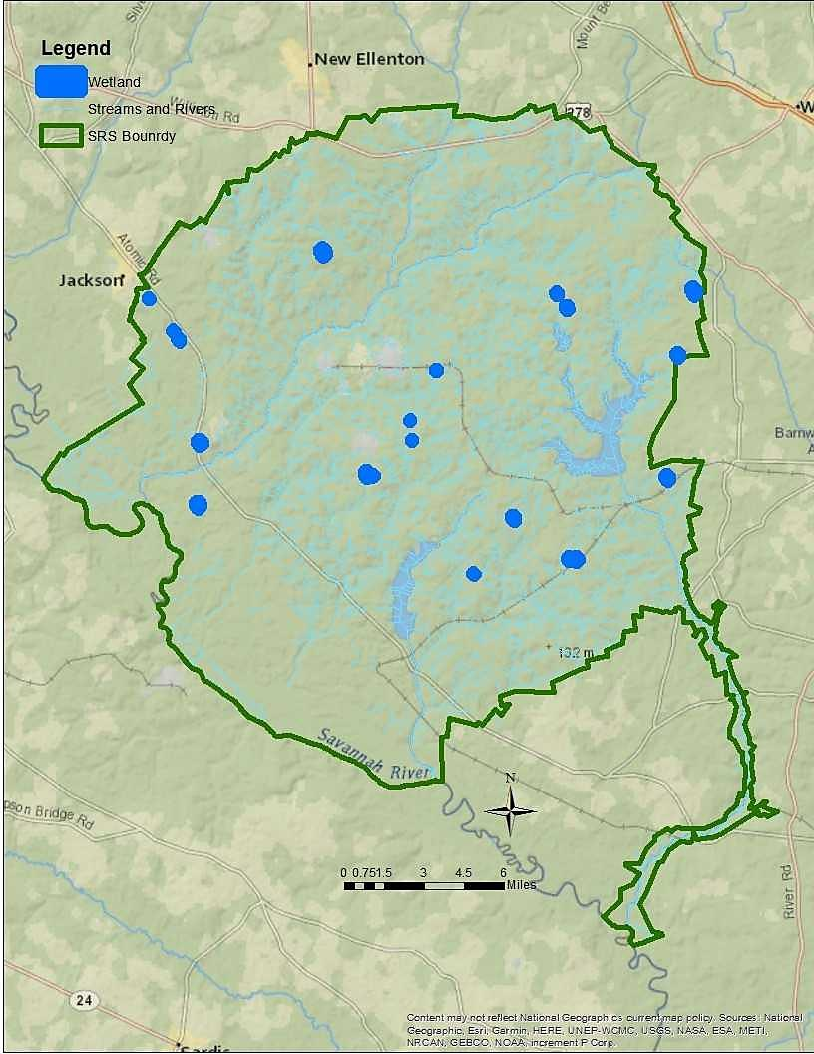

**Figure 1**. Map of the SRS depicting locations of study wetlands.

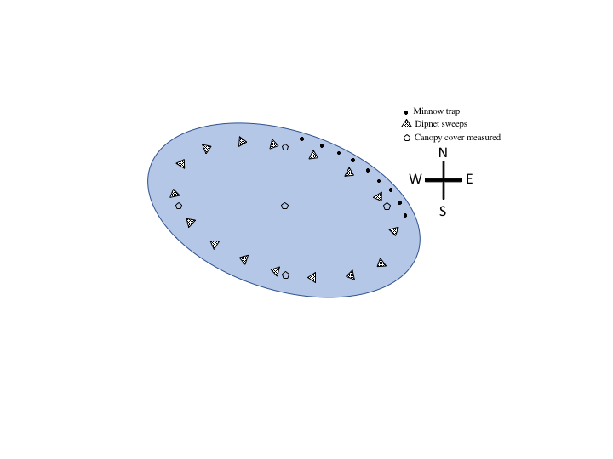

**Figure 2.** Diagram depicting standardized amphibian sampling methods in wetlands. Minnow traps were deployed every 10 m in the northeast corner in shallow water (~20 cm), dipnet sweeps were performed ~0.5 m deep around the entire wetland with three sweeps conducted every 20m. Canopy cover was measured in the center of the wetland and at 0.5 m deep at each cardinal direction.

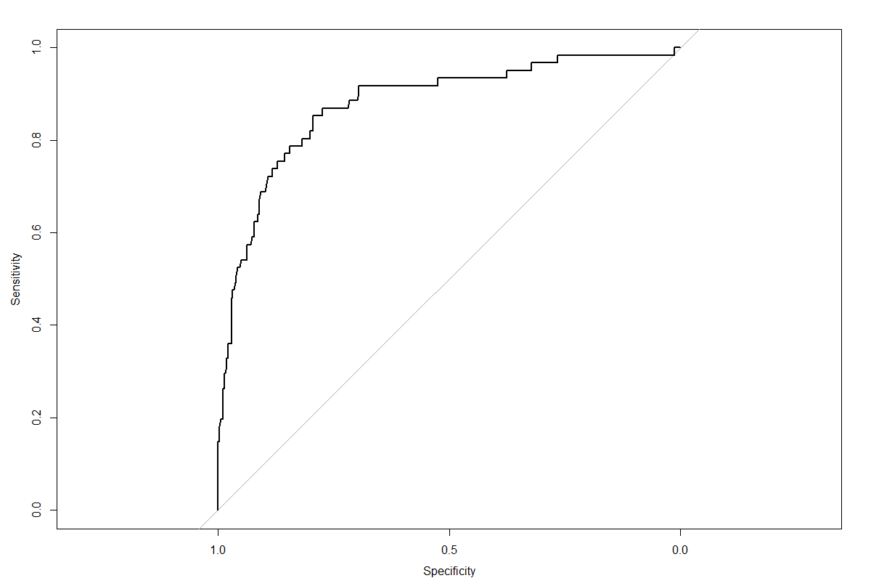

**Figure 3.** Receiver operating characteristics curve (ROC) for the overall RV prevalence BRT. The curve uses testing data to visualize how well the model correctly identifies test observations. ROC plots the sensitivity (true positive) over the specificity (true negative). ROC score for the RV prevalence BRT was 0.87.

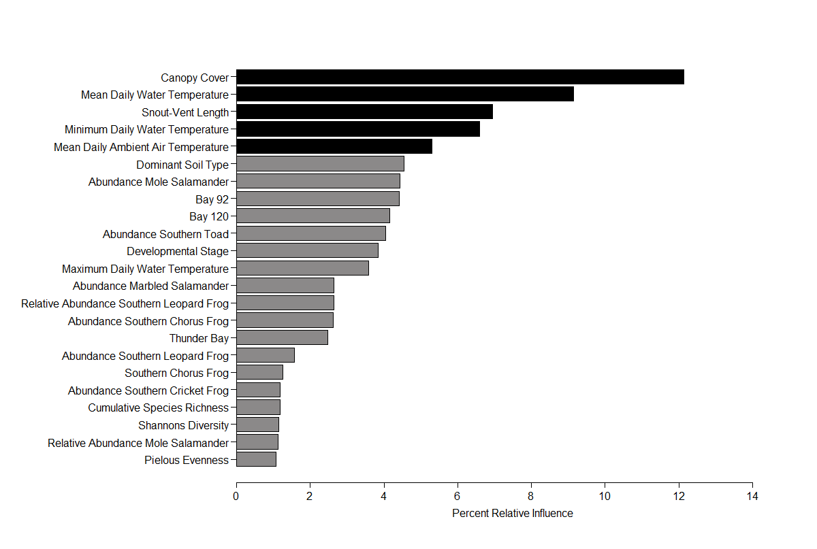

**Figure 4**. Relative influence of predictor variables in explaining the overall prevalence of RV across species and wetlands. Predictors shaded black represent variables with greater than 5% relative influence. Predictors shaded in grey have a percent relative influence of less than 5%, but greater than 1%.

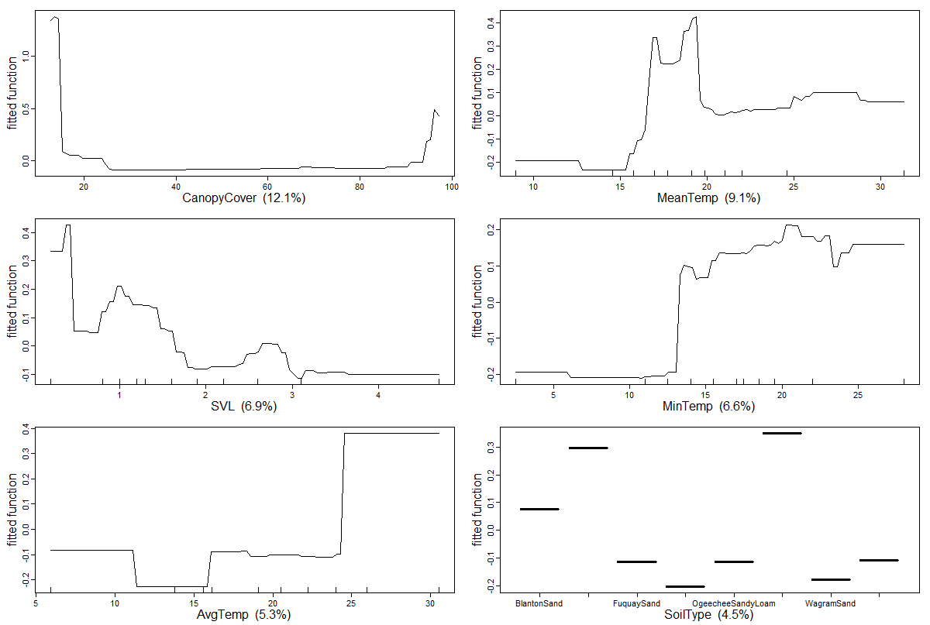

**Figure 5.** Relationships between predictors of interest and the log odds ratio of individual amphibians testing positive for RV when holding all other predictors at their mean values. Each graph is a partial dependency plot with high values on y-axis indicating increased probability of testing positive for RV.

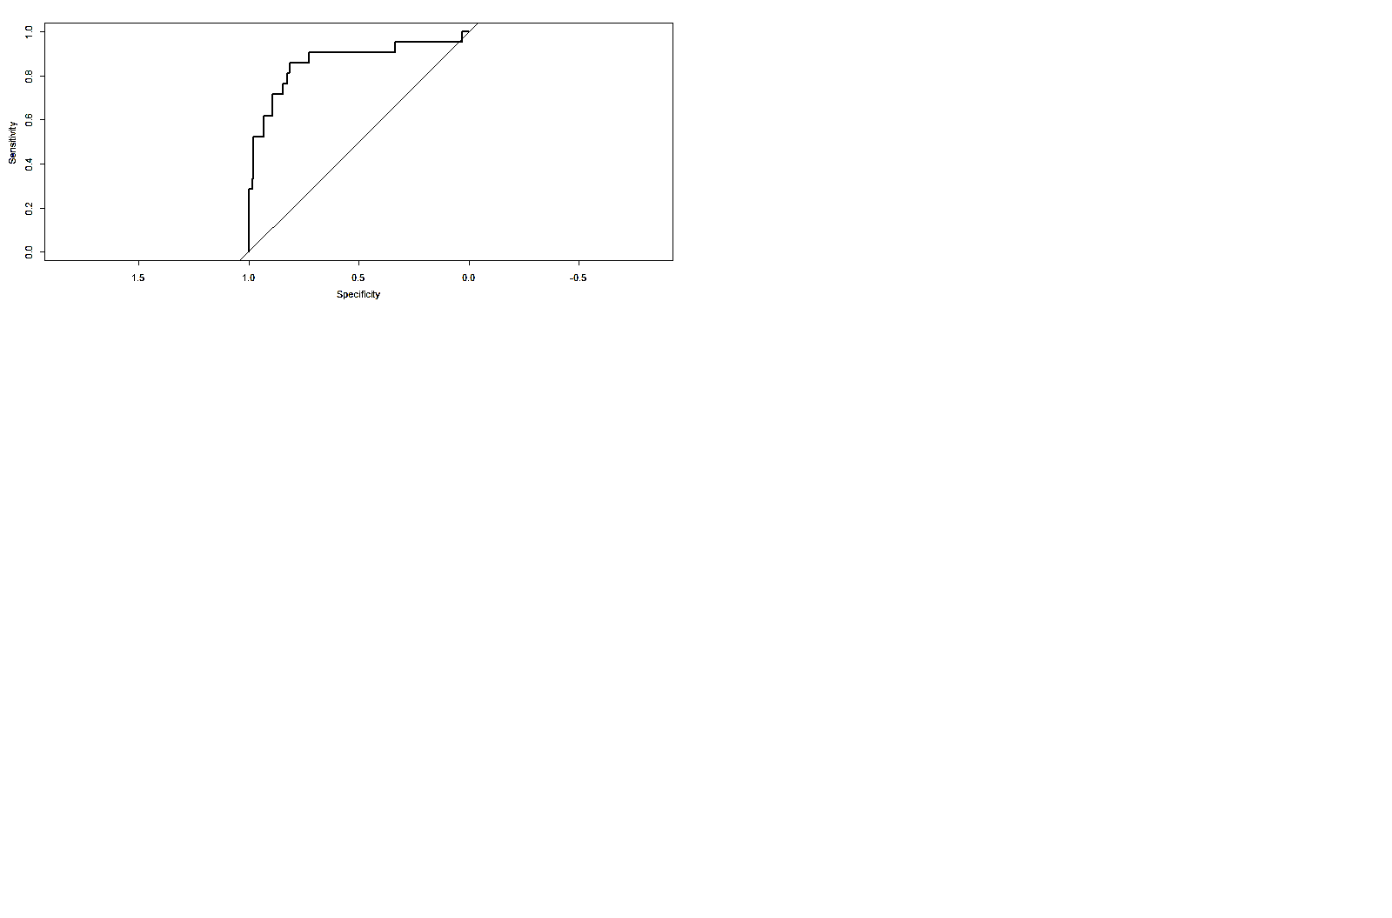

**Figure 6**. Receiver operating characteristics curve (ROC) for the focal species RV BRT. The curve uses testing data to visualize how well the model correctly identifies test observations. ROC plots the sensitivity (true positive) over the specificity (true negative). ROC score for the RV prevalence BRT was 0.86.

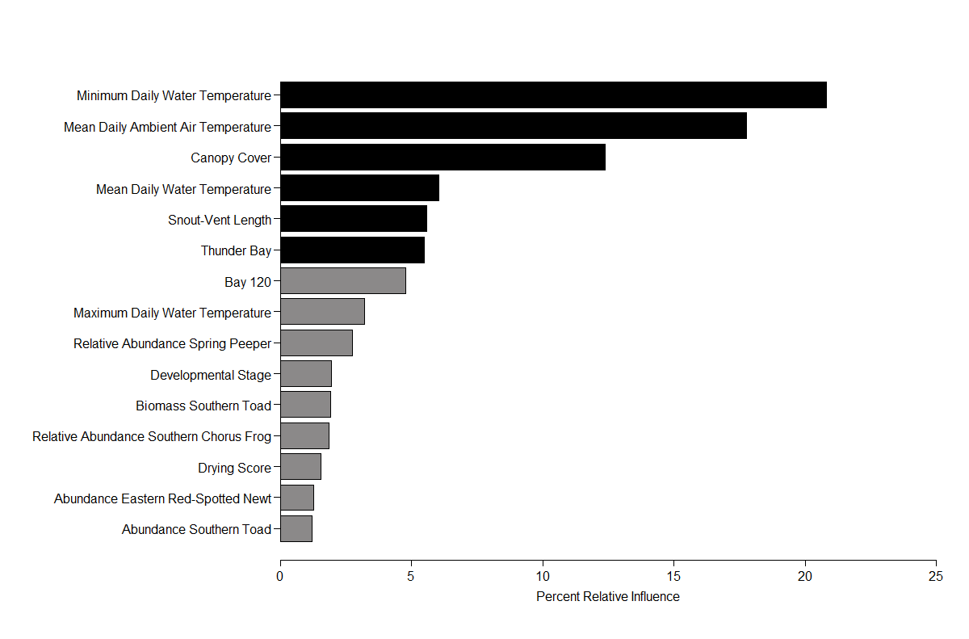

**Figure 7**. Relative influence of predictor variables in explaining the prevalence of RV in the focal species, *L. sphenocephalus*. Predictors shaded black represent variables with greater than 5% relative influence. Predictors shaded in grey have a percent relative influence of less than 5%, but greater than 1%.

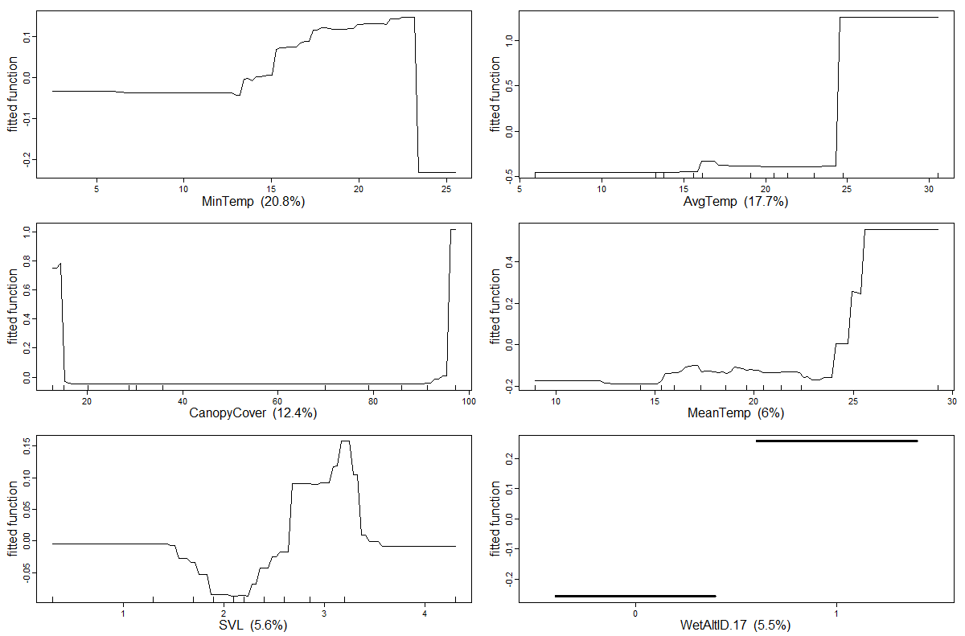

**Figure 8.** Relationships between predictors of interest and the log odds ratio of *L. sphenocephalus* individuals testing positive for RV when holding all other predictors at their mean values. Each graph is a partial dependency plot with high values on y-axis indicating increased probability of testing positive for RV.

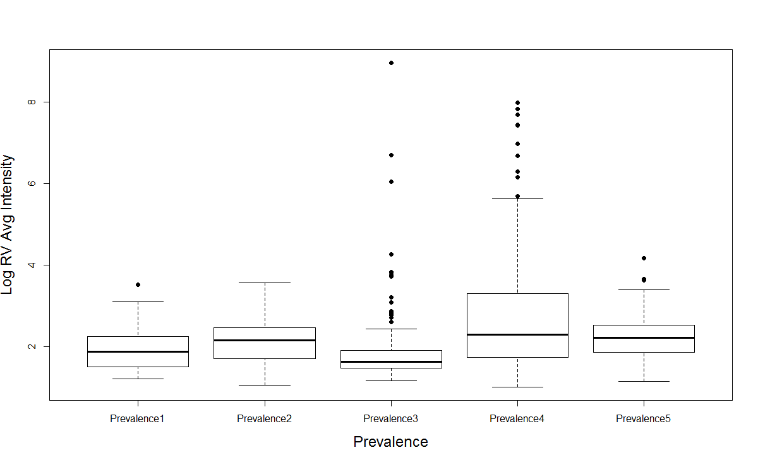

**Figure 9.** The relationship between viral load and prevalence glasses from GLMs. Prevalence was turned into a class variable (1= 0-10%, 2=11-20%, 3= 21-30%, 4=31-40%, and 5=41-76%).

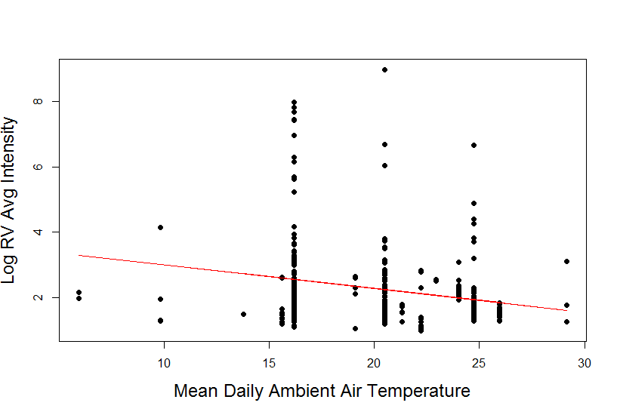

**Figure 10.** The regression relationship between Log RV average intensity and mean daily ambient air temperature. The relationship indicates a weak trend where increasing temperatures result in decreased viral loads.

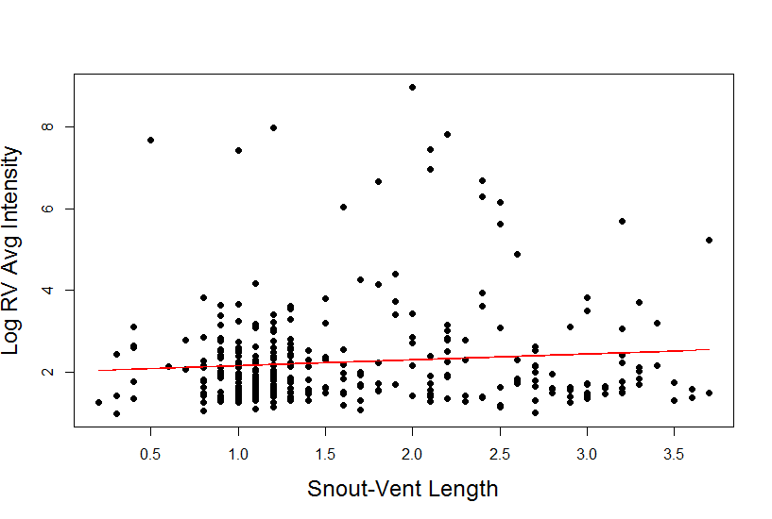

**Figure 11.** The regression relationship between Log RV average intensity and snout-vent length. The relationship indicates a weak trend where increasing snout-vent length results in increasing viral loads.

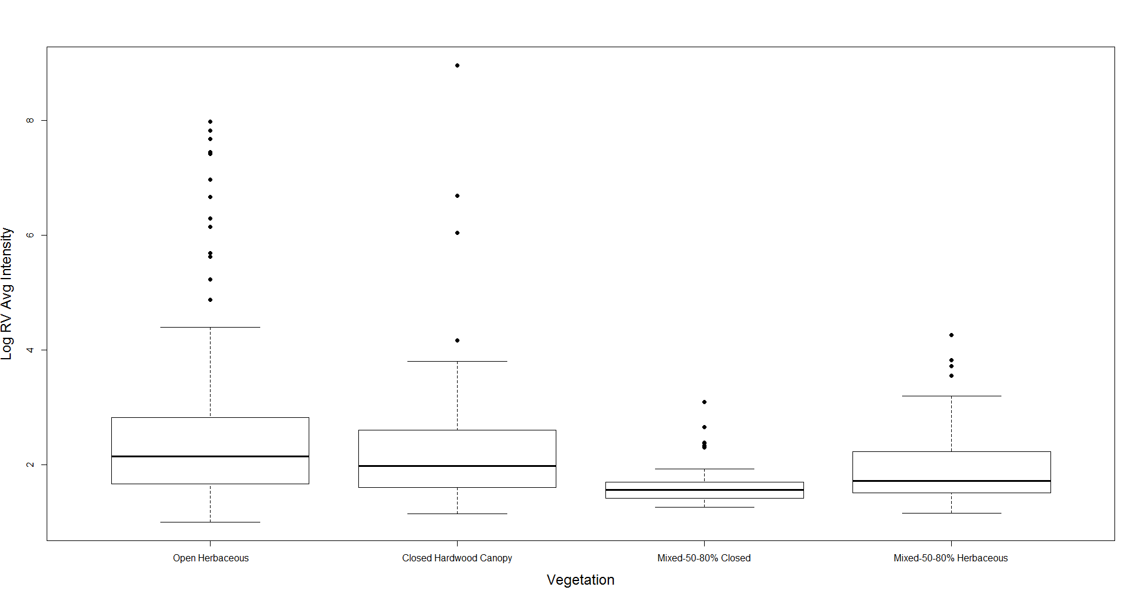

**Figure 12.** Log RV average intensities for individuals associated with wetlands associated with four vegetation types. Open herbaceous wetlands and closed hardwood canopy wetlands had individuals with significantly higher average viral loads.

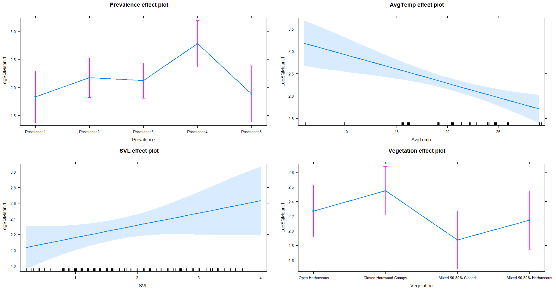

**Figure 13.** Effects plots (*effects package-R)* for all four variables from the most informative GLM explaining trends in average viral loads.