# Introduction

Environmental conditions have direct and indirect effects on pathogen transmission. Directly, abiotic factors such as temperature and humidity can influence transmission by altering persistence times outside of their host (Gray et al., 2009; Nazir et al., 2012). Indirectly, the environment can alter transmission by affecting host community composition, impacting host availability and suitability (Love et al., 2016). For example, temperature can affect host growth rates and population sizes, resulting in changes in the absolute abundance of susceptible hosts (Savage et al., 2004; Sibly & Hone, 2002) and the relative abundance of different host species in a community (Altizer et al., 2013; Blaustein et al., 2010). Over time and space, environmental conditions vary naturally, resulting in altered transmission potential. Despite the importance of both biotic and abiotic factors in pathogen transmission, the existing diversity-disease literature does not commonly address both together. Instead, studies at the local and regional scale typically focus on biotic factors (P. T. J. Johnson et al., 2015; Rohr et al., 2019) while abiotic factors are more often considered at larger spatial scales (Cohen et al., 2016).

Separate lines of evidence suggest that the abundance of hosts, the composition of host communities, and direct effects of environmental conditions influence pathogen transmission. Pathogens with density-dependent transmission rely on host species abundance to be able to invade and persist within a host population (Fenton et al., 2002; Hopkins et al., 2020; Patterson & Ruckstuhl, 2013). For generalist pathogens, variation in host competence, the ability of a host to acquire and transmit a pathogen, across species is an important factor in determining transmission potential and can be assessed at the community scale via community competence (Downs et al., 2019; P. T. J. Johnson et al., 2013; Martin et al., 2016). Further, pathogens with the capacity for environmental transmission are subject to their surrounding environmental conditions. For example, the environmental persistence of influenza virus can enhance transmissibility and is modulated by temperature, humidity, and pH (Rohani et al., 2009; Sooryanarain & Elankumaran, 2015). However, while studies tend to focus on either host abundance, community composition, or environmental conditions, these factors jointly influence transmission and are non-independent. Host abundance and community structure often fluctuate in response to environmental conditions (Werner et al., 2007), and these changes in community structure can result in dramatic shifts in community competence (Streicker et al., 2013). Over seasonal timescales, species exhibit distinct phenologies and experience dynamic strengths of competition (Rudolf, 2019), which generates a relationship between community structure and size. Consequently, considering the separate and combined effects of these three factors can improve our understanding of how generalist pathogens invade and persist within variable host communities (Becker et al., 2012; A. F. Johnson & Brunner, 2014; Nazir et al., 2012) and promises to generate mechanistic insight into diversity-disease studies that frequently rely only on patterns of host species richness and infection prevalence in communities (Rohr et al., 2019).

We use ranavirus infection data in larval amphibian communities to illustrate that the joint influence of biotic and abiotic promoters are likely to be relevant in many disease systems. Ranaviruses represent a genus of viruses known to be associated with global amphibian declines and exhibit both contact and environmental transmission (Brunner et al., 2017; Sage et al., 2019), with the latter known to depend on water temperature and pH (Brenes et al., 2014; Miller et al., 2011). Additionally, there is large variation in the competence of different host species for ranavirus, and the composition and abundance of host communities changes over space and time, allowing for analysis of the effects of host community composition on transmission potential (Love et al., 2016; Snyder et al., 2023). The data span 20 wetlands sampled monthly over 6 months in 2016, and include estimates of host abundance and community composition as well as infection status and viral load concentration for a subset of individuals from each sampling event.

To establish how biotic and abiotic factors jointly influence transmission, we developed a mechanistic model that incorporates direct effects of the environment on the pathogen, specifically the environmental persistence time, as well as changes in both abundance and community composition. While important theoretical developments have described transmission in multi-host communities (Dobson, 2004; Fountain‐Jones et al., 2018; Holt et al., 2003; Roche et al., 2012), and via multiple transmission modes (Eisenberg et al., 2013; Majewska et al., 2019; Rohani et al., 2009), their joint consideration in models is underdeveloped. Accordingly, we develop such a model and assess the effects of host abundance, community composition, and environmental persistence on *R*0, the basic reproductive number for the pathogen, under a range of plausible conditions. We compare findings from the model to the empirical data to demonstrate that each factor has the potential to contribute substantially to transmission, and that these distinct factors can and do simultaneously promote transmission. We contend that studying both biotic and abiotic factors, including their influence on each other, can help us to understand and predict the location and timing of outbreaks of generalist pathogens that employ multiple transmission modes. Our study is well poised to illustrate this phenomenon because larval amphibians occupy discrete wetlands, linked via adult movement, to form a metacommunity occurring at an intermediate spatial scale, which potentially renders biotic and abiotic factors of equal importance. Further, by developing a theoretical model for understanding these joint effects, we present mechanistic insights to explain empirical patterns in our study, which are likely to apply to other studies as well (Bienentreu & Lesbarrères, 2020; Dillon & Meentemeyer, 2019; Youker-Smith et al., 2018).

# Methods

## Data Collection

Data were previously collected (Coleman, 2018) at the Savannah River Site (South Carolina, USA). 20 wetlands were sampled monthly for 6 months from February to July in 2016 at the Savannah River Site. Of the 120 sampling events, 96 produced data, with the others being discounted due to wetlands being dry at the time of sampling. Each sampling event included an estimate of larval amphibian abundance ascertained from minnow traps and dip-net sweeps around the perimeter and center of the wetland. In addition to abundance, a single individual per species was collected per dip-net sweep or minnow trap. These individuals were tested for ranavirus load using qPCR in triplicate, with values averaged to determine the viral load for an individual. At the species-level, all individuals that were analyzed for viral load were then averaged to provide a species level estimate of viral load, a proxy for competence.

## Calculation of community competence and prevalence ratio

Using species-level competence, we calculated community competence as the weighted average of each species’ competence, with weights given by the relative abundance of each species (P. T. J. Johnson et al., 2013). Each site-month combination was treated as a distinct community in these calculations. We designed a metric that summarized ranavirus transmission, hereafter referred to as the prevalence ratio, to test whether community competence, host abundance, and mean water temperature at each site-month were correlated with ranavirus transmission as the epizootics unfolded between February and July. The prevalence ratio was calculated as the percentage increase (before peak prevalence) or decrease (after peak prevalence) in prevalence relative to the potential change in prevalence reached in any site over the study period. Consequently, if prevalence was increasing towards the maximum prevalence (i.e., prevalence had not yet peaked), then the prevalence ratio is the quotient of the difference between next month’s prevalence and the current month’s prevalence divided by the maximum prevalence. If prevalence was decreasing away from the maximum prevalence (i.e. prevalence has already peaked), then the prevalence ratio is one minus the quotient of the difference in the previous month’s prevalence and the next month’s prevalence divided by the maximum prevalence. The advantage of the prevalence ratio is that it allows us to detect whether conditions were favorable or unfavorable for the pathogen along the entire epizootic (both before and after the peak, which was typically in April-May). Before the peak, conditions are deemed favorable for the pathogen (higher prevalence ratio value) if prevalence increases rapidly. After the peak, conditions are favorable for the pathogen if prevalence decreases slowly. Using prevalence ratio as a response variable, we tested to see if community competence, host abundance, and mean water temperature were significantly correlated with a Spearman Rank correlation test and a Holm-Bonferroni correction for multiple comparisons.

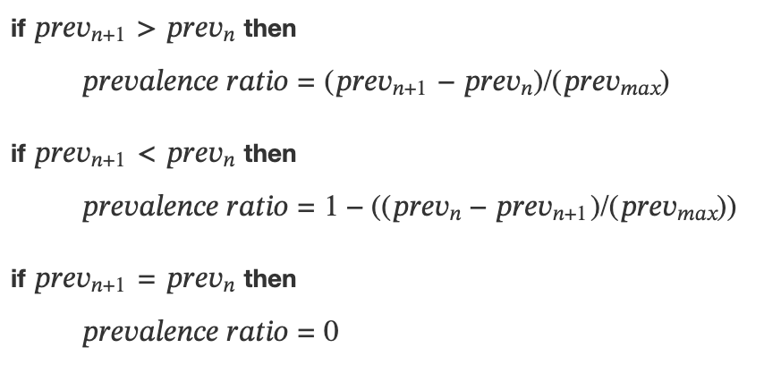

## Transmission model

Ranaviruses can infect a wide range of amphibian hosts and infectious periods can range from a few days up to weeks (Gray et al., 2009). Transmission can occur both directly and indirectly, and exposure appears to induce an adaptive immune response in surviving hosts. Accordingly, we modeled a host community using an SIRV framework for each species, where “V” represents a free-living infectious virion stage (Supplementary Materials). For model tractability, we limited the community to two host types that could vary in key traits including abundance and competence. As well as facilitating model analysis, this choice also reflects the empirical observation that viral loads of host species are bimodal (Supplementary Figure 1). We included environmental transmission, whereby infectious host individuals shed virus into the environment where it persists for some finite time and can cause new infections without host-to-host contact (Gray et al., 2009). We included host demography via a constant birth rate and a constant per capita mortality rate, resulting in a disease-free equilibrium for each host species given by the ratio of the birth rate and mortality rate. For the model to reflect the viral load-based definition of host competence, infectivity, but not susceptibility, varied between the high and low competence hosts. This means that the rate of transmission from infectious individuals did not depend on whether transmission was to an intra- or inter-specific host but rather on the high or low competence status of the infectious individual. In keeping with the assumption of no difference in host susceptibility between species, the environmental transmission rate was the same for both species.

Using the next-generation matrix method (Diekmann et al., 2009), we calculated the community basic reproductive number (Dobson, 2004), hereafter referred to as *R*0, for our community of hosts to determine the conditions necessary for pathogen invasion (*R*0>1). Consequently, we determined how the boundary *R*0=1 is shaped as a function of parameters for communities with varying characteristics, specifically community composition, total host abundance, and viral half-life. To illustrate these effects, we created a reference community and 4 manipulated communities that were each designed to make the communities more suitable for pathogen invasion. The reference community had an equal number of both species, a total host abundance of 150 individuals, and a viral half-life of 1.35 days. Viral half-life was calculated as ln(2)/degradation rate [WRITE OUT MORE FORMALLY]. Then (i) the composition-manipulated community was altered to be dominated by the more competent species by a ratio of 2:1; (ii) the abundance-manipulated community was altered only in abundance, to 175 individuals; and (iii) the half-life-manipulated community was altered by doubling the viral half-life to 2.7 days. Finally, (iv) we constructed a manipulated community that combined each of these single-factor manipulations. For each community, we calculated *R*0 over a range of values for environmental and contact transmission rates of the more competent species while holding the contact transmission rate for the less competent species constant. This allowed us to characterize the extent to which pathogen invasion was more likely, i.e., occurring for an increased set of transmission parameters that included combinations previously associated with failure to invade (*R*0<1). In addition, we observed the dynamics of these systems by numerically solving them over time in order to identify when peaks occurred and how high incidence was at those peaks.

## Community competence, host abundance, and water temperature

Community competence, host abundance, and water temperature are all expected to influence pathogen transmission, and each of these factors vary over time and space. Community competence is fundamentally driven by the composition of hosts in the community, and in order to understand which hosts may be driving transmission, we ordered sites according to community competence values and examined which host species made up these communities. We also recorded phylogenetic distances between species to characterize how competence, as a trait, was distributed among hosts as a function of their relatedness. To determine if there was evidence of limiting similarity or environmental mismatch in host communities, we examined the relative abundance of each host in each community compared to the phylogenetic distance between that host and its closest relative in that community. If this phylogenetic distance is small between host species, this can indicate the potential for strong interspecific competition based on niche overlap, and this may reduce the abundance of each species (Webb et al., 2002; Weinstein et al., 2017). In contrast, if phylogenetic distance is high between host species, then this may indicate that they are ecologically distinct from other species and unlikely to co-occur in high abundance due to an environmental filtering effect. If a host species is neither phylogenetically clustered with others nor an outlier (i.e., it has a moderate phylogenetic distance to other species), then it may attain high relative abundance by avoiding both phylogenetic repulsion and environmental filtering. Finally, we measure the correlation between community competence and both host abundance and mean water temperature using Spearman Rank correlation tests with Holm-Bonferroni corrections for multiple comparisons. Correlations between these variables can be used to estimate how they covary over time and space, which can help anticipate their potential to jointly contribute to high pathogen transmission.

# Results

## Effects of composition, abundance, and temperature on ranavirus transmission

Host community composition, host abundance, and mean water temperature varied across space and time. After ordinating sites according to community composition via PCA, a trend emerges whereby community competence peaks for certain communities and then levels off (Figure 1). These peak communities are typically associated with earlier months (Supplementary Figure 2) and higher host abundances (Figure 1; size), and suggest that certain times and locations may exhibit ‘perfect storms’ in which separate factors that promote transmission (high community competence, high abundance, and lower water temperature resulting in lower rates of viral degradation) co-occur.

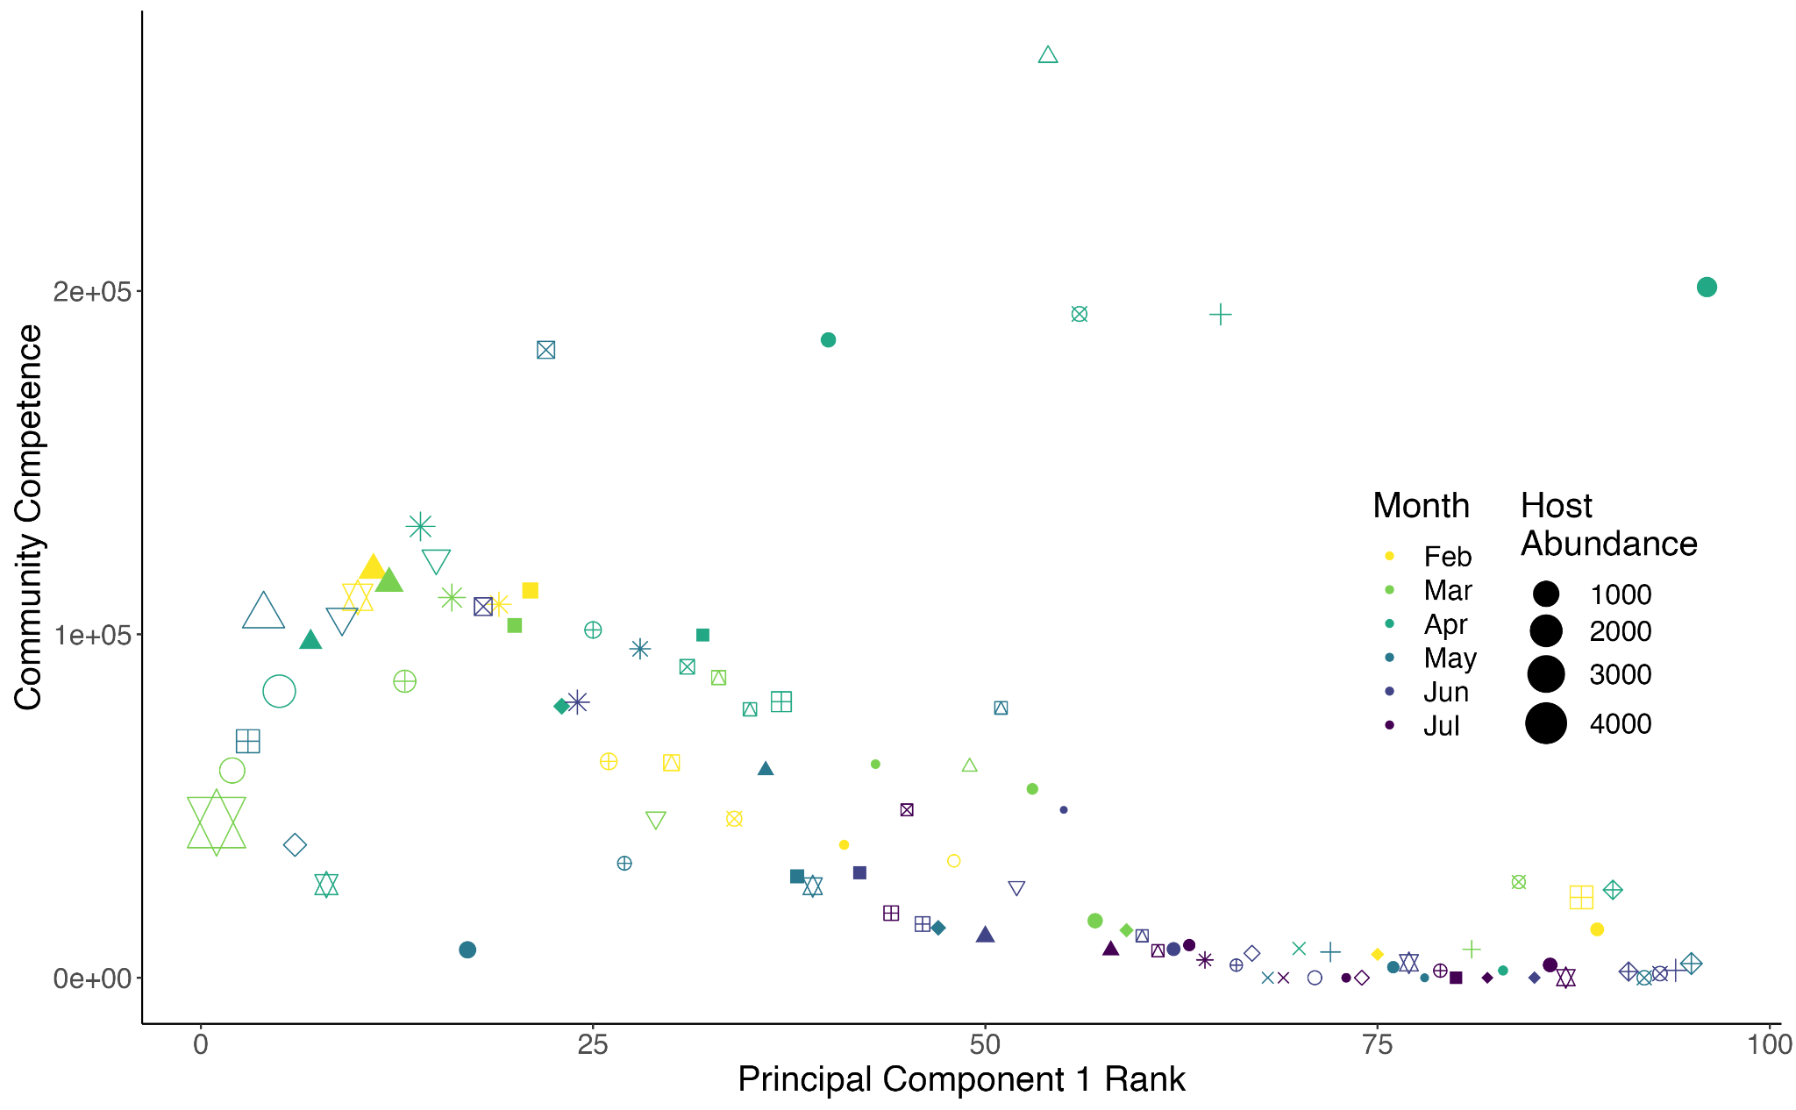

**Figure 1:** **Relationship between Community Competence of sites ranked according to Principal Component 1 Scores.** Similar community compositions result in similar values of community competence. Sampling months are represented by color and wetland IDs are represented by symbols. The size of each community is shown by the relative size of each point. **Inset:** Boxplot of community competence values binned according to month. Community competence varies over time and is lowest during later months (May, June, July)

When analyzing the relationship between these factors and relative changes in infection prevalence (prevalence ratio), community competence and host abundance both exhibit significant positive relationships with the prevalence ratio (Figure 2, Spearman correlations:community competence P<0.01, host abundance P<0.001). The direction of the relationship between prevalence and mean water temperature aligns with predictions but is not significant (Figure 2, Spearman correlation P=0.1).

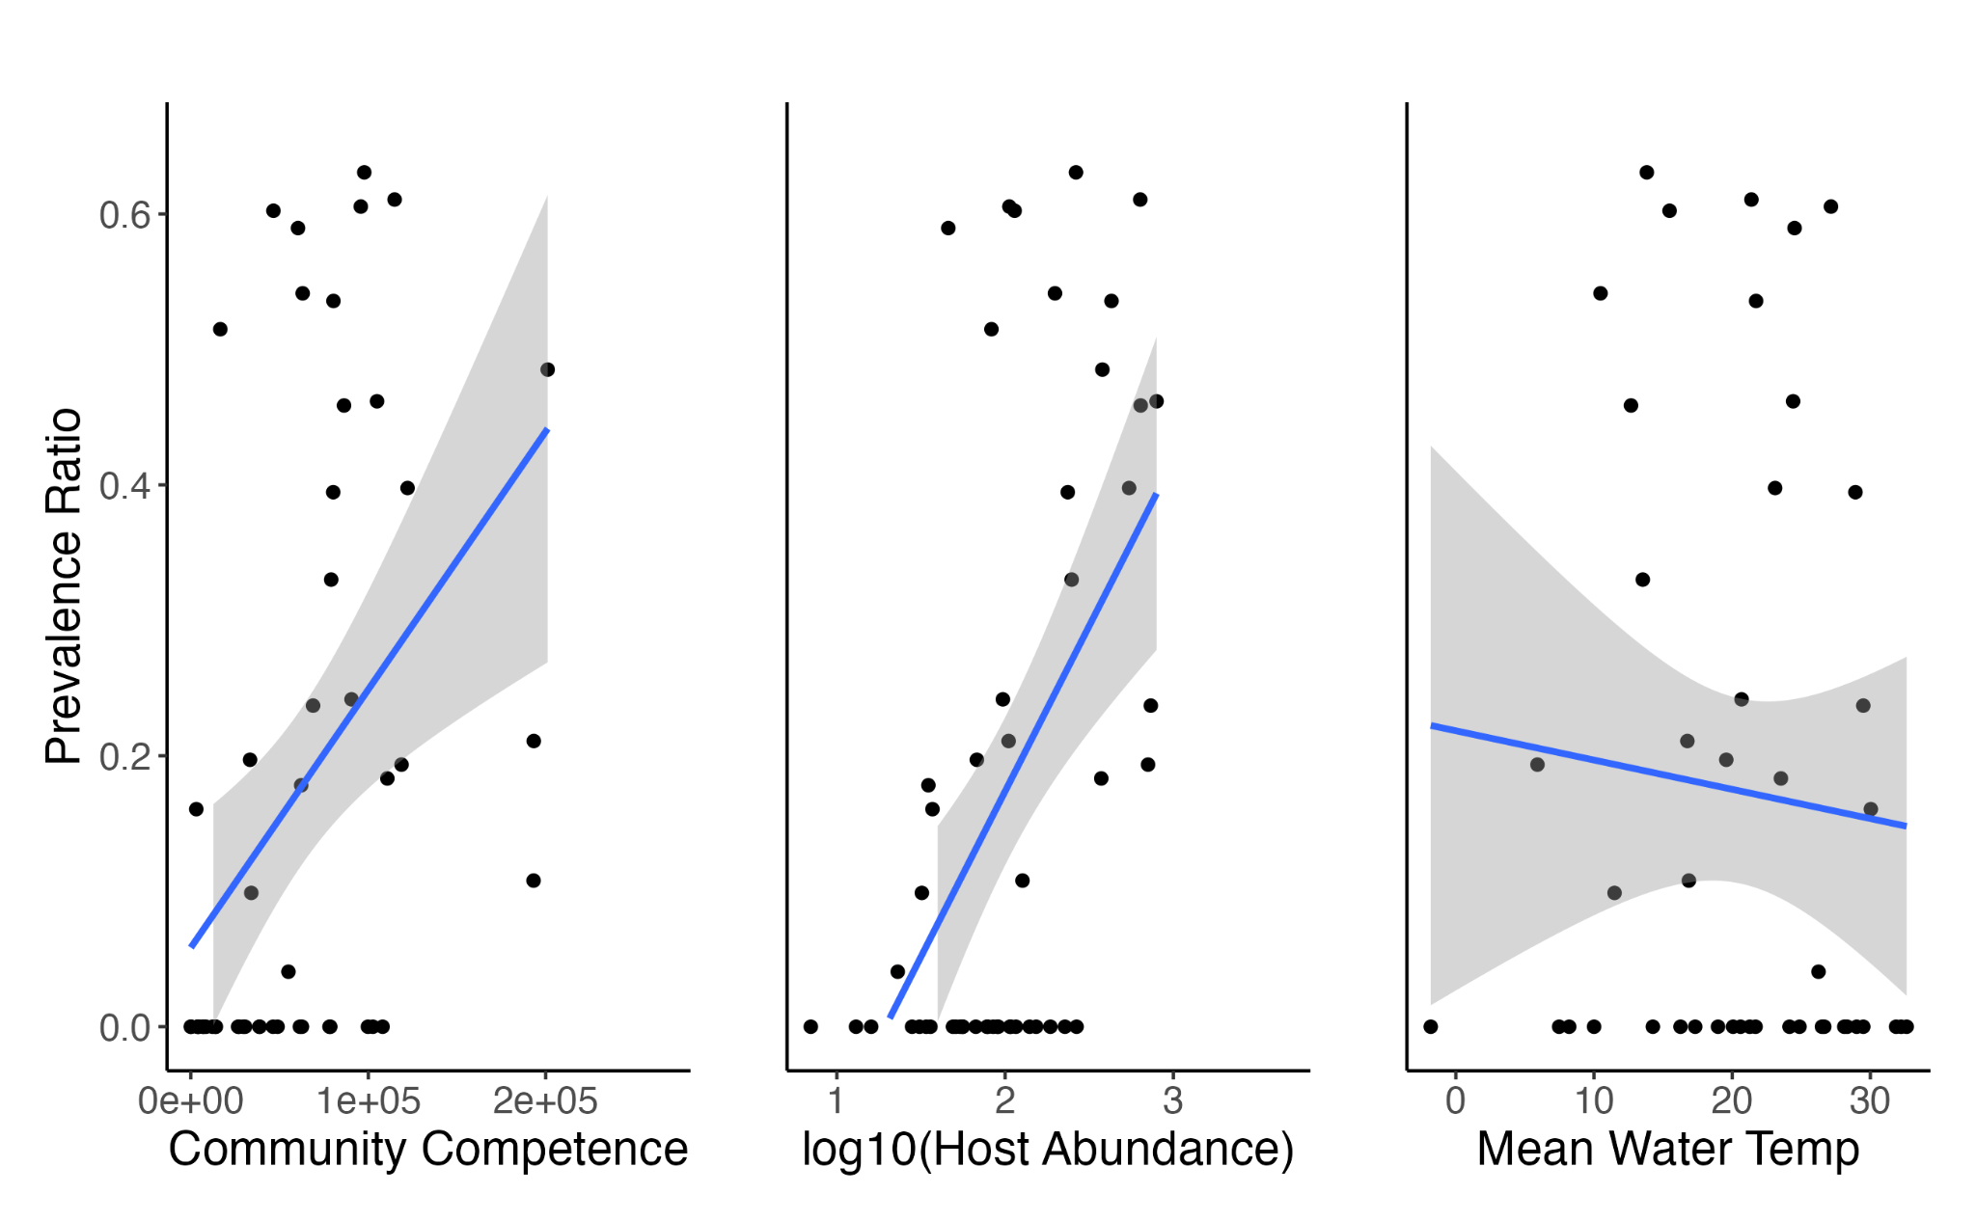

**Figure 2: Correlations between prevalence ratio and community competence, community size, and mean water temperature.** Community competence and community size correlated positively with prevalence ratio while mean water temperature did not have a significant relationship. Each point represents a single month-site combination.

### Multi-species multimodal transmission model

In the transmission model, community composition, host abundance, and viral half-life are all important promoters of transmission and their effects are enhanced when combined. Manipulating each factor in favor of transmission (composition, abundance, and half-life) increases the set of transmission rates that allow pathogen invasion of the host community. However, the effect of each factor varies in the extent to which it permits invasion via lowered environmental versus contact transmission (Figure 3). Changes in community composition result in a community that is more sensitive to changes in contact transmission, i.e., prone to epizootics with lower contact transmission rates. Conversely, an increase in viral half-life renders the community more sensitive to changes in environmental transmission. Abundance has an equal effect on both modes of transmission and the combined effect of all three transmission promoters results in an increase in parameter space that is much greater than any individual factor alone. When observing the dynamics of these communities over time, each factor causes epizootics to occur earlier and with higher intensity (Figure 4). The high and low competence species contribute equally to disease incidence when the relative abundance of both species is equal despite differences in the transmission parameter. In the case of the composition manipulation and the combined manipulation, the higher competence species has a higher relative abundance and contributes more to incidence.

**Figure 3: Threshold of invasion under different conditions.** The parameter space in which R0>1 can be increased through changes in community composition, total host abundance, and viral half-life. The gray line in each plot represents a reference community that is the same throughout each. The colored lines represent manipulated communities. Plot D includes all manipulations and each of the other plots include only one manipulation (composition = community composition, abundance = host abundance, half-life = viral half-life, all = all manipulations combined).

**Figure 4: Transmission dynamics of either species and both species combined.** Using the same initial conditions from the manipulated communities in Figure 3 and parameter values that would ensure R0 is greater than 1, the simulated dynamics of the system show peaks with varying amplitude and timing. This model formulation does not include demography.

### Patterns of community competence, host abundance, and temperature in ephemeral wetlands

Throughout the study period, community competence, host abundance, and mean water temperature varied over time and space, and it was not uncommon for these conditions to combine in ways that favor ranavirus transmission. When community competence was high, it was mostly due to the dominance of certain high competence species (Figure 5). These species are known for being common and in high abundance in the study region (Love et al., 2016). Further, several high competence host species were observed to occur and even co-dominate communities (Figure 5 middle panel). The phylogenetic relationships between these species suggest that they may be dissimilar enough to avert strong interspecific competition, resulting in high relative and absolute abundance of competent hosts in these communities (Figure 6).

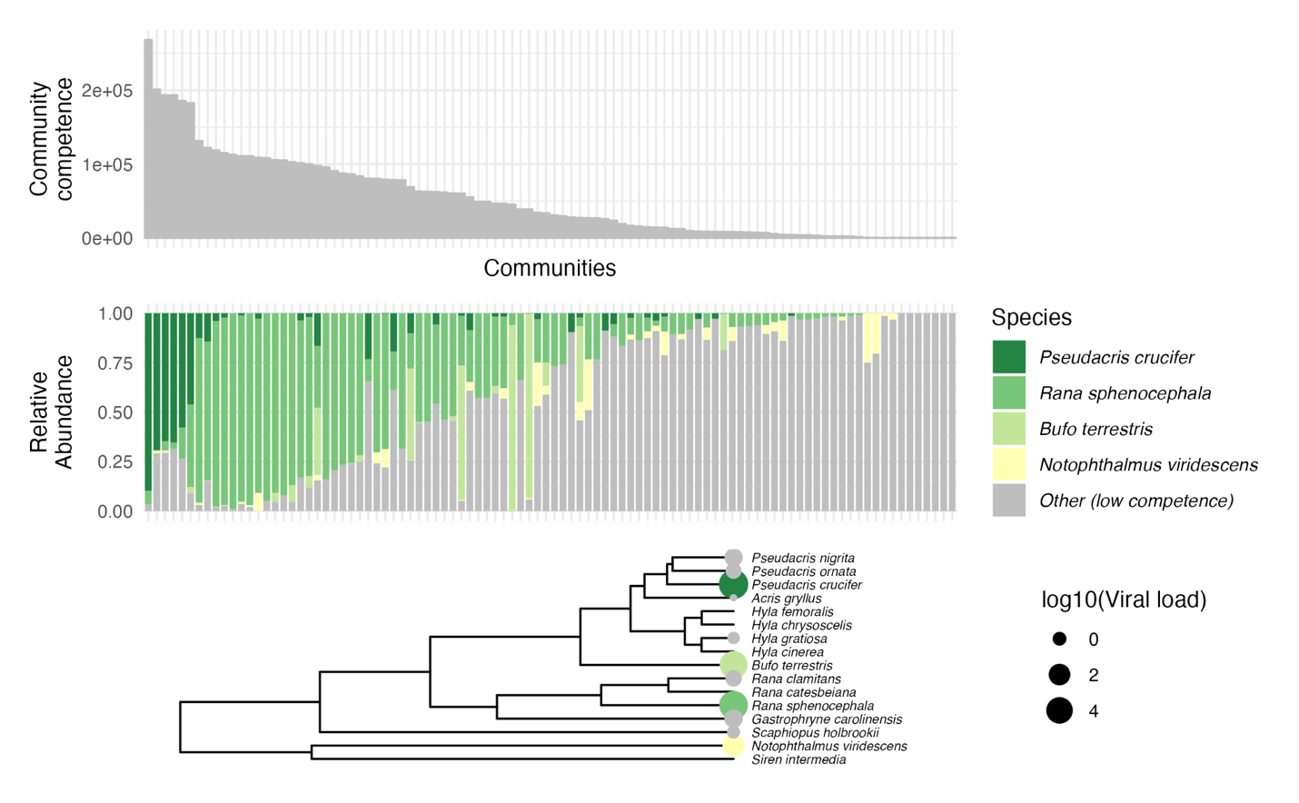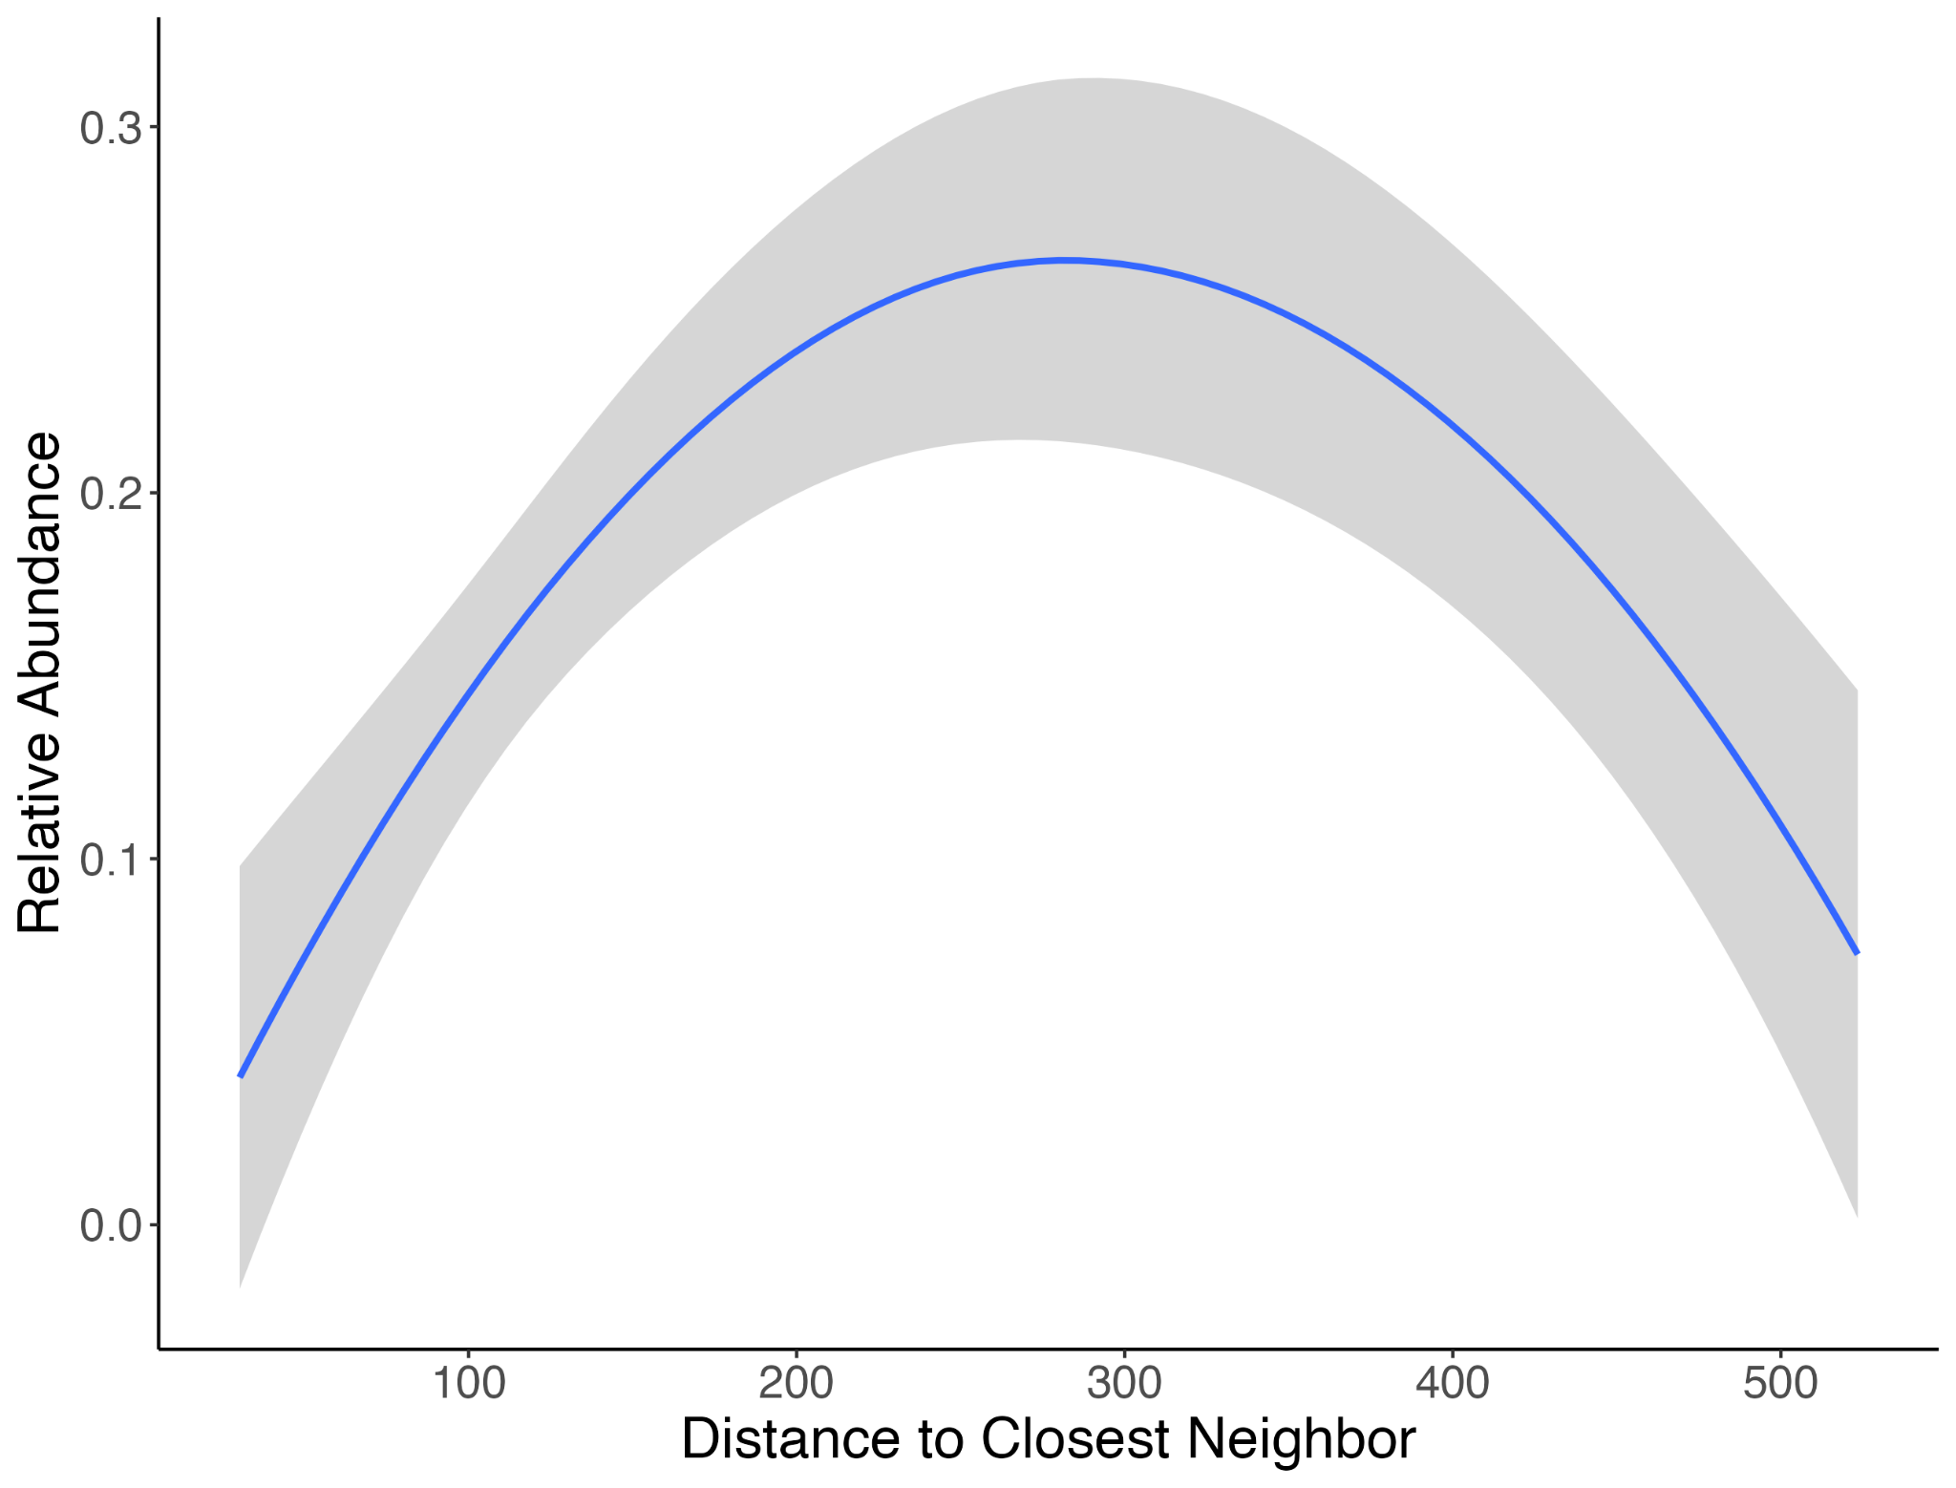

**Figure 5: Relative abundance of high competence species ordered in descending community competence, and phylogeny of amphibians with values of viral load (proxy for competence).** Sites with higher community competence are dominated by species of higher competence and high competence species tend to dominate communities when present. The phylogeny shows that high competence species are moderately dispersed, suggesting that these species may not be excluded by limiting similarity in these communities.

**Figure 6: Relative abundance of host species correlated against the phylogenetic distance of their closest neighbor.** In each community, each host species’ closest neighbor according to phylogenetic distance was recorded as well as the distance between those species. The relative abundance of each host species was then correlated against the distance between a host species and their closest neighbor to identify trends between how similar a host is to their closest neighbor and how abundant they are in their community.

Finally, correlations between both host abundance and mean water temperature with community competence show that there are significant correlations between these variables (Supplementary Figure 4, Spearman Rank Correlation Test with Holm-Bonferroni Correction for Multiple Comparisons P < 0.001). Community competence correlates positively with host abundance which can result in sites with many host individuals that are, on average, highly competent. The negative trend between community competence and mean water temperature suggests that sites of high community competence may occur when water temperatures are low, again resulting in favorable conditions for pathogen transmission.

# 

# Discussion

The transmission of many generalist pathogens is driven by biotic and abiotic factors, but the joint effects of these are rarely considered together. Using a mathematical model, we demonstrate that the effects of host abundance, community composition, and pathogen persistence times can result in conditions for transmission that are more favorable to the pathogen than any factor alone. In addition, we find that these factors can compensate for each other, resulting in a broad range of conditions in which a pathogen may be able to successfully invade a host community. Our analysis of empirical ranavirus data suggests multiple transmission-promoting factors may co-occur, and we describe how each factor is likely to affect transmission. These results emphasize the importance of the joint effects of biotic and abiotic factors on the transmission of generalist pathogens, and the associated model helps to illustrate specific mechanisms likely to manifest across many host-pathogen systems; a topic that has been recommended more broadly in the study of diversity-disease relationships (Shaw & Civitello, 2021).

Diversity-disease research is often studied as a scale-dependent relationship that focuses on the effects of environmental gradients at larger spatial scales, and the effects of host richness at local and regional scales (Rohr et al., 2019). At the intermediate spatial scale of our study, host richness, per se, is not as informative as host evenness, because it fails to capture the relative abundance of host species that contributes to the weighted average of species-level competence (P. T. J. Johnson et al., 2013). Further, a singular focus on either environmental or host factors can obscure the importance of both factors at any spatial scale. For example, in our model, we show that both community composition and environmental persistence of the pathogen can enhance transmission potential overall, and the effects of each of these promoters disproportionately favors a distinct transmission mode. Specifically, as a host community becomes dominated by more competent species, the range of contact transmission rates that permit pathogen invasion increases appreciably, whereas when conditions change to increase pathogen persistence times in the environment, then it is the range of environmental contact rates permitting pathogen invasion that increases. Because ranavirus transmission includes contact based and environmental transmission, if the strength of transmission for one mode decreases, then the threshold for invasion may still be reached if the other transmission mode is sufficiently strong. The flexibility that comes from using multiple transmission modes may be especially advantageous in a changing climate. For example, increasing global temperatures may reduce the effectiveness of routes of transmission that rely on an environmentally viable stage, such as ranavirus, whereby free-living infectious virions may not persist as long in the environment, effectively reducing the strength of environmental transmission. Such situations may even may even lead to the evolution of pathogens to exploit more advantageous transmission routes (Antonovics et al., 2017). The pathogen may evolve to have stronger contact transmission, and the result of this adaptation may result in shorter but more severe epidemics when host densities are at their peak.

Host competence is a complex multifactorial trait and is essential for understanding the transmission of generalist pathogens in multihost communities (Martin et al., 2016). In our study, we found that host species with the highest viral load were also those with the highest relative abundances in their communities, indicating a potential link between host abundance and competence. If host abundance and competence are positively correlated, then this may be important for understanding diversity-disease relationships more broadly. Indeed, the connection between host life history traits and host competence is a growing area of research within disease ecology (Downs et al., 2019; Valenzuela‐Sánchez et al., 2021). An important addition to this body of work in our system is the finding that host species that were of high competence were not clustered within a phylogeny of the host species. Rather, highly competent host species were found to be only moderately related within a phylogeny, which may enhance their ability to co-occur in host communities by avoiding strong interspecific competition. The extent to which this holds true across other disease systems is a promising area for future research.

The ranavirus-larval amphibian system represents a valuable case study among diversity-disease relationships due to pronounced variation in host competence, variation in community composition (distinct from the more commonly studied anthropogenically-generated dynamics of host species richness), and the existence of multiple transmission routes, including environmental transmission (Bienentreu & Lesbarrères, 2020; Lesbarrères et al., 2012; Tornabene et al., 2018). It remains an open question as to how commonly community abundance, composition, and environmental conditions demonstrably interact to influence transmission of multi-host pathogens. Increasing recognition that community competence and host abundance can be positively correlated due to tradeoffs between life history traits such as reproduction and immunity (Ostfeld et al., 2010, 2014; Valenzuela‐Sánchez et al., 2021) suggests the potential for the ideas presented here to occur more generally. In the ranavirus-larval amphibian system, we observed a perfect storm where community competence, host abundance, and environmental factors combined to enhance overall transmission potential for the pathogen. However, the generality of this phenomenon has not yet been explored. The effects of temperature, in particular, can be idiosyncratic and will depend on the epidemiology of the system since temperature ranges for optimal host and pathogen growth rates may not overlap (Gehman et al., 2018).

Our analysis was constrained by certain deliberate but important limitations. First, while the focus of our study was on the transmission potential of ranavirus in larval amphibian communities characterized through the basic reproductive number (*R*0) and observations of ranavirus epizootics, other features of the system such as disease severity (Price et al., 2019), and persistence of pathogens through multiple seasons (Hall et al., 2018) may provide insight into the joint effects of both biotic and abiotic factors on the transmission of generalist pathogens, with suitable data. Second, we use species-specific viral load as a proxy for competence and we model this as infectivity in the system but other traits such as susceptibility and exposure risk due to behavior are also important features of the system that were not explored. Generally, competence may be better understood as a context specific phenomenon that will depend on individual-level host traits, pathogen genotype, and the environmental conditions of the interaction (Merrill & Johnson, 2020). An advantage of a tightly focused definition of competence, namely viral load, is that it allowed us to study how the trait is distributed phylogenetically amongst host species, whereas the consideration of the other components of competence across a phylogeny may make it difficult to assess the distribution of competence more broadly.

The community ecology of generalist infectious diseases is inherently complex. By focusing on either biotic or abiotic variables, the field has identified important patterns relating the effects of the environment and host diversity on pathogen transmission. However, failure to include mechanisms that comprise abiotic and biotic features, and their interactions, may mask important processes and even lead to misinterpretation of patterns. This is highlighted in our study by the non-independence of promoters of transmission and their synergistic interactions. By explicitly considering both the effects of the environment and host community composition, we can better understand the context dependencies that drive pathogen transmission and more accurately predict scenarios in which changing host communities will allow for pathogens to invade and persist.

Altizer, S., Ostfeld, R. S., Johnson, P. T. J., Kutz, S., & Harvell, C. D. (2013). Climate Change and Infectious Diseases: From Evidence to a Predictive Framework. *Science (American Association for the Advancement of Science)*, *341*(6145), 514–519. https://doi.org/10.1126/science.1239401

Antonovics, J., Wilson, A. J., Forbes, M. R., Hauffe, H. C., Kallio, E. R., Leggett, H. C., Longdon, B., Okamura, B., Sait, S. M., & Webster, J. P. (2017). The evolution of transmission mode. *Philosophical Transactions of the Royal Society B: Biological Sciences*, *372*(1719), 20160083. https://doi.org/10.1098/rstb.2016.0083

Becker, C. G., Rodriguez, D., Longo, A. V., Talaba, A. L., & Zamudio, K. R. (2012). Disease Risk in Temperate Amphibian Populations Is Higher at Closed-Canopy Sites. *PloS One*, *7*(10), e48205. https://doi.org/10.1371/journal.pone.0048205

Bienentreu, J.-F., & Lesbarrères, D. (2020). Amphibian Disease Ecology: Are We Just Scratching the Surface? *Herpetologica*, *76*(2), 153. https://doi.org/10.1655/0018-0831-76.2.153

Blaustein, A. R., Walls, S. C., Bancroft, B. A., Lawler, J. J., Searle, C. L., & Gervasi, S. S. (2010). Direct and Indirect Effects of Climate Change on Amphibian Populations. *Diversity*, *2*(2), 281–313. https://doi.org/10.3390/d2020281

Brenes, R., Gray, M. J., Waltzek, T. B., Wilkes, R. P., & Miller, D. L. (2014). Transmission of ranavirus between ectothermic vertebrate hosts. *PLoS ONE*. https://doi.org/10.1371/journal.pone.0092476

Brunner, J. L., Beaty, L., Guitard, A., & Russell, D. (2017). Heterogeneities in the infection process drive ranavirus transmission. *Ecology*, *98*(2), 576–582. https://doi.org/10.1002/ecy.1644

Cohen, J. M., Civitello, D. J., Brace, A. J., Feichtinger, E. M., Ortega, C. N., Richardson, J. C., Sauer, E. L., Liu, X., & Rohr, J. R. (2016). Spatial scale modulates the strength of ecological processes driving disease distributions. *Proceedings of the National Academy of Sciences*, *113*(24), E3359–E3364. https://doi.org/10.1073/pnas.1521657113

Coleman, A. L. (2018). *Incorporating environmental factors into discussions of diversity-disease relationships*. University of Georgia.

Diekmann, O., Heesterbeek, J. A. P., & Roberts, M. G. (2009). The construction of next-generation matrices for compartmental epidemic models. *Journal of the Royal Society Interface*, *7*(47), 873–885. https://doi.org/10.1098/rsif.2009.0386

Dillon, W. W., & Meentemeyer, R. K. (2019). Direct and indirect effects of forest microclimate on pathogen spillover. *Ecology (Durham)*, *100*(5), e02686-n/a. https://doi.org/10.1002/ecy.2686

Dobson, A. (2004). Population Dynamics of Pathogens with Multiple Host Species. *The American Naturalist*, *164*(S5), S64–S78. https://doi.org/10.1086/424681

Downs, C. J., Schoenle, L. A., Han, B. A., Harrison, J. F., & Martin, L. B. (2019). Scaling of Host Competence. *Trends in Parasitology*, *35*(3), 182–192. https://doi.org/10.1016/j.pt.2018.12.002

Eisenberg, M. C., Robertson, S. L., & Tien, J. H. (2013). Identifiability and estimation of multiple transmission pathways in cholera and waterborne disease. *Journal of Theoretical Biology*, *324*, 84–102. https://doi.org/10.1016/j.jtbi.2012.12.021

Fenton, A., Fairbairn, J. P., Norman, R., & Hudson, P. J. (2002). Parasite transmission: Reconciling theory and reality. *Journal of Animal Ecology*, *71*(5), 893–905. https://doi.org/10.1046/j.1365-2656.2002.00656.x

Fountain‐Jones, N. M., Pearse, W. D., Escobar, L. E., Alba‐Casals, A., Carver, S., Davies, T. J., Kraberger, S., Papeş, M., Vandegrift, K., Worsley‐Tonks, K., & Craft, M. E. (2018). Towards an eco‐phylogenetic framework for infectious disease ecology. *Biological Reviews*, *93*(2), 950–970. https://doi.org/10.1111/brv.12380

Gehman, A.-L. M., Hall, R. J., & Byers, J. E. (2018). Host and parasite thermal ecology jointly determine the effect of climate warming on epidemic dynamics. *Proceedings of the National Academy of Sciences*, *115*(4), 744–749. https://doi.org/10.1073/pnas.1705067115

Gray, M. J., Miller, D. L., & Hoverman, J. T. (2009). Ecology and pathology of amphibian ranaviruses. *Diseases of Aquatic Organisms*, *87*(3), 243–266. https://doi.org/10.3354/dao02138

Hall, E. M., Goldberg, C. S., Brunner, J. L., & Crespi, E. J. (2018). Seasonal dynamics and potential drivers of ranavirus epidemics in wood frog populations. *Oecologia*, *188*(4), 1253–1262. https://doi.org/10.1007/s00442-018-4274-4

Holt, R. D., Dobson, A. P., Begon, M., Bowers, R. G., & Schauber, E. M. (2003). Parasite establishment in host communities. *Ecology Letters*, *6*(9), 837–842. https://doi.org/10.1046/j.1461-0248.2003.00501.x

Hopkins, S. R., Fleming‐Davies, A. E., Belden, L. K., Wojdak, J. M., & Golding, N. (2020). Systematic review of modelling assumptions and empirical evidence: Does parasite transmission increase nonlinearly with host density? *Methods in Ecology and Evolution*, *11*(4), 476–486. https://doi.org/10.1111/2041-210X.13361

Johnson, A. F., & Brunner, J. L. (2014). Persistence of an amphibian ranavirus in aquatic communities. *Diseases of Aquatic Organisms*, *111*(2), 129–138. https://doi.org/10.3354/dao02774

Johnson, P. T. J., Ostfeld, R. S., & Keesing, F. (2015). Frontiers in research on biodiversity and disease. *Ecology Letters*. https://doi.org/10.1111/ele.12479

Johnson, P. T. J., Preston, D. L., Hoverman, J. T., & Richgels, K. L. D. (2013). Biodiversity decreases disease through predictable changes in host community competence. *Nature*. https://doi.org/10.1038/nature11883

Lesbarrères, D., Balseiro, A., Brunner, J., Chinchar, V. G., Duffus, A., Kerby, J., Miller, D. L., Robert, J., Schock, D. M., Waltzek, T., & Gray, M. J. (2012). Ranavirus: Past, present and future. *Biology Letters*, *8*(4), 481–483. https://doi.org/10.1098/rsbl.2011.0951

Love, C., Winzeler, M., Beasley, R., Scott, D., Nunziata, S., & Lance, S. (2016). Patterns of amphibian infection prevalence across wetlands on the Savannah River Site, South Carolina, USA. *Diseases of Aquatic Organisms*, *121*(1), 1–14. https://doi.org/10.3354/dao03039

Majewska, A. A., Sims, S., Schneider, A., Altizer, S., & Hall, R. J. (2019). Multiple transmission routes sustain high prevalence of a virulent parasite in a butterfly host. *Proceedings of the Royal Society B: Biological Sciences*, *286*(1910), 20191630. https://doi.org/10.1098/rspb.2019.1630

Martin, L. B., Burgan, S. C., Adelman, J. S., & Gervasi, S. S. (2016). Host Competence: An Organismal Trait to Integrate Immunology and Epidemiology. *Integrative and Comparative Biology*, *56*(6), 1225–1237. https://doi.org/10.1093/icb/icw064

Merrill, T. E. S., & Johnson, P. T. J. (2020). Towards a mechanistic understanding of competence: A missing link in diversity-disease research. *Review*.

Miller, D., Gray, M., & Storfer, A. (2011). Ecopathology of Ranaviruses Infecting Amphibians. *Viruses*, *3*(11), 2351–2373. https://doi.org/10.3390/v3112351

Nazir, J., Spengler, M., & Marschang, R. E. (2012). Environmental persistence of amphibian and reptilian ranaviruses. *Diseases of Aquatic Organisms*, *98*(3), 177–184. https://doi.org/10.3354/dao02443

Ostfeld, R. S., Levi, T., Jolles, A. E., Martin, L. B., Hosseini, P. R., & Keesing, F. (2014). Life History and Demographic Drivers of Reservoir Competence for Three Tick-Borne Zoonotic Pathogens. *PLoS ONE*, *9*(9), e107387. https://doi.org/10.1371/journal.pone.0107387

Ostfeld, R. S., Myers, S. S., Jolles, A., Holt, R. D., Jones, K. E., Hudson, P., Dobson, A., Harvell, C. D., Keesing, F., Belden, L. K., Bogich, T., Daszak, P., & Mitchell, C. E. (2010). Impacts of biodiversity on the emergence and transmission of infectious diseases. *Nature (London)*, *468*(7324), 647–652. https://doi.org/10.1038/nature09575

Patterson, J. E. H., & Ruckstuhl, K. E. (2013). Parasite infection and host group size: A meta-analytical review. *Parasitology*, *140*(7), 803–813.

Price, S. J., Leung, W. T. M., Owen, C. J., Puschendorf, R., Sergeant, C., Cunningham, A. A., Balloux, F., Garner, T. W. J., & Nichols, R. A. (2019). Effects of historic and projected climate change on the range and impacts of an emerging wildlife disease. *Global Change Biology*, *25*(8), 2648–2660. https://doi.org/10.1111/gcb.14651

Roche, B., Dobson, A. P., Guégan, J.-F., & Rohani, P. (2012). Linking community and disease ecology: The impact of biodiversity on pathogen transmission. *Philosophical Transactions of the Royal Society B: Biological Sciences*, *367*(1604), 2807–2813. https://doi.org/10.1098/rstb.2011.0364

Rohani, P., Breban, R., Stallknecht, D. E., & Drake, J. M. (2009). Environmental transmission of low pathogenicity avian influenza viruses and its implications for pathogen invasion. *Proceedings of the National Academy of Sciences of the United States of America*. https://doi.org/10.1073/pnas.0809026106

Rohr, J. R., Civitello, D. J., Halliday, F. W., Hudson, P. J., Lafferty, K. D., Wood, C. L., & Mordecai, E. A. (2019). Towards common ground in the biodiversity–disease debate. *Nature Ecology & Evolution*, *4*(1), 24–33. https://doi.org/10.1038/s41559-019-1060-6

Rudolf, V. H. W. (2019). The role of seasonal timing and phenological shifts for species coexistence. *Ecology Letters*, ele.13277. https://doi.org/10.1111/ele.13277

Sage, M. J. L., Towey, B. D., Brunner, J. L., & Hawley, D. (2019). Do scavengers prevent or promote disease transmission? The effect of invertebrate scavenging on Ranavirus transmission. *Functional Ecology*, *33*(7), 1342–1350. https://doi.org/10.1111/1365-2435.13335

Savage, V. M., Gillooly, J. F., Brown, J. H., West, G. B., & Charnov, E. L. (2004). Effects of Body Size and Temperature on Population Growth. *The American Naturalist*, *163*(3), 429–441. https://doi.org/10.1086/381872

Shaw, K. E., & Civitello, D. J. (2021). Re‐emphasizing mechanism in the community ecology of disease. *Functional Ecology*, *35*(11), 2376–2386. https://doi.org/10.1111/1365-2435.13892

Sibly, R. M., & Hone, J. (2002). Population growth rate and its determinants: An overview. *Philosophical Transactions of the Royal Society of London. Series B: Biological Sciences*, *357*(1425), 1153–1170. https://doi.org/10.1098/rstb.2002.1117

Snyder, P. W., Ramsay, C. T., Harjoe, C. C., Khazan, E. S., Briggs, C. J., Hoverman, J. T., Johnson, P. T. J., Preston, D., Rohr, J. R., & Blaustein, A. R. (2023). Experimental evidence that host species composition alters host–pathogen dynamics in a ranavirus–amphibian assemblage. *Ecology*, *104*(2). https://doi.org/10.1002/ecy.3885

Sooryanarain, H., & Elankumaran, S. (2015). Environmental Role in Influenza Virus Outbreaks. *Annual Review of Animal Biosciences*, *3*(1), 347–373. https://doi.org/10.1146/annurev-animal-022114-111017

Streicker, D. G., Fenton, A., & Pedersen, A. B. (2013). Differential sources of host species heterogeneity influence the transmission and control of multihost parasites. *Ecology Letters*, *16*(8), 975–984. https://doi.org/10.1111/ele.12122

Tornabene, B. J., Blaustein, A. R., Briggs, C. J., Calhoun, D. M., Johnson, P. T. J., McDevitt‐Galles, T., Rohr, J. R., & Hoverman, J. T. (2018). The influence of landscape and environmental factors on ranavirus epidemiology in a California amphibian assemblage. *Freshwater Biology*, *63*(7), 639–651. https://doi.org/10.1111/fwb.13100

Valenzuela‐Sánchez, A., Wilber, M. Q., Canessa, S., Bacigalupe, L. D., Muths, E., Schmidt, B. R., Cunningham, A. A., Ozgul, A., Johnson, P. T. J., Cayuela, H., & Hodgson, D. (2021). Why disease ecology needs life‐history theory: A host perspective. *Ecology Letters*, *24*(4), 876–890. https://doi.org/10.1111/ele.13681

Webb, C. O., Ackerly, D. D., McPeek, M. A., & Donoghue, M. J. (2002). PHYLOGENIES AND COMMUNITY ECOLOGY. *Annual Review of Ecology and Systematics*, *33*(1), 475–505. https://doi.org/10.1146/annurev.ecolsys.33.010802.150448

Weinstein, B. G., Graham, C. H., & Parra, J. L. (2017). The role of environment, dispersal and competition in explaining reduced co-occurrence among related species. *PloS One*, *12*(11), e0185493. https://doi.org/10.1371/journal.pone.0185493

Werner, E. E., Skelly, D. K., Relyea, R. A., & Yurewicz, K. L. (2007). Amphibian species richness across environmental gradients. *Oikos*, *116*(10), 1697–1712. https://doi.org/10.1111/j.0030-1299.2007.15935.x

Youker-Smith, T., Boersch-Supan, P., Whipps, C., & Ryan, S. (2018). Environmental Drivers of Ranavirus in Free-Living Amphibians in Constructed Ponds. *EcoHealth*, *15*(3), 608–618. https://doi.org/10.1007/s10393-018-1350-5

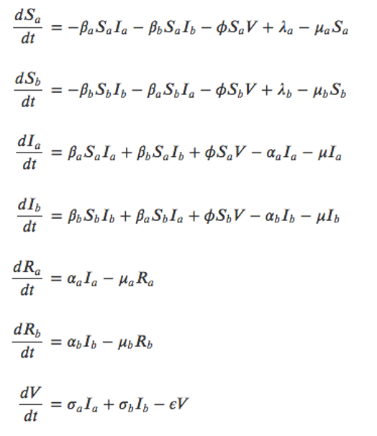

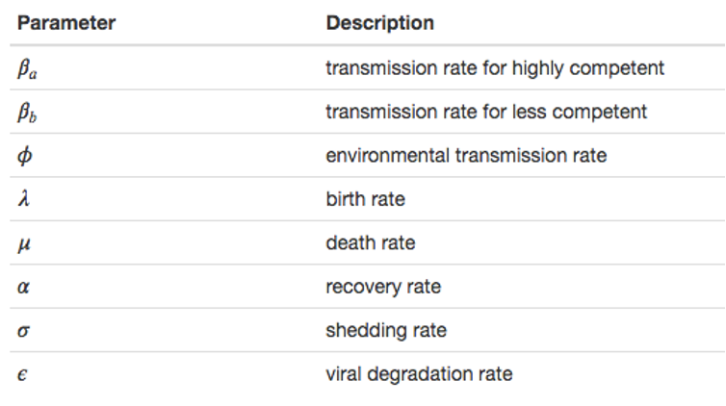

Equations and parameters

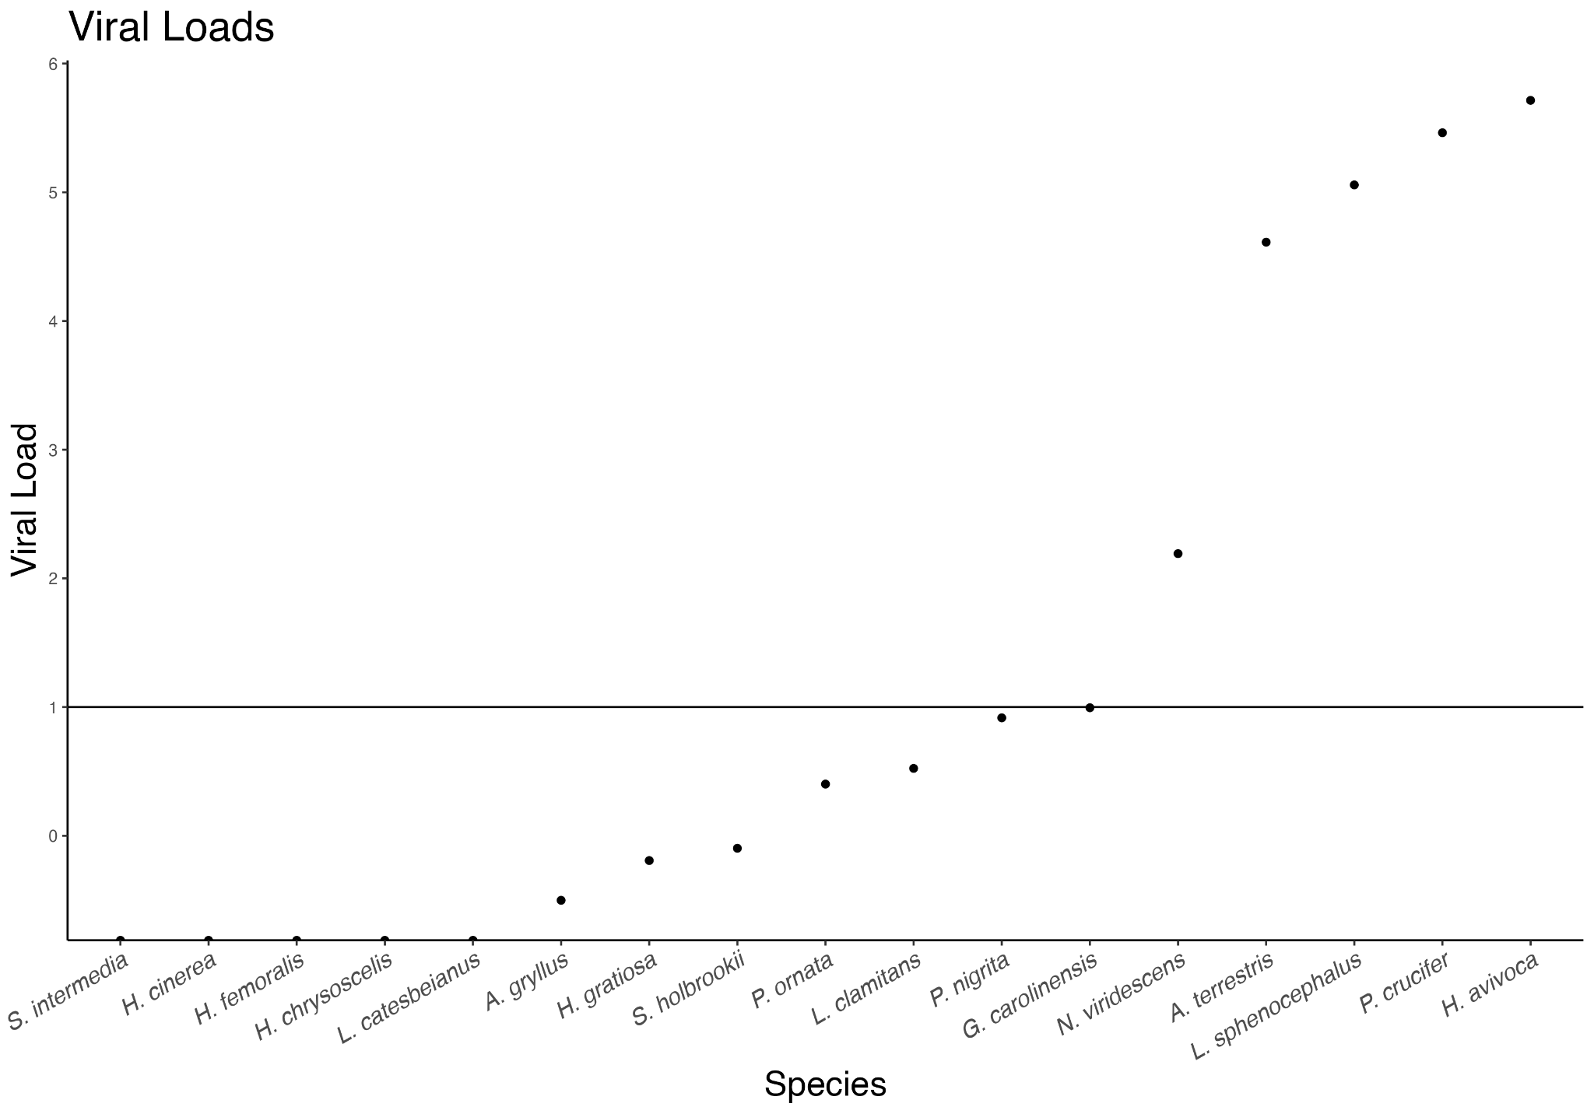

Supplementary Figure 1: Viral loads of all observed host species that were sampled for ranavirus. Viral loads show a bimodal distribution where most host species have relatively low viral loads and a few have high viral loads.

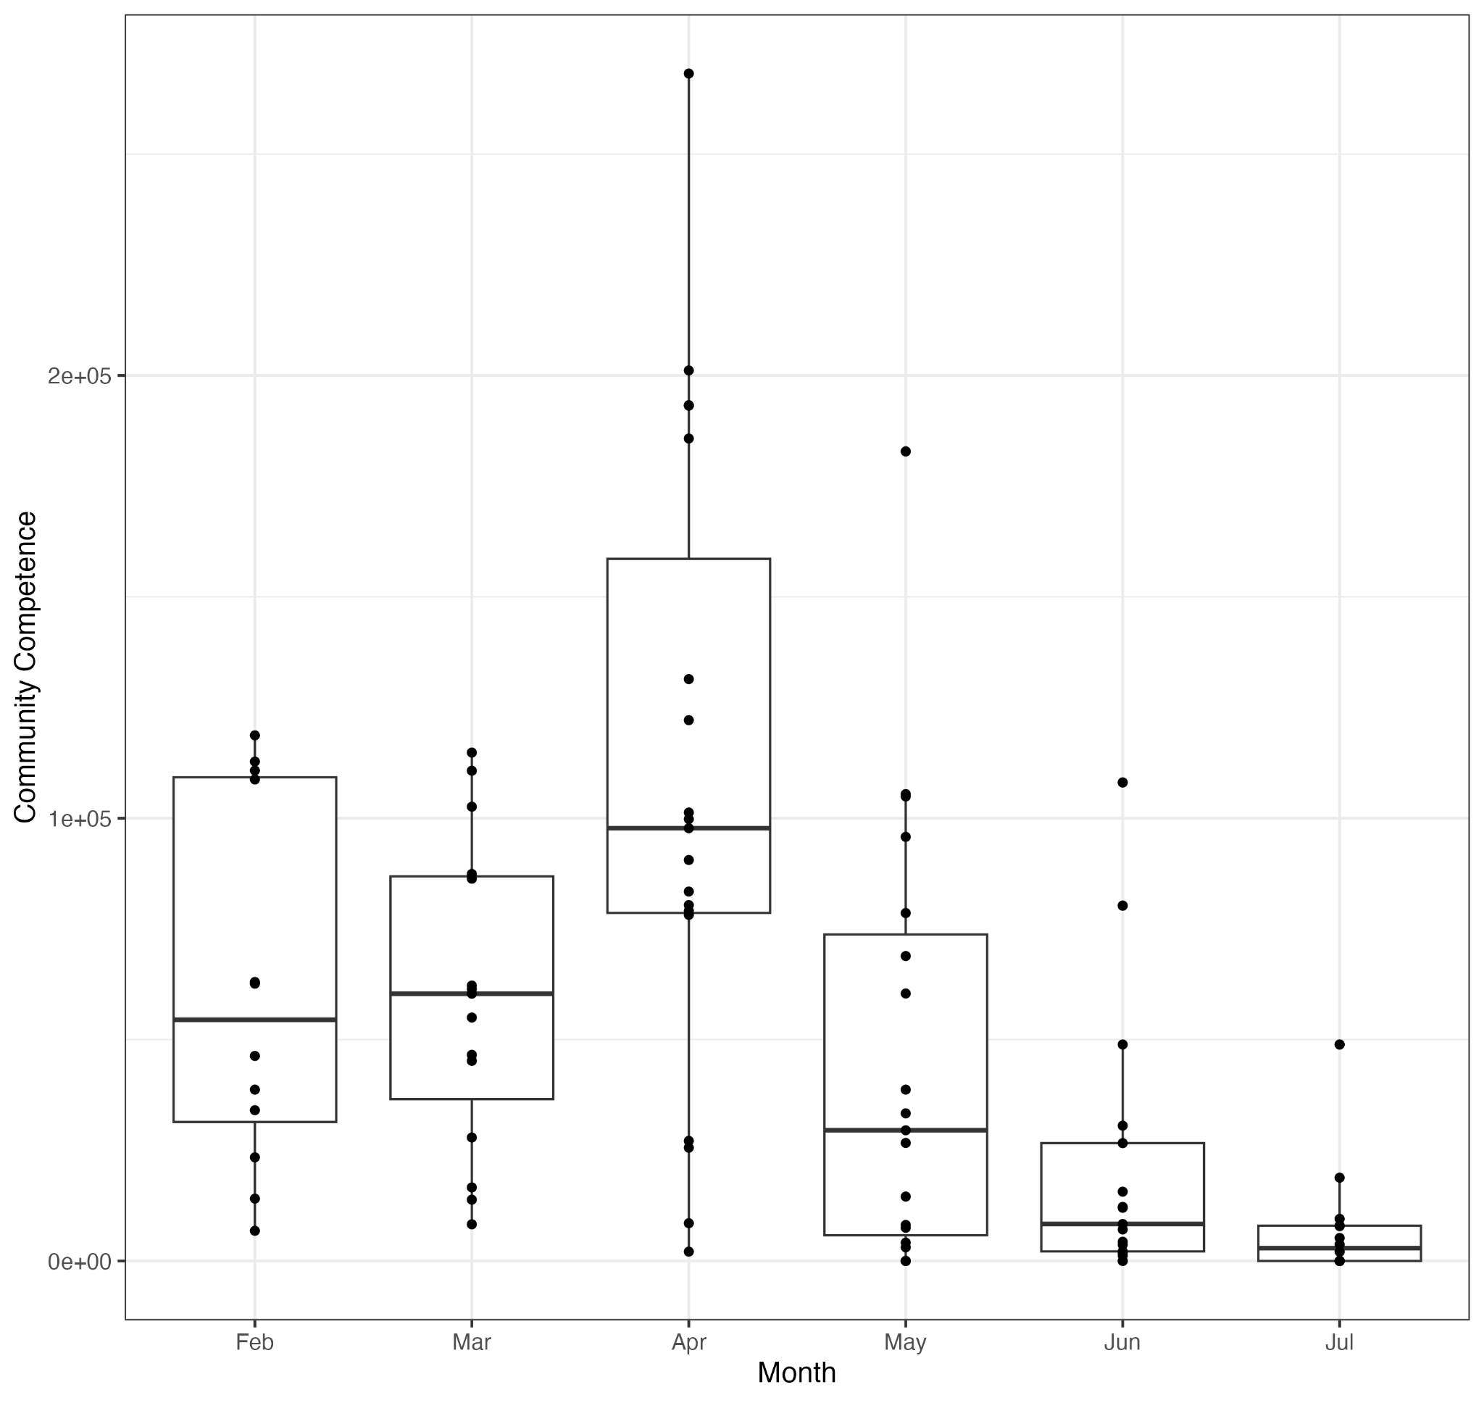

Supplementary Figure 2: Community competence of each community (site-month combination) over the duration of the study period grouped by observation month. Community competence is higher at cooler months (Feb-Mar) and peak in April before declining in later, hotter months.

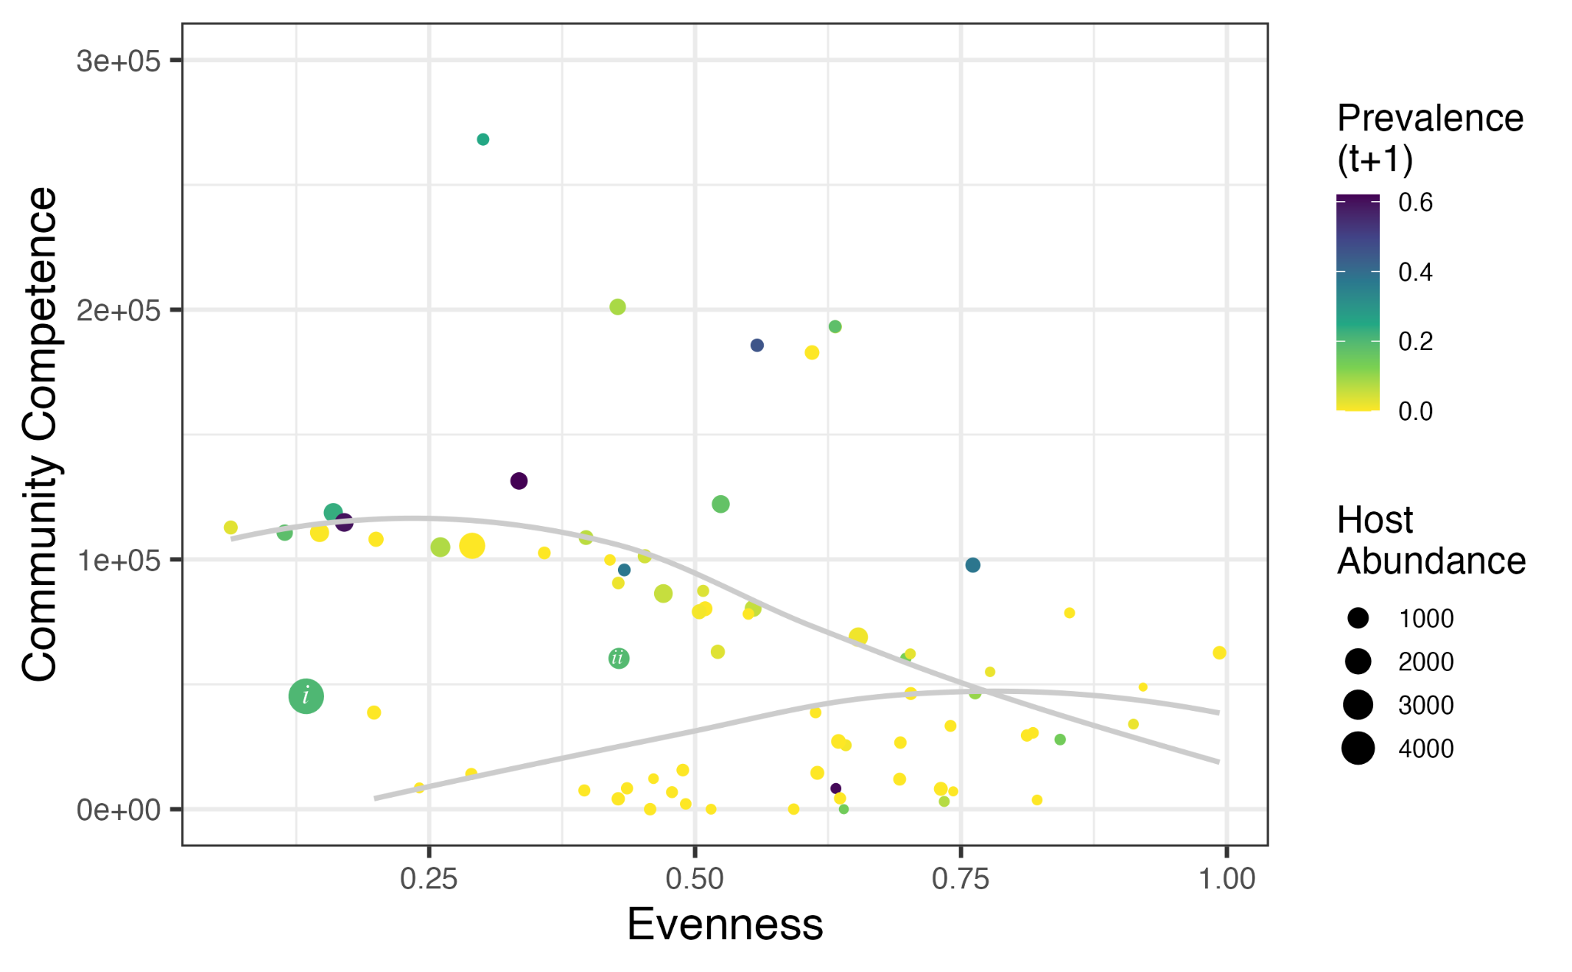

Supplementary Figure 3: Correlation between community competence and evenness of host communities. At low evenness, host communities exhibit a bimodality where some have very low community competence and others have very high community competence. Communities with higher evenness are not dominated by any one host species and exhibit more moderate values of community competence.

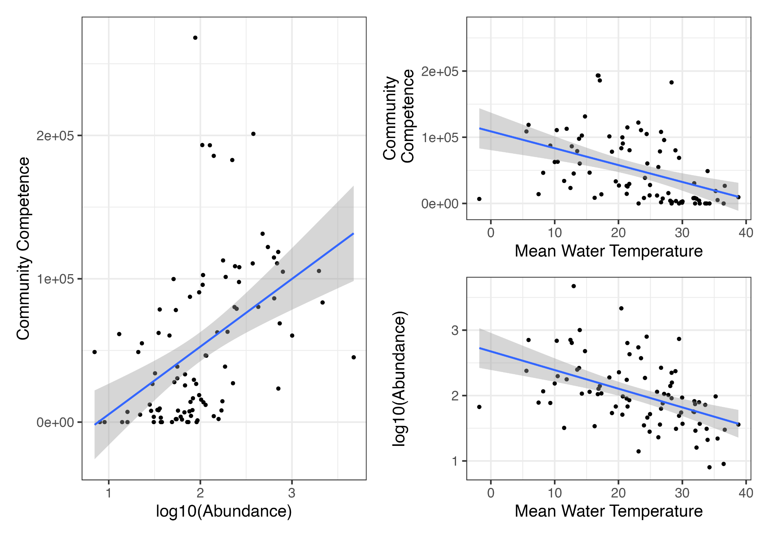

Supplementary Figure 4: Correlations between community competence, host abundance, and mean water temperature. Community competence correlates positively with host abundance and negatively with mean water temperature. These correlations result in instances where the community has high community competence, high abundance, and low water temperature – all factors which may contribute positively to ranavirus transmission.