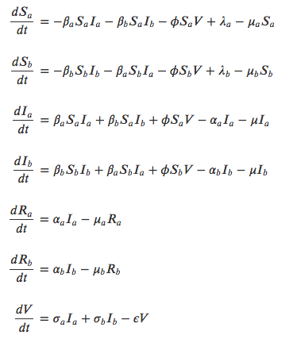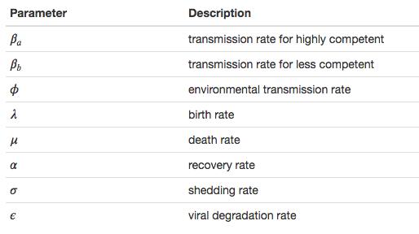

Equations and Parameters

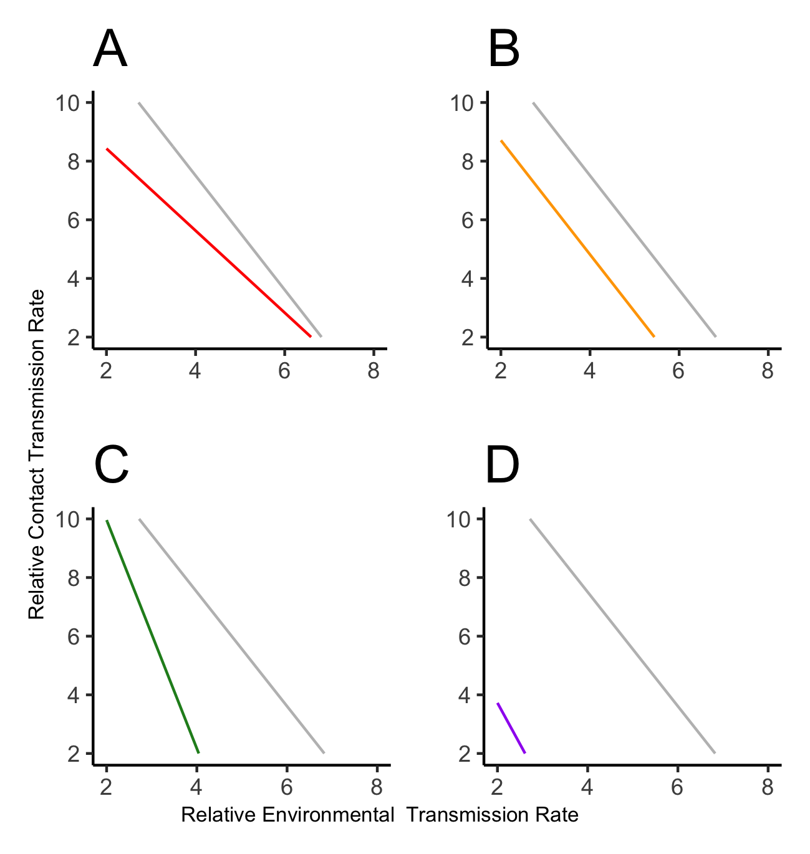

**Figure 1:** The parameter space in which R0>1 can be increased through changes in community composition, total host abundance, and viral half-life. The gray line in each plot represents a reference community that is the same throughout each. The colored lines represent manipulated communities. Plot D includes all manipulations and each of the other plots include only one manipulation (A = community composition, B = host abundance, and C for viral half-life). The change in parameter space favors parasite transmission in each manipulation but the change in the slope of the line is different in each plot, either favoring contact or environmental transmission or having no change at all.

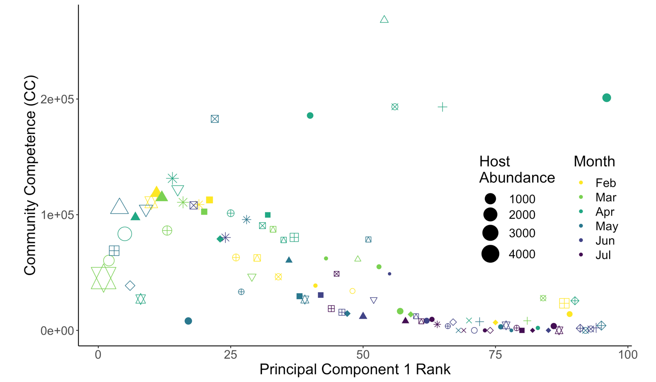

**Figure 2:** **Relationship between Community Competence of sites ranked according to Principal Component 1 Scores.** Similar community compositions result in similar values of community competence. Sampling months are represented by color and wetland IDs are represented by symbols. The size of each community is shown by the relative size of each point.

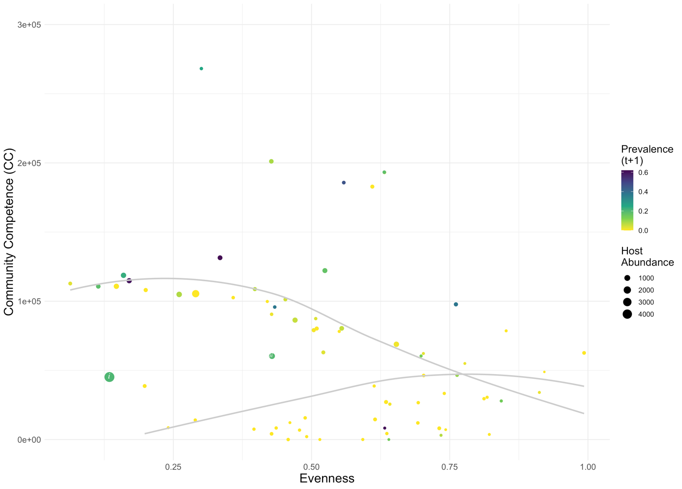

**Figure 3: The effect of Evenness on Community Competence and Parasite Prevalence.** Community competence has a bimodal relationship at low evenness and converges to moderate values of community competence at higher evenness. Future infection prevalence appears higher in sites with higher community competence. The two points (i and ii) at lower evenness and moderate community competence may have higher infection prevalence due to effects of host abundance.

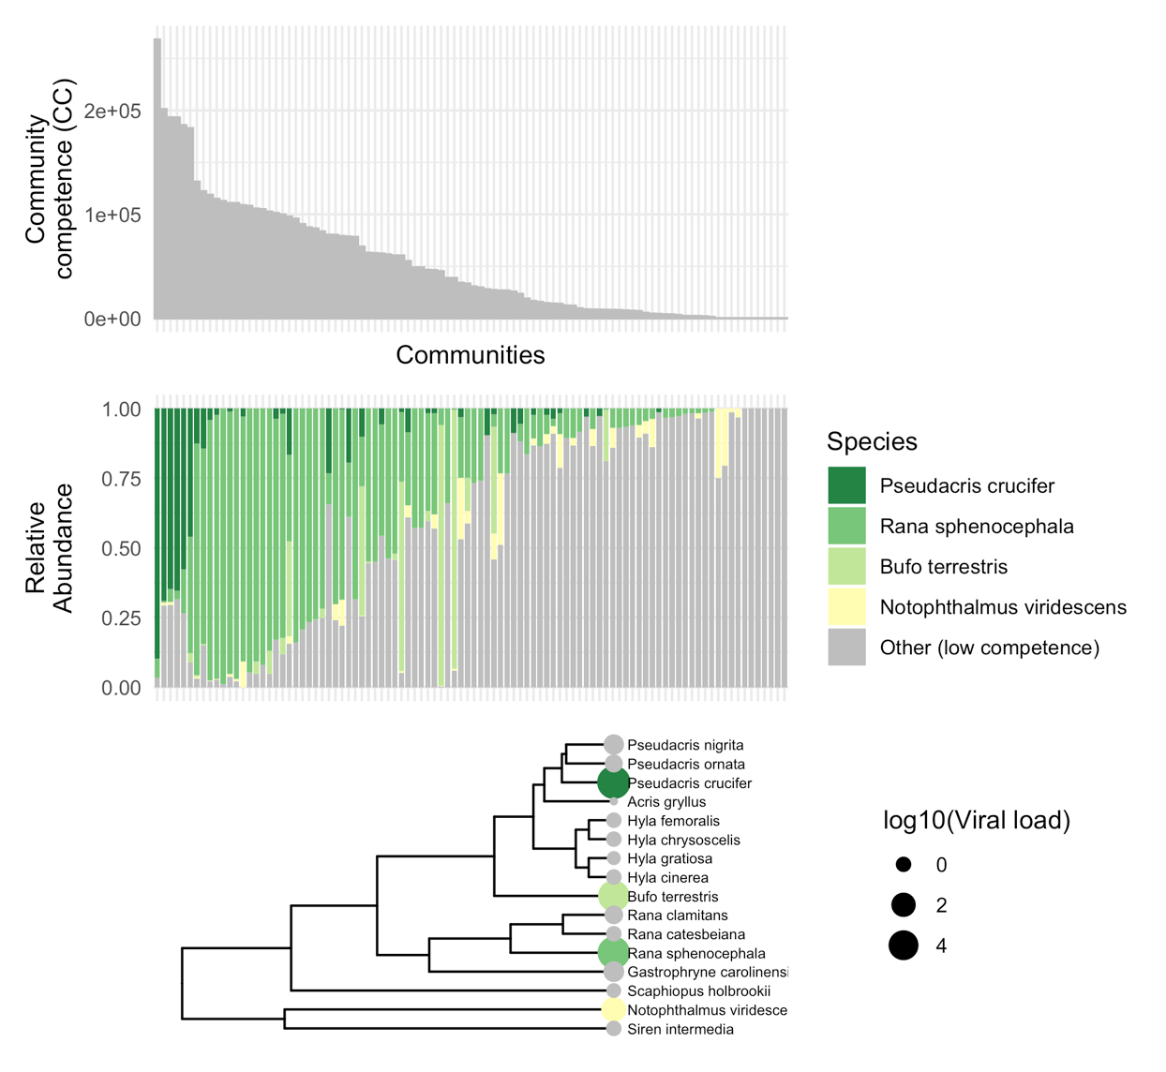

**Figure 4: Relative abundance of high competence species ordered in descending community competence, and phylogeny of amphibians with values of viral load (proxy for competence).** Sites with higher community competence are dominated by species of higher competence and high competence species tend to dominate communities when present. The phylogeny shows that high competence species are moderately dispersed, suggesting that these species may not be excluded by limiting similarity in these communities.

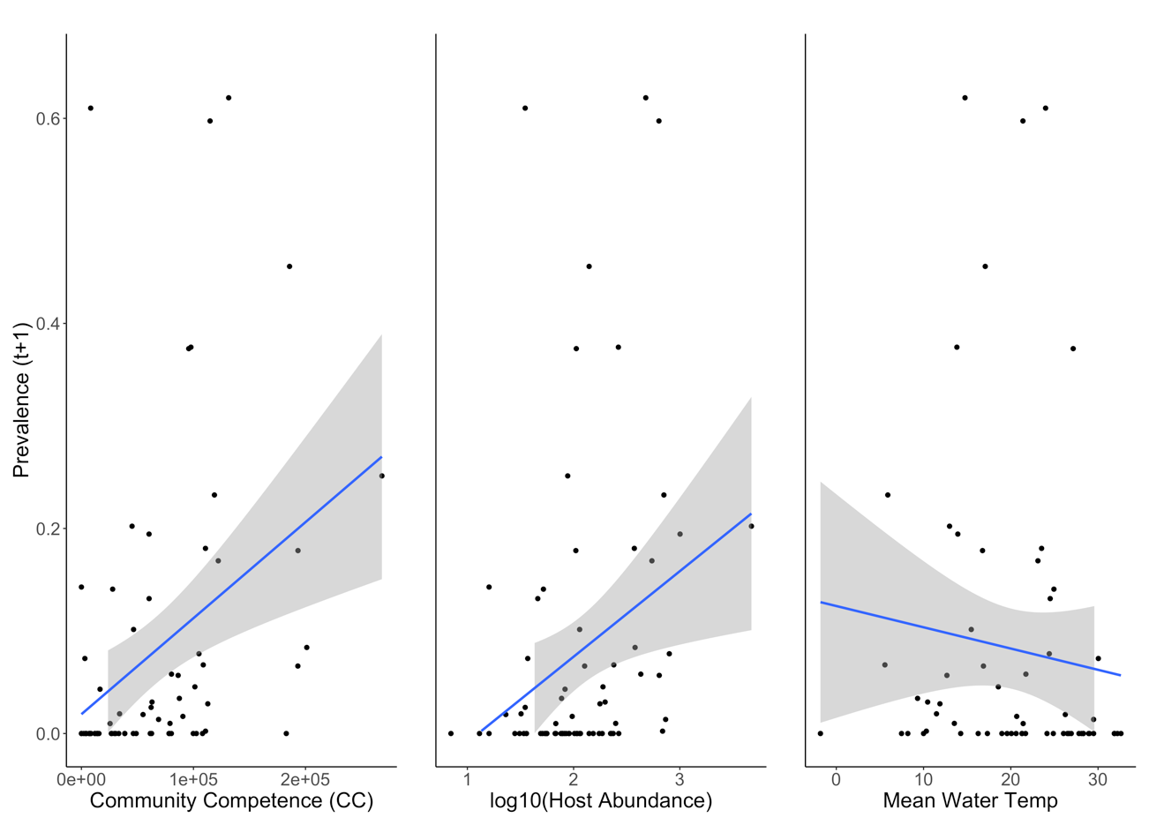

**Figure 5: Correlations between prevalence and community competence, community size, and mean water temperature.** Community competence and community size correlated positively with prevalence while mean water temperature correlated negatively with prevalence. Each of the independent variables were lagged by one month relative to the value for prevalence.

Supplemental Figures

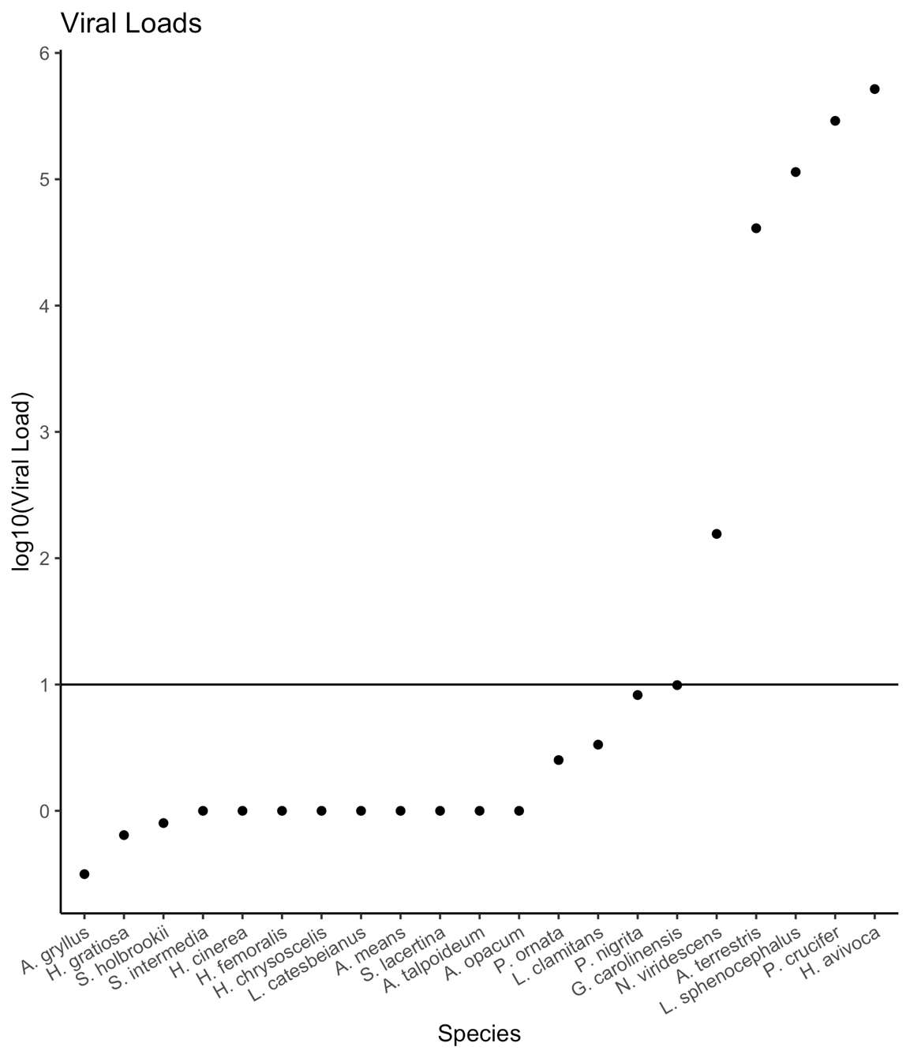

Supp fig 1

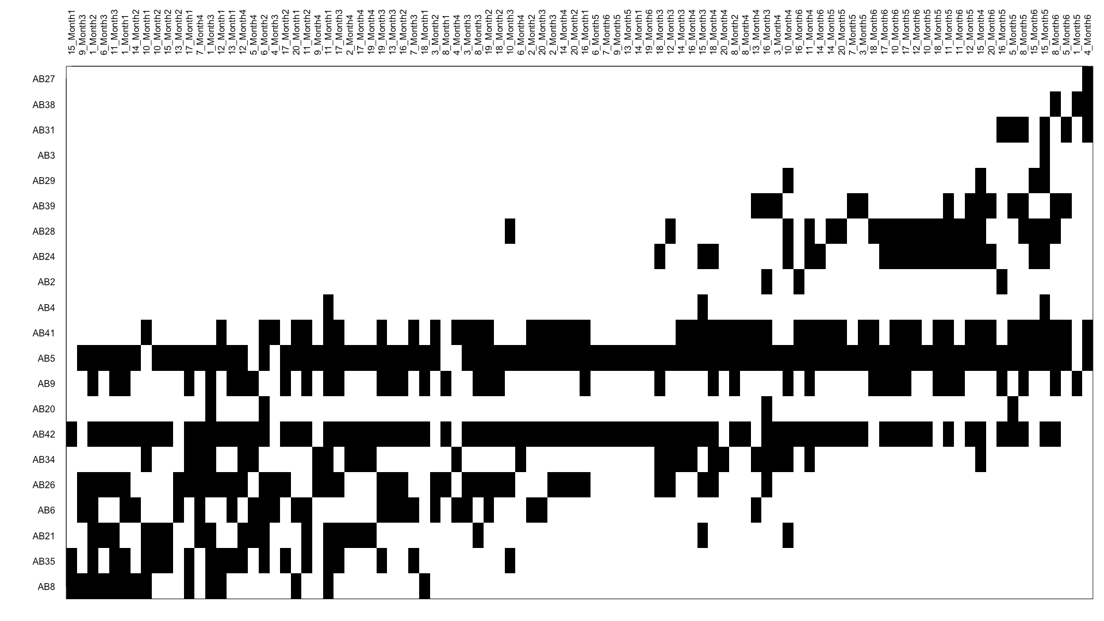

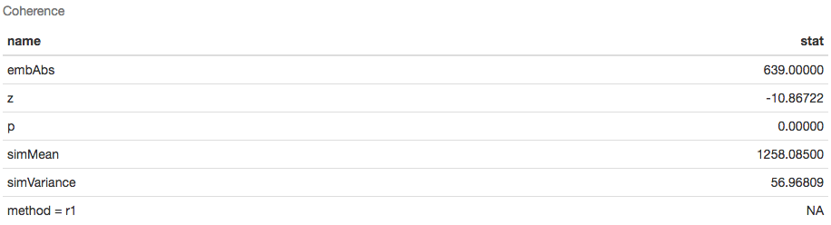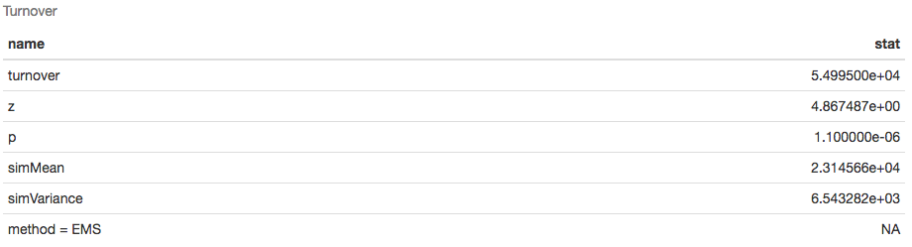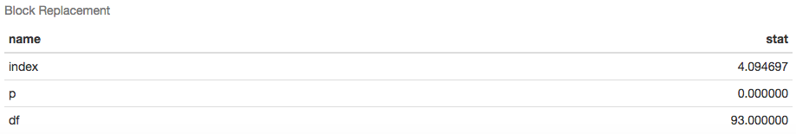

Supp fig 2

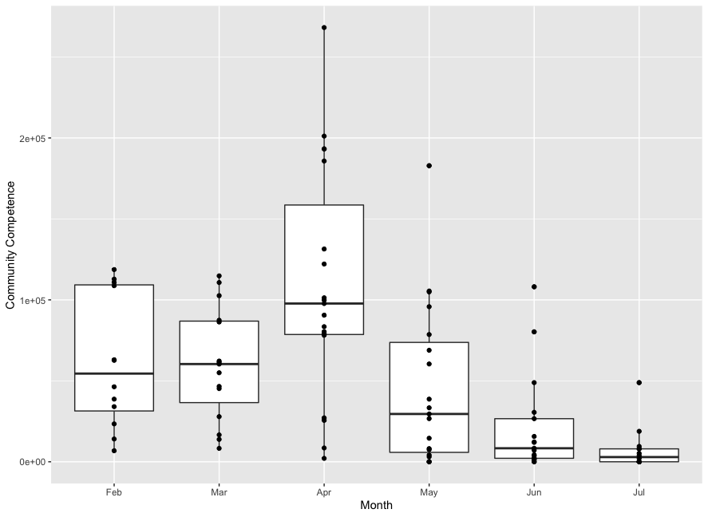

Supp fig 3a

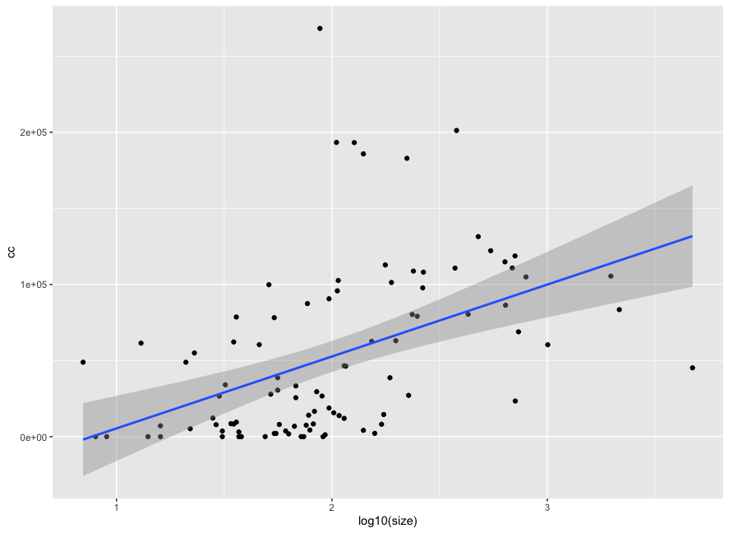

Supp fig 3b

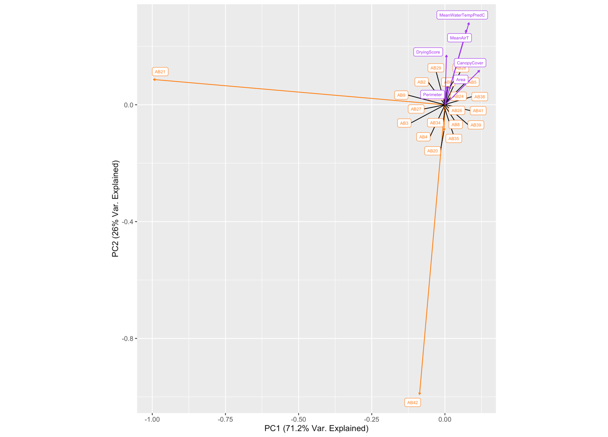

Supp fig 4

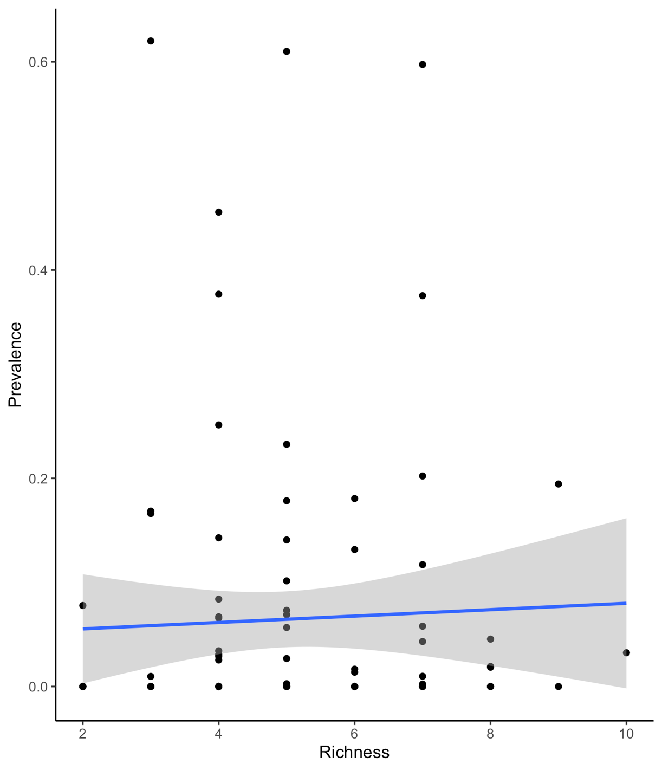

Supp fig 5

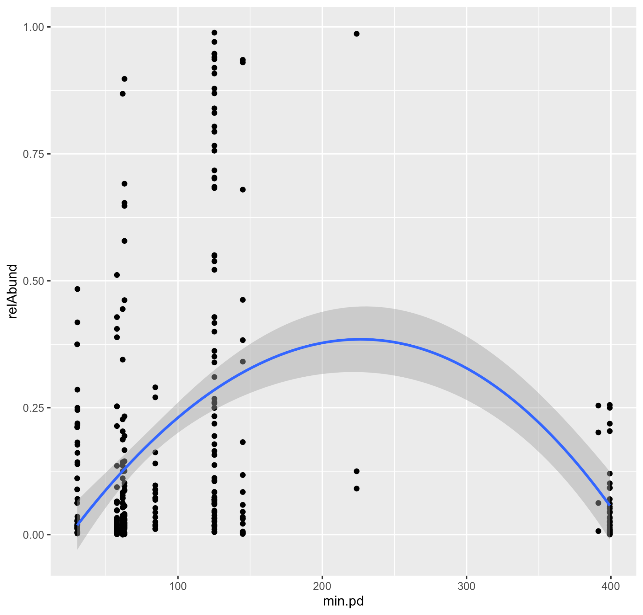

Supp fig 6