**DOM**

**DEADLINE:** 24/02/2019

**FOLDER STRUCTURE**

|  |  |
| --- | --- |
| FLX_homework_11/*     └─ task/      └─ FLX_homework_11.docx  └─ homework/*     └─ src/*  └─ app.js*  └─ assets/*  └─ img/*  └─ images…*  └─ material-icons/*  └─ material icons files…*  └─ styles.css*  └─ index.html* | * ­­­- required |

**TASK**

Using the standard JavaScript functions, create a TODO task list to prepare cat for doctor visit (see Figure 1). The list should support following functionality:

* Add new action. If ‘add new action’ input is empty plus button is disabled.
* Mark action as done. Marked action can’t be unchecked. (checkbox)
* Delete action. When user press ‘delete’ icon, item is removed without any confirmation.
* Drag & drop action. Each item can be moved up and down through list.
* Max item per list is 10.
* When list is full, input and plus button are disabled. Under ‘TODO Cat list’ header, notification ‘Maximum item per list are created’ is displayed.

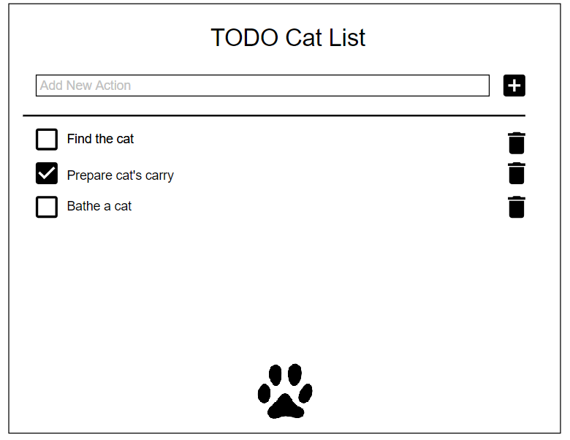

Figure 1 — General UI view

NOTE: Icons can be found at the link - <https://material.io/icons/> (they are already included).

Use icons like this:

<i class="material-icons">done</i> will display icon -> 

**RESTRICTIONS**

* jQuery or another JS library is forbidden.

**BEFORE SUBMIT**

* Verify that code is formatted.
* Remove unnecessary code.
* Verify that all functionality is implemented according to requirements.
* Remove or add comments.

**SUBMIT**

* The folder should be uploaded to github repository **‘FLX’** into **master** branch.

**USEFUL LINKS**

* <https://developer.mozilla.org/uk/docs/Web/API/Document>
* <https://learn.javascript.ru/traversing-dom>
* <https://www.html5rocks.com/ru/tutorials/dnd/basics/>
* <https://www.w3schools.com/htmL/html5_draganddrop.asp>