**UDP service**

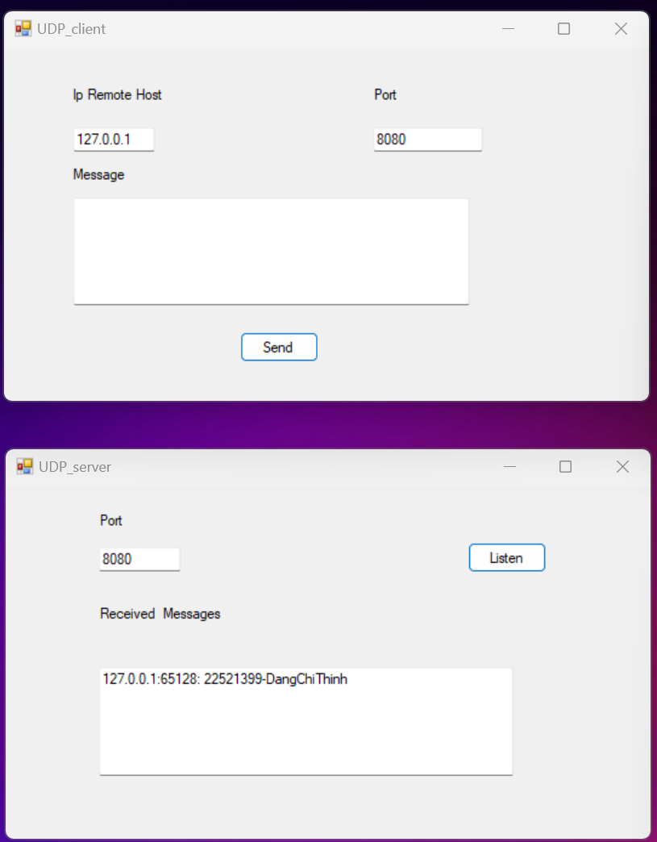

Source code:

CLient UDP

private void button1_Click(object sender, EventArgs e)

{

UdpClient udpClient = new UdpClient();

IPAddress ipadd = IPAddress.Parse(textBox1.Text);

int port = Convert.ToInt32(textBox2.Text);

IPEndPoint ipend = new IPEndPoint(ipadd, port);

Byte[] sendBytes = Encoding.UTF8.GetBytes(textBox3.Text);

udpClient.Send(sendBytes, sendBytes.Length, ipend);

textBox3.Text = "";

}

Server UDP

public void serverThread()

{

int port = Convert.ToInt32(textBox1.Text);

UdpClient udpClient = new UdpClient(port);

while (true)

{

IPEndPoint IpEnd = new IPEndPoint(IPAddress.Any, 0);

//Đón nhận và đẩy dữ liệu nhận được vào mảng Byte

Byte[] recvBytes = udpClient.Receive(ref IpEnd);

string Data = Encoding.UTF8.GetString(recvBytes);

string mess = IpEnd.Address.ToString() + ":" +

IpEnd.Port.ToString() + ": " + Data.ToString();

// Gọi hàm hiển thị thông điệp nhận được lên màn hình

InfoMessage(mess);

}

}

private void InfoMessage(string message)

{

if (InvokeRequired)

{

Invoke(new Action<string>(InfoMessage), message);

return;

}

// Update UI here, for example:

textBox2.AppendText(message + Environment.NewLine);

}

private void button2_Click(object sender, EventArgs e)

{

Task.Run(() => serverThread());

}

**TCP service**

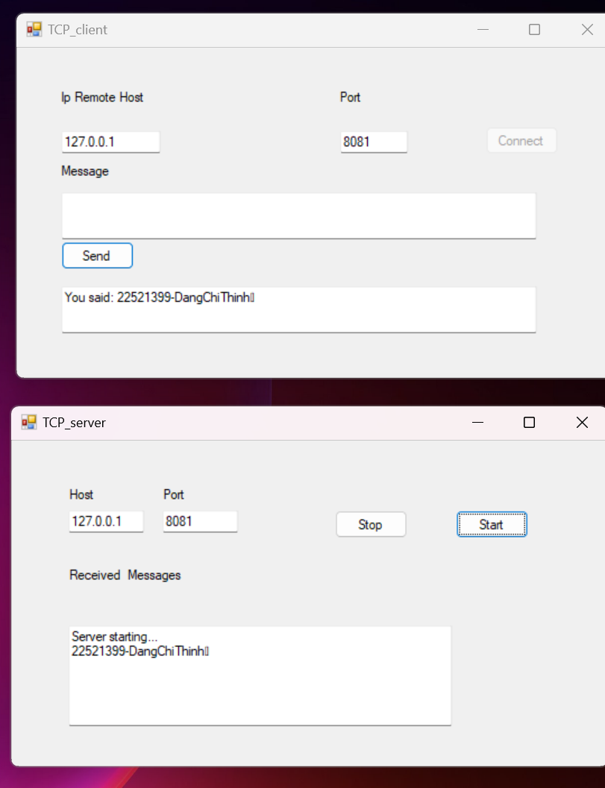

Source code: Trong code này có cài đặt package SimpleTCP.Nên trong trường hợp reuse code thì phải install package SimpleTCP sau đó rebuild lại project.  
TCP client:

SimpleTcpClient client;

private void button1_Click(object sender, EventArgs e)

{

client.Connect(textBox1.Text, Convert.ToInt32(textBox2.Text));

button1.Enabled = false;

}

private void TCP_client_Load(object sender, EventArgs e)

{

client = new SimpleTcpClient();

client.StringEncoder = Encoding.UTF8;

client.DataReceived += Client_DataReceived;

}

private void Client_DataReceived(object sender, SimpleTCP.Message e)

{

textBox4.Invoke((MethodInvoker)delegate ()

{

textBox4.Text += e.MessageString + "\r\n";

});

}

private void button2_Click(object sender, EventArgs e)

{

client.WriteLine(textBox3.Text);

textBox3.Clear();

}

TCP server:

SimpleTcpServer server;

private void Server_DataReceived(object sender, SimpleTCP.Message e)

{

textBox2.Invoke((MethodInvoker)delegate ()

{

textBox2.Text += e.MessageString;

e.ReplyLine(string.Format("You said: {0}", e.MessageString));

});

}

private void button2_Click(object sender, EventArgs e)

{

if (server.IsStarted)

{ server.Stop(); }

}

private void button1_Click(object sender, EventArgs e)

{

textBox2.Text += "Server starting..." + "\r\n";

if (IPAddress.TryParse(textBox3.Text, out IPAddress ip))

{

server.Start(ip, Convert.ToInt32(textBox1.Text));

}

else

{

// Display an error message if the IP address is invalid

textBox2.Text += "Invalid IP address!";

}

}

private void TCP_server_Load(object sender, EventArgs e)

{

server = new SimpleTcpServer();

server.Delimiter = 0x13;

server.StringEncoder = Encoding.UTF8;

server.DataReceived += Server_DataReceived;

}