**Keyword strategy for 1 Million Women To Tech**

# 1 Million Women To Tech: Week 3 Hackathon

**The Market Gap**

While there are some online courses and blogs targeting women (and people identifying is non-binary), the competitors in this space are few. Therefore, there is huge potential for building a strong online following and community with the production of good, content that really speaks to this audience.

**Trending Searches: Women, Non-Binary, Learn Coding**

**Women (+ coding)**

Research using Google Trends (trends.google.com) on searches that include women and coding show that the terms ‘women coding’ and similar phrases are most commonly searched in western countries. Search rates are reasonably low though consistent. They are regularly 30 – 100 per week (2).

As there are few searches for these terms together, there is only a small amount of traffic to be gained by targeting these terms. However, there are also few competitors for these terms. Therefore, by publishing well written pages/articles that target searches that include both ‘women’ and ‘coding’ related words has a good chance of winning the majority of this traffic.

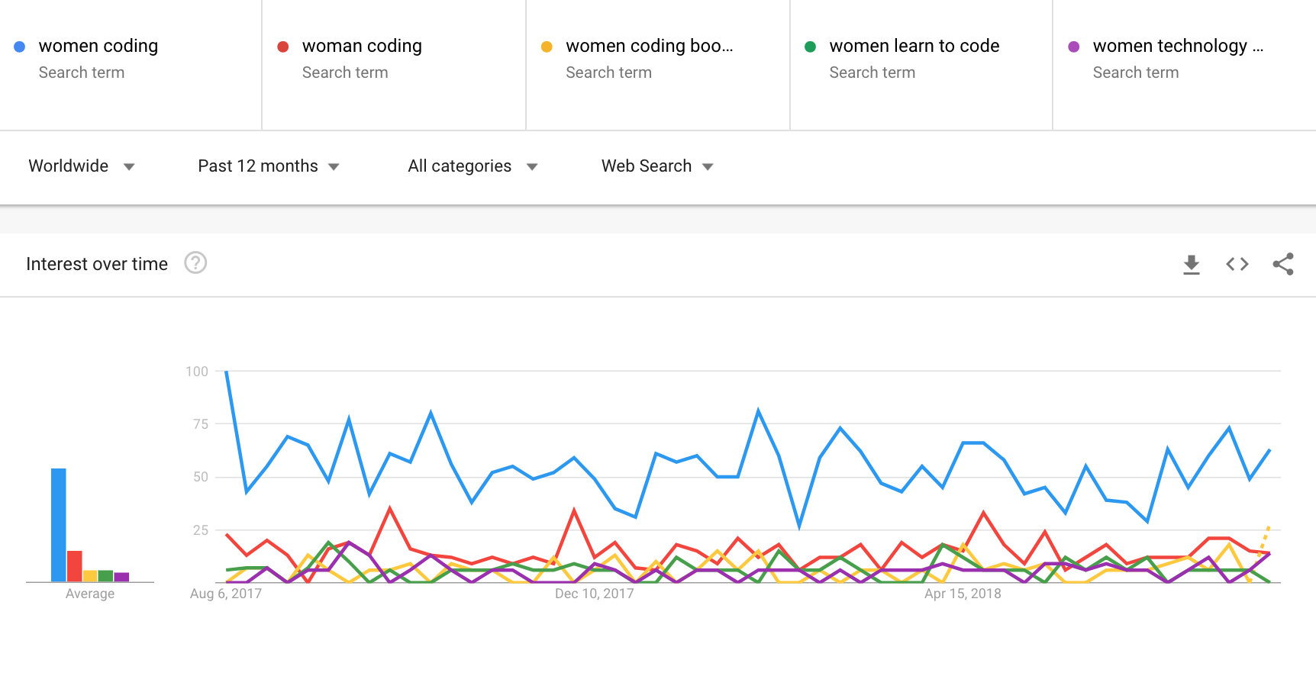

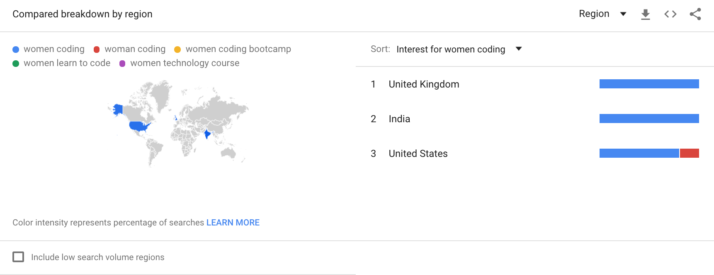

**Non-Binary**

Again, research using Google Trends (trends.google.com) into the terms that people are commonly searching shows that people while the term ‘enbie/s’ is used in the US and UK, it is not a commonly searched term in the rest of the world.

More commonly searched terms(1) are:

1. Genderqueer
2. Agender
3. Non-binary
4. Genderless
5. Pangender
6. Enbies
7. Ungendered
8. Non-gendered
9. Genderfree

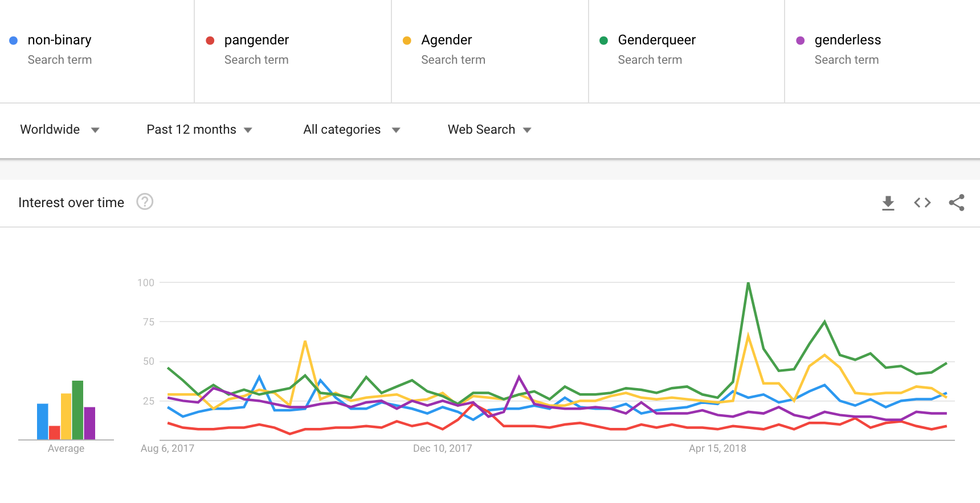

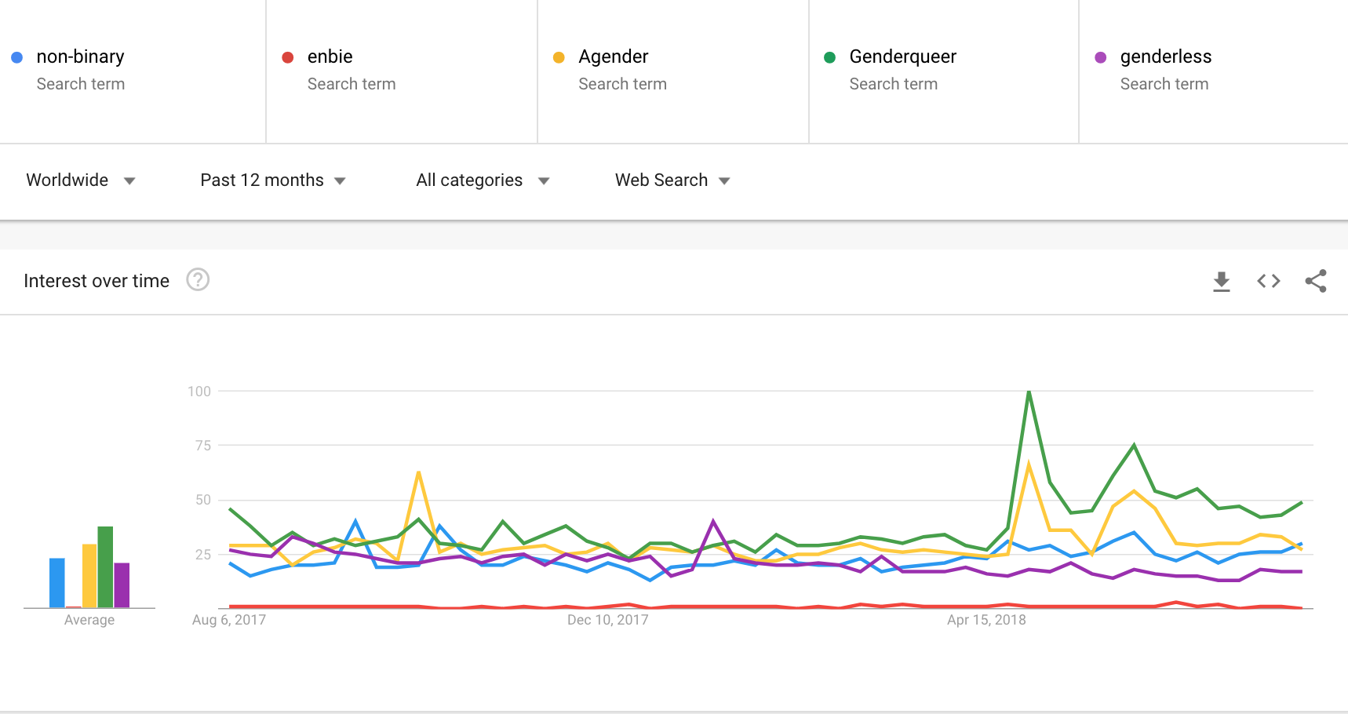

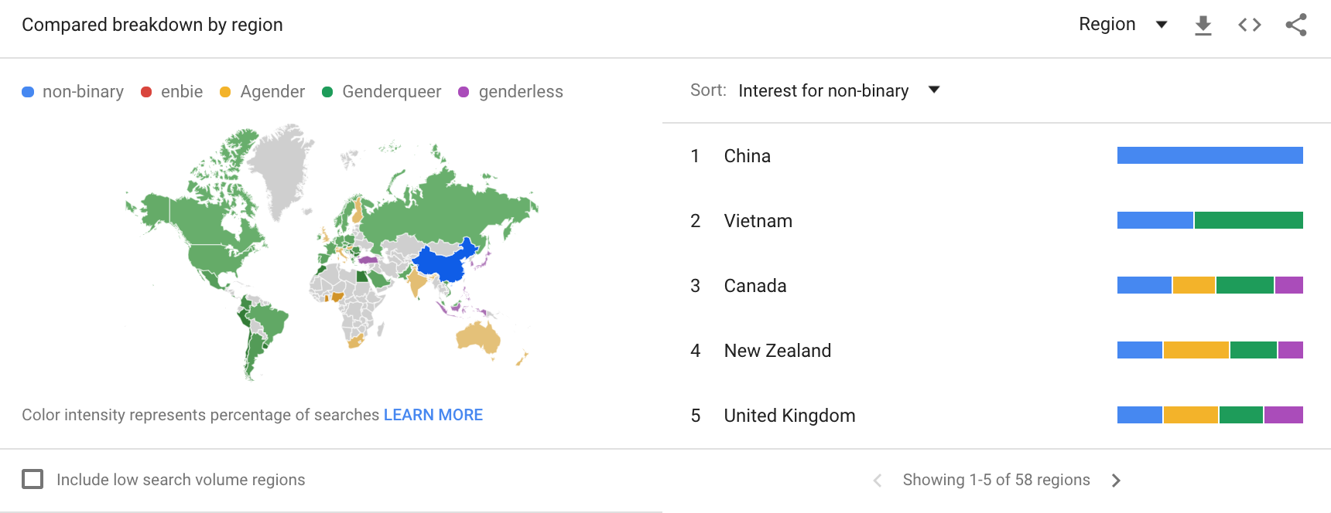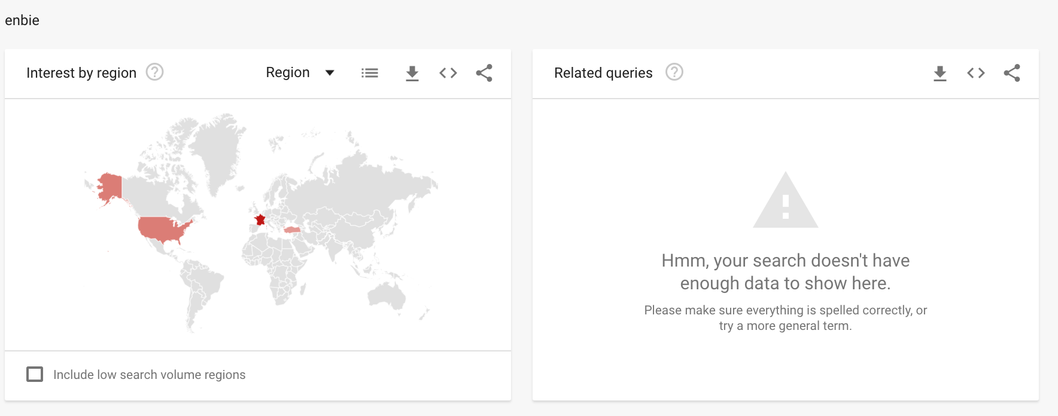

Based on this, perhaps the term ‘non-binary’ or ‘agender’ people/person would be a more globally recognised way of referring to people.

There wasn’t enough data (or searches) for google to return information on terms including both the top 5 searched non-binary related terms **and** ‘coding’/ ‘code’ / ‘learn coding’ etc.

Similar to ‘women’ and ‘coding’, there are even fewer searches for ‘non-binary’ and ‘coding’ together. Though the amount of traffic to be gained is small, there are also few competitors for these terms. Therefore, just a few strong pages/articles targeting these searches should easily win the majority of this traffic.

**Learn Coding**

Interestingly, search trends on terms including and close to ‘learn coding’ have a similar search rate as ‘women coding’ – 40 – 100 per week (3). However, the competition to win these terms is much higher. There are a large number of competitors providing free and low-cost online coding courses.

While it is still relevant for 1 Million Women to Tech to aim to rank for these keywords, this should not be the main goal of the content strategy. Ranking for these terms is likely to take some time and will require a large number of links to the 1MWTT domain, particularly from domains with high authority (i.e. are well established).

The best way to achieve this will be to request endorsement through partner links to the 1MWTT website, and to continue to encourage word-of-mouth recruitment and brand awareness. Media coverage by online news sites and popular blogs will also assist in raising the ranking of the 1MWTT’s website for these competitive keywords.

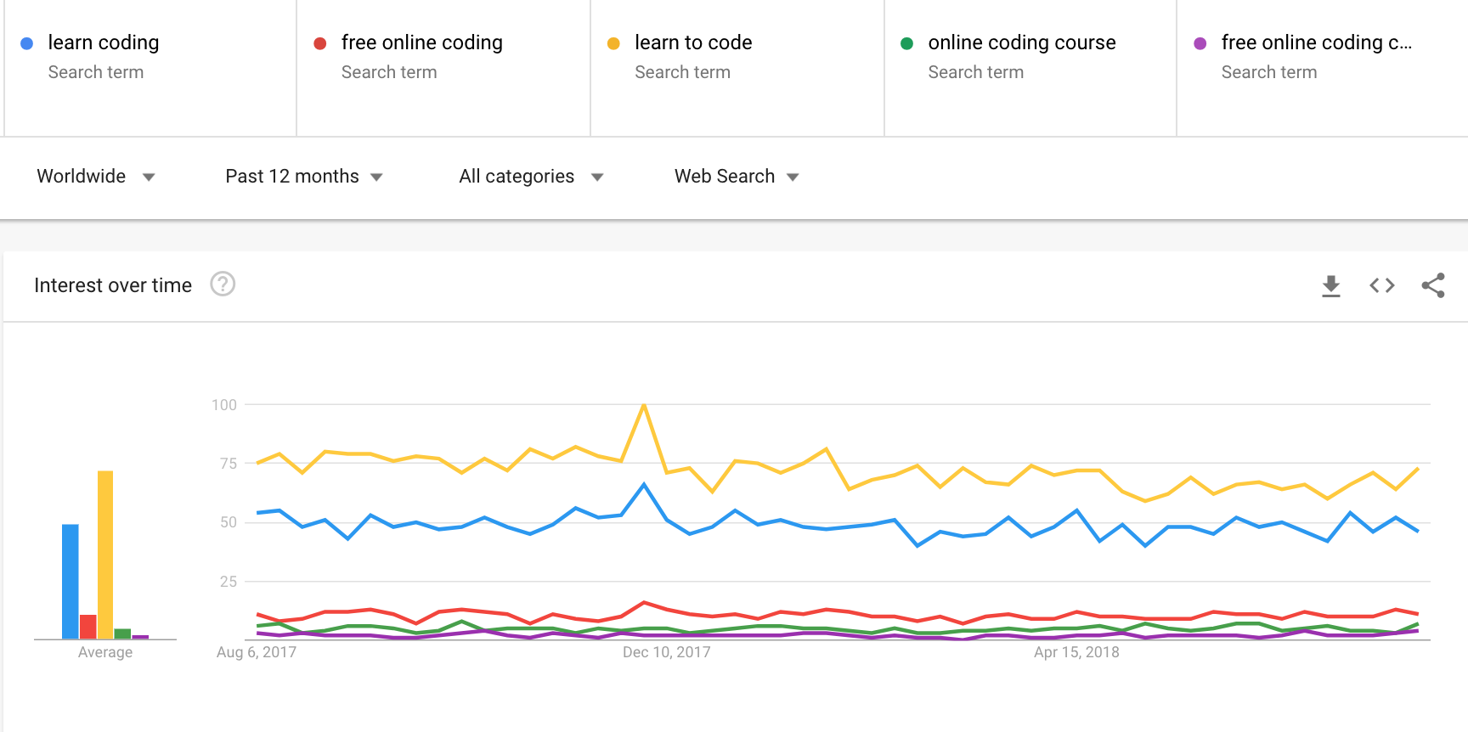

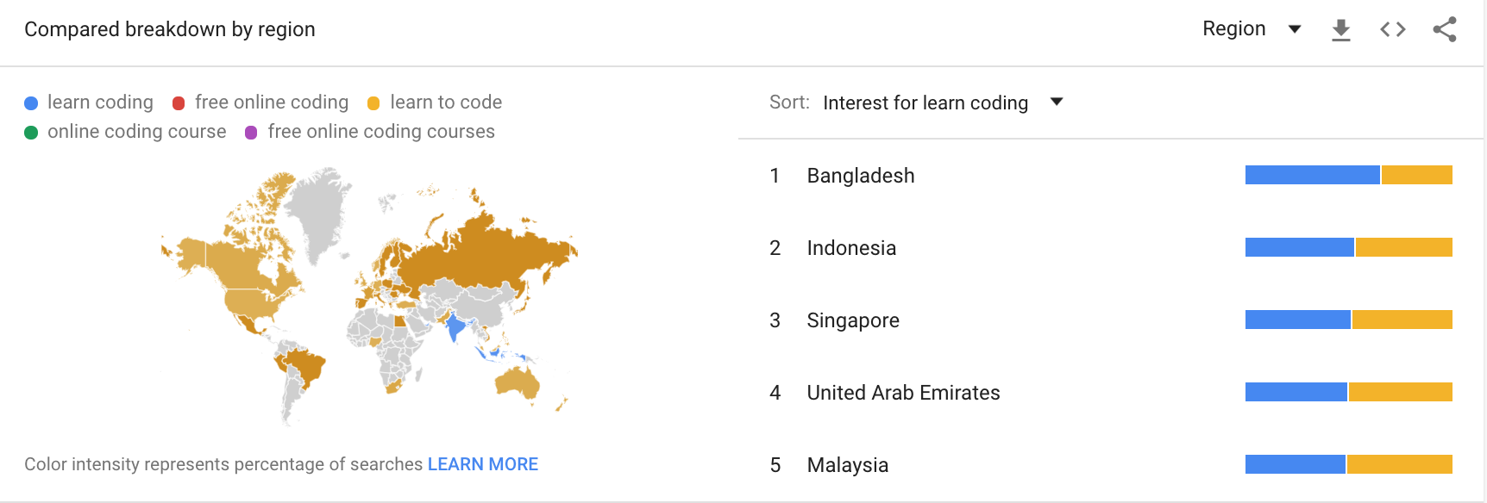

**Keywords to Target**

In the attached file (4) is a combined list of all of the keywords the google ads keyword planner recommends 1mwtt competitors (5) to target. This submission recommends targeting keywords that are commonly recommended across more than one of the competitor sights. These are highlighted in red in the file (4).

Good keywords to target are those that receive more than 100 monthly searches, have low to medium competition, and are relevant to 1mwtt. Potential women related keywords to target have been highlighted in blue. A quick search did not show any non-binary related keywords.

The keyword planner results for each individual competitor page is available in the folder ‘competitor_keywords’. Not all competitors had enough content/received enough traffic for google to suggest keywords. Only those highlighted in green in file (5) returned recommendations from the google keyword planner.

**Blog Article Checklist**

1. **Varied content types.** Post several different types of content—lists, feature articles, interviews, etc—and monitored their success. With such a diverse audience, the 1MWTT community will like different types of content.
2. **Free resources.** As a learning community and because 1MWTT is educational organisation these type of posts will encourage both user engagement and newletter signups.
3. **Proactive list building.** Start a 1MWTT newsletter and proactively build your email list. It’s only been about a month, but you have thousands of new followers online. Now is the perfect time to draw them and build a closer, stronger community.

**Blog Strategy**

Follow similar approach to Free Code Camp – combination of storytelling, knowledge sharing.

**Hosting Suggestion:**

* Create a Medium 1MWTT blog roll. Medium uses an algorithmic timeline that suggests to its readers what stories they might be interested in. Publishing is very simple, and formatting is difficult to mess up. Posts will always look good.
* Medium has a strong DA, so no need to build 1MWTT’s before Google will send traffic there (con, articles published will not contribute as much to 1MWTT’s domain authority.
* Company using Medium successfully e.g. FreeCodeCamp uses Medium as their blog platform well. This is their blog home page: https://medium.freecodecamp.org/

**Writers, editors & writing:**

* Leverage network and supporters – invite network to submit articles for publication:
  + Mentors
  + 1MWTT students
  + Development Professionals
* Recruit a group of 5 – 10 volunteer editors willing to review 1 – 2 articles / month, 2 – 4 editors should have good technical knowledge of a couple of coding languages, esp. python and js. Must have strong level of English and a good grasp of coding knowledge useful but not essential (except for quite technical articles).
* Provide very clear article guidelines, including language, grammar style, including of images, image alt text, headings etc.

**Types of content:**

* **Vary content types:** Post several different types of content—lists, feature articles, interviews, etc—and monitored their success. With such a diverse audience, the 1MWTT community will like different types of content.
* **Storytelling:** people working as developers and how they got there, women taking/who have taken the 1mwtt SOC course and want to share their story.
* **Knowledge sharing:** relevant to different levels of knowledge:
  + High level topics from academics/ experienced developers
  + How to articles of different levels. Can be written by reasonably inexperienced coders about simple concepts
  + Interesting applications of programming in real word situations, especially impact focused projects/businesses
  + Focus on Python and JS – the languages taught in SOC
* **Publish Longer posts:** min 800 words. Thousands of words (within reason) is ok. Many online readers engage deeply with long-form content, so long as it is adding value the entire way!
* **Share Free resources:** As a learning community and because 1MWTT is educational organisation these type of posts will encourage both user engagement and newletter signups.

**Regularity of posting:**

* Minimum 1 post / week, up to 1 post per day. Depending on volunteer editor availability.
* Leverage current SOC program and invite article submissions from current students and mentors. This one program could generate enough article submissions for 6 months – a year’s supply of content, depending on the regularity of posting.

**Article Guidelines:**

1. As much as possible, have articles scheduled at 4-6 weeks in advance;
2. Editorial consistency — Ensure each article goes through an editorial process so each is consistent and meets a publishable standard:
   * Articles should be in English and be carefully checked for grammar, spelling (and coding) errors
   * Making sure all paragraphs are short and readable
   * Include article subheadings and ensure they are numbered correctly
   * Provide a banner image (that is legal to use) for every article
   * Include approximately 2 image per 200 words, spaced throughout the article. Cite all images and provide alt text and captions where relevant.
   * Every article should link to other 1MWTT articles, where relevant
   * All links should be carefully checked
   * If authors are comfortable, they should include a picture of themselves and a brief bio (no more than 50 words).   
     Possibly allow to include a link to their LinkedIn/GitHub/Portfolio Website?
3. First-time writers should be supported with a structured process, including article templates, and a review process.

**Files referenced:**

1. non_binary_search_multiTimeline.csv, non_binary_search_geoMap.csv
2. women_coding_search_multiTimeline.csv, women_coding_search_geoMap.csv
3. learn_coding_search_multiTimeline.csv, learn_coding_search_geoMap.csv
4. 1mwtt_keywordplanner_comb.xml
5. 1mwtt_competitor_research.xlsx