**Demonstration of resonant wireless power Transfer using Toy racing Cars and Tracks**

Tanit Wisessri

Chatpisut Promsatarporn

**Asst.Prof. Denchai Worasawate**

**Department of Engineering, Faculty of engineering, Kasetsart University**

Call 0-2549-3429, 0-2549-3420 Fax 0-2549-3422 E-mail: [fengntk@ku.ac.th](mailto:fengntk@ku.ac.th)

Abstract

Nowadays, spending time charging your car at a charging station is a waste of time and a waste of job opportunities. Charging a car may require booking a charger or queuing to charge and it may take about 30 minutes to fully charge. In this project will be a demonstration of resonant wireless power transfer using toy racing cars and tracks. To make a wireless power transfer and the car is moving smoothly, a dynamic wireless power transfer (DWPT) system was chosen for transfer power and the alternately coupled magneto inductive (ACMI) waveguide with alternate magnetic coupling polarities between successive resonator cells is proposed for a true nulls-free DWPT system with no use of active components for moving smoothly. This project starts with buying an oscillator that can generate 13.56 MHz, buying an amplifier to expand 1000 times of the signal from the oscillator and design attenuator PCB board. Then, design DWPT and ACMI. Finally, test a car moving through the track.

**1. Introduction**

For EV charging, wireless power transfer (WPT) technology has been used. Through electromagnetic coupling, the WPT system may transport power from the transmitting side to the receiving side. As a result, when the EVs are close to the WPT facilities, the batteries can be charged without physical touch. When compared to traditional charging methods, WPT provides advantages to drivers such as safety, convenience, and ease of use. However, the stationary WPT system has yet to tackle two intrinsic problems: a longer charging time than typical fuel-filling time and a lower mileage than engine-powered vehicles.

The dynamic wireless power transfer (DWPT) system is a promising solution to the concerns raised above. DWPT allows the EV to be powered constantly while in motion by the transmitter installed beneath the roadway. It is possible to charge and consume energy at the same time. As a result, the driving range of EVs can be greatly enhanced. Meanwhile, the battery capacity, as well as the cost and weight, might be reduced.

**2. Objectives**

To engage people's curiosity about the fascinating topic of electromagnetic waves and its practical applications.

To create functional and efficient wireless power transfer technologies, such as Dynamic Wireless Power Transfer (DWPT) and Alternately Coupled Magneto Inductive (ACMI) systems, that can be utilized in various everyday scenarios.

**3. Procedures and methods of operation**

1. Study of wireless energy transmission systems.
2. Design transmitter circuit
3. Design radiator
4. Design receiver
5. Summarize the results of the experimental

**4. Related Theories**

**4.1. Theory of Wireless Power Transmission**

Wireless power transmission is the conversion of electrical energy into other forms of energy that can travel without the use of conductors. The process involves a transmitter that sends power to a receiver, which then converts the energy back into electrical energy. Nicola Tesla pioneered the concept in 1899, using a massive square coil to generate a 150 kHz signal with a power output of up to 300 kW. Tesla's experiments demonstrated that when energy was discharged from a copper ball, it induced a DC voltage of approximately 100 MV in the air.

**4.2. Wireless Power Transmission System Infrastructure**

**4.2.1. Wireless Power Transfer Technology**

Wireless power transmission is classified based on the transmission distance into two types: short-range Electromagnetic Induction and long-range Electromagnetic Radiation. Short-range transmission can be further classified based on the type of energy used, including Electrodynamic Induction using magnetic and electromagnetic induction, and Electrostatic Induction transferring energy using an electric field.

**4.2.2. Electrodynamic Induction**

Wireless electric power transfer can use coils as transmitting and receiving devices to transfer electrical energy from low voltage to high voltage. This process is known as magnetic connection and occurs through the induction of a magnetic field. Efficient energy transfer through magnetic fields occurs at the resonant frequency of the system.

**4.3. Types of EV Wireless Charging Technology**

**4.3.1. Static Wireless Charging System**

Stationary wireless charging is a method that allows electric vehicles to charge while parked. The process involves parking the vehicle over a wireless charging station with a receiver located on the undercarriage. Proper alignment of the transmitter and receiver is necessary before leaving the vehicle to complete the charging process. Factors that affect charging time include distance between the transmitter and receiver, size of the pads, and power output of the AC source.

**4.3.2. Dynamic Wireless Charging System**

Dynamic Wireless Power Transfer (DWPT) is a technology that can help reduce range anxiety in electric vehicles and lower the cost of onboard batteries. It enables wireless charging while the vehicle is in motion by using a stationary transmitter to send electricity to a moving vehicle's reception coil. With this system, electric vehicles can continuously recharge their batteries while driving, which can extend their trip range and reduce the need for large energy storage. Additionally, the weight of the vehicle can be reduced since it no longer requires huge battery storage.

**4.4. Alternately Coupled Magneto inductive**

The Alternately Coupled Magneto Inductive (ACMI) coil arrangement is a new approach to implement Dynamic Wireless Power Transfer (DWPT) that aims to achieve nulls-free power transfer. Conventional DWPT using Magneto Inductive Waveguides (MIWs) is known to suffer from power transfer nulls caused by standing waves, which result from changing phases during propagation and reflection. These nulls can be overcome with minimal increase in complexity and cost by utilizing the characteristic of oppositely propagating waves with the same magnitude becoming out-of-phase and resulting in power cancellation, using the ACMI arrangement.

**5. The results of the experimental**

**5.1. Work piece**

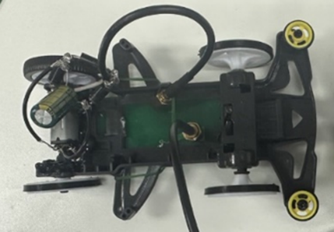

FIGURE 1 Work piece of Rx coil and receiver circuit

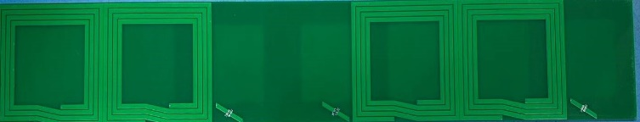

FIGURE 2 Work piece of Tx coil

**5.2. Connect transmitter circuit, radiator, and receiver with load 50 ohms from spectrum analyzer to measure efficiency.**

We measure output from amplifier, and we get approximately 1 watt or 29.9dBm. Then, we measure output from receiver coil. The measured efficiency (η) at 13.56 MHz versus the normalized Rx positions are given in Fig.3.

**5.3. Connect transmitter circuit, radiator, and receiver with load to measure efficiency.**

The power of input to transmitter coil is approximate 1 watt and the output of power by using resister 100 Ω to measure voltage. At the nominal height of 2 cm, the measured efficiency (η) at 13.56 MHz versus the normalized Rx positions are given in Fig.4.

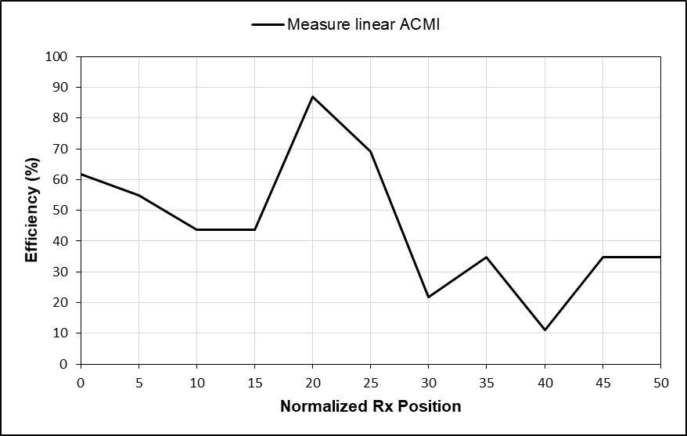

FIGURE 3 Efficiency with load 50 ohms from spectrum analyzer

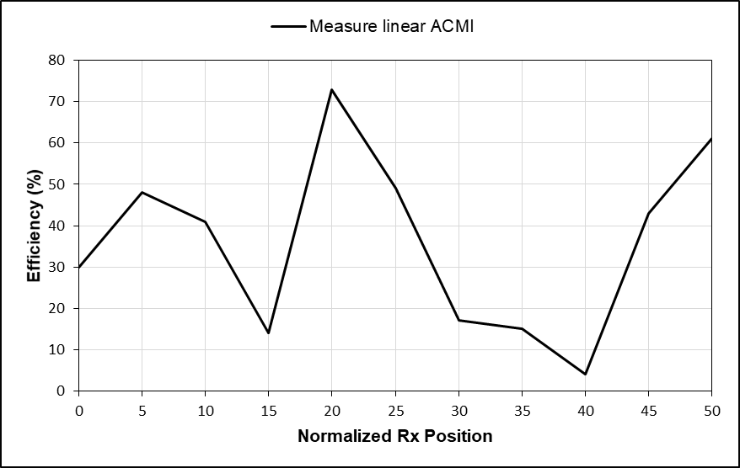

FIGURE 4 Efficiency with load 100 ohms

**6. Conclusion**

ACMI is a practical and efficient technology for Dynamic Wireless Power Transfer (DWPT), which uses magnetic-inductive coupling to transfer energy through an electrical path. It has higher energy transfer accuracy than other wireless energy transfer technologies and can transfer up to 80 percent of energy before loading. Although there is a range where energy transfer is only 10 percent, it can still transfer energy without any power loss or nulls. ACMI was tested by providing energy to a load and making a car run on a track, with the motor adjusted to use less power. The technology is small, easy to install, and has the potential to be a useful tool for wireless energy transfer.

**7. Acknowledgements**

This project was successfully completed with kindness from Asst.Prof. Denchai Worasawate the project advisors who gave advice, suggestions and concepts, as well as helping to solve any flaws and problems that have always arisen during the project work. The developer therefore would like to thank you very much and thanks to the Department of Electrical Engineering Faculty of Engineering Kasetsart University for being generous with the location and equipment for the preparation of the project, including grants to support the project.

Thank you to those who have helped others. Everyone, including fellow students and professors in the Department of Electrical Engineering Faculty of Engineering Kasetsart University who helped until this project was successfully completed.

**8. References**

**References**

A Comparative Study of the Efficiency of Dynamic Wireless Power Transfer with Resonant Frequency, <http://digital_collect.lib.buu.ac.th/project/b00257293.pdf>

[Retrievedon December 2022].

Developing a dynamic wireless power transfer system that supplies electricity to the car while driving, https://bit.ly/3uXdXni

[Retrieved on December 2022].

C. Rakluea, A. Worapishet, S. Chaimool, Y. Zhao and P. Akkaraekthalin, "True Nulls-Free Magnetoinductive Waveguides Using Alternate Coupling Polarities for Batteryless Dynamic Wireless Power Transfer Applications," in IEEE Transactions on Power Electronics, vol. 37, no. 8, pp. 8835-8854, Aug. 2022, doi: 10.1109/TPEL.2022.3145579.