1. Download the program from the link provided.

<https://downloadly.ir/software/engineering-specialized/sonnet-suite/>

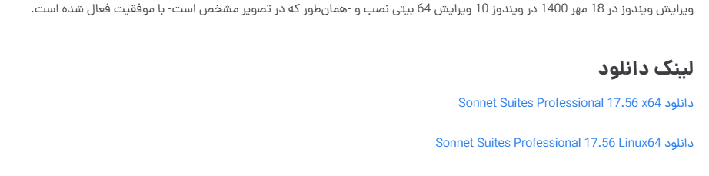

1. Once the file extraction is complete, proceed to set up Sonnet until it is complete.

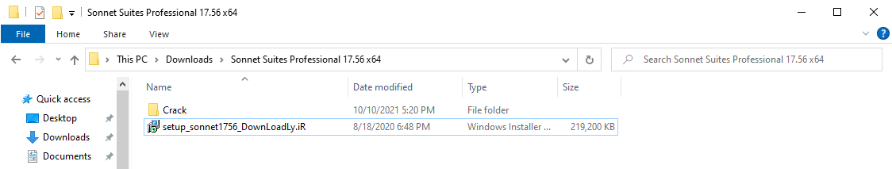

1. Search for "Virus & threat protection" in the Windows search bar and open it.

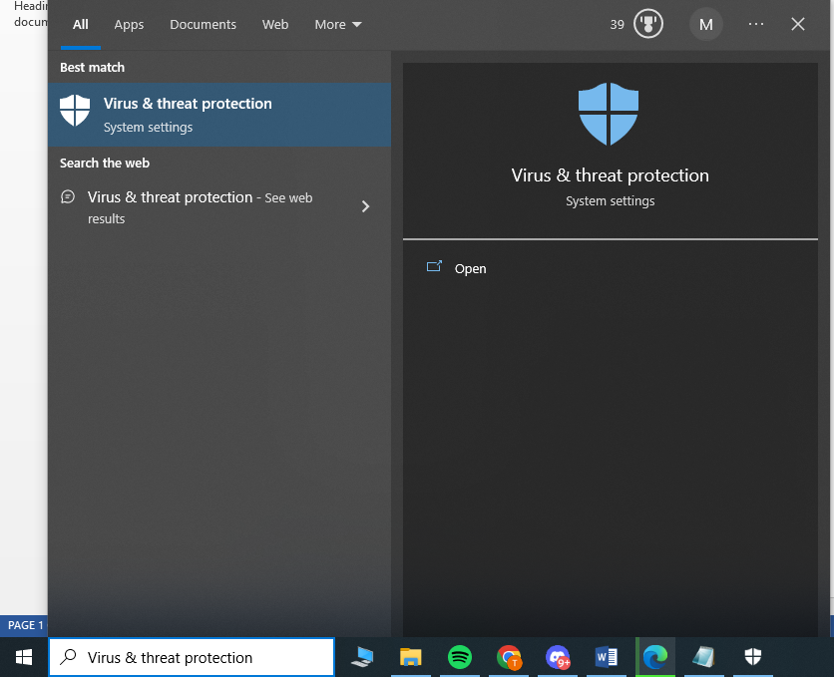

1. 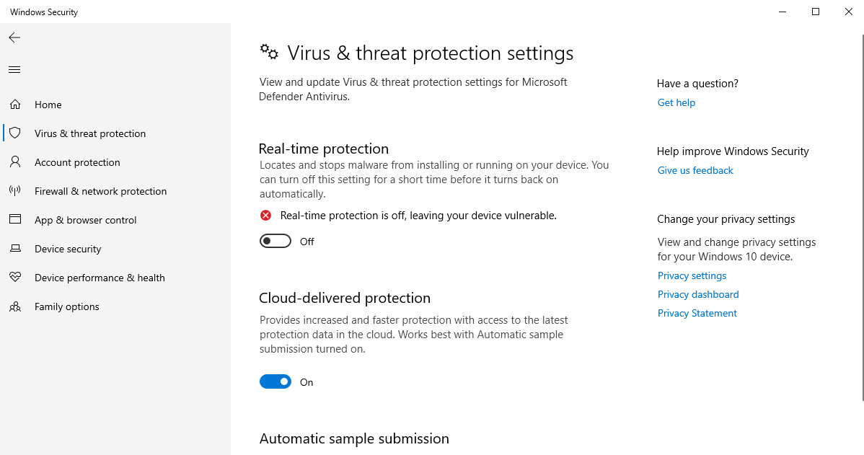close Real-time protection
2. 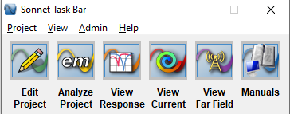 Run Sonnet to find the Host ID by selecting the "ADMIN" menu.
3. 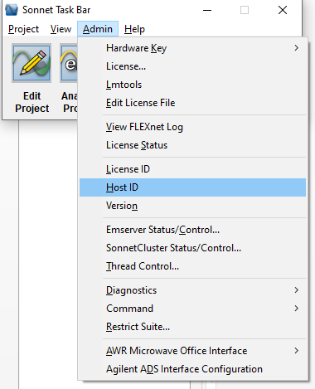Choose Host ID

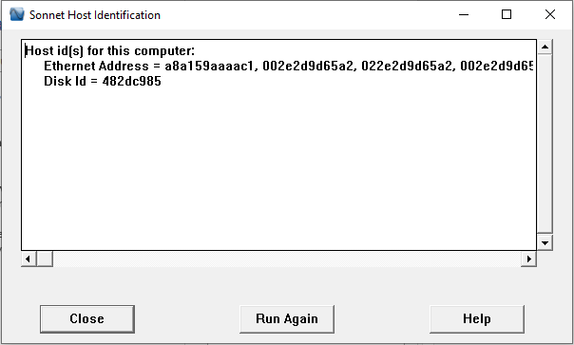

1. Open Crack folder

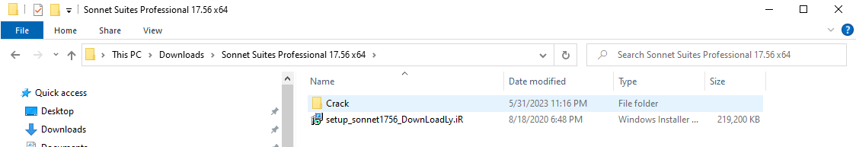

1. Run "sonnetd_nl_DownLoadLy.iR.src" file with Notepad

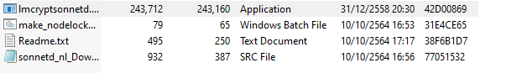

1. Change all "000000000000" with your machine HOST ID 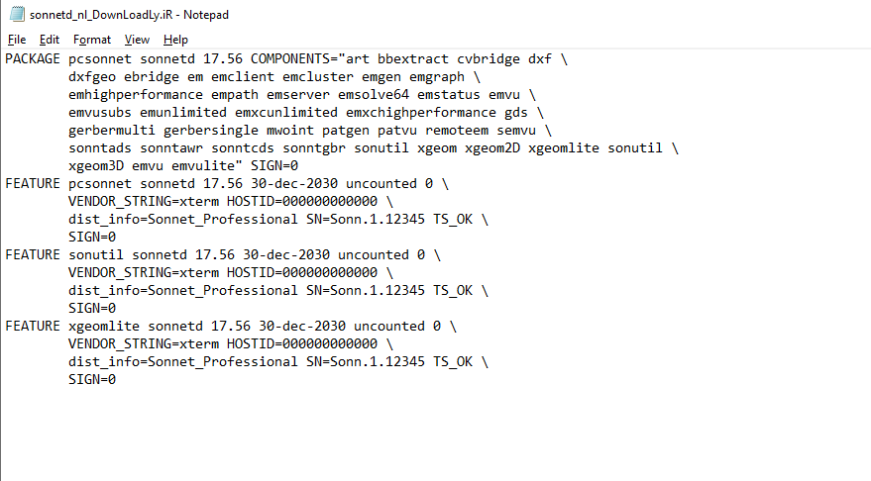Save file

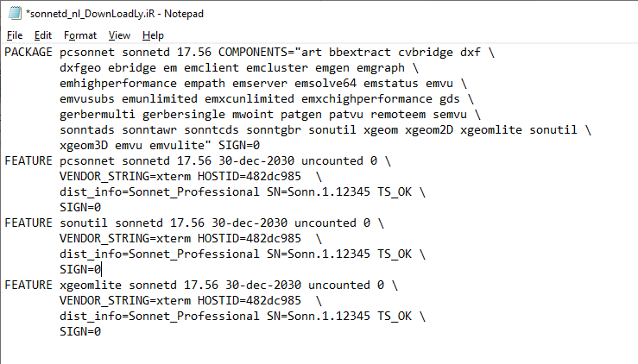

1. Run make_nodelocked.bat, it will make "sonnet_DownLoadLy.iR.lic"

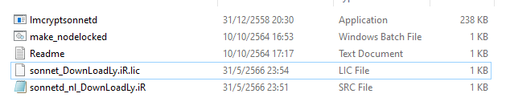

1. Run app, in Admin Menu, select License

Click on Install "New License File" and browse to "sonnet_DownLoadLy.iR.lic"

