1. Draw circuit diagram for pi attenuator. We use Chip Resistors 0805 and SMA connector.



2. Change circuit diagram to PCB board.

2.1 Setting size of PCB 1 inch x 1 inch.

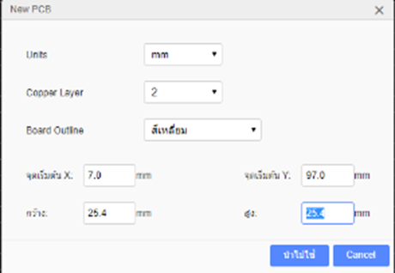

2.2 Place resistor and connector in PCB board.

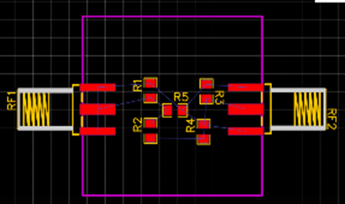

2.3 Draw a signal line and ground.

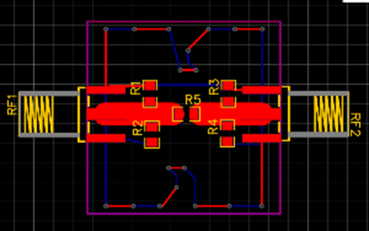

2.4 Place the copper area in the top layer and bottom layer

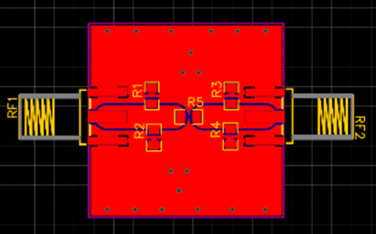

3. Export to altium designer file

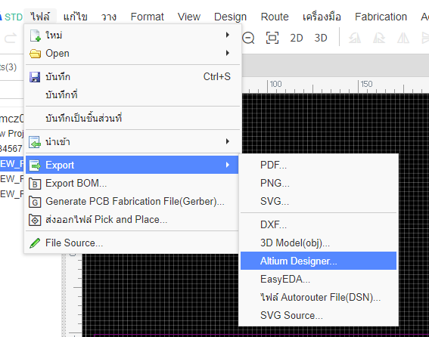

4. Sent file to facebook: Siam PCB

