Transmitter Coil

1. The Sonnet suites professional 17.56 program was utilized to design a rectangular coil measuring 10 x 10 with a thickness of 3.5mm, which was divided into 7 pieces with overlapping sections of 34mm at even positions (coil cell #2-#3, coil cell #4-#5, and coil cell #6-#7). A gap was also incorporated within the coil in the opposite direction to accommodate a capacitor with an 0805 size footprint. In addition, a gap was created in coil cell #1, close to the via but in the opposite direction of the coil, to allow for the soldering of an SMA connector as show in Fig.1.

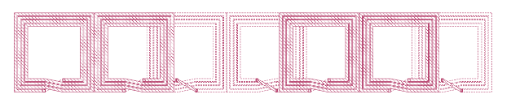 FIGURE 1

1. 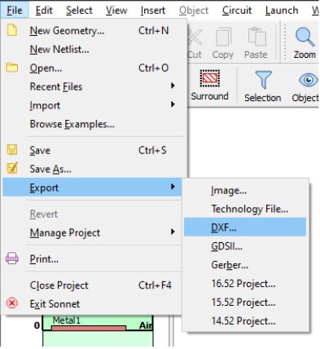Click File and select Export and select DXF.

FIGURE 2

1. Setting via Options and change to manual then change size to 10 mm.

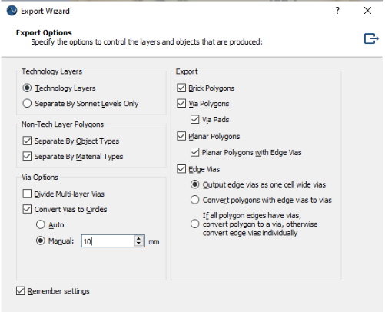

FIGURE 3

1. Click file select import DXF

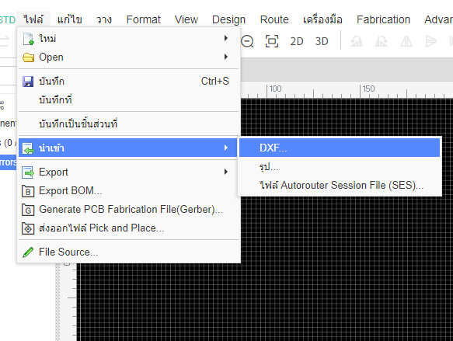

FIGURE 4

1. Select file to import to easyEDA.

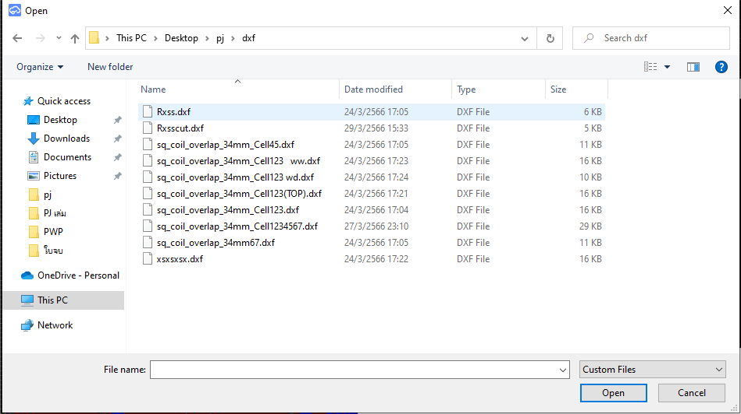

FIGURE 5

1. 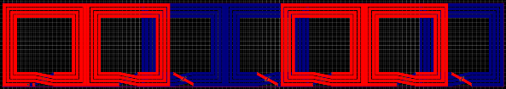After designing a rectangular coil with Sonnet suites professional 17.56 program as show in Fig.6, the coil was exported to EasyEDA program for further processing. In EasyEDA, the coil was covered with a solder mask by setting a solid region to cover all the coil. In addition, the coil was divided into 7 cells, with coil cell #1, #2, #5, and #6 placed on the top layer and coil cell #3, #4, and #7 placed on the bottom layer. This was achieved by utilizing the layer setting functions in EasyEDA.

FIGURE 6

1. 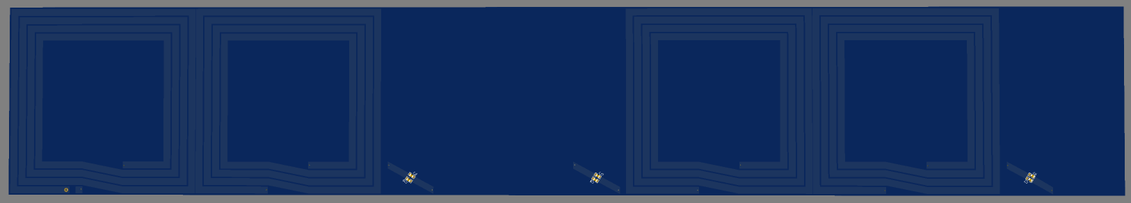Put 2 footprints of capacitor 0805 size and create pad and gap for SMA connector as show in Fig.7.

FIGURE 7

1. Open solder mask at a gap that is created for solder SMA connector as show in Fig.8.

FIGURE 8

Receiver Coil

1. 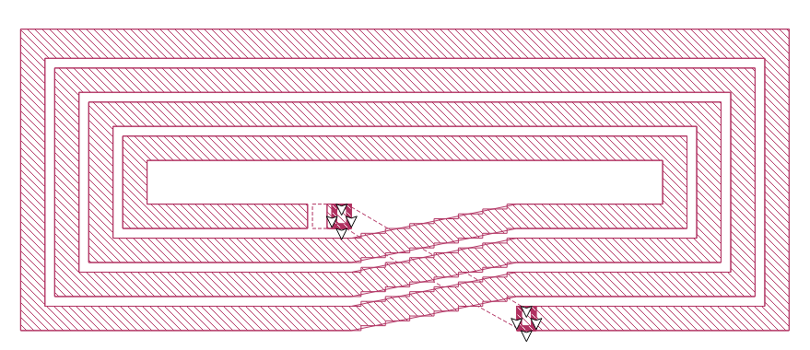 The Sonnet suites professional 17.56 program was utilized to design a rectangular coil with a thickness of 2.5mm, custom-fitted to the Tamiya toy car. The coil design included a gap in the bottom layer to allow for the addition of both an SMA connector and a capacitor as show in Fig.9.

FIGURE 9

1. Export to EASYEDA program to generate solid region and create via and set layer of coil as show in Fig.10.

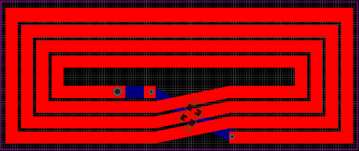

FIGURE 10

1. A picture containing graphical user interface

   Description automatically generated Put 2 footprints of capacitor 0805 size and create pad and gap for SMA connector as show in Fig.11.

FIGURE 11

Order a PCB

1. Click PCB Fablication

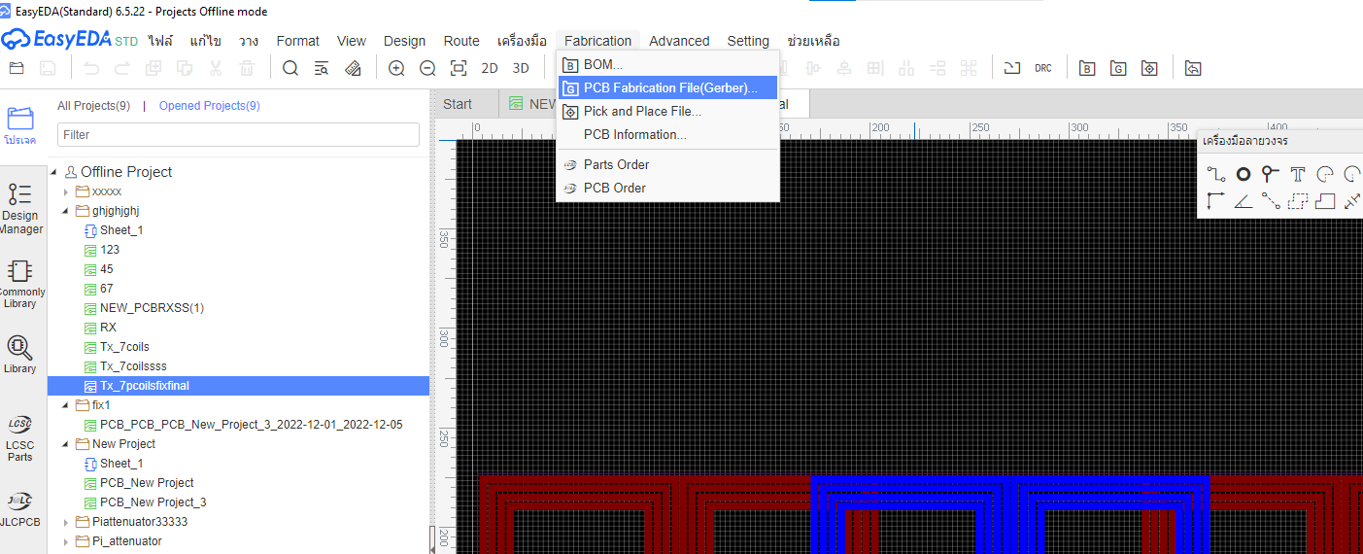

1. 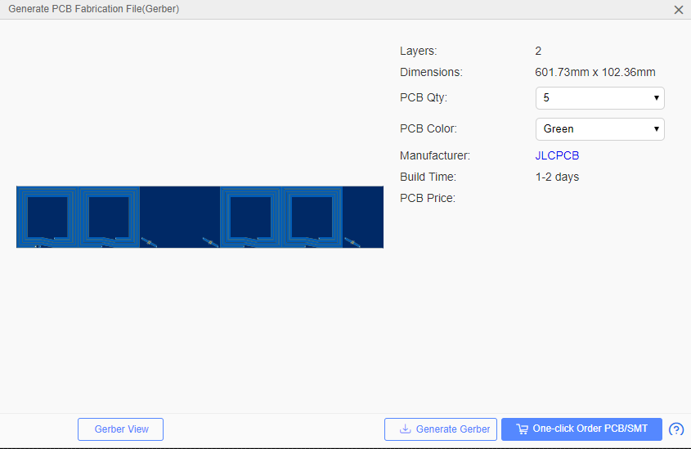Click generate gerber
2. Open this link: <https://jlcpcb.com/?href=easyeda-home>

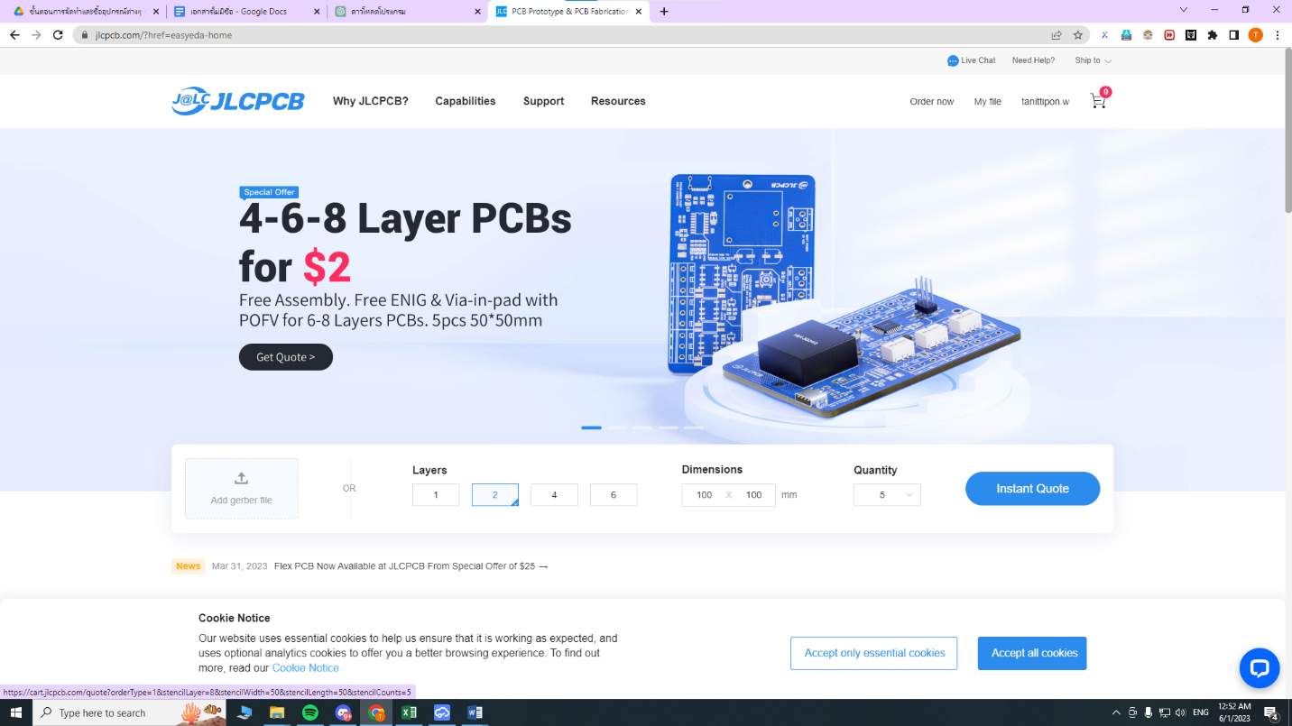

1. Upload your file

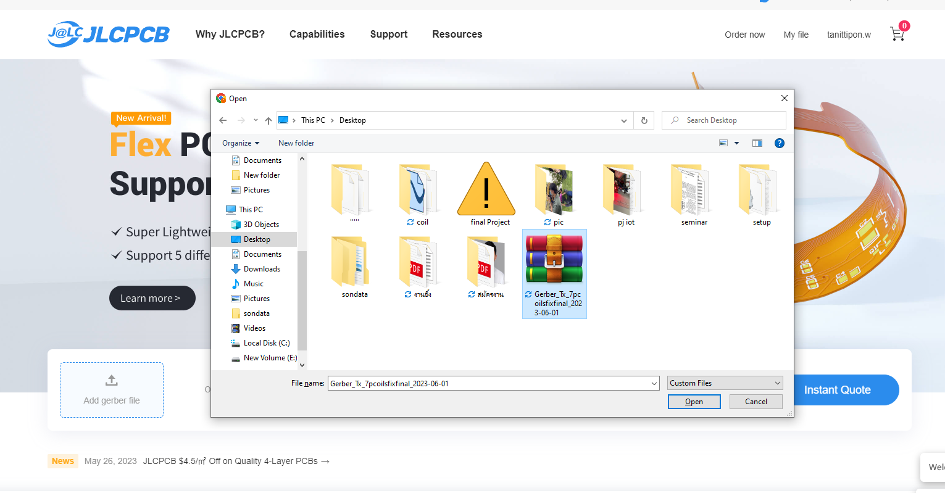

1. Click save to cart

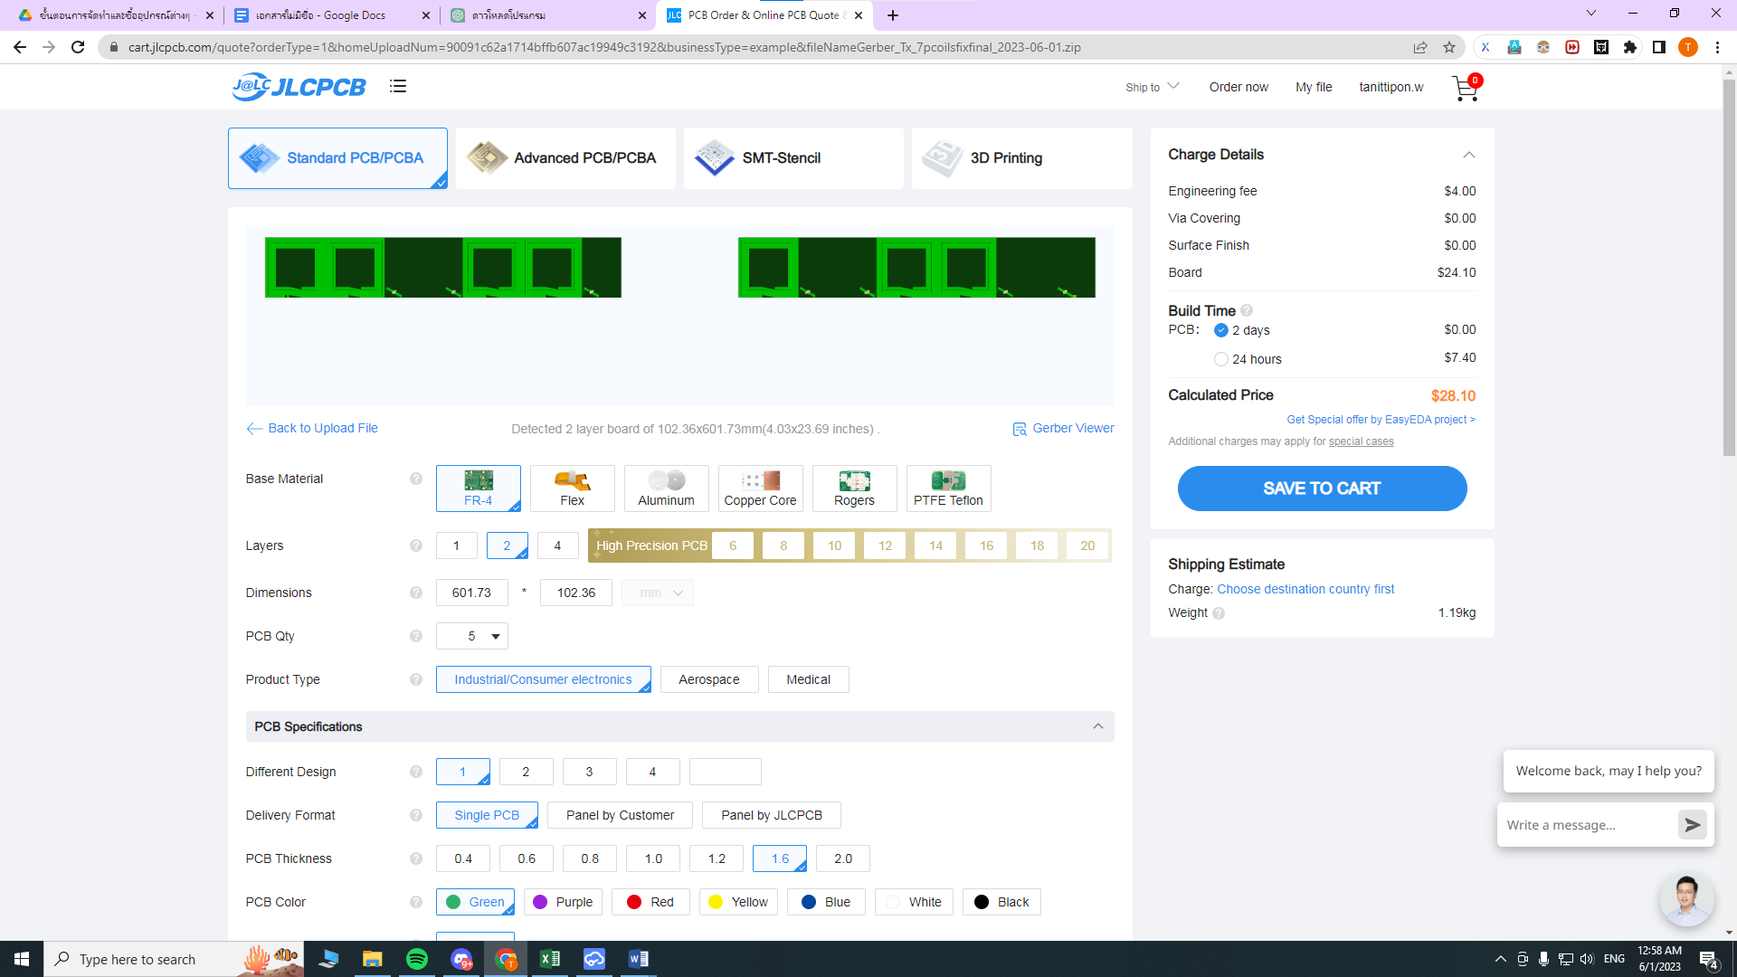

1. 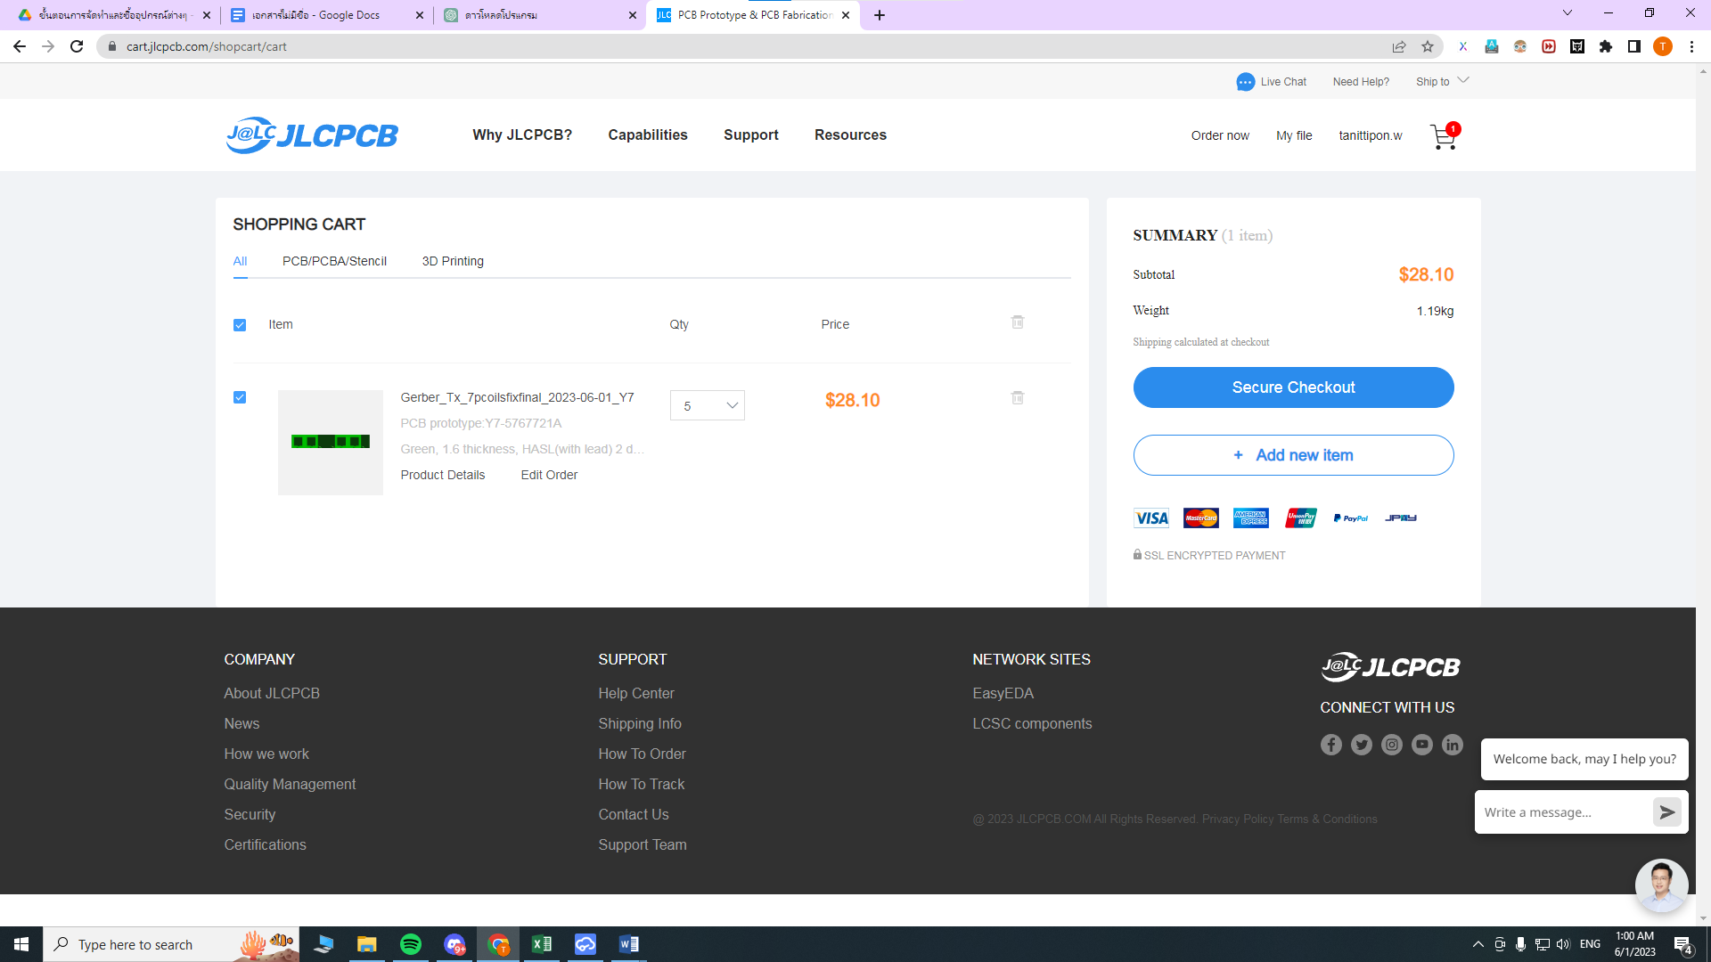Click checkout
2. Fill in the shipping and payment details and wait for the confirmation email.

