Project Report: Intelligent Student Performance Assessment and Management System (ISPAMS)
Course: SEN 301 – Object-Oriented Analysis and Design
Client: Solomon NovationCorp Limited
Group: [Insert Group Number/Names]

1. Introduction and Project Background
The Intelligent Student Performance Assessment and Management System (ISPAMS) is designed to modernize the academic infrastructure of tertiary institutions. Traditional systems often suffer from manual errors in attendance, lost scripts, and subjective grading of soft skills. ISPAMS integrates biometric authentication and AI-driven linguistics to ensure integrity and comprehensive student evaluation.

2. System Requirements

2.1 Functional Requirements
- Biometric Enrollment: System must capture and store facial and fingerprint templates.
- Automated Attendance: System must log attendance via real-time facial recognition.
- NLP Assessment: System must analyze text/speech submissions for grammar, sentiment, and technical accuracy.
- Result Management: Automated calculation of GPA and tracking of carryover courses.
- Evidence Storage: A repository for group projects and learning progress artifacts.

2.2 Non-Functional Requirements
- Security: Multi-factor authentication and AES encryption for biometric data.
- Reliability: 99.9% uptime to ensure attendance is never missed during lecture hours.
- Scalability: Ability to support a growing database of up to 50,000 students.
- Performance: Biometric verification must take less than 2 seconds per student.

3. OOAD Design and UML Diagrams

3.1 Use Case Diagram
The Use Case diagram identifies the boundaries of the system and the interactions between the Student, Lecturer, and Admin.

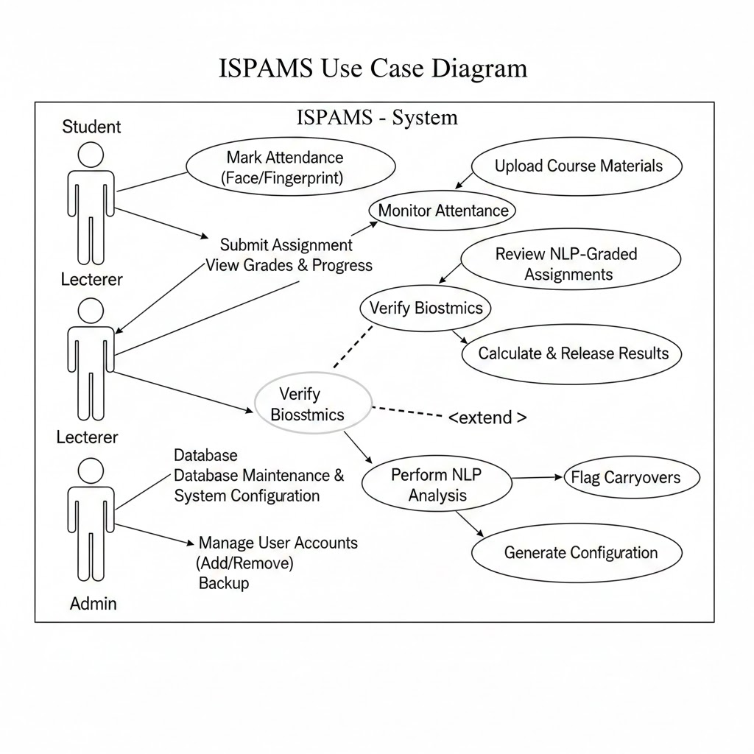

3.2 Class Diagram
The system is modeled using classes such as User, Student, BiometricProcessor, NLPAnalyzer, and CourseRecord.
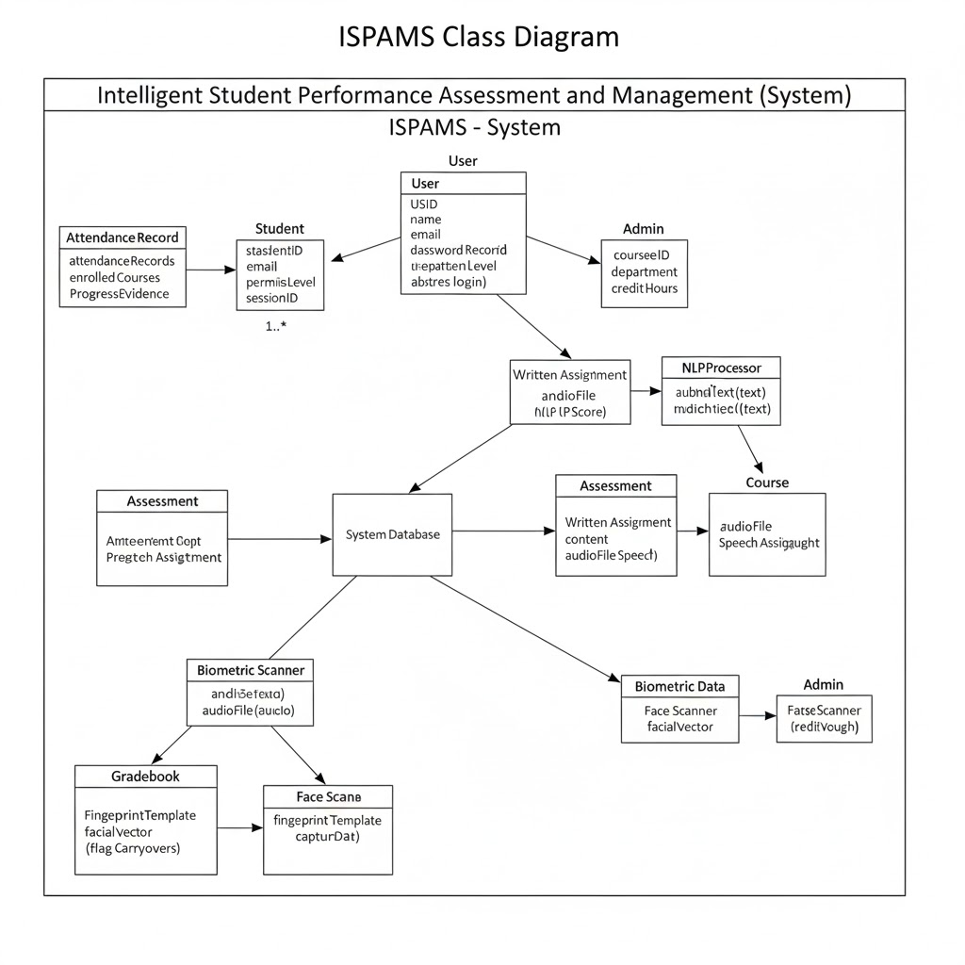

3.3 Sequence Diagram: Attendance Verification
This diagram illustrates the message flow when a student attempts to log attendance.
- Student presents face to camera.
- AttendanceController sends data to FaceRecognitionEngine.
- Database validates the match.
- AttendanceRecord is updated.
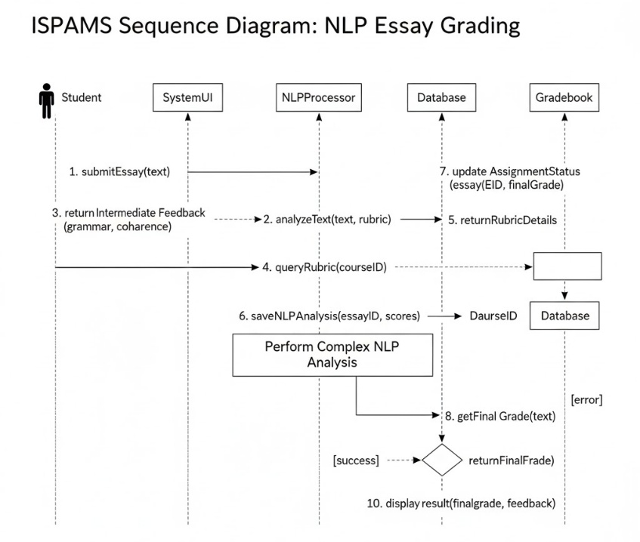

3.4 Activity Diagram: NLP Assessment Workflow
The activity starts when a student submits a written assignment, passing through the NLP parser, grading logic, and finally updating the Gradebook.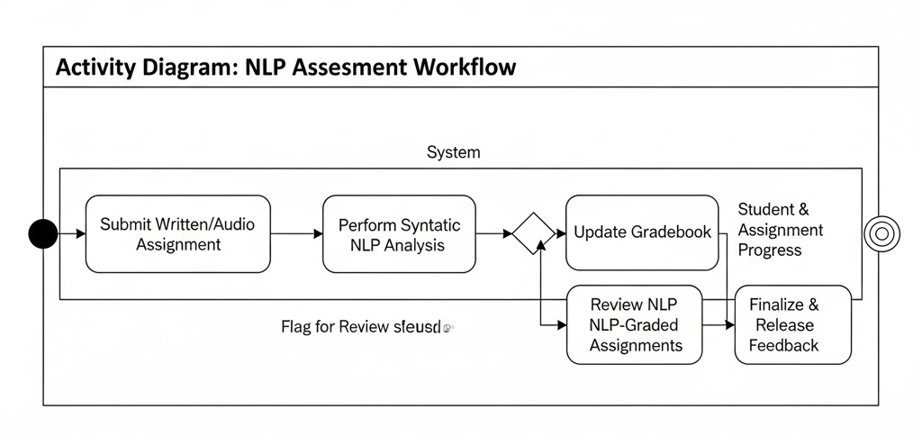

4. AI Integration: Intelligent Assessment Framework
The core "Intelligence" of ISPAMS is powered by two specialized modules: Computer Vision for physical verification and Transformer-based NLP for cognitive assessment.

4.1 Biometric Integrity Module (OpenCV & Deep Learning)
To solve the issue of proxy attendance and identity theft, ISPAMS integrates a dual-layer biometric system:
- Facial Recognition (Attendance): Utilizing OpenCV and Pre-trained Convolutional Neural Networks (CNNs), the system captures video frames in real-time. It extracts 68 unique facial landmarks (facial embeddings) to identify students as they enter the lecture hall.
- Fingerprint Verification (High-Stakes): For examinations and result viewing, the system uses a minutiae-based matching algorithm. This ensures that even if a student uses a photograph to trick the camera, the physical fingerprint provides a non-repudiable second factor of authentication.

4.2 Natural Language Processing (NLP) with BERT Transformers
The system employs BERT (Bidirectional Encoder Representations from Transformers) to evaluate students’ writing and communication skills. Unlike older models that read text linearly (left-to-right), BERT reads the entire sequence of words simultaneously.

Why BERT for ISPAMS?
- Bidirectional Context: BERT understands that the meaning of a word depends on both the words before and after it. This is crucial for grading complex essays where sentence structure varies.
- Semantic Similarity: By converting student essays into high-dimensional vectors (embeddings), the system can calculate the Cosine Similarity between a student's answer and the "Gold Standard" answer provided by the lecturer.
- Grammar & Tone Analysis: BERT is fine-tuned to detect not just spelling errors, but the "coherence" and "logical flow" of an argument, which addresses the project objective of evaluating communication skills.

4.3 Integrated AI Workflow
The following diagram illustrates how these AI components interact with the standard system objects during a student's submission process.
- Input Layer: The student submits a written script (NLP) or presents their face/finger (Biometrics).
- Processing Layer: * OpenCV validates the identity against the StudentProfile class.
  - BERT Encoder processes the text to identify key arguments and linguistic quality.
- Output Layer: The system generates a multi-dimensional score (Grammar, Content, Logic) and automatically updates the AssessmentRecord in the database.

5. Advantages of OOAD in ISPAMS
- Reusability: The Biometric base class can be extended for both Fingerprint and Face modules without rewriting core logic.
- Modularity: The NLP module can be upgraded (e.g., from GPT-3 to GPT-4) without affecting the Attendance or Result modules.
- Maintainability: Encapsulation ensures that a bug in the "Result Calculation" logic does not corrupt the "Biometric Identity" data.

6. Conclusion
ISPAMS leverages OOAD to create a robust, scalable solution for Solomon NovationCorp Limited. By integrating AI with structured object-oriented models, the system ensures academic integrity and provides a data-driven approach to student management

