Task 1: LIFO Behavior on Stack
Create a class Tracer with a default constructor and destructor that print the object name. Create objects in main(), inside a nested block, and inside a function test().
• Implement class Tracer with constructor and destructor messages.
• Create objects in main() scope, a nested {} block, and a separate function test().
• Observe and record the order of constructor and destructor calls.
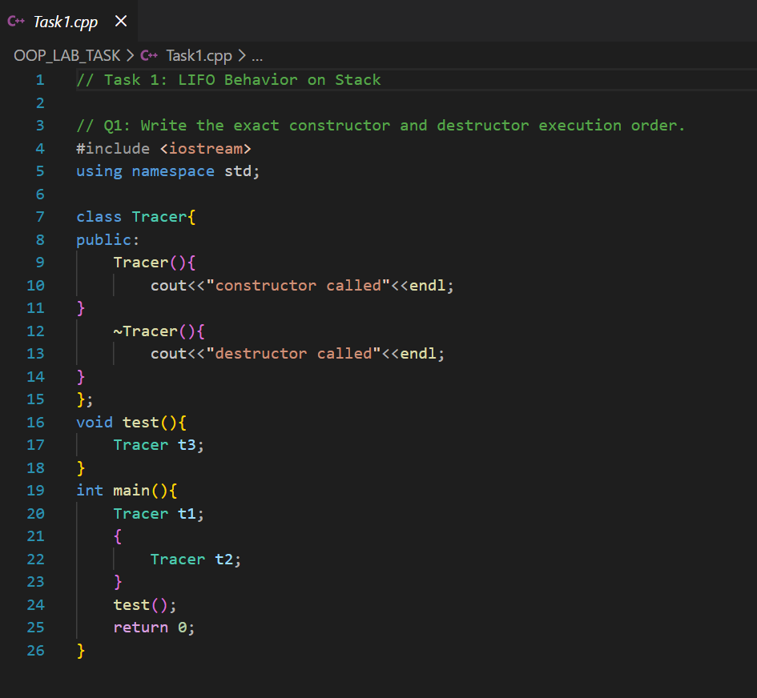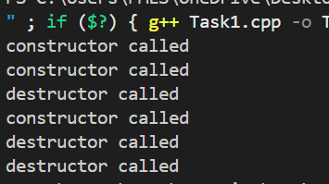
Q1: Write the exact constructor and destructor execution order.
Execution Order:
- Constructor – Object in main()
- Constructor – Object in nested block
- Destructor – Object in nested block
- Constructor – Object in test()
- Destructor – Object in test()
- Destructor – Object in main()
This shows that objects inside inner are destroyed before the object in outer.
Q2: Explain why destructors follow LIFO (Last In, First Out) order.
Destructors follow the LIFO (Last In, First Out) rule because stack memory works like a stack.
The object which is created at last is placed on the top of stack, so when the scope ends, it is destroyed first. This is why destruction happens in reverse order of creation.
Q3: Identify precisely when each object is destroyed.
- The nested block object is destroyed as soon as the {} block ends.
- The object inside test() is destroyed when the function finishes.
- The object in main() is destroyed when the program ends.
In simple words, stack objects are destroyed automatically when they go out of scope.
Task 2: Stack vs Heap Comparison
Create a class Memory Check with constructors, destructors, and a method to print the object address using the this pointer. Create objects on both the stack and the heap. Delete only one heap object.
• Implement class MemoryCheck with constructors, destructor, and address printing.
• Create at least one stack object and two heaps of objects (using new).
• Delete only one of the heap objects and observe the results.
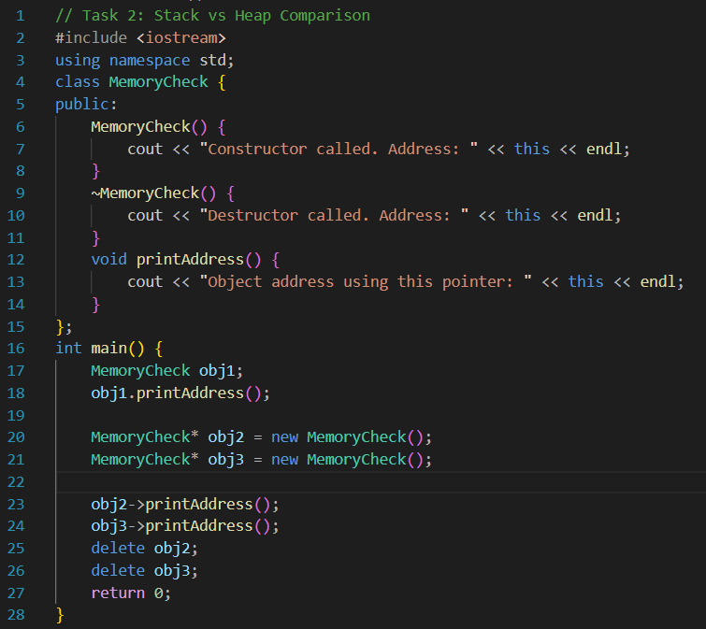
Questions:
- Which destructors are automatically called?
The destructor of the stack object is automatically called when the function ends because stack memory is managed automatically by the system.
- Which destructor is not called, and why?
The destructor of the heap object that was not deleted is not called because memory allocated using new must be manually freed using delete. If delete is not used, the destructor will not execute.
- Explain memory leak in your own words.
A memory leak happens when dynamically allocated memory is not released after use. The program loses access to that memory, and it remains occupied until the program ends, wasting system resources.

- Compare stack and heap memory behavior.
• Stack Memory:
Automatically managed. Objects are destroyed when the function scope ends. No manual deletion is required.
• Heap Memory:
Manually managed using new and delete. If delete is not called, memory leak occurs.

Task 3: Copy Constructor Analysis

Create a class Book with a default constructor, parameterized constructor, copy constructor, and destructor. Create multiple objects using different initialization techniques.
• Implement class Book with all four special member functions.
• Create objects using default construction, parameterized construction, and copy construction.
• Use different copy syntax: Book b2 = b1; and Book b3(b1);.
Questions:
- How many times does the copy constructor execute?
The copy constructor executes two times if we create objects like this:
- Book b2 = b1;
- Book b3(b1);
Both statements create new objects using an existing object, so the copy constructor runs once for each statement.
- When does each destructor run?
Destructors run when objects go out of scope.
- All stack objects are destroyed automatically when the main() function ends.
- Destructors execute in reverse order of object creation.
- If objects were created on the heap using new, their destructor would only run when delete is called.

- Explain the object memory addresses and what they tell you.
Every object has its own memory address.
When we use the copy constructor, a new object is made.
This new object has a different memory address from the original one.
This means:
- b1, b2, and b3 are all different objects.
- They can have the same data, but they are stored in different places in memory.
- The copy constructor makes a completely new object, not just another name for the same object.
Task 5: Object Composition
Create two classes: Engine and Car, where Car contains an Engine object as a member. Add constructors and destructors to both classes and create a Car object in main().
• Implement class Engine with constructor and destructor.
• Implement class Car that has an Engine member variable.
• Create a Car object in main() and observe the construction/destruction order.
Questions:
1. Which constructor runs first — Engine or Car?
The Engine constructor runs first. When a Car object is created, its member objects are constructed before the Car constructor body runs. Since Engine is a member inside Car, it is created first.
2. Which destructor runs first — Engine or Car?
The Car destructor runs first. When the Car object’s life ends, its destructor runs, and after that the Engine destructor runs automatically. Member objects are destroyed after the outer object.
3. Explain the order using object lifecycle logic.
This order happens because of object lifecycle rules in C++. When an object contains another object (composition), the inner object must be created first so the outer object can use it. So, during construction, the member (Engine) is built first, then the main object (Car). During destruction, the order is reversed. The outer object (Car) is destroyed first, then its member (Engine) is destroyed. This ensures proper and safe cleanup of memory.
4. Draw a memory layout diagram showing how Car and Engine coexist.
Stack Memory:

Task 8: Pointer Reassignment & Memory Leak
Create dynamic objects using new. Reassign one pointer to point to another object, then delete one pointer. Analyze what happens.
• Create two dynamic objects: Object *a = new Object(); Object *b = new Object();.
• Reassign: a = b; and then call delete a;.
• Observe which destructor runs and identify any issues.
Questions:
1. Identify if a memory leak occurs.
Yes, a memory leak occurs. When we do a = b;, the original object that a was pointing to is no longer accessible. Since we never delete it, its memory is lost.
2. Which object becomes unreachable?
The first object created Object 1becomes unreachable. We have no pointer to it anymore after reassigning a to b.
3. Which destructor executes?
Only the destructor of the object pointed to by a after reassignment Object 2 executes when we call delete a;. The destructor of the first object never runs, causing a memory leak.
4. Fix the code and explain your correction.

