

GPIO Control

Raspberry Pi 3

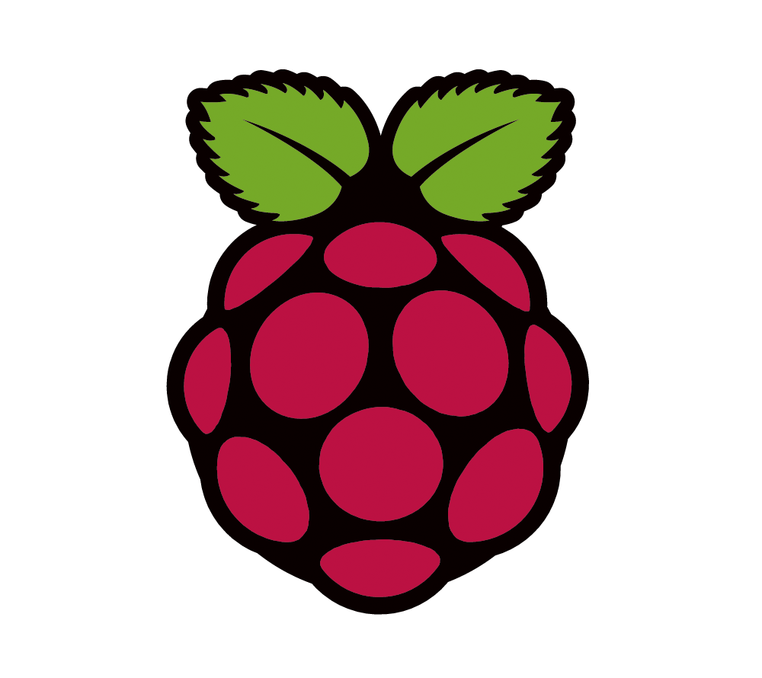

Autors:

Sebastian Mecheş

Daniel-Domiţian Iuonac

Base statement:
Control of GPIO pins of a development board Arduino or Rasperry PI from a web interface (2 students).
Characteristics:
- The web interface will contain a select option for inputs / outputs (GPIO) that are active on the development board. The GPIO pins unused shall be powered-down.
- The web interface will allow the selection of the use mode of each activ pin of development board: ON / OFF (0 or 1 logic) or the posibility to generate PWM.
- A secure login method for the web interface should be implemented, for example Google VPN Authenticator
- The state of the user's current settings will be saved either in the EEPROM memory of a microcontroller or on an SD card so that the system restarts from the last known state when the power is interrupted.

Adapted Statement:
Control of GPIO pins of a development board Arduino or Rasperry PI from a interface (2 students).
Characteristics:
- The interface will contain a select option for inputs / outputs (GPIO) that are active on the development board. The GPIO pins unused shall be powered-down.
- The interface will allow the selection of the use mode of each activ pin of development board: ON / OFF (0 or 1 logic) or the posibility to generate PWM.
- The state of the user's current settings will be saved on an SD card so that the system restarts from the last known known state when the power is interrupted.

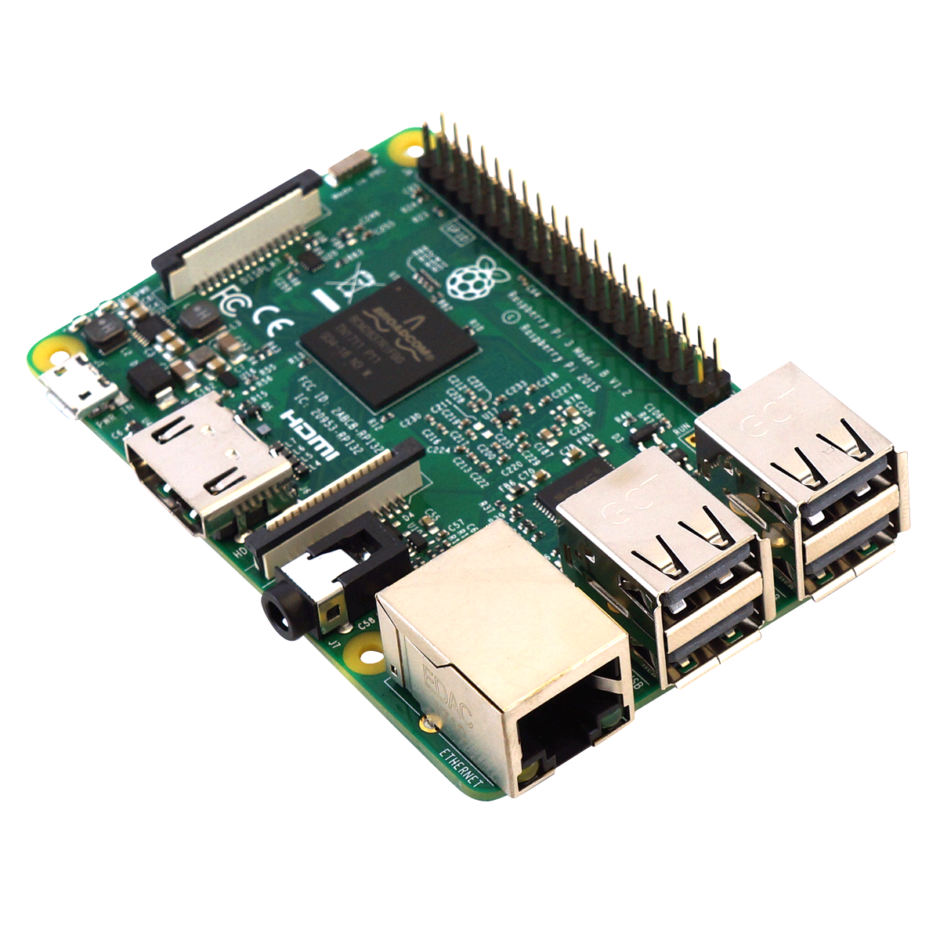
Raspberry Pi 3 Board

Raspberry Pi 3 Specifications [1]
SoC: Broadcom BCM2837
CPU: 4× ARM Cortex-A53, 1.2GHz
GPU: Broadcom VideoCore IV
RAM: 1GB LPDDR2 (900 MHz)
Networking: 10/100 Ethernet, 2.4GHz 802.11n wireless
Bluetooth: Bluetooth 4.1 Classic, Bluetooth Low Energy
Storage: microSD
GPIO: 40-pin header, populated
Ports: HDMI, 3.5mm analogue audio-video jack, 4× USB 2.0, Ethernet, Camera Serial Interface (CSI), Display Serial Interface (DSI)

Wireless radio
So small, its markings can only be properly seen through a microscope or magnifying glass, the Broadcom BCM43438 chip provides 2.4GHz 802.11n wireless LAN, Bluetooth Low Energy, and Bluetooth 4.1 Classic radio support. Cleverly built directly onto the board to keep costs down, rather than the more common fully qualified module approach, its only unused feature is a disconnected FM radio receiver.
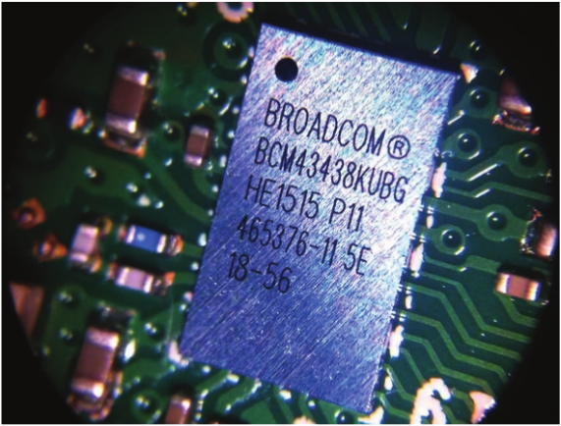

Wireless radio

Antenna
There’s no need to connect an external antenna to the Raspberry Pi 3. Its radios are connected to this chip antenna soldered directly to the board, in order to keep the size of the device to a minimum. Despite its diminutive stature, this antenna should be more than capable of picking up wireless LAN and Bluetooth signals – even through walls.
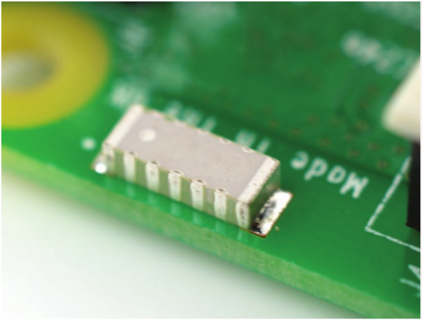

Antena

GPIO
The Raspberry Pi 3 features the same 40-pin general-purpose input-output (GPIO) header as all the Pis going back to the Model B+ and Model A+. Any existing GPIO hardware will work without modification; the only change is a switch to which UART is exposed on the GPIO’s pins, but that’s handled internally by the operating system.
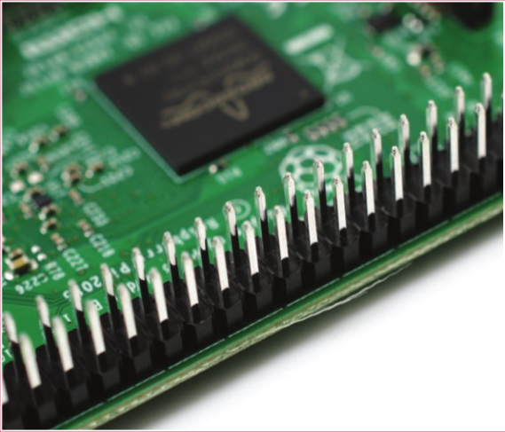

GPIO

SoC
Built specifically for the new Pi 3, the Broadcom BCM2837 system-on-chip (SoC) includes four high-performance ARM Cortex-A53 processing cores running at 1.2GHz with 32kB Level 1 and 512kB Level 2 cache memory, a VideoCore IV graphics processor, and is linked to a 1GB LPDDR2 memory module on the rear of the board.
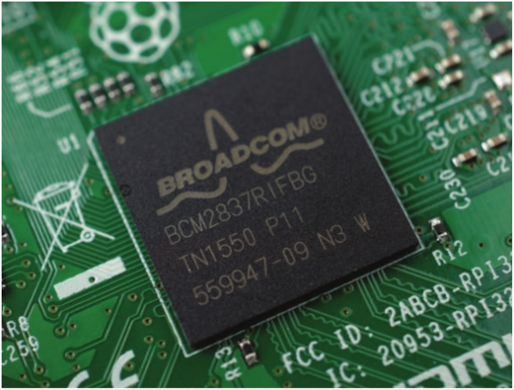

SOC

USB chip
The Raspberry Pi 3 shares the same SMSC LAN9514 chip as its predecessor, the Raspberry Pi 2, adding 10/100 Ethernet connectivity and four USB channels to the board. As before, the SMSC chip connects to the SoC via a single USB channel, acting as a USB-to-Ethernet adaptor and USB hub.
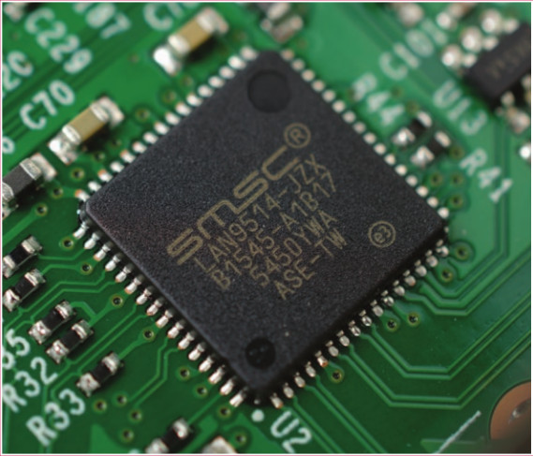

USB chip

GPIO[2][3]

A powerful feature of the Raspberry Pi is the row of GPIO (general-purpose input/output) pins along the top edge of the board. A 40-pin GPIO header is found on all current Raspberry Pi boards (unpopulated on Pi Zero and Pi Zero W). Prior to the Pi 1 Model B+ (2014), boards comprised a shorter 26-pin header.
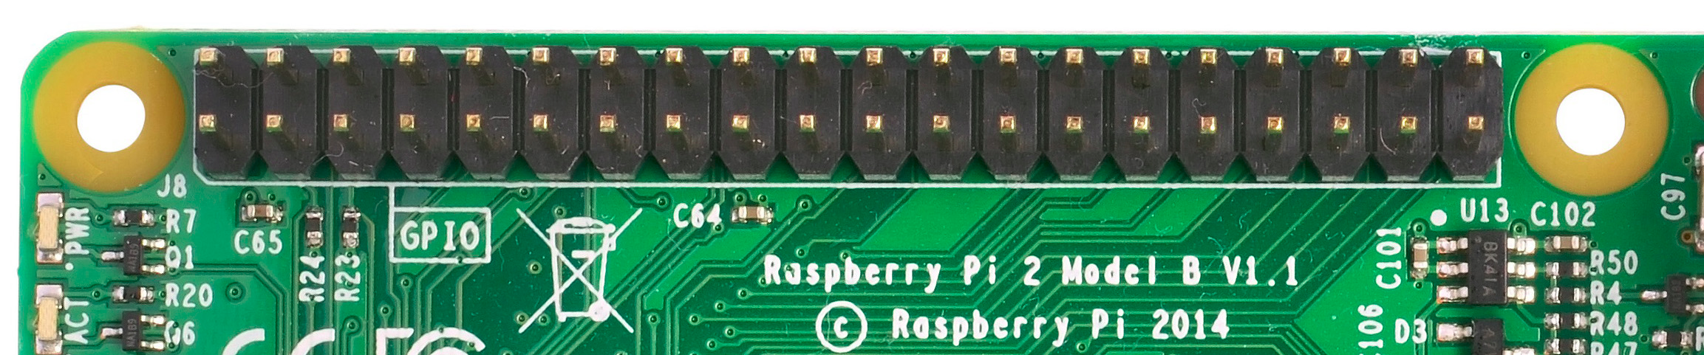
Any of the GPIO pins can be designated (in software) as an input or output pin and used for a wide range of purposes.

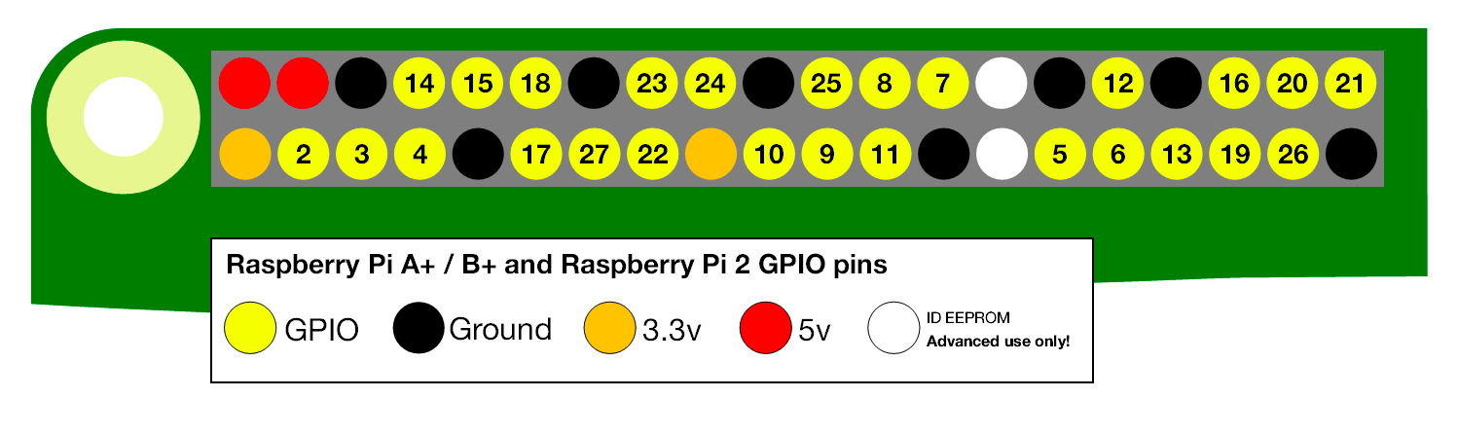
Note: the numbering of the GPIO pins is not in numerical order; GPIO pins 0 and 1 are present on the board (physical pins 27 and 28) but are reserved for advanced use (see below).

Voltages
Two 5V pins and two 3V3 pins are present on the board, as well as a number of ground pins (0V), which are unconfigurable. The remaining pins are all general purpose 3V3 pins, meaning outputs are set to 3V3 and inputs are 3V3-tolerant.

Outputs
A GPIO pin designated as an output pin can be set to high (3V3) or low (0V).

Inputs
A GPIO pin designated as an input pin can be read as high (3V3) or low (0V). This is made easier with the use of internal pull-up or pull-down resistors. Pins GPIO2 and GPIO3 have fixed pull-up resistors, but for other pins this can be configured in software.

More
As well as simple input and output devices, the GPIO pins can be used with a variety of alternative functions, some are available on all pins, others on specific pins.
- PWM (pulse-width modulation)
  - Software PWM available on all pins
  - Hardware PWM available on GPIO12, GPIO13, GPIO18, GPIO19
- SPI
  - SPI0: MOSI (GPIO10); MISO (GPIO9); SCLK (GPIO11); CE0 (GPIO8), CE1 (GPIO7)
  - SPI1: MOSI (GPIO20); MISO (GPIO19); SCLK (GPIO21); CE0 (GPIO18); CE1 (GPIO17); CE2 (GPIO16)
- I2C
  - Data: (GPIO2); Clock (GPIO3)
  - EEPROM Data: (GPIO0); EEPROM Clock (GPIO1)
- Serial
  - TX (GPIO14); RX (GPIO15)

GPIO pinout
It's important to be aware of which pin is which. Some people use pin labels (like the RasPiO Portsplus PCB, or the printable Raspberry Leaf).
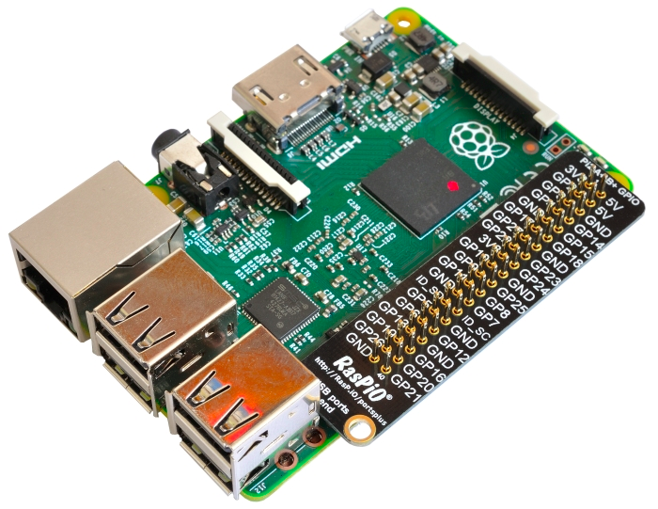

A handy reference can be accessed on the Raspberry Pi by opening a terminal window and running the command pinout. This tool is provided by the GPIO Zero Python library, which it is installed by default on the Raspbian desktop image, but not on Raspbian Lite.
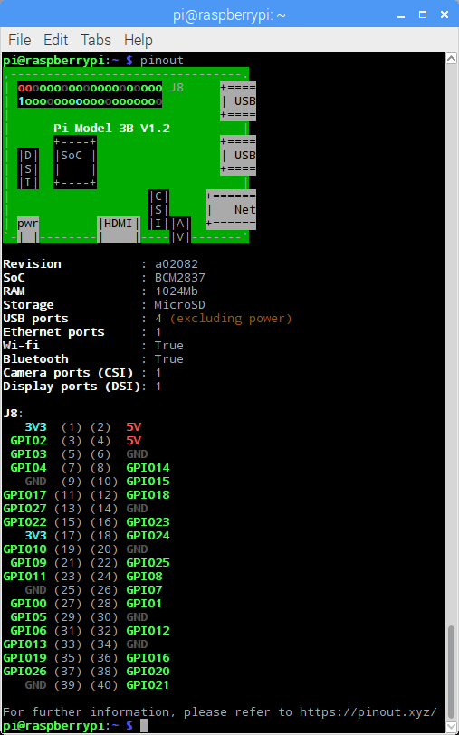

For more details on the advanced capabilities of the GPIO pins see gadgetoid's interactive pinout diagram.

Programming with GPIO
It is possible to control GPIO pins using a number of programming languages and tools:
- GPIO with Scratch 1.4
- GPIO with Scratch 2
- GPIO with Python
Warning: while connecting up simple components to the GPIO pins is perfectly safe, it's important to be careful how you wire things up. LEDs should have resistors to limit the current passing through them. Do not use 5V for 3V3 components. Do not connect motors directly to the GPIO pins, instead use an H-bridge circuit or a motor controller board.


The Qt Framework [4][5]
Qt (pronounced "cute") is a free and open-source widget toolkit for creating graphical user interfaces as well as cross-platform applications that run on various software and hardware platforms such as Linux, Windows, macOS, Android or embedded systems with little or no change in the underlying codebase while still being a native application with native capabilities and speed. Qt is currently being developed by The Qt Company, a publicly listed company, and the Qt Project under open-source governance, involving individual developers and organizations working to advance Qt. Qt is available under both commercial licenses and open source GPL 2.0, GPL 3.0, and LGPL 3.0 licenses.

What is PyQt5?
PyQt5 is a comprehensive set of Python bindings for Qt v5. It is implemented as more than 35 extension modules and enables Python to be used as an alternative application development language to C++ on all supported platforms including iOS and Android.
PyQt5 may also be embedded in C++ based applications to allow users of those applications to configure or enhance the functionality of those applications.

Application Code [8]
The source code of the application is avaiable on github repository [8].
The current aplication uses the Qt5 framework and is written in Python 3. The controlls of GPIO pins of raspberry is made with Rpi.GPIO[6][7] python library.
The application is using MVC pattern and is structured in 4 modules: app.py, controllers.py, models.py, data.py. The start module is main.py and contains the next code:
if __name__ == '__main__':
# import and start the Application
import sys
from package.app import Application
application = Application(sys.argv)
sys.exit(application.exec_())
The app.py module is started from the main.py module and contains the Application class:
import os
from PyQt5.QtGui import QIcon
from PyQt5.QtWidgets import QApplication
from db import save_configuration, load_configuration
from package.controllers import MainWindow
import RPi.GPIO as GPIO
GPIO.setmode(GPIO.BCM)
# Application class extends QApplication from QtWidgets
class Application(QApplication):
def __init__(self, args):
super(Application, self).__init__(args)
# Set some properties
self.setApplicationName('Raspberry Pi - G.P.I.O Control')
self.setApplicationVersion('0.1')
self.icon = QIcon(os.getcwd() + "/icons/rpi.png")
self.setWindowIcon(self.icon)
# On exiting application save the configuration
self.aboutToQuit.connect(save_configuration)
# Load the configuration
load_configuration()
# Create and show the main window
self.main_window = MainWindow()
self.main_window.show()

The controllers.py module contains all the ui controllers and the logic behind.
from RPi import GPIO
import os
from PyQt5 import QtWidgets, QtGui
from PyQt5.QtCore import QModelIndex, Qt
from db import PIN_LIST
from package.models import PinModel
from package.ui.digital_input import Ui_DigitalInput
from package.ui.digital_out import Ui_DigitalOutput
from package.ui.license import Ui_License
from package.ui.main_window import Ui_MainWindow
from package.ui.pulse_width_modulation import Ui_PulseWidthModulation
# DigitalInputController is a QWidget and controls the digital input UI Form
class DigitalInputController(QtWidgets.QWidget):
def __init__(self, parent=None, flags=Qt.Widget):
super(DigitalInputController, self).__init__(parent, flags=flags)
self.ui = Ui_DigitalInput()
self.ui.setupUi(self)
self.current_model_index = None
# Connect signal for pressing Read button
self.ui.pushButton_read.clicked.connect(self.on_read_input)
"""
on_read_input
- get current pin
- read input value
- set the value to line edit in UI
"""
def on_read_input(self, checked):
pin = PIN_LIST[self.current_model_index.row()]
if pin.enable:
value = GPIO.input(pin.id)
self.ui.lineEdit_value.setText(str(value))
def set_selection(self, current):
# Update current index
self.current_model_index = current
# DigitalOutputController controls the UI form for digital output
class DigitalOutputController(QtWidgets.QWidget):
def __init__(self, model: PinModel, parent=None, flags=Qt.Widget):
super(DigitalOutputController, self).__init__(parent, flags=flags)
self.ui = Ui_DigitalOutput()
self.ui.setupUi(self)
self.current_model_index = None
self.model = model
self.pin = PIN_LIST[0]
# Connect slider and spinbox signals to slots
self.ui.slider_value.valueChanged.connect(self.on_slider_value_changed)
self.ui.spinbox_value.valueChanged.connect(self.on_spinbox_value_changed)
"""
on_slider_value_changed
- sets value to spinbox
- outputs value to GPIO pin
- save value to pin data structure
"""
def on_slider_value_changed(self, value):
self.ui.spinbox_value.setValue(value)
GPIO.output(self.pin.id, value)
self.pin.value = value
# similar to on_slider_value_changed
def on_spinbox_value_changed(self, value):
self.ui.slider_value.setValue(value)
GPIO.output(self.pin.id, value)
self.pin.value = value
"""
set_selection
- save current index
- update current pin reference
"""
def set_selection(self, current):
self.current_model_index = current
self.pin = PIN_LIST[self.current_model_index.row()]
"""
showEvent
- when a show event is received then accept it
- update spinbox and slider value
"""
def showEvent(self, a0: QtGui.QShowEvent):
a0.accept()
self.ui.slider_value.setValue(self.pin.value)
self.ui.spinbox_value.setValue(self.pin.value)
# PulseWidthModulationController controls the UI form for PWM
class PulseWidthModulationController(QtWidgets.QWidget):
def __init__(self, model: PinModel, parent=None, flags=Qt.Widget):
super(PulseWidthModulationController, self).__init__(parent=parent, flags=flags)
self.ui = Ui_PulseWidthModulation()
self.ui.setupUi(self)
self.model = model
self.current_model_index = None
self.pin = PIN_LIST[0]
# Connect signals for sliders spinboxes and pwm start/stop button
self.ui.slider_frequency.valueChanged.connect(self.on_slider_frequency)
self.ui.slider_duty_cycle.valueChanged.connect(self.on_slider_duty_cycle)
self.ui.spinbox_frequency.valueChanged.connect(self.on_spinbox_frequency)
self.ui.spinbox_duty_cycle.valueChanged.connect(self.on_spinbox_duty_cycle)
self.ui.button_pwm.clicked.connect(self.on_button_pwm)
"""
on_button_pwm
if button is pressed then
- set Stop text
- start PWM instance
- changeFrequency
else
- set Start text
- stop pwm instance
"""
def on_button_pwm(self, value):
if value:
self.ui.button_pwm.setText("Stop")
self.pin.pwm_instance.start(self.pin.duty_cycle)
self.pin.pwm_instance.ChangeFrequency(self.pin.frequency)
else:
self.ui.button_pwm.setText("Start")
self.pin.pwm_instance.stop()
"""
on_spinbox_duty_cycle
- update slider value
- if pwm instance is not null then change duty cycle
- save value to pin structure
"""
def on_spinbox_duty_cycle(self, value):
self.ui.slider_duty_cycle.setValue(value)
if self.pin.pwm_instance and value > 0:
self.pin.pwm_instance.ChangeDutyCycle(value)
self.pin.duty_cycle = value
# similar to on_spinbox_duty_cycle
def on_spinbox_frequency(self, value):
self.ui.slider_frequency.setValue(value)
if self.pin.pwm_instance and value > 0:
self.pin.pwm_instance.ChangeFrequency(value)
self.pin.frequency = value
# similar to on_spinbox_duty_cycle
def on_slider_frequency(self, value):
self.ui.spinbox_frequency.setValue(value)
if self.pin.pwm_instance and value > 0:
self.pin.pwm_instance.ChangeFrequency(value)
self.pin.frequency = value
# similar to on_spinbox_duty_cycle
def on_slider_duty_cycle(self, value):
self.ui.spinbox_duty_cycle.setValue(value)
if self.pin.pwm_instance and value > 0:
self.pin.pwm_instance.ChangeDutyCycle(value)
self.pin.duty_cycle = value
def set_selection(self, current):
self.current_model_index = current
self.pin = PIN_LIST[self.current_model_index.row()]
# update values to sliders and spinboxes when controller shows
def showEvent(self, a0: QtGui.QShowEvent):
a0.accept()
self.ui.slider_frequency.setValue(self.pin.frequency)
self.ui.spinbox_frequency.setValue(self.pin.frequency)
self.ui.spinbox_duty_cycle.setValue(self.pin.duty_cycle)
self.ui.slider_duty_cycle.setValue(self.pin.duty_cycle)
# The main window controller
class MainWindow(QtWidgets.QMainWindow):
def __init__(self, parent=None, flags=Qt.Window):
super(MainWindow, self).__init__(parent, flags)
self.ui = Ui_MainWindow()
self.ui.setupUi(self)
self.data_mapper = QtWidgets.QDataWidgetMapper()
self.model = PinModel(PIN_LIST)
self.current_model_index = None
# Set the model to data mapper and to list view
self.data_mapper.setModel(self.model)
self.ui.listView.setModel(self.model)
# Set mapping for data mapper
self.data_mapper.addMapping(self.ui.lineEdit_name, 0)
self.data_mapper.addMapping(self.ui.comboBox_type, 1)
self.data_mapper.addMapping(self.ui.comboBox_mode, 2)
self.data_mapper.toFirst()
# When list view's current index changes then set_selection is called
self.ui.listView.selectionModel().currentChanged.connect(self.set_selection)
# Instantiate the others controllers and add them to the layout
self.license_controller = LicenseController()
self.digital_input_controller = DigitalInputController(self)
self.digital_output_controller = DigitalOutputController(self.model, self)
self.pwm_controller = PulseWidthModulationController(self.model, self)
self.ui.layout_values.addWidget(self.digital_input_controller)
self.ui.layout_values.addWidget(self.digital_output_controller)
self.ui.layout_values.addWidget(self.pwm_controller)
# Set slots for combo boxes signals and button enable
self.ui.comboBox_type.currentTextChanged.connect(self.on_type_changed)
self.ui.comboBox_mode.currentTextChanged.connect(self.on_mode_changed)
self.ui.button_enable.clicked.connect(self.on_button_enable)
# Set slots for actions triggers signals
self.ui.action_exit.triggered.connect(QtWidgets.qApp.quit)
self.ui.action_license.triggered.connect(self.license_controller.show)
self.ui.action_about.triggered.connect(self.on_action_about)
self.ui.action_load.triggered.connect(self.on_action_load)
self.ui.action_save.triggered.connect(self.on_action_save)
def set_selection(self, current: QModelIndex, old: QModelIndex):
self.current_model_index = current
self.data_mapper.setCurrentModelIndex(current)
self.pwm_controller.set_selection(current)
self.digital_output_controller.set_selection(current)
self.digital_input_controller.set_selection(current)
self.on_update_ui(current.row())
def on_mode_changed(self, text: str):
pin_type = self.ui.comboBox_type.currentText()
self.on_update_controllers(pin_type, text)
def on_type_changed(self, text):
pin_mode = self.ui.comboBox_mode.currentText()
self.on_update_controllers(text, pin_mode)
def showEvent(self, a0: QtGui.QShowEvent):
pin_type = self.ui.comboBox_type.currentText()
pin_mode = self.ui.comboBox_mode.currentText()
self.on_update_controllers(pin_type, pin_mode)
self.on_update_ui(0)
# This method updates the ui values when a new pin is selected in the list view
def on_update_ui(self, index: int):
pin = PIN_LIST[index]
self.ui.comboBox_mode.setEnabled(not pin.enable)
self.ui.comboBox_type.setEnabled(not pin.enable)
self.pwm_controller.ui.button_pwm.setEnabled(pin.enable)
self.pwm_controller.ui.slider_duty_cycle.setEnabled(pin.enable)
self.pwm_controller.ui.slider_frequency.setEnabled(pin.enable)
self.pwm_controller.ui.spinbox_frequency.setEnabled(pin.enable)
self.pwm_controller.ui.spinbox_duty_cycle.setEnabled(pin.enable)
self.digital_input_controller.ui.pushButton_read.setEnabled(pin.enable)
self.digital_output_controller.ui.slider_value.setEnabled(pin.enable)
self.digital_output_controller.ui.spinbox_value.setEnabled(pin.enable)
self.ui.button_enable.setChecked(pin.enable)
if pin.enable:
self.ui.button_enable.setText("Disable")
else:
self.ui.button_enable.setText("Enable")
# This method updates the ui values and sets GPIO values also
def on_button_enable(self, value):
self.ui.comboBox_type.setEnabled(not value)
self.ui.comboBox_mode.setEnabled(not value)
self.pwm_controller.ui.button_pwm.setEnabled(value)
self.pwm_controller.ui.slider_duty_cycle.setEnabled(value)
self.pwm_controller.ui.slider_frequency.setEnabled(value)
self.pwm_controller.ui.spinbox_frequency.setEnabled(value)
self.pwm_controller.ui.spinbox_duty_cycle.setEnabled(value)
self.digital_input_controller.ui.pushButton_read.setEnabled(value)
self.digital_output_controller.ui.slider_value.setEnabled(value)
self.digital_output_controller.ui.spinbox_value.setEnabled(value)
pin = PIN_LIST[self.current_model_index.row()]
pin.enable = value
if value:
self.ui.button_enable.setText("Disable")
if pin.type.__eq__("Input") and pin.mode.__eq__("Digital"):
GPIO.setup(pin.id, GPIO.IN)
else:
if pin.mode.__eq__("Digital"):
GPIO.setup(pin.id, GPIO.OUT)
GPIO.output(pin.id, pin.value)
else:
GPIO.setup(pin.id, GPIO.OUT)
if not pin.pwm_instance:
pin.pwm_instance = GPIO.PWM(pin.id, pin.frequency)
else:
self.ui.button_enable.setText("Enable")
self.pwm_controller.ui.button_pwm.setText("Start")
self.pwm_controller.ui.button_pwm.setChecked(False)
self.pwm_controller.ui.button_pwm.setEnabled(False)
if pin.type.__eq__("Input") and pin.mode.__eq__("Digital"):
GPIO.setup(pin.id, GPIO.IN)
else:
if pin.mode.__eq__("Digital"):
GPIO.setup(pin.id, GPIO.OUT)
GPIO.output(pin.id, 0)
else:
if pin.pwm_instance:
pin.pwm_instance.stop()
pin.pwm_instance = None
# This method shows or hides the controllers based on the selection made to pin mode and type
def on_update_controllers(self, pin_type: str, pin_mode: str):
if pin_type.__eq__("Input"):
if pin_mode.__eq__("Digital"):
self.digital_input_controller.setVisible(True)
self.digital_output_controller.setVisible(False)
self.pwm_controller.setVisible(False)
else:
self.digital_input_controller.setVisible(False)
self.digital_output_controller.setVisible(False)
self.pwm_controller.setVisible(False)
else:
if pin_mode.__eq__("Digital"):
self.digital_input_controller.setVisible(False)
self.digital_output_controller.setVisible(True)
self.pwm_controller.setVisible(False)
else:
self.digital_input_controller.setVisible(False)
self.digital_output_controller.setVisible(False)
self.pwm_controller.setVisible(True)
# About method show a message box
def on_action_about(self):
msg = QtWidgets.QMessageBox()
msg.setWindowTitle("Raspberry Pi GPIO Control About")
msg.setText("This tool has been made by Daniel-Domiţian Iuonac and Sebastian Mecheş.")
msg.setStandardButtons(QtWidgets.QMessageBox.Ok)
msg.setIcon(QtWidgets.QMessageBox.Information)
msg.exec_()
"""
This is called when Save configuration is pressed
A FileDialog is shown and a file name must be provided
Saves the current pins configuration
"""
def on_action_save(self):
file_dialog = QtWidgets.QFileDialog()
file_dialog.setAcceptMode(QtWidgets.QFileDialog.AcceptSave)
path = os.getcwd() + "/db/"
file_path = file_dialog.getSaveFileName(QtWidgets.QWidget(), "Save G.P.I.O Configuration", path,
filter="Json file (*.json)")
filename = file_path[0]
if filename:
if ".json" not in filename:
filename += ".json"
from db import save_configuration
save_configuration(filename)
"""
This method is load the pins configuration when Load button is pressed
It opens a File Dialog and lets user to select the configuration file
"""
def on_action_load(self):
file_dialog = QtWidgets.QFileDialog()
file_dialog.setAcceptMode(QtWidgets.QFileDialog.AcceptSave)
path = os.getcwd() + "/db/"
file_path = file_dialog.getOpenFileName(QtWidgets.QWidget(), "Load G.P.I.O Configuration", path,
filter="Json file (*.json)")
filename = file_path[0]
if filename:
if ".json" not in filename:
filename += ".json"
from db import load_configuration
load_configuration(filename)
self.model.removeRows(0, 27)
for pin in PIN_LIST:
self.model.insert([0, pin])
# This controller is for License Ui Form
class LicenseController(QtWidgets.QWidget):
def __init__(self, parent=None):
super(LicenseController, self).__init__(parent, flags=Qt.Widget)
self.ui = Ui_License()
self.ui.setupUi(self)
self.setWindowModality(Qt.WindowModal)
self.ui.button_close.clicked.connect(self.close)
file = open("LICENSE", "r")
text = file.read()
file.close()
self.ui.text.setPlainText(text)

The models.py contains the model the application uses in order to display the data in the views.
import typing
from PyQt5.QtCore import QAbstractTableModel, QModelIndex, Qt
"""
This class inherits QAbstractTableModel in order to display data to List View in Main Window
- data method is used to display data to fields in both roles (EditRole and Display Role)
- setData method is used to set data to pin when fields values are changed from UI
- columnCount method specifies how many attributes does a row have (pin attributes)
- rowCount method specifies the number of pins
- removeRows is used to remove pins from the model
- insertRow is used to insert a pin in the model
"""
class PinModel(QAbstractTableModel):
def __init__(self, pins_list, parent=None):
super(PinModel, self).__init__(parent)
self._pins_list = pins_list
def data(self, index: QModelIndex, role: int = ...):
if index.isValid():
if role == Qt.EditRole or role == Qt.DisplayRole:
return self._pins_list[index.row()].data(index.column())
def setData(self, index: QModelIndex, value: typing.Any, role: int = ...):
if index.isValid():
if role == Qt.EditRole or role == Qt.DisplayRole:
self._pins_list[index.row()].set_data(index.column(), value)
return True
return False
def columnCount(self, parent=None, *args, **kwargs):
return 6
def rowCount(self, parent=None, *args, **kwargs):
return self._pins_list.__len__()
def flags(self, index: QModelIndex):
return Qt.ItemIsEnabled | Qt.ItemIsSelectable
def removeRows(self, p_int, p_int_1, parent=QModelIndex(), *args, **kwargs):
self.beginRemoveRows(parent, p_int, p_int + p_int_1 - 1)
del self._pins_list[p_int: p_int_1]
self.endRemoveRows()
return True
def insertRow(self, p_int, parent=QModelIndex(), *args, **kwargs):
self.beginInsertRows(parent, 0, 0)
self._pins_list.insert(p_int[0], p_int[1])
self.endInsertRows()
The data.py module contains the class Pin wich is used as a data structure for each pin properties.
"""
Pin class represents a pin. This class is a data structure
"""
class Pin(object):
def __init__(self):
self.id = 0
self.name = ""
self.type = "Input"
self.mode = "Digital"
self.frequency = 0
self.duty_cycle = 0
self.value = 0
self.enable = False
self.pwm_instance = None
def set_data(self, column: int, value):
if column == 0:
self.name = value
elif column == 1:
self.type = value
elif column == 2:
self.mode = value
elif column == 3:
if value > 0:
self.frequency = value
elif column == 4:
if value > 0:
self.duty_cycle = value
elif column == 5:
self.value = value
def data(self, column: int):
if column == 0:
return self.name
elif column == 1:
return self.type
elif column == 2:
return self.mode
elif column == 3:
return self.frequency
elif column == 4:
return self.duty_cycle
elif column == 5:
return self.value
# Represents the pin state as a dictionary object
def __repr__(self):
data = {
"id": self.id,
"name": self.name,
"type": self.type,
"mode": self.mode,
"frequency": self.frequency,
"duty_cycle": self.duty_cycle,
"value": self.value,
"enable": self.enable
}
return data
# Loads a dictionary to current object
def load(self, config: dict):
self.id = config["id"]
self.name = config["name"]
self.type = config["type"]
self.mode = config["mode"]
self.frequency = config["frequency"]
self.duty_cycle = config["duty_cycle"]
self.value = config["value"]
self.enable = config["enable"]

References:
[1] https://www.raspberrypi.org/magpi/raspberry-pi-3-specs-benchmarks/
[2] https://www.raspberrypi.org/documentation/usage/gpio/
[3] https://www.raspberrypi.org/documentation/hardware/raspberrypi/gpio/README.md
[4] https://doc.qt.io/qt-5/index.html
[5] https://pypi.org/project/PyQt5/
[6] https://pypi.org/project/RPi.GPIO/
[7] https://sourceforge.net/p/raspberry-gpio-python/wiki/Examples/
[8] https://github.com/dd-iuonac/rpi-control-gpio

