Datadog Live Debugger
onboarding audit
Beginner experience and professional QA for Live Debugger and Source Code Integration
Work in progress | Updated 8 October 2026 at 03:31 UTC

Executive summary
The public onboarding path contains a reproducible Python command defect and a desktop documentation layout defect. Authenticated product testing is still in progress; the results below cover only the evidence established so far.
- Fix the Python quickstart first. The documented module command includes a .py suffix and fails for an ordinary Python script. Both corrected forms pass the isolated local check.
- Make navigation labels readable. At the observed desktop viewport, the documentation contents rail breaks several section names mid-word.
- Give empty states a next step. The authenticated manual route is visible and prevents starting without a service, but the empty service/environment sections do not explain setup recovery.
- Explain the first irreversible decision. Region selection is clearly marked permanent, but a complete beginner receives little in-place help choosing one.
Severity index below: HIGH 0 · MEDIUM 1 · LOW 3. Click a finding ID to jump to its detail page.
Open the High severity only view

Decision boundaries
A documented prerequisite is not proof that it worked. This report distinguishes directly observed behavior, local reproduction, UX recommendations, and tests not run. Real capture, exact source revision, authorization boundaries, expiry, and cleanup require separate evidence.

Severity ranked finding index
Record | Classification | Observed impact | Part
DOC01 | MEDIUM · bug | Python portion fails the isolated module invocation check | 2
DOC02 | LOW · bug | Navigation labels break mid-word at desktop width | 1
UX01 | LOW · UX | Permanent region choice precedes explanatory context | 1
UX02 | LOW · UX | Empty services and environments need a concrete setup recovery step | 1

Highest value retests
After the command fix, run one clean Python quickstart through first real variable capture. Then verify the exact deployed commit in source view, an A-only repository grant, stop/expiry behavior, and safe recovery from missing prerequisites.

AUDIT METHOD

Scope and interpretation
The requested outcome is a real end-to-end debugging journey: create a fresh account, find the feature, prepare a simple application, observe runtime values, connect the matching source, and stop collection cleanly.

Two distinct review tracks
Beginner track. Assess what the page itself explains to someone unfamiliar with Datadog and APM. Record the first path, unclear terms, missing prerequisites, progress feedback, and recovery steps. Confusion is a UX assessment unless a specific promised behavior fails.
Professional QA track. Verify identity, configuration, deployed source revision, runtime state, error handling, permissions, lifecycle, and data presentation. A green badge or successful save is not evidence of a real event or correct source.

Evidence rules
- Actual browser screenshots and continuous screen capture support UI observations. Red outlines are editable report overlays; screenshot content is unchanged.
- A local Python process check isolates the quickstart syntax. It does not validate the ddtrace-run wrapper, Agent, log ingestion, or a long-running instrumented application.
- Only observed states are called passed or failed. Blocked and not-run cases remain explicit, including parts of otherwise useful partial tests.
- Dates and times are UTC. Screenshot-file timestamps and recording offsets are identified separately; approximate offsets are not capture clocks.

Severity definitions
Severity | Meaning
HIGH | Core task blocked or significant incorrect behavior with no reasonable workaround
MEDIUM | Material task failure or misleading behavior with a practical workaround
LOW | Readability, discoverability, or localized friction without demonstrated task failure

Environment
Cloud desktop browser; approximately 1180 × 757 page viewport at default zoom. Documentation evidence images are 1165 × 747 pixels. Local reproduction uses Python 3.12.14. A dedicated synthetic sample contains no real customer data. Final account/runtime versions and coverage will be reconciled at audit close.

BRAND NEW TO DATADOG AND APM

Part 1 New user usability study
This is a structured walkthrough from a complete beginner’s perspective, rather than a recruited-participant study. It records what the interface explains, where prerequisite knowledge is assumed, and how recovery is presented. No population-wide usability rate or aggregate time-on-task claim is made.
Stage | What a beginner needs to understand | Observation
Choose region | Where the account lives and whether the decision can change | Permanent-choice warning is visible; choosing criteria are not explained in the captured form
Find the feature | How APM, Live Debugger, sessions, and logpoints relate | Debugger entry and manual route observed; independent first-path discoverability still under review
Prepare an app | Which commands run on the host, in the app, and in the Agent | Docs surface several independent prerequisites; Python launch syntax is faulty
Get a first result | Difference between service discovery, active logpoint, and captured data | No services/environments shown; session start safely disabled; actual capture remains unverified
Connect source | Difference between repository access and exact deployed-commit mapping | Source integration is recommended; manual entry is available without a source connection
Stop safely | How expiry and disable affect collection and old results | Lifecycle path still under review

Make the first success concrete
Show a short path from one running test service to one visible captured value. State which setup checks are complete and which still need action. Keep the manual path visible when source integration is optional, then explain what source linking adds.

Do not collapse distinct states
A beginner should be able to tell whether an app is unknown, not instrumented, waiting for activation, receiving no matching traffic, or capturing data that is hidden by filters. These are test questions, not unverified defects.
See the reproducible Python command finding in Part 2

PART 1 | UX01 | LOW | UX RECOMMENDATION

A permanent region choice needs decision support
The signup form clearly warns that the selected region cannot be changed later. The captured form does not explain what should drive that choice.
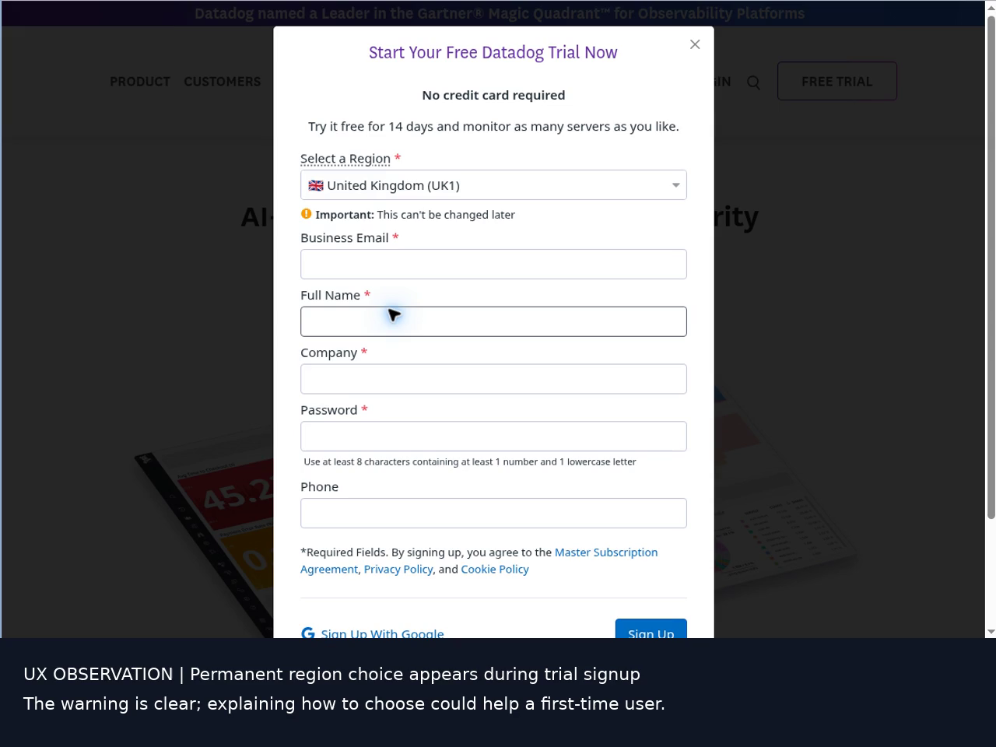
E08 · Actual edited-video frame at 00:20, sourced from raw capture 00:50, about 02:15:17 UTC. All identity fields are blank.
Video evidence 00:20 to 00:34
Reproduce Start a fresh trial and inspect Select a Region before submitting the form.
Recommended experience Give a short explanation or linked chooser covering account location and relevant selection criteria before the irreversible step.
Assessment The permanent-choice warning is explicit and useful. Additional decision support would reduce guesswork for a complete beginner.
Boundary This is an onboarding recommendation. No wrong-region account, data loss, or failed submission was demonstrated.

PART 1 | DOC02 | LOW | CONFIRMED BUG

Documentation navigation breaks words at desktop width
The right-hand contents rail wraps ordinary section names in the middle of words, making the onboarding outline harder to scan.
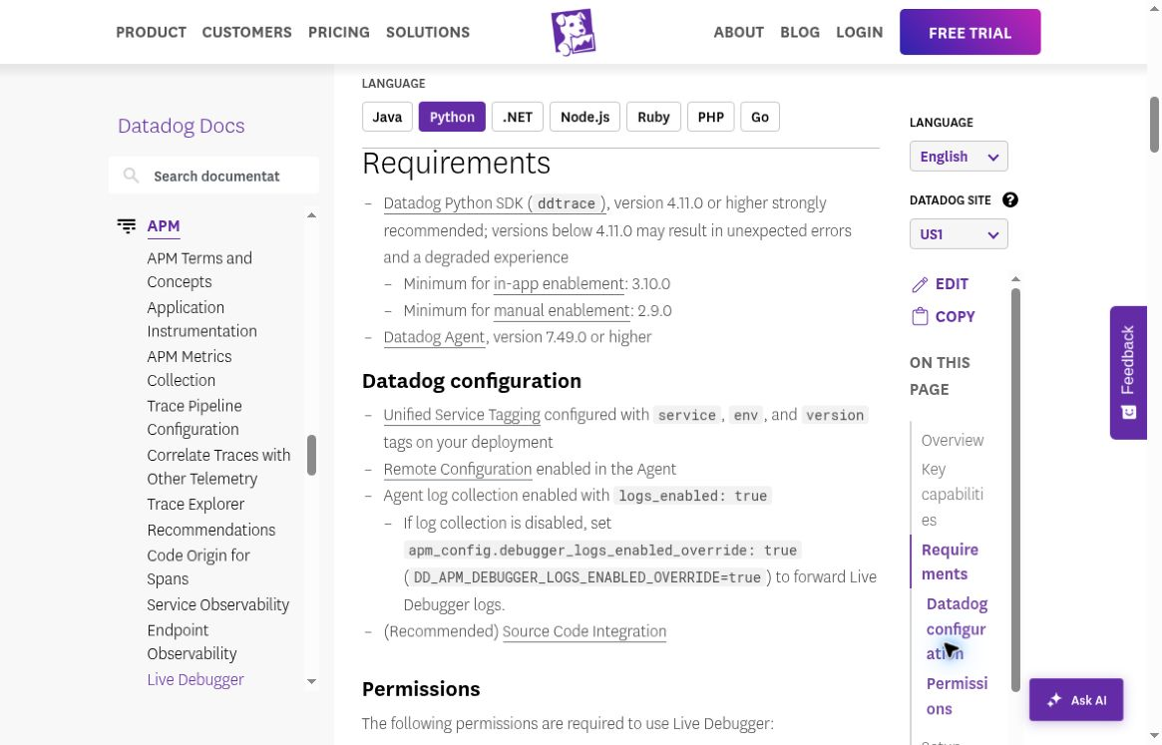
E03 · Requirements page · Screenshot file 02:19:51 UTC · 1165 × 747 captured page image; default browser zoom.
Video evidence 00:34 to 00:58
Reproduce Open the Python Live Debugger documentation at the observed desktop width and scroll to Requirements. Inspect the right-hand contents rail.
Expected Section names remain readable, either wrapping at word boundaries or collapsing into a usable navigation control.
Actual Labels such as Requirements, Permissions, and Datadog configuration split mid-word. The defect is visible in two separate scroll positions.
Fix and retest Reserve sufficient rail width or collapse the rail earlier. Retest default desktop widths and 125–150% zoom, including long translated labels.

PART 1 | UX02 | LOW | UX RECOMMENDATION

Empty service states do not explain setup recovery
A fresh account reaches a manual-debugging path, but unavailable services and environments leave a newcomer without a concrete next step in the captured setup section.
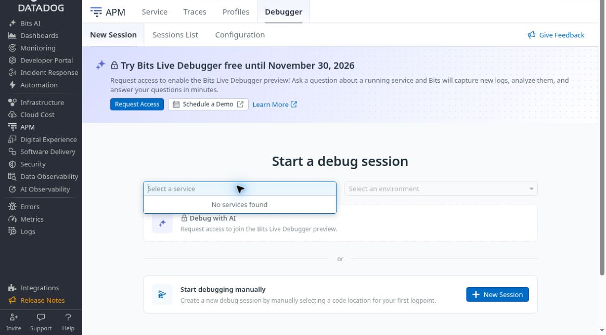
E10 · 03:21:54 UTC · Actual screenshot with top 76 pixels removed to exclude the account greeting. Remaining UI pixels are unchanged beneath the red border.
Online finding with both annotated screenshots
Reproduce Open New Session, inspect the empty service picker, enter the manual logpoint modal, close it, then inspect Configuration. The setup section reports No environments found.
Recommended experience The empty state should offer a concrete route to connect or troubleshoot the first service and explain which prerequisites are missing or not yet known.
Positive controls The modal requires a service and safely disables Start Debug Session. Close returns correctly. Manual debugging remains visible without source integration.
Boundary The missing-service cause was under separate runtime/Remote Configuration investigation. This is a guidance recommendation, not evidence that a configured service is incorrectly absent. A privacy-reviewed authenticated video excerpt is pending.

LIVE DEBUGGER AND SOURCE CODE INTEGRATION

Part 2 Professional QA
This part evaluates correctness and recovery using explicit preconditions, a known sample oracle, expected versus actual results, and reproducible evidence. The shared index links each confirmed finding to its detail page. Planned scenarios stay separate from executed outcomes.
The 63-case plan is tracked in QA_MATRIX.md. This checkpoint establishes two scoped matrix outcomes: B02 records UX02, and B04 passes manual-route discoverability without source integration. F14 has one observed Close variant and remains open. No runtime capture or source-mapping pass is claimed.
Check | Observed outcome | Scope and remaining work
B02 | FINDING UX02 · LOW UX | Natural first-run no-service/no-environment states lack contextual recovery steps in the captured section
B04 | PASS · discoverability only | Manual route visible and enterable without SCI; successful session/capture not tested
F14 | OPEN · partial observation | Close returns without a created session; Escape, Back, Forward, refresh and saved-state variants remain open
Runtime | SETUP IN PROGRESS | Agent/service readiness does not prove ingestion; first captured values remain unverified
Source and access | IN PROGRESS | Setup path inspected; exact deployed SHA, repository boundaries and role tests remain unverified
Other planned cases | NOT RUN | Remain individually tracked; no inferred passes from the two scoped outcomes

Permission tests need precise interpretation
An organization integration can legitimately share access according to its grant model. Do not call lack of a per-user GitHub check a vulnerability without verifying that model. Old source may remain cached for up to seven days under the documented contract; revocation tests must distinguish cached content from a newly fetched, never-seen revision.

High risk tests before confidence in release readiness
- Capture actual quantity 3 locals at pricing.py line 17 and match the correct service, environment, and deployed revision.
- Confirm repo A works while never-granted private repo B cannot return source through the tested integration.
- Observe capture before and after real expiration, distinguishing late ingestion from late execution.
- Reload after stopping and verify every created test session/logpoint is inactive.
See the beginner documentation navigation finding in Part 1

PART 2 | DOC01 | MEDIUM | CONFIRMED BUG

Python quickstart contains an invalid module command
The launch example uses python -m myapp.py. Python’s module switch expects a module name rather than a script filename.
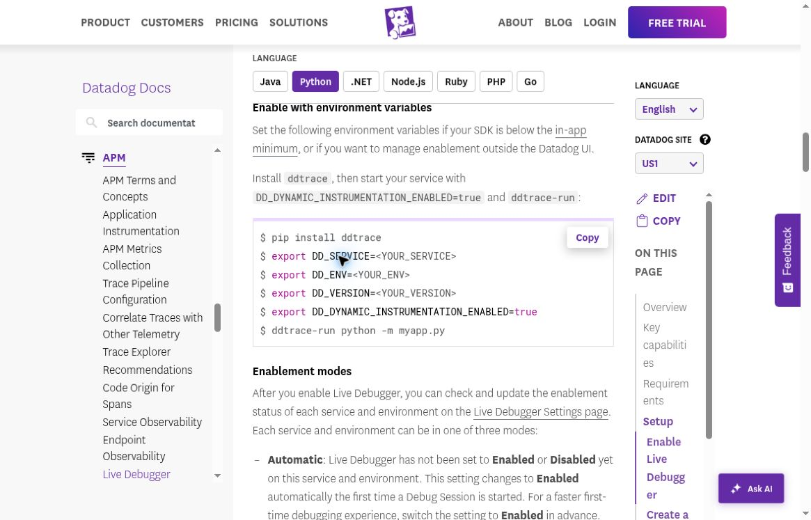
E04 · Official Live Debugger documentation, Python tab · Screenshot file 02:20:19 UTC. Red outline identifies the launch command.
Video evidence 00:58 to 01:20
Reproduce Open Live Debugger docs, select Python, then Enable with environment variables. Follow the final launch line with an ordinary myapp.py script.
Expected A copied quickstart command starts the intended Python application without a module-resolution error.
Actual The Python portion exits 1 for a minimal script. Import-time code runs before the error, so this check does not imply that no application code executes.
Fix and retest Use ddtrace-run python myapp.py for a script, or ddtrace-run python -m myapp for a module. Add a quickstart smoke test that asserts successful process startup.

TECHNICAL APPENDIX

Reproduction and fixture oracle

Command isolation
Independent reproduction: 02:31:35 UTC on 8 October 2026. The file myapp.py contains one harmless print statement; no Datadog SDK or telemetry is involved.
myapp.py:
print("INERT_FIXTURE_EXECUTED")
$ python -m myapp.py
INERT_FIXTURE_EXECUTED
ModuleNotFoundError: __path__ attribute not found on myapp
Exit: 1
$ python myapp.py
INERT_FIXTURE_EXECUTED
Exit: 0
$ python -m myapp
INERT_FIXTURE_EXECUTED
Exit: 0
The error is abbreviated for readability. Python also suggests using myapp instead of myapp.py as the module name. The working alternatives establish the module-versus-filename distinction; neither has been claimed as an instrumented Datadog success.

Known sample behavior
The synthetic quote service intentionally uses quantity > 3 instead of quantity >= 3. It is a target bug in the demo application, not a Datadog defect. At pricing.py line 17 all calculated locals are available for the intended line logpoint.
Quantity | Subtotal | Discount eligible | Discount | Actual total
2 | 2400 | false | 0 | 2400
3 | 3600 | false | 0 | 3600
4 | 4800 | true | 480 | 4320

All monetary values are integer cents. The intended quantity 3 total is 3240. A valid debugger result should expose the actual 3600 and the false eligibility, making the boundary error explainable.
Local test rerun at 02:36 UTC: nine tests completed, eight passed and one intentional expected failure. HTTP tests bind to loopback and clean up their server.

APPENDIX

Evidence and reference index
ID | Evidence | UTC time or recording location
E10 | Empty service picker evidence crop | 03:21:54 UTC; account greeting excluded
E13 | No environments found configuration | 03:23:59 UTC; clean scrolled screenshot
E08 | Blank Datadog trial form video frame | Edited video 00:20; raw 00:50; approximately 02:15:17 UTC
E03 | Python requirements and navigation | File timestamp 02:19:51; initial video approximately 05:15–05:45
E04 | Python environment-variable launch example | File timestamp 02:20:19; initial video approximately 05:45–06:20
R01 | Independent Python invocation reproduction | 02:31:35; Python 3.12.14; bad form exits 1, alternatives exit 0
R02 | Local fixture test rerun | 02:36; 8 passes, 1 intentional expected failure

The 80-second edited excerpt covers public signup and documentation only. Its chapters are 00:20 region choice, 00:34 contents-rail wrapping, and 00:58 invalid Python command. Authenticated account-creation footage is not claimed by this excerpt.
The initial continuous recording began at 02:14:27 UTC and ended at 02:21:01 UTC. It is 393.7 seconds at 1364 × 1024 pixels, 20 fps. Edited-video offsets will differ from raw recording offsets. E03 and E04 are direct page captures; E08 is an extracted video frame. Published evidence excludes browser chrome.

Primary product references
Live Debugger setup and session behavior
Python source mapping
Source Code Management Providers and caching
GitHub integration
Live Debugger expression language
References inform expected behavior and test design. They are not substitutes for observed product results. All current findings are limited to the captured site, viewport, and isolated runtime check.

PLANNED ONLY | NO NEW EXECUTION CLAIMS

Planned scenario coverage
The baseline matrix contains 54 cases. B02 and B04 have scoped outcomes; F14 and S01 are partially in progress. The groups below describe planned coverage, not blanket completion. P0 is test priority, not defect severity.
Scenario group | Baseline IDs | Result to establish
Fresh account to first capture | B01–B08, F01 | A beginner can reach a real captured value and explain the sample bug
Missing prerequisites | B02, B03, B06 | Missing APM, Remote Configuration, runtime compatibility, or roles have distinct recovery guidance
Traces but no debugger service | B02, B05, B07 | An APM-visible service that is absent from debugger selection has an actionable explanation
Repository A allowed and B denied | S01–S04, S11 | A works, never-granted private B is denied, and recovery keeps the intended scope
Revoked source and caching | S10, S15 | Separate cached old contents from newly fetched never-seen source and verify the actual grant model
Runtime commit and moving files | S02, S05–S09 | Branch drift, missing commit, renamed paths, and mixed versions cannot silently show wrong code
Invalid targets and expressions | F04–F07 | Bad lines, unknown variables, invalid syntax, and unsupported context fail usefully
Never true and erroring conditions | F02–F05 | No matching traffic is distinguishable from expression errors and inactive installation
Duplicate and stale actions | F08–F10, F14 | Double clicks, old tabs, back/refresh, and canceled drafts do not hide unintended changes
Expiry and restart | F11–F13, F18–F20 | Capture stops at the effective lifecycle boundary and recovery uses the correct target
Permission loss | S12–S16 | Lost read/write access and cross-org navigation respect effective authorization
Variable safety and complexity | F16, F21–F23 | Redaction, truncation, types, nesting, and rate limits are represented honestly
Cleanup and minimal reproduction | C01–C03 | Every test entity is reconciled and observed failures have a fresh-state positive control

The full executable preconditions, steps, expected outcomes, evidence, and cleanup requirements remain in QA_MATRIX.md. Runtime and access tests require the appropriate synthetic deployment and isolated permission setup.

PLANNED ONLY | X01 TO X09

Additional edge case plan
These nine supplementary cases preserve the original 54-case matrix. They add specific concurrency and deployment challenges; none is an observed defect or executed result.
ID | Scenario | Evidence required before a result
X01 | Mixed-commit rolling deployment | Two active replicas of the same service carry different commits and numeric markers. Each capture resolves to its executing replica’s source.
X02 | Same service names across environments and forks | Use distinct environment, owner/repo, and numeric markers. Filters and direct links must never silently attach a capture to the wrong target.
X03 | Never-executed function versus uninstalled probe | Compare a healthy installed location with no executions against a failed installation. UI and runtime evidence distinguish these cases.
X04 | Delete or expiry versus late snapshots | Record execution, expiry/delete, and ingest times. Buffered old snapshots cannot be mistaken for new capture after the effective stop.
X05 | A selected line moves during deployment | Shift the statement in a new commit and roll forward. Source location and installed definition remain correctly attributed or explicitly require a new target.
X06 | Asynchronous concurrency correlation | Run bounded overlapping synthetic requests with unique numeric IDs. Captured locals, request/trace context, and selected source belong to the same execution.
X07 | Cyclic Unicode values and nested sensitive fields | Capture small cyclic structures, Unicode keys/values, and nested dummy sensitive identifiers under unchanged protection. Inspect safe truncation and masking.
X08 | Repository recovery without reinstall | Remove and restore an approved test-only prerequisite or grant. Correct source becomes available again without unexplained full reinstall or expanded scope.
X09 | Same-location sessions with different conditions | Run two explicit sessions at the same line with disjoint predicates. Captures, edits, stop, and expiry remain associated with the correct session.

Each case requires a baseline positive control, exact identities, UTC execution/capture timestamps, a reload or independent state check, and cleanup. Any missing prerequisite is a blocked test, not a product failure.

REFERENCE

Beginner glossary
These terms describe the debugging workflow. A visible setup check is not the same as a captured event.
Term | Plain language meaning
APM | Application Performance Monitoring. Traces show how requests move through application operations.
Agent | A process near the application that receives and forwards supported telemetry and configuration.
SDK or tracer | A language-specific library in the application. Python uses ddtrace.
Trace and span | A trace follows a request or task; a span represents one operation within it.
Service | The named application or component being monitored. Names alone do not establish environment or source identity.
Environment and version | Tags identifying where the application runs, such as staging, and which release it runs.
Remote Configuration | A channel for supported configuration changes to reach a running Agent or SDK without a new deployment.
Debug session | A bounded investigation containing debugger configuration and related results. Check its actual expiry and active state.
Logpoint | A location and rule that collect a message or values without editing the deployed source for each observation.
Snapshot or captured locals | Values observed at a specific runtime execution. Availability, redaction, sampling, and truncation affect what appears.
Source Code Integration | Repository access plus mapping that connects runtime evidence to source files. A connected account alone is insufficient.
Commit SHA | A Git revision identifier. The source shown for a capture should match the deployed commit, not merely the latest branch.
Redaction | Protection that removes or masks selected data. Missing, unavailable, and redacted values mean different things.

