Customs Value (Customs Valuation)
Why Are Customs Duties Higher Than Expected? — Reasons for Adding Freight and Royalties to Customs Value
Cello Square Insight | Samsung SDS Cello Square
Key Takeaways
• Customs value is calculated according to internationally unified rules based on the WTO Customs Valuation Agreement. The principal method, the Transaction Value Method (Method 1), determines values by adding certain cost elements to the price actually paid.
• The WTO Customs Valuation Agreement delegates to each member country, under its own domestic law, the decision of whether to include freight and insurance to the port of import in the customs value. Most countries, including Korea and the EU, adopt the CIF basis, which includes freight and insurance; while the US, Canada, and Australia adopt the FOB basis, meaning freight and insurance are excluded.
• Since export declarations are based on the FOB amount, while import declarations (in CIF-basis countries such as Korea) are based on the CIF amount, international freight and insurance must be added to or deducted from the invoice amount depending on the Incoterms used — otherwise, undervaluation risk cannot be avoided.
• Duty payable is calculated as customs value × duty rate, and the duty rate is determined by the HS code, country of origin, and whether an FTA applies. Even if the customs value is the same, the final duty amount will differ if the HS code differs.

1. International Rules Governing Customs Valuation — WTO Customs Valuation Agreement
Customs duty is not simply levied on the invoice amount of goods, but on the customs value. The method for determining customs value is not left to each country's discretion; it follows internationally unified rules based on the WTO's Customs Valuation Agreement (Agreement on Implementation of Article VII of GATT 1994), which each member country reflects in its domestic customs laws.
The Agreement sets out six methods for determining customs value. The Transaction Value Method (Method 1) must be applied first and the subsequent methods are applied in sequence only when the preceding method cannot be applied.

Order | Valuation Method | Legal Basis | Description
1 | Transaction Value Method | Article 1 | Based on the price actually paid or payable by the buyer for the goods (principal method)
2 | Transaction Value of Identical Goods | Article 2 | Based on the transaction value of identical goods
3 | Transaction Value of Similar Goods | Article 3 | Based on the transaction value of similar goods
4 | Deductive Method | Article 5 | Derived by deducting specified costs from the selling price in the importing country
5 | Computed Method | Article 6 | Based on the sum of production costs, profit, etc.
6 | Fall-back Method | Article 7 | Based on reasonable criteria, when none of the above methods can be applied

💡 Special Rule — reversing the order of application of Method 4 and 5 (Important in practice)
Article 4 of the WTO Customs Valuation Agreement and Korea's Customs Act allow the sequence of Method 4 (Deductive Method) and Method 5 (Computed Method) to be switched at the importer's request.
In other words, while the default order is Method 4 → Method 5, if the importer requests it, Method 5 may be applied before Method 4.

💡 Basic Formula for the Transaction Value Method
Customs value = Price actually paid (the price actually paid or payable by the buyer to the seller for goods) + Additions + Deductions (where separately identifiable)

2. 7 Elements Added to the Transaction Value
The WTO Customs Valuation Agreement (Article 8) stipulates the following elements to be added to the actual price paid or payable, and these have been incorporated into the customs laws of each member country, including Korea. However, the specific scope of application of these additional elements may vary by member country.
Category | Addition Item | Key Details & Practical Notes
① | Commissions and Brokerage fees | Buyer bears commissions and brokerage fees. However, buying commissions are excluded — they are paid to an agent acting on behalf of the buyer, and are not subject to addition
② | Cost of containers | Cost of containers treated as one with imported goods
③ | Packing cost | Labor and material costs incurred in packing imported goods
④ | Assists | Materials, parts, tools, molds, dies, consumables, technology, design, and engineering supplied free of charge or at a reduced price by the buyer for use in producing and exporting goods — molds and design are typical examples
⑤ | Royalties and License fees | Amounts related to patents, trademarks, and copyrights that the buyer must pay in connection with the goods being valued, under a condition of sale. Both the “relatedness” and “condition of sale” requirements must be met simultaneously for addition (referred to as “royalty for the use of rights” under Korea’s Customs Act)
⑥ | Proceeds of Resale (Subsequently Accruing Proceeds) | Any part of the proceeds from the resale, disposal, or use of the goods that accrues, directly or indirectly, to the seller — addition is possible only where objective, quantifiable data exists
⑦-1 | Transport cost | Transportation costs of imported goods to the import port (place)
⑦-2 | Loading/Unloading costs & Handling charges | Loading/unloading, and handling charges associated with transport to the import port
⑦-3 | Insurance premium | Cargo insurance premium to the import port

💡 Note — WTO Agreement Terminology vs. Korean Customs Act Terminology
WTO Agreement: “royalties and license fees” → Korean Customs Act: “royalty for use of rights”
WTO Agreement terminology may be expressed differently in each member country’s customs law, so practitioners should check the relevant country’s customs law provisions when applying these rules.

3. Customs Value Varied by Different Incoterms

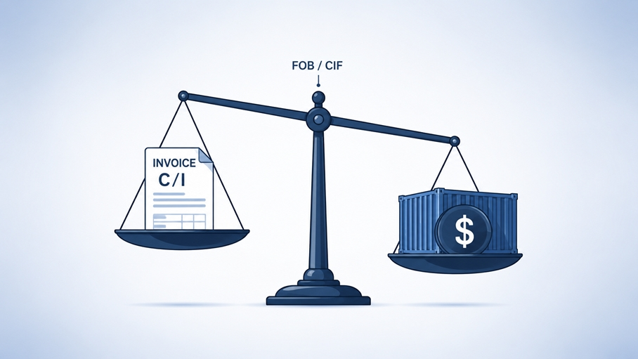

3-1. CIF vs FOB — Customs Valuation Standards by Country
Article 8.2 of the WTO Customs Valuation Agreement delegates to each member country the decision, under its domestic legislation, whether to include freight and insurance to the port of import in the customs value. As a result, countries have adopted different standards, as shown below.

Standard | Freight & Insurance Included or Not | Major Adopting Countries | Characteristics
CIF Basis | Included in customs value | Most countries including Korea, EU, China, Japan, Southeast Asia, etc. | Adopted by the majority of WTO member countries worldwide
FOB Basis | Not included in customs value | US, Canada, Australia | Exception among a minority — customs value is calculated lower for the same shipment

💡 Practical Note — Always Check the Importing Country’s Standard
Incoterms merely define how costs and risks are allocated between seller and buyer under the sales contract; they do not themselves determine the basis for calculating customs value.
Even if the contractual Incoterms are FOB or EXW, if the importing country uses the CIF basis, the actual freight and insurance incurred must still be added to the customs value.
Conversely, when importing into an FOB-basis country such as the US, freight and insurance must be deducted from an invoice quoted on CIF terms before declaring.

3-2. Whether Freight and Insurance Are Included by Incoterms Condition
Incoterms Condition | Category | Freight Included or Not  in C/I Unit Price | Insurance Included or Not  in C/I Unit Price
EXW | Delivery at factory | Not included | Not included
FCA / FOB / FAS | Carrier/on-board/quay delivery | Not included | Not included
CFR / CPT | Freight-inclusive delivery | Included | Not included
CIF / CIP | Freight/insurance-inclusive delivery | Included | Included
DAP | Delivery at destination (duty unpaid) | Included | Included (conventional)
DDP | Delivery at destination (duty included) | Included | Included

※ Freight and insurance are as indicated in the C/I (Commercial Invoice). Whether or not insurance is included under DAP/DDP may vary depending on the specific contract terms.

3-3. Example of Calculating Export and Import Declaration Amounts According to Incoterms

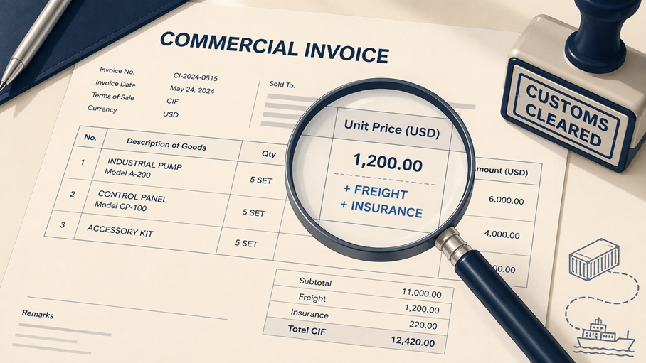

The unit price on the C/I (Commercial Invoice), which is a key document for import declarations, may include or exclude international freight and cargo insurance depending on the Incoterms, so it is essential to verify this when filing the declaration.
Category | Incoterms | Items included in the C/I unit price | Freight, insurance paid by
E·F conditions | EXW, FCA, FAS, FOB, etc. | Only product prices | By importer (buyer)
C·D conditions | CFR, CIF, CPT, CIP, DAP, DDP, etc. | Product price + international freight + cargo insurance | By exporter (seller)

📊 Example of calculating declaration amount (Assuming product price $5 + freight & insurance $2)

Export declaration amount: Based on FOB → $5 (Product price only)
Import declaration amount: Based on CIF → $7 (Product price + Freight & Insurance)

[ In case of contract under E·F terms ] C/I amount = $5 (Product price only)
→ Import declaration: Declare $7, adding $2 for freight and insurance based on the forwarder's actual invoice

[ In the case of a contract under C·D terms ] C/I amount = $7 (including freight and insurance)
→ Export declaration: Declare $5 after deducting the $2 of freight and insurance received from the consignee

⚠️ Under Value Risk — Must check it
When importing into countries based on CIF, if you declare the FOB amount excluding freight and insurance, you may be deemed by customs authorities to have intentionally underreported the declared amount (Under Value) and may face disadvantages.
The international freight and insurance premiums received from the forwarder must be declared based on the actual invoice, not the quotations.

4. How HS Code (Item Classification) Impacts on Customs Duty
The HS code is an item classification number assigned to exported and imported goods according to the international unified commodity classification system (Harmonized System) managed by the World Customs Organization (WCO). Each country forms its tariff schedule based on the HS code and determines the tariff rates for each item.
💡 Formula for calculating customs duty
Customs Duty = Customs value × Applicable customs rate for the item

※ Some items may be subject to duties based on weight or quantity (specific duties·mixed duties).

Tariff rates can also vary depending on the HS code, origin, whether the FTA is applied, and whether quota tariffs or anti-dumping duties are applied. Therefore, even if the customs value is accurate, if the HS code is different, the final tariff amount will differ.
Item | Description
HS Code → Tariff Rate | Even with the same customs value, if the HS code changes, the applicable tariff rate changes, resulting in a change in the final tariff amount
HS Code → FTA Application | Preferential tariff rates and the criteria for origin are regulated based on the HS code, so accurate item classification is a prerequisite for FTA benefits
HS Code → Origin Criteria | The rules for determining the origin (a change in tariff classification, value-added criterion, etc.) vary by HS code, so accurate classification is essential
Caution | To benefit from the preferential tariff, you must also meet not only accurate HS code classification but also additional requirements (fulfilling the origin criteria and providing a certificate of origin, etc.)

5. Practical Checklist for Assessing Customs Value
Category | Check items | Check
C/I confirmation | ① Check whether the C/I contract terms are under E·F terms or C·D terms | □
C/I confirmation | ② In the case of E·F terms, check whether the international freight and cargo insurance have been added based on the forwarder's actual invoice. | □
Incoterms | ③ Verify Incoterms conditions (FOB, CIF, etc.) on a contract and whether freight and insurance are included | □
Freight·Insurance | ④ Verify the import country criteria (CIF/FOB) and confirm that freight and insurance costs to the port of import are properly reflected in the declared price | □
Royalty | ⑤ Review whether the “relatedness” and “condition of sale” requirements for royalties and license fees apply | □
Production Support | ⑥ Confirm whether a buyer provided assists (molds, designs, etc.) with free of charge or at a reduced price | □
Item Classification | ⑦ Verify accuracy of HS code classification and applicable tariff rate | □
FTA | ⑧ Verify eligibility for preferential tariff and compliance with the HS code-based origin criteria | □
Special relationship | ⑨ Review whether to apply for Advance Customs Valuation Agreement (ACVA) in the case of transactions between related parties | □
Deduction factors | ⑩ Check if post-import expenses (domestic transportation, installation, interest, etc.) can be separately identified and deducted. | □

※ Tax price review checklist may vary depending on the customs laws of each country. It has been prepared based on Korea, and separate confirmation is required for each importing country.
6. Unique Features of Cello Square
Why Cello Square Helps in Determining Customs Value
✔ Confirm actual freight settlement amount: When calculating the customs value, freight and insurance should be reflected based on the actual settlement rather than quotations. On Cello Square, you can check both the quotation and settlement documents together to immediately identify the actual logistics costs.
✔ Integrated Management of Import Declaration Documents: Store and view documents required for import declarations (C/I, P/L, etc.) in one place based on the cloud.
✔ Integrated reservation and tracking on single platform: Manage integrated reservations and real-time cargo tracking for sea, air, and transshipment all on one screen.
✔ Dedicated Counterpart One-stop Communication: Without changing PIC for each leg, a dedicated counterpart immediately provides detailed information in case of any abnormal situations.
✔ AI-based alternative route simulation: Automatically provide AI-based alternative routes in case of abnormal cargo situations based on Samsung SDS's global network.

7. FAQ
Q. Can the same item exported at the same price have different tariffs depending on the country?
A. It may vary. The WTO Customs Valuation Agreement stipulates that each member country shall determine under its own laws whether to include freight and insurance costs up to the port of import in the customs value. Most countries, including Korea and the EU, adopt the CIF basis (including freight and insurance), while the United States, Canada, and Australia adopt the FOB basis (excluding freight and insurance), so that the customs value and customs duty for the same goods may differ depending on the importing country.
Q. When importing into a country based on CIF, if the contract is made on FOB or EXW terms, is the freight not included in the customs duties?
A. It is included. Since the country has adopted the CIF basis, which includes freight and insurance costs to the port of import in the customs value, even if the incoterms on the contract are EXW, FOB, etc., and freight is not included in the invoice, the actual freight and insurance costs to the port of import are added to the customs value.
Q. Does the customs value change if the HS code changes?
A. The applicable tariff rate changes, not the assessed value itself. The tariff amount is calculated by multiplying the assessed value by the item-specific tariff rate determined by the HS code, etc. Even if the assessed value is the same, if the item classification differs, the final tariff amount may vary.
Q. Can I use the C/I (commercial invoice) amount as the import declaration amount as is?
A. Depending on the contract terms. In E·F terms (where an importer bears the freight and insurance costs), only the product price is included in the C/I, so when filing the import declaration based on CIF, the actual international freight and insurance costs from the forwarder's invoice must be added to the declaration. In C·D terms (where an exporter bears the freight and insurance costs), the freight and insurance costs are already included in the C/I, but when filing the export declaration based on FOB, these must be deducted.
Q. What happens if you declare the FOB value excluding international freight costs?
A. Customs authorities in the country based on CIF may consider it as an intentional under value to reduce customs duties, which can lead to disadvantages. The international freight costs and insurance premiums received from the forwarder must be declared based on the actual invoice amount, not the quotation.
Q. Is royalty always included in the customs value?
A. No. In order for royalties and license fees to be added to the customs value, both ① the requirement of ”relatedness” to the subject goods and ② the requirement of being a “condition of sale” for the payment of those goods must be satisfied simultaneously. If both requirements are not met, they are not subject to addition. Whether or not royalties are subject to addition depends on the contract structure, so it is recommended to have a review from a customs expert.

Be More Convenient With Cello Square
When calculating the customs value, it is important to verify the freight and insurance costs based on the actual settlement amount rather than a quotation. Cello Square is a digital logistics forwarding platform operated by Samsung SDS, allowing users to check both the quotation and settlement statements together to immediately identify the actual logistics costs incurred. Documents required for import declarations, such as C/I and P/L, can also be stored and reviewed in one place on a cloud-based system, and in case of any abnormal situations, detailed information can be promptly provided through a dedicated operator.
▶ Go to Cello Square Quote

