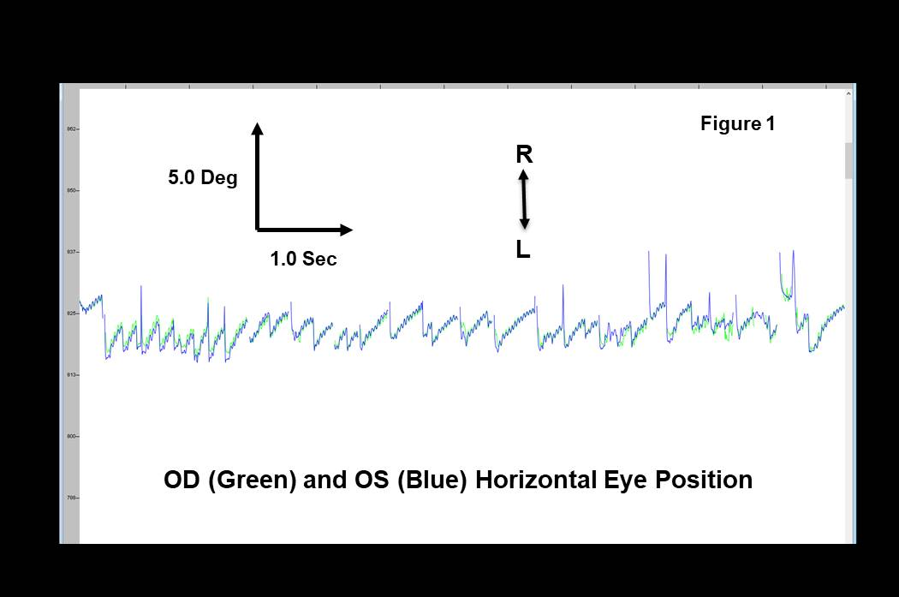

Figure 1. Eye movement recordings from a 19 month old Asian Male, CNGA3 mutation Achromatopsia Autosomal Recessive, Coding DNA c.[396_11 C>G]; [14956>T] Homozygous Mother and Father.

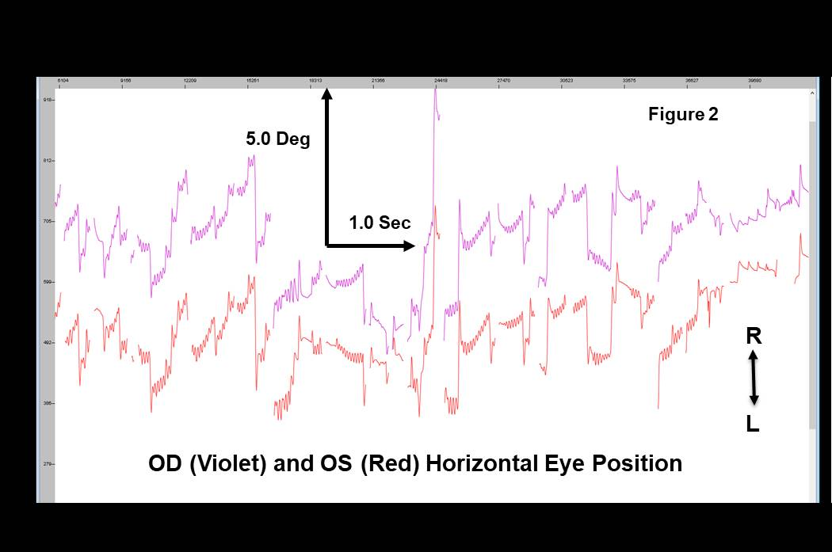

Figure 2. Eye movement recordings from a 10 year old Caucasian female, CABP4 Mutation, Cone-Rod Synaptic Disorder, Autosomal Recessive, Coding DNA c.[800_801delAG] Homozygous Mother and Father.

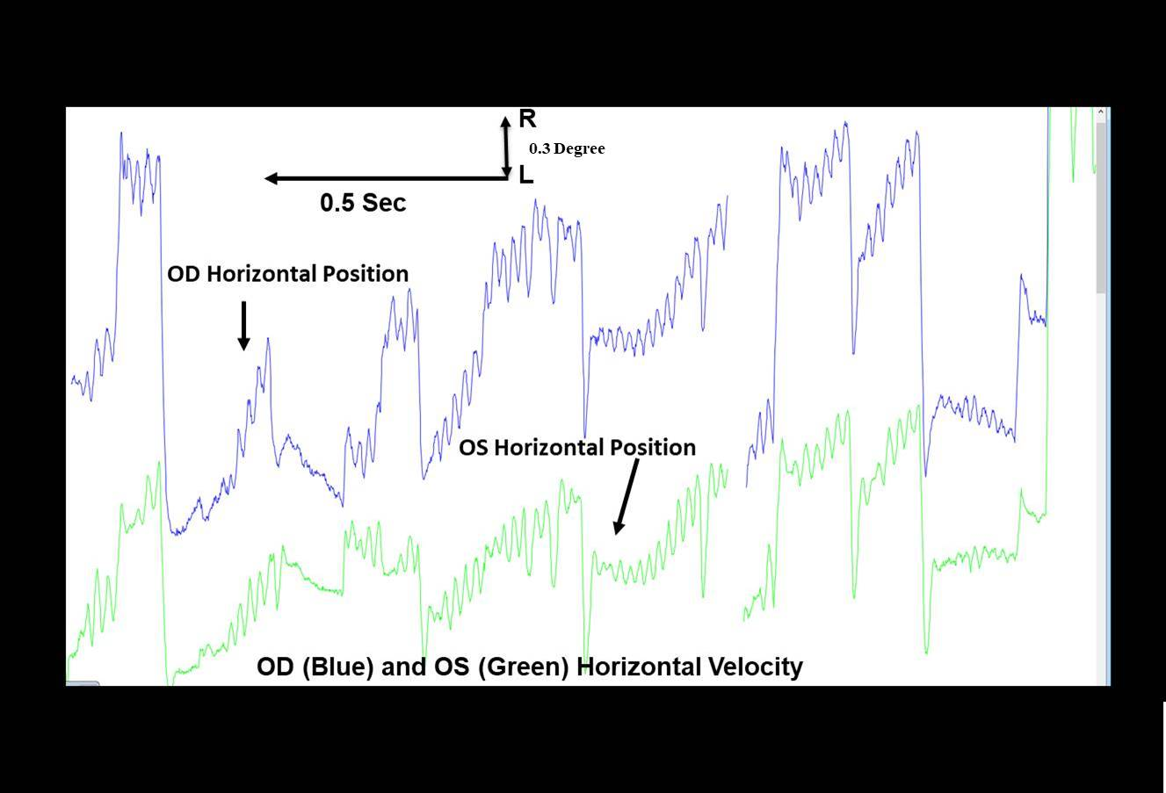

Figure 3. Eye movement recordings from a 5 year old Caucasian male, 2 Mutations, Oculocutaneous Albinism Type 2, Autosomal Recessive, Coding DNA c.[2228 C>T, p.P743L] Heterozygous Mother *and* ATP 1A3 Related Disorder Autosomal Dominant c.[2486 C>T, p.P829L] Heterozygous, De Novo.