Assignment 2
Concurrency and multithreading 2016
Dimitri Diomaiuta – 2553339
Hugo Brandao - 2553124

Introduction:
This assignment is about Fine grained locking. Fine grained locking can be seen as an improvement over coarse grained locking. This implementation, in fact, does not lock the whole data structure to make it thread safe, it locks instead just the parts needed by each thread to perform update operations (in this case adding or removing elements). This allow multiple threads to access the same data structure at the same time and update it since only parts of it will be locked by each thread. There is still the probability that some threads will have to wait to acquire a lock on a an object but overall the thread concurrency allowed by this implementation is much higher than the previous one. The two data structure used are the same of the previous assignment: singly linked list and binary search tree.

Hypotheses:
We now formulate three hypothesis on how the Fine grained implemented versions of the two data structure will behave in comparison to the previous implementations (coarse grained ones), each other (fine grained list vs fine grained tree) and having more or less parallelization allowed (the work time parameter):
- H1: Increasing the work time parameter does not result always in slower execution. Running the same data structure with the same parameters (number of threads, number of items) but an increased work time parameter may result in a faster execution since avoids too many context switches from one thread to another.
- H2: Knowing that the fine grained data structure allow a much higher thread concurrency we can hypothesize that with the same number of threads and number of items the same data structures will perform faster in their fine grained implementation than in the coarse one. The work time parameter will be set differently for the different data structure according to the value that provides a fastest execution. The number of threads must be bigger than one to see the concurrency gain.
- H3: Knowing that the tree data structure provides on average faster access than the list one we can hypothesize that with the same parameters (number of threads, number of items) the fine grained tree will perform faster than the fine grained list. The work time parameter will be set differently according to the value that provides a fastest execution.

Evaluation:
Support or disprove of the hypotheses statements was done by testing the implemented data structures, with different parameters, and analyze the gathered data. The environment used for running the implemented data structures was the DAS4 cluster. We used, as in the previous assignment, the averageTime.sh script (appendix A) to have an average of 2 different runs of the same program in order to have more accurate results (we changed to 2 since number of elements used this time were much bigger).

H1 evaluation:
The first hypothesis was evaluated by running the fine grained implemented data structure with the same parameters but an increased work time parameter each time (we initially increase it to 5 and if there are speed gains we continue increasing it other wise we decrease it). In this evaluation we tested both the list and the tree in their fine grained implementation. The number of items, for each data structure, was chosen high enough to cause the program to run at least for more than one second. This in order to make it possible to see speed ups changing the work time parameter. The number of threads was chosen in order to start from 2 and increase in different steps to reach 1% of the number of elements (that means that each threads deals with 100 elements) in order to see how the work time has different effects on different number of threads. The data gathered from testing can be seen in table 2.1
Structure | Implementation | No of threads | No of items | Work time | Average time results (20 runs) in ms
Tree | Fine | 2 | 1.000.000 | 0 | 3461
Tree | Fine | 2 | 1.000.000 | 5 | 8973
Tree | Fine | 2 | 1.000.000 | 1 | 4894
Tree | Fine | 8 | 1.000.000 | 0 | 9233
Tree | Fine | 8 | 1.000.000 | 5 | 8136
Tree | Fine | 8 | 1.000.000 | 10 | 5032
Tree | Fine | 8 | 1.000.000 | 15 | 5014
Tree | Fine | 8 | 1.000.000 | 20 | 6247
Tree | Fine | 10 | 1.000.000 | 0 | 9049
Tree | Fine | 10 | 1.000.000 | 5 | 8480
Tree | Fine | 10 | 1.000.000 | 15 | 6037
Tree | Fine | 10 | 1.000.000 | 20 | 5599
Tree | Fine | 10 | 1.000.000 | 30 | 7209
Tree | Fine | 100 | 1.000.000 | 0 | 5238
Tree | Fine | 100 | 1.000.000 | 5 | 9402
Tree | Fine | 100 | 1.000.000 | 1 | 7948
Tree | Fine | 1000 | 1.000.000 | 0 | 7630
Tree | Fine | 1000 | 1.000.000 | 5 | 9134
Tree | Fine | 1000 | 1.000.000 | 1 | 8482
Tree | Fine | 10.000 | 1.000.000 | 0 | 15789
Tree | Fine | 10.000 | 1.000.000 | 1 | 15970
List | Fine | 2 | 20.000 | 0 | 6288
List | Fine | 2 | 20.000 | 5 | 6730
List | Fine | 2 | 20.000 | 1 | 6830
List | Fine | 8 | 20.000 | 0 | 1828
List | Fine | 8 | 20.000 | 5 | 2616
List | Fine | 8 | 20.000 | 1 | 2153
List | Fine | 20 | 20.000 | 0 | 1694
List | Fine | 20 | 20.000 | 5 | 1729
List | Fine | 20 | 20.000 | 1 | 1697
List | Fine | 100 | 20.000 | 0 | 1490
List | Fine | 100 | 20.000 | 5 | 1608
List | Fine | 100 | 20.000 | 1 | 1576
List | Fine | 200 | 20.000 | 0 | 2027
List | Fine | 200 | 20.000 | 5 | 1757
List | Fine | 200 | 20.000 | 10 | 1777
Table 2.1
As it can be seen from table 2.1 the work time parameter behavior depends on the number of threads used and on the type of data structure. We can see that it never affects the list execution to have an high speed gain, instead it affects the tree execution to have an high speed gain on small number of threads. When used 8 or 10 threads the tree structure can execute almost 2 times faster when the work time is increased. The obtained data confirms our hypotheses that increasing the work time parameter does not always slow down the program but can increase its execution speed. An increased work time parameter result in a speed gain when a small number of threads is used since it makes the program having less context switches. When the number of threads is too small or too big (in our case < 8 and > 10) the work time context switch gain is lower than the overhead it adds to each thread, hence it result in a slower execution. The motive why the speed gain is almost nothing in the list is that, differently from the tree, threads must visit the same path each time (list does not have many levels as a binary search tree) so the more a thread works the higher the probability of holding a lock on an element needed by another thread. In this case the context switch gain is lower than the busy waiting cause by threads increased work time.

H2 evaluation:
The second hypothesis was evaluated by testing each data structure fine grained implementation with its coarse one. The number of items for the tests was chosen high enough to make the data structures run for more than one second in order to be able to record speed ups. The number of threads was chosen to start from 2 and increase in different steps to reach 1% of the number of elements (that means that each threads deals with 100 elements) in order to make comparison of the different implementations using different number of threads. The work time parameter was chosen accordingly to the one making the data structure to run faster. When comparing a data structure fine grained implementation with a coarse one the parameters are all the same except from the work time that can be different. The data gathered can be seen in table 2.2.
Structure | Implementation | No of threads | No of items | Work time | Average time results (20 runs) in ms
Tree | Coarse | 2 | 1.000.000 | 0 | 6294
Tree | Fine | 2 | 1.000.000 | 0 | 3461
Tree | Coarse | 8 | 1.000.000 | 0 | 5882
Tree | Fine | 8 | 1.000.000 | 15 | 5014
Tree | Coarse | 10 | 1.000.000 | 0 | 5689
Tree | Fine | 10 | 1.000.000 | 20 | 5599
Tree | Coarse | 100 | 1.000.000 | 0 | 5538
Tree | Fine | 100 | 1.000.000 | 0 | 5238
Tree | Coarse | 1000 | 1.000.000 | 0 | 6096
Tree | Fine | 1000 | 1.000.000 | 0 | 7630
Tree | Coarse | 10.000 | 1.000.000 | 0 | 10.804
Tree | Fine | 10.000 | 1.000.000 | 0 | 15.789
List | Coarse | 2 | 20.000 | 0 | 3453
List | Fine | 2 | 20.000 | 0 | 6288
List | Coarse | 8 | 20.000 | 0 | 3208
List | Fine | 8 | 20.000 | 0 | 1828
List | Coarse | 20 | 20.000 | 0 | 3678
List | Fine | 20 | 20.000 | 0 | 1694
List | Coarse | 100 | 20.000 | 0 | 2374
List | Fine | 100 | 20.000 | 0 | 1490
List | Coarse | 200 | 20.000 | 0 | 2061
List | Fine | 200 | 20.000 | 10 | 1777
List | Coarse | 1000 | 20.000 | 0 | 2682
List | Fine | 1000 | 20.000 | 0 | 5316
List | Coarse | 10.000 | 20.000 | 0 | 9849
List | Fine | 10.000 | 20.000 | 0 | 15.840
Table 2.2
We decided to add an high number of threads also on list, even though it is bigger than 1% of the number of elements, in order to make our data more relevant and useful to prove/disprove our hypothesis. As it can be seen from table 2.2 the data gather by the tests do not confirm our second hypothesis completely. It can be seen, in fact, that when the same data structures are run with an high number of threads (1000 or 10.000 in our tests) the coarse grained implementation performs better than the fine grained one. This is because of cache misses. Cache misses occur every time a new thread operates for the first time since its local cache is empty. This initial cache miss is shared by both the coarse grained implementation and the fine one and causes an equal overhead. What causes the fine grained implementation to have more overhead than the coarse one are subsequent cache misses. The fine grained implementation, in fact, do not work on the whole data structure but only on parts of it. This causes more cache misses than the coarse implementation where each thread works on the whole structure. The overhead caused by this behavior makes the fine grained data structures run slower than the coarse one on an high number of threads (in our tests more than 1000 threads). We can finally state that the data gathered during the tests does not confirm our hypothesis hence when run with the same parameters the fine grained implementation is not always faster than the coarse one.

H3 evaluation:

on the data structure performance behavior by increasing the number of threads (it confirms again our first hypothesis since the tree data structure always runs faster than the list one when having the same parameters). The list performance behavior and the tree one can be seen respectively in the chart 2.3 and chart 2.4. As we can see from the tables and the charts the two data structures are behaving exactly the same: after incrementing from 8 to 10 threads the execution time increases. At a first glance this may seem not logical, but subsequent runs with an increased number of threads result in slower execution. There is a clear cutoff in performance between 8 and 9 threads (this is valid for this testing session where we used these exact values, with other parameters the cutoff could be between a different number of threads). In theory this happens because of different problems that are common in parallel programming:
- Creating and destroying each thread adds load to the total overhead, hence the more the threads the more the program overhead
- Saving and restoring a thread register state adds load to the total overhead.
- Saving and restoring the cache state of a thread adds load to the total overhead.
- The more the threads the more probable is that virtual memory will be trashed. Retrieving memory from the disk is a very expensive operation that adds load to the total overhead.
- Lock convoy can happen when the implemented programs deal with coarse grained locking data structures. When multiple threads with the same priority want to access the same data structure and fail in acquiring the lock they add overhead to the program execution. The overhead consist in the repeated context switches from one thread to another when a lock acquaintance is failed.
To see which one of the previous points affected our program performance we should run again the programs under the linux command line tool perf. This analyzes the execution of the program and it saves in a report (that can be accesses after the perf record your_program command with the perf report one). We did four different runs with perf and analyzes the report content. We first run the list data structure with 8 threads, 400 items and 40 as work time. After this run we did the same but increasing the number of threads from 8 to 400 in order to have a much different work load to analyze (running with 400 threads emphasizes why running the program with more threads slows it down). The third and fourth run were the same as the first and the second ones but with the tree data structure. The tests were performed on a local machine due to the impossibility of accessing the perf utility under the DAS4 node environment. As it can be seen from the first and the second reports (see image 2.5 and 2.6) and from the third and the fourth one (see image 2.7 and 2.8) increasing the number of threads makes the program dealing most of the time with this call: rwsem_down_write_failed. This call happens when a thread does not succeed to acquire a lock

Image 2.5

Image 2.6

Image 2.7
for writing to the data structure. On the other hand with 8 threads the most expensive call was the one dealing with data decompression (inflate). It is clear, from the gathered data, that the problem why the program runs slower if it is executed with a number of threads bigger than 10 it is lock convey. Multiple threads, in fact, try to acquire a lock in order to write the items to the data structure but they fail since there is already another thread having the lock. The context switch after failing to acquiring the lock causes a lot of overhead. This is the cause of the biggest overhead for both the data structure. It can also be noted that the tree data structure is slowed down by the page_fault (see second entry image 2.8) call that is the consequence of the virtual memory trashing (this probably because the tree data structure performs its operation in a recursive way creating many memory instances). The list, on the other hand, it is slowed down by the _raw_spin_lock call (see second entry image 2.6) that means that the threads are repeatedly trying to access the wanted resource in a loop.

Image 2.8

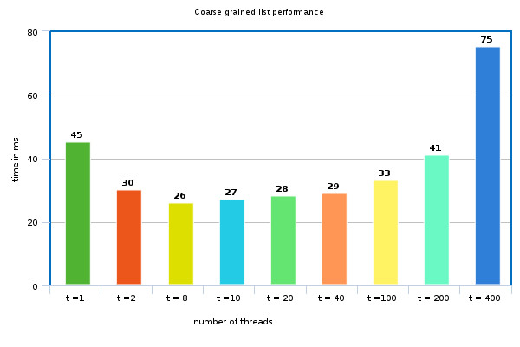
Chart 2.3
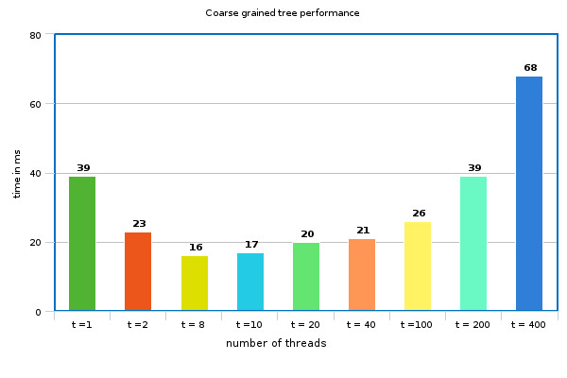
Chart 2.4

Appendix A:
The following script runs the input test data structure program 20 times and outputs the average of each execution time.
The script is run as follows: ./averageTime.sh "./bin/test_data_structures p1 p2 p3 p4"
This is the script code:
#!/bin/bash
command="$1"
for i in $(seq 1 2)
do
y=$($command | grep time | awk '{print $2}')
x=$((x+y))
done
average=$(echo "$x/2" | bc -l)
echo "for the command $command the average is: $average"

