DelphiDabbler
8 Queens Problem Solver
User Guide
for release 4.1.1

Introduction
To solve the eight queens problem you need to find all possible ways of placing eight queens on a chess board so that no queen can capture any other. In chess, queens can capture any pieces sharing the same file (column), rank (row) or diagonal.
This program solves the problem and displays all the solutions, one by one, on a virtual chess board.
Given that the purpose of writing the program was to find out how to solve the problem, the main interest is in the source code. This is open source and freely available. See the “Get the Source Code” section towards the end of this document for details.
The following sections show how to use the program.

Start-up
The program starts with a blank chess board, as can be seen in screen shot 1. (All screen shots are of v4.1.1 running on Windows 10.1).
The actions available at any time are shown in the prompt box that is displayed towards the bottom of the window.
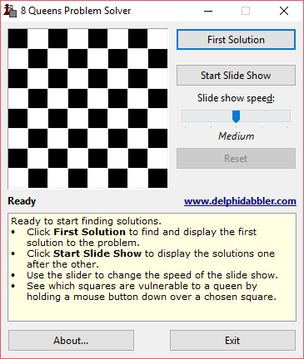Screen shot 1
Solutions can be generated in one of two ways:
- Manually
- By using the slide show feature.

Manual operation
Click the Find Solution button to display the first solution on the chess board. The button's caption then changes to Next Solution. Click the button repeatedly to find and display subsequent solutions. The Reset button can be clicked at any time to start again. See screen shot 2.
Once all solutions have been displayed the Next Solution button will be disabled and the chess board will be cleared, as screen shot 3 illustrates.
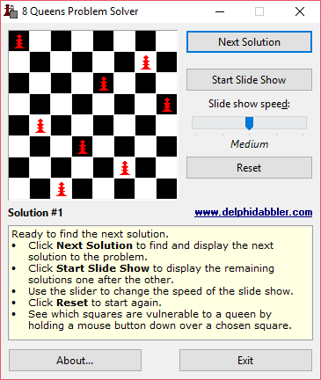Screen shot 2
You must click the Reset button if you want to run the program again. The display then reverts to its initial state, as shown in screen shot 1 above.
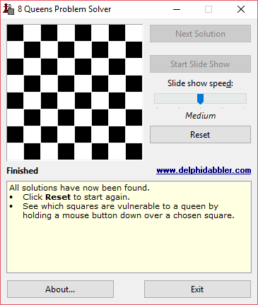Screen shot 3

Slide show
You can run a "Slide Show" by clicking the Start Slide Show button whenever it is enabled. The program will then display each solution automatically in sequence.
There is a delay between the display of each solution. This delay can be changed by moving the Slide show speed slider.
When the slide show starts running the slide show button's caption changes to Stop Slide Show, as is shown in screen shot 4. Clicking the button halts the slide show. Once halted, subsequent solutions can be displayed using the Next Solution button or by restarting the slide show again using the Start Slide Show button again.
You can use the Next Solution button to skip to the next solution while the slide show is running. Once again the Reset button can be clicked at any time to return to the start.
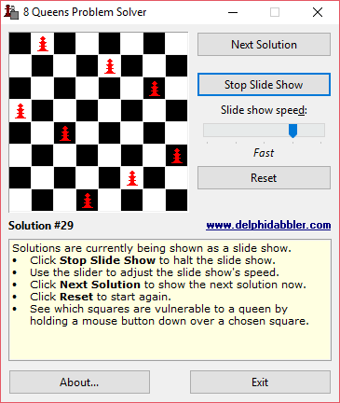Screen shot 4
Once all the solutions have been displayed, the slide show button's caption reverts to Start Slide Show and it is disabled. The chess board is cleared and the window appears as in screen shot 3 above. The Reset button must be pressed if you want to run the program again. The program will then revert to the state shown in screen shot 1.

Checking the Results
There is an easy way to see for yourself that none of the queens in any solution can capture any others. Just point the mouse at a square containing a queen and press and hold down a mouse button. Dotted lines will appear along the columns, rows and diagonals where the queen could capture a piece – see screen shot 5. No line will cross another queen. Release the mouse button to hide the lines.
You can use this technique on any square, not just those containing queens. In fact for every empty square the lines should intersect at least one queen, showing that no more queens can be placed on the board.
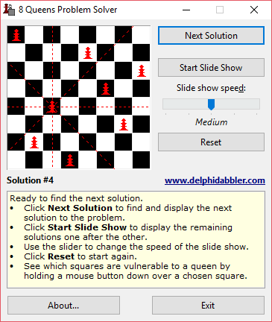Screen shot 5

Other options
- The program's about box can be displayed by clicking the About button. Any active slide show will continue to run while the about box is displayed.
- Close the program by clicking the Exit button.
- You can visit the DelphiDabbler.com website by clicking the link that appears under the Reset button.

Get the source code
If you want to know how the problem was solved then download the source code. You can get it from http://www.delphidabbler.com/software/queens. The solution logic is in the UCalc.pas unit.
The program is coded in Delphi Object Pascal.

Copyright and license
The program is copyright © 1991-2016 by Peter D Johnson, (www.delphidabbler.com). and is released under the MIT License.
The license (including disclaimer) is displayed by the program's installer. A copy is also installed with the program – see the LICENSE file in the program's installation folder.
This user guide is copyright © 2016, Peter D Johnson (www.delphidabbler.com).
It is licensed under the Creative Commons BY-NC-SA 2.5 License


