1. info VARCHAR(50) NULL - Can be NULL if additional info is not available, everything else NOT NULL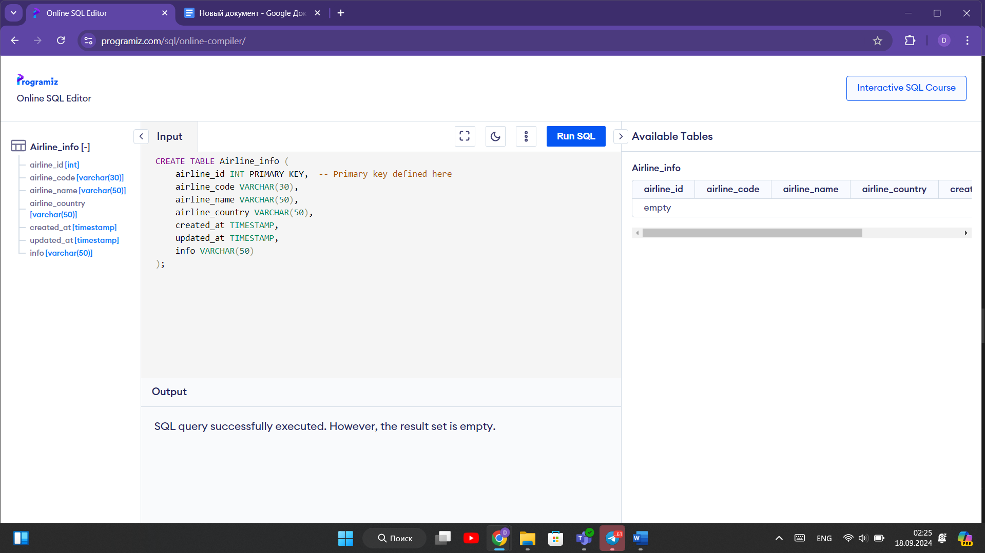 2. state VARCHAR(50) NULL, -- Can be NULL for countries without states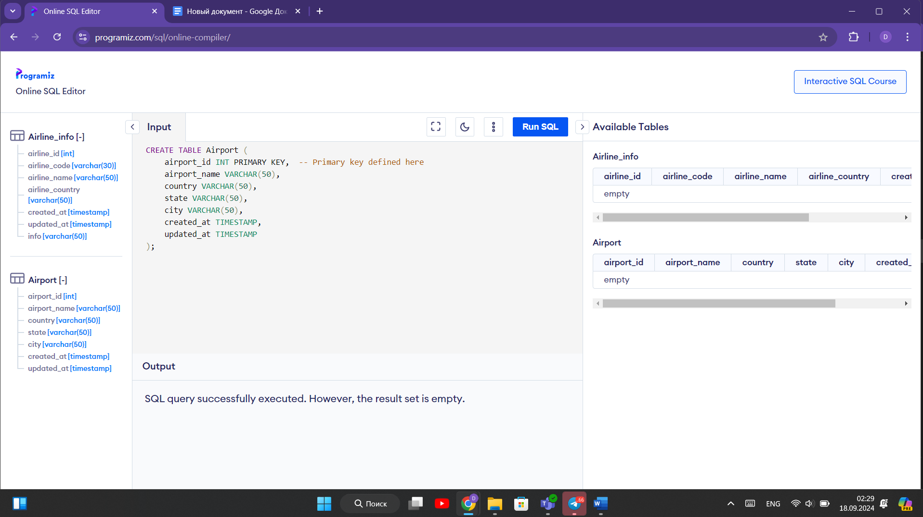 3. everything NOT NULL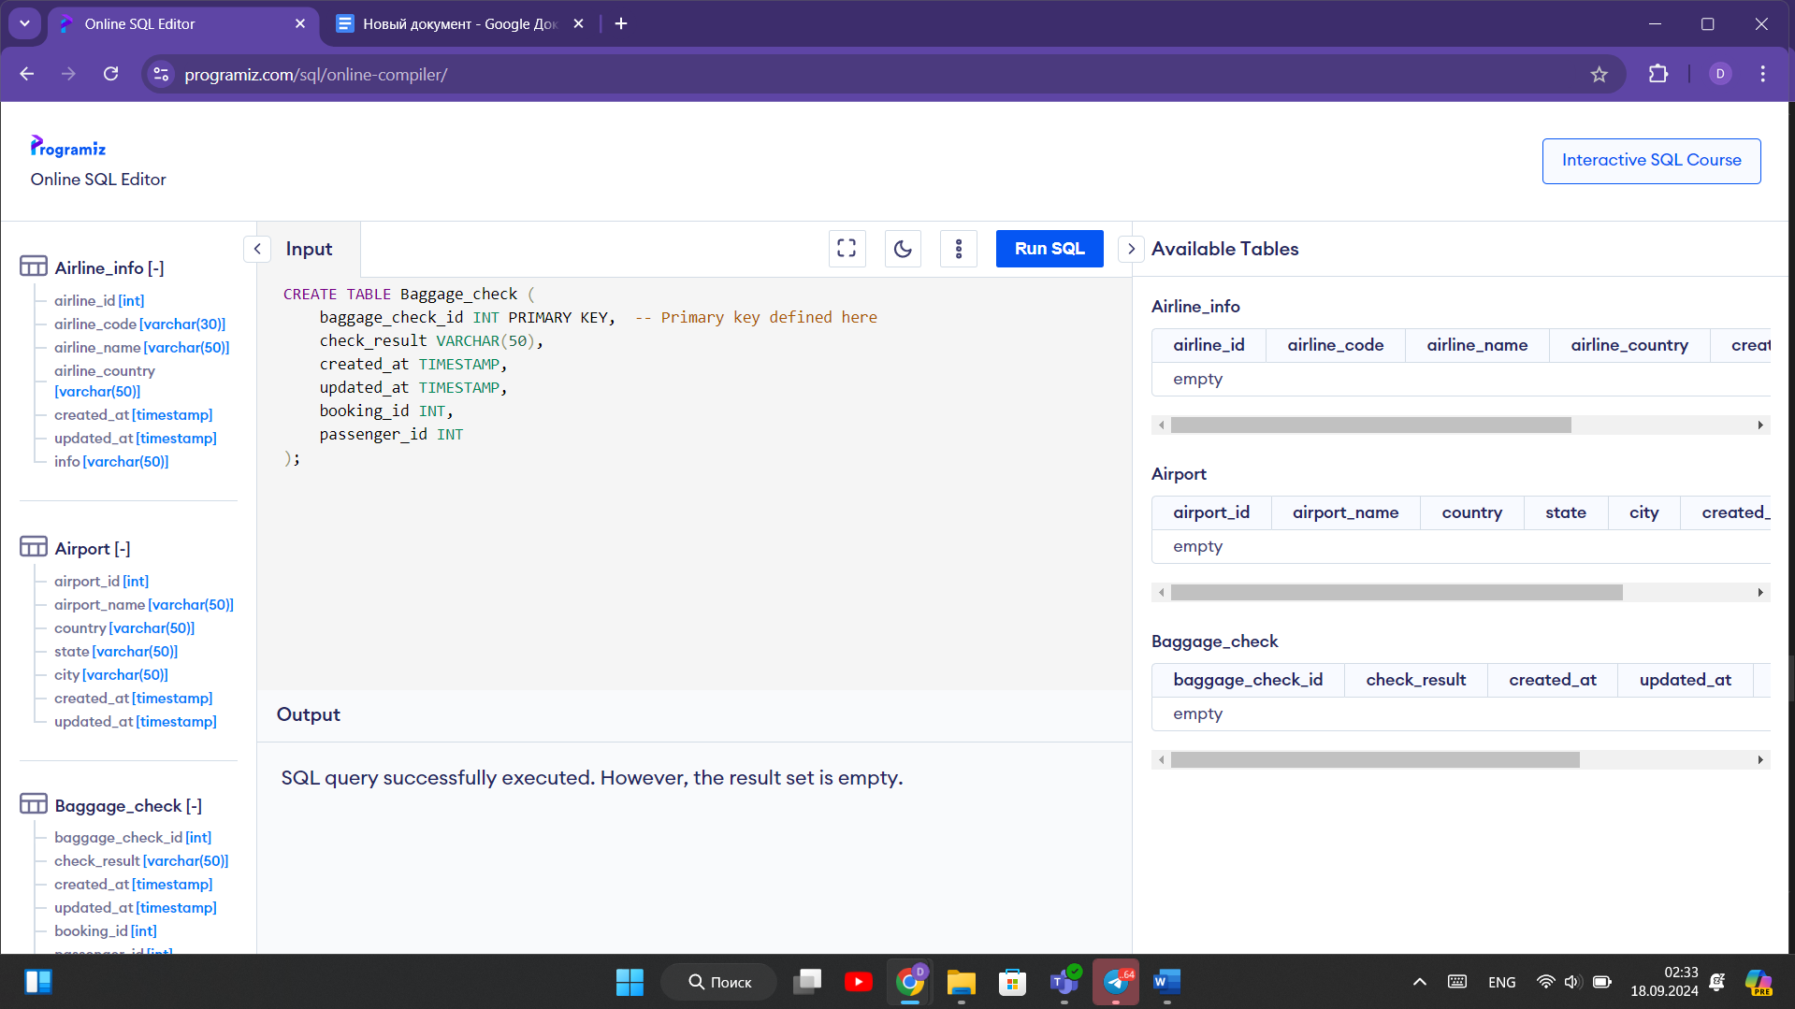 4. everything NOT NULL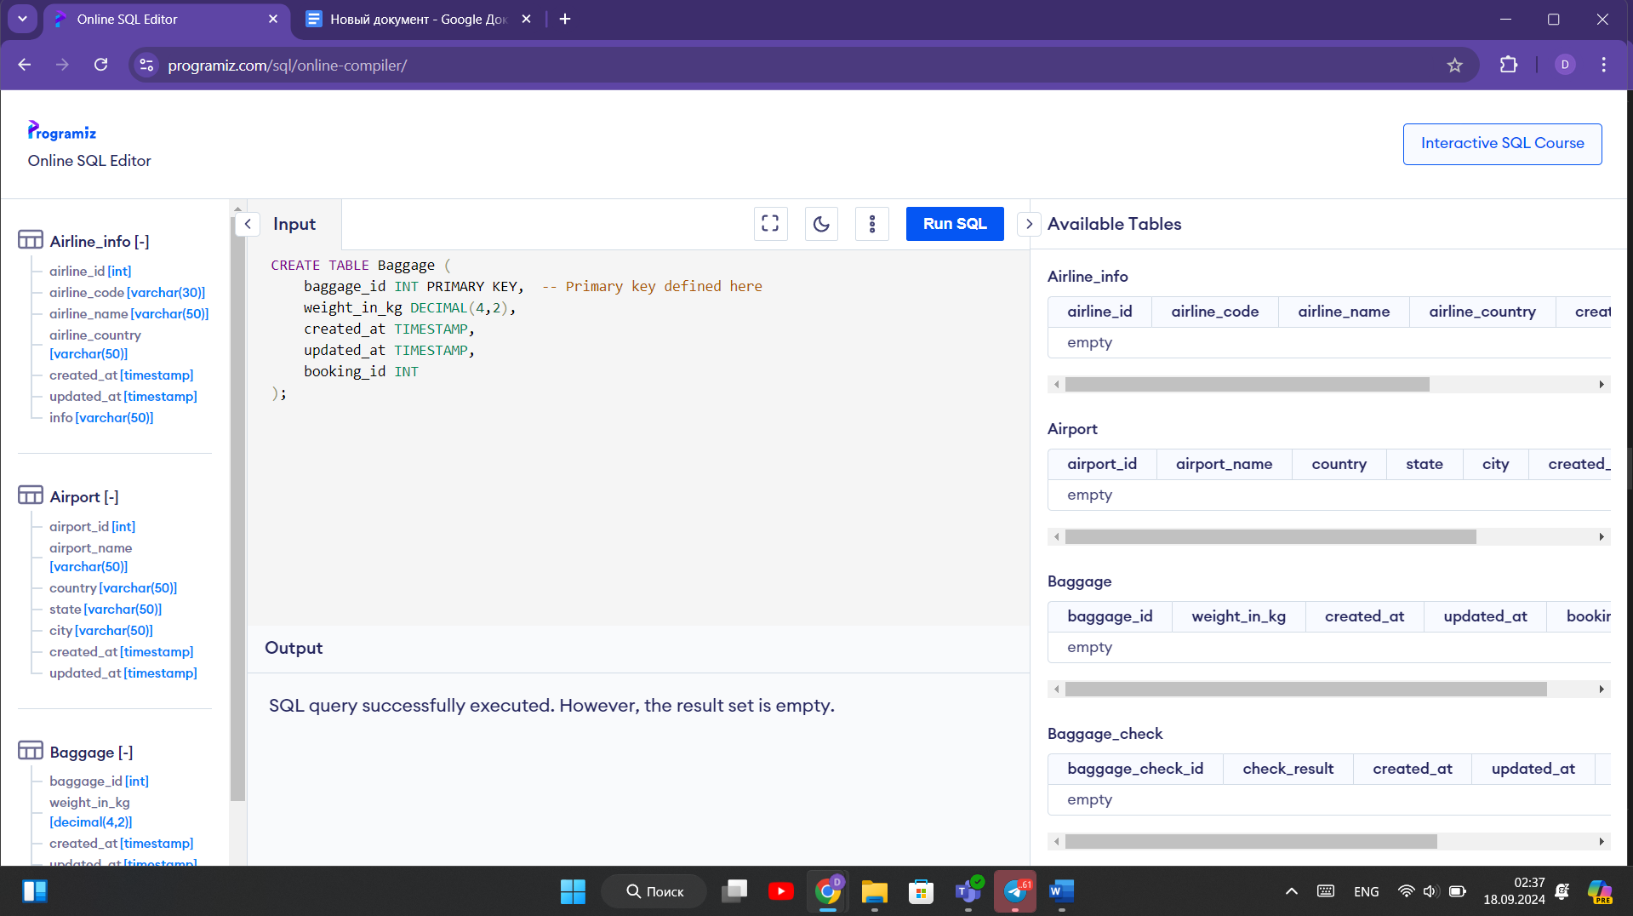 5. everything NOT NULL

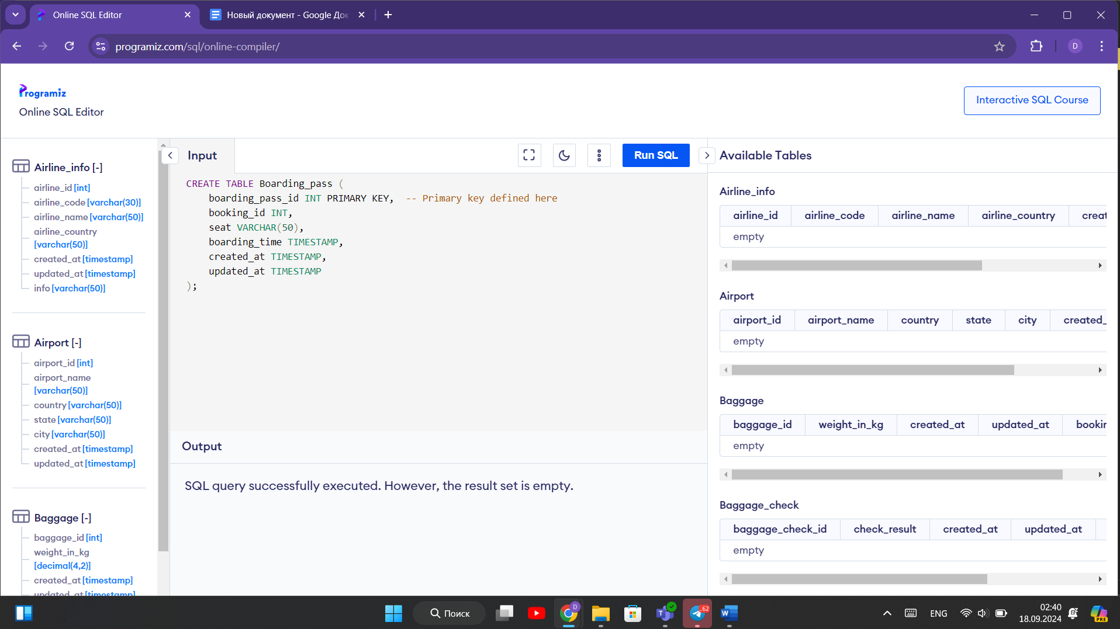 6. Everything not null

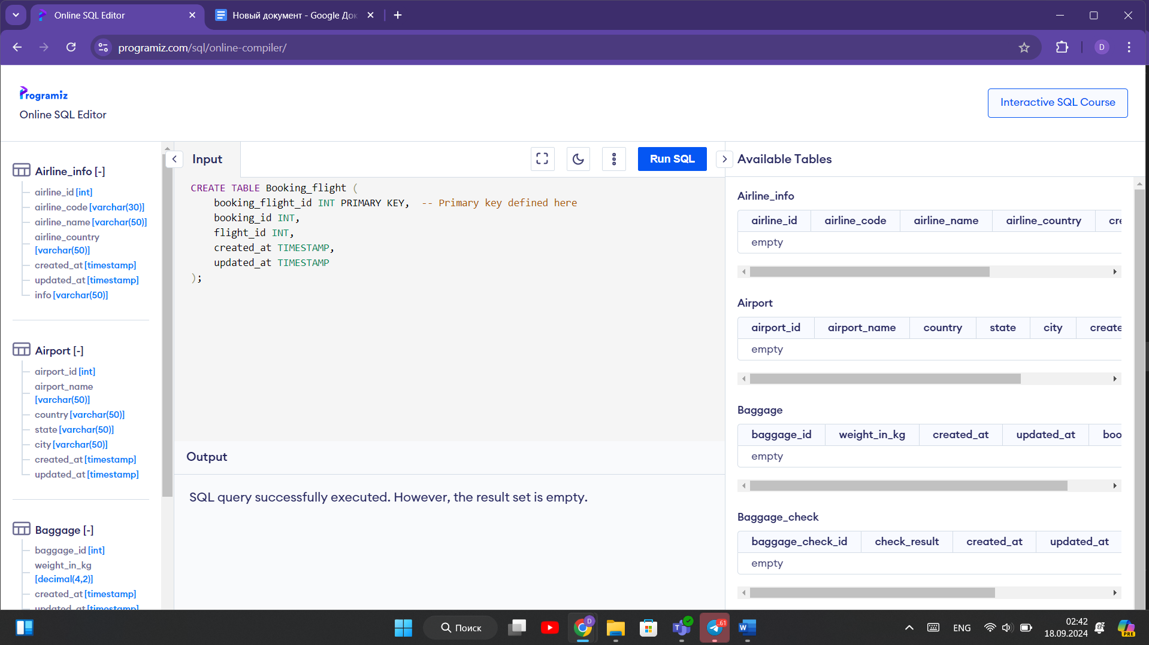 7. everything not null

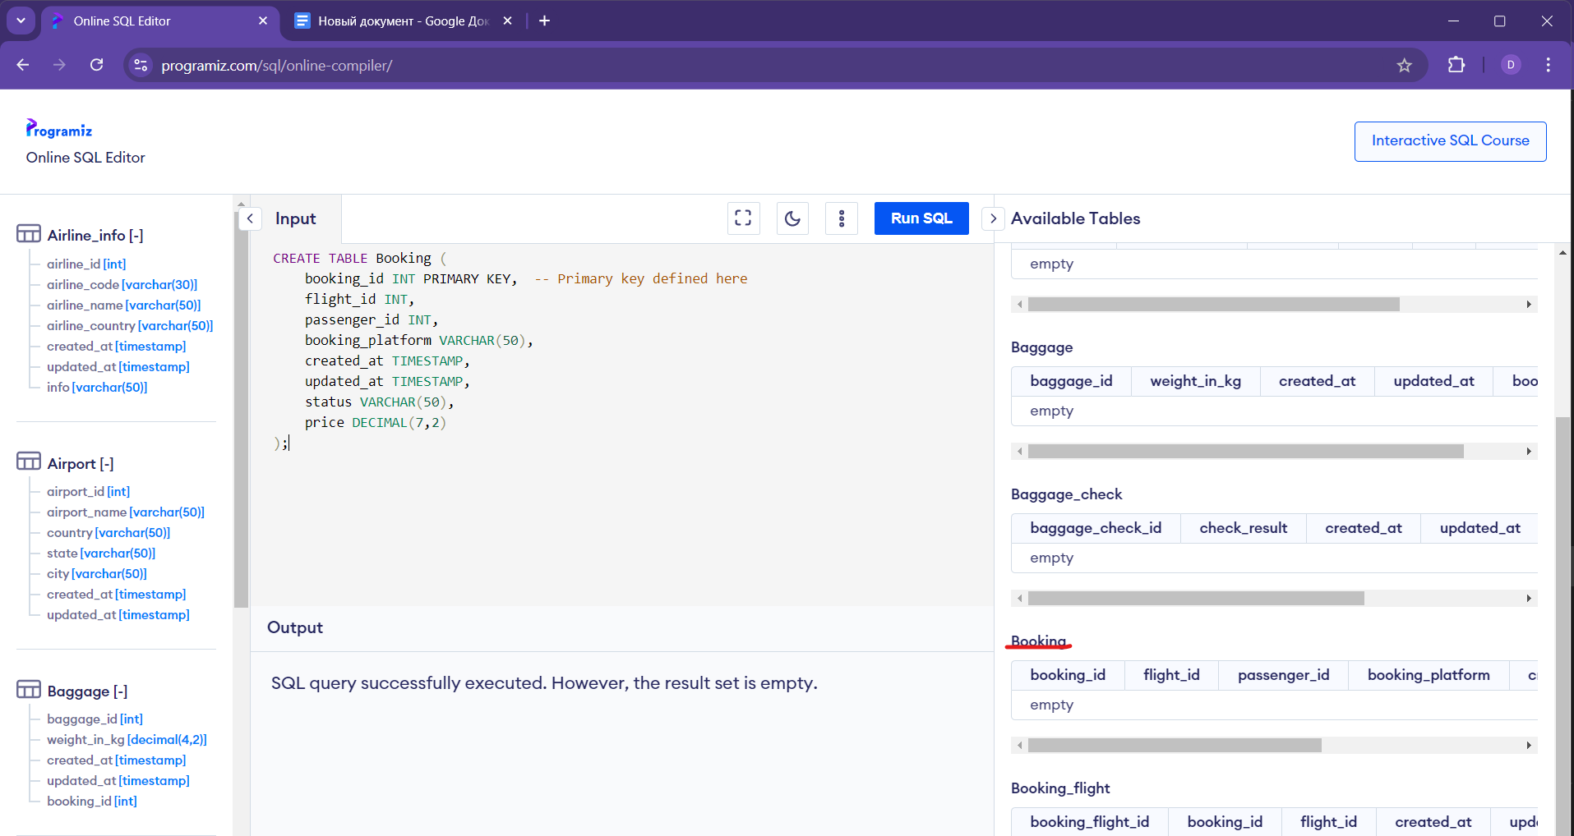

8. everything is not null

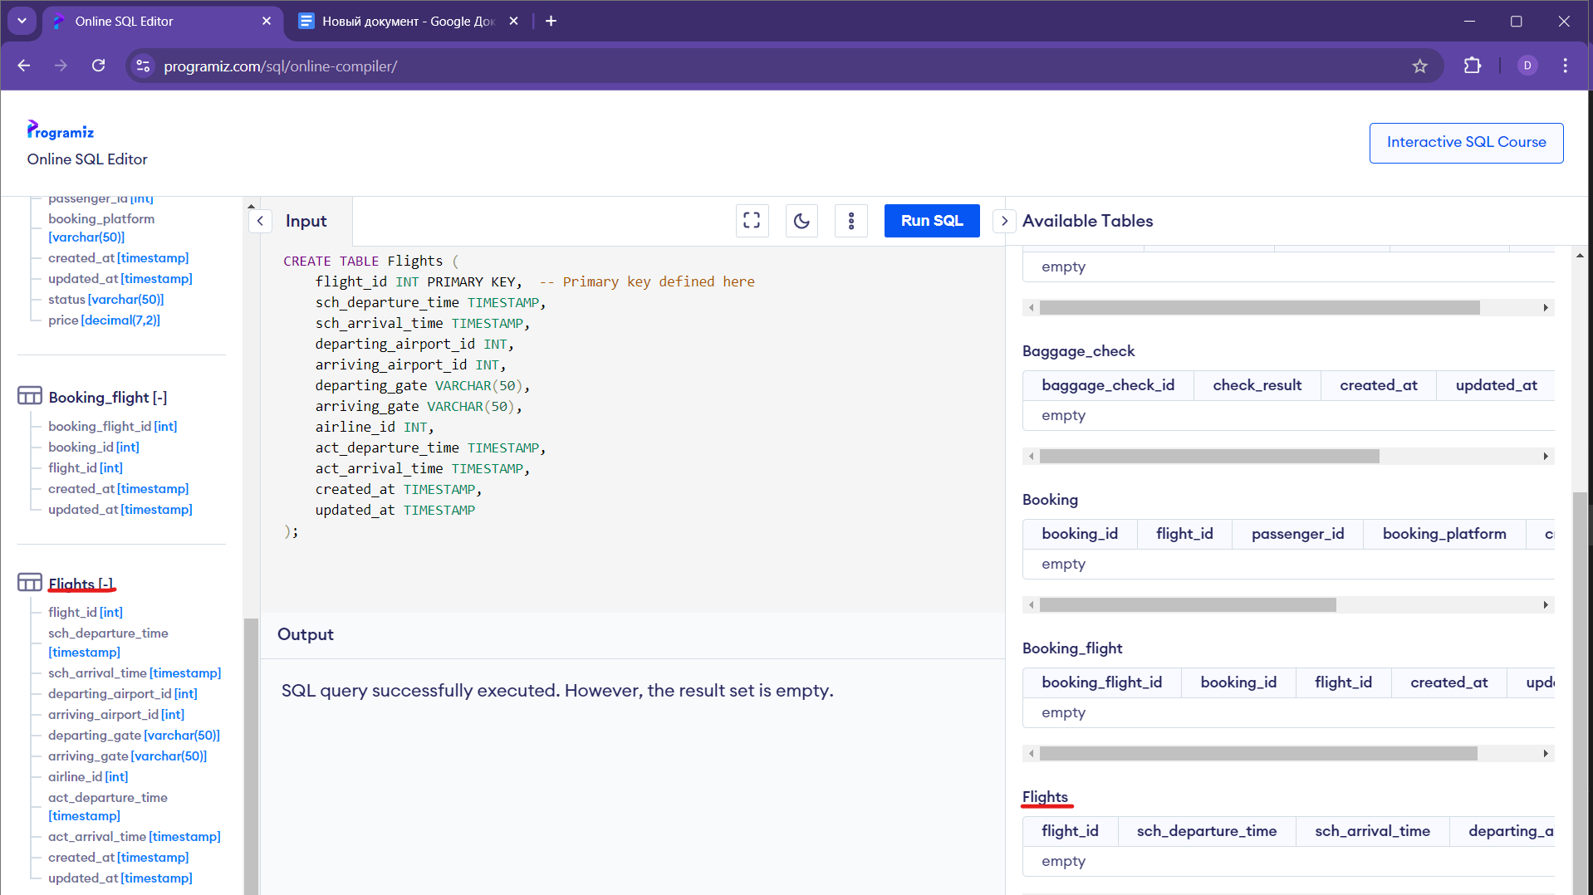 9. everything is not null 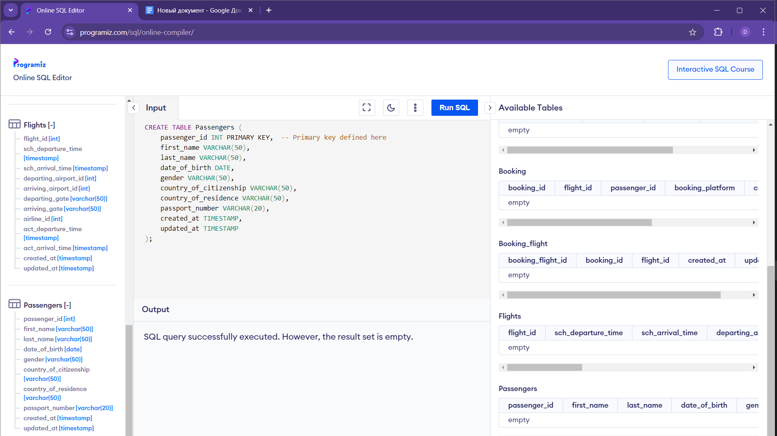10.everything is not null 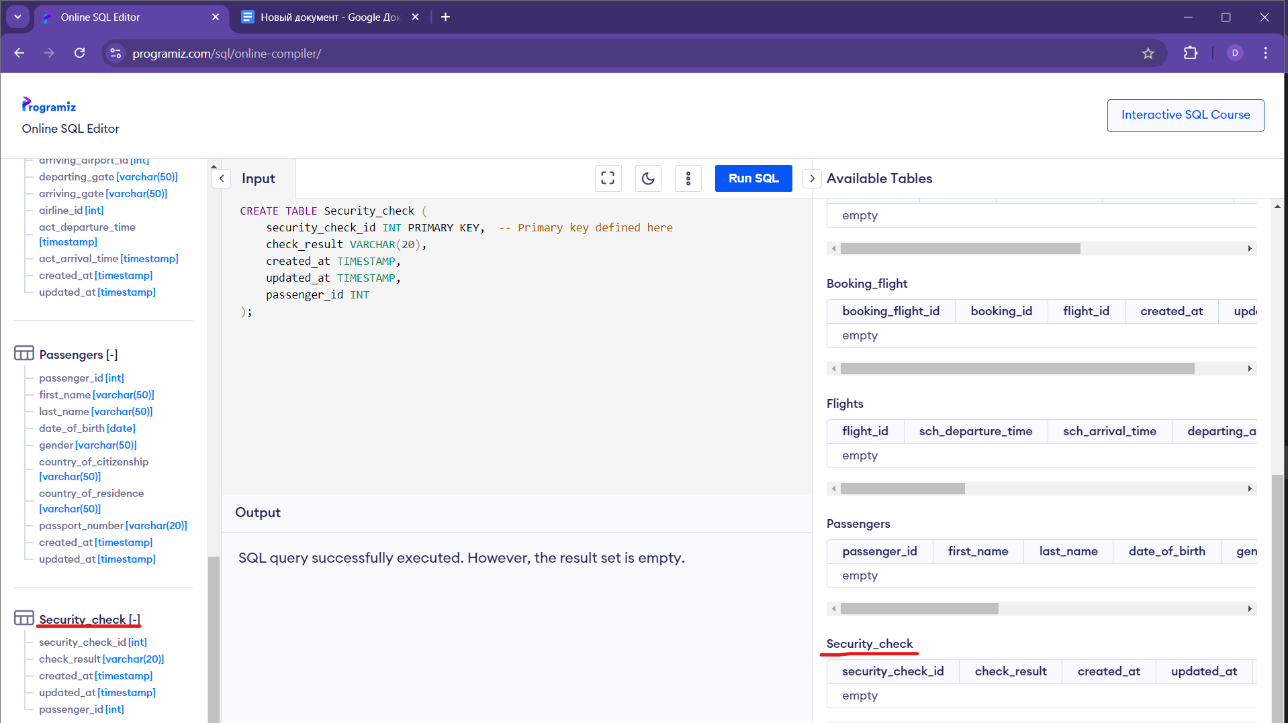

**Rename Airline_info to Airlane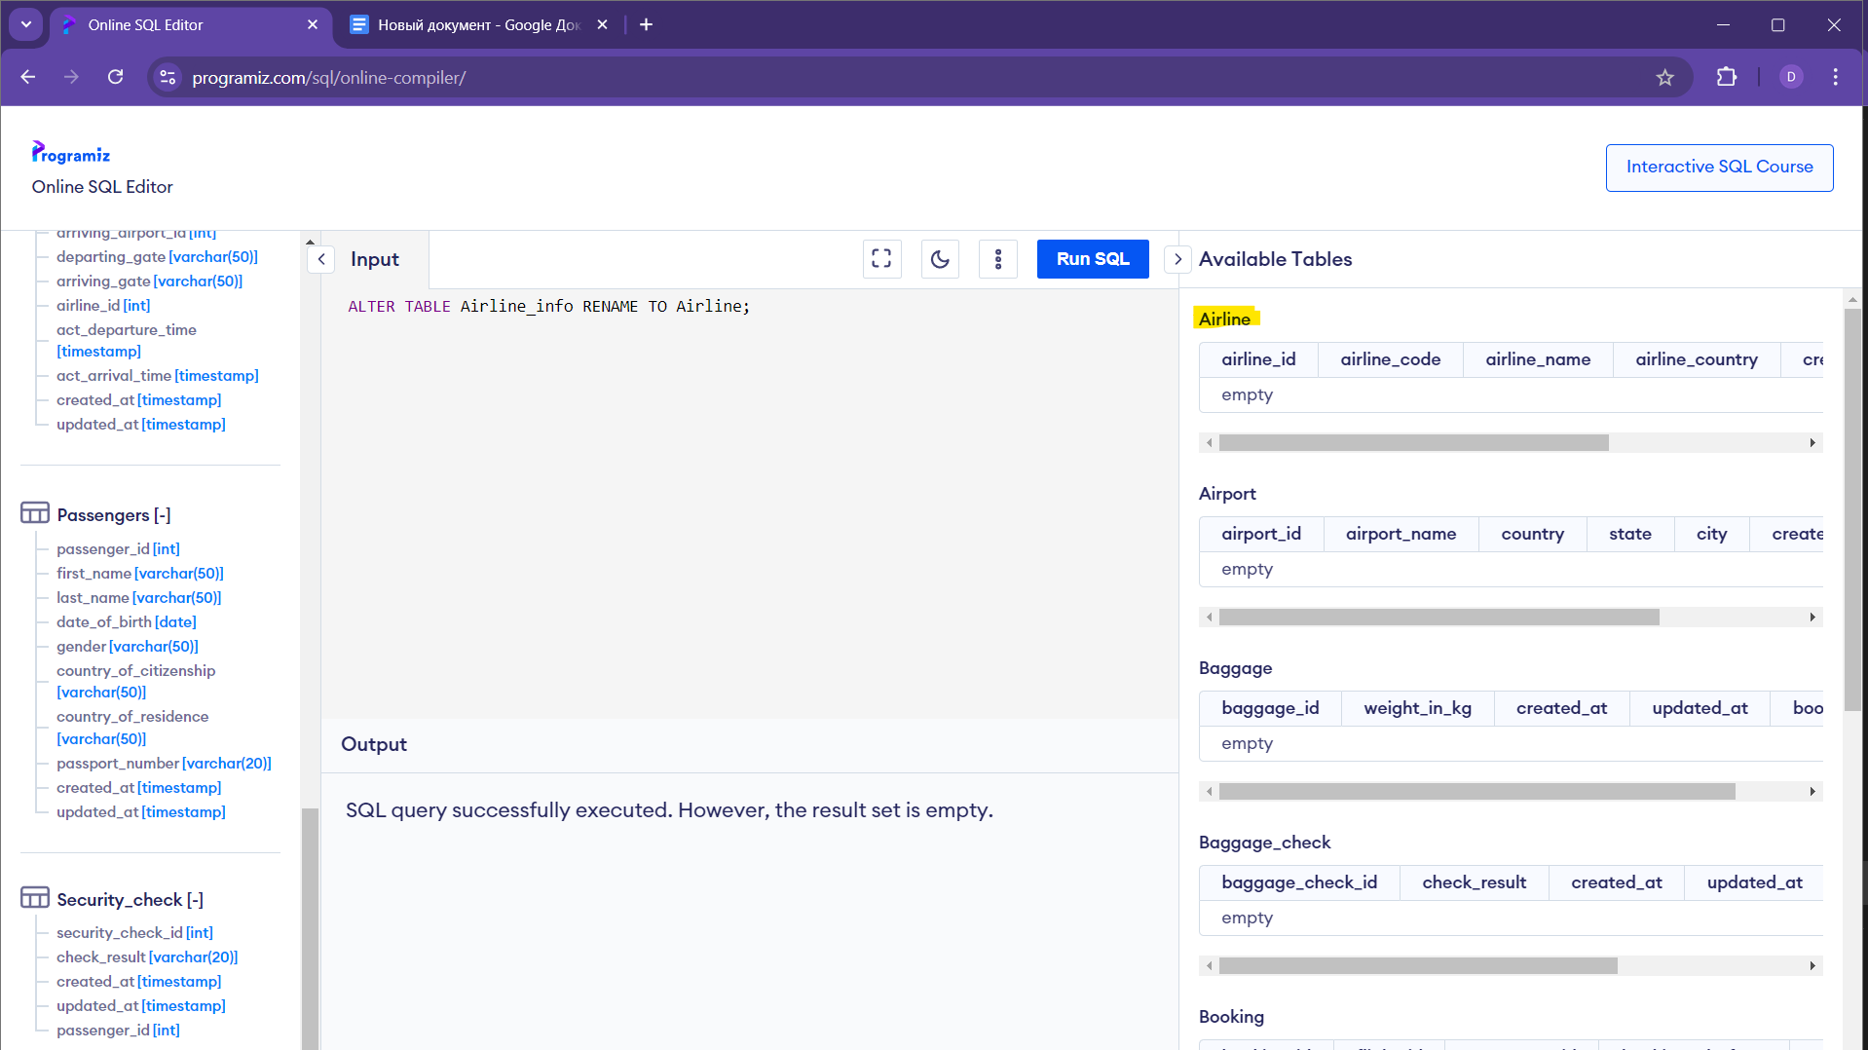Rename column price to ticket_price**

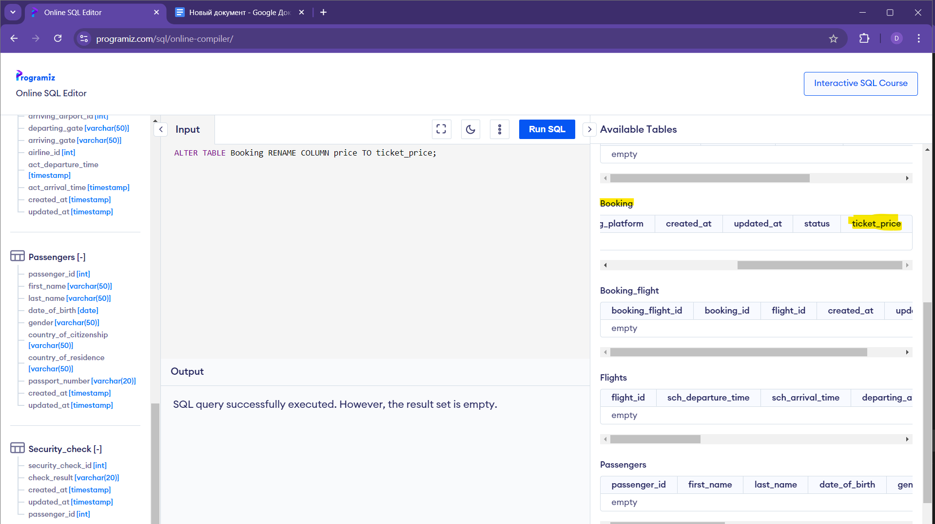

**Change data type of departing_gate(varchar(50)) from varchar(50) to text**

ALTER TABLE Flights ALTER COLUMN departing_gate SET DATA TYPE TEXT; in Postgres

ALTER TABLE Flights MODIFY departing_gate TEXT; in MySQL

online compiler shows error

**Drop the column info(varchar(50)) from the airline table**

