alter TABLE booking

add constraint fk_passenger

foreign key (passenger_id)

references passengers(passenger_id)

(внешний ключ fk_passenger в таблицу booking, ссылается на passenger_id в таблице passengers, каждый passenger_id в таблице booking должен существовать в таблице passengers)

alter TABLE security_check

add constraint fk_passenger

foreign key (passenger_id)

references passengers(passenger_id)

alter TABLE public.baggage_check

add constraint fk_passenger

foreign key (passenger_id)

references passengers(passenger_id)

alter TABLE baggage_check

add constraint fk_booking

foreign key (booking_id)

references booking(booking_id);

alter TABLE baggage

add constraint fk_booking

foreign key (booking_id)

references booking(booking_id);

alter TABLE booking_flight

add constraint fk_flight_id

foreign key (flight_id)

references flights(flight_id);

ALTER TABLE airastana ADD PRIMARY KEY (airline_id);

alter TABLE flights

add constraint fk_airline_id

foreign key (airline_id)

references airastana(airline_id);

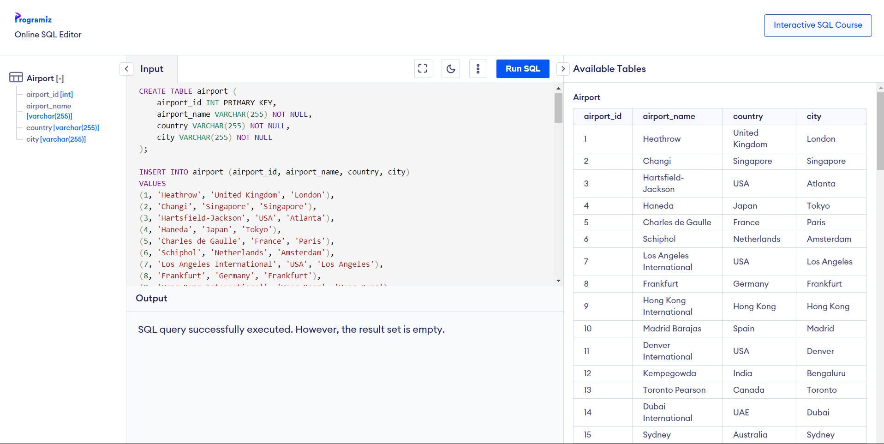

CREATE TABLE airport (

airport_id INT PRIMARY KEY,

airport_name VARCHAR(255) NOT NULL,

country VARCHAR(255) NOT NULL,

city VARCHAR(255) NOT NULL

);

INSERT INTO airport (airport_id, airport_name, country, city)

VALUES

(1, 'Heathrow', 'United Kingdom', 'London'),

(2, 'Changi', 'Singapore', 'Singapore'),

(3, 'Hartsfield-Jackson', 'USA', 'Atlanta'),

(4, 'Haneda', 'Japan', 'Tokyo'),

(5, 'Charles de Gaulle', 'France', 'Paris'),

(6, 'Schiphol', 'Netherlands', 'Amsterdam'),

(7, 'Los Angeles International', 'USA', 'Los Angeles'),

(8, 'Frankfurt', 'Germany', 'Frankfurt'),

(9, 'Hong Kong International', 'Hong Kong', 'Hong Kong'),

(10, 'Madrid Barajas', 'Spain', 'Madrid'),

(11, 'Denver International', 'USA', 'Denver'),

(12, 'Kempegowda', 'India', 'Bengaluru'),

(13, 'Toronto Pearson', 'Canada', 'Toronto'),

(14, 'Dubai International', 'UAE', 'Dubai'),

(15, 'Sydney', 'Australia', 'Sydney'),

(16, 'Beijing Capital', 'China', 'Beijing'),

(17, 'Dallas/Fort Worth', 'USA', 'Dallas'),

(18, 'Guarulhos', 'Brazil', 'Sao Paulo'),

(19, 'Heathrow', 'United Kingdom', 'London'),

(20, 'Changi', 'Singapore', 'Singapore'),

(21, 'Hartsfield-Jackson', 'USA', 'Atlanta'),

(22, 'Haneda', 'Japan', 'Tokyo'),

(23, 'Charles de Gaulle', 'France', 'Paris'),

(24, 'Schiphol', 'Netherlands', 'Amsterdam'),

(25, 'Los Angeles International', 'USA', 'Los Angeles'),

(26, 'Frankfurt', 'Germany', 'Frankfurt'),

(27, 'Hong Kong International', 'Hong Kong', 'Hong Kong'),

(28, 'Madrid Barajas', 'Spain', 'Madrid'),

(29, 'Denver International', 'USA', 'Denver'),

(30, 'Kempegowda', 'India', 'Bengaluru'),

(31, 'Toronto Pearson', 'Canada', 'Toronto'),

(32, 'Qazaq Air', 'Kazakhstan', 'International'),

(33, 'Bek Air', 'Kazakhstan', 'Regional'),

(34, 'SCAT Airlines', 'Kazakhstan', 'Charter'),

(35, 'Aeroflot', 'Russia', 'Cargo'),

(36, 'Turkish Airlines', 'Turkey', 'Domestic'),

(37, 'Lufthansa', 'Germany', 'International'),

(38, 'Emirates', 'UAE', 'Regional'),

(39, 'Air Arabia', 'UAE', 'Charter'),

(40, 'Fly Dubai', 'UAE', 'Cargo'),

(41, 'Air Astana', 'Kazakhstan', 'Domestic'),

(42, 'Qazaq Air', 'Kazakhstan', 'International'),

(43, 'Bek Air', 'Kazakhstan', 'Regional'),

(44, 'SCAT Airlines', 'Kazakhstan', 'Charter'),

(45, 'Aeroflot', 'Russia', 'Cargo'),

(46, 'Turkish Airlines', 'Turkey', 'Domestic'),

(47, 'Lufthansa', 'Germany', 'International'),

(48, 'Emirates', 'UAE', 'Regional'),

(49, 'Air Arabia', 'UAE', 'Charter'),

(50, 'Fly Dubai', 'UAE', 'Cargo'),

(51, 'Air Astana', 'Kazakhstan', 'Domestic'),

(52, 'Qazaq Air', 'Kazakhstan', 'International'),

(53, 'Bek Air', 'Kazakhstan', 'Regional'),

(54, 'SCAT Airlines', 'Kazakhstan', 'Charter'),

(55, 'Aeroflot', 'Russia', 'Cargo'),

(56, 'Turkish Airlines', 'Turkey', 'Domestic'),

(57, 'Lufthansa', 'Germany', 'International'),

(58, 'Emirates', 'UAE', 'Regional'),

(59, 'Air Arabia', 'UAE', 'Charter'),

(60, 'Fly Dubai', 'UAE', 'Cargo'),

(61, 'Air Astana', 'Kazakhstan', 'Domestic'),

(62, 'Qazaq Air', 'Kazakhstan', 'International'),

(63, 'Bek Air', 'Kazakhstan', 'Regional'),

(64, 'SCAT Airlines', 'Kazakhstan', 'Charter'),

(65, 'Aeroflot', 'Russia', 'Cargo'),

(66, 'Turkish Airlines', 'Turkey', 'Domestic'),

(67, 'Lufthansa', 'Germany', 'International'),

(68, 'Emirates', 'UAE', 'Regional'),

(69, 'Air Arabia', 'UAE', 'Charter'),

(70, 'Fly Dubai', 'UAE', 'Cargo'),

(71, 'Air Astana', 'Kazakhstan', 'Domestic'),

(72, 'Qazaq Air', 'Kazakhstan', 'International'),

(73, 'Bek Air', 'Kazakhstan', 'Regional'),

(74, 'SCAT Airlines', 'Kazakhstan', 'Charter'),

(75, 'Aeroflot', 'Russia', 'Cargo'),

(76, 'Turkish Airlines', 'Turkey', 'Domestic'),

(77, 'Lufthansa', 'Germany', 'International'),

(78, 'Emirates', 'UAE', 'Regional'),

(79, 'Air Arabia', 'UAE', 'Charter'),

(80, 'Fly Dubai', 'UAE', 'Cargo'),

(81, 'Air Astana', 'Kazakhstan', 'Domestic'),

(82, 'Qazaq Air', 'Kazakhstan', 'International'),

(83, 'Bek Air', 'Kazakhstan', 'Regional'),

(84, 'SCAT Airlines', 'Kazakhstan', 'Charter'),

(85, 'Aeroflot', 'Russia', 'Cargo'),

(86, 'Turkish Airlines', 'Turkey', 'Domestic'),

(87, 'Lufthansa', 'Germany', 'International'),

(88, 'Emirates', 'UAE', 'Regional'),

(89, 'Air Arabia', 'UAE', 'Charter'),

(90, 'Fly Dubai', 'UAE', 'Cargo'),

(91, 'Air Astana', 'Kazakhstan', 'Domestic'),

(92, 'Qazaq Air', 'Kazakhstan', 'International'),

(93, 'Bek Air', 'Kazakhstan', 'Regional'),

(94, 'SCAT Airlines', 'Kazakhstan', 'Charter'),

(95, 'Aeroflot', 'Russia', 'Cargo'),

(96, 'Turkish Airlines', 'Turkey', 'Domestic'),

(97, 'Lufthansa', 'Germany', 'International'),

(98, 'Emirates', 'UAE', 'Regional'),

(99, 'Air Arabia', 'UAE', 'Charter'),

(100, 'Fly Dubai', 'UAE', 'Cargo');

**Add a new airline named "KazAir" based in "Kazakhstan" to the airline table:**

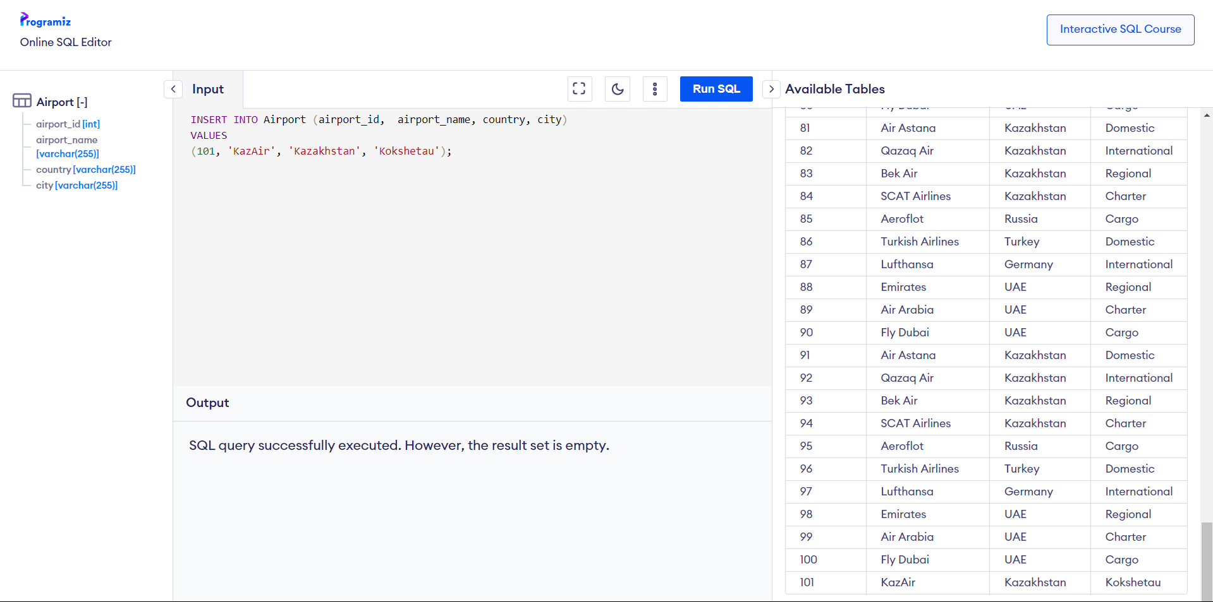

INSERT INTO Airport (airport_id, airport_name, country, city)

VALUES

(101, 'KazAir', 'Kazakhstan', 'Kokshetau');

**Update the airline country "KazAir" to "Turkey":**

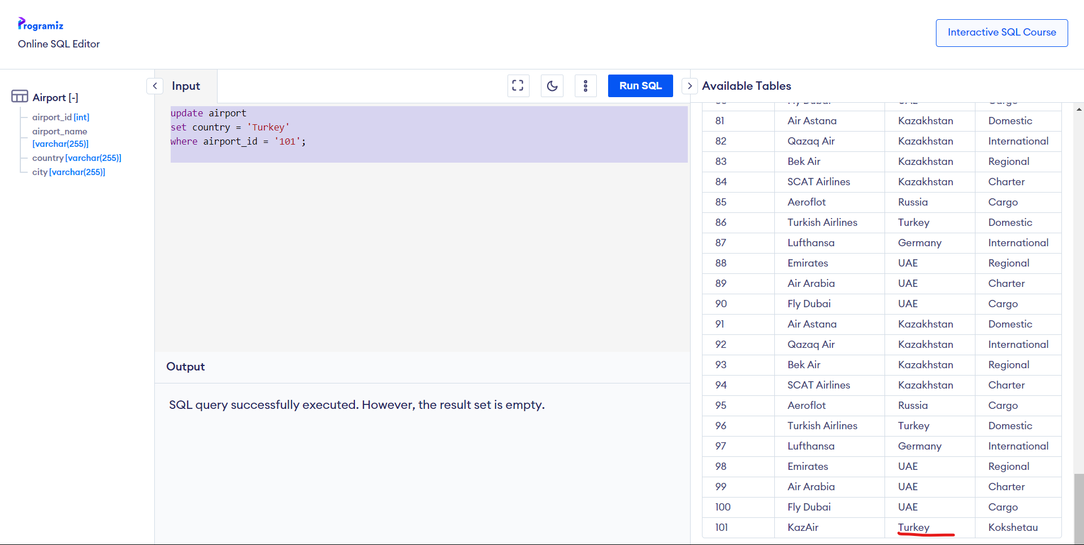

update airport

set country = 'Turkey'

where airport_id = '101';

**Remove the airline named "SIT" from the airline table:**

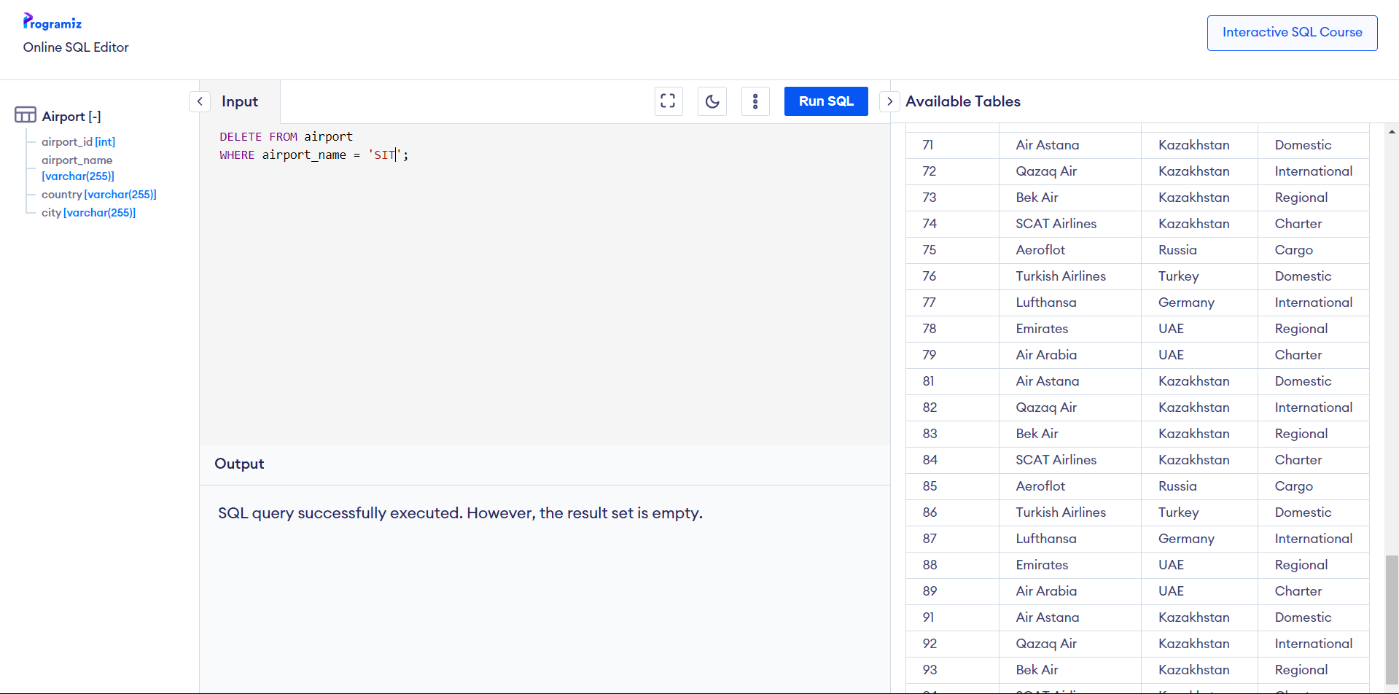

DELETE FROM airport

WHERE airport_name = 'SIT';

**Add three airlines at once: "AirEasy" in "France", "FlyHigh" in "Brazil", and "FlyFly" in "Poland":**

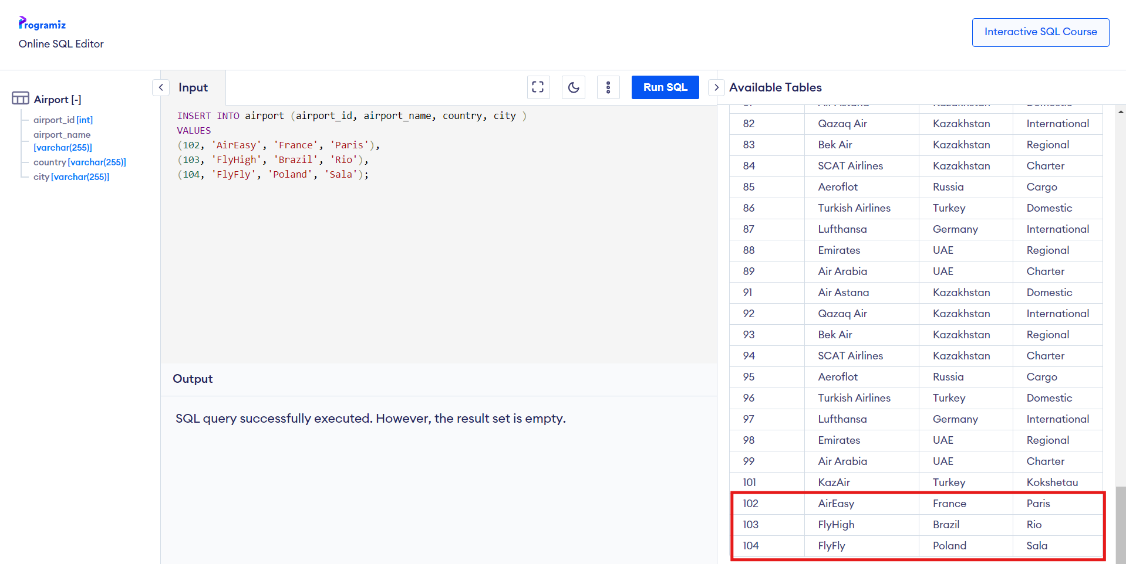

INSERT INTO airport (airport_id, airport_name, country, city )

VALUES

(102, 'AirEasy', 'France', 'Paris'),

(103, 'FlyHigh', 'Brazil', 'Rio'),

(104, 'FlyFly', 'Poland', 'Sala');

**Delete all flights whose arrival is in the year 2024:**

DELETE from flights

where extract(YEAR from act_arrival_time) = '2024'

**Increase the price of all tickets in the booking table for flights by 10%:**

UPDATE booking

SET price = price * 1.10;

**Delete all tickets whose price is less than 1000 units:**

DELETE FROM booking

WHERE price < 1000;