Assingment-3.R

thomas

2021-02-07

frequency <- c(0.6,0.3,0.4,0.4,0.2,0.6,0.3,0.4,0.9,0.2)  
BP <- c(103,87,32,42,59,109,78,205,135,176)  
First <- c(1,1,1,1,0,0,0,0,NA,1)  
Second <- c(0,0,1,1,0,0,1,1,1,1)  
FinalDecision <- c(0,1,0,1,0,1,0,1,1,1)  
  
df <- data.frame(frequency,BP,First,Second,FinalDecision)  
  
boxplot(frequency)

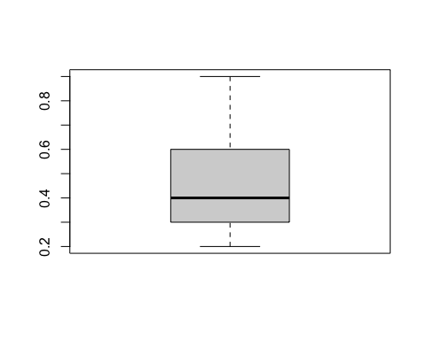

boxplot(BP)

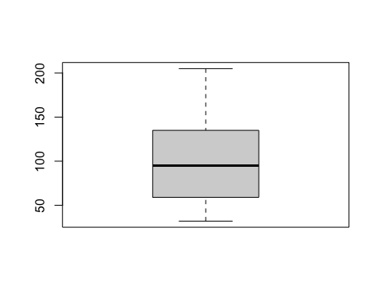

boxplot(First)  
boxplot(Second)

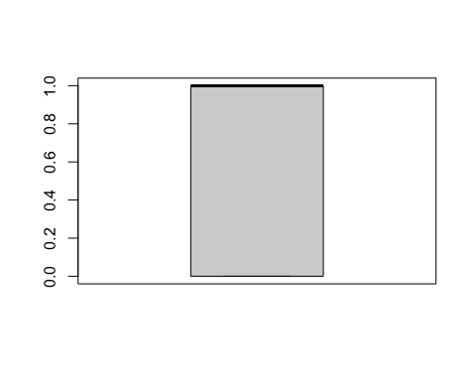

boxplot(FinalDecision)  
  
hist(frequency)

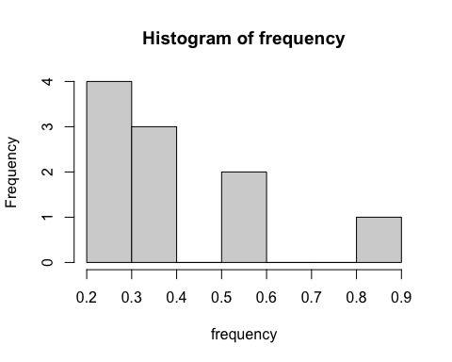

hist(BP)

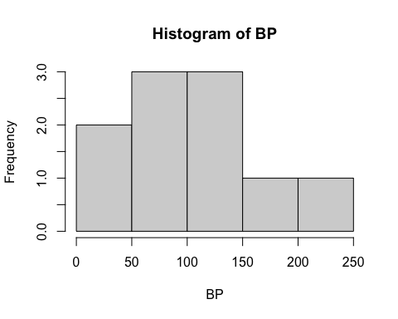

hist(First)

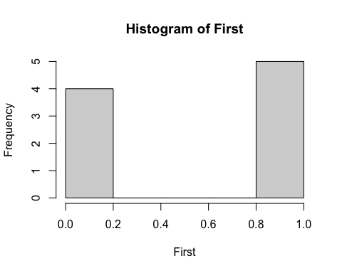

hist(Second)

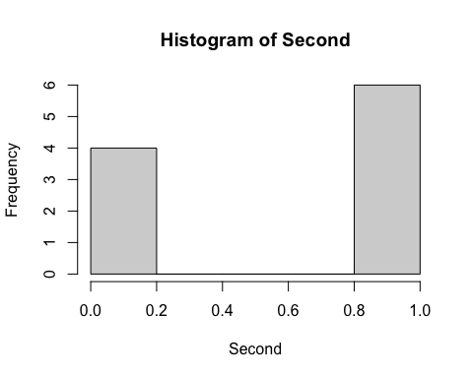

hist(FinalDecision)

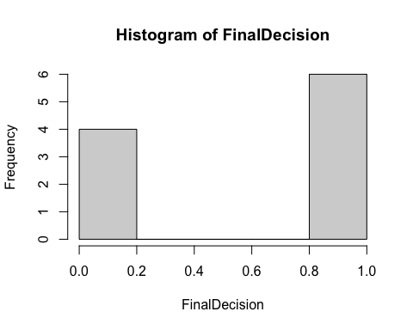

#2  
  
#From the results, i can see that with the BP's, most of them were around the avereage, 3 were below average and 2 above normal. Those that weren't average were  
#considered bad assessment and High inregards to immediate care. From the MD's assessment, there were mixed decisions in regards to the condition of the patient, same with the final decision.