**Assignment 1**

**Objective:**

This assignment is to create a simple Console application using XCode and Objective-C. The application will gather students through the interactive console and able to display the information back on the screen.

**Requirement**:

1. The program will prompt the user via the console to read in:
   1. Student First Name
   2. Student Last Name
   3. Student CWID
2. The program will loop and prompt the user via the console to read in:
   1. The course name that they are taken
   2. The score weights percentage for Home Work, Midterm, and Final
   3. The actual average Homework score, Midterm score, and final Score
3. The program must be able to output on the console the following:
   1. Student’s Name and CWID
   2. The average score for each course taken by the student

**Issue/Limitation:**

1. The program will assume that user will actually enter CWID up to nine numbers.
2. The program will assume that the total score is between 0 and 300
3. The program will assume that the total weights must be equal to 100%
4. The program does not limit the number of courses taken by students

**Design:**

I chose to create two classes.

The first class is DHDCourse, which will hold the name of the course, its weights, and its scores. The class has two main methods.

The first method is to calculate the average scores based on the input weights and scores.

The second method is to display the course information including the course name and the calculated average score.

The second class is DHDStudent, which will hold first name, last name, and CWID for a given student. This class also has a private dictionary to store all the courses the student enrolled. There are three main methods.

First is a class method called createStudentFromPrompt. This method will use the interactive prompt from the console to gather the student information such as name and CWID and create the appropriate Student object.

The second method is addCoursesFromPrompt. This method is called by the student object and allow user to add courses that the student enrolled along with its weights and its average scores from the interactive console.

The third method is showStudentInfo. This method is call by the student class which allow it to display the student information on the console.

**Program Flow:**

The driver program should perform the following:

* The program will call the class method createStudentFromPrompt on DHDStudent:
  + The program will prompt the user to input First Name, Last Name, and CWID.
  + The program will read in the input using scanf into 3 C string variables
  + The program will allocate memory and create a student object with the above information
* The student object can now call addCoursesFromPrompt
  + The program will prompt for the course name and its weights of Homework, Midterm, Final
  + The program will create and initialized the DHDCourse object
  + The student object then calls enrolledCourse method to enroll the course
  + The program will prompt for the course’s Homework Average score, Midterm, Final
  + The student object then calls updateCourseScore method to update the input scores for the given course.
* The student can call showStudentInfo to display information
  + Output the student Full Name in the FirstName LastName format
  + Output the student CWID
  + Loop through the dictionary. For each course found in the dictionary:
    - Tell the course object to call showCourseInfo to display the Course Name and its average score
* The program will loop if user request to run it again
* The program terminates.

**Test Case:**

|  |  |
| --- | --- |
| Student: Ted Williams CWID: 123456789  Course: CPSC211  Weights: HW = 15%, Midterm = 35%, Final = 50% Scores: HW = 89.5, Midterm = 90, Final = 92.5  Course: CPSC343  Weights: HW = 25%, Midterm = 35%, Final = 40% Scores: HW = 89.5, Midterm = 90, Final = 92.5 | Result:  Student Name: Ted Williams  CWID: 123456789  Course: CPSC211  Course Overall grade: 91.175  Course: CPSC343  Course Overall grade: 90.875 |
| Student: John Doe  CWID: 987654321  Course: CPSC411  Weights: HW = 40%, Midterm = 25%, Final = 35% Scores: HW = 89.5, Midterm = 90, Final = 92.5  Course: CPSC456  Weights: HW = 30%, Midterm = 30%, Final = 40% Scores: HW = 89.5, Midterm = 90, Final = 92.5 | Result:  Student Name: John Doe  CWID: 987654321  Course: CPSC411  Course Overall grade: 90.675  Course: CPSC456  Course Overall grade: 90.85 |

**Program Run Result**:

Below is the program run result of the first Student entered:

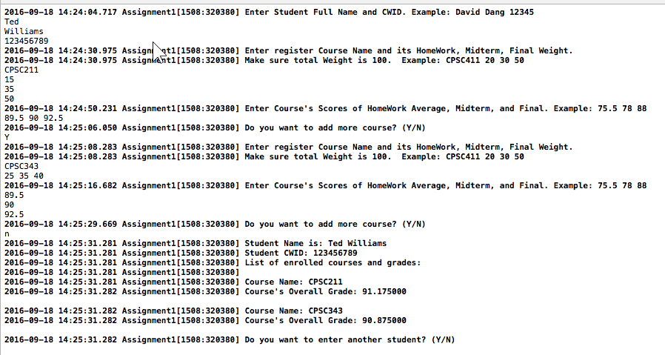

Below is the program run result of the second Student:

