

Information Technology and Implementation (Satellite)

9 7 8 9 6 6 9 6 9 1 5 4 5

**I**SBN 978-966-969-152-1 (e-book)

TARAS SHEVCHENKO NATIONAL UNIVERSITY OF KYIV

(FACULTY OF INFORMATION TECHNOLOGY, FACULTY OF COMPUTER SCIENCE AND CYBERNETICS)

NATIONAL TECHNICAL UNIVERSITY OF UKRAINE “IGOR SIKORSKY KYIV POLYTECHNIC INSTITUTE”

VIKTOR GLUSHKOV INSTITUTE OF CYBERNETICS OF THE NAS OF UKRAINE INSTITUTE OF INFORMATION TECHNOLOGY AND LEARNING TOOLS OF THE NAES OF UKRAINE

INSTITUTE FOR INFORMATION RECORDING OF THE NAS OF UKRAINE INSTITUTE OF SOFTWARE SYSTEMS OF THE NAS OF UKRAINE

THE COUNCIL OF YOUNG SCIENTISTS OF THE FACULTY OF COMPUTER SCIENCE AND CYBERNETICS AND THE FACULTY OF INFORMATION TECHNOLOGY OF TARAS SHEVCHENKO NATIONAL UNIVERSITY OF KYIV

IX INTERNATIONAL CONFERENCE

**Information Technology and Implementation (Satellite)**

1 December, 2022 Conference Proceedings

Kyiv 2022

UDC 004.9

І-74

*Volume editor:* Vitaliy Snytyuk, Dr.Sc., Prof.

*Program Committee:* Aldrich Chris, Andreas Pester, Frederic Mallet, Hiroshi Tanaka, Iurii Krak, Iulia Khlevna, Karsten Henke, Oleg Chertov, Oleksandr Kuchanskyi, Oleksandr Marchenko, Sándor Bozóki, Vitaliy Tsyganok, Vladimir Vovk

*Organizing Committee:* Anatoly Anisimov, Vitaliy Snytyuk, Oleksii Bychkov, Oleh Ilarionov, Yuriі Kravchenko, Iurii Krak, Oleksandr Kuchanskyi, Nataliia Lukova-Chuiko, Oleksandr Marchenko, Viktor Morozov, Taras Panchenko,Anatolii Pashko, Valentyna Рleskach, Yurii Samokhvalov, Oleksii Tkachenko, Serhii Toliupa.

*Conference Secretary:* Hryhorii Hnatiienko.

І-74 Information Technology and Implementation (Satellite): Conference Proceedings, December 01, 2022, Kyiv, Ukraine / Taras Shevchenko National University of Kyiv and [etc]; Vitaliy Snytyuk (Editor). – Kyiv: Publisher Individual entrepreneur Picha Y.V., 2022. 186 p.

ISBN 978-966-969-154-5 (e-book)

This book includes abstracts of the 9th International Conference "Information Technology and Implementation (Satellite) – 2022". Philosophical, theoretical and applied aspects which describe the results, problems and prospects of the creation and use of intelligent computing methods and creating of information systems and technology on their basis are reviewing.

Main tracks of the conference are: Artificial Intelligence Technologies, Cyberspace Protection Technologies, Data Analytics, Digital Project Management Technologies, E-commerce, E- government and E-learning Technologies, Mathematical Foundations of Information Technology, Network and Internet Technologies.

До цієї збірки увійшли тези 9-ї Міжнародної конференції «Інформаційні технології та впровадження (сателітної) – 2022». Розглядаються філософські, теоретичні та прикладні аспекти, які описують результати, проблеми та перспективи створення і використання інтелектуальних обчислювальних методів та створення на їх основі інформаційних систем і технологій.

Основні напрямки конференції: Технології штучного інтелекту, Технології захисту кіберпростору, Аналітика даних, Технології цифрового управління проєктами, Електронна комерція, Електронне урядування та Технології електронного навчання, Математичні основи інформаційних технологій, Мережеві та Інтернет-технології.

UDC 004.9

© Authors of abstracts, 2022 ISBN 978-966-969-154-5 (e-book) © Publisher Individual entrepreneur Picha Y.V., 2022

CONTENTS

|  |  |
| --- | --- |
| *Avramenko К., Latysheva Т.* Internet of Things Eco-System Concept for Healthy Eating | 7 |
| *Biloshchytskyi A., Kuchansky A., Biloshchytska S., Andrashko Yu., Faizullin A.* Development of a Mathematical Model Determination of the Proximity of Vectors in the Project-Vector Space | 11 |
| *Bovsunovska M., Hnatiienko H.* Investigation of the Algorithm of Near Search of the Compromise Median in the Problem of Collective Ranking of Objects | 14 |
| *Buchyk S., Saroka S.* Analysis of Host Detection Methods | 18 |
| *Buchyk S., Tsapro D.* Symmetric Encryption of Messages Based on the Use of Images | 21 |
| *Buzyurova A., Kiktev N.* Use of Forecasting Methods in the Information System of Efficient Water Supply to Prevent Accidents | 24 |
| *Cherevatov A., Chychkan I.* An Approach to Slowly Changing Dimension Data Encryption Using the Scrypt Algorithm | 28 |
| *Chyzhenko V., Kubiavka L.* Possibilities of Project Management Using Artificial Intelligence | 30 |
| *Dakov S., Holubnycha A.* Results of the Study of the State of Information Security in the Medical Information System | 33 |
| *Dakov S., Mohylevych V., Parkhomenko I.* Using Blockchain for Data Storage | 35 |
| *Dolgikh S.* Unsupervised Concept Learning and Conceptual Structure of Complex Sensory Data | 37 |
| *Fedirko Yu., Yehorchenkov O.* Deep Learning Model in Predicting Diabetes (Type 2) | 41 |
| *Gaivoronski A., Gorbachuk V., Dunaievskyi M., Suleimanov Seit-Bekir.* Digital Platforms to Deal with the Information Asymmetry Problem | 44 |
| *Gavryliuk V., Khlevnyi A.* Creative Methods of Project Management | 46 |
| *Guzhva Yu., Morozov V.* Project Management of the Development of the Web Platform to Provide Psychological and Career Guidance Support "My Future Career" | 50 |
| *Hazun H., Morozov V.* Automated Stakeholder Management System | 53 |
| *Hnatiienko H., Gamotska S., Vlasenko O.* The Problem of Constructing the Ranking of Objects on the Base of Multiple Comparisons for the Cook Metric | 55 |
| *Hnatiienko O.* Web Application for Ensuring the Communication Between Elements of the Organizational System | 59 |

|  |  |
| --- | --- |
| *Hnatiienko V., Hnatiienko H., Yermak V., Zozulia O.* Problems, Features of Software Implementation and Development Perspectives of Some Problems of Digital Agronomy | 62 |
| *Hudymenko M., Shabatska S.* Analysis of Data Interpretation with Business Intelligence Tools | 67 |
| *Ivanov I., Yehorchenkov O.* Gamification in IT Companies | 69 |
| *Kalinichenko N., Khlevna Iu.* Investment Portfolio Construction and Optimization by Means of Data Analysis | 71 |
| *Khlevna Iu., Nesterenko Ye.* Face Recognition Technology as a Component of Emotional Marketing | 74 |
| *Kolumbet A., Khlevnyi A.* Recommender Systems for E-Commerce Using Association Rule Learning | 76 |
| *Kopp A., Orlovskyi D.* Enterprise Architecture Web Mining Apporach | 79 |
| *Kruk N., Scherbak V., Stepanov M.* Monitoring IoT Home Devices | 81 |
| *Liashenko O., Kravets T., Kostovetskyi Ye.* Analysis of Machine Learning Algorithms for Forecasting Bankruptcy of Enterprises | 84 |
| *Lukova-Chuiko N., Toliupa S., Laptieva T., Laptiev S.* The Method of Detecting Deviations in the Nature of Traffic from the Elements of the Information Communication Network | 86 |
| *Merkulova K., Ivanenko I.* Implementation of Artificial Intelligence in the Program for Identifying a Means of Personal Protection in the Image of a Person's Face | 90 |
| *Merkulova K., Lybak I.* The Strategy of the Management of ZVO Based on Neuro-Fuzzy Models | 93 |
| *Minaeva Ju.* Application of Fuzzy Mathematics in the Tensor Basis | 95 |
| *Mishchenko D., Yeremenko B.* Project Management During the Automation of Business Processes of Companies | 98 |
| *Morozov V., Kubiavka L., Synelnyk K.* Mental Health Mobile Application Development: How to Manage a Project to Turn Value into Profit | 100 |
| *Mykhalchuk V.* Evaluation of Cognitive Biases in Brain-Computer Interfaces | 103 |
| *Mykhalchuk V., Kuchansky A.* Brain-Computer Interfaces and Education | 105 |
| *Naberegniy A., Hnatiienko H.* Web Application for Evaluating the Level of Criticality of Organizational System Elements | 107 |
| *Nakonechnyj V., Lutsenko V.* How Blockchain Technology Can Affect the Banking Industry | 111 |
| *Nikolayev M., Onyshchenko A.* Current Information Technology Trends in Financial Management | 113 |

|  |  |
| --- | --- |
| *Nizov Ya., Latysheva T.* Effectiveness of the Work of the Project Management Team for the Development and Implementation of Automated Technology to Solve Environmental Problems (for the "Smart Parks" IT Project) | 116 |
| *Palko D., Babenko T., Myrutenko L., Bigdan A.* Intelligent Risk Assessment Models in Dis Based on the Neural Network Approach | 118 |
| *Pikulsky R.* Using Screen Space Ray Marching as a Proxy Ray Tracing Algorithm for Specular Reflection Calculation | 121 |
| *Pryidun M., Khlevna Iu.* Development of a Сonceptual Model for Sentimental Analysis Using Data Science Methods | 124 |
| *Pryshchepa V., Yehorchenkov O.* Project Approach to Individualization of the Educational Process Using Mathematical Modeling | 128 |
| *Rymchuk V., Yehorchenkov O.* Specifics of Project Quality Management | 131 |
| *Saiko V., Hrytsun Ya.* Data Protection in the iOS Operating System | 134 |
| *Sakharova S., Paliy S.* IoT Control System for Technological Processes of Alcohol Production | 136 |
| *Shats H., Kravchenko O.* Combining the Internet of Things and Data Analytics in Animal Health Care | 138 |
| *Shcheblanin Yu., Zahynei A.* Responsibility of the Parties for Information Security Management in Cloud Technologies | 140 |
| *Shlapak O., Yehorchenkov O.* Overview and Ways to Improve Modern Systems for Managing Projects and Tracking Current Tasks | 142 |
| *Shvydchenko A., Kuchansky A.* IoT Solutions and Drones in Localization of Emergency Accidents | 144 |
| *Shykhmat A., Veres Z.* Selection of Protocols for Real-Time Data Streaming from IoT Devices to the Cloud for Further Analysis | 146 |
| *Sokol-Chernilovska K., Yehorchenkov O.* Security Project Management | 149 |
| *Sukhina K., Kubiavka L.* Recommendations of Using Microsoft Azure Devops in Agile Project Management | 151 |
| *Surovtseva O., Yehorchenkov O.* Human Resources Management as an Investment for Projects | 154 |
| *Svoboda I., Steshenko G.* Leveraging Metaverse Digital Economies for Business Opportunities | 156 |
| *Tmienova N., Chernenko A.* Approach to Automatic Verification of Answers to Open Questions When Performing Control Measures | 158 |
| *Toliupa S., Shestak Ya., Torchylo A.* Comparison of Neural Network Algorithms Efficiency in Data Center Cybersecurity | 161 |

|  |  |
| --- | --- |
| *Tsesliv O., Morozov V.* New Approaches to Project Management and Related Digital Technologies with PMBOK 7 Edition | 163 |
| *Vakulenko O., Timinskyi O.* Use of Artificial Intelligence Method to Optimize it Project Team Management Processes | 165 |
| *Vashchilin O., Vashchilinа O., Tumasonis R.* Unified Portal of Vacancies | 168 |
| *Vasylieva A., Melnyk R.* Classification of Cloud Types on Satellite Images Using Deep Learning | 171 |
| *Vedmid S., Timinskyi O.* А Collaboration Model for Creating an Innovative Pedagogical Product Using the "Inschool" Web Platform | 173 |
| *Zhylka I., Selivyorstova T., Kaliberda Yu.* A Study of the Modern Approach to the Development of Android Applications in the Kotlin Language Using the Jetpack Compose Framework | 177 |
| Authors | 180 |

## 1 Kateryna Avramenko

Student

## 2 Tetiana Latysheva

Candidate of technical sciences, assistant of the Department of Management Technologies

*1,2 Taras Shevchenko National University of Kyiv, Ukraine*

# INTERNET OF THINGS ECO-SYSTEM CONCEPT FOR HEALTHY EATING

**Abstract.** A healthy lifestyle is a way of living that lower the risk of being ill or dying early. The article describes how the Internet of Things can improve everyday life, including nutrition and health monitoring.

**Keywords:** Healthy Eating, nutrition, іnternet of Things, information technology, lifestyle

# INTRODUCTION

Ukraine is among the top ten countries with the highest mortality risk from an unbalanced diet, according to a study by The Lancet magazine [1]. Among the main reasons are excessive sugar, salt, and meat consumption. According to WHO, 70% of a person's health depends on what he eats [2]. It has been scientifically proven that irrational nutrition significantly affects a person's life expectancy and leads to the emergence and development of non-infectious diseases: cardiovascular, diabetes, and metabolic disorders.

A balanced diet is a unique tool that can strengthen human health, improve the body's adaptive capabilities and, most importantly, prevent the development of many diseases.

In turn, the Internet of Things provides powerful tools to collect and process different data. Sensors and devices connected to Internet can be used for monitoring and improving our health and nutrition.

*Application for planning balanced nutrition*

Considering the above information, it is advisable to examine the possibility and prospects of developing an information system for planning balanced nutrition. The end product should help the end user to form a personal plan for a balanced diet and provide an opportunity to monitor his eating behavior in the form of statistics.

With the help of this application, we want to offer ways to solve the problem of an unhealthy eating trends, such as insufficient information support, spending a lot of time on following a balanced diet, spending a lot of material resources on a balanced diet.

It is essential to address these issues, as unhealthy eating is detrimental to our health and overall quality of life. The application should include the following modules:

* meal planning module: input and processing of personal data, an algorithm for forming a meal plan, planning purchases according to a meal plan;
* food diary module: logging of consumed products and dishes, reactions of the body to consumed food;
* food behavior statistics module: generation of reports based on the diary;
* communication module with specialists: the creation of appointments with specialists.

*Internet of Things Overview*

The Internet of Things is the concept of connecting any device (if it has an on/off switch) to the Internet and other connected devices. IoT represents a vast database in which intelligent sharing devices are known through sensors, electronics, system network, and hardware [3].

Communication between devices can occur between different physical objects, for example, in the office / home. Some examples of devices with IoT integration are lighting devices, smoke alarms, etc. Basically, devices that users can connect to any other device or via the Internet.

Creating a personal eco-system of connected devices can allow us to bring many smart features into our everyday life.

# USING IOT FOR HEALTHY EATING

The diagram shows an example of IoT eco-system that can be deployed for improving healthy eating [Figure 1].

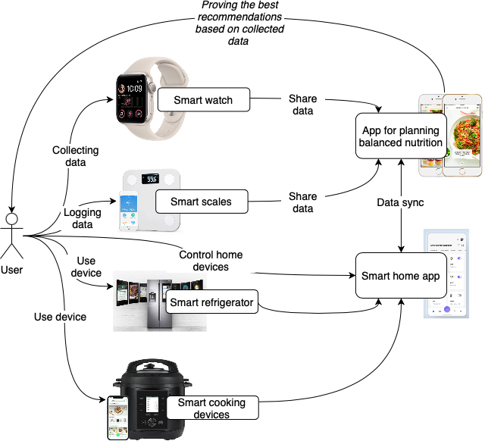

**Figure 1:** IoT for Healthy Eating example

As we can see from the figure, the following elements are involved in our future eco-system:

**User**. A user is a person who will be the final consumer of the results that will be produced by the eco-system. The user is primarily interested in improving his nutrition. At the moment, he realizes that his diet is unbalanced and far from WHO recommendations. The user is worried about his health and is ready to start improving the quality of his life. However, he has very limited knowledge about balanced nutrition.

## Smart devices:

**Smart watches**. Smartwatches have become an important device in our life. Heart monitors are included in wearable technologies and are used to measure heart rates. Smartwatches allow measuring spent calories. This could be helpful for people with diabetes, obesity, or other chronic diseases who comply with a specific diet advised by their care providers [4].

**Smart scales.** The smart scales can now connect to your smartphone and show you a collection of metrics from weight to body composition.

**Smart refrigerator.** The Smart refrigerator not only stores food but also allows you to use the Internet, through which you can access hundreds of different recipes for cooking and even order food from online stores with home delivery.

**Smart cooking devices**. All the functionality of the multicooker and even more will be available on your smartphone. From a distance, you can give commands: cook

/ do not cook (stew, fry, in general, start cooking), cook at a higher / lower temperature, end one program and switch to another, switch to the dish heating mode, and so on.

## Applications:

**Application for creating a personal plan for balanced nutrition.** The application should help the end user to form a personal plan for a balanced diet, provide an opportunity to monitor his eating behavior in the form of statistics, and provide an opportunity to receive informational support from nutritionists [5].

**Smart home application.** Smart Home is an Android/IOS application that allows you to match your lifestyle and seamlessly control all aspects of your property, including lighting, climate, appliances, curtains and blinds, multi-room audio/video, security, digital video surveillance, entertainment and energy saving anywhere in the world.

How this will work together.

***The first part.***

In real time, the smart watch will collect a certain overflow of parameters about the user, such as his heart rate, activity, the number of calories burned, trends inherent to the user during the day, sleep statistics, and others. These data will be transferred to the user's phone, and part of them will be used by the application for planning a balanced diet. Based on the received data, this application will determine the daily calorie needs of a given user and analyze the user's lifestyle and basic health parameters to take these indicators into account when planning a personalized diet[6].

Smart Scales not only measure weight but are also able to calculate the percentage of muscle mass in the body, measure fluids in the body, and the percentage of bone mass in the body. These indicators will be transmitted to the user's watch and phone. And again, they will be used by the application for planning a balanced diet.

With this data, the application for creating personal plan for balanced nutrition can generate more accurate statistics and provide the best recommendations.

A smart refrigerator and smart cooking devices are designed to simplify the process of preparing dishes that the application will recommend. Smart functions will help reduce the amount of time spent on cooking, preparing, and purchasing products.

***The second part.***

The second part of the user's interaction with the IoT eco-system begins with the moment when the user starts to follow the nutritious plan that the application suggested. According to the concept, the user should log the body's reaction to the nutrition plan. Then the application will start forming statistics, enriching it also with data from smart devices.

Thus, we have a continuous interaction process between devices and the user.

# CONCLUSION

In this article, we have described a personalized IoT eco-system that can provide the user with tools to manage and improve their diet. Using a smart watch, smart scales, smart refrigerator, smart devices for cooking, as well as appropriate applications, the user can easily monitor the main indicators of your health, get basic recommendations for healthy eating, follow a meal plan, record changes in the body depending on the food consumed, receive generated personalized nutrition and health statistics, improve and simplify life.

**References:**

* 1. GBD 2017 Diet Collaborators. Health effects of dietary risks in 195 countries, 1990– 2017: a systematic analysis for the Global Burden of Disease Study, 2017, Lancet 2019; 393: 958–72
  2. World Health Organization ‘Healthy Living’, 1998. URL: https://apps.who.int/iris/bitstream/handle/10665/108180/EUR_ICP_LVNG_01_07_02.pdf
  3. Alexander S. Gillis ‘What is the Internet of Things (IoT)’, 2022. URL: <https://www.techtarget.com/iotagenda/definition/Internet-of-Things-IoT>
  4. IoT Worlds ‘The Best Smart Scales to Achieve Fitness Goals’, 2022. URL: https:/[/www.iotworlds.com/the-best-smart-scales-to-achieve-fitness-goals/](http://www.iotworlds.com/the-best-smart-scales-to-achieve-fitness-goals/)
  5. PMBOK Guide. URL: https:/[/www.pmi.org/pmbok-guide-](http://www.pmi.org/pmbok-guide-) standards/foundational/PMBOK

## 1 Andrii Biloshchytskyi

Doctor of Technical Sciences, Professor, Vice-Rector for Science and Innovation

## 2 Alexander Kuchansky

Doctor of Technical Sciences, Head of the Information Systems and Technology Department

## 3 Svitlana Biloshchytska

Doctor of Technical Sciences, Professor of the Department of Computer Technology and Data

## 4 Yurii Andrashko

Candidate of Technical Sciences, Associate Professor of the Department of System Analysis and Optimization Theory

## 5 Adil Faizullin

Phd student

*1,3,5 Astana IT University, Kazakhstan*

*2 Taras Shevchenko National University of Kyiv, Ukraine*

*4 Uzhhorod National University, Ukraine*

# DEVELOPMENT OF A MATHEMATICAL MODEL DETERMINATION OF THE PROXIMITY OF VECTORS IN THE PROJECT-VECTOR SPACE

As a result of the decomposition of the subject area, the classification of projects of educational environments is made, and the task of optimal management in the design-vector space is formulated. The research enables us to proceed to formalization of educational environment management processes. We will define the basic definition of this part of the research.

Definition 1. By project-vector management of educational environments, we will understand the implementation of functions that ensure the organization, planning, and control of the distribution of available resources between the objects of educational environments and ensure their maximum rapid progress in the project-vector space.

Mathematically, the multisystem of project-vector management of educational environments will reflect the vectors formed in the project-vector space (direction of change of objects), evaluate and adjust them based on the needs of stakeholders and project goals. The project-vector space contains a set of objects and subjects of the projects developing in time. The development of the objects and subjects of the projects corresponds to the movement in the project-vector space. The evaluation of the effectiveness of the multisystem of project-vector management of educational environments will be carried out through the evaluation of the distance between the vectors reflecting the required and development of objects/subjects of projects.

Mathematically, a set of vectors can represent the unit movements of project objects and subjects in the discrete project-vector space. Each vector coordinate represents the place of the object/subject of the project in one of the measurements at the current moment in time. The endpoint of these movements is the end of the project and the collapse of the project-vector space again (for the project that has ended) into

a point. Each vector is defined by coordinates that reflect the state at some discrete point in time t of the object/subject *Qj* of the project *Пk* in the project space  :

*A*( *j* ) ( *t* )  x(j) (t), x(j) (t),..., x(j) (t),..., x(j) (t),

*k*  k1 k2 ki kp  (1)

where

x (j) (t)

– the coordinate value of the object/subject *Qj*

of the project *Пk*

along the *Ni* axis in the project-vector space at time *t*.

ki

The motion vector determines the priority measurements (priority values of the project) and is defined through the magnitude of the change in the distance along the given directions per quantum of time.

Building an effective project management system is not the "aspirations" of individual objects that matter but how similar or different their movement vectors are in the project-vector space. The same vectors mean that the movements of different project objects are equally predetermined. Therefore, a single system (or subsystem) of management of these projects can be created.

In order to create an effective multisystem of project management, it is necessary to group projects in such a way that the distance between vectors of projects included in one group is minimal.

The coordinates of the vectors in each measurement are as different as the attributes of the objects and subjects of the projects displayed in this measurement. It is necessary to develop a mathematical apparatus for calculating the distance between the directions of development of objects and the subjects of projects. This will make it possible to create optimal functional procedures for the formation of vectors and minimize the time and cost of creating a multisystem of project-vector management of educational environments.

The mathematical apparatus of vector algebra is used to calculate the distances between vectors and determine the optimal set of groups of projects (and, respectively, the subsystems of the multisystem of project management).

Assume that for some time interval *dt* the coordinate value of some object/subject *Qj* of the project *Пk* change from the value

x(j) (t - dt), x(j) (t - dt),..., x(j) (t - dt),..., x(j) (t - dt) ,

k1

k2

ki

kp

to the value

x(j) (t), x(j) (t),...,x(j) (t),...,x(j) (t)

k1 k2 ki

kp ,

где t − instant of time;

dt – the time quantum of the discrete project-vector space.

Then the value corresponding to the development of the object/subject *Qj* of the project *Пk*,can be determined from the formula

*l* (j) (t) 



*i*1

*p*

(x (t) - x (t - dt))

(j)

(j)

2

ki

ki

k ,

where

*l* (j) (t)

− the vector estimate of the change of the object/subject Qj of the

project Пk at time t (instantaneous displacement velocity).

k

However, there is one peculiarity in the design-vector space. In operations on vectors, the distance between them in some measurement is given by the difference of coordinates in that measurement. This cannot be used to calculate the degree of proximity of different vectors. Firstly, because the direction of the object/subject cannot be evaluated over small discrete time instants, it is necessary to evaluate them over a sufficiently long-time interval.

Secondly, the creation of a single system (subsystem) of management of many projects is based not only on the "unidirectional" development of individual objects and subjects of projects but also on their proximity in the project-vector space. For example, whether the same methods or means of project management are used, the same performers, and whether the same input information is used.

The two problems will be solved.

## 1 Mariia Bovsunovska

Master’s student of the Faculty of Information Technology

## 2 Hrygorii Hnatiienko

PhD, Deputy Dean of the Faculty of Information Technology

*1,2 Taras Shevchenko National University of Kyiv, Ukraine*

# INVESTIGATION OF THE ALGORITHM OF NEAR SEARCH OF THE COMPROMISE MEDIAN IN THE PROBLEM OF COLLECTIVE RANKING OF OBJECTS

**Abstract**. Many works are devoted to the problem of creating efficient algorithms for solving problems of high dimensionality, when the brute-force search methods become too time-consumin. This work is also devoted to the development of an efficient algorithm in the field of expert evaluation problems, namely, the algorithm for solving the problem of collective evaluation coordination. The main goal of this work is to implement in software the algorithm for the near search of the compromice median, which is sometimes called the GV-median. It is also necessary to investigate the program for performance at different values of input parameters.

**Keywords**: expert evaluation, collective evaluation, coordination of individual expert evaluations, algorithm of near search of GV-median.

**Introduction.** The problem of ordering a set of objects by the degree of manifestation of some properties is one of the most common problems of expert evaluation [1]. This class of problems formalizes a large number of practical problems in various subject areas. Since such problems are NP-hard, much attention is paid by researchers to the development and research of methods that significantly accelerate the finding of solutions to such problems. Usually, the acceleration of problem solutions is carried out due to the successful determination of the problem structure and the successful use of the features of the structure of admissible solutions.

**Features of nearest search problems.** The classification of ranking problems is quite wide. Problems with the following parameters will be considered for the application of the GV-median nearest search algorithm:

* expert information about the relationship on the set of objects is used: from the expert committee;
* input information: individual expert assessments;
* metric for determining the distance between object ranks in the decision space: the module of differences between object ranks;
* class of relations between objects for which algorithms for finding a solution are built: strict rankings of objects;
* type of criterion of optimality of the optimization problem: minimax criterion.

**Software implementation.** Python language was chosen for software implementation. One of the most influential disadvantages of Python is the speed of code execution, however, Python programs are usually written much faster due to the

relative conciseness of the language and a wide range of libraries. In addition, using Python increases the readability of the code for other developers.

**Algorithm of the nearest search of the GV-median.** The nearest search algorithm can be represented by a sequence of the following steps:

Step 1. The input is *k* rankings of *n* objects that will be designated

*Ri* , *i*  1,..., *k*,

and represented as a matrix

*A**k*, *n*.

(1)

Let us transform the matrix of object

numbers

*A**k*, *n*

in individual rankings of the form (1) into the corresponding matrix

of object ranks

*B* *k*, *n*.

Step 2. Calculate the distance matrix

*D* *k*, *k* 

between the rankings of the form

1. by the rank mismatch metric using the formula

*n*

*d* *R* , *R*    *r*  *r* ,

*i j i j*

*l l*

(2)

where

*l* 1

*i* denotes the rank of *l* object in the ranking of *i* expert

*r*

*l*

Step 3. We look for the maxima along the rows of the matrix *D(k,k)*, and among them we determine the minimum (or minima, if this value is not the only one). This minimum corresponds to the modified GV-median (also called the compromise median). The solution may not be unique. We track the row from which the GV-median was taken and look at the distances for which rankings were calculated in it. This

ranking will be considered as a reference. Define the vector of ranks of the reference

ranking as

*Ko*  *r*0 ,..., *r*0 ,

and by

*Ro*  *a*0 ,..., *a*0 ,

denote the order of objects in

1 *n* 1 *n*

the reference ranking.

Step 4. Around the reference ranking we look for the closest to it, that is, those

that are at a distance of 2. Their number is exactly *n* 1 ranking. To do this, it is

necessary to swap the neighboring elements in pairs and calculate the distance matrix and the modified GV-median for them. If the new median delivers a lower criterion value, it becomes the new reference. The ranking obtained in the end is the closest to the rankings set by the experts for the given criteria.

**Computational experiment.** The tendency of increasing time consumption with increasing number of objects and experts is obvious. By conducting a computational experiment, we will determine the specific time required to solve problems of different dimensions. The computational experiment was conducted for variations of different

parameters: with a fixed number of experts *k*  10 and a variable number of objects

4  *n*  50 , as well as with a fixed number of objects *n*  10

and a variable

number of experts 4  *k*  50 . The results of the computational experiment are shown in Figure 1 and Figure 2.

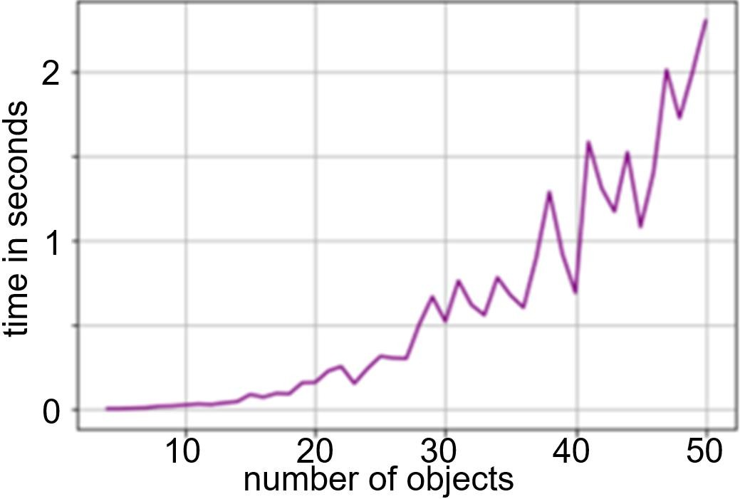

Figure 1. Time in seconds to solve the problem with the number of experts 10

*k*  10

and the number of objects in the rankings from 4 to 50 4  *n*  50

With a fixed number of objects and a variable number of experts, it is expected that the dependence of the solution time on the number of experts is close to linear.

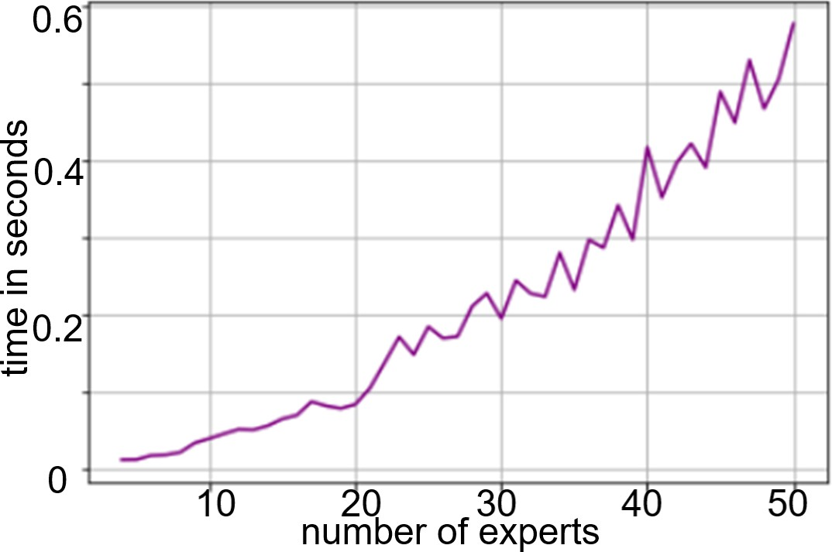

Figure 2. Time in seconds to solve the problem for the number of objects in the

rankings 10 *n*  10 and the number of experts from 4 to 50 4  *k*  50

It should be noted that the time complexity of the constructed algorithm for the

nearest median search is

*O* *k* 2*n*2  .

The computational experiment also investigated the percentage of improvement of the result compared to the reference ranking. The results are presented in Figure 3.

It is obvious that for a small number of experts *k*  10 the improvement reaches

30% on average. For a larger number of experts 10  *k*  50

the improvement

reaches about 15%. At the same time, the improvement rate of the result when applying

the genetic algorithm was only 3-5% [2], however, for a large number of objects

*n*  500.

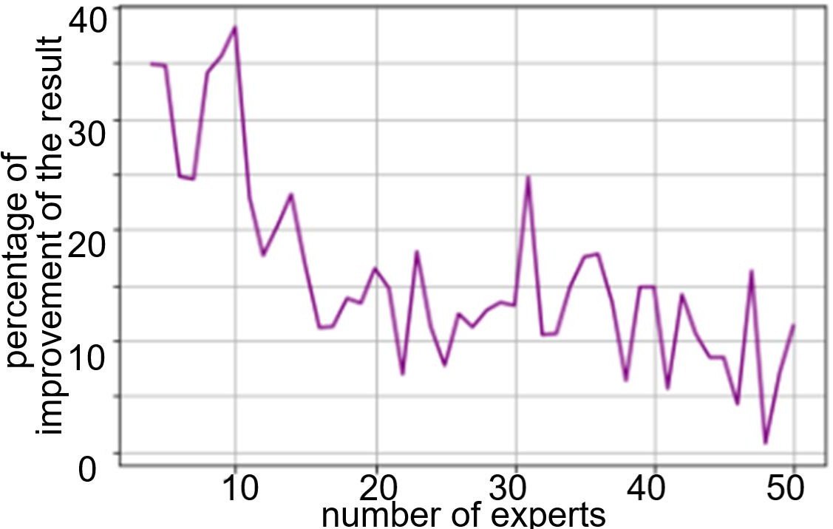

Figure 3. Percentage of improvement of the result (criteria values at the GV-

median) for the number of objects *n*  10 and the number of experts from 4 to 50

4  *k*  50

**Conclusions.** Humanity will not abandon the methods of solving the problems of collective coordination for a long time, because expert opinion is the only way to provide an assessment of objects, a full description of all the impacts on which is very complex and confusing. That is why the development and creation of new methods of working with expert assessments is necessary for more efficient use of available resources.

**References:**

* 1. Hnatiienko H.M., Snytyuk V.Y. Expert decision making technologies: Monograph. – К.: PLC «Maclaut», 2008. – 444 p.
  2. Hnatiienko H., Tmienova N., Kruglov A. (2021) Methods for Determining the Group Ranking of Alternatives for Incomplete Expert Rankings. In: Shkarlet S., Morozov A., Palagin

A. (eds) Mathematical Modeling and Simulation of Systems (MODS'2020). MODS 2020. Advances in Intelligent Systems and Computing, vol 1265. Springer, Cham. <https://doi.org/10.1007/978-3-030-58124-4_21>. Pp. 217-226.

## 1 Serhii Buchyk

Doctor of Technical Sciences, Professor at the Department of Cyber Security and Information Protection, Faculty of Information Technologies

## 2 Svitlana Saroka

Student at the Department of Cyber Security and Information Protection, Faculty of Information Technologies

*1,2 Taras Shevchenko National University of Kyiv, Ukraine*

# ANALYSIS OF HOST DETECTION METHODS

**Abstract.** New malicious software fills the Internet every day. In this regard, the protection of personal data is currently an important task. The first stage of many computer attacks is intelligence, and one of its mechanisms is port scanning, which allows an attacker to find out which services are running on the desired system. It means that in the future it can prepare and conduct an attack against the detected services and their vulnerabilities. This article provides an information and describes host detection methods.

**Keywords:** host, scanning, Nmap ARP, IP, TCP, UDP, ICMP.

Internet users pay little attention to the protection of personal data, and they are good prey for hackers. The first step to mastering information is to collect it. Nmap is one of the most common tools for scanning target hosts. This article analyses the methods of their detection.

A host is a computer or other device that communicates with other hosts on a network. Hosts on a network include clients and servers that send or receive data, services, or applications [1].

One of the first tasks when investigating any network is to reduce the set of IP ranges to a list of active or interesting hosts. Network and port scanners are the most common tools for collecting information using technical methods.

Host discovery methods [2]:

1. ARP scanning is used to scan the local Ethernet network. On most LANs, especially those using the private address ranges provided by RFC 1918, the vast majority of IP addresses are not in use at any given time. When Nmap tries to send a raw IP packet, such as an ICMP echo request, the operating system must determine a hardware destination address (ARP) that matches the target IP address so that it can properly address the Ethernet frame. This requires it to send a series of ARP requests.
2. UDP scanning has no concept of a connection and no equivalent of a TCP SYN packet. If a UDP packet is sent to a closed port, the system will respond with an ICMP port unreachable message. The absence of such a message is interpreted as a port opening signal. However, if the port is blocked by a firewall, the method will return a false response that the port is open. If ICMP port missing messages are blocked, all ports will be displayed open. Also, a limit on the frequency of ICMP packets can be set, which also affects the results given by the method.
3. Ping scanning is a basic network scanning technique used when you want to know which hosts on the network are on. In terms of network scanning, there are the following types of ICMP messages [3]:

*Type Echo Ping.* Echo request messages are also known as ping packets. A commonly used scanning tool is Nmap to perform ping checks and easily identify available hosts.

*Type Timestamp Ping.* A timestamp request message requests system time information from the target host. The response is in decimal format and displays the number of milliseconds since midnight GMT.

*Type Address Mask Ping.* The address mask query message shows the subnet mask used by the target host. This information is useful when mapping networks and determining the size of subnets and network spaces used by organizations.

Security-conscious organizations firewalls often filter incoming ICMP messages, so ICMP inspection is not effective. However, ICMP is not filtered on most networks because ICMP messages are often useful for troubleshooting network problems.

1. TCP SYN scanning is used by default. It can be launched quickly and is capable of scanning thousands of ports per second on a fast connection, without being hindered by restrictive firewalls. This type of scanning is non-intrusive and unnoticeable because the TCP connection is never fully established. It works with any TCP stack, regardless of any specific platform features.
2. TCP scanning using the connect system call is the default TCP scanning type when SYN scanning is not available. It occurs when the user does not have privileges to use raw packets or when scanning IPv6 networks. Instead of using raw packets like most other types of scanning, Nmap "asks" the operating system to establish a connection to the target machine on a specified port via the connect system call.
3. TCP ACK scanning is similar to TCP SYN scanning. The difference is that the TCP ACK flag is set instead of the SYN flag. Such an ACK packet claims to acknowledge data over an established TCP connection, but no such connection exists. Therefore, remote hosts must always respond with an RST packet, revealing their existence in the process.
4. TCP NULL, FIN and Xmas scanning. Sometimes TCP SYN scanning is not sufficiently stealthy. Some firewalls and packet filters monitor SYN packets to protected ports. There are also programs like Synlogger and Courtney that can detect such scans. The advanced scans discussed here can pass through said obstacles undetected.

The common idea of these methods is that closed ports should respond to “unintelligible” packets (packets with unexpected, incorrect, invalid character combinations) with RSTs, while open ports should simply ignore such packets. FIN scan uses “unexpected” FIN packets as a probe, “Xmas tree” scan uses packets with FIN, URG and PUSH flags, null scan uses packets without flags [4].

Some operating systems ignore the standard and send RSTs from open ports when they should simply skip (discard) the packet. Therefore, these types of scans will not work against such systems.

1. IP protocol scanning. This type of scan allows you to determine which IP protocols (TCP, ICMP, IGMP, etc.) are supported by the target machines. Technically, such scanning has ceased to be a type of port scanning, for which IP protocol numbers are cycled instead of TCP or UDP port numbers [5]. Although the - p option can be used here to select the protocol numbers to scan, the results are output in a port table format, and even use the same scanning engine as the various port scanning options.

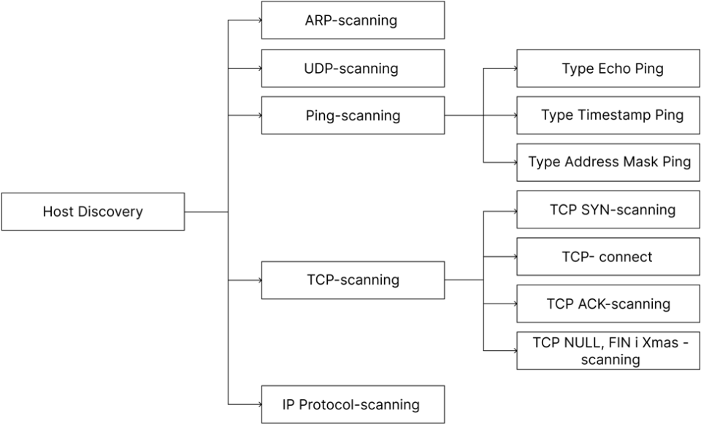

Figure 1 – Host discovery methods using the NMAP module Analysing the above, we can say that the main mechanism of intelligence is port

scanning. It allows the attacker to find out which services are running on the target system and to prepare and conduct a targeted attack against the services and their vulnerabilities. The most common information gathering tools are network and port scanners. Among the well-known network scanning methods are:

|  |  |
| --- | --- |
| 1. ARP scanning. 2. UDP scanning. 3. Ping scanning. 4. TCP SYN scanning. | 1. TCP scanning using the connect system call. 2. TCP ACK scanning. 3. TCP NULL, FIN and Xmas scanning. 4. Scanning of the IP protocol. |

**References:**

* 1. E. M. Proidakov, L. A. Teplytskyi. Anhlo-ukrainskyi tlumachnyi slovnyk z obchysliuvalnoi tekhniky, internetu i prohramuvannia, c. 552, 2005.
  2. Nmap.org [Елекронний ресурс]. - https://nmap.org/man/ru/man-port-scanning- techniques.html
  3. eTutorials.org [Елекронний ресурс]. - [http://etutorials.org/Networking/network+security+assessment/Chapter+4.+IP+Network+Scanning/](http://etutorials.org/Networking/network%2Bsecurity%2Bassessment/Chapter%2B4.%2BIP%2BNetwork%2BScanning/) 4.1+ICMP+Probing/
  4. C. Zhou, “Complete appendix of nmap rules,” http:

//cloud.eic.hust.edu.cn:8084/∼yayugao/students/chenming zhou/ chenming zhou.html

**5.** G. Kaur and N. Kaur, “Penetration testing–reconnaissance with nmap tool.”

International Journal of Advanced Research in Computer Science, vol. 8, no. 3, 2017.

## 1 Serhii Buchyk

Doctor of Technical Sciences, Professor at the Department of Cyber Security and Information Protection, Faculty of Information Technologies

## 2 Dmytro Tsapro

Student at the Cyber Security and Information Protection Department, Faculty of Information Technologies

*1,2 Taras Shevchenko National University of Kyiv, Ukraine*

# SYMMETRIC ENCRYPTION OF MESSAGES BASED ON THE USE OF IMAGES

**Abstract.** This work is devoted to the problem of message transmission protection in an unsecured communication channel. It presents possible enhancements of message transmission protection by symmetric encryption creating image arrays using one-way math operations to mix public and private keys and a modified Diffie-Hellman method as a way to exchange private keys in an insecure channel.

**Keywords:** images, Diffie–Hellman method, symmetric encryption, rgb.

Nowadays the development of information systems and technologies, global computer systems and multimedia means, the question of ensuring the reliability and safety of data stored in digital form, as well as their reproduction and transmission through information communication channels is becoming more and more urgent and is getting more and more attention than ever. Even ordinary Internet users can become victims of an attack on their personal data or correspondence, as well as small and large companies. So, the focus of our work is on correspondence between users and its protection.

One of the solutions that seems most promising is based on computer stenography, an encryption technique, the existence of which an average person is unaware of as there is no substantial evidence about such information or data.

According to the basic principle of shorthand, a small amount of critical data is usually mixed with an array of information in such a way that an average user will not be interested in it. One of these arrays can be the most common available media files, e.g., audio, video and images. According to RAS research, about 1.13 trillion photos were taken in 2020 [1]. This means that if we divide this value by the number of people who have a phone or a camera, it will be about 211 photos per person. So, this conveys that most people already have a large number of unique photos in correspondence, which can be used as public keys. Furthermore, lots of people have personal messages that they have not published anywhere and have not forwarded, in case if there is none, then one can take their phone, take a photo and in a minute, they will have a unique private photo. These photos can act as a private key.

At this stage, there may be doubts about the use of the symmetric method of encrypting future messages, as it is possible to use an asymmetric one. Still, we will

consider the case when it is planned to exchange a large number of messages, and for this the symmetric model is for sure the favourite [2].

The model situation presupposes that you and your interlocutor have public keys and each of you has your own private key. The next step it to exchange private keys so that they are not declassified. The Diffie-Hellman method can be appropriate for this task, which is the use of a one-way mod operation with prime numbers.

This method is based on the use of prime numbers for maximum security. So now we have a method of transferring two keys, but the question is raised how to move from theory to practice. The first proposal was to use prime numbers up to 256, that is, to generate a photo by choosing for each of the rgb colors a random prime number in the range from 0 to 255. But, firstly, there are only 53 of such numbers. Secondly, the remainder of dividing by some of them, such as 2 or 3, is too easy to calculate, so they should also be removed. This leads to the fact that out of these 53 at least a couple of numbers will remain, and an image with exactly the same color may raise suspicion even among average users.

Therefore, there put forward a method of creating a table that contains 256 prime numbers in ascending order is. In this case you and your interlocutor are able to choose any open image, and even maybe more than one. Furthermore, this solution has a particular advantage as we do not have to take only prime numbers as in the first method, which will significantly increase possible variations, and as a consequence will increase the level of protection of the offered method.

There is an example in which mixing means taking a pixel from an open image, separately adding the corresponding color from the rgb of the closed and open image according to the formula (𝑔𝑘mod n)mod 256, where *n* is a prime number from the table with the corresponding index, which is equal to the value of the base color in the open image, *k* is the value of the base color in closed + 1 (to avoid the 0 power), *g* is the product of the values from the table with indices equal to the other two values of the base colors in the open image.

There is given an example of Alice and Bob to consider. If to put it briefly, Figure 1 demonstrates how it works, with the remark that instead of four colors, all pixels are presented in the image.

That is, Bob takes and mixes his closed image with the open one, and gets the image that he will send to Alice.

She, in her turn, performs the same operation and sends the public image mixed with her private key.

Next, Bob mixes his closed image with what Alice sent him, and she in her turn performs the same action with what Bob sent to her.

In this way, these two will receive the same images that they exchanged in an unsecured channel. That is, if an attacker intercepts all their messages, he will not receive the same image as these two.

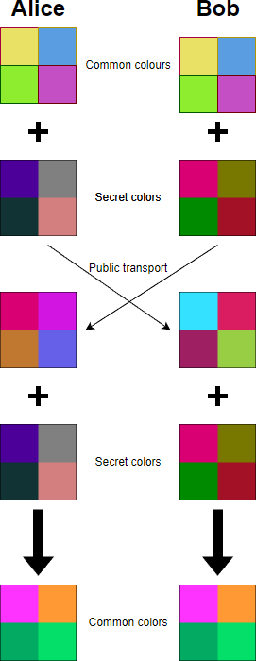

Figure 1 – Visual demonstration of Diffie–Hellman method work

The use of this method will allow users to create a set of images that will be incomprehensible to an average user, later on using this set for symmetric encryption of messages in the future.

**References:**

1. Rise Above Research Estimates that 1.13 Trillion Photos Will Still be Taken in 2020 (2020). Retrieved from: https://riseaboveresearch.com/rise-above-research-estimates-that-1-13-trillion- photos-will-still-be-taken-in-2020/
2. Kontsevoy E. (2020). Comparing SSH Keys - RSA, DSA, ECDSA, or EdDSA? Retrieved from: https://goteleport.com/blog/comparing-ssh-keys/
3. Zhang X & Wang S. (2005). Steganography using multiple-base notational system and human vision sensitivity. *IEEE Signal Processing Letters*, 12(1), pp.67-70.
4. Odii. J. N., Hampo J. A. C., Okpalla C. L & Onukwugha C.G. (2019). Hybridization of Cryptography and Steganography for Information Security. *Futo Journal*, 5(2), pp. 227-234.

## 1 Anna Buzyurova

Master’s student of the Faculty of Information Technology

## 2 Nikolay Kiktev

Candidate of Technical Sciences, Associate Professor of the Department of Intellectual Technologies

*1,2 Taras Shevchenko National University of Kyiv, Ukraine*

# USE OF FORECASTING METHODS IN THE INFORMATION SYSTEM OF EFFICIENT WATER SUPPLY TO PREVENT ACCIDENTS

**Abstract.** This article describes the developed information system of efficient water supply based on the parameters obtained from the devices located on the pipes.

**Keywords:** Water supply, costs, humidity, accidents, forecasting, distributed information system, database, application, graphical interface.

The article is devoted to issues of notification of the water supply system using the emergency alarm system. The advantages of using an alarm monitoring system are that the alarm warns of moisture on the pipe and protects it from corrosion. With the help of an electronic device, it is possible to monitor the condition of the pipe and register the corresponding indicators, which, if they exceed the norm, can lead to an accident.

The issue of improving the calculation and optimization of the water supply system of large cities, taking into account the wear and tear of pipelines, is considered in the dissertation research of Nguen Huy Cuong (Vietnam) [1]. The work [2] describes the creation of the hardware and software complex of the ACS of the Southern water supply zone of the agglomeration with a population of 5 million inhabitants. The development of a three-tier ACS for water supply management is described in the work of researchers from Donetsk National University (Ukraine) [3]. The article [4] describes the energy efficiency management system for pipeline water supply systems based on the information database of daily statistics of energy, hydraulic and production indicators. The issue of modeling and designing hydraulic systems, in particular in agricultural objects, was considered in the work of researchers of the National University of Life and Environmental Sciences of Ukraine [5].

The information system that’s being developed will make it possible to make recommendations for repairing the pipe in a certain place before an accident occurs, saving people and businesses from water supply interruptions. At the stage of the database development we will conduct an analysis of the subject area, so we will determine the objects of the subject area and the relationship between them. Objects and attributes of the subject area: Device (number; coordinate x – for placing the device on the diagram; coordinate y – for placing the device on the diagram; pipe number); History of indications (number; number of the device; date – the date of taking the indications; indication – the value of the humidity level in percent; water consumption – the value of water consumption in liters since the beginning of the day); Pipe (id; length; district number; material number; date of last repair); District: (number; name); Material (number; name; moisture level that can withstand this material). In the next

step, we will build the logical model itself using the description given above. The result of building the model is shown in fig. 1. Let's move on to creating the application itself. At this stage, we will determine the structure of the application. The application that’s being developed will consist of: a server on which all logical operations will be performed and interaction with the database will take place; web applications – an application for browser users; databases; controllers - devices located on pipes that transmit data to the database.

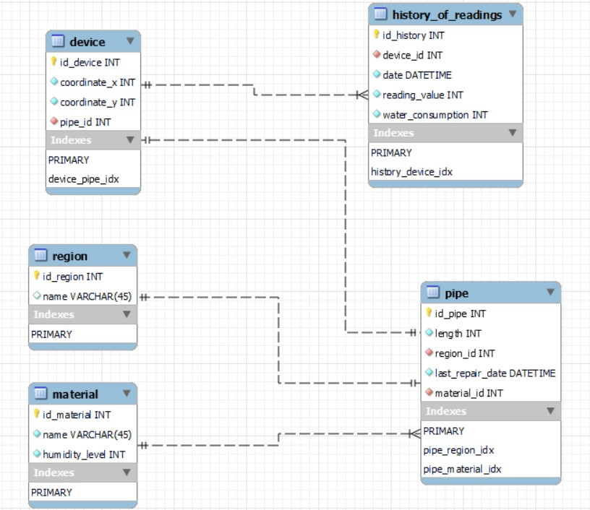

Fig. 1 – Presentation of the logical model

Let's start creating a database for application development. At this stage, we use the MySQL Workbench application and create the database itself (according to the model presented in Fig. 1). We will also create tables and data types, define primary, external and unique keys. We will use the JavaScript programming language to connect to the MySQL database from the application. We will demonstrate the execution of the application for users of the Chrome browser. In this application, the content is divided using tabs, which are menus. The user can switch between following menu items: "Main", "Network diagram", "Table data", "Charts and forecast". On the main page, the user can see basic information about this system. The network plan, where the devices for measuring humidity are located, the coordinates of which are stored in the database can be seen on the second tab (Fig. 2). Date data, humidity indicators and water consumption for each of the devices in tabular form can be seen on the third tab (Fig. 3). It is possible to select the device through the menu (Fig. 4), the data of which the user wants to receive. The fourth tab contains graphs of indications for each device, which can be selected through the corresponding menu, as in the previous tab (Fig. 5) and forecasts for two parameters, namely the level of humidity and water consumption, created using the selected method.

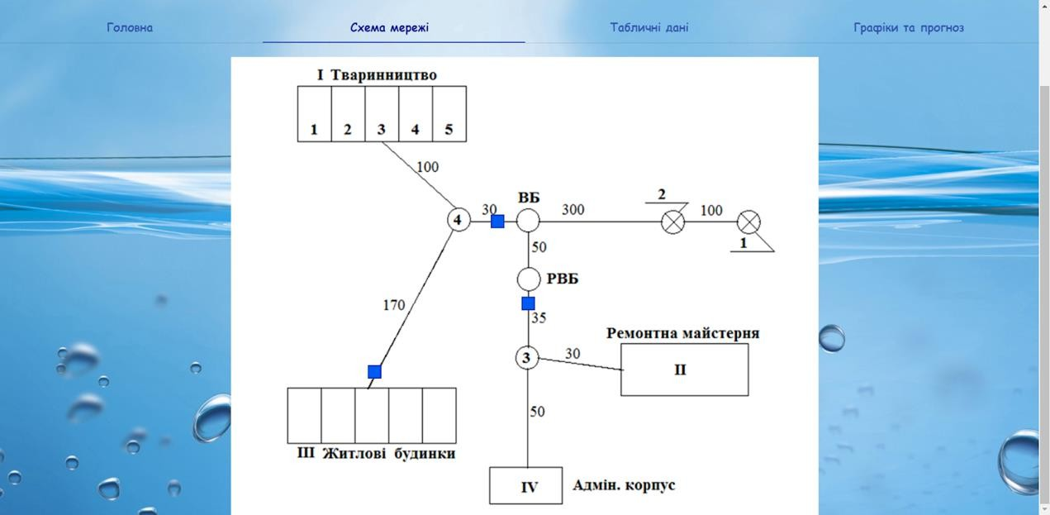

Fig. 2 – Tab with modified network diagram

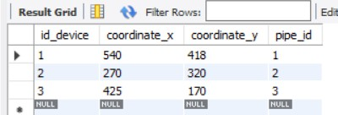

Fig. 3 – Coordinates recorded in the database

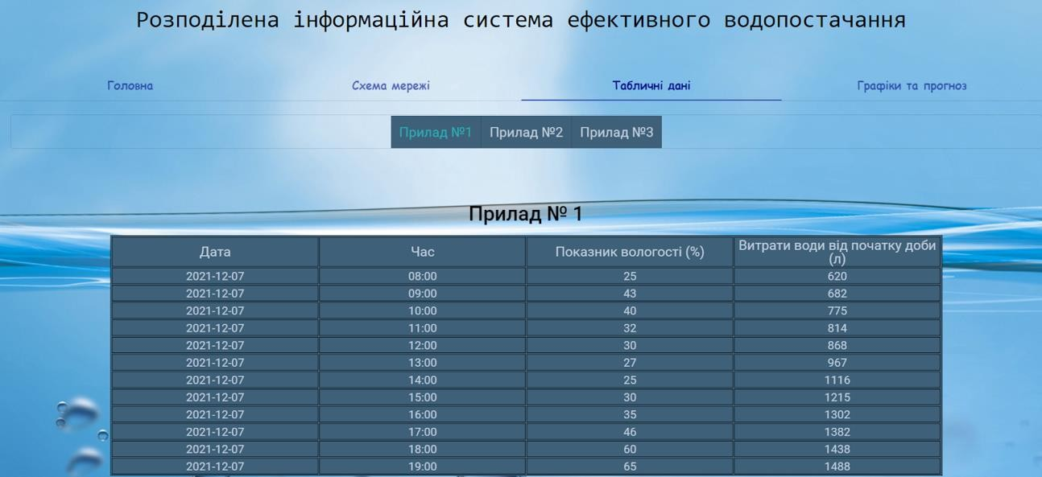

Fig. 4 – Tab with tabular data (device 1)

If the predicted humidity indication is greater than the value recorded in the database for the corresponding material, then the user sees a red message about a possible accident on the pipe and the name of the area that may be left without water supply. The date of the last repair of the pipe is also shown above the first graph. Data on the formation of the message and information about the repair are obtained from the database.

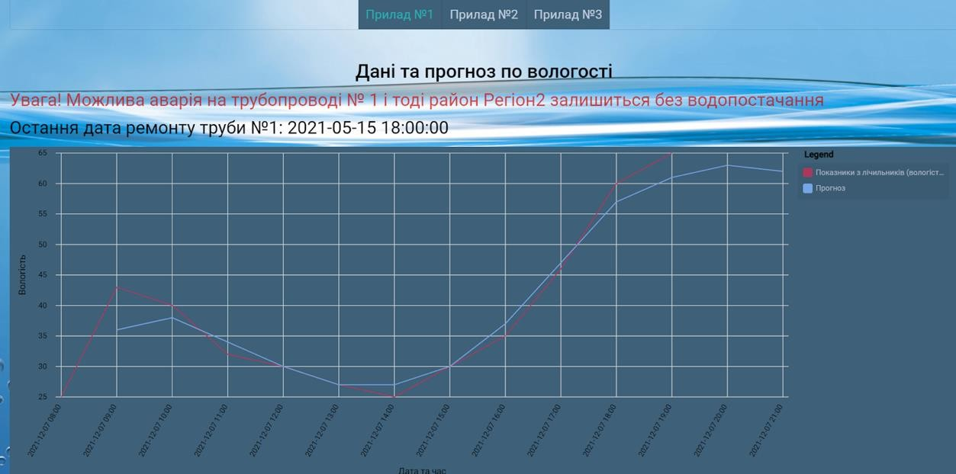

Fig. 5 – Tab with graphs and forecasts (device 1, graph by humidity level)

**Conclusions.** As a result of the research, an information system for efficient water supply was developed based on the parameters obtained from the devices located on the pipes. An application has been developed and it can provide the user with a convenient interface for tracking possible accidents in the water supply network, thanks to which the user can make a timely decision to carry out repairs and prevent such a situation.

**References:**

1. Nguen Huy Cuong. Improving the calculation and optimization of the water supply system of large cities, taking into account the wear of pipelines [Sovershenstvovanie rascheta i optimizaciya sistemy vodosnabzheniya krupnyh gorodov s uchetom iznosa truboprovodov]. Dissertation for the degree of Cand. tech. Sciences. Voronezh State Technical University, 2019. – 173 p. (In Russian).
2. Implementation of the project "Creation of an automated control system for the Southern Water Supply Zone". [Link](https://www.gov.spb.ru/static/writable/ckeditor/uploads/2018/10/18/6%20%D0%97%D0%B0%D0%B9%D1%87%D1%83%D0%BA_%D0%9A%D0%BE%D0%BC%D0%B8%D1%82%D0%B5%D1%82_%D0%AE%D0%B6%D0%BD%D0%B0%D1%8F%20%D0%B7%D0%BE%D0%BD%D0%B0_%D0%9F%D1%80%D0%B5%D0%B7%D0%B5%D0%BD%D1%82%D0%B0%D1%86%D0%B8%D1%8F.pdf) (Access 08.01.2021).
3. S. Romanchuk. Directions for the development of urban water supply and drainage systems [Napravleniya razvitiya gorodskih ASU TP vodosnabzheniya i vodootvedeniya]. Scientific works of DonNTU. Series "Informatics, Cybernetics and Computer Engineering", №1 (19), 2014. -

pp. 131-138. (In Russian).

1. A. A. Kapansky. Energy efficiency of technological systems of water supply and sanitation and methods of its assessment [Energoeffektivnost' tekhnologicheskih sistem vodosnabzheniya i vodootvedeniya i metody ee ocenki. Energy. News of higher educational institutions and energy associations of the CIS. Vol. 59, № 5 (2016), pp. 436–451. (In Russian).
2. Vasylenkov, V. Ye. Water supply systems in agriculture and their technological equipment [Systemy vodopostachannia v silskomu hospodarstvi i yikh tekhnolohichne osnashchennia]. Scientific bulletin of NULES of Ukraine, № 1, 2015. – pp. 55-63. (In Ukranian).

## 1 Andrii Cherevatov

Student

## 2 Ivan Chychkan

PhD of physical and mathematical sciences, associate professor of the department of information systems and technologies.

*1,2 Taras Shevchenko National University of Kyiv, Ukraine*

# AN APPROACH TO SLOWLY CHANGING DIMENSION DATA ENCRYPTION USING THE SCRYPT ALGORITHM

Reliable algorithms are always needed to ensure protection of data from compromise and illegal interference in processes. There are two main processes in the cryptography, encryption and decryption. In the encryption process the key has been used to convert the plain text into cipher text after which the decryption process takes place, that is, the transformation of encrypted data (automatically or manually) into an unencrypted form.

Scrypt is a Password Based Key Derivation function. When we consider a standard approach to hashing a dataset to obtain a password, the algorithm passes through a hash function and generates a password that is stored in the database. If password verification is required, the software will query the database to obtain the user's hash. After that, the password entered by the user passes through the hash function and the obtained result is compared with a record from the database. If they match, the password is correct.

Hashed passwords by default remain vulnerable to brute-force attacks, or rainbow attacks, when huge tables of prehashed data are created. In order to protect against brute force attacks, we use a salt.

In cryptography, PBKDF1 and PBKDF2 (Password-Based Key Derivation Function 1) are key derivation functions with a sliding computational cost, used to reduce vulnerabilities of brute-force attacks [1]. This function receives a password, a salt, and the number of iterations as an input. Inside, the function applies a pseudo- random function in a loop with a given number of iterations.

Since this process takes more time than encryption with a standard method, rainbow table type attacks become irrelevant, since table generation now requires much more time and computing resources. Generation of a 1024-bit key with the number of iterations in 4000 takes 0.588 seconds [2].

Whereas derivation functions with a sliding computational cost can still be attacked by parallel operations. Scrypt PBKDF was created. It is a memory intensive algorithm that makes it costly to perform large-scale hardware attacks.

As input parameters, the algorithm takes a phrase, a salt, a CPU Cost Parameter(N), a Memory Cost Parameter(R), a Parallelization Parameter(P), and a user-specified output length(dkLen).

Smix is a key function inside Scrypt. The number of iterations of the cycle is set by the P parameter, the parallelization parameter. The basic idea of the Smix function is to make cracking unreasonable. Inside a Smix function. There is a BlockSalsa20.

This is a block of code whose main idea is do not possess excessive internal parallelism to speed up the function.

Based on available data concerning DES, MD5, Blowfish, SHA-256, and Salsa20 cores, we provide the following estimates for the size and performance of cryptographic circuits on a 130 nm process [3].

* A DES circuit with ≈ 4000 gates of logic can encrypt data at 2000 Mbps.
* An MD5 circuit with ≈ 12000 gates of logic can hash data at 2500 Mbps.
* A SHA256 circuit with ≈ 20000 gates of logic can hash data at 2500 Mbps.
* A Blowfish circuit with ≈ 22000 gates of logic and 4 kiB of SRAM can encrypt data at 1000 Mbps.
* A Salsa20/8 circuit with ≈ 24000 gates of logic can output a keystream at 2000 Mbps.

Conclusion:

As new types of attacks emerge and technologies do not stand still, cybersecurity professionals must create new methods of deterrence and prevention.

The report proposes an approach using Scrypt as a data hashing algorithm, which provides a number of advantages, in particular:

SHA-512 is significantly faster than PBKDF2, which has been deliberately slowed down, and is designed in such a way that its slowness can be controlled by adjusting the iteration count parameter. And therefore, creating tables for "rainbow" attacks and brute force attacks will take catastrophically longer, and since it is proposed to use an algorithm for slowly changing dimensions, the system will not require constant creation of a hash from a data array. It is enough to create it once and recreate it in rare cases.

**Referenses:**

* 1. Raeburn, Kenneth (2005). "Advanced Encryption Standard (AES) Encryption for Kerberos 5". tools.ietf.org. doi:10.17487/RFC3962. RFC 3962. Retrieved October 23, 2015.
  2. Tahir, Hasan & Tahir, Ruhma & McDonald-Maier, Klaus. (2018). On the security of consumer wearable devices in the Internet of Things. PloS one. 13. e0195487. 10.1371/journal.pone.0195487.
  3. Colin Percival, Stronger Key Derivation via Sequential Memory-Hard Functions, presented at BSDCan'09, May 09. [Electronic resource] Access mode: <http://www.tarsnap.com/scrypt/scrypt.pdf>

## 1 Valeriia Chyzhenko

Student

## 2 Lyubov Kubivka

PhD in Technical Sciences, Associate Professor at the Department of Management Technologies

*1,2 Taras Shevchenko National University of Kyiv, Ukraine*

# POSSIBILITIES OF PROJECT MANAGEMENT USING ARTIFICIAL INTELLIGENCE

**Abstracts.** The world is currently undergoing many changes as technology continues to evolve to improve people's lives. Technological progress has made things that seemed impossible in the last decade a part of modern life. All industries are using technology to improve efficiency and effectiveness while making management reliable, secure and interoperable. The integration of human capabilities and technological systems increases productivity and ensures continuous improvement. The combination of technology and human capabilities is also used for project management.

**Keywords:** technological processes, artificial intelligence, project management, automation, integration of human capabilities and technical systems.

**Introduction.** As the use of AI in organizations continues to grow and its benefits remain significant even during the COVID-19 pandemic, it is important for project managers to understand where AI can have the greatest impact.

Better decision-making and more accurate forecasting of project completion dates.

One of the constant tasks of project management is the collection of sufficiently accurate and up-to-date information for making informed decisions. The ability of artificial intelligence to process huge data sets in real-time and changing organizational mindsets can help bridge this gap and facilitate the decision-making process. The ability to connect different types of information and find problems that people would otherwise have missed can be a real turning point for project management.

AI has the potential to detect (in real-time) anomalies in datasets and alert managers to project changes (schedule, budget, timelines, project funding...) that could have a significant impact on the project. Ideally, an AI system automatically outputs data critical to project success, making it easier for senior management to make the right decisions [1].

AI can help contextualize data by providing more information than traditional systems provide, linking data to information from other parts of the system, adding meaning to that particular set of data (often related to context: constraints, requirements, etc.). Artificial intelligence and contextual data can play a key role in filling the knowledge gaps and reducing the uncertainty associated with emerging markets, and enabling companies to deploy continuous real-time analytics for rapid decision-making.

AI has the potential to detect new trends and indicate to the project manager when a new variable may affect how projects unfold (for example, if a new type of delay appears). This will allow the project manager to stay abreast of the latest data that affects the project's schedule, budget, or schedule [2].

1. Automation of routine administrative tasks.

Active AI assistance or AI virtual assistants are playing an increasing role in eliminating repetitive lower-level tasks, freeing project managers from routine tasks such as meeting scheduling, reminders, daily updates, report preparation, data entry and collection, error detection, and other tasks. By saving time with artificial intelligence in the project management process, project managers can focus on complex higher-level activities that are more important to them, such as planning and customer engagement.

In addition to performing the mundane tasks of a project manager, such as an administrator, AI technologies can automate repetitive decision-making processes.

1. Better perception of information and identification of risks.

Thanks to its computing power, AI is able to quickly run multiple scenarios and assess the risks of future projects.

Unlike current tools that need to be pointed in the right direction, a deep learning algorithm can potentially identify potential risks without being asked.

This ability to process massive datasets ensures that issues and dependencies that would otherwise go unnoticed are captured during modeling and improve the quality of the proposed mitigation plan. And it can repeat the calculation when new updated data arrives.

The main areas where artificial intelligence systems offer the greatest potential for project risk management are:

* creation of more accurate cost and time forecasts using empirical data, thus reducing costs and time overruns in portfolios;
* early identification of problems in projects (with the help of data analytics, project managers can accurately determine which of their projects have the greatest risk of over-execution and under-execution, and therefore determine the actions that will have the greatest impact on problematic projects);
* developing more effective mitigation plans and finding better solutions for risk management that have been implemented;
* improvement of adaptation and training [3].

1. Resource management and capacity planning.

Artificial intelligence systems enable project managers to better execute future projects through more efficient allocation of resources. As a result, organizations can anticipate needs and adapt schedules accordingly. The ideal AI system will assist project managers with capacity planning strategies that consider all relevant aspects of the project, including manpower, facilities, schedules, budgets and supplies. A byproduct of this advanced planning is a happier workforce as tasks are delegated based on past performance and overall capacity employee

AI can help improve the processes used to manage people, including:

* + calculation of the best distribution of resources and forecasting the deficit or surplus of resources;
  + determination of the right skills for the right job;
  + providing feedback on the implementation of the project;
  + determination of special training for a specific employee;
  + increasing the productivity of capital (reducing obstacles for employees can have a significant impact on the company's efficiency) [4].

With artificial intelligence as a complement to humans, design decisions will be based on a larger set of data and with greater computing power. This will broaden the project manager's view of the entire project landscape and allow him to react more quickly and offer better solutions to the changing business environment.

Although AI will obviously have a major impact on project management, artificial intelligence is not human. Human skills such as empathy, emotional intelligence, negotiation, decision-making and human resource management will be valued in the near future—perhaps more than ever.

**References:**

1. Abduh, M., & Soemardi, B. W. (2018). Web-Based Project Management Applications in construction. *World Wide Web Internet And Web Information Systems*.
2. Anastasi, G., Corucci, F., & Marcelloni, F. (2019). An intelligent system for electrical energy management in buildings. *International Conference on Intelligent Systems Design and Applications, ISDA*, *Nov 2019*, 702–707.: [Електронний ресурс] – Режим доступу: https://doi.org/10.1109/ISDA.2011.6121738.
3. Butt, A. (2018). *Project Management through the lens of Artificial Intelligence - A Mixed-Methods Research into How AI Systems can Support Project Managers to become more Efficient in their Daily Work*.
4. Auth, G., Jokisch, O., & Dürk, C. (2019). Revisiting automated project management in the digital age – a survey of AI approaches. *Online Journal of Applied Knowledge Management*, *7*(1), 27–39.: [Електронний ресурс] – Режим доступу: https://doi.org/10.36965/ojakm.2019.7(1)27-39.

## 1 Serhii Dakov

Candidate of technical sciences, assistant of the Department of Cyber Security and Information Protection

## 2 Anna Holubnycha

Student

*1,2 Taras Shevchenko National University of Kyiv, Ukraine*

# RESULTS OF THE STUDY OF THE STATE OF INFORMATION SECURITY IN THE MEDICAL INFORMATION SYSTEM

**Abstract.** An examination was conducted of the medical information system (MIS), which provides telemedicine services.

## Introduction

MIS provides online communication with leading doctors of the country who work in private and public medical institutions of Ukraine. Electronic MIS provides the ability to exchange data with the central database of the electronic health care system through an open application software interface.

## Basic material

During the analysis of the company's documentation for compliance with Ukrainian regulations on information protection, personal data (PD) protection, information security, a number of points were found that seemed suspicious or that are a violation of Ukrainian legislation. National regulatory documents [1-7] were taken as the basis for the research. The Public Offer Agreement and the company's Privacy Policy were subjected to careful analysis.

The next stage of the study was registration on the website and an online consultation with a doctor in MIS. During this stage, a number of controversial issues were also identified regarding the fulfillment of the requirements of Ukrainian legislation and the company's internal documentation. For example, there are no clear provisions in the resource documentation regarding the issuance of sick leave, although such services are provided. Another point is that you need to add a card to pay for the service. To do this, you need to enter bankcard data on the platform. This moment is a threat to the security of the data and can lead to its theft by the administrators of the information system (IS) or other persons involved in this.

Regarding the consultation process itself, I can say that I am skeptical about this format of providing medical services. The dialogue is short, the answers are monosyllabic, and there is no feeling of "inclusion" in the process. I consider this a big drawback. In addition, you can get an answer from your family doctor free to all questions for which it is possible to get a consultation online for technical reasons. As for the topic of collection of PD during consultations, no special issues arose here.

Next, my goal was to analyze the work of IS with PD at the stages of registration and online consultation with a doctor. When registering, we are asked to enter a phone number, which is necessary for user verification by sending an SMS message. There are no questions here. When filling out the patient's personal office, we are asked to

enter their height, weight, blood type, allergies and chronic diseases. It is also possible to create a "personal medical card" where photos of tests, examinations, etc. are added. In addition to the photo, it is also necessary to indicate the date, the name of the document and the type of document. This is data containing a medicinal secret. Moreover, with its processing, according to the analysis of the company's documentation, there are some contradictions. For an advisory opinion, data is taken from the patient's personal office.

## Conclusion

In general, the idea is good: quick access to doctor's consultations, a modern solution for a technologically developing society. However, this field requires work with a large number of drugs, some of which are medical secrets. Therefore, the regulatory documents of the company that owns the MIS must contain clear instructions regarding the processing of PD.

**References:**

1. Law of Ukraine "On Protection of Personal Data" [Electronic resource] – Mode of access: <https://zakon.rada.gov.ua/laws/show/2297-17#Text>
2. Law of Ukraine "On Protection of Information in Information and Communication Systems" [Electronic resource] – Mode of access: [https://zakon.rada.gov.ua/laws/show/80/94-](https://zakon.rada.gov.ua/laws/show/80/94-%D0%B2%D1%80#Text)

[%D0%B2%D1%80#Text](https://zakon.rada.gov.ua/laws/show/80/94-%D0%B2%D1%80#Text)

1. The standard procedure for processing personal data, approved by the order of the Commissioner for Human Rights of the Verkhovna Rada of Ukraine dated January 8, 2014 No. 1/02- 14 [Electronic resource] – Mode of access: <https://zakon.rada.gov.ua/laws/show/v1_02715-14#n11>
2. Law of Ukraine "Basics of the legislation of Ukraine on health care" [Electronic resource] – Mode of access: <https://zakon.rada.gov.ua/laws/show/2801-12#Text>
3. The procedure for maintaining the Register of medical records, referral records and prescriptions in the electronic health care system, approved by order of the Ministry of Health of Ukraine dated February 28, 2020 No. 587 [Electronic resource] – Mode of access: <https://zakon.rada.gov.ua/laws/show/z0236-20#n23>
4. The procedure for maintaining the Register of medical opinions in the electronic health care system, approved by the order of the Ministry of Health of Ukraine dated September 18, 2020 No. 2136, registered in the Ministry of Justice of Ukraine on September 30, 2020 under No. 952/35235 [Electronic resource] – Mode of access: [https://zakon.rada.gov.ua/laws/show/z0952-](https://zakon.rada.gov.ua/laws/show/z0952-20#n21) [20#n21](https://zakon.rada.gov.ua/laws/show/z0952-20#n21)
5. The procedure for the organization of medical care at the primary, secondary (specialized), tertiary (highly specialized) levels with the use of telemedicine, approved by order of the Ministry of Health of Ukraine dated October 19, 2015 No. 681, registered in the Ministry of Justice of Ukraine on November 9, 2015 under No. 1400/27845 [Electronic resource] – Mode of access: <https://zakon.rada.gov.ua/laws/show/z1400-15#n19>

## 1 Serhii Dakov

Ph.D., assistant of the department of cyber security and information protection

## 2 Vadym Mohylevych

Student

## 3 Ivan Parkhomenko

Ph.D., associate professor of the department of cyber security and information protection

*1,2,3 Taras Shevchenko National University of Kyiv, Ukraine*

# USING BLOCKCHAIN FOR DATA STORAGE

**Abstract.** The paper considers the use of blockchain for data storage. The main problems in use and possible ways to solve them are considered.

## Introduction

At the heart of the blockchain is a sequence of blocks, each of which carries a certain amount of information. This volume is limited by the technical implementation of the blockchain. The limit shows the maximum file size that can be uploaded to the blockchain. This is sufficient for storing transaction information, however, if you need to store a larger file, you need to look for another solution.

## Basic material

The problem of limiting the maximum block size can be solved in several ways.

The simplest of them implies:

* Splitting a file into segments smaller than the block size. Thus, even the largest file can be written to the blockchain with a small block size.
* Encryption of data in segments. This will allow you to store information in an open blockchain and be sure of its confidentiality.
* Distribution of segments on the blockchain network. Thanks to this, the file will be saved in an unchanged form as long as at least one user is synchronized with the blockchain.

This approach is borrowed from torrent trackers, but it is not suitable for storing data using the blockchain, even if you remove the fees for creating transactions, for the following reasons:

Recording of information in the blockchain is carried out using transactions, which, in turn, require confirmation. A large file can take several thousand transactions, that is, several hours or even days of processing.

Information in the blockchain is immutable. Therefore, you cannot delete or modify unnecessary data. All the files that got into the network and their variations will forever remain in the blockchain and theoretically someone will be able to view them sooner or later.

Immutability will lead to another problem – an avalanche of blockchain size. If information cannot be deleted, it will only accumulate, eventually making the size of the blockchain too large.

Let's consider several examples of using blockchain to store information:

BigChainDB cloud storage with huge volume and very fast transactions, it is built on the RethinkDB cluster and uses NoSQL mechanisms to store blocks, thanks to which it has high fault tolerance and bandwidth. BigchainDB is a scalable blockchain database. It is designed to combine the best properties of distributed databases and blockchain.

Sia is a decentralized cloud storage platform secured by blockchain technology. Sia's storage network uses hard drive capacity around the world, which is used to create a more reliable and cheaper way to store data than traditional cloud storage providers. Sia has its own blockchain and utility token that ensures its operation - Siacoin.

MaidSafe is a decentralized internet project. The concept of MaidSafe predates Bitcoin by several years, although it is currently still in beta. When the SAFE network is complete, it will work similarly to the TOR network, meaning that the distribution and access of Internet content will be done in a P2P core network.

## Conclusion

So, there are various options for data storage, but when using the blockchain, it is important to remember that current technologies do not allow storing large amounts of information inside the block chain. Therefore, the blockchain in this industry is used as an intermediary and ledger that monitors compliance with the terms of the agreement on providing storage from one person to another.

**References:**

1. Haug C. J. Peer-Review Fraud – Hacking the Scientific Publication Process [Electronic resource] / Charlotte J. Haug // New England Journal of Medicine. – 2015. – Т. 373, № 25. – С. 2393– 2395. – Access mode: <https://doi.org/10.1056/nejmp1512330>.
2. A Distributed-Ledger Consortium Model for Collaborative Innovation [Electronic resource] / Chris Khan // Computer. – 2017. – Т. 50, № 9. – С. 29–37. – Access mode: [https://doi.org/10.1109/mc.2017.3571057.](https://doi.org/10.1109/mc.2017.3571057)
3. Wang H. Blockchain-Based Private Provable Data Possession [Electronic resource] / Huaqun Wang, Qihua Wang, Debiao He // IEEE Transactions on Dependable and Secure Computing. – 2019. – С. 1. – Access mode: <https://doi.org/10.1109/tdsc.2019.2949809>.
4. Blockchain challenges and opportunities: a survey [Electronic resource] / Huaimin Wang

// International Journal of Web and Grid Services. – 2018. – Т. 14, № 4. – С. 352. – Access mode: [https://doi.org/10.1504/ijwgs.2018.10016848.](https://doi.org/10.1504/ijwgs.2018.10016848)

## 1 Serge Dolgikh

MSc, Research Associate, Chair of Applied Mathematics

*1 National Aviation University, Kyiv*

*1 Solana Networks, Ottawa, Canada*

# UNSUPERVISED CONCEPT LEARNING AND CONCEPTUAL STRUCTURE OF COMPLEX SENSORY DATA

**Abstract**. Conventional methods of analysis of complex sensory data often rely on availability of large collections of data containing significant prior knowledge of the domain, in any of used forms, including training datasets labeled with pre-known truth. Availability or even existence of such data cannot be relied on especially in novel problems and domains where significant amount of confident prior knowledge has not been accumulated. In this work we discuss alternative approaches to analysis of complex sensory data that do not require massive amount of prior knowledge based on unsupervised concept learning and clustering.

**Keywords**: unsupervised learning, Principal Component Analysis, manifold learning, concept learning, clustering.

**Introduction.** Many studies described examples of bias in different practical and functional applications of AI systems, including criminal justice, health care, human resources, social networks and others. Alongside exciting examples of success in many areas, a number of limitations of conventional methods were noted, including dependence on massive of prior data for successful development of functional systems, as well as the problems of explainable and trustworthy AI that are closely related to understanding the reasons why learned systems make certain decisions. In this work we will examine an alternative approach and viewpoint on these problems from the perspective of understanding and analysis of the natural structure of the data itself that does not require massive prior knowledge neither in the form of prior known decisions (that is, labeled datasets) or significant prior knowledge of composition, distribution or characteristics of structure. This direction is generally known as unsupervised concept learning.

**Methods and approaches in unsupervised concept learning.** A number of methods and approaches have been developed in the field of unsupervised concept learning with the objective of describe and characterize conceptual structure of complex sensory data. These include:

* methods of unsupervised dimensionality reduction, with the objective of reduction of complexity of sensory data that can be both instrumental and important in identification of characteristic types (natural concepts) in the data;
* methods of unsupervised generative learning with production of informative low-dimensional representations of complex sensory data; informative representations produced by such methods can simplify analysis of characteristic conceptual structure of the data.
* clustering methods instrumental in confident identification of distinct distributions of subsets of data (including in embeddings and representations of reduced dimensionality) that can be identified with natural types or concepts in the data.
* statistical methods of analysis of distributions, including identified subsets associated with distinct natural types;

and other methods.

**Linear and Non-linear embeddings.** A well-known method of production of informative low dimensional representations (embeddings) of sensory data is Principal Component Analysis (PCA). The method identifies linear combinations of observable parameters that produce highest variation in the dataset. PCA is a simple and effective method that can provide important informative conclusions about the distribution of data without any prior knowledge of its content. A downside of the method is it essentially linear nature that can be less effective in analysis of more complex data.

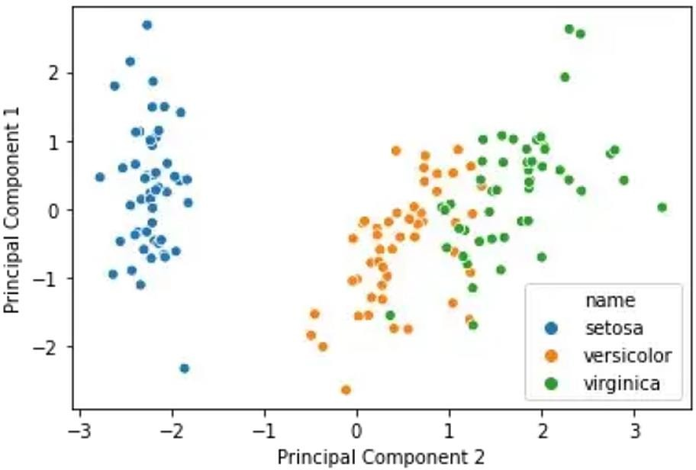

Figure 1. Dimensionality reduction of visual data with PCA (dataset of images IRIS, [1])

Limitations of linearity prompted development of methods of non-linear low- dimensionality embedding under general umbrella of manifold learning. Detailed description of these methods falls beyond the limits of this work, however their general objective is to produce low-dimensional embedding or informative representation of the observable data while preserving characteristic inner structure in the data, for example effective distances between samples. These methods can be effective in analysis of more complex data such as interpretation of symbols.

To non-linear methods of dimensionality reduction can be also classified methods of generative unsupervised learning that produce informative low- dimensional representations of sensory data learning under the incentive to minimize the distance between the input data and generations produced by the learning model.

**Natural Conceptual Structure of Complex Sensory Data.** We can consider an example of a visual dataset of basic geometrical shapes (Shapes dataset, [2]) that can

model a simple but realistic natural environment of a simple biological learning system. The dataset includes grayscale images of triangles, circles and empty backgrounds of variable size and contrast. Different shapes in the set can model different objects in the natural environment of the learning system, for example sources of food versus predators.

A method of unsupervised learning with generative neural network model was used to produce low-dimensional representation of the dataset, illustrated in Figure 2.

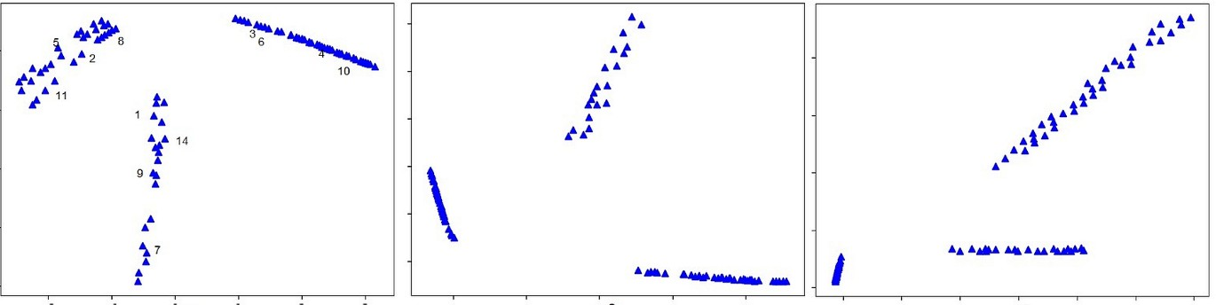

Figure 2. Shapes dataset: 2D embeddings with independently-trained unsupervised generative models (convolutional autoencoder).

It can be observed that unsupervised embeddings of the data with selected embedding model (generative self-learning neural network) allows to identify clearly distinct characteristic clusters in the observable data (3 clusters). Importantly, the conclusion that the dataset contained three distinct types of data can be made without any prior knowledge of semantics of the samples or external knowledge about composition of the dataset.

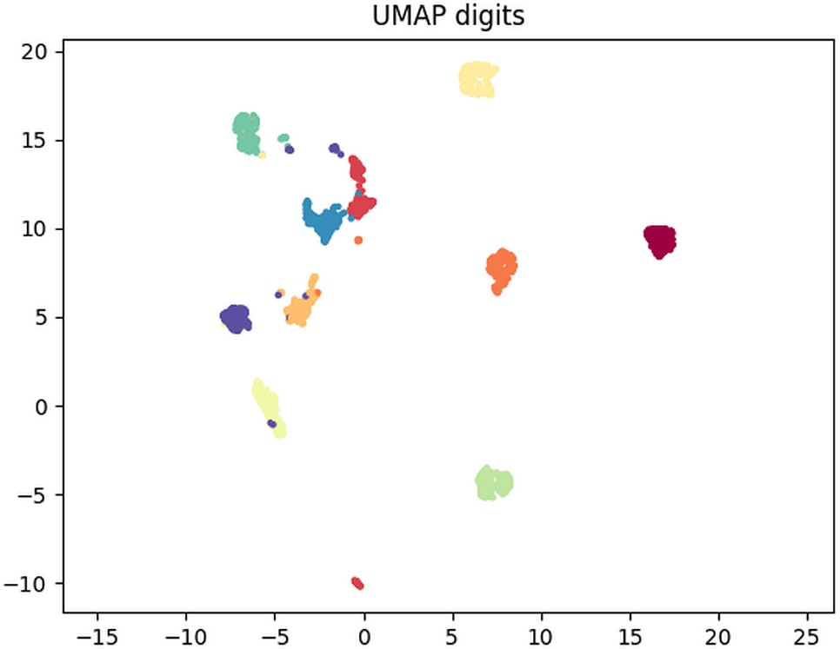Similar results can be obtained with another visual datasets, of grayscale images of digits (Figure 3, manifold learning package *umap*).

Figure 3 Digits dataset: 2D embedding with manifold learning (umap).

Cluster structure identified with methods of unsupervised low-dimensional embedding can thus define the natural conceptual structure of the dataset as:

𝐿(𝐷) = { 𝑑𝑗 }, 𝑗 = ̅1̅̅,̅𝑛̅ = 𝐾𝑑(𝐸(𝐷))

where *L*(*D*): concepts associated with distinct structures (clusters) in the informative representation;

*dj*: set of distinct clusters in the informative embedding;

*Kd*: method of resolving cluster structure (such as, density clustering);

*E*: embedding of the data *D*

Unsupervised conceptual landscape can provide additional perspective for analysis and applications of the data including:

* analysis and description of characteristic content of the data, including distributions of identified natural concepts;
* generation of new data based on identified conceptual structure in the embedding. Importantly, generated datapoints can be associated with concepts of the associated embedded region;
* confident recognition of natural types (concepts) in the data without requirements for prior labeled data.
* improvement in classification performance in some scenarios where external class is closely associated with a natural concept.
* applications in the analysis of bias and trustworthiness of machine intelligence systems.

**Conclusions.** Low-dimensional informative embedding and definition of natural conceptual structure in complex sensory data can provide perspectives in analysis of data even in the absence of large amounts of prior knowledge. For these reasons the approach proposed in this work in our view, merits the attention of the research community.

**References:**

1. Hall B. An intuitive approach to PCA. Medium, online: [https://medium.com/swlh/an-](https://medium.com/swlh/an-intuitive-approach-to-pca-fc4d05c14c19) [intuitive-approach-to-pca-fc4d05c14c19](https://medium.com/swlh/an-intuitive-approach-to-pca-fc4d05c14c19) 2020.
2. Dolgikh S. Topology of conceptual representations in unsupervised generative models. In: Proc. 26th International Conference on Information Society and University Studies (IVUS 2021) Kaunas, Lithuania, CEUR-WS.org 2915, p. 150–157 (2021)..

## 1 Yuliia Fedirko

Master's degree student Department of Technology Management

## 2 Oleksii Yehorchenkov

PhD, Associate Professor of the Department of Technology Management

*1,2 Taras Shevchenko National University of Kyiv, Ukraine*

*2 Slovak University of Technology in Bratislava, Slovakia*

# DEEP LEARNING MODEL IN PREDICTING DIABETES (TYPE 2)

**Abstract.** The purpose of this paper is to present the relevance of predicting diabetes applying artificial neural networks, as well as to developed efficient model. During the research, we've created a deep learning model with accuracy rate 97% using 2 hidden layers neural network. We`ve used Iraqi dataset, having previously processed the data using outlier rejection, data normalization, and attributes selection. Due to research we`ve got a model for determining diabetes with high accuracy using neural network.

**Keywords:** Neural Network, Deep Learning Model, Diabetes, Machine Learning.

In 2022, type 2 diabetes mellitus is a common chronic and fatal disease, if not identified in time. 537 million adults (20-79 years) are living with diabetes – it's 1 in

10. This number is predicted to rise to 643 million by 2030 and 783 million by 2045 [2, 5].

The earlier and more accurately a diabetic is diagnosed, the more controllable it is, because lifestyle changes and supportive medicine make the life of a sick person no different from a healthy one. However, it is difficult to determine the disease, because many factors provoke it, and most often it is found by chance or in the middle-late stages. Modern solutions in machine learning can help solve this problem. Our analysis was performed on previously tested and pre-prepared data, the latest data provided by the laboratory of the Medical City Hospital [3].

Table 1

Dataset Summary After Preprocessing and Feature Selection

|  |  |  |  |  |  |  |  |  |
| --- | --- | --- | --- | --- | --- | --- | --- | --- |
|  | **count** | **mean** | **std** | **min** | **0,3** | **0,5** | **0,8** | **max** |
| Gender | 836,0 | 0,5 | 0,5 | 0,0 | 0,0 | 0,0 | 1,0 | 1,0 |
| AGE | 836,0 | 54,2 | 8,2 | 28,0 | 51,0 | 55,0 | 60,0 | 79,0 |
| Urea | 836,0 | 4,9 | 1,9 | 0,5 | 44715,0 | 44716,0 | 44747,0 | 44633,0 |
| HbA1c | 836,0 | 8,3 | 2,5 | 0,9 | 44779,0 | 44569,0 | 10,1 | 15,0 |
| Chol | 836,0 | 4,8 | 1,1 | 44593,0 | 4,0 | 44777,0 | 44686,0 | 44720,0 |
| TG | 836,0 | 2,2 | 1,2 | 0,3 | 44652,0 | 2,0 | 2,7 | 44626,0 |
| VLDL | 836,0 | 1,3 | 1,6 | 0,1 | 0,7 | 0,9 | 1,3 | 44754,0 |
| BMI | 836,0 | 29,6 | 4,6 | 19,0 | 26,0 | 30,0 | 33,0 | 40,0 |
| CLASS | 836,0 | 0,9 | 0,3 | 0,0 | 1,0 | 1,0 | 1,0 | 1,0 |

For predicting we can use a lot of deep learning technics, but we preserve deep learning models with several layers, as it allows us to make better predictions. Also, as classification and prediction are classical machine learning problems, we expect great accuracy in determining diabetes [1].

Deep learning methods are commonly used in the field of medical forecasting. Many research papers prove that deep learning methods provide better results, reduce the classification error rate, and are more robust to noise than other strategies.

The study process includes building models, adding layers, training, and improving performance. For all tasks, we use the common library in machine learning: Tensorflow, Keras, Scipy, and Scikit-learn.

If data is less complex and is having fewer dimensions or features then neural networks with 1 to 2 hidden layers would work. If data is having large dimensions or features then to get an optimum solution, 3 to 5 hidden layers can be used. Our data is complex but small, so we've chosen a 2-layer network. This network should be capable of learning relationships in the current shape of data [4].

As the problem of determining diabetes is more classification problem, we used the activation function also on the visible layer in form of the sigmoid (as the value is from 0 to 1). Hidden layers have ReLu, as it is most commonly used and shows better performance.

To prevent overfitting or underfitting we use the early stopping method. Once we detect that the validation loss is starting to rise again, we can reset the weights back to where the minimum occurred. This ensures that the model won't continue to learn noise and overfit the data. Training with early stopping also means we're in less danger of stopping the training too early before the network has finished the learning signal. So besides preventing overfitting from training too long, early stopping can also prevent underfitting from not training long enough. We set up 0.001 as a minimum amount of change to count and 20 as the number of epochs to wait before stopping.

For the optimizer, we used adam algorithm, which is a stochastic gradient descent method that is based on the adaptive estimation of first-order and second-order moments. SGD is stochastic in nature as it picks up a “random” instance of training data at each step and then computes the gradient, making it much faster as there are much fewer data to manipulate at a single time, unlike Batch GD.

Also, we used binary cross-entropy as a loss function as it is used in binary classification tasks. These are tasks that answer a question with only two choices (diabetic/not diabetic).

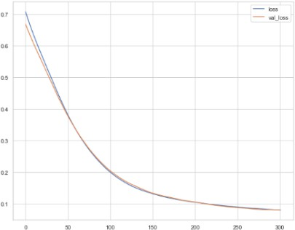

Figure 1. Validation Loss of proposed model

As we observe the training loss and validation loss both decrease and stabilize at a specific point, indicates an optimal fit, this is a model that does not overfit or underfit.

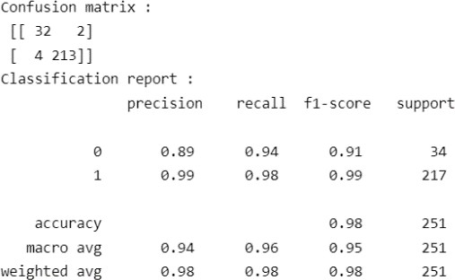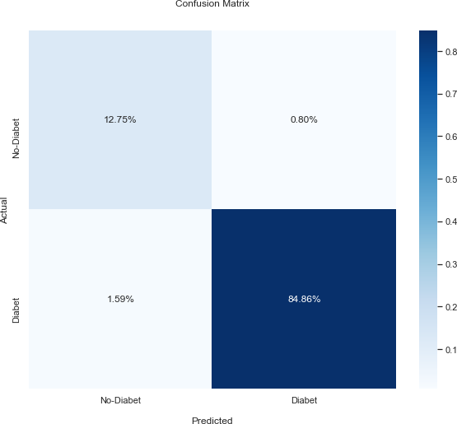

Figure 2. Classification Report for proposed model

As we can see model has average 98% of accuracy, 99% accuracy in determining diabetes and 89% in non-diabetes.

Proposition and further improvements: we propose to use more distributive data, representing more non-diabetes cases, changing structure of hidden layers, changing activation function.

**Conclusions.** In our research, we used neural network as deep learning method, which showed high accuracy. We used eight input instances and one output (CLASS) in the dataset. We used two hidden layers with ReLu activation function and sigmoid function for visible layer. Also, we used optimization technics. Model shows high results for accuracy, precision, recall, and F-measure. Model provided accuracy near 98%. We proposed further actions in this research, but definitely neural network can be an accurate choice in determining diabetes type 2.

**References:**

1. Ayon, Safial & Islam, Md. (2019). Diabetes Prediction: A Deep Learning Approach. International Journal of Information Engineering and Electronic Business. 11. 21-27. 10.5815/ijieeb.2019.02.03.
2. Diabetes Overview by WHO. URL: <https://www.who.int/health-topics/diabetes>.
3. Rashid, Ahlam (2020), “Diabetes Dataset”, Mendeley Data, V1, doi: 10.17632/wj9rwkp9c2.1
4. Riccardo Miotto, Fei Wang, Shuang Wang, Xiaoqian Jiang, Joel T Dudley, Deep learning for healthcare: review, opportunities and challenges, Briefings in Bioinformatics, Volume 19, Issue 6, November 2018, Pages 1236–1246, <https://doi.org/10.1093/bib/bbx044>
5. Symptoms & Causes of Diabetes by U.S. Department of Health and Human Services. URL: https://[www.niddk.nih.gov/health-information/diabetes/overview/symptoms-causes.](http://www.niddk.nih.gov/health-information/diabetes/overview/symptoms-causes)

## 1Alexei Gaivoronski

PhD, Professor, Department of Industrial Economics and Technology Management

## 2Vasyl Gorbachuk

DSc, Senior Scientist, Head of Department of Intelligent Information Technologies

## 3Maksym Dunaievskyi

MSc, Junior Research Associate, Department of Intelligent Information Technologies

## 4Seit-Bekir Suleimanov

MSc, Junior Research Associate, Department of Intelligent Information Technologies

1 *Norwegian University of Science and Technology, Trondheim*

2-4 *V.M.Glushkov Institute of Cybernetics, National Academy of Sciences, Kyiv*

# DIGITAL PLATFORMS TO DEAL WITH THE INFORMATION ASYMMETRY PROBLEM

**Abstract.** Market intermediaries coordinate the actions of buyers and sellers. Due to the centralized operation of the platform, the intermediary can add value and capture rents by facilitating the internalization of the externalities related with network effects. The characteristics of intermediaries must meet certain expectations of market participants.

**Keywords:** network effects, intermediated trade, self-selection, decentralized pricing, matching, big data.

To understand the choice of an intermediary, let us focus on the organization of exchange of products (goods and services) between sellers and buyers through the two extreme forms of intermediary exchanges, ignoring the other roles that intermediaries often play [1]. In one form of intermediary exchange, the intermediary acts as a dealer (retailer) in a sense it buys products from sellers and resells them to buyers: pricing is centralized by the intermediary. In the second form of intermediary exchange, the intermediary does not take control of the seller’s products, but simply offers access to a platform (or marketplace) where buyers and sellers can interact as they see fit: pricing is decentralized to market participants, and the platform taxes trade. The first form corresponds to a business model in which the dealer sets the wholesale price for sellers and sets the retail price for buyers, and sellers and buyers are price-takers. The second form corresponds to a business model in which the platform operator collects a platform usage charge from each seller and collects a platform usage fee from each buyer, and sellers set retail prices for buyers.

Firms carry out transactions, servicing the payment system, inventory control, and record keeping, which are important for the functioning of markets [2]. In addition, firms provide a central place of exchange, thus reducing the search costs for buyers and sellers. By comparing the costs of intermediation with the costs of non-intermediated exchange in the markets, matching buyers and sellers, or the costs of search, it can be shown that an intermediated exchange happens to be more beneficial. Indirect network effects on both sides of the market lead to the concept of so-called two-sided platforms [3]. In such a platform, the primary role of intermediary is to control access to the platform that at least two groups of economic agents use to their interaction. A similar

platform should be valued more by users of each group when the platform is used more by another group. Individual decisions to join a particular platform (including Platform as a Service (PaaS)) then generate indirect network effects on agents on the other side of platform [4].

However, in a multi-intermediary world, consumers and suppliers continue to incur search costs due to reacting to multiple intermediaries [5]. Consumers and suppliers discount future net gains due to monetization of search time costs. Consumers have different levels of willingness to pay, suppliers have different opportunity costs, and intermediary firms have different transaction costs. These firms set both bid prices and ask prices. Consumers look for firms that offer a lower purchase price, and suppliers look for firms that offer a higher sale price. Due to such heterogeneity and search costs, the market equilibrium is a distribution of sale prices and a distribution of purchase prices. This equilibrium depends on the discount rate of consumers and suppliers, for whom a higher discount rate stands for a decrease in activity (the number of active consumers and suppliers), while a higher discount rate means an increase in the activity of intermediary firms (the number of active firms): a higher discount rate increases the costs of time-consuming search for consumers and suppliers. Intermediary firms then raise their purchase prices and lower their sale prices because consumers and suppliers are willing to pay a premium to avoid further search, thus increasing the returns to intermediation for firms and stimulating growth in the number of intermediary firms active at the market equilibrium.

Thus, the discount rate determines the search costs. When this rate falls to zero, the search costs are eliminated and the relationships between the size of the bid-ask spread and transaction costs are revealed. Then the Walras equilibrium will be the limiting case of the intermediated market when transaction costs fall, and the supply and demand model can be considered an ideal case compatible with the market under consideration at the presence of search costs and price-setting firms. The cloud technologies are saving the general search costs.

**References:**

1. Khimich O., Ivlichev V., Malchevskyi I., Bespalov S., Pustovoit M., Golotsukov G., Shchetynin I., Nikolenko D., Ivanov S., Kirsanov V. A framework for the creation of distributed information technology to support the scholarly research and organizational activities of the NAS of Ukraine. *Science and Innovation*. 2018. 14 (1). P. 47–59.
2. Belleflamme P., Peitz M. Inside the engine room of platforms: reviews, ratings, and recommendations. *Economic Analysis of the Digital Revolution*. *FUNCAS Social and Economic Studies*. Vol. 5. J.-J.Ganuza, G.Llobet (eds.). Madrid, Spain: FUNCAS, 2018. P. 75−114.
3. Hagiu A. Merchant or two-sided platform? *Review of Network Economics*. 2007. 6 (2). P. 115–133.
4. Gaivoronski A., Gorbachuk V. The stochastic problem for cloud services. *Mathematical Modeling, Optimization and Information Technologies* (November 15–19, 2021, Chisinau (Moldova), Kyiv (Ukraine), Batumi (Georgia)). Chisinau: Moldova State University; Kyiv: V.M.Glushkov Institute of Cybernetics of the NAS of Ukraine; Batumi: Batumi Shota Rustaveli State University, 2021. P. 64−69.
5. Гайворонський О.О., Горбачук В.М., Дунаєвський М.С. Стратегічна взаємодія провайдерів диференційованих Інтернет-послуг. *Проблем управления и информатики*. 2021.

№ 6. С. 102−113.

## 1 Vladislav Gavryliuk

Student of the Master's Project Management Program

## 2Andrii Khlevnyi

PhD, Associate Professor of the Department of Technologies Management

*1,2 Taras Shevchenko National University of Kyiv, Ukraine*

# CREATIVE METHODS OF PROJECT MANAGEMENT

**Abstract.** In the current article the question of creative methods in object management, their importance and methods of application is covered. The main problem is the lack of documented methods for modern object management and search of information sources. In the context of the article highlighted the relevance of this topic and noted the role of creativity in managerial activity.

**Keywords:** creativity, methodology, object management, creative, competence, creative mortgage.

**Formulation of the problem.** Creative methods of approach despite modern trends of practice, a large number of project managers are often ignored project managers. Also known sources of information supply quite a small number of information that to such methods of implementation and approaches in projects. However, creativity is not only innovation and creativity, it is a constructive way of thinking. Creative thinking is a non-standard, original type of thinking that can lead to unexpected decisions or new discoveries. Creativity in business and management is an ability to adapt to new management styles, to change according to changing market conditions and needs.

**Setting objectives.** The main idea of this work was the search for creative methods and approaches. Also search for possibilities of development of creative technologies in modern realities of it-market. Study of peculiarities of implementation of such technologies in projects.

**Presentation of the main research material**. Recently, problems related to managing the creative potential of it project teams are actively discussed in the framework of various profile events and on the pages of periodic editions. The interest to the concept of creative management or creative approach in the solution of project tasks is conditioned by the fundamental importance of this category, from the conceptual conception of which the solution of key problems is expected both in the aspect of application in a particular project, and far beyond it – in the problems of other sciences and spheres of activity of society. The need for creative potential of it- specialists is often stated in many key competencies, which the employer stresses for the description of a particular profile vacancy. This is caused by the situation in the modern business space, when there is a significant increase in inventions due to scientific technological progress, and a passive and culturally limited person, an April, is not able to cope with the flow of information and requirements to it by the surrounding world.

The cost for lack of creative approach is to de-define and reduce productivity during the decision of project tasks. Project development consists of actions, and those

operations accordingly. If a procedure is carried out, you can imagine every step of it, or have a general idea of it. Creativity is a "black box", there is no idea of the mechanism of information processing in it.

Creative management is used to process large volumes of information, so it is very important to collect as much information as possible in the investigated area. This is a special condition of a person, in which its worldview, concerns, propensity do not influence the process of information processing. It is desirable to understand the nature of creative management as a perfect mechanism, an invariable, in which there is no need to add anything, development is subject only to the skills of its actual application. Developing in itself as a creative manager can be endless.

Creative team management is work with templates of creativity, the pursuit of creativity. There are "small" and "big" templates. The former have no direct practical benefit, but on their basis they form "big" templates, which are divided into relatively stable and unstable (created for each specific project).[11] Creativity is mainly used to form the style and form of presentation of the content. Creativity, unlike creativity, does not remove temporary limitations, but on the contrary, adds them to overcome some of the limitations, and begins to form together with the experience of general project management. Management of complex systems development (31 – 2017) ISSN 2219-5300 76 Creative approach in it projects management begins with search of own understanding and interpretation of project tasks, the accompanying information loses the objective limitation, attention of the project team to separate non-standard ideas or ideas. Accumulated information is consolidated, then compared with what is already known in the subject area, and when receiving a unique result may claim to define a creative product. [10]

It projects are the most risky, dynamic projects, characterized by a large number of problems, high stress and conflicts, often require solving unusual tasks, and statistics show only one third of them complete quite successfully. Introducing a creative approach to it project management, revealing and developing the creative potential of the project team is a necessary condition for solving problems and increasing the efficiency of it projects. Analysis of the latest research and publications Creative thinking and creativity are undoubtedly useful skills in modern project management. However, the literature still does not provide a comprehensive approach to the formation of a creative thinking team of the project, which would take into account the tools of project management in combination with methods of personnel management. It is from such group characteristics as degree of cohesion and efficiency, common vision of purpose and end result that creative activity and economic effect depend on it.

Over time, interest in improving processes in the team has made progress and on its basis a number of creative methods have been created which are quite often used in object management.

## Analysis of recent research and publications.

**Method of "mental maps" Tony Buzena**. Mental maps (diagrams of connections, intelligence-card, etc.) – It is a theory founded by Tony Buzenom, in which the creative process is closely connected with human memory and associated thinking. He proposed to write a key concept in the center of the sheet, and all useful

associations – on branches coming from the main word (or problems), around. Next, each association grows with its new association, which expands the possibilities of creating a new idea. Creating such a map helps to develop new social links, and the map image is much better remembered, especially in illustrated form. For creative thinking is especially convenient: On the left edge of the sheet we depict the point of departure, the problem to be solved, and on the right – the ideal solution. Then we will recreate the chain of actions that must connect the two starting points. As a result, a scheme is developed to determine the optimal line of behavior to achieve the goal. In addition, the scheme also shows intermediate tasks, which can be oriented in the creative process.

**The Smart Card** is a powerful graphical method that provides a universal key to unleashing the potential hidden in mind. The sociability of thinking is evidence that the process of processing information in our brain has a non-linear form. Arbitrary opinions never represent a string, direct, logical chain. They are as if spread in different directions from the central idea or image, cutting from one idea to another, "touching" all new associations, sometimes quite unexpected. As a result, the opinion often goes far in the direction of the original reference, leads to absolutely unexpected conclusions. The process of learning thinking, as a rule, leads to attempts to organize it, to make consistent and linear.

**Method of Edward de Bono "six hats"**. In this theory, the famous lateral thinking expert Edward de Bono shows his original approach, which allows to improve the mental process. The method of six hats of thinking is based on the fact that we can think six different ways.

The color key is defined to include the appropriate thinking mode, in which the team should be supported, arguing its position in the process of the discussion game:

* White is the focus of information (analysis of known facts and figures and an assessment of what information is missing and from which sources it can be obtained).
* Yellow - study of possible success, search for the benefit and optimistic consideration of the predicted events, ideas, situations.
* Black is an assessment of the situation in terms of shortcomings, risks and threats to its development.
* Red – attention to emotions, feelings and intuition. Failure in details and conversations, all the intuitive events are expressed at this stage.
* Green - search for alternatives, generation of ideas, modification of already existing work.
* Blue - management of the process of the discussion, make conclusions and discuss the use and effectiveness of the method in specific circumstances.

**Brainstorming** is a method of finding new ideas and solutions. The essence of it is that the participants announce as many variants as possible, in particular the most improbable, and then from all of them choose the best ideas or solutions which can be realized in practice.[8]

**Conclusion.** Thus, in modern realities, regardless of the effectiveness of the developed methods there are potentially many undocumented ideas that will help to

implement creative technologies in management processes that will solve many modern problems in the development of objects, or processes of product export and save enough amount of company finances. When analyzing information resources, it is possible to notice that the authors allocate improvement of productivity and interest of the working team in the project at introduction of creative methods. The use of such methods provides the possibility of psychological discharge among the staff and improved understanding of problematic places of members.

**References:**

1. Busuyev S.D. Creative technologies of project and program management: monograph

/ C.D. Busuyev. - K.: «Summit Book», 2010. - 768 p.

1. Creativity is the main quality of man in 21 century, 2020 URL: <https://vybor.zp.ua/?p=9802>.
2. Different thinking, 2010 – 2022. URL: <https://pidru4niki.com/15890315/psihologiya/riznovidi_mislennya>.
3. Publishing house "School World", 2020. URL: <https://osvitaua.com/2020/05/90099/>.
4. R. A. Semenova, Intellect, Encyclopedia of modern Ukraine, 2011. URL: [https://esu.com.ua/search_articles.php?id=12386.](https://esu.com.ua/search_articles.php?id=12386)
5. G. Gardner, Intelegence types, 2020. URL: [https://osvitoria.media/experience/9-typiv-](https://osvitoria.media/experience/9-typiv-intelektu-za-govardom-gardnerom-yakyj-u-vashyh-uchniv/) [intelektu-za-govardom-gardnerom-yakyj-u-vashyh-uchniv/](https://osvitoria.media/experience/9-typiv-intelektu-za-govardom-gardnerom-yakyj-u-vashyh-uchniv/).
6. K. Goncharenko, Not only IQ: 18 types of intelligence, 2021. URL: [https://budni.rabota.ua/ua/corporate-culture/ne-tilki-iq-18-vidiv-intelektu.](https://budni.rabota.ua/ua/corporate-culture/ne-tilki-iq-18-vidiv-intelektu)
7. A. Grinyova, What is brainstorming, 2021. URL: [https://happymonday.ua/shho-take-](https://happymonday.ua/shho-take-mozkovyj-shturm) [mozkovyj-shturm.](https://happymonday.ua/shho-take-mozkovyj-shturm)
8. Maindmepping: How to memorize more with mental maps, 2020. URL: <https://www.yuzhbud.news/majndmepping/>.
9. A. A. Vojtushenko, Concept Of Creative Potential In The Field Of Project Management, 2019. URL: [http://urss.knuba.edu.ua/files/zbirnyk-37/4.pdf.](http://urss.knuba.edu.ua/files/zbirnyk-37/4.pdf)
10. K. V. Kolesnikova, Creative Project Management Techonologies, 2019. URL: [https://moodle.fit.knu.ua/course/view.php?id=200.](https://moodle.fit.knu.ua/course/view.php?id=200)

## 1 Yulia Guzhva

Student

## 2 Viktor Morozov

PhD, Professor, Head of the Department of Technologies Management

*1,2 Taras Shevchenko National University of Kyiv, Ukraine*

# PROJECT MANAGEMENT OF THE DEVELOPMENT OF THE WEB PLATFORM TO PROVIDE PSYCHOLOGICAL AND CAREER GUIDANCE SUPPORT "MY FUTURE CAREER"

**Abstract.** The article describes the problems of providing psychological and career guidance support to schoolchildren and proposes their solution by developing a web platform for providing online consulting services.

**Keywords:** System, psychology, career guidance, IT project, web platform, Kanban*,* Agile.

## Introduction

One of the results of each person's life is the choice of a future profession, because this choice will be a decisive factor in the formation of a social personality. The most people experience certain difficulties in choosing a future profession and how to master it, and therefore the need for a conscious choice of profession is of the greatest value in adolescence and young adulthood, when certain processes of personality formation take place. psychological qualities, including abilities, interests, value orientations, aspirations, professional plans, ideals, beliefs. It should be noted that when choosing a profession, a person first of all needs psychological help, since he can acquire certain information of a professional nature on his own.

Solving a set of problems related to the organization, mental support and information support of the process of professional self-determination of an individual requires making changes in shifting the center of attention to the provision of psychological support [2].

## The aim of the research

The purpose of the work is the development and planning of the implementation of the web platform service for the comprehensive training of future graduates "My future career", which will contribute to the maintenance of the psychological health of schoolchildren and help in determining a profession and a higher educational institution, regardless of their location.

## Basic material

"My Future Career" web platform consists of:

* + Functionality of the user: a personal office with a schedule and work plan, homework completion, storage of educational materials. Implementation on the platform of video communication with course teachers, chat with the curator and communication with technical support. Creation of a blog with constant updating of thematic information for users.

The system provides an opportunity to leave feedback regarding the course or consultation. The user has the opportunity to edit personal data set up notifications, change the language from 5 possible: Ukrainian, English, Polish, German, French.

* + Functionality for teachers: checking homework and feedback to the student, conducting a lesson broadcast, uploading educational materials, developing a study schedule.
  + Functionality for the administrator: management of the payment system, addition and removal of students from the group, formation of financial reports, reports of learning processes.

4 products: "What should I know about myself?" Course, "What Should I Know About Myself" Premium Course Including Counseling, "Choice of a profession" Course, "Choice of a profession" Choice Premium Course including counseling.

The course "What should I know about myself?" includes the following topics: how to cope with anxiety and stress; emotional intelligence, the importance of mental health and self-care, how to support a loved one, the importance of family in a person's life; spiritual development; the past and how it affects the future; main personality types; self-defense, etc.

The premium course to the basic course includes counseling with a psychologist. The course "Choice of a profession" deals with topics: career strategies, which myths teenagers face when choosing a profession; what do we actually choose when we talk about a career; what are the stages of choosing a profession and what career strategies exist; what is currently happening in the labor market and what teenagers need to know and be able to be successful; working with professional interests and tasks that we want to solve in the profession and performing a practical test; acquaintance with the main professional areas and professions within them, the practical task of finding several options for professions that may be interesting; self- esteem; work with "NO"; different classifications of strengths; tests that help determine a teenager's strengths; analysis of the degree of application of one's strengths in the desired direction; 8 main career values, testing to determine personal values, their

correlation with desired professions, etc.

The premium course "Choice of a profession" includes counseling with a career pathologist.

## Conclusions

System development requires a long time and a team of developers. The project development workflow will be managed using the Kanban methodology, which is part of the Agile philosophy. Development according to the Kanban system is one of the most popular for both small and large projects due to its focus on tasks, namely: reducing the number of simultaneously performed tasks and reducing the time for each task, flexibility in decisions made and the frequency of changes in priorities, close interaction between by all team members. The scientific value of the given method lies in the increase efficiency and improvement of existing methods of software development organization [3].

In the future, if the project is successfully implemented, it is possible to create a web and mobile application based on the developed system.

Thus, the use of the system is possible regardless of the location of the user. The user receives a result from a new comprehensive approach to providing advice, which solves the following problems: spending a lot of time searching for information; low efficiency of the time used to solve the child's problem; feedback; work with psychological injuries of a child; location dependence; not understanding one's own desires, fears, beliefs.

The school provides a working career guidance system. The state more effectively uses budget expenditures for state procurement of universities. Labor productivity increases, high staff turnover decreases. Young people don't waste time learning professions they will never work for.

**References:**

1. PMBOK Guide. URL: https:/[/www.pmi.org/pmbok-guide-](http://www.pmi.org/pmbok-guide-) standards/foundational/PMBOK
2. CURRENT STATE AND PROBLEMS OF VOCATIONAL GUIDANCE OF YOUNG PEOPLE IN UKRAINE AND CANADA/CONTINUING PROFESSIONAL EDUCATION: THEORY AND PRACTICE (SERIES: PEDAGOGICAL SCIENCES) ISSUE № 3-

4 (56-57), 2018. URL:

https://elibrary.kubg.edu.ua/id/eprint/36854/1/N_Oshurkevych_Z_Potikha_NDLOSV_2018_3- 4_NPO.pdf

1. Kyrychek H.H., Chubich A.I. KANBAN-METHOD USE FOR SOFTWARE DEVELOPMENT ORGANIZATION. Url:

<http://www.tech.vernadskyjournals.in.ua/journals/2020/6_2020/part_1/15.pdf>

## 1 Hanna Hazun

Master student

**2 Viktor Morozov**

PhD, Professor, Head of the Department of Technologies Management

*1,2 Taras Shevchenko National University of Kyiv, Ukraine*

# AUTOMATED STAKEHOLDER MANAGEMENT SYSTEM

**Abstract.** The project of creating an automated stakeholder management system solves the actual problems of technology companies. The system allows you to manage teams and communication, as well as track the main indicators of projects in real time. **Keywords:** System, Management System, stakeholder management, Scrum,

Jira, project, IT project, analytics, automation, communication.

The project to create information technology should meet the needs of the modern market. The project should be relevant, solve the basic needs of companies, and be built based on modern project management approaches. Creating an automated stakeholder management system enables managers and senior management to manage the company and teams effectively.

The automated system should include two main types of stakeholders in project management, internal and external. Internal stakeholders are people or groups in a business, such as team members, managers, executive. External stakeholders are people or groups outside the business. These usually include customers, users, suppliers, and investors.

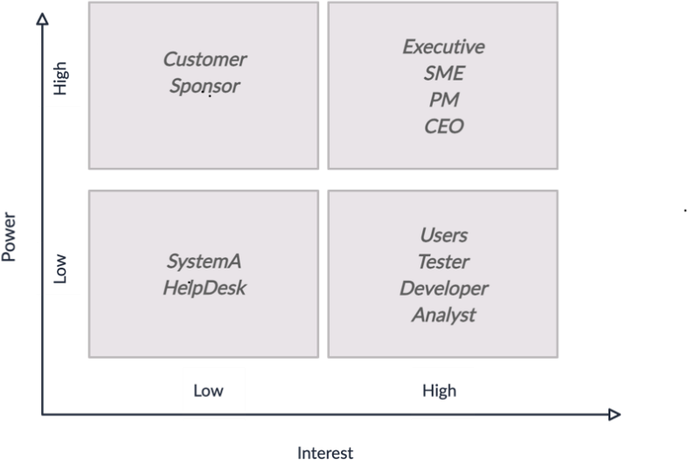

Figure 1 - Stakeholder influence

There are already systems on the market for organizing the work of companies based on Scrum and Agile. For example, IT companies often use Jira to track current tasks within the Scrum circle. All modern programs help manage specific sections of the project. However, only some products are adapted for use at all stages of the project life cycle, so creating an automated stakeholder management system is a compulsory need for companies.

The next essential step at the stage of preparation for the project development is to compile a list of all those interested in participating development and implementation of the project. Involving stakeholders in the project's development helps to determine the information that will be used and reduce unreasonable costs. Stakeholder analysis should be carried out at every project development and implementation stage.

Priority and separation of stakeholders by the level of influence allow us to analyze time constraints. For example, lower-level stakeholders communicate within the team, and practical interaction increases according to the stakeholder's influence on the organization's business goals.

The IT product's parameters must meet the project's requirements and be constantly checked. Creation a unified management system, it is necessary to determine all indicators, project duration, financial resources, and human potential. All changes must be documented and justified.

A unified stakeholder management system includes working with all departments and teams of the company. Its main advantage is its versatility for the personnel department, development team, testers, management, analysts, customer service department, and senior management.

Creating an automated system will improve the quality of management of all stakeholders in the company. Stakeholder management systems are fundamental to management processes. Project analytics provided by the system allows understanding of the organization's positioning better and therefore improve the speed of response in the short term and more sound strategic planning in the long term.

Consequently, creating an automated stakeholder system helps project managers and teams understand a difficult situation and manage and communicate with stakeholders effectively, allowing them to concentrate resources where the maximum benefit will be obtained. As a result, the team receives a tool for practical work throughout the entire project life cycle.

**References**

1. Cooper, D. G., Edgett, D. J., & Kleinschmidt, D. J. (2000). New problems, new solutions: Making portfolio management more effective. Research Technology Management, 43(2). [[http://www.stage-gate.net/downloads/working_papers/wp_09.pdf](http://www.stage-gate.net/downloads/working_papers/wp_09.pdf)]
2. Morgan, M., Levitt, R. E., & Malek, W. A. (2007). Executing your strategy: How to break it down and get it done. Harvard Business School Publishing.
3. Seeber, J. (2011). Project selection criteria: How to play it right. International Project Management Association. [[http://www.ipma-usa.org/articles/SelectionCriteria.pdf]](http://www.ipma-usa.org/articles/SelectionCriteria.pdf)
4. SHRM. (2022). Practicing Strategi Human Resources. [https://[www.shrm.org/resourcesandtools/tools-and-](http://www.shrm.org/resourcesandtools/tools-and-) samples/toolkits/pages/practicingstrategichumanresources.aspx]
5. Bigelow, B. (2011, 22 October). Scope – mastering the fuzzy constraint [Paper presentation]. PMI Global Congress 2011, Dallas, TX, United States. [https://[www.pmi.org/learning/library/scope-understanding-change-perspectives-managing-6177]](http://www.pmi.org/learning/library/scope-understanding-change-perspectives-managing-6177)
6. OptiSol. (2015, February 23). What is the scope creep in agile development? [https://[www.optisolbusiness.com/insight/what-is-scope-creep-in-agile-development]](http://www.optisolbusiness.com/insight/what-is-scope-creep-in-agile-development)

## 1 Hrygorii Hnatiienko

PhD, Deputy Dean of the Faculty of Information Technology

## 2 Snezhana Gamotska

Assistants of the Intellectual Technologies Department

## 3 Oksana Vlasenko

Postgraduate Student of the Faculty of Information Technology

## 4 Ravshanbek Zulunov

PhD, Associate Professor, Department of Software Engineering

*1-3 Taras Shevchenko National University of Kyiv, Ukraine*

*4 Ferghana Branch of the Tashkent University of Information Technology, Uzbekistan*

# THE PROBLEM OF CONSTRUCTING THE RANKING OF OBJECTS ON THE BASE OF MULTIPLE COMPARISONS FOR THE COOK METRIC

**Abstact**. The task of determining the ranking of objects, i.e. constructing a linear order, based on multiple comparisons of fixed-length objects specified by experts, is considered. The task has a wide practical application and in the future can be successfully implemented in various spheres of human activity. To formalize the problem, the object rank mismatch metric is used, which is sometimes called Cook's metric. When determining the resulting ranking, it is proposed to use different heuristics that reflect different approaches to understanding the optimality of the resulting ranking.

**Keywords**: object ranking, linear order, multiple comparisons, rank mismatch metric, team, leader

**Introduction.** Many practical life situations do not require a formal straightforward solution, but can be successfully solved by applying special procedures. Such procedures smooth out the initial problem, pre-harmonize the views of different experts on possible solutions to the problem, and thus prepare the team of experts for a compromise solution. The specified procedures cannot be spontaneous or introduced by a spontaneous and volitional method. They should be prepared in advance, formalized, substantiated and researched.

**Setting of the problem.** Let *k* the experts carry out a preliminary examination of some *n* projects, objects or applicants for a position from the plural *A* . According to

the terms of the examination, the members of the team (TM) at the first stage should

set multiple comparisons (MP) *ν* of objects, and *ν*  *n* . An additional requirement

may be a fixed value for all experts. The upper limit of the value is determined by the psycho-physiological capabilities of a person. It cannot be greater, for example, than 9, given the Miller number 7  2 .

We will denote that the subset of applicants selected by the *i*  th TM, on which the

*i*

TM establishes the order relation in the form of MP, by

*Aν* ,*i*  *I*  1,..., *k*,

*ν*  *n* .

Note that at the initial stage, the number of Cheka and the number of objects coincide:

*k*  *n* . Without reducing the generality, we will assume that



...

*a j*

*j*

*i*2

...

*a* ,

*iν*



*Aν*  *a j*

*j i*1

(1)

for all TM: *j*  *I* .

Such a procedure can be considered as an intermediate stage in the transition from informal leadership, that is, the process of influencing the team with the help of one's abilities, skills, to the formal one – the process of influencing people from the position of holding a position. That is, as a result of such elections, a person combines two aspects and becomes a leader:

* a person who is recognized by the TM as having the right to take the most responsible decisions that affect their interests;
* the person who is officially entrusted with the functions of managing the team and organizing its activities;
* a person recognized by the group as authoritative, who enjoys recognition and authority in the group.

It is necessary to find the resulting ranking of alternatives, consistent with the given MP of the experts, taking into account the metric of the mismatch of ranks and various criteria. That is, it is necessary to find a reasoned order that is closest to the given expert MPs.

Such approaches can be applied in problem groups. The purpose of the procedure of preliminary ranking of objects can be:

* minimization of the level of conflict that is brewing or has already entered an active stage;
* a soft check of the level of support of potential leaders in the team
* assessment of existing groups in the team, i.e. structuring its polarity and thus obtaining more information about the team, distribution of sympathies of the Cheka, popularity and number of leaders, etc.;
* determining the competence coefficients of the TM, and it is obvious that the experts with the greatest relative competence are the most realistic and can be directly involved in the resolution of the conflict.

**Characteristics of the team.** Note that a team is a set of people united by common activities, common interests, a declared common goal, or to focus their efforts on a project. The collective, in which the preliminary survey is carried out, is characterized by the following factors:

* existence of a common goal;
* regular joint activity aimed at achieving the goal;
* availability of formal and informal leadership;
* the presence of established industrial and psychological relations between the TM.

In this regard, it is necessary to additionally note the features of the preliminary rating:

* all TM know each other;
* the evaluation of the applicants of the TM is reliable;
* each individual evaluation of the TM reflects not the qualities of the candidates for the position, who are elected, but the attitude towards the leaders

At the same time, do not focus on the negative and do not organize anti-leadership polls.

**Formalization of the task of determining the resulting ranking.** The most common method of finding the resulting ranking of alternatives is to calculate the median of the given rankings. This group of methods of summarizing expert

information is the most reliable and mathematically based. The solutions of the problem, which are determined by applying different metrics and different criteria, are the medians of the linear orders given by the experts. In particular, this is due to the fact that the theory of measurement provides for the definition of average values in the form of medians for ordinal scales. Therefore, the methods of middle ranks, etc., in such cases look at least approximate and doubtful: they cannot provide confidence in the adequate selection of the leader.

If you use point scoring to solve this problem, there will definitely be a deviation, because all the TMs are interrelated. After all, the organization is a living organism, and indirectly, the opinions of each TM are not autonomous. Therefore, evaluating possible applicants in points would mean not taking into account, destroying the relationships between TM.

In such cases under consideration, instead of point evaluation, ratio evaluation is used in the form of:

* matrix of pairwise comparisons between objects;
* object rankings;
* multiple comparisons between objects;
* incomplete rankings on multiple objects.

**Prerequisites to use.** For the successful application of the proposed procedure, some preliminary requirements should be established.

In particular, the confidentiality and, at the same time, the authenticity of individual MPs should be ensured in order to protect against falsification of results. Maybe you should use hash tables for this.

It is also necessary to introduce heuristics for aggregating (smoothing) individual MPs.

Heuristics E1. The team exists, it is one. That is, the graph that corresponds to the preferences of the TM, revealed on the basis of the previous vote, although this does not exclude the situation of polypolar leadership.

On the basis of given individual MPs, the union of subsets of applicants who got into MPs of type (1) is determined

*A*

*j*

*Aλ*  *A*,

*j**I*

*ν*  *Aλ*

 *A*,

(2)

Definition Let us call the core of leaders of the organization (team) a subset

*Aλ*  *A*,

of the initial set of TM *A* . Such a statement is fair.

Assertion. Only the kernel of type (2), i.e., the union of subsets of applicants, remains for selection and ordering. Sympathies of the TM to other applicants who are not included in the subset (2) do not affect the selection and ordering.

Even after the domain of admissible solutions is narrowed down to a subset of (2),

the problem is NP-hard, so finding *n*  10 its solution is problematic. If the selected

core of leaders remains large, it is allowed to narrow the core at the expense of those applicants who received support, for example, less than 1-3 votes of the TM. Thus, the computational complexity of the problem is reduced.

Heuristics E2. The least popular candidate figures may be removed from the final

subset

*Aλ*  *A*,

without significant impact on the final decision.

**Approaches to determining the resulting ranking of objects.** Distances between the rankings of alternatives are determined using Cook's metric of dissimilarity of ranks (places, positions) of alternatives,

*d* *R j* , *Rl*   *r j*  *rl* ,

(3)

*i i*

*i**I*

where

*rl*  is the rank of

*i*  th alternatives in the ranking of the

*l*  th TM, ,

*Rl* ,

*i*

*l*  *L*,

1  *rl*

 *n*.

The Cook metric (3) is popular in alternative ranking problems. To use it in solving the task of analyzing incomplete rankings, we will introduce heuristics and, based on them, determine the distances from the rankings given by experts to the reference ranking. To determine the agreed ranking of candidates, we will introduce additional heuristics.

*i*

Heuristics E3 (maximum satisfaction of desires). Meaning I want all my objects to become winners in the order I specified. Plus the desire to win as much as possible.

Thus, the desire of each expert appears to be utopian. But given the fact that they are all in the same conditions, the situation is not so idealized.

Let the conditions of the previous (rating) vote determine that *ν*  3 the TM set



*ai*

2

*ai* ,

3

the MP in the form

*a*

1

*i*

where

*i*1 , *i*2 , *i*3  *I*.

Then it is easy to see that when in the options from which a certain ranking is chosen, depending on the sequence of indexes of the objects of the same triple, it is possible to determine the distances for choosing a compromise ranking.



...

*ai*

3

...

*ai* ,

2



...

*ai*

1

...

*ai* ,

3

For sequences

*a*

1

*i*

and

*a*

2

*i*

distances are

equal to 2. For sequences



...

*ai*

2

...

*ai* ,

1

*a*

2

*i*

*a*

3



...

*ai*

3

...

*ai* ,

1

*i*

and

*a*



...

*ai*

1

...

*ai* ,

2

*i*

3

distances are equal to 4.

*l*  1 *rl*

*d*

*i*

*M*

1

* 2  *rl*

2

*i*

* 3  *rl* ,

3

*i*

*l*  *I*.

Heuristic E4 (moderate reciprocity). That is, each TM in conditions of fair voting understands that not everyone can be a winner, that the probability of satisfying all wishes is negligible. Moreover, not one can be defeated, but at least the individual order set by each TM should be preserved: it is important for victory.

In this case, the distance from the given individual MPs to the resulting ranking



*a*0

*i*2

... *a*0 ,

*iν*

*R*0  *a*0

*i*

1

is determined as follows:

*d l*  *r*0  *rl*

* *r*0  *rl*
* *r*0  *rl* .

*l*  *I*.

*V i*1 *i*1

*i*2 *i*2

*i*3 *i*3

**Conclusion.** Thus, a preliminary rating voting procedure for collectives consisting of several dozen members is proposed and studied. This task has been formalized and additional heuristics have been introduced to substantiate the approaches that will be used to determine the resulting ranking of job applicants.

## Oleksii Hnatiienko

Postgraduate Student of the Faculty of Information Technology

*Taras Shevchenko National University of Kyiv, Kyiv, Ukraine*

# WEB APPLICATION FOR ENSURING THE COMMUNICATION BETWEEN ELEMENTS OF THE ORGANIZATIONAL SYSTEM

**Abstract.** Web application «Resilience» is described. The software was created by the author in order to ensure stable and quick communication between elements of the organizational system. Forehand informing of relevant services of the organization regarding the state of the system`s elements, occurrence of emergencies, etc. allow to make quality decisions about system reconfiguration on time. Thus, procedures that are replacing executors of specific functions are starting off and ensuring the functional stability of the organizational system.

**Keywords**: functional stability, stable communication, address awareness, decision-making, reconfiguration

**Introduction.** Ensuring the functional stability of the organizational system is the problem of current interest [1]. At the same time, such factors as the efficiency of information exchange between the relevant elements of the system and the correspondence of the information environment that accompanies the system to its real state play an important role.

Thereby, the performance of the operating system and its elements, as well as their response to the changes of environment have to come up with adequate, precise, univocal display in the informational support of the system.

**Formulation of the problem.** For a forehanded and qualitative display of the state and the nearest perspectives of the functioning of the system elements, it is essential to create an appropriate toolkit of operational notification. This toolkit should be scalable to all elements of the system. As a result of the implementation of this software in the system of communications between the elements of the system, the need to promptly inform the relevant services of the organizational system must be implemented as well as notification of the direct management of the system elements and their functional management about the nearest plans of the system element. Herewith, the information must be displayed only in cases when deviations from established procedures appear and bring the danger of the negative impact on the normal functions of the elements.

## Justification of the development and use of the web application

**«Resilience».** It is essential that usage of the web application can bring the same effectiveness in each and every organizational system. The appropriate corporate culture that is maintained in the organizational system plays the main role in creation, implementation and exploitation of the web application. Applying of the web application should also be accompanied by described and implemented procedures, formalized business processes, etc. Also, stuff of the organization should be motivated

to strictly follow the procedures related to the use of the web application «Resilience» on a regular basis. Only in this case, the use of such a tool will be effective and efficient.

**Purpose of the web application.** The creation of a web application was motivated by many reasons. In the case of the vigorous activity of a large organization, there are always employees who at every current moment:

* are on sick leave, on vacation, on business trips;
* are absent for unknown reasons;
* have officially taken time off or are unofficially on time off;
* violate labor discipline;
* absent due to force majeure;
* are forced to move due to family circumstances;

In all these cases, the timely informing of the management and relevant services of the organizational system can be effectively fulfilled thanks to the developed web application.

In the current version web application was developed in the first place with the next aims:

* prompt informing of target officials about personnel plans;
* advance semi-official notification by subordinates of their direct management;
* creation of a local informational environment for cross and preventive informing of interested persons about the nearest likely states of some elements of the organizational system;
* prediction of possible changes in the activity of system elements;
* informing about deviations from the standard procedures of system operation;
* transmission of information about the location and changes in the location of staff;
* minimization of uncertainty associated with deviations from the standards of actions of some elements of the system.

Such informing allows to provide the system with options for a justified redistribution of functions in order to maximize the quality of the functioning of the organizational system [1] by generating options for replacing executors. At the same time, some elements of reconfiguration [2, 3] of the organizational system can be implemented. It means that automated partial restructuring of the information exchange structure or a change in operating procedures can be implemented in the system in order to increase the efficiency of the system's functioning on its available working resources.

**Features of the web application.** Various options for providing a set of functions were considered before creation of the web application; all of them were implemented to improve the sustainable functioning of the organizational system. Firstly, all available applications of today`s market were analyzed: Facebook Messenger, Viber, standard document flow automation systems, Slack, etc.

But such systems are multifunctional, difficult in implementation or in usage.

Therefore, it was decided to develop a standalone web application.

The web application «Resilience» was developed with the no-code platform Thunkable.

For now, the web application «Resilience» is PoC (*Proof of concept),* so it is developed to the level of the concept check. In addition, «Resilience» is a demonstration application of the system that provides an object with information about other surrounding objects. The first page of the application contains two buttons and a text field. The user data is provided when the page is open for the further provision of any information about the user that is to be exchanged in the system. After the user clicks the button “Confirm”, the input name, coordinates, and current time are transferred in the database and the next page opens. The next page contains a text field with the username, map and the button “Update”. When a user goes to this page, the information about other users who have recently used the application gets from database. When clicking on the "Update" button, the user data is re-collected and updated in the database, as well as the updated data about other objects are read from the database and displayed on the map.

**Prospects for improving the web application.** In future the improvements of the web application are planned by updates in such areas:

* decreasing the size of the required disk space for the operation of the application;
* addition of a menu for some expansion of functions, as well as the possibility of setting recipients: recipient's last name, department, HR department, manager, etc.;
* ensuring logging of all actions and information received from user applications.

**Conclusions.** A simple and convenient tool for a user and system manager was created in order to maintain quick communication between the elements of the organizational system.

**References:**

1. Hnatiienko O.H., Kuchanskii O.Y conception Hnatienko O.H., Kuchanskyi O.Yu. The concept of building a system for ensuring the functional stability of the enterprise using relations in ordinal scales // Applied systems and technologies in the information society: a collection of theses of reports and science messages of participants of the VI International Scientific and Practical Conference (Kyiv, September 30, 2022) / by general edition V. Pleskach, V. Zosimov, M. Pyrog - K.: Taras Shevchenko National University of Kyiv, 2022. - P.99-104.
2. Oleksandr G. Dodonov, Olena S. Gorbachyk, Maryna G. Kuznietsova Dynamic Reconfiguration in Automated Organizational Management Systems// Selected Papers of the XX International Scientific and Practical Conference "Information Technologies and Security" (ITS 2020). CEUR Workshop Proceedings (ceur-ws.org). - Vol-2859 ISSN 1613-0073. URL: [http://ceurws.org/Vol-2859/paper13.pdf.](http://ceurws.org/Vol-2859/paper13.pdf)
3. Oleksandr G. Dodonov, Olena S. Gorbachyk, Maryna G. Kuznietsova Automated Organizational Management Systems of Critical Infrastructure: Security and Functional Stability // Selected Papers of the XXI International Scientific and Practical Conference "Information Technologies and Security" (ITS 2021), Kyiv, Ukraine, December 9, 2021 / CEUR Workshop Proceedings, 2021, 3241, pp.1-12.

## 1 Vladyslav Hnatiienko

Master’s student of the Faculty of Information Technology

## 2 Hrygorii Hnatiienko

PhD, Deputy Dean of the Faculty of Information Technology

## 3 Victor Yermak

Master, CEO

## 4 Oleksandr Zozulia

PhD, Head of the group of regional technical experts

*1-2 Taras Shevchenko National University of Kyiv, Ukraine*

*3 Skyglyph*

*4 Ltd «Syngenta»*

# PROBLEMS, FEATURES OF SOFTWARE IMPLEMENTATION AND DEVELOPMENT PERSPECTIVES OF SOME PROBLEMS OF DIGITAL AGRONOMY

**Abstract.** Some areas of improvement of digital agronomy tasks and features of creation of appropriate software are considered. Taking into account the world food crisis caused by Russia's war against Ukraine and other factors, the specified direction of research becomes especially relevant. If this problem is not solved comprehensively, by all available methods, the threat of hunger is deepening before the world.

**Keywords:** global food crisis, digital agronomy, crop losses, pattern recognition

**Introduction.** According to the Food and Agriculture Organization of the United Nations (FAO), compared to the level of 2010, global food production should increase by 70% by 2050.

The year 2022 has seen growing crises in various parts of the world, which have been caused by geopolitical, economic and natural causes: extreme heat, floods and droughts caused by climate change. These challenges are compounded by supply chain disruptions and exacerbated by the COVID-19 pandemic.

After the start of the Russian invasion of Ukraine in February 2022, a collapse in food supplies and an increase in prices naturally occurred. Wheat prices jumped to their highest level since 2008 in reaction to the 2022 war. At the time of the invasion, Ukraine was the fourth largest exporter of corn and wheat and the largest exporter of sunflower oil in the world.

**Digital agronomy.** One of the ways to increase yield and fight hunger in the world is the use of digital agronomy - the use of indirect methods of measuring physical quantities, which are then converted into agronomic (biological) indicators based on correlation dependence.

Digital agronomy is characterized by obtaining various agronomic parameters (availability of nutrients, soil parameters, state of plant development, moisture availability, etc.) by finding a correlation between the measurement of various physical indicators (electrical voltage, light spectrum, temperature and moisture, etc.) and indicators that use in agriculture.

The main source of data for digital agronomy is the use of aerial vehicles or artificial Earth satellites. Moreover, the use of satellites is one of the elements of a multi-vector system for monitoring agricultural crops. After all, without a combination with a ground mission, it is impossible to perform a full assessment of the condition of agricultural crops. At the same time, there are many devices, using which you can quickly obtain the values of individual parameters of the condition of plants, soil, etc. These parameters are chlorophyll activity, pH, availability of nutrients, density, soil moisture, and many others.

**Formulation of the problem.** Let there be a set of data characterizing the state of maturity of some field K1. It is also known that retrospective data on the yield of this K2 field in previous cropping seasons. As a result of the data analysis of the K1 and K2 fields, it is possible to determine some dependencies and what the yield was in each plot, for which certain index values are known. The reason for the difference between yields on plots with different vegetation indices is that the harvester is adjusted to the harvesting maturity of the main massif before starting work, without taking into account the mass of small plots that have other indicators. But this unevenness in ripening can be leveled with the help of special drugs. But to determine how expedient it is to use them is already possible to understand the possible volume of crop losses.

On the basis of these data, the task arises to obtain an estimate of possible losses that occurred as a result of uneven ripening of grain in a specific field. The task follows from this - based on the evaluation of the unevenness of ripening, understanding the area under the plots with different levels of ripening, to determine the potential losses of the crop sown in the field.

Based on the results of solving such a problem, it is possible to better predict crop losses. But it should be noted that in order to increase the yield of agricultural crops at this stage, the management has rather limited management capabilities. Solving the mentioned problems will allow to more accurately determine the moment of harvesting, as well as to reasonably choose the level of adjustment of agricultural machinery.

**A mathematical model of an effective research tool.** For such crops as sunflower, rapeseed, wheat and some others, an agronomic technique called desiccation is traditionally used. It consists in the fact that a special drug is introduced that accelerates ripening and dries the plants. But the drug itself and its introduction are accompanied by additional costs. Therefore, it is important for the farmer to understand whether such costs are justified, because it may happen that the potential losses are much higher than the costs of applying the drug.

Neither individual plant protection products nor their systems increase crop yield. They only make it possible to preserve and reduce the loss of what was laid in the genetics of seeds, the fertilizer system, the soil treatment system, natural fertility and so on. And far from always, effective protection at the beginning of the growing season cannot be leveled by subsequent agronomic errors or weather conditions.

To build a mathematical model for determining the dependence between the indexing map K1 and the yield map of the same field K2, we will introduce some notations for the neural network and the parameters of this network.

Input parameters:

*p*0  seed moisture in the recording area, %;

1

*p*0  seed moisture "On a circle", %;

2

*p*0  the number of frames involved in the experiment, pcs.;

3

*p*0  field area, ha;

4

*p*0  % of the field area;

5

*p*0  index value;

6

*p*0  average field index from FarmShots. Output parameters:

7

*p*1  yield kg per hectare from the field;

1

*p*1  total weight of seed losses from frames, grams;

2

*p*1  losses per 1 ha, kg;

3

*p*1  % losses from productivity per hectare;

4

*p*1 losses from the field, kg.

5

Let us denote the neural network dependence between the cultivated crop and vegetation indices, which can be determined remotely, through

*M*  *p*0 , *p*1 ,

*i j*

*i*  1,..., 7 ;

*j*  1,..., 5 ,

where

*p*0,*i*  1,..., 7

is the set of input parameters,

*p*1 , *j*  1,...,5

is the set of

output parameters of the neural network.

*i*

*j*

Therefore, the task of determining the dependence between data sets that correspond to the field with indicators presented on the map K1 and the same field with indicators presented on the map K2 can be formalized as follows:

*M*  *p*0 , *p*1   max , (1)

*i j*

*p*0  *P*0,*i*  1,..., 7 ; *p*1  *P*1, *j*  1,...,5 , (2)

*i*

*j*

where

*P*0 is the set of admissible values of the input parameters, is the set of

admissible values of the output parameters.

The objective function of type (1) reflects the neural network dependence between the input data, which was reflected on the K1 map, and the output data, which was obtained as a result of the study of the harvest results and was reflected on the K2 map. A constraint of type (2) is a naturally given set of admissible values of the input and output parameters of the mathematical model.

**Features of information support.** When solving the problem of yield maximization, problems arise already at the stage of modeling and information provision. In particular, the tasks of digital agronomy are accompanied by a number of limitations: there is not enough data, the formulation of the task is blurred, the priorities and dependencies are not fully understood, it is not possible to conduct a sufficient

number of experiments, the methods of recording crop losses are imperfect, the research results are incomplete, as they are based only on experiments, due to the ubiquitous human factor, the results of experiments may not fully correspond to reality, etc.

Compared to biological models, mathematical models look too crude and primitive. This is due, in particular, to the fact that the population is a collection of complexly organized individual organisms. In turn, each organism consists of organs, tissues and cells, carries out metabolic processes, moves, is born, grows, reproduces, ages and dies. And each living cell is a complex heterogeneous system, the volume of which is delimited by membranes and contains subcellular organelles and so on, up to biomacromolecules, amino acids and polypeptides. It is clear that for such systems any mathematics gives only a grossly simplified description.

Therefore, in many publications devoted to the remote study of the earth's surface, the need to conduct ground-based research is indicated, and the obtained various indices are the basis for building a plan for field research. In the process of analyzing index maps, it is possible to determine zones in which plants have deviations in some parameters (intensity of photosynthesis, development of biomass, etc.). Analyzing these data, it is possible to determine the number of points of sampling or survey, their coordinates on the field. This improves the quality and accuracy of the examination, makes it possible to determine the level of the problem, and determine their location.

**Features of software implementation.** It was decided to use the Python language to train the neural network for the implementation of model (1)-(2). The program is written in Python, as this programming language contains a large number of libraries for the development of artificial intelligence and data analysis. Thanks to this, it is easy to write simple and understandable code in python, despite the complexity of the tasks that arise during the development of artificial intelligence systems.

In this work, a simple fully connected neural network was used to quickly check the presence of connections in the data and obtain approximate results. First, simplified tasks were considered to demonstrate the need for a high-quality dataset - without it, the model cannot be fully applied. It is clear that regardless of the quality of the model, it is impossible to get good results from incorrect data

An exploratory data analysis was conducted to identify significant dependencies and clean them up. It turned out that the dataset is too small and when removing some outliers, new ones appeared: due to uneven and sparse distribution, the data were too scattered. It was also experimentally found that deleting data only leads to worse results.

The training of the neural network showed that there is a dependence between the data and the output can be obtained with an accuracy of up to 20% of the entire range of possible values of the variable

Thus, the use of a simple model on a small dataset demonstrates the presence of dependencies and the feasibility of a more detailed consideration of the issue. Using a full-fledged dataset with a large amount of data and writing a more complex qualitative

model configured for a specific task, it is possible to obtain results that adequately model the real situation.

In the future, based on the results of the analysis, it is possible to move away from processing the entire field to local processing of areas that have different harvesting qualities. Such an operation can be successfully carried out with the help of drones.

**Problems.** Today, during martial law, it is prohibited to fly drones for commercial purposes. But such a situation is not fixed forever. In addition, these calculations are also important when using ground sprayers: both with continuous treatment and with differentiated introduction of drugs.

There is also insufficient cooperation between specialists in business companies and researchers or software developers.

It is also necessary to take into account the imperfection of auxiliary methods for determining potential crop losses and the limited possibilities of conducting experiments in the fields.

Today, digital agronomy is also characterized by a limited complexity: information collection methods, mathematical methods, agronomic problems, management stages, experiments for learning, research history, etc.

**Prospects for further research.** In order to improve the effectiveness of the application of the described technology, the following promising tools for improving the task can be taken into account in the future.

* to improve the quality of yield forecasting, it is possible to use various vegetation indices and other indicators (grain moisture, weather conditions), and also conduct experiments with combinations of these indices for one field;
* conduct research using fuzzy parameter values and apply fuzzy logic tools;
* to expand the number and geography of researched fields for the purpose of more advanced learning of the neural network;
* together with the described model, it is promising to solve the problem of automatic recognition of clouds on satellite optical images. Cloud detection is the most important step in the preprocessing of optical satellite images; failure to mask clouds in an image will have a significant negative impact on any crop monitoring analysis.

**Conclusion.** In this work, a mathematical model for determining the neural network dependence between vegetation indices and grain yield losses in the fields is proposed. The degree of reliability of such a model depends on the yield of agricultural crops as a whole, and not only at the stage of harvesting. Prospective approaches to further improvement of approaches and solutions to the issues presented in this work are proposed.

## 1 Hudymenko Maksym

Master's degree student Department of technology management

## 2 Svitlana Shabatska

Teacher of the department of medical and biological physics and informatics

*1 Taras Shevchenko National University of Kyiv, Ukraine*

*2 Bogomolets National Medical University, Kiev, Ukraine*

# ANALYSIS OF DATA INTERPRETATION WITH BUSINESS INTELLIGENCE TOOLS

**Abstract.** Nowadays businesses are moving at neck-breaking speeds and so is their competition. For these businesses to have an edge in the market, every decision they make must be informed. Irrespective of the industry, every business has access to a lot of data that they can leverage to their advantage. The purpose of this paper is to show how Business Intelligence (BI) helps these businesses to use their data to their advantage by presenting the otherwise unusable pile of data into an understandable and interpretable form.

**Keywords:** Business intelligence, data, data warehouse, dashboard.

**Introduction.** Business intelligence combines business analytics, data mining, data visualization, data tools and infrastructure, and best practices to help organizations make more data-driven decisions. Modern BI solutions prioritize flexible self-service analysis, governed data on trusted platforms, empowered business users, and speed to insight. In the development sector, streams of data pass through our hands, inboxes, and online tools every day. But collecting data is much easier than discovering knowledge, and many organizations still struggle to make the most of the data they collect. With the definition of the Sustainable Development Goals (SDGs), the development sector has embraced large scale and large volume data use [1].

The human mind is better at understanding pictures and visuals than plain text and numbers. When we look at a table containing a few text labels and numbers, our mind doesn’t interpret that information quickly. It takes some effort for our brain to even understand what is being presented to it. But when the same data is presented in a graphical form, our brain not only quickly understands, but also quickly observes any patterns in the data. This is the power of data visualization and the primary reason why data visualization has become so popular in recent times.

Data visualization is an integral part of business intelligence and it helps you to visualize your data as maps or graphs and interact with them [2]. This makes it much easier for the human mind to digest the data and thus allowing it to spot patterns and trends in a much better way.

Over the past few years, business intelligence has evolved to include more processes and activities to help improve performance. These processes include:

* Data mining: Using databases, statistics, and machine learning (ML) to uncover trends in large datasets.
* Reporting: Sharing data analysis to stakeholders so they can draw conclusions and make decisions.
* Performance metrics and benchmarking: Comparing current performance data to historical data to track performance against goals, typically using customized dashboards.
* Descriptive analytics: Using preliminary data analysis to find out what happened.
* Querying: Asking the data-specific questions, BI pulling the answers from the data sets.
* Statistical analysis: Taking the results from descriptive analytics and further exploring the data using statistics such as how this trend happened and why.
* Data visualization: Turning data analysis into visual representations such as charts, graphs, and histograms to more easily consume data.
* Visual analysis: Exploring data through visual storytelling to communicate insights on the fly and stay in the flow of analysis.
* Data preparation: Compiling multiple data sources, identifying the dimensions and measurements, and preparing it for data analysis.

The data journey methodology consists of four phases: Design, Capture, Understand and Act [3]. They form the starting point for organizations to ensure data is used to contribute to lasting and inclusive impact. These phases aren’t always consecutive or prescriptive, there may be some overlaps, and it may be necessary to go back to a previous phase due to findings at a later stage.

Benefits of business intelligence [4]. Great BI helps businesses and organizations ask and answer questions of their data. Some of the top business intelligence benefits include: faster analysis, intuitive dashboards, increased organizational efficiency, data-driven business decisions, improved customer experience, improved employee satisfaction, trusted and governed data, increased competitive advantage. Examples of BI tools [4]: SAP Business Objects/ Intelligence, MicroStrategy, Yellowfin BI, Microsoft Power BI, Tableau, QlikSense, Sisense, Oracle BI

**Conclusion.** The effectiveness of BI tool directly proportional to data quality, developers’ team skill and clearly set goal for analytics. BI software connects people with information when and where they need it, and provides capabilities far beyond spreadsheets to deliver a true picture of the business. So having a great business intelligence system is quite essential for every business these days. Having an active vigilance upon the company’s internal processes and its external health is critical for today’s fast-paced businesses. Leveraging data to improve the company should be integral to the business’s core values.

**References:**

1. Rick Sherman. Business Intelligence Guidebook: From Data Integration to Analytics 1st Edition, Kindle Edition, 2014, 31 – 110.
2. O’Reilly Media, 2022. URL: https:/[/www.oreilly.com/library/view/business-](http://www.oreilly.com/library/view/business-) intelligence-and/9781118631720/21_conclusion.html.
3. Jeremy Kolb, Business Intelligence in Plain Language: A practical guide to Data Mining and Business Analytics Kindle Edition, 2012, 47 – 77.
4. Crayon Data, 2020. URL: https://[www.crayondata.com/business-intelligence-](http://www.crayondata.com/business-intelligence-) strategy-easy-steps-effective/

## 1 Ivan Ivanov

Postgraduate

## 2 Oleksii Yehorchenkov

Doctor of technical science, associate professor

1,2 *Taras Shevchenko National University of Kyiv, Ukraine*

*2 Slovak University of Technology in Bratislava, Slovakia*

# GAMIFICATION IN IT COMPANIES

**Abstract.** This abstract provides an overview for an upcoming PhD thesis on models and methods of gamification in IT digitalization projects. The reasoning for choosing this topic, the methods used in modeling and expectations for the study are described.

**Keywords:** gamification, project management, IT enterprise

Turnover is one of the big problems of our society. For example, in 2021 the average annual turnover rate in the USA was 57.3%. That means that over the year, more than half of the employees changed their place of work. Experts say that the average annual turnover rate of 10% or less is the optimal [1]. That ratio varies between different fields and the job itself also makes the difference. Turnover rate in IT industries is around 13.2%. while turnover rate for software developers is almost double of that, sitting at around 21.7%. And while the reasons vary from person to person, one of the bigger reasons is job burnout – a state when the work you once liked no longer brings you satisfaction.

With the war raging in Ukraine, many people are afraid to change their place of work. Ministry of Economics approximate the unemployment level at 30% by the end of 2022 [2]. This forces people who no longer enjoy their job to stay, leading to lower motivation and thus lower work efficiency. With the situation at hand, Ukrainian enterprises need ways to enhance work flow to mitigate the crisis.

Main ways to prevent burnout include increasing engagement with work by creating a better “fit” between the individual and the job. The second approach draws from the decision-making literature and reframes burnout in terms of how perceptions of the risk of burnout may lead to suboptimal choices that actually increase the likelihood of burning out [6]. However, since burnout is mostly seen as a management or psychological problem, there is little to no research on using software to help mitigate burnout. We believe that software used as the main tool of the job can be helpful in preventing burnout. To do that, we want to address the concept of “gamification”.

Gamification works by applying game design principles to non-gaming contexts [3]. The main fields of application include marketing, health, work and education. While there are many studies about the usage of gamification in education, the implications of using gamification in business weren’t studied that much, especially in Ukrainian studies.

Game elements that are used in applications are divided into three types:

Dynamics, Mechanics and Components. Together they form what is called “The Game Element Hierarchy” [5]. These elements are combined in pairs that are called Narratives [4] and may be described by a bipartite graph.

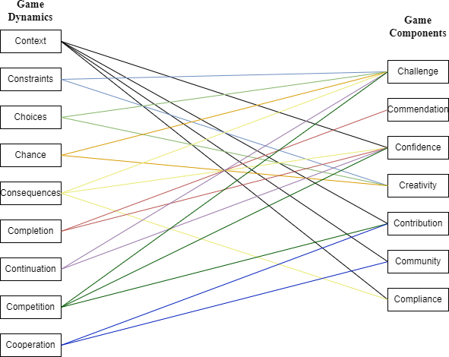

Figure 1 – An example of Narratives

During the study we expect to come up with a comprehensive model for gamification for Ukrainian IT industries. This includes finding fields where gamification is applicable and trying to optimize the elements used.

**References:**

1. 27 us employee turnover statistics [2022]: average employee turnover rate, industry comparisons, and trends. URL: https://[www.zippia.com/advice/employee-turnover-statistics](http://www.zippia.com/advice/employee-turnover-statistics)
2. В Україні на кінець року безробіття становитиме 30% - Мінекономіки. URL: https:/[/www.ukrinform.ua/rubric-economy/3599946-v-ukraini-na-kinec-roku-bezrobitta-](http://www.ukrinform.ua/rubric-economy/3599946-v-ukraini-na-kinec-roku-bezrobitta-) stanovitime-30-minekonomiki.html
3. Robson, Karen, et al. Is it all a game? Understanding the principles of gamification. Business horizons 58.4 (2015): 411-420.
4. Ruhi, Umar. Level up your strategy: Towards a descriptive framework for meaningful enterprise gamification. arXiv preprint arXiv:1605.09678 (2016). URL: <https://arxiv.org/ftp/arxiv/papers/1605/1605.09678.pdf>
5. Werbach, Kevin, and Dan Hunter. The gamification toolkit: dynamics, mechanics, and components for the win. University of Pennsylvania Press, (2015).
6. Maslach, Christina, and Julie Goldberg. Prevention of burnout: New perspectives. Applied and preventive psychology 7.1 (1998): 63-74.

## 1 Nazar Kalinichenko

Master's degree Student, Department of Technology Management

## 2 Iulia Khlevna

Doctor of Technical Science, Associate Professor, Department of Technology Management

*1,2 Taras Shevchenko National University of Kyiv, Ukraine*

# INVESTMENT PORTFOLIO CONSTRUCTION AND OPTIMIZATION BY MEANS OF DATA ANALYSIS

**Abstract.** In modern portfolio theory, an investor chooses different assets for investment with different levels of risk and expected return. The purpose of this paper is to present a proposal of determining and constructing the most beneficial investment portfolio, in terms of volatility, profit and applicability to different markets.

**Keywords:** Risk, portfolio, returns, volatility, diversification, asset.

**Introduction.** Nowadays, many people are concerned about preserving or increasing the value of their savings. The most reasonable path to turn to is investing into assets. This is a rather complex and extensive process, so the best way to approach it will be discovering the most optimal investment strategy from various points of view. With the results of the research, it will be possible to formulate a successful investment algorithm, depending on the initial variables, such as the type of financial instruments, the type of market, the time available for the construction of the portfolio, the degree of risk aversion of an investor etc.

The understanding of the essence of the investment process and assessing the relationship between risk and expected returns can give important insights. In order to grasp it, a simplistic example is proposed. Implementation of the mean-variance analysis according to Markowitz proposition gives the valuable understanding of the power of diversification and shows that it is quite possible to mathematically justify and most importantly evaluate one or another way of constructing an investment portfolio.

The numerical data used in the example is price trends of 8 companies’ stocks from the S&P500 index, the largest by market capitalization in 2018 [1, 2]:

* Apple Inc.
* Amazon.com, Inc.
* Berkshire Hathaway, Inc.
* Facebook Inc.
* Alphabet Inc. Class A
* JPMorgan Chase & Co
* Microsoft Corporation
* NVIDIA Corporation

Using the time series of the returns of the stocks of these companies from 2013 to 2018, re-sampled to the basis of a month, one can obtain the first and second moments of the corresponding eight random variables. Every one of these variables

expresses the distribution of the growths of a stock during the period of a month. The following simulation consists of 2,500 investors who randomly invest in stocks of the selected companies.

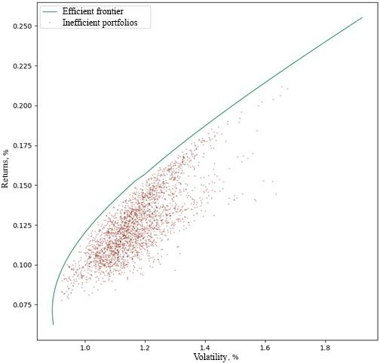

Figure 1 – Efficient frontier and inefficient portfolios on a returns-volatility

graph

In Figure 1, the efficient frontier [3] is depicted by a green curve. This curve is the locus of the most optimal portfolios (from the point of view of the mean-variance analysis). In other words, this curve displays numerical characteristics (mean and standard deviation) of the least risky portfolios for an arbitrarily chosen value of return. As can be seen from the distribution of the numerical characteristics of the randomly generated portfolios, the overwhelming majority of them are suboptimal, that is, they do not provide sufficient profit compared to the level of risk. Several natural conclusions are to be drawn from this simple experiment:

* Such a complex process as investing requires mathematical reasoning and rigorous technical justification.
* Using certain assumptions about the trends of value of assets, it is possible to obtain a quite realistic measure of portfolio optimality.

Considering only one of the many models and means of data analysis that can theoretically be used to solve the problems of this subject area can be insufficient.

Powerful insights about portfolio construction can be drawn not only by studying the time series of asset values. One cannot fail to mention the factor models [4], which are used to analyze the observed profits. Basically, these are regression models that allow establishing a relationship between investors' returns and various sets of factors. Among the most famous such models are CAPM and the three-factor Fama-French model.

Very often investors have additional information about the market situation that does not intersect with the time series of price trends. For example, they might know with extreme certainty that the shares of some company will rise or fall for a particular

reason (scientific discovery, natural disaster, legislative changes etc.). The Black- Litterman class of models provides a reasonable way to integrate such knowledge when constructing a portfolio. This model improves the equilibrium allocation of the portfolio using the knowledge of the investor vision on the future tendencies of the asset.

The effectiveness of the selected model is directly dependent upon its applicability in a particular field. A careful investigation must take place before applying various strategies and all the results should be verified.

One must figure the desired outcome of the data analysis process and also take note of the initial conditions prior to performing any modelling or formulating conclusions. The results of a particular strategy are subject to error, noise pollution, statistical outliers etc.

Taking into account all of the above, the following conclusions can be drawn:

* Development of investment strategies in modern conditions and in various markets is a complex issue and does not have a single definite answer.
* It is worth constructing an investment portfolio based solely on a set of input

data.

* Any obtained results should be checked for statistical significance.

**References:**

1. Cam Nugent, S&P 500 stock data, 2017. URL: https:/[/www.kaggle.com/datasets/camnugent/sandp500.](http://www.kaggle.com/datasets/camnugent/sandp500)
2. Value Today, "S&P 500 Top Companies List by Market Cap as on Jan 7th, 2019". URL: https://[www.value.today/stocks/sp-500-index.](http://www.value.today/stocks/sp-500-index)
3. Martin Haugh, "Mean-Variance Optimization and the CAPM", IEOR E4706: Foundations of Financial Engineering, 2016.
4. Andrew Ang, "Asset Management: a systematic approach to factor investing", Oxford University Press, 2014.

## 1 Iulia Khlevna

Doctor of Technical Science, Associate Professor, Department of Technology Management

## 2 Yehor Nesterenko

Master of degree, specialty Project Management, Faculty of information Technology

*1,2 Taras Shevchenko National University of Kyiv, Ukraine*

# FACE RECOGNITION TECHNOLOGY AS A COMPONENT OF EMOTIONAL MARKETING

**Abstract.** Video surveillance cameras have outlived their function of only recording and displaying the video stream. They have reached the level of automation, cameras are not just equipment for capturing images, but tools for optimising business processes. One of the use cases is video surveillance systems for emotion recognition in marketing.

**Keywords**: Video Surveillance; Marketing Analysis

According to a survey by independent research company Gartner [1], almost 30% of marketing executives believe that the lack of sufficient tools to measure the needs of users in the field has negatively affected the implementation of marketing strategies during the COVID-19 pandemic when people's habits have changed in some way. Gartner's experts also concluded that today's marketers need to update information as soon as possible, including processing information from video cameras. Video cameras, especially in combination with video solutions, have really become the tools in which business is interested. For example, in marketing, the main task is to create personalized advertising campaigns. Having data from video cameras

* another component is added to provide personalized advertising - the emotional state of the client. Any data obtained from various sources should be used to perform logical steps, and if we talk about marketing, one of the goals of using video solutions is to obtain new information about customers based on the analysis of available data. It is relevant to analyze the classification and selection of business tasks, and management decisions which will be based on the processed data from video cameras, to establish the emotional state of the user.

An emotion recognition algorithm usually contains six stages:

* 1. image detection;
  2. primary image processing;
  3. identification of the person in the image;
  4. highlighting the key elements of the person;
  5. selection of key points on the face;
  6. classification of emotions

First, the technology detects the presence of a person's face in the frame, then analyzes anthropometric points. Anthropometric points are points located on the human body, which are formed by the skeleton and are clearly defined by muscles, so they are easily determined. Special algorithms can "see" at least 68 such points located along the entire contour of the face, chin, eyes, nose and mouth.

After the face has been extracted, it is necessary to have information on the basis of which the emotion analysis will be done. Emotions can be manifested with the help of eyes, eyebrows, and mouth. Therefore, the first step is to find the key points of the selected elements of the person.

Usually, the selection of key points is carried out as follows:

* + 1. converting a color image to a halftone;
    2. conversion from halftone form to binary focus;
    3. application to the binary image of the gradient mask;
    4. localization of key points.

After selecting the key points, you can perform the classification of the emotion.

For example, Table 1 presents the characteristics of emotions by a combination of eyebrows and mouth.

## Table 1.

Characteristics of emotions with a combination of eyebrows and mouth

|  |  |  |
| --- | --- | --- |
| Emotion | Eyebrow | Mouth |
| Surprise | Rising | Opens |
| Fear | Rising | It opens, the clenched teeth are visible |
| Disgust | Lowers | The corners of the lips are lowered |
| Anger | Lowers, grimaces | It opens, the corners of the lips fall |
| Happiness | Rising | The ends are rising |
| Sorrow | Lowers | The ends are lowered |

This approach to emotion recognition can be used in various intelligent man- machine systems.

Conclusion. For marketing, the area of video solutions, and especially face and emotion recognition systems, is quite an important component nowadays, as marketers are looking for ways to a more personalized approach to the sale of certain groups of goods. Currently, the algorithms available on the market do not yet meet the tasks set by 100%, so there is constant development and improvement of existing methods.

Moreover, most of the presented modified methods are used in libraries for working with machine vision, but their source code is always closed, which does not allow full studying of such methods.

**References:**

1. Gartner Says Nearly 30% of Marketing Leaders Believe Lack of Agility and Flexibility Negatively Impacts Marketing Execution During COVID-19 Pandemic, 2020. URL: https:/[/www.gartner.com/en/newsroom/press-releases/2020-05-14-gartner-says-nearly-30--of-](http://www.gartner.com/en/newsroom/press-releases/2020-05-14-gartner-says-nearly-30--of-) marketing-leaders-believe-.
2. K. Matsuno, C. Lee, and S. Tsuji, “Recognition of human facial expressions without feature extraction,” ECCV, 1994.

## 1 Anton Kolumbet

Master's degree student Department of technology management

## 2 Andrii Khlevnyi

PhD, Associate Professor of the Department of Technologies Management

*1,2* Taras Shevchenko National University of Kyiv, Ukraine

# RECOMMENDER SYSTEMS FOR E-COMMERCE USING ASSOCIATION RULE LEARNING

**Abstract.** Modern e-commerce relies on the use of customer data analytics and machine learning to increase sales, this applies both to the customer service area of the online stores themselves and contextual advertising offered by services such as Google. So-called Recommender Systems are designed to increase incremental sales of online stores by analyzing the actions, pages, products and shopping cart of buyers and applying Machine Learning algorithms to find relationships and associations in data and then displaying the recommendation of interest to the potential buyer.

**Keywords:** association rule, machine learning, patterns

**Introduction.** Most used machine learning method in recommender systems development is Association rule learning method. Association rule learning is a rule- based machine learning method for discovering interesting relationships between variables in large databases. It is designed to discover strong rules found in databases by using some curiosity measures. In any given transaction with many items, association rules are designed to discover rules that define how or why certain items are related to each other.

Based on the concept of strong rules, Rakesh Agrawal, Tomasz Imielinski and Arun Swamy[1] presented association rules to discover patterns between products in large-scale transaction data recorded by point-of-sale (POS) systems in supermarkets. For example, rule {spaghetti + ketchup = cheese}, found in supermarket sales data, indicates that if a customer buys spaghetti and ketchup together, he is likely to also buy cheese to make pasta. Such information can be used as a basis for making decisions about marketing activities such as, for example, promotional pricing or product placement.

The purpose of this study is to research development of a machine learning model that can be used to predict interests and recommend products for potential clients of e-commerce businesses that will increase increment sales.

Association rule learning works based on the concept of "If" and "Otherwise" statements, for example, if A, then B. Here the If element is called the antecedent and the Then statement is called the consequent. These types of relationships where we can find some association or connection between two elements are known as single cardinality. It is all about creating rules and if the number of elements increases, then the cardinality also increases accordingly. There are several metrics to measure associations between thousands of data elements. These metrics are Support, Confidence and Lift.

Support - is the frequency or occurrence rate of an element in a dataset. It is

defined as the fraction of transactions T containing a set of items X. Confidence shows how often a rule turns out to be true. Or how often items X and Y occur together in a data set when the occurrence of X is already given.

Confidence shows how often a rule turns out to be true. Or how often items X and Y occur together in a data set when the occurrence of X is already given.

Lift - This is the ratio of the measure of observed support and expected support if X and Y are independent of each other. It has three possible values:

If Lift=1: The probability of the antecedent and the follower are independent of each other.

Lift>1: Determines the level of dependence of two sets of elements on each

other.

Lift<1: tells us that one element is a substitute for the other elements, which

means that one element negatively affects the other.

For developing of recommender system F-P growth algorithm can be used. The F-P growth algorithm stands for Frequent Pattern and it is an improved version of the Apriori algorithm. It is a database in the form of a tree-like structure, which is known as a frequent pattern or tree. The purpose of this frequent pattern tree is to extract the most frequently occurring patterns.

Fp Growth is a Data Mining model based on association rules.

This model allows to determine the set of most frequently occurring association rules in a dataset based on the transaction history. To do this, it requires as input a set of transactions consisting of baskets of products that customers have already purchased.

Given a set of transactions, the first step of FP-growth is to calculate the frequencies of items and identify the most frequently occurring items.

In the second step, FP-growth uses a suffix tree structure (FP-tree) to encode transactions without explicitly generating candidate sets, which is usually computationally expensive. After the second step, frequent item sets can be extracted from the FP tree and the model returns a set of product association rules, as shown in the example below:

{Product A + Product B} --> {Product C} with 60% probability

{Product B + Product C} --> {Product A + Product D} with 78% probability

{Prodcut C} --> {Product B + Product D} with 67% probability etc.

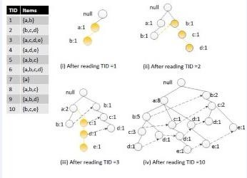

Figure 1 – Construction of FP-tree

To create a probability table, the model needs 2 hyperparameters: minSupRatio: the minimum support for a set of elements to be defined as

frequent. For example, if an item occurs 3 times out of 5 transactions, its support is 3/5=0.6.

minConf: the minimum confidence to create an association rule. Confidence is a measure of how often an association rule is true. For example, if X occurs 4 times in the transaction set, but X and Y occur only 2 times, the confidence of the rule X => Y is 2/4 = 0.5. This parameter does not affect the search for frequent item sets, but defines the minimum confidence for generating associative rules based on frequent item sets.

Once the associative rules are calculated, all that remains is to apply them to customer shopping carts.

**References:**

1. Ecommerce Analytics: Analyze and Improve the Impact of Your Digital Strategy, 1st. ed., 2016.
2. G. Bonaccorso, Machine Learning Algorithms. Birminghem, Mumbai, 2017.
3. R. Agarwal, T. Imielinski, A. Swami. Mining Association Rules between Sets of Items in Large Databases, 650 Harry Road, San Jose, CA, 1994.
4. A. Geron. Hands-On Machine Learning with Scikit-Learn, Keras, and TensorFlow: Concepts, Tools, and Techniques to Build Intelligent Systems, 2017.
5. A. Muller. Introduction to Machine Learning with Python: A Guide for Data Scientists, 1st. ed. 2017.
6. K. Singh, S. D. Ratnoo. Improved FP Growth Algorithm for Mining Association Rules, 2017.
7. Statistics for Machine Learning handbook. URL: https:/[/www.oreilly.com/library/view/statistics-for-machine/9781788295758/c71ea970-0f3c-4973-](http://www.oreilly.com/library/view/statistics-for-machine/9781788295758/c71ea970-0f3c-4973-) 8d3a-b09a7a6553c1.xhtml
8. C. Zhang, S. Zhang. Association Rule Mining: Models and Algorithms, 2014.
9. S. Shalev-Shwartz, Shai Ben-David. Understanding Machine Learning: From Theory to Algorithms, 1st. ed., 2014.
10. J. Kelleher, B. Mac Namee. Fundamentals of Machine Learning for Predictive Data Analytics: Algorithms, Worked Examples, and Case Studies (The MIT Press), 1st. ed. 2015.

## 1 Andrii Kopp

Ph.D., Associate Professor **2 Dmytro Orlovskyi** Ph.D., Associate Professor

*1,2 National Technical University “Kharkiv Polytechnic Institute”, Kyrpychova str. 2, Kharkiv, 61002, Ukraine*

# ENTERPRISE ARCHITECTURE WEB MINING APPORACH

**Abstract.** This paper considers the enterprise architecture model extraction from organizational websites in an automatic way to simplify the blueprinting of enterprise architecture landscapes at the conceptual level. Thus, such a technique is proposed to be called “enterprise architecture web mining”.

**Keywords:** Enterprise Architecture, Business Process, Web Content Mining.

This paper proposes an approach and a software tool for the automatic extraction of Enterprise Architecture (EA) landscapes from websites that nowadays virtually represent organizations on the Internet. It aims at simplifying the procedure of building high-level models in the preliminary stages of EA development. It is well known that today most enterprises offer their products and services on their homepages top-ranked by multiple search engines. Usually, organizational websites contain information not only about offered products or services but also about related activities that allow customers to receive respective products or services (e.g. order, buy, learn, etc.). The study object is the procedure of EA structure extraction from organizational websites that serve as virtual enterprise representations on the Internet. The study subject is the approach and software tool to extract EA landscapes from organizational websites. The study goal is to simplify the process of EA description in the early stages of EA development.

The suggested “EA web mining” is focused on the automatic construction of EA models using corporate websites as sources of data about EA elements and the relationships between them. Hence, the main problem is finding mentions of business processes and other EA elements in HyperText Markup Language (HTML) pages of corporate websites. Whereas the direct search in Google Scholar using the “enterprise architecture web mining” key phrase did not give any results, the “enterprise architecture mining” allowed us to discover several studies in this direction. In [1] the author states that manual maintenance of EA models is costly and time-consuming, so they propose EA mining algorithms and tools based on process mining. The study [2] also considers automatic EA modeling methods that are supposed to reduce the drawbacks of manual EA modeling (error-proneness, time and cost consumption, accuracy, etc.). The systematic review [3] also states that automatic EA modeling could respond challenges of manual EA modeling but this field is still immature and requires further research.

First of all, the web page should be parsed to work with its tags, their attributes, and text content. Then web page tags should be used to extract the data about the

organization’s activity described on its web page on the Internet. Using the structured tag data, business activities that help an organization virtually promote its products or services on the Internet should be detected. Finally, using the set of business activities and the previous outcomes, the EA model should be built. The conceptual model of automatic EA model construction using the company’s homepage on the Internet is demonstrated in Fig. 1.

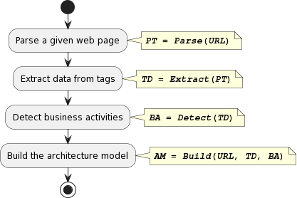

Figure 1 – The conceptual model of “EA web mining” approach

The proposed workflow (Fig. 1) should help automatically build high-level architectural models using only the websites of organizations using the suggested technology we can name “enterprise architecture web mining”. Obtained models may describe landscapes of top-level business processes based on products or services offered to customers on the company’s homepage. Moreover, obtained EA models should include application layers to demonstrate website maps, and technology layers to complete the EA cross-layer architecture. However, the most valuable outcome is still a business architecture layer that includes core value-added business processes and the business service offered to the organization’s clients. EA models automatically produced using the company’s website can help to understand the current state of the enterprise, including its customer relationship strategy, offered products, and services. Then, shortcomings could be detected in such an EA model, and the decisions to improve the enterprise’s virtual representation on the Internet could be made.

**References:**

1. A. Fajri, Enterprise Architecture Mining, MS thesis, University of Twente, 2019.
2. R. Pérez-Castillo, F. Ruiz, M. Piattini, A decision-making support system for Enterprise Architecture Modelling, Decision Support Systems 131 (2020) 113249. doi:10.1016/j.dss.2020.113249.
3. R. Perez-Castillo et al., A systematic mapping study on enterprise architecture mining, Enterprise Information Systems 5(13) (2019) 675–718. doi:10.1080/17517575.2019.1590859.

## 1 Nazar Kruk

Student

## 2 Vladyslav Scherbak

Student

## 3 Mykhailo Stepanov

Professor of the Department of Information Systems and Technologies

*1-3 Taras Shevchenko National University of Kyiv, Ukraine*

# MONITORING IOT HOME DEVICES

**Abstract.** Current events, namely the coronavirus pandemic and martial law throughout Ukraine, have made adjustments to everyday life. For the sake of life and health, people stay at home most of the time and need constant access to relevant information, such as the state of the air alarm in the village, where there are no sirens as such, but an Internet connection is available. This document analyzes the construction of the infrastructure of the Internet of Things of a small house (home, small office, cottage, etc.), which includes the general coverage of the involved territory, the study of the method of optimal signal retransmission and monitoring of all devices in the system that can be implemented as a home system or a cloud-based solution with remote access to the monitoring of various users, thanks to which the system is constantly monitored and controlled.

**Keywords:** IoT, Wi-Fi, repeater, microcontroller, ESP, C#, HTML, TypeScript, CSS, database, monitoring, SQL Server, application, software product, API, Angular.

The modern development of technology is steadily gaining momentum, and a large number of things we are used to, such as a heater, boiler, lighting devices, can be controlled wherever their owner is, provided there is an Internet connection. The Internet of Things (IoT) technology has an impact on a large number of areas of human life: health care, business, science, etc. One such application of IoT is the creation of so-called smart homes. A smart home is a home with a network and smart devices aimed at ensuring safety and comfort, as well as energy efficiency - the components of such a system exchange data with each other, and control is often implemented in the form of a convenient application on a smartphone, tablet or other end device. Examples of the improvement of common household items can be: smart TVs that download media content, intelligent lighting systems that save electricity and the working resource of devices, smart thermostats that create the most comfortable conditions at the right time, etc.

Obviously, when replacing household items with IoT versions that require Internet connection, it is necessary to provide the house with a stable connection in every corner. However, the coverage area from the home router is often less than desired - in this case, there is a need for expansion. The modern market offers several solutions: Wi-Fi extender from an additional router, commercial Wi-Fi repeater, Wi- Fi repeater based on Raspberry Pi or LuaNode32, etc. According to information found in open sources, instead of using the Raspberry Pi as a computer, it can be used as the

basis of a smart home[1] and affordable and budget-friendly ESP microcontrollers support a wide range of technologies, making it possible to build the smart home of your dreams and fully control it[2].

The most profitable of the considered solutions is the repeater based on LuaNode32 (ESP) - in Figure 1, basic information about each of the solutions is collected.

|  |  |  |  |  |
| --- | --- | --- | --- | --- |
| **Solution** | **Connection of the system** | **Expansion method** | **Openness of the system** | **Minimum cost of the system** |
| Additional router | Power from the outlet, twisted pair | Extender | Closed | ~550+₴ |
| Commercial repeater | Power from the outlet, Wi-Fi | Repeater | Closed | ~620+₴ |
| Raspberry Pi | Power from the outlet, twisted pair or Wi-Fi | Extender or repeater | Open | ~400+₴ |
| LuaNode32 | Power from an outlet or battery, Wi-Fi | Repeater | Open | ~300+₴ |

Figure 1 – Comparison of solutions

Modern smart home complexes usually have a mobile application for control and ongoing monitoring of devices. But usually such solutions have an insufficient level of monitoring and information storage, as well as most of them are focused on the devices of one specific company, which becomes a problem when equipping a smart home with devices from different manufacturers. And applications that allow synchronization of devices work even worse with these devices, and often have problems. Therefore, it is advisable to create an application fully aimed at collecting and storing information from sensors and smart home devices in the form of a web application. Such a software product will allow you to access information from any place and device with an available Internet connection, or when located in the local network where the application is located - the implementation depends on the customer's wishes. Access via the Internet is more comfortable, but access only via a local network is safer. Also, we receive not only current data from devices, but also statistics of their operation over a long period of time, which will allow us to find weak points of the smart home complex, errors, hacking attempts and opportunities for improvement.

The monitoring system itself consists of three main parts: database, backend and frontend. SQL Server is recommended as a database due to its convenience and availability, although other options can be used. The server-client part should be developed using the MVC design template[3] – Model, View, Controller. This design pattern is used to clearly separate the server part, where the database requests will be processed, the logic of data transfer and interaction, and the client part, which allows you to consider each part as a separate object and freely modify it if necessary. It is very convenient to develop a project in MS Visual Studio because there is already this template for development there, and it will also allow you to use the quite popular and not the most complicated programming language C#. The Angular[4] framework is

recommended for the frontend. It will allow you to easily create a web page adapted for both desktop and mobile display. The "modularity" of the framework will also be very useful, where each page and pop-up window are separate objects, due to which the application is developed and easily modified block by block. These blocks themselves are also divided into different elements, namely HTML, CSS and TypeScript. For the interaction between the database and the web application, you should use API methods that are prescribed in the server part.

There are two ways to fill such a monitoring system: manual, which can be rare, inaccurate and not to the owner's liking, and automatic. Since the presence of devices from different manufacturers is allowed, a library should be created to collect data from the devices of the most popular manufacturers with the possibility of individual modification. It is also possible to create a bot that would collect this data instead of a person, with the possibility that the owner must first show how to collect data from a new device, and then the bot will do it itself.

house/.

**Referenses:**

1. RASPBERRY PROJECTS. Smart House. URL: https://projects-raspberry.com/smart-
2. ESPHome. URL: https://esphome.io/.
3. MVC: Model, View, Controller. URL: https://[www.codecademy.com](http://www.codecademy.com/) /article/mvc.
4. «Удивительный Angular / Хабр». URL: https://habr.com/ru/post/348818/.

## 1 Olena Liashenko

Doctor of Sciences (Economics), Professor of Economic Cybernetics Department

## 2 Tetyana Kravets

PhD, Associate Professor of Economic Cybernetics Department

## 3 Yevhenii Kostovetskyi

Student

*1,2,3 Taras Shevchenko National University of Kyiv, Ukraine*

# ANALYSIS OF MACHINE LEARNING ALGORITHMS FOR FORECASTING BANKRUPTCY OF ENTERPRISES

**Abstract.** The use of various machine learning algorithms for the task of forecasting the company's bankruptcy based on financial indicators is studied. Different approaches to the formation of the data set on which the models are trained are compared, in particular, data balancing methods. It is shown that models trained on small training data sets cope best with the classification of the company into the "bankruptcy" class, i.e. methods of artificial reproduction of data are ineffective for such tasks.

**Keywords:** bankruptcy forecasting, machine learning, data balancing, binary classification

Bankruptcy is the final stage of the crisis state of the enterprise, which is characterized by the fixation of negative results of financial and economic activity, starting from the temporary inability to pay a monetary obligation to a full-fledged stable inability to pay debts. The crisis situation of the enterprise can be caused by external and internal factors. External factors are objective in relation to the bankrupt enterprise. They do not directly depend on the actions of the enterprise and cannot be prevented or controlled. The internal causes of bankruptcy are determined by problems within the company itself, they are subjective for the enterprise, and if they are detected in time, they can be solved in order to avoid a crisis [1].

Under the conditions of increasing economic instability in the world, the urgency of the problem of the financial crisis is increasing both at the global and national levels, and at the level of a specific enterprise. Companies, especially small ones, always have a hard time surviving crisis situations and are often unable to remain solvent after a crisis occurs at the company, as a result of which most of them are forced to file for bankruptcy. In the context of constant economic instability in the world and the constant increase in the number of bankruptcies in America, companies, in particular American ones, need to implement methods of financial monitoring and predicting bankruptcy [2].

The purpose of this work is to compare different machine learning algorithms for predicting the bankruptcy of an enterprise for a certain period of time based on a set of financial indicators of the company. To achieve this goal, the tasks were set: to determine the features of bankruptcy forecasting using machine learning methods; to analyze various machine learning algorithms for the tasks of classifying bankrupts; apply data balancing methods; choose a system of indicators to assess the accuracy of

classification; to compare machine learning algorithms and data balancing methods based on selected accuracy metrics. Research methods - 9 machine learning algorithms (bootstrap aggregation, support vector machines with a linear and radial basis kernel, artificial neural networks, random forest, boosting algorithm, k-nearest neighbor algorithm, decision trees and logistic regression), as well as 5 methods data balancing (Random over-sampling, SMOTE, ADASYN, Random under-sampling and Near- Miss).

The models were built based on the data of American companies that officially declared themselves bankrupt in the period from 1980 to 2014 and about which there is financial information for at least two years before the registration of bankruptcy, as well as firms that did not go bankrupt during this period. The set consists of 69,290 observations of companies, of which 557 are bankrupt, and 68,733 have not filed bankruptcy for the specified period [3].

As a result of the research, it was established that artificial neural networks, as well as algorithms whose classifiers are based on the principle of building decision trees - bootstrap aggregation, random forest, and decision tree algorithm turned out to be the best for the task of predicting bankruptcy. The results of training on a balanced training set were compared, as well as the results of training models on data to which Random over-sampling, SMOTE, ADASYN, Random under-sampling and Near-Miss methods were applied. Based on the obtained comparison results, it can be concluded that, given the above-described features of the structure of financial data, it is not appropriate to use large training sets, and therefore data multiplication methods (Random over-sampling, SMOTE and ADASYN) are not optimal options for bankruptcy classification.

With an extremely large difference in the number of instances of the "bankrupt" and "non-bankrupt" classes, artificial data propagation algorithms are not able to clearly separate the two classes, and therefore effectively replicate the structure of examples of the minority class. This leads to the fact that the model trained on such data misclassifies most of the bankrupts, which is not practically acceptable.

On the other hand, in cases where the training set was quite small, i.e. with balanced data or when Random under-sampling or Near-Miss was used for balancing, the models could more accurately distinguish between instances of different classes when classifying test data.

**References:**

1. A. Schwartz, J. B. Doyle, N. D. Yavorsky, X. Chen, Trends in Large Corporate Bankruptcy and Financial Distress, Cornerstone Research (2021).
2. A. Litwin, Low-income, low-asset debtors in the U. S. bankruptcy system, International Insolvency Review 29.1 (2020) 116-136. doi:10.1002/iir.1362.
3. S. Sanyal, US Bankruptcy Prediction Data set (1971-2017) (2021). URL: [https://www.kaggle.com/datasets/shuvamjoy34/us-bankruptcy-prediction-data-set-19712017.](https://www.kaggle.com/datasets/shuvamjoy34/us-bankruptcy-prediction-data-set-19712017)

## 1 Natalia Lukova-Chuiko

Doctor of Technical Sciences, professor

## 2 Serhii Toliupa

Doctor of Technical Sciences, professor

## 3 Tetiana Laptieva

PhD-student, Department of Cyber Security and Information Protection

## 4 Serhii Laptiev

PhD-student, Department of Cyber Security and Information Protection

1-4 *Taras Shevchenko National University of Kyiv, Ukraine*

# THE METHOD OF DETECTING DEVIATIONS IN THE NATURE OF TRAFFIC FROM THE ELEMENTS OF THE INFORMATION COMMUNICATION NETWORK

**Abstract.** A method of providing operational traffic analysis is proposed in order to provide information about suspicious situations that require further detailed analysis. The developed method makes it possible to inform responsible specialists in real time about deviations in the nature of traffic. Deviations measured from the normal traffic of the telephone network. This method has a methodology that takes into account practical recommendations for constant coefficients for calculations.

**Keywords**: method, traffic deviation, calculation coefficients, primary data.

# INTRODUCTION

According According to the latest research by the World Telecommunication Network Disruption Association (CFCA), in 2021, losses from breaches in the telecommunications industry amounted to 90-119 billion. This is about 67% more than the figure obtained in CFCA research three years ago [1]. Violations on telecommunication networks are the actions of subscribers, telecommunications operators or third parties aimed at obtaining telecommunication services at a reduced rate or without payment. Experts count about 200 types of violations in telecommunication networks. The most common violations by subscribers are the connection of third parties to the subscriber's line in order to receive free telematics services. Conducting long-term international talks, organization of unauthorized negotiation points [2]. The use of hardware and software to receive international traffic from the Internet and pass it over a public telecommunications network undercover is a third-party violation.

On the part of operators, the most common is the unauthorized termination of incoming long-distance and international traffic to the public network under the guise of local, without appropriate contracts. Abuses lead to loss of revenue, subscriber complaints and disruptions in telecommunications networks.

The fight against misuse of telecommunications networks is largely based on the analysis of data about services and data contained in payment systems with subscribers

and operators [3]. Detection of suspicious actions of subscribers and their analysis is the main principle of modern fraud protection systems - Fraud Management System, FMS. The key criteria for the effectiveness of the Fraud Management System are the speed of work and the flexibility of debugging algorithms. This provides incident detection and analysis, as well as standardized interfaces for integration with billing platforms and customer relationship management (CRM) systems.

## Formulation of the problem

Based on the analysis of modern literature and scientific research, it is possible to conclude that there are no universal devices or software that would ensure fast implementation of traffic analysis and information transfer by automated systems or relevant specialists. Therefore, developing a method that can provide the quick performance of traffic analysis and information about suspicious situations that require further detailed investigation is relevant and very important.

## The material and methods

The operation of violation detection mechanisms is based on the processing of records of network-registered CDR events (Call Detail Record). The anti-fraud system looks for non-compliance with certain conditions or non-compliance with a given pattern, the characteristics of the subscriber's behavior. When the detection module finds one of the anomalies, it generates a warning message.

Typical conditional checks for FMS systems include:

1. Non-existent numbering (calling party number «A»)
2. Verification of authorization, temporary blocking of number «A»
3. Correspondence to the set template
4. Checking the «black and white lists»
5. Frequently repeated subscriber numbers «A» or «B»
6. Check the connection duration
7. Verification of suspicious calls from «A» subscribers for inclusion in the list of «B» subscribers who most often receive calls from abroad.
8. Changes in the intensity of signal and information load.

The search for a given template is based on traffic patterns that are created for each telecommunications operator. The difference between the existing signal and information traffic and the template indicates a possible violation. An additional use of templates is to compile a profile of the subscriber (telecommunications operator) of the attacker and search for compliance with such a profile among existing subscribers (telecommunications operators). Profiles can contain such characteristics as:

* + activity during the day;
  + activity in the evening;
  + activity at night;
  + volumes of outgoing traffic to mobile phones;
  + volumes of outgoing traffic to fixed local numbers (including frequently used numbers);
  + volumes of outgoing traffic to fixed numbers in other cities (including frequently used numbers);
  + volumes of outgoing traffic to fixed numbers in other countries (including frequently used numbers);
  + number range of the operator;
  + average number of connections over time;
  + average amount of traffic over time;
  + average connection duration;
  + number of unique numbers;
  + characteristic directions.

The most critical for the Customer in terms of reducing revenue loss are: violation of the routing of long-distance and international calls, detection of subscriber numbers on outgoing local traffic, activity of operators on incoming local traffic, similar to the operation of gateways to complete incoming long-distance and international traffic in the activity of subscriber numbers, which may be evidence of third-party connection to the subscriber line or actions of the subscriber that potentially lead to complaints, non-payment for services and debt write-off. Automated analysis of data on services must be operational. Thus, at this stage it is important to develop a method designed to analyze traffic and inform about situations that are suspicious and require further detailed analysis by automated systems or relevant specialists.

The main tasks in developing the method will be:

1. Debugging the elements of the telecommunications network. Automatic or with the participation of the operator
2. Providing automatic analysis, data classification, search for deviations of behavior of elements of a telecommunication network from a usual profile.
3. Creation of an detection algorithm based on the features of violations that create a dynamic over time impact on the network, causing anomalous phenomena.
4. Development of a graphical display of changes in quantitative characteristics over a period of time.
5. Estimation of conformity of parameters of anomalies (non-existent number, big duration of a call, etc.) to the values characteristic of this type.
6. Assessment of anomalies on the degree of probability of violation to determine the priority of response.
7. Development of information on the detection of deviations and events.
8. Development of a user-friendly operator interface.

Block detection scheme, which is based on the characteristics of violations, it is possible to present in Figure 1.

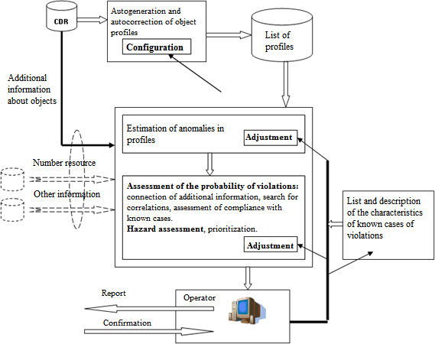

Figure.1- Block diagram of detection of estimates of profile anomalies for detection of violations

# CONCLUSIONS

The analysis showed the absence of scientific and methodological apparatus, universal devices or automated software packages to ensure the rapid implementation of traffic analysis and information transfer to automated systems or relevant specialists. Therefore, a method has been developed to ensure the prompt implementation of traffic analysis and information about situations that are suspicious and require further detailed analysis by automated systems or relevant specialists.

The developed method allows to carry out operative (real-time) informing of responsible specialists, or transfer of necessary data to the automated complex, about deviation of character of traffic from network elements (separate telephone numbers, number capacities, trunk groups, etc.) which is fixed in primary data. Deviations, the nature of traffic from the elements of network parameters are measured from the usual traffic of the telephone network relative to these elements.

The given technique takes into account practical recommendations concerning constant coefficients, calculations. These coefficients are selected by calculation and empirical. This reduces the response of the System using the developed method to the deviation of the communication parameters by 9% compared to existing methods. This is a perfectly acceptable result.

**References:**

1. Бреславський В. О., Лаптєв О. А., Правдивий А. М., Зозуля С. А. Розробка алгоритму маршрутизації самоорганізованих радіомереж. Науково-практичний журнал

«Зв'язок». К. : ДУТ, 2020. №6 , С.54 – 57.

1. Vladislav Breslavskyi, Oleksandr Laptiev, Vitalii Savchenko, German Shuklin, Anatoliy Biehun. Development of Routing Algorithm for Self-Organizing Radio Networks. International Journal of Science and Engineering Investigations (IJSEI) Vol. 9, Issue 107, December, 28, 2020. рр.46-50. ID: 910720-08
2. Lubov Berkman, Oleg Barabash, Olga Tkachenko , Andri Musienko, Oleksand Laptiev, Ivanna Salanda. The Intelligent Control System for infocommunication networks. International Journal of Emerging Trends in Engineering Research (IJETER) Volume 8. No. 5, May 2020. Scopus Indexed - ISSN 2347 – 3983. P.1920 – 1925.

**1 Kateryna Merkulova** PhD associate professor **2 Ivan Ivanenko** Student

*1-2 Taras Shevchenko National University of Kyiv, Ukraine*

# IMPLEMENTATION OF ARTIFICIAL INTELLIGENCE IN THE PROGRAM FOR IDENTIFYING A MEANS OF PERSONAL PROTECTION IN THE IMAGE OF A PERSON'S FACE

**Abstract**. At this time, human civilization must quickly adapt to the impending threat. Although wearing a mask is not a permanent solution, it does reduce the rate of transmission of the virus. Creating such a safe ecosystem requires mask detection techniques to ensure that transmission rates are kept to a minimum in crowded public spaces and other places where the risk of transmission is high. Throughout its development, humanity has always sought to automate as many of its life processes as possible, since such an approach frees the person from unnecessary actions and work, and also increases labor productivity. It is not surprising that automation has reached such a process as detecting people without medical masks in public and public places. Thus, solving the problem of medical mask detection is an important aspect of security and control during a pandemic.

**Keywords**: face detection, medical mask, artificial neural network, CNN, viola- jones method, oriented gradient histogram, comparative analysis.

The main function of the developed software is the detection of personal protective equipment on the image of a person's face. The task can be conditionally divided into two tasks:

1. Detection of a person's face on the input image (Face Detection) is finding the pixel coordinates of the license plate on the image.
2. Detection of personal protective equipment on a localized face of a person (Mask Recognition) - assignment of the input image to one of the classes (a person in a mask, without a mask, in an incorrectly worn mask).

First of all, it is necessary to understand exactly how we will localize a person's face in this image. Today, such a task in the field of computer vision is known as "Face Detection". It is far from new, so it is not surprising that there are dozens of different methods and technologies that differ primarily in the quality of the final result. Therefore, among the most popular solutions to the "Face Detection" problem, it is necessary to determine the most relevant solution according to the developed quality criteria:

1. 𝐼𝑜𝑈

∑𝑁

= 𝑖=1

𝐼𝑜𝑈𝑖 - Intersection over Union. This criterion evaluates the

𝑐 𝑁

accuracy with which the face detector localizes the face in the image.

∑𝑁

1. 𝑇 = 𝑖=1

𝑁

𝑇𝑖 - average face localization time. This criterion is intended to

demonstrate the speed of face recognition by the detector.

1. 𝑅 =

𝑁

𝑖=1

∑

∑𝑁

𝑚𝑖

𝑘𝑖

- the ratio of the number of correctly localized faces to the

𝑖=1

number of all faces. This criterion evaluates such a quantitative characteristic of the

face detector as the ability to recognize faces.

To date, there is no exact analytical solution to the problem of image detection or recognition, which complicates the development of a universal algorithm. Nevertheless, in order to endow computer systems with the possibility of a kind of "sight", a large number of methods and algorithms have been created and proposed. Based on my own experience and various articles on the Internet, the following most popular and used methods for detecting objects in the image were chosen:

1. The Viola-Jones method - the advantages of this method can be considered a high speed of operation and a percentage of the probability of correctly detecting the object in the image. Thus, this method can be applied in many fields of activity, for example, to detect the recognition of license plates on cars (for further analysis) or in our case, to detect faces in an image [1].
2. Histogram of Oriented Gradients (HOG) – this method is based on counting the number of gradient directions in local areas of the image [2].

As a result of the study of the above detection methods in the context of the proposed quality criteria, the following results were obtained: if a detection method based on a histogram of oriented gradients is used for the task of localization of a human face in an image, then a gain in localization frequency by 10% and localization accuracy by 11% is observed , instead, we lose in the time spent on localization, which is as much as 6 times greater, compared to the Viola-Jones method. The quality criteria, on the basis of which the comparative analysis was carried out, was calculated with an error of the order of 10e-5. Thus, based on the obtained results, it can be said that each of the considered detection methods has its own advantages and disadvantages.

The description of the Mask Recognition task can be presented as follows: the image of a localized human face acts as input data, and as output data it is necessary to determine which of the three classes the current image belongs to:

* + there is no medical mask on the face;
  + a medical mask is present and correctly worn on the face;
  + a medical mask is present and is not properly worn on the face.

Today, similar problems of image classification are very often solved with the help of so-called artificial neural networks, because in this direction they show very good results compared to other technologies.

At this stage, we decided on the technology that will be used to solve the problem of Mask Recognition. This technology does not stand still and has begun to develop at a particularly fast pace in recent decades. That is why, today, there are various architectures of artificial neural networks, each of which is designed to a greater extent to solve its specialized problems. In our case, the so-called convolutional neural network (CNN) proved to be the best for the task of image classification.

Various modifications were developed on the basis of convolutional neural networks. Within this section, such modifications as:

* ResNet - the winner of the ImageNet competition in 2015, contains more than 150 layers and scored 96.43% accuracy.
* EfficientNet is one of the most modern CNNs, presented by Google in 2019 [3]. Thus, we have three possible ways of solving the “Mask Recognition” problem, namely using one of the following artificial neural networks: Normal CNN, ResNet and EfficientNet. For each of them, its own structure was developed, which after training gives the best results, based on the results of the conducted experiments. The comparison of the results of network training was carried out according to the quality criterion "test accuracy" (the percentage of correctly classified images for the test sample), since this metric is the most objective, since the test sample of images does not take any part in the training of neural networks. According to the obtained results, a neural network based on EfficientNet performed best for solving the given problem, as its classification accuracy on the test sample was 99.21% - this result is the best among trained neural networks. The neural network based on EfficientNet performed better on the test sample than the network based on ResNet by 1.48%, and by 11.86%

than the conventional convolutional network.

As a result of the conducted research, a software architecture was developed, on the basis of which the final software product was developed, which, as a result of the testing, showed excellent results, which were predicted even at the stage of research of detection methods and methods of image classification.

**References:**

1. Viola-Jones detection method [Electronic resource] – Mode of access to the resource: <https://infopedia.su/17x9179.html>
2. Histogram of oriented gradients Macroscop [Electronic resource] – Mode of access to the resource: <https://wiki5.ru/wiki/Histogram_of_oriented_gradients>
3. EfficientNet [Electronic resource] – Mode of access to the resource: [https://github-](https://github-wiki-see.page/m/AshokBhat/ml/wiki/EfficientNet) [wiki-see.page/m/AshokBhat/ml/wiki/EfficientNet](https://github-wiki-see.page/m/AshokBhat/ml/wiki/EfficientNet)

**1 Kateryna Merkulova** PhD associate professor **2 Iryna Lybak** postgraduate

*1,2 Taras Shevchenko National University of Kyiv, Ukraine*

# THE STRATEGY OF THE MANAGEMENT OF ZVO BASED ON NEURO-FUZZY MODELS

**Abstract.** Formation of the management strategy of a higher education institution (HEI) is an extremely urgent issue in modern realities. It is the construction and effective use of the higher education management strategy that will enable a quick response to dynamic changes in modern conditions, as well as significantly increase the competitiveness of the higher education institution in the market of educational services. Ways to solve this problem can be mathematical methods and models of fuzzy logic.

**Keywords:** higher education institution, neuro-fuzzy models, fuzzy logic, management strategy, concurrency, market of educational services.

One of the most important problems of the development of society is the development of education. Today, the educational environment is undergoing a global transformation due to internationalization, globalization of the world economy and modern challenges caused by the Covid-19 pandemic and the full-scale invasion of the territory of Ukraine. The increase in society's demands for the quality of education, changes in the organizational and economic conditions of higher education institutions, the implementation of higher education in the European educational space and the related process of updating technologies and standards of education as a whole have led to intensified competition not only in the domestic market of educational services

, but also abroad.

In modern conditions, the formation and application of an effective management strategy of a higher education institution is an important factor not only for existence, but also for ensuring its competitiveness in the market of educational services and the labor market [1, 2]. In addition, the implementation of this task can solve a number of issues, namely, the identification of new and strengthening of existing strengths of higher education institutions, their flexible response to unforeseen situations, in particular, the forced transition to mixed or distance education [3].

Ways to solve this problem can be mathematical methods and models of fuzzy logic [4]. Today, the main "consumers" of fuzzy calculations on the Ukrainian market are bankers and financiers, as well as specialists in the field of political and economic analysis. They use fuzzy calculations to create models of various economic, political, stock exchange situations.

The use of neuro-fuzzy models in the formation of a management strategy is caused primarily by the existence of the ESS in conditions of inaccuracy and uncertainty, as well as in the application of expert knowledge formulated in a linguistic

form. After all, it is believed that fuzzy logic arose as the most convenient way to build control systems for complex technological processes, and only later found wide use in various types of computer analytical systems. An important element of fuzzy logic is the concept of fuzzy and linguistic variables, which is used when describing objects and phenomena with the help of a fuzzy set [4].

The main advantages of fuzzy logic in comparison with other technologies of intellectual analysis are that with the same volumes of input and output information, the central decision-making unit becomes easier for human perception, and also, the solution to the complex and cumbersome task of calculating precise actions is replaced by a simpler and a flexible strategy of adaptive adjustment, maintaining the necessary accuracy of the result.

It is the ability to make correct decisions in conditions of incomplete and unclear information that is the most significant property of human intelligence. Therefore, the construction of models that are close to human thinking and their use in computer systems is one of the most important scientific problems.

In particular, the use of fuzzy calculations achieves significant results in strategic planning, that is, they can be used to describe the state of the educational services market, the competitiveness of higher education institutions, to assess its strengths and weaknesses, and to analyze the comprehensive state of a higher education institution.

**References:**

* 1. L. Prus. Theoretical principles of managing the competitiveness of higher educational institutions / Lyudmila Prus // Ternopil State Gazette. economy university - 2006. - No. 2. - P. 114- 123.
  2. Lavrynenko L.M. Interaction of the market of educational services and the labor market: features and modern trends. Integration of fundamental and applied sciences in the paradigm of post-industrial society: Collection of scientific documents "ΛΌГOΣ" with acts of the International Scientific and Practical Conference. Vol.1, 24 de abril de 2020. Barcelona. P. 45-48.
  3. Kravchenko O.I. Modeling of the strategic development of the university: a monograph / O.I. Kravchenko – Kh.: I.S. Ivanchenko Publishing House, 2017. – 398 p.
  4. Fuzzy modeling and control / A. Pegat; trans. with English — 4th ed., electronic. —

M. : Laboratory of Knowledge, 2020. — 801 p.

## Julia Minaeva

Ph.D., Associate Professor, Associate Professor *at the Department* of Intellectual Technologies.

*Taras Shevchenko National University of Kyiv, Ukraine*

# APPLICATION OF FUZZY MATHEMATICS IN THE TENSOR BASIS

The modern level of uncertainty processing is characterized by the wide implementation of intelligent systems and technologies. These systems can essentially perform symbolic processing or operations that preserve a logical conclusion. Ultimately, information can be processed heuristically, according to well-represented procedures that may require other types of languages.

Due to theory, defined in [1], it is assumed the priority of informational characteristics of the phenomenon of uncertainty. Uncertainty calculus, theory, or usage method that allows describing this phenomenon should obviously be compatible with the characteristics of the phenomenon, i.e. without requiring information on a higher level than intended, without making any axiomatic assumptions about the causes of uncertainty, etc., which is not satisfied by the real situation [1]. This clearly contradicts the point of view that, for example, any uncertainty can be modeled by possibility theory, fuzzy set theory or any other unified method.

Most of the existing theories and methods for modeling uncertainty are focused on specific "types of uncertainty" defined by their causes, or they at least imply certain causes, they also require specific types or qualities of information depending on the type of information process used.

Uncertainty acquires special features in the case of BIG DATA processing. If "standard uncertainty" is mostly a situation of lack of computer-readable data, therefore for BIG DATA we have a complete redundancy, in which the human mind is not able to find relevant and valuable information in the arrays of available data. Obviously, there is an increased need to reduce the complexity of data compression. This is the reason for the growing importance of (intelligent) data, including methods and tools. Web technology opens completely new fields of application.

The most important conclusion of [1] is that all defined cases, in which the Fuzzy Set Theory is correctly used as a modeling tool. These cases are characterized by the following features:

1. Fuzzy phenomena, relationships, or assessments are modeled by well-defined and grounded theories.
2. The best approximation of real phenomena by formal models is achieved by using the Fuzzy Set Theory (FST) apparatus.
3. The task requirements are such that dichotomous modeling cannot guarantee to obtain fundamentally new information, the real phenomenon normally requires more detailed information, typical to the human mentality.
4. The amount of computer-readable data is too large to be understood by a human observer.

One cannot agree with these conclusions 100%, moreover, there are no criteria for the correctness of the selection of fuzzy models (which, by the way, forces the use of model variability), but as a working tool, they are suitable for use.

Recall that a fuzzy set 𝐴̃ in some (non-empty) space𝑋, 𝐴̃ ⊆ 𝑋 is a subset of ordered pairs 𝐴̃ = (𝑥, 𝜇𝐴̃(𝑥)), 𝑥 ∈ 𝑋, 𝜇𝐴̃(𝑥) [0,1] - the membership function of the fuzzy set, which assigns to each element the degree of its belonging to the fuzzy set (FS), while 𝜇𝐴̃(𝑥)=1 means the full membership of the element x to the fuzzy set *A*, i.e.; *x*  *A*; 𝜇𝐴̃(𝑥)=0 means that the element does not belong to the fuzzy set, i.e.

𝑥 ∉ 𝐴̃; 0 ≤ 𝜇𝐴̃(𝑥) ≤ 1; means the partial membership of the element x to the fuzzy set

𝐴̃. 𝑋 = {𝑥1, . . . , 𝑥𝑛} - the universal set on which the membership function (MF) is

formed, it is often given in the form of an interval 𝑋 = [𝑥min, 𝑥max].

MF models the person’s mental ability to give an appropriate assessment of certain phenomena, based on hidden knowledge, conditioned by the common sense inherent in a person, experience and, as a rule, is assigned by an expert. Note that, in general, the universal set (US) can be determined only based on a subset of the initial data, which may be distorted, have missing data, inaccurate or ambiguous data, etc., which makes it difficult to objectively determine the US, but this circumstance is practically ignored when forming the FS [2].

The concept of a tensor variable in the context of fuzzy sets was introduced in [3]. In the context of this work, the author uses the representation of FS in the form of a matrix with dimension *n*2

𝑥̃ ≜

{𝑥⁄𝜇𝑥}

𝑥1 𝜇 𝑥1

𝑥 𝜇 𝑥2

2 (

= ( ⋮ ) =

𝑥𝑛 𝜇 𝑥𝑛

𝑥1 𝜇

𝑥1 ;

𝑥2 𝜇

𝑥2

; ⋯ 𝑥𝑛 𝜇

𝑥𝑛), 𝑥 ∈ 𝑋, 𝜇𝑥 →

[0,1]. (1)

In Matlab notation, each component of the *n*2 - matrix representation of FS 𝑥̃ has the form: 𝑥̃ (:,1)= [𝑥1 𝑥2 ⋯ 𝑥𝑛]𝑇, 𝑥̃ (:,2)= [𝜇 𝑥1 𝜇 𝑥2 ⋯ 𝜇 𝑥𝑛]𝑇respectively, *x* = *x* (:,1) *x* (:,2), tensor model of FS in Matlab notation can be represented as a tensor

variable , where  is the symbol of the tensor (Kroneker) product. The procedure of

singular tensor-variable decomposition of which (u s v)=svd( *x* **T** )



*vx*

*x/ v**x**, nx*

*x/ n**x*

allows to obtain a new subset of ordered pairs - , moreover,



*x,*  *x*

is the closest (in the sense of the F-norm) to *x* *x/* *x* , , i.e.

*x**vx*

*F*

→ *min,*

*x**nx*

*F*

→ *min,*, takes place

*def*  *nx*  *def*  *x*

 *def* *vx*.

The tensor model of FS allows to significantly expand the set of standard operations on FS due to the Kronecker product [4] (detection and consideration of new uncertainty properties), in particular, the solution of fuzzy equations at the level of standard matrix equations



## Conclusions:

1. The expediency of using hidden knowledge, presented in the FS structure, is shown, which consists in the fact that based on the singular decomposition of Toeplitz (or Hankel) matrices formed on a universal set, it is possible to form subsets of ordered pairs or sequences that can be used as analogs of membership functions.
2. A new method of forming subsets of ordered pairs with FS properties is proposed, which does not require heuristic assignment of MF. It is shown that in several cases, the application of the FS formed by using a heuristically assigned MF, and the subset of ordered pairs calculated by using the fuzzy models in the form of Toeplitz matrices give close or coincident results in case of solving problems of fuzzy mathematics.

**References:**

* 1. Zimmermann, H.-J. Fuzzy set theory and its applications. 4-th edn. Publisher, Kluwer Pub. – Boston. – 2001. – 475 p.
  2. Kofman A. Introduction to the theory of fuzzy sets: Per. with French. M.: Radio and communication. 1982.
  3. Yu.N. Minayev, O.Yu. Fylymonova. Nechetkaya matematyka na osnove tenzornykh modeley neopredelennosty. I. Tenzor-peremennaya v systeme nechetkykh mnozhestv // Élektronnoe modelyrovanye. — 2008. — T. 30, № 1. — p. 43-57.
  4. Julia Minaeva, Oksana Filimonova ,Yuri Minaev. Tensor Models for Data Extraction and Use of Hidden Knowledge in the Environment of Uncertainty Modeled by Fuzzy Sets of 1 and 2 Types. Workshop Proceedings International Workshop on Modern Machine Learning Technologies and Data Science (MoMLeT&DS’2021).

*1***Diana Mishchenko** Master’s degree student *2***Bohdan Yeremenko**

PhD, associate professor of The Department of Technology Management

*1,2 Taras Shevchenko National University of Kyiv, Ukraine*

# PROJECT MANAGEMENT DURING THE AUTOMATION OF BUSINESS PROCESSES OF COMPANIES

In the conditions of an increase in the scale and complexity of projects, the number of participants and organizations, the growth of requirements for the terms of implementation, the use of financial, material and labor resources, the only universal approach is project management.

Project management has such key advantages as direction to achieve set goals, as well as a focus on communication and management of stakeholder expectations, which can increase their satisfaction. These advantages allow economic entities to make decisions faster and better and bring new goods and services to the market [1].

Each actively developing enterprise seeks to increase its competitive advantages by creating a new product, service or introducing fundamentally new processes in its activities. Currently, there are two main directions in the development of project management. Normative project management is a well-structured management model suitable for bureaucratic systems. The second direction is a creative-reflexive model, which is designed to manage dynamic and changeable projects in conditions of a high level of uncertainty in the external environment. In practice, the most widely used design methods are Agile and Waterfall [1].

However, despite the fact that the presented methods of project management demonstrate clear advantages, at present, experts note an insufficiently high level of effectiveness of the application of the project approach. So, for example, PricewaterhouseCoopers research conducted on more than 10,640 projects showed that only 2.5% of companies complete their projects 100% successfully. The main problems causing failure to achieve the goals of projects are related to non-compliance with the deadlines or budget of the project, and failure to complete assigned tasks [4]. In order to manage digitalization projects in the field of innovation, given the complexity, complexity and novelty of both the projects themselves and the environment in which they are implemented, a variant of the project approach is required that will satisfy both the needs of the general trend of digitalization and the specifics of innovation. expressed in uncertainty, high risks, and a negative response

to the transformations being made by project participants.

In this regard, a new, adapted, approach to the management and implementation of digitalization projects of innovative activity, based on the advantages of Agile and Waterfall methods, should now be implemented.

We propose the development of existing approaches by forming an adapted approach that includes elements of Agile and Waterfall methods projected onto an information platform and a risk management system, which in synergy will determine the creation of the necessary basis for effective planning and implementation of

digitalization projects in the innovative sphere of domestic enterprises.

The concept of this method is based on the focus on achieving results within the established time and budget limits, subject to the timely leveling of the influence of risk factors due to high uncertainty, the possibility of which is determined by integration during execution with an information system that permeates all stages of the digitalization project.

The concept of a project approach based on an adapted method includes the following main elements:

* Project management methodology is based on the synergy of Agile and Waterfall methods, but the main goal is set on the process of the improvement approach to standardize common project management procedures including resource, risk, and quality management (CMMI).
* The applied project management tools are based on modern information technologies and engineering, modern means of collecting and processing management information on ongoing digitalization projects. Samples of these tools can be the combination of Azure DevOps and MS Project during the project implementation.

At the same time, the most important principle of the adapted method is the principle of information security, compliance with which is achieved by creating the necessary information contour, the elements of which permeate all the structural components of the digitalization project. Firstly, it allows you to effectively plan the project, and secondly, it provides the monitoring system with the necessary information. Thirdly, it contributes to the effective interaction of all project participants. And, finally, it has a certain leveling effect on resistance to change, since the use of information technology is part of the digitalization process.

**References:**

1. Nambisan S., Lyytinen K., Majchrzak A., Song M. Digital Innovation Management: Reinventing innovation management research in a digital world // MIS Quarterly. 2017. Vol. 41. No.

1. Pp. 223–238

1. Digital Innovation as a Fundamental and Powerful Concept in the Information Systems Curriculum, 2014. URL: <https://www.jstor.org/stable/26634929>
2. CMMI vs. Agile. URL: <https://study.com/academy/lesson/cmmi-vs-agile.html>
3. Only 2.5% of Global Businesses Achieve 100% Project Success, 2004. URL: [https://www.hr.com/en/communities/human_resources_management/only-25-of-global-](https://www.hr.com/en/communities/human_resources_management/only-25-of-global-businesses-achieve-100-project-s_ead1mh3n.html) [businesses-achieve-100-project-s_ead1mh3n.html](https://www.hr.com/en/communities/human_resources_management/only-25-of-global-businesses-achieve-100-project-s_ead1mh3n.html)
4. Measuring external factors influencing innovation in firms, 2018. URL: [https://www.oecd-ilibrary.org/docserver/9789264304604-10-](https://www.oecd-ilibrary.org/docserver/9789264304604-10-en.pdf?expires=1667250686&id=id&accname=guest&checksum=35ACF71E3D41DB238557FEC30376780C) [en.pdf?expires=1667250686&id=id&accname=guest&checksum=35ACF71E3D41DB238557FEC3](https://www.oecd-ilibrary.org/docserver/9789264304604-10-en.pdf?expires=1667250686&id=id&accname=guest&checksum=35ACF71E3D41DB238557FEC30376780C) [0376780C](https://www.oecd-ilibrary.org/docserver/9789264304604-10-en.pdf?expires=1667250686&id=id&accname=guest&checksum=35ACF71E3D41DB238557FEC30376780C)

## 1 Viktor Morozov

PhD, Professor, Head of the Department of Technologies Management

## 2 Lyubov Kubiavka

PhD, Associate Professor, Associate Professor of the Department of Technologies Management

## 3 Kateryna Synelnyk

Master’s student

*1,2,3 Taras Shevchenko National University of Kyiv, Ukraine*

# MENTAL HEALTH MOBILE APPLICATION DEVELOPMENT: HOW TO MANAGE A PROJECT TO TURN VALUE INTO PROFIT

**Abstract.** About one billion people globally experience mental illnesses in different forms, reported the United Nations in 2022 [1]. While more people understand how crucial it is to maintain psychological well-being, many still do not address their concerns to specialists for a variety of reasons. Fortunately, in the era of digital solutions we have numerous mental health mobile applications which can help us to maintain overall mental health condition. Developing such apps might be a promising idea, which can not only provide benefit to users, but also bring income to creators.

**Keywords:** mental health, psychological wellbeing, mobile application, development, making a profit, project management.

Stephen Schueller, PhD, executive director of One Mind PsyberGuide, a nonprofit organization that offers accurate information about mental health mobile applications, evaluates its number between 10,000 and 20,000 these days [2]. In addition, the Medgadget predicts there will be up to 50,000 similar online services by 2025 (Figure 1) [3].

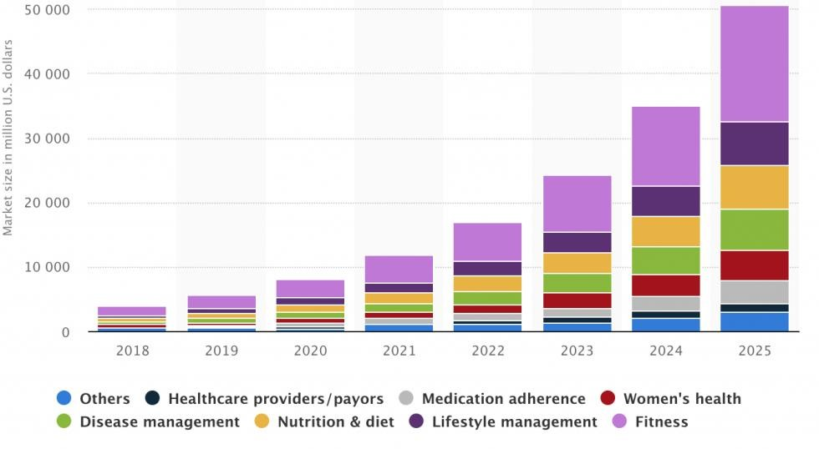

Figure 1 - Projected number of mental health mobile applications in 2018 - 2025

Unfortunately, a lot of products are developed by small teams that do not involve professionals in creating relevant functionalities and content which should help users overcome their psychological disorders.

It is obvious that any possible mental health mobile application cannot substitute treatment sessions with a psychologist/psychotherapist or medication, but at least they can help to improve quality of sleep, teach how to meditate and breath, track mood, make users happier, increase productivity, reduce anxiety and depression etc.

The market for mental health apps is growing. Recently, Global View Research studied that a compound annual growth rate (CAGR) will be expanded up by 16.5% from 2022 to 2030 [4]. They believe an increasing awareness of mental health as well as people lifestyle will be main reasons of the market expansion.

In 2018, the top ten mental health digital solutions gained $15 million in the U.S. alone and $27 million worldwide [5]. They used the following monetization strategies:

1. Subscriptions. The technique allows users to gain access to premium content by renewing their subscriptions weekly, monthly, or yearly.
2. Freemium. It is also possible to let users access an application for free to view some content and do certain activities, however any other meaningful content should be paid separately.
3. In-app advertising. Advertising banners can generate income, however it has small margin. Also, it is necessary to display materials that will be relevant to users. Analysis of available applications in App Store or Google play shows that successful products mostly stick with subscription payments, as people used to pay regularly to get what they want in full volume. Even Apple noted that the subscription revenue strategy makes more money for applications, comparing with other techniques. Nevertheless, One Mind PsyberGuide says, while the number of available mental wellbeing apps increases, user engagement remains low. To succeed, creators should consider developing a solution relevant to their end user instead of setting higher prices

or getting more subscribes.

While stages for developing a mental health mobile application are similar when comparing with general applications, there are two aspects which should be considered when managing the project:

1. Conduct product discovery. There are plenty of psychological disorders, so you need to have a clear vision which exact problems you wish to solve. It is also crucial to understand your target audience, as, for example, teenagers and the elderly have different concerns.
2. Build a strong team. To develop a successful mobile application, that will help people and not harm them, hiring specialized professionals is a must. They will help to find out what problems people experience, and which activities are more effective.

In general, if you manage a mental health mobile application development project, you should follow the next steps: idea validation, market research, preparing a list of app requirements, building a project team, involving specialists in the mental health field, designing, developing, testing, and releasing the app (the Figure 2).

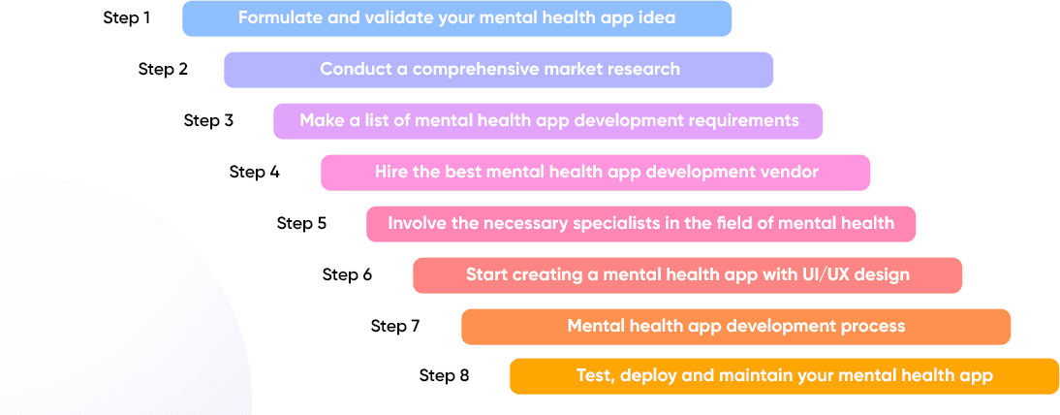

Figure 2 – Mental health app development from idea to launch in 8 steps

To sum up, developing a mental health mobile application is a very responsible project as it should assist people with making their lives better. If a project team considers all aspects to make the application outstanding, more people will be getting mental wellbeing improved while creators could receive significant recognition and income.

**References:**

* 1. World Health Organization. World mental health report, 2022. URL: https:/[/www.who.int/publications/i/item/9789240050860](http://www.who.int/publications/i/item/9789240050860)
  2. R. A. Clay, Mental health apps are gaining traction, 2021. URL: https:/[/www.apa.org/monitor/2021/01/trends-mental-health-apps](http://www.apa.org/monitor/2021/01/trends-mental-health-apps)
  3. Medgadget, Tech therapy 2020 or how mental health apps bridge gaps in the healthcare system, 2020. URL: https:/[/www.medgadget.com/2020/12/tech-therapy-2020-or-how-mental-](http://www.medgadget.com/2020/12/tech-therapy-2020-or-how-mental-) health-apps-bridge-gaps-in-the-healthcare-system.html
  4. Balaskas A, Schueller S, Cox A, Doherty G, The Functionality of Mobile Apps for Anxiety: Systematic Search and Analysis of Engagement and Tailoring Features, JMIR Mhealth Uhealth 9 (2021). URL: https://mhealth.jmir.org/2021/10/e26712. doi: 10.2196/26712
  5. Yana Petlovana, How to Develop a Feature-rich Mental Health Solution, 2021. URL: <https://steelkiwi.com/blog/how-to-develop-a-feature-rich-mental-health-solution>
  6. Yuriy Matviyuk, How to Create a Mental Health App in 2023? [Features, Roadmap, Real Cases]. URL: https://northell.design/blog/how-to-create-a-mental-health-app

## Vitalii Mykhalchuk

Ph.D. Student

*Taras Shevchenko National University of Kyiv, Ukraine*

# EVALUATION OF COGNITIVE BIASES IN BRAIN-COMPUTER INTERFACES

**Abstract.** Decision making is faced with the influence of cognitive biases. Minimizing the action of such factors allows you to optimize workflows and increase performance efficiency. To achieve this goal, special strategies can be developed in smart environments equipped with a BCI-mode.

**Methodology.** Human-machine interaction involves the combination of several components. Therefore, the development of technologies takes place along the lines of improving hardware and software and the development of human neuroplasticity, increasing the level of brain-computer literacy.

Much attention is paid to the issue of quality development of brain-computer interfaces in such fundamental works as "Fundamentals of BCI" by A. Nijholt, "Clocking the mind" (Jensen A. R.), "Toward Brain-Computer Interfacing" (Dornhege, G.) [1, 2, 3]. An important research method eis multi-level analysis in system design. One of the newest research projects directed in the most near about this topic is “Cognitive Stress Classification” (Blanco J., 2019) [5].

**Results.** The research is conducted in an environment with a brain-computer interface. A smart component is the testing system covering the field of professional knowledge created on the basis of a bank of tasks. Each task and answer options are stimuli offered to the student. The test participant trains his own reaction to these stimuli.

According to our research [6] mental activity in efficient network represented by cognemes of idiolect compared with “typical” jargon. In actual research such approach combined with evaluation of cognitive biases influence in working process. With such aim working process presented as flow of tasks and decisions. Performance prospective can be represented in correlation of indicators such as efficiency (accuracy and reaction time) and its mental view. Each task is stimuli with own degree of complexity, which may be described by type of object (code, algorithm, decision etc.), typical reaction time, cognemical view, accuracy distribution for these conditions, answer array or tree, and evaluated into this representation. Cognitive biases [4] can be described by type (motivational, performance, memory, and perception), intense (difference between normal reaction time and performed in the study), coordinate in perfomogramme (timed event-related position in the performance matrix correlated with decision making). Fixation of performance metrics includes EEG analysis by data correlation of ideal and current with biases marked.

For the 7’30-10’20 cut of 15 minutes routine of debugging the cognitive biases influence have presented on the Fig. 1 correlation matrix.

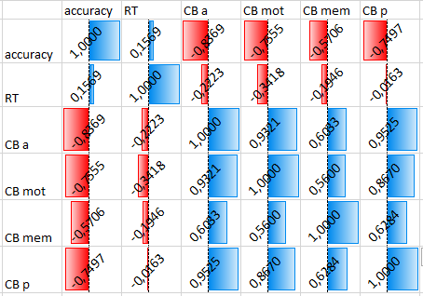

Figure 1 – Cognitive biases evaluation by Pearson criteria (correlation matrix). Results by study of 15 attempts through previous BCI illiteracy diagnosis (1-4th – Stroop color test, navigation 8 sec. training and 2’30-5 min transformation with spontaneous decisions and reactions), individual training session in routine 15 min tasks (5-11th) with different performance condition (usual, stressed and spontaneous workload), mindfulness (13th - meditation) and correctional training (14-15th - ideal performance)

## Conclusion.

Implementation of cognitive technology on the model of advanced companies in educational activities allows students to develop the skills of effective adaptation to modern working conditions and increases the efficiency of training. Expanding the power of research (complex tests, several stages of processing results, adaptation of test programs to the curriculum studies system) will be the stage of mastering neuroplasticity as a new type of competence.

**References:**

* + 1. Nam, Chang & al. (2018). Brain-Computer Interfaces Handbook: Technological and Theoretical Advances. 284 p.
    2. Dornhege, G. Toward Brain-Computer Interfacing. MIT Press, 2007. 520 p.
    3. Jensen A. Clocking the Mind: Mental Chronometry and Individual Differences. Elsevier, 2006. 286 p.
    4. Kahneman, D., & Tversky, A. (2000). Choices, Values, and Frames. 840 p.
    5. Blanco J.A., et al. Single-Trial Cognitive Stress Classification Using Portable Wireless Electroencephalography. Sensors (Basel). 2019 Jan 25;19(3):499. doi: 10.3390/s19030499. PMID: 30691041; PMCID: PMC6387350.
    6. Mykhalchuk V. Cognitive design of educational brain-computer interfaces. ITTAP’2022: 2nd International Workshop on Information Technologies: Theoretical and Applied Problems, November 22–24, 2022, Ternopil, Ukraine.

## 1 Vitalii Mykhalchuk

PhD Student, Department of Information Systems and Technology

## 2 Alexander Kuchansky

Doctor of Sciences, Professor of the Information Systems and Technology Department

*1,2 Taras Shevchenko National University of Kyiv, Ukraine*

# BRAIN-COMPUTER INTERFACES AND EDUCATION

**Abstract.** One of the achievements of modern society is the brain-computer interface (BCI) as a way to organize an intelligent environment. Such systems have already been successfully implemented and contribute to integrating people with disabilities into society, overcoming disorders, diagnosis, and monitoring well-being. Studying mental activity in business interaction, training, consumer activity, and entertainment is becoming increasingly popular. The study of the peculiarities of the functioning of human consciousness contributes to the successful integration of brain- computer interfaces into modern technologies of information systems such as invisible computing.

**Keywords:** brain-computer interfacing, e-society, connectivity.

The study of the peculiarities of the functioning of human consciousness contributes to the successful integration of brain-computer interfaces into modern technologies of information systems such as invisible computing. The article highlights the latest trends in the development and implementation of neuro-computer interfaces with the principles of the organization of e-society and the problems and prospects that arise in the conditions of its evolution. The analysis was carried out based on the research of real successfully implemented projects, and the experience of participation in conferences was applied. Possible actual implementations are described, and examples have already been implemented. Particular attention is paid to the issue of neuro-computer inequality and its solution, which is one of the main detachable issues that have been updated in recent years. The implementation of neuro-computer interfaces in combination with popular trends and technologies such as post-quantum programming, consciousness uploading, cloud, and fog computing, and enter civilization communication are investigated. The nearest electronic society stage (2035-2050) based on Z and α generations will acquire critical skills in the mental management of intelligent environments, increasing the efficiency of information systems of any complexity and purpose. The first steps to this point of development that have already been done are the legalization of BCI technology and mass user implementation, which continue to be investigated along with the rapid growth of generation and the performance of new ideas following the latest opportunities and conditions.

Brain-computer became more popular and developed their comprehensive improvement for different spheres of human activity in various technological decisions and specializations. Today we have a range of successfully used projects such as assistive and for typical users. Technology includes consumer, education, business,

navigation, fashion, health monitoring, emotion control, etc. Shared experience and the number of equipment realize the opportunity to raise a BCI community at the nearest time. The 2015 BNCI society report showed significant growth in customer activity in 2011 when in comparison with the previous year, 4 million devices were sold. Also, this report presented an essential and large volume of prognosis for the nearest paths of BCI development:

* increasing hybrid functional use in 2025;
* the rising number of devices for non-medical use by 2035;
* the growing BCI society by 2045.

The technology overcame a range of problems by 1980-1990, and the main achievement of implementation in 2008-2011 is a trend of wireless devices available for everyday use for mood monitoring, health care, input and administration, business, etc. [1]. Mental commands are accessible for interfacing with any task, and an open software development policy improves the efficiency of the exchange of ideas and practices of its implementation.

The comprehensive development of BCI at the intersection of many trends in information technology forces us to evaluate the next steps in technology development and outline the likely directions and solutions for wide implementations. It is also worth noting the new challenges and problems of using such technologies in the predicted conditions. The most significant interest lies in the fascination of the next 20-30 years, and the progress of development technologies and approaches to system design influences the conditions. No less critical factors will be the co-alignment in the labor market of different generations and the difference in the ability to use such tools.

Neuro-computer interfaces are becoming a standard technology in modern society. Careful regulation of implementation standards and different quality of developer products, availability, and ease of use indicate readiness for widespread implementation. The use of BNCS in adjustment with the latest immersive technologies (VR, voice input, game learning) expands the possibilities of mastering the skills of neurocomputer management. The availability of methods for improving neurocomputer literacy, regulation of this concept, and active research to improve the quality of BCI implementation means a fundamental stage in developing technology in modern intellectual environments and the world of IoT.

**References:**

1. C. Brunner, N. Birbaumer, B. Blankertz, C. Guger, A. Kübler, D. Mattia, J. del R. Millán, F. Miralles, A. Nijholt, E. Opisso, N. Ramsey, P. Salomon, G. R. Müller-Putz. BNCI Horizon 2020: towards a roadmap for the BCI community, Brain-Computer Interfaces, 2:1, 2015, 1- 10, DOI: 10.1080/2326263X.2015.1008956
2. C. Wegemer. Brain-computer interfaces and education: the state of technology and imperatives for the future. International Journal of Learning Technology. 14. 2019. 141. 10.1504/IJLT.2019.101848

## 1 Artur Naberegniy

Master’s student of the Faculty of Information Technology

## 2 Hrygorii Hnatiienko

PhD, Deputy Dean of the Faculty of Information Technology

*1,2 Taras Shevchenko National University of Kyiv, Ukraine*

# WEB APPLICATION FOR EVALUATING THE LEVEL OF CRITICALITY OF ORGANIZATIONAL SYSTEM ELEMENTS

**Abstract**. In today's rapidly changing world, an important aspect of ensuring the functional stability of organizational system is the stable functioning of critical elements of a system. Determining the level of influence of critical elements on the functioning of organizational systems in a quantitative form is a complex multifactorial problem. Its solution requires large labor costs, the use of special procedures and considerable time spent by specialists in various fields. The purpose of this work is to study the problem of determining the criticality of elements of organizational systems and to create a web application for structural analysis of organizational systems.

**Keywords:** expert evaluation, organizational system, critical element, diagram, structure

**Introduction.** The critical elements of any system are such elements, the state and functionality of the system depends on their functioning [1, 2]. It is clear that not all critical elements affect the state of the system to the same extent, and may differ from each other in the intensity of influence on the functionality of the system, i.e., the level of criticality. One of the tools for determining the level of criticality of organizational system elements is expert methods [3]. Such methods are flexible to account for ambiguity in the problem because experts have an understanding of the trends and features of the system being evaluated. The disadvantages of expert evaluation method are subjectivity of experts and evaluation criteria. For example, in the European Union, the most critical are power plants and main transport highways. In Israel, due to the dominance of the "Symbolic significance of objects" criterion, the most critical are museums, archives, monuments, etc.

**System structure.** The analysis of the task made it possible to form the following list of system functions (Figure 1) for the implementation of the platform for evaluating the organizational structure in the form of a web application. They can be conditionally divided into three groups, according to three groups of users. Client services include various project management capabilities and view results. Experts can view a visualization of the structure and provide their assessment. Administrators have a variety of options for interacting with all categories of users.

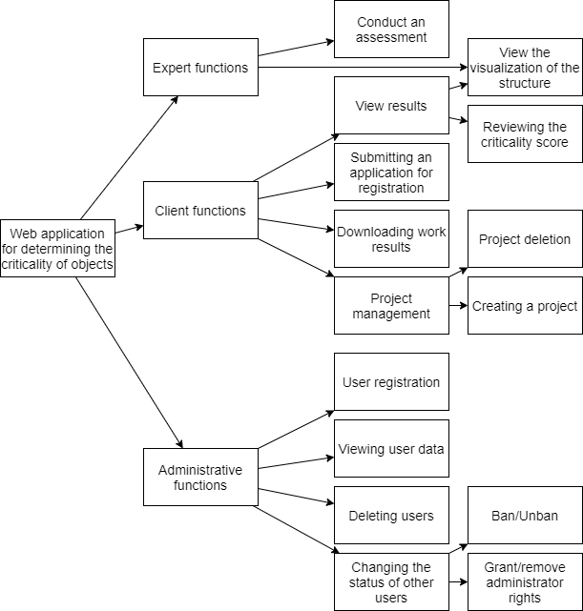

Figure 1. Diagram of functions of a web application for assessing the criticality of elements of organizational systems

the criticality of elements based on visualization. After that, their ratings are aggregated and displayed Figure 2 shows the interaction process of users and experts with the system in IDEF0 notation. After authorization, the user creates a project and uploads data about his organization. After that, a visualization of the system is created and provided to experts and users. Experts evaluate to the client.

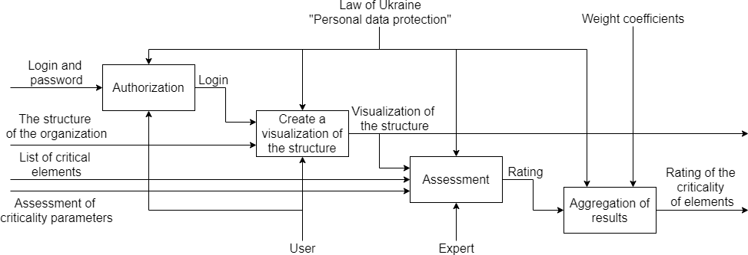

Figure 2. Diagram of a web application for assessing the criticality of elements of organizational systems in the IDEF0 notation of the first level of decomposition

**Expert evaluation of the level of criticality of elements.** In order to reduce the

burden on each of the *k* experts with indices

*i*  1,..., *k*,

the evaluation process was

divided into two rounds. At the first stage, voting is held for 10% of the most critical elements, which go to the second round. In the case of an equal number of votes, all edge votes are taken. In the second round, experts evaluate specific elements

*aj* , *j*  1,..., *n*,

by three parameters with indices

*l*  1, 2, 3 :

* impact on system resources;
* streams that the element controls;
* influence on decision-making in the system.

We will denote these parameters as

*gil* , *i*  1,..., *k*,

*l*  1, 2, 3,

(1)

and rate them on a scale of 1 to 5, where 5 is the highest level of criticality of impact. The results of this round are the levels of criticality of each element, whose

integral indicator

*ξ j* , *j*  1,..., *n*,

is determined by applying linear convolution, with

equal weight of all experts and parameters:

3 *k*

*ξ j*   *gil* ,

*j*  1,..., *n*.

(2)

*l* 1 *i*1

Thus, each critical element of the system receives a reasonable indicator of the impact on the functioning of the system - the level of criticality, calculated according to formula (2) based on expert assessments (1).

**Database.** A relational database was designed to store all the above-mentioned data (Figure 3). The customer entity includes credentials and contacts. He creates projects and enters the data of experts who will participate in it.

Each expert provides evaluation results for both rounds, on the basis of which the results of the rounds are formed, connected to the project.

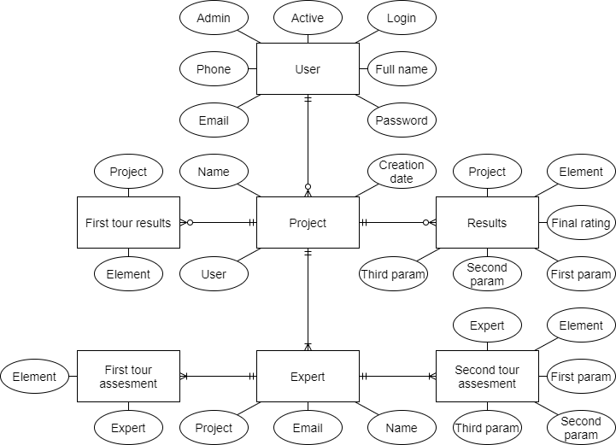

Figure 3. Conceptual database structure for evaluating the criticality of organizational system elements in bird's foot notation

Experts enter the system through an invitation link sent to an e-mail address specified by the user when creating a project. This invitation takes them to the assessment page. After that, they go to the thank you page, from where they can go only to public pages of the application.

**Conclusions.** The analysis of the features of organizational systems and modern approaches to the task of determining the criticality of their elements showed that such a task can be effectively solved by creating an information system. The design of the information support of the information center was carried out. These diagrams can be used for further development of information software in this direction, which will facilitate and automate the process of assessing the criticality of elements of organizational systems for any direction.

**References:**

1. Babenko, T., Hnatiienko, H., Ignisca, V., Iavich, M. Modeling of critical nodes in complex poorly structured organizational systems // Proceedings of the 26th International Conference on Information Society and University Studies (IVUS 2021), Kaunas, Lithuania, April 23, 2021 / CEUR Workshop Proceedings, 2021, 2915, pp. 92–101.
2. Hryhorii Hnatiienko. A model for determining the critical elements of a complex weakly structured system // Problems of cyber security of information and telecommunication systems: Collection of materials of reports and theses; Kyiv, April 15-16, 2021; Kyiv National University named after Taras Shevchenko / Editor: O.K. Zakusylo (head) and others. – Kyiv.: PPC «Kyiv University», 2021 – Pp.147-148.
3. Hnatiienko H.M., Snytyuk V.Y. Expert decision making technologies: Monograph. – К.: PLC «Maclaut», 2008. – 444 p.

## 1Volodymyr Nakonechnyj

Doctor of Technical Sciences, Professor at the Department of Cyber Security and Information Protection, Faculty of Information Technologies

## 2Vladyslav Lutsenko

Student at the Department of Cyber Security and Information Protection, Faculty of Information Technologies

*1,2Taras Shevchenko National University of Kyiv*

# HOW BLOCKCHAIN TECHNOLOGY CAN AFFECT THE BANKING INDUSTRY

**Abstract.** Everyone nowadays is aware of the value of investing in technology and the excess returns it provides. One of the trendiest technologies on the market right now is blockchain. For the first time ever, not only have investors made their fair share of investments in blockchain, but investment banks are also currently employing this technology.

**Keywords:** card, blockchain, data exchange, online, transaction, financial institutions, cryptography, investing

Blockchain technology can destroy not only the global currency market, but also the banking industry as a whole, replacing intermediaries with a reliable, limitless and transparent system that is easy to access for anyone.

Blockchain can reduce the waiting time for transactions, make them cheaper, facilitate the process of access to capital, improve data security, ensure mutual fulfillment of obligations in agreements through smart contracts, as well as smoother compliance and much more.

On top of that, thanks to the innovative nature of blockchain technology, the ways in which new blocks of transactions interact with each other could lead to completely new kinds of financial services.

Information is kept in "blocks" that are connected together and are stored in a decentralized database called a blockchain. It performs extremely particular duties that set it apart from the conventional centralized database, including computing, storing, and analyzing the data contained in this database [1].

Using blockchain technology, money transfers and payments become decentralized. This has a number of implications for the financial sector [2]:

* Because the decentralized database is less vulnerable to data breaches, hacking, or the statistics being manipulated with, there is a decrease in fraudulent crimes and activities. This implies a more open financial system as well.
* Since blockchain technology relies on real-time payment executions, banks will be able to transfer payments at a faster rate.
* Additionally, it aids in promptly recognizing illicit activity and discovering irregularities in financial operations.
* Blockchain also prevents most human mistakes since data transmitted to the blockchain cannot be changed, altered, or tampered with once it has been sent. Additionally, everyone can see it.

The intensity of interaction with technology grows annually. While from 2017 to 2019 the main priority was to learn blockchain in practice, in 2019 there was a shift in focus to patenting inventions.

The problems faced by the Facebook and Telegram projects could play a certain role - Financial institutions are cautious, fearing regulatory risks. In addition, commercial expectations from the launched blockchain projects could not be justified. However, Financial institutions do not want to be left behind in the blockchain arms race and want to take their place in the emerging markets for blockchain solutions, which explains the increase in scientific developments and the transition to more closed formats of interaction with technology.

Thus, the “blockchain revolution” continues and moves to a qualitatively new level, despite the decrease in the number of public blockchain projects. The largest financial institutions in the world continue to actively work with technology, investing both time and money in it [3].

How to ensure that transaction and wallet information is correct, complete and confidential and how to get access to your assets in conditions of anonymity: some of the issues that need to be addressed. There is a whole science of how to solve these problems - cryptography. Encryption is one of its methods.

In blockchain networks, the buyer and seller of an asset confirm the transaction using cryptographic keys - special unique digital codes [4].

It is almost impossible to guess the sequence of characters of the digital code of cryptographic keys. This makes blockchain technology one of the best for financial transactions. But at the same time, there have already been cases of wallets being hacked, so it is better to connect them to the network only for the duration of transactions, and keep them offline the rest of the time.

**References:**

1. David Lukic, As blockchain becomes widely used in banking, what are its security risks?, 2021. URL: https://forkast.news/blockchain-banking-security-risks/
2. How can blockchain change the current banking system?, 2019. URL: https://academy.binance.com/ru/articles/how-blockchain-technology-will-impact-the-banking- industry
3. Ruslan Yusufov, Alexander Anichkin, Evgeny Soloviev, Blockchain revolution in banks and financial institutions, 2020. URL: https:/[/www.researchgate.net/publication/346648359_Blokcejn-](http://www.researchgate.net/publication/346648359_Blokcejn-) revolucia_v_bankah_i_finansovyh_institutah_2020
4. Blockchain revolution in banks and financial institutions, 2020. URL: https://fincult.info/article/blokcheyn-chto-eto-takoe-i-kak-ego-ispolzuyut-v-finansakh/

## 1 Mykyta Nikolayev

PhD Student, Department of Information Systems and Technology

## 2 Andrii Onyshchenko

Doctor of Sciences, Professor of the Information Systems and Technology Department

*1,2 Taras Shevchenko National University of Kyiv, Ukraine*

# CURRENT INFORMATION TECHNOLOGY TRENDS IN FINANCIAL MANAGEMENT

**Abstract.** Advances in technology have led to fundamental changes in the way financial markets work, starting with the initial stage of forming stocks and continuing through trading those stocks. Technologies have fundamentally changed the way investments are made. Financial markets today are primarily computerized, from software-based bidding to price determination and direct clearing and settlement. Computer technology has displaced manual operations and simplified functions throughout the value chain. Stock markets worldwide are using technological advances to manage and monitor transactions securely.

**Keywords:** information technologies, stock market, financial instruments, stock trading.

Advances in technology have led to fundamental changes in the way financial markets work, starting with the initial stage of forming stocks and continuing through trading those stocks. Technologies have fundamentally changed the way investments are made. Financial markets today are primarily computerized, from software-based bidding to price determination and direct clearing and settlement. Computer technology has displaced manual operations and simplified functions throughout the value chain. Stock markets worldwide are using technological advances to manage and monitor transactions securely. Currently, modern trading on the stock exchange takes place without the physical contact of brokers and provides unlimited opportunities for researching market trends and buying shares. Thanks to the introduction of technology, the stock market has become more user-friendly, providing faster settlement of transactions, increased transparency, security, automated monitoring, and much more. The close connection between information technologies and financial markets is beyond doubt, as is the relevance of research into using information technologies and innovative solutions to achieve the highest results in financial markets. The purpose of this study is to review and analyze modern information technologies used in securities trading. In particular, attention is focused on

* tools for forecasting trends in financial markets;
* technological solutions to increase the financial literacy of the population, open access to the securities market regardless of the age category of the user, his professional activity, etc.;
* the advantages and disadvantages of online trading, the specifics of the work of online brokers, and their role in trading on financial markets;
* technical analysis, time series analysis, and quantum computing for trend analysis in financial markets;
* the use of information technologies in the derivatives market.

However, despite the radical changes caused by modern information technologies in disseminating information, the impact of contemporary information technologies on the production of knowledge by market participants still needs to be studied [1].

A few decades ago, managing your finances required recording your income and expenses in a paper ledger or, more recently, manually entering information into an Excel spreadsheet. The development of technologies significantly simplified this process, and various mobile applications began. The rapid growth of mobile applications for personal finance (Personal financial management, PFM) has benefited both businesses and consumers. Wealth management applications allow them to benefit from simplified payment processes and better understand market needs and customer spending habits.

Programs for managing personal finances and the stock market have a direct connection. Investment is something that a person often does only if he already has savings or temporarily free funds that can be invested without harming the financial situation. Investing in the stock market can only be done if you fully understand your current financial situation. In this case, personal finance programs play a significant role. They provide an overview and can track a person's spending, which helps you manage your budget correctly. In addition, such programs contribute to the growth of financial literacy among the population, prepare the younger generation to invest their savings in the stock market, and help them in this.

The average user has 2.5 financial apps on their phone, one of which is most likely a personal finance management tool. More and more services offer the opportunity to make small investments, that is, to receive part of the shares if only one part is worth thousands of dollars, as in the case of Amazon and Booking Holdings.

Investment services have become one of the leading directions in personal finance. For example, consider the popular mobile app Robinhood, which allows you to invest in stocks, ETFs, and options. The built-in functions and investment opportunities determine the effectiveness and popularity of modern mobile applications for financial management. Of course, some wealth management programs have offered investment options for some time. First, these are investment tools with the additional ability to track expenses.

Robinhood's goal was not to create a program for day traders or portfolio managers but to create a program for beginners, that is, retail investors. The developers of this application claim that they make investments accessible to young people. “Most stock brokers have been around for over 30 years, their interfaces are clunky, and they target older professionals and active traders. They're not a place for novice investors, and that's one of the things we focus on. Make it accessible. To make it convenient for mobile devices" [2]. Thus, the application teaches young people to control their daily expenses, save pocket money, and try themselves as an investor and make a small profit in the long run.

Another general application is Stash, which helps users think more intelligently about where to invest, learn more about different investment options, compare them and make an appropriate decision. About 25,000 users join investment processes and stock trading every week. Analysts estimated that from January to September 2020, the number of users increased by 1 million and amounted to 6 million. The application also opened opportunities to diversify the investment portfolio, which was different from the previous application. Unlike an app like Robinhood, which until early 2020 required users to have a significant amount of cash in their account to buy shares in companies like Facebook or Amazon, Stash allowed them to invest in bundles of related stocks for as little as $5 . Instead of investing in stocks, users invest in ETFs, exchange-traded funds, or securities that rise and fall depending on the value of their underlying asset or commodity [3].

Technology has led to fundamental changes in the way financial markets work, starting from the very first stage of the formation of stocks and continuing through trading those stocks. Technology, without a doubt, has fundamentally changed the way investments are made. Financial markets today are primarily computerized – from software-based order submission to price determination and direct clearing and settlement, computer technology has displaced manual operations and simplified functions throughout the trading value chain. The emergence of modern information technologies has radically changed the way information is disseminated in financial markets, making a large amount of information available to a broad base of financial market participants in real-time at low costs. The close connection between information technologies and financial markets is beyond doubt, as well as the relevance of research into using various information technologies and innovative solutions to achieve the highest results in financial markets.

**References:**

1. M. Gao, J. Huang. Informing the market: the effect of modern information technologies on information production. The review of Financial Studies, 33 (4), 2020,1367-1411. https://doi.org/10.1093/rfs/hhz100
2. This Is What Makes 2022 Best Time for Launching Personal Finance App, 2022. URL: https://shakuro.com/blog/what-makes-now-a-great-time-to-build-a-personal-finance-app.
3. How Top Personal Finance Companies Built The Best PFM Apps, 2022. URL: https:/[/www.cbinsights.com/research/personal-finance-apps-strategies.](http://www.cbinsights.com/research/personal-finance-apps-strategies)

## 1Ya. Nizov

Student

## 2Tetiana Latysheva

Lecturer at the Faculty of Information Technology specializing in IT project management

*1,2 Taras Shevchenko National University of Kyiv, Ukraine*

# EFFECTIVENESS OF THE WORK OF THE PROJECT MANAGEMENT TEAM FOR THE DEVELOPMENT AND IMPLEMENTATION OF AUTOMATED TECHNOLOGY TO SOLVE ENVIRONMENTAL PROBLEMS (FOR THE "SMART PARKS" IT PROJECT)

**Abstract.** The article describes an effective approach to the work of a team management on its own method "Rings of curiosity".

**Keywords:** Project, smart, managing, development, parks, effective.

1. Introduction

The success of projects always depends on many factors, but there is one without which the project cannot exist at all - the team. The team can be different, divided into subgroups and have their own goals, but it must be effective, because only in this way will work in the project make sense and bring results.

The IT project management team is no exception to this rule, although projects of this specification may contain flexible personnel and have the ability to work remotely more than anyone, but if there is no effective work, then the project will not reach the release stage. Therefore, I will explain what, in my opinion, depends on the effectiveness of the project management team. An example will be the imaginary IT project "Smart Parks"[1], which should present automated technologies as a solution to the environmental problem of maintaining parks and other urban green areas. The success of this project completely affects the development of the infrastructure of the cities where this system will be implemented, so the team must do everything possible for its implementation.

1. General rules for managing a team.

Of course, the first criterion for creating effective work will be the recruitment of suitable personnel, and since the system must have not only a software part, but also a physical part with real smart technologies, the team management will distribute responsibilities according to the specifications of the participants[2]. This stage is the first step in determining whether your team will be effective or not, because the manager must establish connections between the teams of the1i software part, physical technologies and specialists in environmental studies. This will provide an opportunity to have up-to-date information on each area of the system's activity and develop the entire system at the same time. Creating synergy in this way, it is necessary to set certain goals and objectives, limiting the spread of ideas of developers. Also, the management team should specify time constraints, i.e. deadlines and control points for each division. After that, the management team itself will have to monitor the activities and the performance of tasks, so as not to create the appearance of a manager who, apart from the formation of goals and control milestones, can do nothing else. Management is also work, but the project worker must know that their managers are

competent in the goals and tasks they set; and they will be able to participate in the development as an employee, if necessary. This could be called creating equality between project participants, but this is not the case, because the main goal in this case is to make the employee understand that the manager is completely confident in the tasks he has set and knows for sure that they are possible and important.

1. Rings of curiosity.

All of the above, except for the last one, of course, are general criteria[3] for forming a quality team. Then any team is effective according to these criteria. No. The above should contain the "Three Components of Interest" at each stage of project work, which in turn will contribute to the effective work[5] of the team of workers, which means that the management team performs its work effectively. "Three components of interest"[Figure 1] are three interrelated factors of effective activity, or more precisely, encouragement for it. The components consist of interest (For What?), argumentativeness (Why?) and motivation (What?). First, the manager needs to determine, "For What?" employees on this project, their own goals and needs, after which he connects the team's various goals to the project and argues "Why?" everyone needs it. But motivation acts as anchor, namely "What?" successful completion of this project will provide each participant.

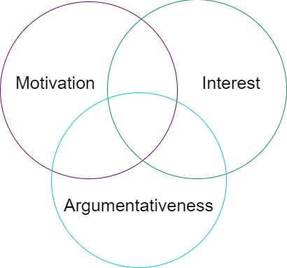

Figure 1: Rings of curiosity.

1. Conclusion.

Thus, the management team being on a complex IT project, which counts specialists from different technical fields of activity, can direct, organize and encourage them, which will show the effectiveness of the method of managers who were able to interest their entire team, even in circumstances where specializations can be difficult to interact with.

**References:**

* 1. Fedoskenko, N. (2016). A "smart" park will appear in Israel. [online] Available: <https://ecotown.com.ua/news/V-Izrayili-z-yavytsya-rozumnyy-park> [Date of application November 15 2021].
  2. Wang, C., & Zhang, P. (2012). The evolution of social commerce: The people, management, technology, and information dimensions. Communications of the Association for Information Systems, 31(1), 105–127.
  3. PMBOK Guide. URL: [https://www.pmi.org/pmbok-guide-](https://www.pmi.org/pmbok-guide-standards/foundational/PMBOK) [standards/foundational/PMBOK](https://www.pmi.org/pmbok-guide-standards/foundational/PMBOK)
  4. Projectlibre URL: <https://www.projectlibre.com/>
  5. Career Options in Management URL: [https://www.upgrad.com/blog/career-options-](https://www.upgrad.com/blog/career-options-in-management/) [in-management/](https://www.upgrad.com/blog/career-options-in-management/)

## 1 Dmytro Palko

PhD student, Cybersecurity and Information Protection Department

## 2 Tetiana Babenko

Doctor of Technical Science, Professor of Cybersecurity and Information Protection Department

## 3 Larysa Myrutenko

PhD in Technical Science, Associate Professor of Cybersecurity and Information Protection Department

## 4 Andrii Bigdan

Assistant of Cybersecurity and Information Protection Department

*1-4 Taras Shevchenko National University of Kyiv, Ukraine*

# INTELLIGENT RISK ASSESSMENT MODELS IN DIS BASED ON THE NEURAL NETWORK APPROACH

**Abstract.** The research focuses on the current trends and existing approaches to information security risk assessment in distributed information systems. It analyzes the importance of risk management in the process of ensuring information security, and also describes a core principles of intelligent security risk assessment in DIS based on the neural network approach. It also presents a comprehensive model of cyber risk assessment based on backpropagation neural network architecture and several optimization methods.

**Keywords:** information security, information security risk, risk assessment, risk management, risk evaluation, distributed information system, neural network.

With development of computer networks the security issues in distributed systems have acquired special significance. Distributed information and computing networks unite all structural divisions and branches of organizations into a single system, allow simultaneous work with distributed and centralized applications, databases, and other services, as well as connect computer systems to each other to distribute functions and share resources. Managing the cybersecurity risk assessment in distributed systems involves solving a set of problems related to functional distribution and hierarchy, a high degree of resources parallelization, and a near-complete lack of centralized management [1].

Organization of cyber security risk assessment in distributed systems is a complex task. When solving it, one has to take into account many factors and risks that can have a negative impact on the company's activities, threat confidentiality, integrity, availability of information, the quality and speed of its processing and transmission [2]. Cyber security risks should be considered as a key factor in the strategic planning of business processes [3].

According to the results of the annual ISACA`s «STATE OF CYBERSECURITY 2022: GLOBAL UPDATE ON WORKFORCE EFFORTS, RESOURCES AND

CYBEROPERATIONS» global State of Cybersecurity Survey, conducted in the fourth quarter of 2021, the vast majority of respondent’s enterprises at least once a year conduct a regular assessment of information security risks (41 percent, compared with

last year’s 39 percent). Enterprises face many obstacles to conducting frequent cyber risk assessments – time, lack of internal expertise, lack the right cyber tools to effectively perform an assessment or their cost. This, in turn, points to an important issue that signals the lack of sufficiently accurate and universal methods of cyber security risk assessment [4].

Classical statistical methods of risk analysis (qualitative, quantitative, or even combined) do not supply the desired result due to their imperfection and significant limitations in terms of use.

An expert analysis requires a significant level of competence and extensive practical experience from the experts. On the other hand, it's time consuming and can't be applied for analysis of large raw datasets [5].

A very promising direction of research in the field of risk assessment for complex, large-scalable and distributed systems is the application of intelligent solution modeling methods based on the neural network approach [6]. Even the simplest back- propagation neural network architecture can perform live-time pattern recognition with reasonable speed (Figure 1) [7-8].

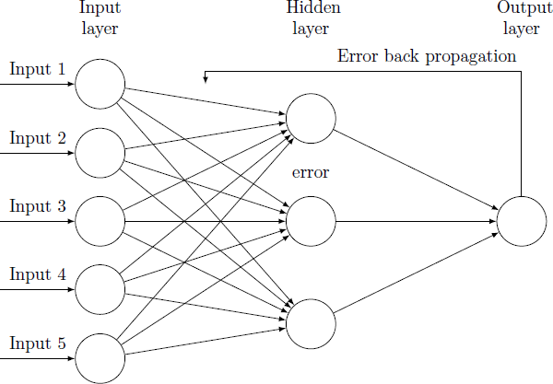

Figure 1 – Back propagation neural network architecture

Neural networks are not a new concept, but only in recent years, various companies have begun to explore and understand its full potential. The absolute advantage of neural network structures is their ability to learn, self-organize and generalize, as well as the ability to solve complex tasks [9].

An important aspect of the current research is the theoretical proof of the effectiveness of the application of back-propagation neural networks in this subject area and the practical implementation of the information security risk assessment model for solving risk management problems in distributed environments that have a number of advantages compared to classical methods of risk assessment. Research

presents a dynamic and comprehensive model of cyber risk assessment in DIS based on back propagation neural network architecture and several methods of its optimization, which provides sufficient accuracy and reliability of risk assessment in the conditions of analysis of security metrics in large arrays of heterogeneous distributed data.

**References:**

1. Dmytro Palko, Hrygorii Hnatienko, Tetiana Babenko, Andrii Bigdan «Determining Key Risks for Modern Distributed Information Systems» // IntSol-2021 Intelligent Solutions, September 28–30, 2021, Taras Shevchenko National University of Kyiv, Kyiv, Ukraine
2. Pihovkin N., Sakharov D. SECURING A DISTRIBUTED INFORMATION NETWORK, TAKING INTO ACCOUNT RISK MANAGEMENT / ТРУДЫ УЧЕБНЫХ ЗАВЕДЕНИЙ СВЯЗИ

№ 2, 2016

1. Dmytro Palko, Vira Vialkova, Tetiana Babenko «Intellectual models for cyber security risk assessment» // Processing, transmission and security of information : Monografia. Tom 2. / Akademia Techniczno-Humanistyczna w Bielsku-Białej. –Bielsku-Biała : Wydawnictwo Naukowe Akademii Techniczno-Humanistycznej w Bielsku-Białej, 2019. – S. 284–288.
2. 2022 Global State of Cybersecurity Survey «STATE OF CYBERSECURITY 2022: GLOBAL UPDATE ON WORKFORCE EFFORTS, RESOURCES AND CYBEROPERATIONS»

[Електронний ресурс] // ISACA® [(www.isaca.org).](http://www.isaca.org/) – 2022. – Режим доступу до ресурсу: https:/[/www.isaca.org/state-of-cybersecurity-2022](http://www.isaca.org/state-of-cybersecurity-2022)

1. Dmitry Palko, Tetiana Babenko, Larysa Myrutenko, Andrii Bigdan «Model of information security critical incident risk assessment» // Proceedings of the 2020 IEEE International Conference «Problems of infocommunications. Science and technology» PIC S&T′2020, 6-9 October 2020, Kharkiv, Ukraine DOI: 10.1109/PICST51311.2020.9468107
2. Haykin S. Neural networks / S. Haykin. − W.: Williams, 2006. − 1104 p. – Режим доступу до ресурсу: <https://cours.etsmtl.ca/sys843/REFS/Books/ebook_Haykin09.pdf>
3. Rassel S. Artificial Intelligence: Modern approach / S. Rassel, P. Norvig. − W.: Williams, 2005. − 1424 p. – Режим доступу до ресурсу: <https://www.twirpx.com/file/1626837/>
4. A. Adebiyi, Johnnes Arreymbi and Chris Imafidon «Security Assessment of Software Design using Neural Network» // (IJARAI) International Journal of Advanced Research in Artificial Intelligence, Vol. 1, No. 4, 2012
5. Zne Jung Lee, Zhao Yun Yang, Chou Yuan Lee, Zhi Hao Chen, Wen BingWu «Using improved neural network for the risk assessment of information security» // IOP Conference Series Materials Science and Engineering 1113(1):012025, March 2021 DOI: [10.1088/1757-](http://dx.doi.org/10.1088/1757-899X/1113/1/012025) [899X/1113/1/012025](http://dx.doi.org/10.1088/1757-899X/1113/1/012025)

## Rostyslav Pikulsky

PhD student

*Taras Shevchenko National University of Kyiv, Ukraine*

# USING SCREEN SPACE RAY MARCHING AS A PROXY RAY TRACING ALGORITHM FOR SPECULAR REFLECTION CALCULATION

**Abstract.** Ray tracing optimization is a relevant topic in computer graphics. This paper focuses on analyzing the possibility to use screen space ray marching as a proxy ray tracing algorithm to increase ray tracing performance in terms of execution time. The article provides improvement rate estimation based on the mathematical model and experimental results.

**Keywords**: computer graphics, ray tracing, optimization, screen space ray marching

Ray tracing is an important technique in computer graphics used for visibility determination when solving a rendering equation or its adaptations [3]. Recently, hardware ray tracing acceleration of a bounding volume hierarchy ray tracing (BVHRT) [1] has appeared in modern graphics hardware, which has greatly increased efficiency in contrast to software-implemented algorithms, so nowadays it is often used as a primary ray tracing solution for interactive graphics applications on consumer PCs. However, the ray tracing routine remains a bottleneck in typical scenarios, since even being hardware accelerated this algorithm intends heavy computations and random memory accesses.

One way to optimize it is to use screen space ray marching (SSRM) [2] as a proxy algorithm. Instead of using all the information about present geometry as a data source, SSRM only uses a rendering depth buffer [5], simplifying the calculations and making memory access more plausible for the hardware, thus making SSRM much more efficient in terms of execution time and memory consumption. Unfortunately, some rays cannot be traced by this algorithm due to a lack of information in the depth buffer (it only stores surface elements that are visible to the observer, while occluded and offscreen elements are missing), so it is impossible to use it as a standalone precise ray tracing method. Nevertheless, if using it as a preliminary stage, we can avoid performing BVHRT for those rays which SSRM can provide valid results for, which may result in an overall execution time decrease on some ray tracing workloads. In this paper, the potential efficiency gain from this optimization in a specular reflection ray tracing scenario is analyzed.

Let the ray tracing workload be the set of 𝑁 rays, where the i-th ray needs 𝑡𝐵𝑉𝐻 of time to be processed by BVHRT and 𝑡𝑆𝑆 of time to be processed by SSRM. Then the overall BVHRT and SSRM execution times can be defined as:

𝑖

𝑖

𝑇𝐵𝑉𝐻 = 𝑁𝐸(𝑡𝐵𝑉𝐻),

𝑇𝑆𝑆 = 𝑁𝐸(𝑡𝑆𝑆),

where 𝐸 is an expected value. Now, assuming SSRM can provide valid results for 𝑁𝑆𝑆 rays from the set, the execution time of an optimized algorithm can be approximated as follows:

𝑇𝑂𝑃𝑇 ≈ 𝑇𝑆𝑆 + (𝑁 − 𝑁𝑆𝑆)𝐸(𝑡𝐵𝑉𝐻),

and the potential improvement in execution time is going to be:

𝑇𝐵𝑉𝐻 𝑇𝐵𝑉𝐻 1

𝑋 = 𝑇𝑂𝑃𝑇 ≈ 𝑇𝑆𝑆 + (𝑁 − 𝑁𝑆𝑆)𝐸(𝑡𝐵𝑉𝐻) =

𝑁𝑆𝑆

,

1 + 𝑇𝑆𝑆 − 𝛼

𝑇𝐵𝑉𝐻

𝛼 = .

𝑁

For a specular reflection scenario, we considered reflection ray generation from [2], which is common for modern rendering engines. For every pixel which contains a surface element that is a specular reflector, we trace the mirror-like ray according to the law of reflection. We applied both BVHRT and SSRM to this scenario and measured their execution times in different situations (Table 1-2). The average complexities for those are:

𝑇𝐵𝑉𝐻 = 𝑂(𝑁 log 𝑀),

𝑇𝑆𝑆 = 𝑂(𝑁 log(𝑊𝐻)),

where 𝑀 is the number of triangles in the scene, 𝑊 and 𝐻 are screen width and height respectively. So, for SSRM we just measured execution time on different screen resolutions, while for BVHRT we measured execution time on different screen resolutions and scene sizes. The 𝛼 value remains unchanged on different resolutions but depends on scene and observer configurations in a barely predictable way. So we collected the values of 𝑁𝑆𝑆 and 𝑁 for different configurations and computed the average value of 𝛼, which turned out to be ~0.31. All the measurements were done on a PC with GeForce RTX 2080 Super graphics card.

|  |  |  |  |  |
| --- | --- | --- | --- | --- |
| Resolution | 1280x720 | 1920x1080 | 2560x1440 | 3840x2160 |
| Time, ms | 0.212 | 0.503 | 0.937 | 2.205 |

Table 1. SSRM execution time measurements.

|  |  |  |  |  |
| --- | --- | --- | --- | --- |
| Scene\Resolution | 1280x720 | 1920x1080 | 2560x1440 | 3840x2160 |
| Sphere  (~210 triangles) | 0.91 | 1.76 | 2.78 | 5.49 |
| Sponza  (~218 triangles) | 2.76 | 5.59 | 10.24 | 23.79 |
| Bistro  (~220 triangles) | 7.65 | 9.63 | 25.11 | 52.81 |

Table 2. BVHRT execution time measurements.

|  |  |  |  |  |
| --- | --- | --- | --- | --- |
| Scene\Resolution | 1280x720 | 1920x1080 | 2560x1440 | 3840x2160 |
| Sphere  (~210 triangles) | 1.083 | 1.025 | 0.96 | 0.901 |
| Sponza  (~218 triangles) | 1.304 | 1.282 | 1.273 | 1.271 |
| Bistro  (~220 triangles) | 1.393 | 1.347 | 1.372 | 1.363 |

Table 3. Estimation of the performance improvement, times.

Based on all measurements above, we estimated how the improvement from the proposed modification depends on screen resolution and scene size (Table 3). As may be observed from the table, using SSRM as a proxy ray tracing algorithm appears to be a major improvement on big scenes.

**References:**

1. Günther, Johannes & Popov, Stefan & Seidel, Hans-Peter & Slusallek, Philipp. (2007). Realtime ray tracing on GPU with BVH-based packet traversal. Keller, Alexander; Christensen, Per: IEEE Symposium on Interactive Ray Tracing 2007, RT'07, IEEE, 113-118 (2007). 2007. 10.1109/RT.2007.4342598.
2. McGuire, Mara. Efficient GPU Screen-Space Ray Tracing, Journal of Computer Graphics Techniques (JCGT), vol. 3, no. 4, 73-85, 2014.
3. Pharr, Jakob, Humphreys. 2016. Physically Based Rendering: From Theory to Implementation (3rd ed.). Morgan Kaufmann Publishers Inc., San Francisco, CA, USA.
4. Rupard, Jason. "Ray Tracing And Global Illumination" (2003).
5. Theoharis, Theoharis & Papaioannou, Georgios & Karabassi, Aggeliki. (2001). The Magic of the Z-Buffer: A Survey.
6. Wald, Purcell, Schmittler, Benthin, Slusallek. Realtime Ray Tracing and its use for Interactive Global Illumination.

## 1 Mariia Pryidun

Master's degree student of Department of technology management

## 2 Iulia Khlevna

Doctor of Technical Science, Associate professor Department of technology Management

*1,2 Taras Shevchenko National University of Kyiv, Ukraine*

# DEVELOPMENT OF A СONCEPTUAL MODEL FOR SENTIMENTAL ANALYSIS USING DATA SCIENCE METHODS

**Abstract.** This work describes the importance of sentimental analysis, its application areas, its types, and the problems it faces. The work considered 3 models, on the basis of which another one was created.

**Keywords:** Sentimental analysis, Emotional analysis.

## Introduction

Emotions have a great influence on our life and interaction with the surrounding world. They are not just what we feel, but also a way of transmitting information, for example, our reaction to an external stimulus: the feeling of fatigue conveys information about the temperature around, the feeling of hunger - about the amount of our energy.[1] Emotions can also show our impression of a product or service, and based on them, we can make predictions about our future choices. That is why sentimental analysis is gaining even more popularity and is increasingly being expanded and used.

Analysis of emotions is the process of identifying a certain emotion that was embedded in the writing of the text or its verbal interpretation. Sentiment analysis and text emotion recognition are related. Sentiment analysis aims to determine opinions or attitudes about topics or objects (eg, a product, a video). Emotion recognition, on the other hand, focuses on recognizing emotions expressed in text without being tied to a specific target.[2]

Sentiment analysis is widely used in companies to evaluate brands and services. Analysts in large companies use it to analyze public opinion, market research. There are many advantages of emotional analysis, such as forming a base of users/buyers who will benefit from the product, developing a marketing strategy.[3]

## Types of sentimental analysis

There are several types of sentiment analysis. Let's consider them further:

Aspect-based sentiment analysis - аnalysis of textual data is based on their aspects. It is used to relate an emotion and an aspect of a product.

Fine-grained sentiment analysis - this type of analysis increases popularity accuracy. It can be conducted on different categories of data.

Emotion detection - designed to detect specific emotions: anger, fear, happiness or neutrality. It is most often used in the analysis of texts.

Intent analysis - the analysis is based on the motives and intentions on the basis of which the author wrote the given text

All these types of sentiment analysis have a number of problems associated with:

* Sentences or phrases with irony and sarcasm
* Sentences or phrases taken out of context
* Phrases that can be understood ambiguously [3]

These analyzes are carried out by many methods to minimize the problems indicated above.

## Methodology

Let's consider the methodology of emotional analysis. Emotional analysis takes place mainly with the help of classification. It helps to understand exactly what emotion is embedded in a certain sentence or phrase. However, in order to proceed to the classification itself, it is necessary to do several stages of data processing, which we can see in Figure 1.

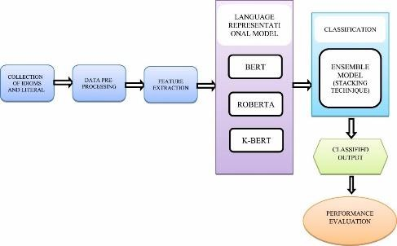

Figure 2: General scheme of emotional analysis methodology[4]

At the first stage, idioms and literals are collected. These are followed by data preprocessing. During it, words are translated into a certain case, punctuation marks are removed, etc. The last stage before training the pre-trained models is feature extraction. Next, we use one of the methods to categorize the text. Consider such methods as BERT, ROBERTA, K-BERT.

# BERT

BERT is based on a search engine contextual connections between words. The advantage of BERT over other convergence models is that it reads all the words at once, rather than sequentially, which helps the model to be more accurate. The two main parts of the model are the encoder that reads the text and the decoder that predicts.

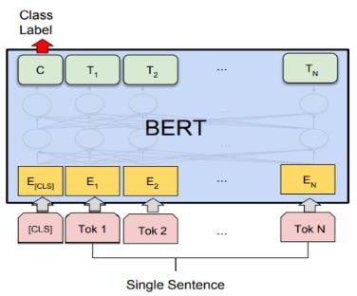

Figure 2: General scheme BERT[5]

# K-BERT

As the name makes clear, this method is based on BERT. It differs in that additional steps are added: creation of a tree of sentences, which is a knowledge layer. Also embedding layer, mask-transformer levels appear in the method. The general scheme of the K-BERT is shown in Figure 3.

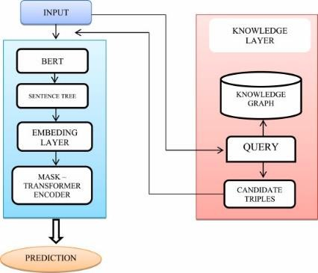

Figure 3: General scheme K-BERT[4]

## RoBERTa

For this model, tokenized data is converted into identifiers. Unlike BERT, in RoBERTa masking is performed during training, so the number of possible options is not limited. Also, for this model, training in longer sequences is possible. ROBERTA scheme is shown in Figure 4.

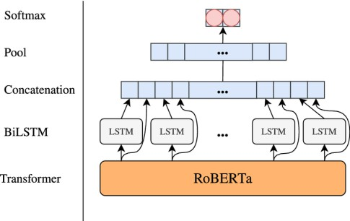

Figure 4: General scheme RoBERTa [6]

## Stacking model

A meta-learning algorithm is used to combine one or more machine learning algorithms. That is why, after analyzing ready-made solutions, we came to the conclusion that the results of these methods can be connected using learning algorithms is known as stacking. This will help us get a more accurate result. The resulting scheme of the method is shown in the figure below.

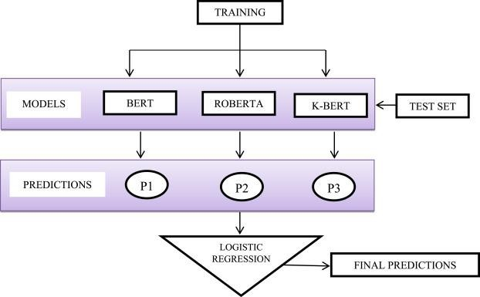

Figure 5: Stacking model

## Conclusion

Sentimental analysis finds its use in many areas. This work showed its importance, types, as well as the problems it faces. 3 methods of sentiment analysis were considered. Based on the results of the method analysis, a model was built that combines the results of each method to increase accuracy.

**References:**

1. Benjamin Robert Palmer. An Analysis of the Relationships Between Various Models and Measures of Emotional Intelligence, Centre for Neuropsychology School of Biophysical Sciences and Electrical Engineering Swinburne University of Technology, 2003
2. Biqiao Zhang, Emily Mower Provost, in Multimodal Behavior Analysis in the Wild, 2019, doi: 10.1016/C2017-0-01387-3
3. Siddhartha Bhattacharyya, Advanced Data Mining Tools and Methods for Social Computing, 2022, doi:10.1016/C2020-0-01963-8
4. S. Abarnaa, J.I.Sheebaa, S. PradeepDevaneyan, An ensemble model for idioms and literal text classification using knowledge-enabled BERT in deep learning, 2022, doi:10.1016/j.measen.2022.100434
5. P. Moravec, R. Minas and A.R. Dennis, Fake news on social media: People believe what they want to believe when it makes no sense at all, Kelley School of Business Research Paper, 2018, pp. 18-87
6. Rolandos Alexandros Potamias, Georgios Siolas, Andreas - Georgios Stafylopatis, A transformer-based approach to irony and sarcasm detection, 2020, doi: 10.1007/s00521-020-05102- 3

## 1 Vladyslav Pryshchepa

Master’s student of the Faculty of Information Technology

## 2 Oleksii Yehorchenkov

D.Sc, Professor of The Department of Technology Management

*1-2 Taras Shevchenko National University of Kyiv, Ukraine*

*2 Slovak University of Technology in Bratislava, Slovakia*

# PROJECT APPROACH TO INDIVIDUALIZATION OF THE EDUCATIONAL PROCESS USING MATHEMATICAL MODELING

**Abstract.** The process of learning in the modern world requires constant improvement in order to keep up with the trends of the time. That is why this paper presented the existing adaptation of AGILE methodology for education, which in turn is built directly on the value system of this methodology. On the basis of the adapted system of values it is possible to build a variety of educational programs, formulating their own values, clearly repulsed by the global understanding of the challenges of modern university education. To automate the process of individualization of learning was presented a mathematical model, which is built on the real characteristics of students and curricula.

**Keywords:** learning methodology, individualization, education enviroment, Agile, mathematical modeling.

University as an institution of education plays an important role in the development of society, while it is constantly influenced by the opposing sides of modern trends and traditions of classical education, global and local culture, the achievement of short-term plans and long-term goals the situation is complicated by the challenges faced by the university in the era of transition to the information society.

Thus, due to the transformation, the main stakeholders of the process become the students [1]. On the one hand, they are used to constant learning since their childhood, mastering new technologies of the time [2], but on the other hand, students are not ready to spend a lot of time on professional development, they want to master new knowledge and get new competencies quickly and in the most convenient way [3]. Hence, traditional educational methods are losing their effectiveness when working with modern students [4]. The search for new ways of learning makes us turn to other spheres where we can borrow effective methods and practices [5]. Now it is generally recognized that one of the main means of improving the quality of the educational process in higher education is *individualization* of education. [6]

As a new form of existence, the university turned to the *AGILE* philosophy, well established in software development. The philosophy of agile work allows universities to adapt quickly to changes in the environment and the requirements of employers. In

addition, *AGILE* as a *project management technology* also allows students to develop project work skills.

The application of this technology in education can have many rules and principles, but basically it can be reduced to 5 main ideas [7].

The first idea is *teacher-student interaction*. It was implemented in three variants: where in class the instructor asks students and initiates discussions with them, outside of class the instructor meets with students in consultations, additionally the instructor communicates with students through electronic means of communication.

The second idea is *goal-oriented learning*. In the program of this pedagogy, this principle can be implemented as follows: the lesson material is structured to best meet the goals and objectives that have been defined in advance, at the beginning of each lesson the instructor explains to the students the goal and objectives of the current lesson. After the students have completed the tasks, there is a control activity in a short The main task of which is to evaluate how successfully the goals and objectives voiced by the instructor at the beginning of the class were achieved.

The third idea is *learning in pairs*. Two students do work on a learning project. When one student directly performs the task, the second student observes his or her colleague, suggests ways to improve, alternative solutions to the problem, etc. Periodically, they switch places to ensure that both are fully engaged.

The fourth idea is *frequent interim control of students' knowledge.* The final grade is averaged over all the grades received for the course, and the form of the interim control can be anything. This regular monitoring helps provide feedback to be able to keep a constant check on the process, even if the student has not been in pairs.

The fifth idea is *simplicity*. This means that instructors should deliver the material in the simplest and clearest way possible so that students can easily absorb the material. Difficulties begin when the instructor cannot assess the students' ability to comprehend, in which case the topic becomes inaccessible to understanding of the students.

Improvement of the task of *individualization* of education can be achieved by mathematical modeling of the process. In general, the task of such a model can be formalized using the terminology of multi-purpose systems (MS) . [6]

Let the set of students with their individual characteristics be an external set in relation to the educational system, while its set of strategies is a set of alternative educational projects, for example, variants of the curriculum or technological map of the discipline. In this case, the local efficiency function *f(x,y)* determines the efficiency of training a set of students *x∈X* according to a set of curricula *y∈Y*. Individualization of training consists in the optimal choice of a subset of projects *A={yi}*, where *i=1..m*

*⊂ Y* and a distribution function *E(x)* defined on *X*. This function assigns to each student

*x∈X* the number of the element *A* to which the student is assigned. The effectiveness of the educational system considered in the framework of the guaranteeing multi- purpose system (GMS) is characterized in this case by the minimum guaranteed quality of learning material for the entire sample of students, that is, the quality of training of the weakest student. The educational system considered in the framework of the integrated multipurpose system (IMS) is characterized by an average level of training for the entire sample.

The development of this technology requires further research in this area and ongoing practical applications to improve the model.

**References:**

1. Bagdasarova E., “Interview with Professor Lancaster University Paul Ashwin // Education Issues. No. 1”, pp. 18-20, 2016.
2. Dicker R., Garcia M., Kelly A., Mulrooney H., “What does 'quality' in higher education mean?. Perceptions of staff, students and employers // Studies in Higher Education.”, pp. 1-13, 2018.
3. D'Souza M. J., Rodrigues P., “Engaging Millennial Students in an Engineering Classroom using Extreme pedagogy // Indian Journal of Science and Technology”, vol. 8, no. 24, pp. 1-6, 2015.
4. King A. "From Sage on the Stage to Guide on the Side / College Teaching", vol. 41, no. 1,

pp. 30-35, 1993.

1. Chirkov I. "The Mystery of Russian Students: Poor Learning Experience, High Satisfaction

//Education in Russia and Beyond", vol. 3, no. 1, pp. 10-11, 2015.

1. Pryshchepa V., Pyroh M., “Technology of individualized training of specialists in the field of infocommunications based on mathematical modeling”, 2021.
2. Anderssor: R., Bendix L. “eXtreme teaching: A framework for continuous improvement, Computer Science Education”, vol. 16, no. 3, p. 175-184, 2006

.

## 1 Victoria Rymchuk

Student of the Master's Project Management Program

## 1,2 Oleksii Yehorchenkov

D.Sc, Professor of The Department of Technology Management

*1 Taras Shevchenko National University of Kyiv, Ukraine*

*2 Slovak University of Technology in Bratislava, Slovakia*

# SPECIFICS OF PROJECT QUALITY MANAGEMENT

**Abstract.** The thesis reveals the theoretical essence of the quality management system in projects, examines the components and tools of the quality management system. The place of the quality management process in projects in the overall project management system is determined. Conclusions regarding the expediency of implementing a quality management system in the organization were considered and made.

The purpose of this work is to study the quality management system in projects, as well as to determine the problems that arise when implementing such a system in the organization.

**Keywords:** project management, quality management, project, quality management principles, quality management components, quality management problems.

## Formulation of the problem.

Today, a new strategy has been created in the world, which interprets quality as the most important factor in ensuring the competitiveness of any company. In foreign practice, such two main elements regarding quality are distinguished as compliance with the goals of the project and compliance with consumer requirements. With the transition to market relations in Ukraine, the problem of quality appeared before every manufacturer. It is the solution of this problem that the project manager should deal with. The task of ensuring project quality is relevant at all phases of its life cycle. The new management policy is primarily based on the understanding by project participants of the vital need to ensure their quality.

**Analysis of recent research and publications.** The study of the problems of quality management in projects in the activity of any enterprise was reflected in the works of domestic and foreign authors: I. A. Harutyunyan, V. I. Anina, A. O. Ichetovkina, V.V. Dragomirova, A.Ya. Kazarezova, L.B. Chirun, Y. M. Derenskaia,

G. V. Starchenko and I. A. Baranyuk, etc. However, despite the attention of scientists to this issue, the theoretical aspects of quality management in projects remain relevant and require further research.

**Setting objectives.** The purpose of this article is to reveal the essence of project management, as well as ways to increase the efficiency of the process of managing certain projects of an enterprise when implementing a quality management system.

**Presentation of the main research material.** The general scheme of the organization of works to ensure the quality of the project includes the following components:

* Determining the work required to achieve the desired level of quality;
* Identification of persons responsible for the implementation of these works;
* Division of work into functional parts;
* Determination of persons responsible for the implementation of each

work;

* Creating connections between different work activities [1].

The quality control system includes works in the project that affect the quality

of the project's product.

In the process of project quality management, four main components can be distinguished:

* + Quality control planning (definition of goals, definition of resources, definition of quality standards, and criteria for achieving these standards)
  + Quality control (verification and testing of what was determined at the quality planning stage, re-evaluation of both processes and product)
  + Quality assurance (constant maintenance of documentation in an up-to- date state, training of employees in new processes)
  + Quality improvement (control measures and monitoring of results to ensure that results meet expected criteria) [2].

In general, the advantages of implementing a quality management system in the project are:

* + Quality products.
  + Customer satisfaction
  + Financial profits.
  + Establishing communication [3].

However, the implementation of a quality management system in an organization that did not have one before presents a number of problems.

The first place among such problems is the different opinions of the members of the organization regarding the quality management system since all the interested parties of the organization have a different idea of what exactly the quality management system should look like, and what are the final expectations for the quality management system in general.

The solution to this problem is to organize communication with the senior management team, after which a presentation can be made to the employees, where any input and suggestions can also be considered and added.

The next problem that often arises when implementing a project quality control system is the involvement and participation of personnel: as mentioned above, the use of the principles of consultation and participation of personnel is vital not only for the content of the quality management system but also for the involvement of employees in the process [4].

The project quality management process can be improved by using visual quality management tools such as:

* Affinity diagrams (generation and arrangement of product information)
* Diagrams of the decision-making program (determining what can go wrong in the project and planning such scenarios)
* Interrelationship diagrams (identification of changes that occur during work on the project and which parts these changes may affect)
* Matrix of priorities (determining which problems may arise and their priority)
* Network diagrams (demonstrates scope and critical path of the project)
* Matrix diagrams (demonstrates relationships between objectives, factors and causes) [5]

## Conclusions from this study and prospects for further development in this direction

Thus, the process of project quality management at the enterprise in modern conditions is a whole system of organization, planning, implementation and improvement of project quality during the project cycle, aimed at effective achievement of goals through the use of modern methods and tools to achieve maximum results in ensuring product quality . The search for the latest approaches to improving the quality of the company's activity is one of the most urgent issues today. Its solution is possible due to the conceptual implementation of project quality management practices, taking into account the problems that arise when implementing a quality management system with the aim of reducing costs, aligning strategic planning at different levels, and achieving synergistic efficiency in the implementation of various types of enterprise activities.

**References:**

1. PMBOK 7th Edition, 2021. - 370 p.
2. V. A. Petrenko Quality management and certification / V. A. Petrenko., 2005. – 289 p. – (Kirovohrad: KNTU). - (Tutorial).
3. Sarancha G. A. Metrology, standardization, compliance, accreditation, and quality management / G. A. Sarancha., 2006. – 668 p. - (Center for educational literature). – (Textbook).
4. M. I. Shapoval. Basics of standardization, quality management, and certification / M. I. Shapoval., 2001. – 172 p. – (Publishing House of the European University). – (Textbook).
5. Quality management tools [Electronic resource] – Resource access mode: https:/[/www.forecast.app/blog/what-is-project-quality-management.](http://www.forecast.app/blog/what-is-project-quality-management)

## 1 Volodymyr Saiko

Doctor of Technical Science, Professor, Professor of the Department of Applied Information Systems.

## 2 Yaroslav Hrytsun

Student

*1,2 Taras Shevchenko National University of Kyiv, Ukraine*

# DATA PROTECTION IN THE IOS OPERATING SYSTEM

**Abstract.** The levels of protection of available options to securely store data in the iOS operating system are considered. For this purpose, guides to the use and programming of applications for the iOS operating system were used. The curated information reflects the features, structure, and levels of protection of two ways of storing information in digital form available for use in applied information systems developed for execution in the environment of the iOS operating system that is downloaded from cyberspace.

**Keywords:** the levels of protection of digital data, iOS operating system, secure storage, file, Keychain.

Given the large volume of information that passes through mobile devices and their limited storage capacity, the developers should skillfully manage available ways to store users’ sensitive data and the levels of protection they offer.

The iOS operating system offers the following options to securely store data on a device:

* storage in files with several degrees of protection;
* storage using Keychain;

## Security levels storing data in files

An application can store any number of files of any size, being limited only by the free space on the device. When creating a file, the developer indicates its security level. Below are all possible file security levels:

* "Complete" security level. Such files are stored in an encrypted format and can only be read or written when the device is unlocked. At other times, attempts to read and write the file will fail.
* "Complete unless open" security level. Similar to the "Complete" security level, but access to such a file is preserved even after the device is locked if the file was opened at the time when the device was unlocked.
* "Complete until first user authentication" security level. At this level, the file is not accessible until the user unlocks the device for the first time. After the user unlocks the device for the first time, the file remains available until the device is turned off or rebooted.
* "No protection" security level. Such files are stored unencrypted and can be accessed at any time.

## Overview and security level of data stored in Keychain

Keychain is the most secure way to save small amounts of data. This level of security is powered by the hardware features of iOS devices.

Storing data with Keychain, as in the case of writing to files, also has several levels of access available to the developer:

* "When passcode set" security level. These items are only available when the device is unlocked. To do this, a password must be set on the device. If the user removes the password from the device, all items with this level of protection are automatically removed.
* "When unlocked" security level. These items are only available when the device is unlocked. If no password is set on the device, it is always considered unlocked.
* "After first unlock" security level. Access to these items is not possible until the user unlocks the device after rebooting; if no password is set on the device, it is always considered unlocked.

## Determination of the appropriate method of safe data storage

To decide on the method of secure data storage in the context of a specific task, a developer can use the following overview table of the available approaches.

|  |  |
| --- | --- |
| What to store in files | What to store in Keychain |
| Data that needs to be copied, cut, and pasted often | Data that requires the highest protection (e.g., passwords from a banking app) |
| Data of big size | Data of small size |

Table 1 - Use cases overview of secure data storage methods

In the final analysis, the iOS mobile operating system provides developers with two mechanisms for safe data storage: in files and Keychain storage with different degrees of protection. The features and use cases of both approaches in the process of developing applied information systems have been examined.

**References:**

1. Data Persistence in iOS apps with Swift - Overview - Swift Tutorial. URL: https://iosapptemplates.com/blog/ios-development/data-persistence-ios-swift.
2. Keychain Services. Apple Developer Documentation. URL: https://developer.apple.com/documentation/security/keychain_services.
3. Core Data. Apple Developer Documentation. URL: https://developer.apple.com/documentation/coredata
4. Encrypting Your App’s Files. Apple Developer Documentation. URL: https://developer.apple.com/documentation/uikit/protecting_the_user_s_privacy/encrypting_your_a pp_s_files

## 1 Sofiia Sakharova

Student

## 2 Sergiy Paliy

Candidate of technical sciences, associate professor, associate professor of the department of information systems and technologies

*1,2 Taras Shevchenko National University of Kyiv, Ukraine*

# IOT CONTROL SYSTEM FOR TECHNOLOGICAL PROCESSES OF ALCOHOL PRODUCTION

**Abstract.** The relevance of introducing automated systems in the production of alcohol based on the Internet of Things to improve and stabilize the quality of products, as well as reduce resource and energy costs in processes.

**Keywords:** Internet of Things, automation systems, SCADA.

The food industry, which specializes in the production of ethyl alcohol from food raw materials, is one of the major sectors of the national economy. A large number of parameters that determine product quality, complex patterns that characterize the technological process, and the desire to increase the profitability and competitiveness of manufactured products require the introduction of advanced technologies and a significant increase in the level of training of specialists in managing modern technological processes of food production.

By automating production and making some adjustments to the system, you can get the following **benefits:** *reduction of hard physical labor for workers directly involved in production; increase in labor productivity; increase in product quality; reduction of defects and waste; reducing the cost of raw materials and energy.*

The technological process for obtaining alcohol consists of the following steps:

* Preparation of raw materials and materials for saccharification and grinding of material;
* Boiling and saccharification of the raw material composition;
* Yeast cultivation;
* Fermentation of the resulting mass;
* Extraction of alcohol from a mash with subsequent purification (rectification).

In the technological process of obtaining edible alcohol, the chemical and biological composition of the raw material and the physical and chemical properties of the water used to have a dominant influence on its quality. All this imposes increased technological requirements on the production process, which are solved both with the help of the improvement of old and the introduction of new technological solutions and with the use of automation tools [1].

One of the main types of technological equipment used in the alcohol industry is distillation units. The quality and cost of the manufactured products are largely determined by the bragorectification process.

In the production of alcohol, the technological processes of bragorectification - rectification of the cultural alcohol-containing liquid - are the most energy-intensive

and significantly impact the quality of the finished product. Therefore, the problems of improving and stabilizing the quality of manufactured products, as well as reducing resource and energy costs in the processes of distillation, are very relevant. One of the solutions is the creation of highly efficient and highly reliable automated control systems. Today's most promising automated control technology is SCADA systems (Supervisory Control And Data Acquisition - supervisory control and data collection) [2, 3]. They are especially effective in creating an automated process control system for industries with human and material resource restrictions.

It is proposed to develop an adaptive system for energy-efficient alcohol production at an industrial enterprise using the Internet of Things technology.

In order to ensure the optimal flow of the production process, it is necessary to receive information on the values of current parameters in a timely manner and, at the same time, be able to compare them with the required values of the parameters of the technological process of alcohol production.

Introducing such a system to your production, it is necessary to provide a prompt output of information about the current state of any required parameter, its deviation from the optimal set value, and the most optimal value of this parameter.

To organize a system of automatic control and regulation of technological parameters of alcohol production, the following constituent elements are required:

* regulator (micro-computer or microprocessor controller);
* primary measuring transducers (pressure and temperature sensors);
* means of displaying information;
* executive mechanisms.

The main requirements that should be presented to automatic control and regulation systems should be simplicity and ease of use [4], flexibility, survivability, and economy.

Simplicity and ease of use are associated with the need to master systems without involving highly qualified specialists. The flexibility of a system is characterized by its ability to be upgraded. Survivability is associated with the preservation of performance not only under normal operating conditions but also under external emergency scenarios; in this case, the appearance of deterioration of control is allowed. Profitability is determined by low capital investments and operating costs.

The stated requirements are satisfied by the systems of automatic control, regulation, and control built on the basis of microprocessor controllers and microcomputers.

**References:**

1. Evsyukov, V. N., “Food Process Control Systems” 177, 2009.
2. SCADA. URL: <https://en.wikipedia.org/wiki/SCADA>.
3. What is SCADA, Video, 2019. URL: https:/[/www.youtube.com/watch?v=nlFM1q9QPJw.](http://www.youtube.com/watch?v=nlFM1q9QPJw)
4. Ireland's leading distillery automation solutions provider. URL: https://rockbrooktechnologies.com/distillery-automation.

## 1 Hryhorii Shats

Master's degree of the Department of Information Systems and Technology

## 2 Olha Kravchenko

PhD, Associate Professor of the Department of Information Systems and Technology

*1,2 Taras Shevchenko National University of Kyiv, Ukraine*

# COMBINING THE INTERNET OF THINGS AND DATA ANALYTICS IN ANIMAL HEALTH CARE

**Abstract.** In recent days, the Internet of Things (IoT) has been used to connect many devices and communicate with each other, creating a greater impact on animal health systems. IoT devices take the form of wearables that have been used to track people's activities. Wearable devices are now being used to monitor animal activity. Internet of Things in animal health research uses biosensors and software to monitor and maintain animal health records. Such technologies produce accurate predictions of health and disease that are most effective for humans, but can be applied to animals with minor modifications. Some of these recent technologies have gained importance for use in animal health and development. The integration of affordable medical sensors creates a connected digital platform that improves connectivity for pets and livestock. But just collecting information with the help of sensors does not reflect the condition of the animal and does not predict morbidity. Without modern analytical methods and business intelligence tools, it is impossible to investigate the exact changes in the vital activity indicators of animals.

**Keywords:** Analytical methods, Animal health care, Internet of things

The combination of Internet of Things, wireless technology and analytics enables animal watchers to monitor animal health from anywhere. Nowadays, engineering and sensing research together have reduced the cost of electronic devices and led to the introduction of biosensing and intelligent computing solutions that incorporate cloud resources and Internet connectivity to create cyber-physical systems [1]. These cyber-physical systems facilitate the autonomous acquisition of data such as physiological parameters, dairy farm environment, yield measurements and features. Similarly, electronic devices have become an integral part of human life, which are interconnected and interact with each other. IoT devices are self-realizing, facilitated by machine-readable identification, and can transmit data across networks without human intervention. Smart sensors are a key enabler of low-power IoT. Smart sensors and communications have become dominant factors that will transform the communication, sensing and computing technologies and devices of the next generation.

A large number of researchers are working on animal care systems. The system developed by Sweta Jha et al. (2017), which was supposed to be able to identify and rapidly detect diseases affecting livestock [2]. The sensors used were connected to a microcontroller, and if the data received was outside the normal range, the farmer could detect that a particular cow was sick and take the necessary measures. Wireless sensor networks also monitored physical conditions such as humidity, pressure and

temperature, storing the data in a central location and providing access to it via a web page. Wireless sensor networks (WSNs) in the animal health monitoring system are also finding their users. Such a system was proposed by two researchers, Shinde & Prasad (2017) [3]. The technique used by the authors consisted of two different architectures: one for animal health monitoring and the other for crop monitoring. For the animal monitoring system, a method of supplying power to wireless sensor devices using a battery and regularly replacing it and setting up a unique channel for data transmission between network devices between sensor nodes was used.

Such IoT systems are a good example of data collection and processing. For farmers who do not understand the collected data, it is important to understand the information received. Although new digital tools make animal disease monitoring more accessible, timely analysis of animal vital signs data for meaningful information can be challenging. Business intelligence software has the potential to solve these problems. Jason David Wark (2022) conducted research on the feasibility of using business intelligence tools in conjunction with the Internet of Things to improve proactive zoo animal welfare reporting. Business intelligence software combines the ability to integrate multiple data streams with advanced analytics and robust data visualization. As a result, the author created a system that uses Microsoft Power BI in combination with a data acquisition system. The system meets the needs of keepers in proactively reporting on the welfare of animals in the zoo.

**Conclusions.** The latest technology has undoubtedly improved the management of animal health by enabling data acquisition, real-time medical intervention, decision- making and process automation at a reduced cost. The combination of Internet of Things technologies and data analytics allows you to qualitatively monitor the vital signs of animals and in advance predict morbidity. Various sensors and other technologies used in animal health were reviewed from the perspective of domestic, farm and wild animals. Researchers and development organizations have begun to find solutions to improve animal health. Investments should be made in technologies in the field of animal husbandry, which are not yet sufficiently developed and are not used to their full extent.

**References:**

1. Karthik G.S., Pankajavalli P.B. Overview of the Internet of Things in Human Health: A Technical Perspective. SN Comput Sci. 2020; 1:198.
2. Vaishnavi Shinde, Prof. Sweta Jha, Amruta Taral, Komal Salgaonkar, Shraddha Salgaonkar, 2017, IOT Based Cattle Health Monitoring System, INTERNATIONAL JOURNAL OF ENGINEERING RESEARCH & TECHNOLOGY (IJERT) ICIATE – 2017 (Volume 5 – Issue 01),
3. Varsha Bapat, Prasad Kale, Vijaykumar Shinde, Neha Deshpande, Arvind Shaligram, WSN application for crop protection to divert animal intrusions in the agricultural land, Computers and Electronics in Agriculture, Volume 133, 2017, Pages 88-96, ISSN 0168-1699, https://doi.org/10.1016/j.compag.2016.12.007.
4. Wark, J.D. Power Up: Combining Behavior Monitoring Software with Business Intelligence Tools to Enhance Proactive Animal Welfare Reporting. Animals 2022, 12, 1606. https://doi.org/10.3390/ani12131606

## 1Yurii Shcheblanin

Candidate of technical sciences, senior researcher, associate professor. Department of Cyber Security and Information Protection

## 2Anton Zahynei

Student. Systems of information and cybernetic protection

*1 Taras Shevchenko National University of Kyiv*

*2 State University of Telecomunication*

# RESPONSIBILITY OF THE PARTIES FOR INFORMATION SECURITY MANAGEMENT IN CLOUD TECHNOLOGIES

**Abstract.** The article considers the issues of information resources protection using cloud technologies. A study was conducted on the delimitation of the responsibilities of the provider and the customer of cloud services for the application of information resource protection technologies. The principles of interaction that can be the basis of trust between the customer and the cloud service provider are considered.

**Keywords:** Cloud technology, cloud services, PaaS, IaaS, SaaS

Cloud technologies are used in many areas of human activity. The issue of ensuring the protection of information processed in such systems remains relevant today. The separation of responsibilities for the use of protection technologies is determined individually in each system, however, there must be certain principles that gives the capabilities and effectiveness of security management. Relevant principles are given in the table. 1 [1]:

Table 1 – Principles of interaction of the customer of services and the provider of cloud computing

|  |  |  |
| --- | --- | --- |
| **№** | **Principle** | **Brief description** |
| 1 | Restrictions on  areas of use | Companies cannot claim information owned by the customer, except when  it is necessary according to the terms of the contract |
| 2 | Security  management systems | Cloud computing service providers have a strong information protection  system that satisfies the information owner and meets international and / or Ukrainian standards. |
| 3 | Additional security  opportunities | The provider, undertakes to perform and offer additional data protection  capabilities with the necessary staff of information protection specialists. |
| 4 | Data placement | Provider gives customer the information about the physical location of his  data (countries, cities, etc.) |
| 5 | Report information leaks | Provider undertakes to give complete information about the event of an offense of unauthorized access to data owned by the customer |
| 6 | Audit | Companies that provide cloud computing services turn to third parties to  conduct security audits and compliance checks. |

There are three types of cloud technology models: Software as a Service (SaaS), Platform as a Service (PaaS), and Infrastructure as a Service (IaaS) [2]. SaaS is a specific type of software product that is cloud-based and can be easily accessible via the web interface. PaaS are platforms that provided to the end user to create their own objects and software products. IaaS is an infrastructure that allows the system

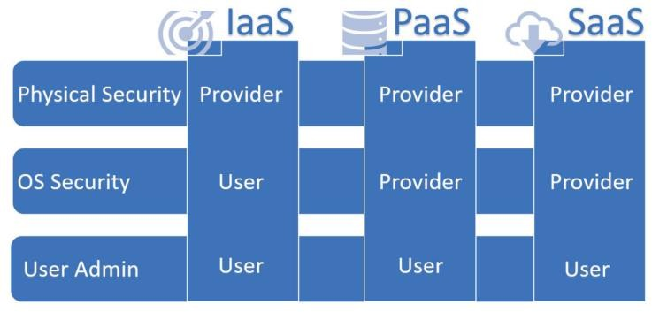administrator to deploy its own systems and structures. Given these models, it is possible to build the responsibility of each party (provider and end user), as shown in Figure 1 [3].

Figure 1 – Responsibility for compliance with the safety of cloud technologies The service provider is responsible for physical protection regardless of the

cloud technology model. This means the control of access control systems, video surveillance cameras, fire safety equipment, etc. [3].

Protection of the operating system, or operating systems (if they are several, and they interact within a single virtualization system) relies on the technology provider in the case of SaaS and PaaS. For example, the task of setting up the server part on which the software development platform is deployed, or the service is assigned to the provider. In the case when the provider provides its own infrastructure, where the user uses virtualization tools to create their own infrastructure, the protection of operating systems rests with the user. The protection of a particular service, site, database deployed in «cloud » rests with the end user, ie the customer. All settings of such systems are performed by the customer administrator.

## Conclusions

Nowadays, it is quite simple to deploy your own system using cloud technologies, but the issue of information protection, which is processed in this system, is still relevant. It is impossible to ensure the security of such a system without clear and high-quality interaction with the provider, so the work offered reference models on the basis of which you can build your own information protection systems. When distinguishing responsibilities between the parties for security, it is necessary to focus primarily on the capabilities of each party and the effectiveness of the remedies they use.

**References**:

1. National Institute of Standards and Technology Special Publication 500-292 Natl. Inst. Stand. Technol. Spec. Publ. 500-292, 35 pages (September 2011).
2. Peiris C. Threat Hunting in the Cloud / C. Peiris, B. Pillai, A. Kudrati. – New Jersey: John Wiley & Sons Inc., 2022. – 547 с.
3. Cesar B. Mastering Defensive Security / Bravo Cesar. – Birmingham: Packt Publishing Ltd., 2021. – 528 с.

## 1 Oleh Shlapak

Master’s student of the Faculty of Information Technology

## 2 Oleksii Yehorchenkov

D.Sc, Associate Professor, Professor of the Department of Technology Management

*1,2 Taras Shevchenko National University of Kyiv, Ukraine*

*2 Slovak University of Technology in Bratislava, Slovakia*

# OVERVIEW AND WAYS TO IMPROVE MODERN SYSTEMS FOR MANAGING PROJECTS AND TRACKING CURRENT TASKS

**Abstracts.** Modern programs for tracking issues, designed for organizing communication with users and project management, are considered. In particular, the following systems: Jira, Trello. Also, their main shortcomings are considered and it is proposed to add new functionality that solves some of them.

**Keywords:** JIRA, Trello, project management software, timeline, progress tracking.

Today, there are many programs for tracking issues, designed for organizing communication with users, as well as for project management. Let's take for example a well-known program from the developer of Atlassian Corporation Plc - Jira. Initially, the Jira system was created as a solution for tracking tasks and bugs. But today, Jira is a powerful work management tool suitable for a variety of cases, from requirements management and test scenarios to agile software development [1].

But nothing in the world is perfect, and neither is Jira. The main problems of the software program [2]:

* The tool is difficult to set up and get used to
* Its complex user interface can make task management difficult
* No built-in timeline to track project progress
* No collaboration features to communicate with the team
* It is mainly designed for teams of engineers and software developers
* No idea management features to keep track of your ideas and plans
* It is known as a slow tool with long query load times

I would also like to consider the Trello System, a visual tool that allows a team to manage various projects and work processes and track the completion of tasks [3].

The main problems of the software program [4]:

* Trello's commenting feature needs improvement.
* No built-in timeline to track project progress
* It is suitable for small projects. However, this can be a problem if the team grows and the project becomes more complex

Among the above problems, I would like to highlight the timeline, because both the customer and stakeholders want to see the project development process in general. They need to see clearly at what speed the project is heading towards its completion and when it can be presented to the general audience. Unfortunately, Jira and its analogues do not have such functionality yet, so I would like to offer my solution to this problem.



Figure.1 Timeline by weeks



Figure. 2 Timeline by steps (phases) As shown above, the following timelines can be added:

* By weeks
* By phases of the project life cycle

This tool will provide an in-depth overview of the entire project from start to finish. Helps you see when a task starts and when it needs to be completed. Also, does it depend on another task. That is why it is important to have this tool at hand. Of course, you can do it and update it manually with Excel, but it will take a lot of time and will have a negative impact on productivity. The timeline will help you more easily navigate the development and release of the project. The developed tool will be used by customers, project managers and developers to predict the completion of project development, understanding the steps that must be taken to complete the work on time. **Conclusion:** So, in this work, two main tools for project management and monitoring of current tasks were considered. Their weaknesses are identified, and own

ideas for improving their work and functionality are proposed.

**References:**

1. What is Jira used for? - [Online] - 2022 -[https://www.atlassian.com/software/jira/guides/use-](https://www.atlassian.com/software/jira/guides/use-cases/what-is-jira-used-for) [cases/what-is-jira-used-for](https://www.atlassian.com/software/jira/guides/use-cases/what-is-jira-used-for) – (Accessed 11.11.2022).
2. Jira Review 2022 (Features, Pros, Cons, Pricing) –[Online] – 2022 - <https://clickup.com/blog/jira-review/#14-what-are-the-limitations-of-jira-> - (Accessed 11.11.2022).
3. Trello – [Online] – 2022 - <https://trello.com/uk/tour> - (Accessed 11.11.2022).
4. The Pros and Cons of using Trello Software - [Online] - 2022 -https://bridge24.com/blog/the- pros-and-cons-of-using-trello-software/ - (Accessed 11.11.2022).

## 1 Alexander Shvydchenko

Student, Department of Information Systems and Technology

## 2 Alexander Kuchansky

Doctor of Technical Sciences, Head of the Information Systems and Technology Department

*1-2 Taras Shevchenko National University of Kyiv, Ukraine*

# IOT SOLUTIONS AND DRONES IN LOCALIZATION OF EMERGENCY ACCIDENTS

**Abstracts.** The research developed an IoT system for dealing with emergencies. The study's relevance is due to the development of the Internet of Things and unmanned aerial vehicle technologies, which saves life, property, and equipment from the consequences of sabotage or an accidental incident. The need to create a system capable of dealing with emergency situations (man-made and natural), able to meet the need to ensure the safety of rescuers and victims of an emergency.

**Keywords:** IoT, unmanned aerial vehicles, drones, sensors, automation.

Today, the technologies of unmanned aerial vehicles (drones) are becoming more and more common and are used in many companies and government institutions. Examples of the successful use of drones are the armed forces of many countries using unmanned aerial vehicles for reconnaissance, the Amazon company working on a delivery system using unmanned aerial vehicles, and private and public agricultural enterprises. Drones can perform tasks automatically after receiving the necessary information, and they can navigate in space with the help of installed sensors, GPS, and machine learning. Such IoT solutions are tested in practice by the company "Amazon" with its project "Prime Air" [1].

The study developed an IoT system for dealing with emergencies. However, the idea of the system can also be used in such fields as the agricultural sector (protection of property and products), the armed forces (protection of equipment, BC warehouses, and soldiers from accidents, the consequences of sabotage or enemy shelling), security enterprises and national police bodies (assistance in investigations of incidents and offenses as a tool of technical supervision), etc.

In addition to the ability to work and respond to certain events remotely, using drones increases the efficiency of using resources. One of the main advantages of using drones in the agricultural sector is the optimization of the use of chemicals, reduced risk to human life, reduced harmful effects on the environment, and high application efficiency. All this leads to high competitiveness [2]. Therefore, using drones and the corresponding IoT systems increases the efficiency of the use of resources.

In turn, IoT technologies are already used in the development of systems, the purpose of which is to ensure the safety of people, which, in turn, can be used in the proposed system. This study analyzed the "SAFETYSCAPE" system, which is a system for generating an escape route based on information received from BLE (Bluetooth) beacons with built-in temperature sensors and ESP32 microcontrollers working with a gas detector [3]. This system, combined with the technology of

unmanned aerial vehicles, given its modularity, has the potential to become an effective rapid response system in the event of a fire. The system can be used in residential buildings or office premises and strategic facilities such as nuclear power plants, thermal power plants, essential warehouses, or factories. At these objects, drones can perform a wide range of tasks and respond to various possible emergencies, from fires and neutralizing chemicals to evacuation and providing the victims and rescuers of the objects with everything necessary: tools, water, medicine, etc.

An essential element of the research is the combination of the IoT system with the task of optimal placement of emergency stations. Moreover, it is necessary to ensure a higher level of coverage by stations in the relevant region, the minimum cost of construction and operation, etc. Work [4] describes placing emergency stations appropriately considering the identified risks. For this, the idea of two-level programming on the modified NSGII genetic algorithm is used.

**References:**

1. Amazon Prime Air prepares for drone deliveries, 2022. URL: https:/[/www.aboutamazon.com/news/transportation/amazon-prime-air-prepares-for-drone-deliveries](http://www.aboutamazon.com/news/transportation/amazon-prime-air-prepares-for-drone-deliveries)
2. Basf – Ready For Takeoff: How Drones Bring More Safety To Farming, 2022. URL: https://agriculture.basf.com/global/en/media/featured-stories/drones-in- agriculture.html?at_medium=sl&at_campaign=AP_BAW_GLOB_EN_none_TRA_DronesInAgricu lture&at_term=drones%20in%20agriculture&at_creation=Search_Google_Search_DronesInAgGen eral&at_platform=google&at_variant=DronesInAgGeneral
3. ESP32. A feature-rich MCU with integrated Wi-Fi and Bluetooth connectivity for a wide-range of applications, 2022. URL: <https://www.espressif.com/en/products/socs/esp32>
4. J. Lu, Q. Yang. Location Optimization of Emergency Station for Dangerous Goods Accidents Considering Risk, Sustainability (2022), 14, 6088. https://doi.org/10.3390/su14106088

## 1 Anton Shykhmat

Ph.D. Student

## 2 Zenoviy Veres

Ph.D., assistant

*1,2 Lviv Polytechnic National University (Lviv, Ukraine), Department of Computerized Automatic Systems*

# SELECTION OF PROTOCOLS FOR REAL-TIME DATA STREAMING FROM IOT DEVICES TO THE CLOUD FOR FURTHER ANALYSIS

**Abstract.** The Internet of Things (IoT) enables the creation of networks between devices, humans, applications, and the Internet, creating new ecosystems with higher productivity, better energy efficiency, and higher profitability. Nodes in the networks should be able to communicate and exchange data. For this purpose, data protocols are used. This paper provides an overview of existing data protocols, compares each protocol's strengths and weaknesses, and performance for MQTT and HTTP protocols, and selects the best-fil protocol for the real-time data transmission use case.

**Keywords**: SOAP, HTTP, REST, CoAP, WebSocket, XMPP, MQTT, AMQP

An outdated technical and technological base is one of the significant problems in Ukraine. Frequent malfunctions require larger capital investments and more time to solve them, which reduces volumes and increases the cost of growing crops, leading to increased final prices for the consumer. According to a Global Network Against Food Crises study, rising prices are leading to starvation in many regions of the world. The most crucial aspect of agriculture vehicles is timely repair and maintenance. Agriculture vehicles are manufactured in such a way that they can withstand thousands of hours of service. However, these indicators can be achieved only under the condition of periodic maintenance of the tractor. Timely detection and prevention of malfunctions are key approaches to reducing maintenance costs, and updating and replacing equipment, reducing the cost of growing crops. The Internet of Things (IoT) technology can be used to solve this problem. It is possible to create an IoT device that will connect to the CAN bus of the tractor to intercept all signals, process them, track the geographic position of the tractor at the current moment in time and tie the signals to this position. Finally, this data needs to be transmitted to some server-side with geospatial and telemetry data for further analysis. The purpose of this study is to provide an overview of existing data protocols and selects the best-fil protocol for the real-time data transmission use case.

Qualitative analysis using Architecture Tradeoff Analysis Method [7] and performance analysis were used to select data protocol from the following list: SOAP, HTTP, REST, CoAP, WebSocket, XMPP, MQTT, AMQP. Each protocol’s sensitivity points, tradeoff points, risks, and applicability to the use case quality attribute scenarios were analyzed.

SOAP is verbose and complex from a coding perspective, with a slow parsing speed and does not have built-in functionality for failed requests processing re-try, but it is versatile and has built-in error handling that can make resolving issues easier [2,3]. The advantages of using REST are its simplicity, security, and scalability.

However, the disadvantages include the impossibility of sending one message to many recipients with one request, the increased need for server resources, and the increased time for sending and processing the request, as is built on top of the Transmission Control Protocol (TCP), comparing to application protocols built on top of the User Datagram Protocol (UDP) transport layer protocol, and the lack of automatic resending of a message in the event of a message processing error on the server, which reduces reliability [4].

CoAP protocol has advantages in its reduced need for client resources, security using DTLS, synchronous and asynchronous communication support, and fast message transfer. Disadvantages include lower reliability of data transmission (compared to application protocols built on the TCP transport layer protocol), the inability to send one message to many recipients (for this, you need to send a separate message to each recipient), problems with communication with NAT devices [5].

The advantages of the WebSocket protocol are the fast message exchange since it is not necessary to open a connection between the client and the server every time, the reduced volume of traffic, and the security using TLS. The main disadvantages of WebSocket include the requirement for a stable TCP connection and the lack of automatic connection restoration in case the connection is lost, which reduces the reliability of this protocol, increased requirements for node resources, and problems with scaling and load distribution [1].

The main advantages of the XMPP protocol are its simple addressing, scalability, and security. Still, it has its disadvantages, in the form of slower transmission and data processing due to increased traffic volume, because of XML format, the TCP transport protocol usage, and the reliability is reduced because there is no confirmation of message processing [1].

MQTT has advantages in its scalability, architecture that provides loose coupling between clients, reliability because it guarantees different types of message delivery, and security using SSL/TLS. Disadvantages include slower sending of messages (compared to application protocols built on top of the UDP transport layer protocol) [1].

Like MQTT, the AMQP protocol has advantages in scalability, security, and loosely coupled clients. Disadvantages include increased message size and time to send and process the message [6]

The MQTT protocol is the best solution for real-time data streaming from constrained environments. This protocol depends on reliable connection and could be inefficient in situations with a weak or absent Internet connection. HTTP protocol could be used in such use cases for telemetry data transmission to the cloud for further analysis. According to the tests performed to deliver 1K messages over MQTT and HTTP - MQTT was shown almost 20 times faster and required almost 55 times less traffic on the task of posting consistent time-valuable data and is more efficient from a

power consumption point of view:

|  |  |  |
| --- | --- | --- |
| 10k messages | Bytes transmitted | Time (seconds) |
| MQTT (with SSL) | 3,121,173 | 65.021 |
| HTTPS | 170,216,893 | 1,272.359 |

A number of areas of research that have to be conducted to build an information system to monitor and predict agriculture vehicles faults have been identified, among which the following should be highlighted:

* Receiving signals from the CAN bus by the IoT device;
* Tracking of the agriculture vehicle geographical position by the IoT device;
* Transformation of signals and geographical position into geospatial and telemetry data by an IoT device;
* Processing of data that was not sent on time due to IoT device network connectivity issues
* Storage of the received geospatial and telemetry data using cloud solutions;
* Analysis of stored data and detection of malfunctions that have been already occurred using cloud services;
* Creating a model to predict potential failures and notify farmers about

them.

**References:**

1. S. Misra, A. Mukherjee, A. Roy. “Introduction to IoT”. Cambridge: Cambridge University Press, 2021, pp. 184 – 200. doi: 10.1017/9781108913560
2. B.Suda. “SOAP web services”. Edinburgh: University of Edinburgh. 2003, pp. 2 – 4
3. D.Hanes, G. Salgueiro, P. Grossetete, R. Barton, J. Henry. “IoT fundamentals: networking technologies, protocols, and use cases for the Internet of Things”. Indianapolis, Indiana: Cisco Press, 2017, pp. 177 – 204
4. N.M.Shaikh, Y.Ingle. “Application of Restful APIs in IoT": A Review. Haryana: iJRASET, 2021. doi: 10.22214/ijraset.2021.33013
5. A.Alhaj. “Constraint application protocol (CoAP) for the IoT”. Frankfurt: Frankfurt University of Applied Sciences, 2018. doi: 10.13140/RG.2.2.33265.17766
6. S.Vinoski. “Advanced message queuing protocol”. Cyprus: University of Cyprus, 2006. doi: 10.1109/MIC.2006.116
7. L. Bass, P. Clements, R. Kazman. Software Architecture in Practice, 4th Edition. – Boston, Massachusetts: Addison-Wesley Professional, 2021

## 1 Kateryna Sokol-Chernilovska

master's student at the Faculty of Information Technologies

## 2 Oleksii Yehorchenkov

D.Sc., Professor of the Department of Technology Management

*1,2 Taras Shevchenko National University of Kyiv, Ukraine*

*2 Slovak University of Technology in Bratislava, Slovakia*

# SECURITY PROJECT MANAGEMENT

**Abstract.** Software errors can be introduced by disconnects and miscommunications during the planning, development, testing, and maintenance of the components. The likelihood of disconnects and miscommunications increases as more system components have to satisfy security requirements. Project managers should consider the additional communications requirements, linkage among life-cycle activities, and the potential usage environment as these items relate to security needs.

**Keywords:** security project management, protection of information services, security project management responsibilities.

Over time, technologies have tended to evolve and improve. But the rapid pace leaves enough gaps that are further used to cause harm for a specific purpose. However, methods of crime prevention (both cybercrime and ordinary) are also not standing still. Protection of state information resources and other objects of critical information infrastructure is significant within the framework of present Ukraine. According to officially published statistics [1], among the state information resources connected to the system of secure access of state authorities to the Internet, official web representations of the President of Ukraine (president.gov.ua, petition.president.gov.ua), sites of the Security Service of Ukraine [2], the State Bureau of Investigation and the National Anti-Corruption Bureau of Ukraine are most often attacked. So, we see numerous vulnerable objects, but this is only a tiny part of the

whole picture.

It comes to a private business as well. Security has become an integral attribute of every company that cares about its customers, users, and employees. Large corporations are starting to create departments dedicated exclusively to product safety and company safety policies. Usually, the team size exceeds ten people, and for effective management of the processes, it is necessary to involve a project manager to coordinate the operations.

A security project manager's responsibilities are to supervise the creation of security systems for companies and organizations to ensure the safety and protection of personnel, campus assets, and information. The security project manager leads a team or teams of security professionals to generate a plan of action to mitigate threats to the company. This person's duties may also include helping a company create policies to improve site security, running safety drills and tests of the safety systems, and training staff on how to follow safety procedures and help improve security through individual action steps. The security project manager must also understand and

apply municipal, state, and federal regulations related to the installation and implementation of security equipment.

Based on the previous paragraph, it is evident that a security project manager should be at least a bachelor's degree in the technology field, such as computer science (cybersecurity), along with relevant experience. Additional qualifications include excellent technical, analytical problem-solving, and communication skills and leadership ability to oversee projects and staff.

What is needed to become an effective security project manager:

* At least 3-4 years of project management experience in the IT industry to gain expertise in usual project management;
* High-level understanding of cybersecurity;
* Experience in gathering/processing/preparing project requirements;
* Experience in long/mid/short term planning for scrum teams, change management;
* Understanding of web development principles and SDLC;
* Excellent stakeholders management skills;
* Ability to coordinate multiple projects in a changing environment (because security departments can be separated into few groups such as Network, Application, Physical, Offensive security, etc., it means that the security project manager should seal with few teams at the same time);
* Excellent written and verbal communication skills;
* Upper-intermediate (and higher) written and spoken English.

What is also essential, as businesses become more reliant on technology, the need for better communication between security and business teams becomes increasingly crucial. This is because security professionals need to be able to communicate the risks that are present in order to get the support they need to do their jobs effectively.

Project managers can play a vital role in this process by helping to bridge the gap between security and business teams. They can do this by developing effective communication channels and creating opportunities for collaboration. In addition, they can also help to ensure that security concerns are addressed promptly.

Security project managers can advance their careers by taking on larger and more complex projects. As they gain experience, they will be able to handle more responsibility and may eventually be promoted to a senior management position. In addition, security project managers certified by a professional organization such as the Project Management Institute (PMI) will have an advantage when competing for jobs.

To sum up, the world is rapidly developing and changing, so new job positions such as security project manager appear on the market. It is essential to understand this person's role and importance within the company.

**Refferences:**

1. <https://cert.gov.ua/>
2. <https://ssu.gov.ua/en>

## 1Karyna Sukhina

Student

## 2Liubov Kubiavka

PhD, Associate Professor of the Department of Technologies Management

***1,2*** *Taras Shevchenko National University of Kyiv, Ukraine*

# RECOMMENDATIONS OF USING MICROSOFT AZURE DEVOPS IN AGILE PROJECT MANAGEMENT

**Abstract.** Microsoft Azure DevOps offers the interactive and modifiable project management tools. The agile planning and portfolio management features of Azure Boards enable project managers to rapidly plan, organize, and monitor the work of your whole team. This article describes the best practices of agile project management, along with the primary benefits and features of using Azure DevOps in the workflow of project management.

**Keywords:** Microsoft Azure DevOps, Agile project management, features, planning, organizing, monitoring

Microsoft Azure DevOps (MS ADO) is an environment which support collaboration of the project team with the client in order to develop a product effectively and due to selected methodology. MS ADO is customizable cloud environment which supports Agile, Kanban and Scrum methodologies of project management. This article lists basic recommendations of setting up MS ADO by project managers.

Firstly, user control should be set up in MS ADO environment. Project Managers (PM) should have Admin role with the full license; therefore, they have access to setting up and editing of dashboards, backlogs, test plans and other services. The most beneficial feature of MS ADO is real time updating and collaboration of client users and project members, which helps to build strong and effective communication during the development of the product by assigning of work items, adding descriptions and comments, prioritizing of work items therefore the proper source could be notified about required action.

Secondly, it is very important how the project backlog is set up. Backlogs are where PMs handle the work items that are waiting to be completed. Backlogs are used for the planning of both the product and its features as well as the organization of the labor. Backlogs are capable of being segmented into tiers in accordance with project requirements. The kinds of problems that are assigned to each backlog are determined by the workflow type that has been chosen. The following is a list of the three primary categories of backlogs:

* the Portfolio backlog, often known as a higher-level backlog consisting of epics and features;
* the Iteration backlog is a task-level backlog for each iteration that is time- scoped;
* the Requirement backlog is a more thorough backlog that includes problems, product backlog items, or user stories [1].

Epics of the backlog is workstream areas of the project which consists of features of the product and a separate epic for project management activities, such as meeting planning, project documentation creation, controlling of risks and others. Each feature could include user stories or processes, to which test cases and requirements are linked. Test cases could be linked with bugs and issues reported by the client during UAT testing. In addition, this backlog could be represented in the form of Boards which consists of cards with brief information about pending work that are divided by columns which are statuses (New, In Progress, Confirmed, Closed, Cancelled and others) of work items. PMs could use this Board on status meetings to track progress of the project workflow. Therefore, such structure organizes the work on the project and simplify finding of the information by users, as well as makes monitoring of project processes by PMs and workstream leads more effective.

Thirdly, Iteration Paths, which are often commonly referred to as sprints, provide PMs the ability to allocate work items to certain time intervals. At the project level, iteration paths are specified, and individual team members are given the option to pick and choose which ones they need to use while creating new work item in the backlog. PMs have the option of building a flat set of iteration paths or a hierarchical collection of iteration pathways in order to facilitate releases, sub-releases, and sprints [2]. Iterations are used throughout the planning process. Although MS ADO is capable of automatically forecasting the amount of work that will need to be done, it is challenging to accurately and completely record every work item up front. Because of this, it's possible that forecasts will be inaccurate. Scrum employs a sprint planning cycle in an effort to tackle this issue. In Scrum, PMs would just schedule the work for the next two weeks, pulling in work from the backlog, and learning how much it could be completed in an iteration. On the other hand, the Kanban method relies on a continuous pull rather than on discrete planning cycles. It could be advantageous to utilize iterations just as planning cycles, despite the fact that releases are not required to be a part of iterations [3]. Thus, each iteration should include the number of processes of product development along with project management activities, for effective and precise forecasting of sources’ capacity and schedule by iteration (sprint). To monitor sprints, it is recommended to use sprint burn-down chart, which should be reviewed by PMs at the beginning and at the end of the sprint, to update statuses of work items, assign tasks and discuss issues and blockers with project team and client team separately.

In addition, PM could use extending functionality of MS ADO Dashboards which allow PMs to construct individualized views, giving them the ability to obtain insight into project current state, assess progress, and do trend analysis. The freedom to exchange information and the improvement of workflow procedures are both provided by dashboards, which allows sharing of information and track workflow progress [3]. Variety of analytics reports are already included into MS ADO, such as control charts, cumulative flow diagrams, and burn charts, so that workflow patterns may be better comprehended. Charts available for pipelines as well as build health and for evaluating issues. PMs may add charts to dashboards or view them independently using the Azure Boards tool, which is connected to the functionality [3]. The

recommendation is to set up dashboard by workstream, each of which should include statistics about: recently created work items (user stories, processes, features and others), pending tasks (due dates, assigned to), blockers (bugs and issues), test results (passed and failed test cases, tested by). These Dashboards should be reviewed on weekly project team meeting with development team and client users.

In conclusion, using of Microsoft Azure DevOps environment along with suggested recommendation in this article could help project managers organize work on the implementation or development project and simplify communications between team and client users, as well as monitor the progress of work. Therefore, the project team could focus more on the development and communication with client, rather then trying to catch the current project stage, or understand what is need to be done. Microsoft Azure DevOps fix project backlog of work at the mobilization and analysis phases, help track progress on design and development phase, and support work on GoLife phase of the project.

**References:**

1. Phil Vuollet, Azure DevOps Tutorial: Agile Project Management. URL: <https://www.cprime.com/resources/blog/azure-devops-tutorial-agile-project-management/>
2. PPM Express, Azure DevOps Tutorial: Agile Project Management, 2022. URL: <https://ppm.express/blog/azure-devops-tutorial-agile-project-management/>
3. Microsoft, What is Azure Boards? 2022. URL: [https://learn.microsoft.com/en-](https://learn.microsoft.com/en-us/azure/devops/boards/get-started/what-is-azure-boards?view=azure-devops) [us/azure/devops/boards/get-started/what-is-azure-boards?view=azure-devops](https://learn.microsoft.com/en-us/azure/devops/boards/get-started/what-is-azure-boards?view=azure-devops)

## 1 Olga Surovtseva

Student of the Master's Project Management Program

## 1,2 Oleksii Yehorchenkov

D.Sc, Professor of The Department of Technology Management

*1 Taras Shevchenko National University of Kyiv, Ukraine*

*2 Slovak University of Technology in Bratislava, Slovakia*

# HUMAN RESOURCES MANAGEMENT AS AN INVESTMENT FOR PROJECTS

**Abstract.** In this work, we have determined why investing in human resources is a long-term investment for projects and can be a valuable project assets. It was also concluded what tasks the human resource manager performs and what his role is in managing human resources in projects. It is emphasized that manager’s attitude to employees has a great influence on the efficiency of work performed by employees. Results of this research can become the basis for further researches and bring a certain contribution to study of resources management in projects.

**Keywords**: human resources, human capital, investment, employees, project management, training, recruiting.

Employees are not just resource, but rather capital or assets for projects. Due to this, a new term emerged outside human resources, namely human capital. Here human resources must be seen not only as the main asset, but as assets that are valuable and can be multiplied, developed (compared to investment portfolios) and not vice versa as liabilities. The perspective of human resources as an investment for projects is more prominent [1].

The purpose of the work is to determine why it is necessary to invest in human resources in projects and what the role of an HR manager is in this field.

The relevance of the research is approved by the fact that this theme has not been fully explored in the field of project management. Currently, the role of the manager’s influence on the work of employees and the leading of projects has been little studied. Nevertheless, the HR manager performs several functions in the company such as identifying the needs of employees, recruiting and training the best employees, control of working process, managing employee payroll, benefits and compensation, increasing employee motivation [2].

It appears that project success requires success in project team management, which is a function of HR. Three main processes are taken into account: recruiting, training and management. They represent the levels of the HR department's overall role in project management. They are described and analyzed, while raising the key issues that have to be faced [6].

It is accepted that investments in human capital include training. Training equips employees with the skills and confidence they need to achieve organizational goals. Investing in employee development increases retention as well as their ability to create value [5].

Besides, investing in human resources encourages employees to work together and identify improvements that will directly benefit them. These investments often open up channels of communication between departments and levels of management, allowing human capital to flow more freely within the organization.

This is especially important in construction, given that the work of each department usually either builds on or serves as the basis for the work of another [4].

According to several studies, employees can be much more productive when their bosses and managers give them more attention. The father of human relations, Elton Mayo, was the first to emphasize the importance of employee communication, collaboration, and inclusion [3]. His research concluded that sometimes human factors are more important than physical factors such as lighting quality and workplace conditions.

As a result, people in today's society often place more value on how they feel than on other working conditions. For example, the reward system in human resource management is effectively applied because in all work, employees should be valued and rewarded, which can stimulate them to continue to achieve their best results.

Strategic investments in human capital can bring unprecedented returns to the projects that employees work on.

**References:**

1. Greer, Charles R. Strategy and Human Resources: A General Managerial Perspective. New Jersey: Prentice Hall, 1995, 268 p.
2. Mathis, R.L; Jackson, J.H. Human Resource Management. South-Western: Thomson, 2008, 592 p.
3. Kaufman, Bruce E. Human Resources and Industrial Relations: Commonalities and Differences, 2001, Vol. 11, No. 4, pp. 339-374.
4. https://gobridgit.com/blog/benefits-of-investing-in-human-capital/
5. https:/[/www.betterup.com/blog/human-capital-examples](http://www.betterup.com/blog/human-capital-examples)
6. https://ideas.repec.org/a/rdc/journl/v5y2014i1p36-40.html

## 1 Igor Svoboda

Bachelor’s degree in Management

## 2 Grygorii Steshenko

Ph.D. in Physics and Mathematics, Associate Professor of the Department of Technologies Management

*1,2 Taras Shevchenko National University of Kyiv, Ukraine*

# LEVERAGING METAVERSE DIGITAL ECONOMIES FOR BUSINESS OPPORTUNITIES

**Abstract.** The growing interest in the idea of metaverse attracts both new capital and consumers. The article describes what business models can be used to leverage this rapidly growing and largely untapped new market.

**Keywords:** Metaverse, business, blockchain, information technology, virtual reality.

The metaverse is a digital reality that combines aspects of social media, online gaming, augmented reality (AR), virtual reality (VR), and cryptocurrencies to allow users to interact virtually [1]. Although the term itself is now 30 years old, only recently with the advancements in technology we were able to recreate the concept [2].

The concept of the metaverse is not exclusive to a single player. There exist dozens, if not hundreds of virtual worlds that can match the definition, although there are only a few major players that are currently pushing the boundary, namely Meta with their “Horizon Worlds”, Roblox platform, VRChat virtual world, and blockchain- powered Decentraland [3].

When talking about types of the metaverse, we can make a clear distinction between centralized, also known as “Web 2.0”, and the decentralized metaverse. While centralized metaverse is fully owned and operated by a business entity that created it (Roblox, Horizon Worlds), the decentralized metaverse type is largely not connected with a single business entity, and all assets are owned by the users instead of being “leased”. Examples of the second type can be Decentraland and, to a lesser extent, VRChat [4].

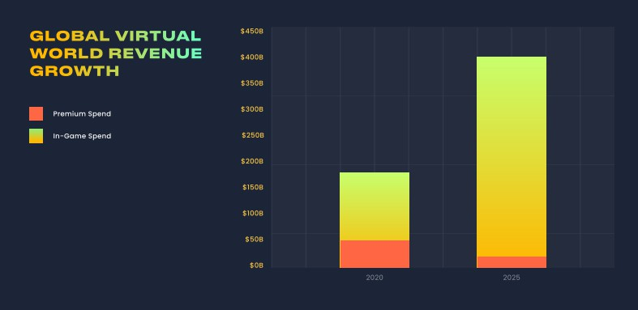

Figure 1 – Metaverse revenue growth projection

Currently, the centralized metaverse platforms are the largest revenue generator, with a “premium” subscription being a large portion of the cash inflow. However, it is projected that over the next several years decentralized platforms will leap forward, more than doubling total metaverse revenue generated to $400 billion and reducing the

importance of subscription-based revenue systems in favor of direct in-platform spending [3].

With the rapidly evolving and expanding scope of metaverse platforms, new and previously unseen business opportunities begin to appear. For simplicity, we can group them into several categories [4]:

* Marketing & Advertising
* Events & Conferences
* Virtual Assets Creation
* Product Development
* Virtual Goods Commerce

Currently, the most well-explored categories are marketing & advertisement for well-established businesses willing to tap into the metaverse userbase and virtual asset creation for small entrepreneurs working strictly inside metaverse platforms and catering to the local digital communities [5].

However, over the past year, two more categories, namely events & conferences and metaverse product development have risen to prominence. Events & conferences are a great way for established businesses to bring new experiences to both their existing consumers, but also employees and investors. While the Roblox platform is actively used as a virtual venue for popular artists and brands to promote themselves, Meta is actively promoting its virtual world as a place to hold conferences and a new type of work collaboration [6]. On the other side of the spectrum, small creative teams began to develop programs, modifications, and tools for existing metaverse platforms, catering to the metaverse users looking for advanced features and experiences.

Finally, we have virtual goods commerce as an emerging and not yet fully realized business opportunity. Just as virtual assets are created by members of the metaverse platforms, they can be purchased and sold by the other members of the platform. Usually, these marketplaces cater to users that would like to acquire something that is not available from inside the platform, or, oppositely, they would like to sell a unique asset for a good profit [7].

In conclusion, while the metaverse is only emerging as a real-life concept, it has already attracted billions in investments and generated billions in revenue. Such a new, but rapidly growing market creates a lot of previously unseen business opportunities that we have yet to discover. This paper focuses on exploring just the most popular and visible ones.

**References:**

1. Jean Folger, What Does Metaverse Mean and How Does This Virtual World Work?, 2022. URL: https://[www.investopedia.com/metaverse-definition-5206578.](http://www.investopedia.com/metaverse-definition-5206578)
2. Theo Zenou, A novel predicted the metaverse (and hyperinflation) 30 years ago, 2022. URL: https://[www.washingtonpost.com/history/2022/06/30/snow-crash-neal-stephenson-metaverse/](http://www.washingtonpost.com/history/2022/06/30/snow-crash-neal-stephenson-metaverse/)
3. Grayscale Research, Web 3.0 Virtual Cloud Economies, 2021. URL: https://grayscale.com/wp-content/uploads/2021/11/Grayscale_Metaverse_Report_Nov2021.pdf
4. Eran Elhanani, Constantin Kogan, The Metaverse Business Opportunities, 2022. URL: https://gamespad.io/the-metaverse-business-opportunities/.
5. Jon Radoff, Virtual Items and the Creator Economy, 2021. URL: https://medium.com/building-the-metaverse/virtual-items-and-the-creator-economy-2a248d6d8955.
6. Jazz Monroe, Charli XCX to Play Metaverse Concert on Roblox Platform, 2022. URL: https://pitchfork.com/news/charli-xcx-to-play-metaverse-concert-on-roblox-platform/.
7. Geri Mileva, The Ultimate Guide to Metaverse Marketplaces, 2022. URL: https://influencermarketinghub.com/metaverse-marketplace/.

## 1 Nataliia Tmienova

PhD in Physical and Mathematical Sciences, Associate Professor of the Intelligent Technologies Department, Associate Professor

## 2 Arthur Chernenko

Master student of the Intelligent Technologies Department

*1,2 Taras Shevchenko National University of Kyiv, Ukraine*

# APPROACH TO AUTOMATIC VERIFICATION OF ANSWERS TO OPEN QUESTIONS WHEN PERFORMING CONTROL MEASURES

**Abstract.** In universities of Ukraine, control measures are held annually, and open questions make up a large part of them. In order to automate the process of checking answers to open questions, there was developed an approach, which consists in automatically comparing the student's answers with the teacher's reference version of the answer. The approach is based on a combination of Natural Language Processing methods and tools.

**Keywords:** control measures, open questions, Natural Language Processing, standard, n-grams, semantic analysis, parse tree, RAKE algorithm, cosine distance, LSTM, CNN, word2vec, BeautifulSoup.

In universities of Ukraine, every year a large number of control measures are held

- independent works, modular control works, tests and exams, which can have a different structure, but in most cases they contain test or open questions, and often their combination. And if, in the case of tests, platforms provide an automatic check function along with the possibility of forming questions, then the teacher has to check the answers to open questions, and this process has certain disadvantages.

The first drawback is that the teacher has a number of signs or subjective traits that are inherent to a person and that can affect the rational evaluation of a student's work. For example, a teacher may have characteristics such as illness, bad mood or other features that may negatively affect the evaluation process and make it not objective.

The second disadvantage is the teacher's personal involvement in the evaluation process, which can lead to a situation where the teacher is accused of being biased towards the student.

In order to prevent such situations from arising, it is better that the verification of answers to open questions is performed by an automatic system, which will make the evaluation process objective.

Such a system can be implemented using an approach that consists in automatically comparing the student's answers with a reference version of the teacher's answer using Natural Language Processing (NLP) tools, such as lemmatization, keyword extraction, knowledge tree construction, named entity recognition, and others [1].

The algorithm of such system can be divided into several stages:

* preparatory stage – adding a standard, keywords, dictionaries and own text base;
* 1st stage – splitting the input text into sentences;
* 2nd stage – checking for full compliance to the standard variant;
* 3rd stage – semantic analysis of sentences;
* 4th stage – combining the results.

We will describe in more detail the 2nd and 3rd stages of the algorithm.

At the 2nd stage of checking for complete compliance with the reference option, a comparison of the reference value (the teacher's answers) with the student's answer will be performed by applying methods based on symbols using n-grams - sequences of the n numbers of symbols and words used together [2] .

For this, it is necessary to establish connections between the sentences (strong or weak), break the sentences into n-grams and build a binary matrix (for the standard and for the tested text). Next, it is necessary to calculate the threshold for the similarity of sentences

𝜆 = 𝑁𝑠,

𝑁𝑎

where *Ns* is the number of identical n-grams,

*Na* is the total number of n-grams.

The general level of compliance is establishing according to the matrix. If it corresponds to a certain specified value, then we complete the work, if it does not correspond, then we proceed to the next stage.

At the 3rd stage, it is necessary to perform a semantic analysis of sentences. As a result, those sentences that exceeded the threshold λ will be excluded, but can be used for the analysis of other sentences.

This stage can be divided into the following 3 sub-stages:

* search in downloaded documents from the relevant academic discipline;
* corpus search;
* internet search.

The search by downloaded documents is carried out using keywords contained in the question. To obtain keywords, we can use the RAKE algorithm [3] or another, if it gives a better result, use the metric to search for less used words and, having already found them in the sources, we can perform semantic analysis of the context.

Next, an analysis is performed using the corpus, which is replenished in the process of working with the program. For this purpose, you can use parsing trees and parsers formed on their basis [4], as well as use the approach based on the cosine distance between the words of one and another sentence, which is described in [5], but taking into account some specified stop words and linking them to a certain word or set of words.

It is also possible to apply the approach using LSTM and CNN networks, described in [6] or word2vec, described in [7], taking into account the independence of words among themselves.

The last one is internet search and analysis. For this, we can use a tool like BeautifulSoup [8] or a similar approach for obtaining the content of web resources and performing its semantic analysis.

The disadvantage of the proposed approach is a large number of operations, but the quality of verification has a much higher priority than speed, and the increase in computing power every year will be able to overcome this disadvantage over time.

For practical implementation, the best programming language is Python, because it provides many tools for processing text, such as nltk, spacy, and others. Functionality in these libraries can act as ready-made tools, or can be used as parts of more complex approaches.

**References:**

1. U. Mishra, 10 Top NLP Algorithms, 2022. URL: https:/[/www.analyticssteps.com/blogs/top-nlp-algorithms](http://www.analyticssteps.com/blogs/top-nlp-algorithms)
2. N. Agarwal, N-gram Language Modeling in Natural Language Processing, 2022. URL: https://[www.kdnuggets.com/2022/06/ngram-language-modeling-natural-language-](http://www.kdnuggets.com/2022/06/ngram-language-modeling-natural-language-) processing.html
3. Pradeep T, Keyword Extraction Methods from Documents in NLP, 2022. URL: https:/[/www.analyticsvidhya.com/blog/2022/03/keyword-extraction-methods-from-documents-in-](http://www.analyticsvidhya.com/blog/2022/03/keyword-extraction-methods-from-documents-in-) nlp/
4. P. Sharma, Dependency Parsing in Natural Language Processing with Examples, 2021. URL: https:/[/www.analyticsvidhya.com/blog/2021/12/dependency-parsing-in-natural-language-](http://www.analyticsvidhya.com/blog/2021/12/dependency-parsing-in-natural-language-) processing-with-examples/
5. Y. Peirsman, Comparing Sentence Similarity Methods, 2018. URL: <http://www.nlp.town/blog/sentence-similarity/>
6. Mansoor, M., Rehman, Z. U., Shaheen, M., Khan, M. A., Habib, M. Deep Learning Based Semantic Similarity Detection Using Text Data. Information Technology and Control, 49(4), 495-510. https://doi.org/10.5755/j01.itc.49.4.27118
7. Z. Ali, A simple Word2vec tutorial, 2019. URL: [https://medium.com/@zafaralibagh6/a-simple-word2vec-tutorial-61e64e38a6a1](https://medium.com/%40zafaralibagh6/a-simple-word2vec-tutorial-61e64e38a6a1)
8. Beautiful Soup Documentation. URL: https:/[/www.crummy.com/software/BeautifulSoup/bs4/doc/](http://www.crummy.com/software/BeautifulSoup/bs4/doc/)

## 1 Yanina Shestak

Assistant at the Department of Cyber Security and Information Protection, Faculty of Information Technologies

## 2 Serhii Toliupa

Doctor of Technical Sciences, Professor at the Department of Cyber Security and Information Protection, Faculty of Information Technologies

## 3 Anna Torchylo

Master’s student at the Department of Cyber Security and Information Protection, Faculty of Information Technologies

*1,2,3 Taras Shevchenko National University of Kyiv, Ukraine*

# COMPARISON OF NEURAL NETWORK ALGORITHMS EFFICIENCY IN DATA CENTER CYBERSECURITY

**Abstract.** This paper proposes a research for neural network architectures in order to evaluate the performance of the application of neural network algorithms in accordance with the target indicators of the accuracy of machine analysis. At the same time, it is proposed a comparison of classical neural network architectures, which are characterized by a minimal load on the hardware resource of the machine analysis system, with neural network architectures of deep learning.

**Keywords:** data center, multi-layer autoencoder, cyber attack, deep belief network, convolutional neural network, recursive neural network.

Neural network algorithms are widely considered relevant in solving the problem of identifying and classifying cyber attack patterns nowadays. At the first stage, based on a set of statistical analysis indicators {𝑁𝑇𝑃 , 𝑁𝑇𝑁, 𝑁𝐹𝑃, 𝑁𝐹𝑁} presented in studies [1,

2], it is proposed to determine the ranges of values for the objective functions {𝐹𝐴𝐿 }and

{𝐹𝑃𝐿}for the architecture of the autoencoder and multi-level autoencoder according to equation (1).

|  |  |
| --- | --- |
| 𝑁𝛴𝑇  ⎡𝐹𝐴𝐿 =  ⎢ 𝑁𝛴 , 𝑤ℎ𝑒𝑟𝑒 [𝑁𝛴𝑇 = 𝑁𝑇𝑃 + 𝑁𝑇𝑁  ⎢𝐹 = 𝑁𝑇𝑃 𝑁𝛴𝑃 = 𝑁𝑇𝑃 + 𝑁𝐹𝑃  [ 𝑃𝐿 𝑁  𝛴𝑃 | (1) |

The calculation results demonstrate that the classical neural network architectures shows mediocre performance values.

When moving from a standard autoencoder (values of the objective functions

𝐹0 and 𝐹0 ) to a deep learning neural network of the multi-layered autoencoder (values

𝐴𝐿 𝑃𝐿

of the objective functions 𝐹+ and 𝐹+ ), the accuracy of the analysis does not increase,

𝐴𝐿 𝑃𝐿

but the spread of values significantly decreases, which makes it possible to fix the target indicators at the maximum possible level of this model of values. The reliability of the application of the deep learning architecture is based on the comparison of the values obtained at the output of each layer, which corresponds to a separate autoencoder, with the next layer. In turn, neural network algorithms based on deep belief network (DBN) architecture are based on the composition of basic neural networks and classification

layers. Within the framework of the SIEM system, this approach highlights high-level features of the code at the level of deobfuscation.

In addition to the basic architecture (values of the objective functions 𝐹𝐷 and

𝐴𝐿

𝐹𝐷 ), the research paper presents modeling results for DBN with a linear regression

𝑃𝐿

function. It is the value of the objective functions 𝐹𝐿𝑅 and 𝐹𝐿𝑅 and the elements of the

𝐴𝐿 𝑃𝐿

architecture of the probabilistic neural network (PNN) are the values of the objective

functions 𝐹𝑃 and 𝐹𝑃 , respectively [3, 4].

𝐴𝐿 𝑃𝐿

The simulation results show, neural network algorithms based on the DBN architecture with LR layers provide maximum accuracy in both indicators ( 𝐹𝐿𝑅 ∈

𝐴𝐿

[97%, 98%] and 𝐹𝐿𝑅~98%, respectively) with minimal spread (∆𝐹𝐿𝑅~2% and

𝐴𝐿

∆𝐹𝐿𝑅~1%, respectively).

𝑃𝐿

𝐴𝐿

The last group of neural network architectures, which was considered in this paper, includes such architectures as CNNs using a long chain of short-term memory elements (LSTM). The simulation results demonstrates, neural network algorithms based on the RNN architecture with the LSTM scheme provide maximum accuracy in

both indicators (𝐹𝑅 ~96% and 𝐹𝑅 ~96%, respectively) with minimal spread

𝐴𝐿 𝐴𝐿

(∆𝐹𝑅 ~1% and ∆𝐹𝑅 ~1%, respectively).

𝐴𝐿

𝑃𝐿

The main advantage of the particular scheme is the flexibility of convolutional

operators in reducing the number of parameters. Such networks provide superior performance by simulating signals in temporal information and provide highly efficient detection of suspicious events using a long chain of short-term memory cells.

As a result, the proposed approach can be adapted for a wide range of tasks in the field of organization, configuration and optimization of the SIEM scheme through the assessment of the accuracy of machine analysis in the selection and classification of cyber attack patterns according to a specific task (threat level, volume of incoming data flow and available computing resource and the memory resource of the hardware platform of the service).

**References:**

1. Ma, X., Zhang, X., Dong, C., & Chen, X. (2021). A survey on Secure Outsourced Deep Learning. Cyber Security Meets Machine Learning, 129–163. https://doi.org/10.1007/978- 981-33-6726-5_6.
2. Jiang, P., Wu, H., & Xin, C. (2021). DeepPOSE: Detecting GPS spoofing attack via deep recurrent neural network. Digital Communications and Networks. https://doi.org/10.1016/j.dcan.2021.09.006.
3. He, J., Tan, Y., Guo, W., & Xian, M. (2020). A small sample DDOS attack detection method based on Deep Transfer Learning. 2020 International Conference on Computer Communication and Network Security (CCNS). https://doi.org/10.1109/ccns50731. 2020.00019.
4. Yu, Y., Long, J., & Cai, Z. (2017). Network intrusion detection through stacking dilated convolutional autoencoders. Security and Communication Networks, 2017 , 1–10. https://doi.org/10.1155/2017/4184196.
5. Song, Y., Hyun, S., & Cheong, Y.-G. (2021). Analysis of autoencoders for network intrusion detection. Sensors, 21 (13), 4294. https://doi.org/10.3390/s21134294.

## 1 Oleksandr Tsesliv

Student of the Master's Project Management Program

## 2 Viktor Morozov

PhD, Professor, Head of The Department of Technology Management

*1,2 Taras Shevchenko National University of Kyiv, Ukraine*

# NEW APPROACHES TO PROJECT MANAGEMENT AND RELATED DIGITAL TECHNOLOGIES WITH PMBOK 7 EDITION

The Project Management Institute (PMI®) published the new PMBOK Guide Seventh Edition, on August 1, 2021. In six editions, the PMBOK had become larger and more elaborate – and therefore harder to read. Hence, the Seventh edition has aimed to give a fresh start and re-load the standard. The structure has also been changed.

A Guide to the Project Management Body of Knowledge (PMBOK® Guide) is PMI’s fundamental PMI publication. The guide is a basic resource for effective project management in any industry. The book includes The Standard for Project Management. The standard is the foundation upon which the extended body of knowledge builds. The guide explains and summarizes that knowledge.

## Why isn't the PMBOK a methodology?

It's important to highlight that, the PMBOK isn't a methodology. Considering it's widely followed, the PMBOK guide doesn't offer unique approaches for different types of projects and, it's a collection of best practices with general recommendations.

A methodology is defined explicitly by a specific approach. And, as a result, it considers the oddity of a domain. However, the PMBOK and the guide it offers are a reference for several working methodologies in use today.

## What is changing in PMBOK Guide – Seventh Edition

PMBOK 7th Edition is based on principles rather than processes and it is much shorter than the 6th edition.

In PMBOK 7th Edition, projects do not only produce products or deliverables. Projects deliver outcomes and these outcomes bring value to the organization and its stakeholders.

There are 12 Project Delivery Principles and a Value Delivery System newly introduced in the 7th edition. The Value Delivery System is focusing on delivering valuable outcomes rather than deliverables. Projects are fundamental components of the Value Delivery System and principles guides the Project Managers, Team Members and stakeholders on how to achieve intended outcomes to deliver value to the organization and stakeholders.

## “Value Delivery System” approach

Based on this system, the strategies, missions or objectives of an organization decides the next portfolios or investments. Portfolios can include sub-portfolios, programs or projects. To ensure the objectives of the portfolios, the program and project delivery must achieve its intended targets. Based on the outcomes of the projects, business impacts are analyzed and portfolios are reviewed or adjusted for the next steps.

Once the projects are delivered successfully, expected business values must be achieved as well. This is called “Business Value Realization”. Based on the realized business values and outcomes of the delivered projects, organizations adjust their strategy to initiate new portfolios.

Project teams can produce outcomes by using different delivery methodologies. For some projects, activities might be obvious and the results can be delivered by completing the activities. However, for other projects, there might be ongoing actions, monitoring and elaborating the outcomes of previous activities to determine the next steps in the project. The “project management” might not be an appropriate term for some projects. Therefore, “project delivery” is used instead of “project management” in PMBOK 7th edition to cover outcomes as well as deliverables of a project.

## Project Delivery Principles

There are 12 principles in PMBOK 7th edition and these principles define the “what” and “why” of the project delivery. Project delivery principles describe a fundamental truth, norm, or value and are not prescriptive. To ensure the intended outcomes of the project delivery, project team members must follow these principles. The following are the 12 principles.

1. Stewardship: Be a diligent, respectful, and caring steward.
2. Team: Build a culture of accountability and respect.
3. Stakeholders: Engage stakeholders to understand their interests and needs.
4. Value: Focus on value.
5. Holistic Thinking: Recognize and respond to systems’ interactions.
6. Leadership: Motivate, influence, coach, and learn.
7. Tailoring: Tailor the delivery approach based on context.
8. Quality: Build quality into processes and results.
9. Complexity: Address complexity using knowledge, experience, and learning.
10. Opportunities & Threats: Address opportunities and threats.
11. Adaptability & Resilience: Be adaptable and resilient.
12. Change Management: Enable change to achieve the envisioned future state

## PMBOK Guide: The 8 New Project Performance Domains:

The below-mentioned 8 Project Performance Domains can be considered as an alternative to the 5 Process Groups, though it does not come out neither is such correlation defined in the PMBOK 7.

Stakeholder Team

Development Approach and Life Cycle Planning

Project Work Delivery Measurement Uncertainty

## Conclusion

The biggest change is the shift from “process-based project management” to “principle-based project delivery”. Instead of processes, inputs, outputs, tools, and techniques, project delivery focuses on principles and outcomes.

These changes continue the change of PMBOK from waterfall to agile methodologies, making PMBOK a more generic body of knowledge and showing PMI's effort to keep the leading positions in project management institutions.

**References:**

1. Web site PMI: Project Management Institute [https://www.pmi.org](https://www.pmi.org/)
2. Web site PMI Ukraine Chapter [https://pmiukraine.org](https://pmiukraine.org/)
3. PMBOK Project Management Body of Knowledge (PMBOK® Guide)

## 1 Olha Vakulenko

Master’s student of the Faculty of Information Technology

## 2 Oleksandr Timinskyi

PhD, Associate Professor, Associate Professor of the Department of Technologies Management

*1,2 Taras Shevchenko National University of Kyiv, Ukraine*

# USE OF ARTIFICIAL INTELLIGENCE METHOD TO OPTIMIZE IT PROJECT TEAM MANAGEMENT PROCESSES

**Abstract**. The integration of advanced technologies into management and decision-making procedures is a continuous effort toward projects performances optimization. Well prepared team with high professional knowledge and good communication inside is one of the main factors of successfully realized projects. The paper proposes and describes the process of developing and using Neural Networks (NNs) in order to optimize the management procedures of teams. The benefits of using artificial intelligence for management purposes showed by analyzing syntactic Human Resources (HR) data with R and Python languages and developing a neural model with the usage of the TensorFlow library.

**Keywords**: Project management, team building, Neural Networks, Artificial Intelligence.

The search for better variants of business processes never stop, there is enough space for optimization. Today, Artificial intelligence (AI) optimization is becoming an essential topic in the business area as it might save human energy for a big number of tasks in any organization. This paper review how AI can help to optimize team management.

The goal of project team management is to guarantee that project participants’ potential is utilized as effectively as possible. The efficiency of the team’s work will have a significant impact on the outcome of the company idea’s execution.

The foundation for the project team’s efficiency is built at the time of its inception. However, even if the ideal team composition could be chosen, managing the team would not get any easier; on the contrary, it would become more challenging. Real specialists are considerably harder to handle than mediocre specialists [1]. They are more independent in their judgments, less disciplined, more ambitious, and are characterized by other characteristics that make the project manager's job more difficult.

Burnout and the following dismissal of employees will affect the business even more. The projects of ex-employees might be delayed, and hiring new workers will take time and team resources from the project development. The majority of the time, new hires need to be taught for the position and/or given time to adjust to the organization. The business wants to determine what aspects impact the dismissal process the most in order to prevent it and save money.

The logical step in this situation is to hire analysts in HR team, so they can analyze the data and control the employee aspects. It is hard to analyze large data manually, a lot of fields and their correlations might be confusing for the human eye. Using this approach analysts might build a lot of graphics, and lists of correlations on dependencies and then analyze them one by one. Does not sound like the best way to the improvement of team management. For purpose of example, a correlation matrix on IBM synthetical HR dataset is built [2]. From the dependency matrix (Figure 1) between attrition of employees and factors related to them, it is seen that ‘Age’, ‘Marital status’, ‘Total working years’, ‘Years at company’, and ‘Years with current manager’ impact the most the possibility of occupational burnout.

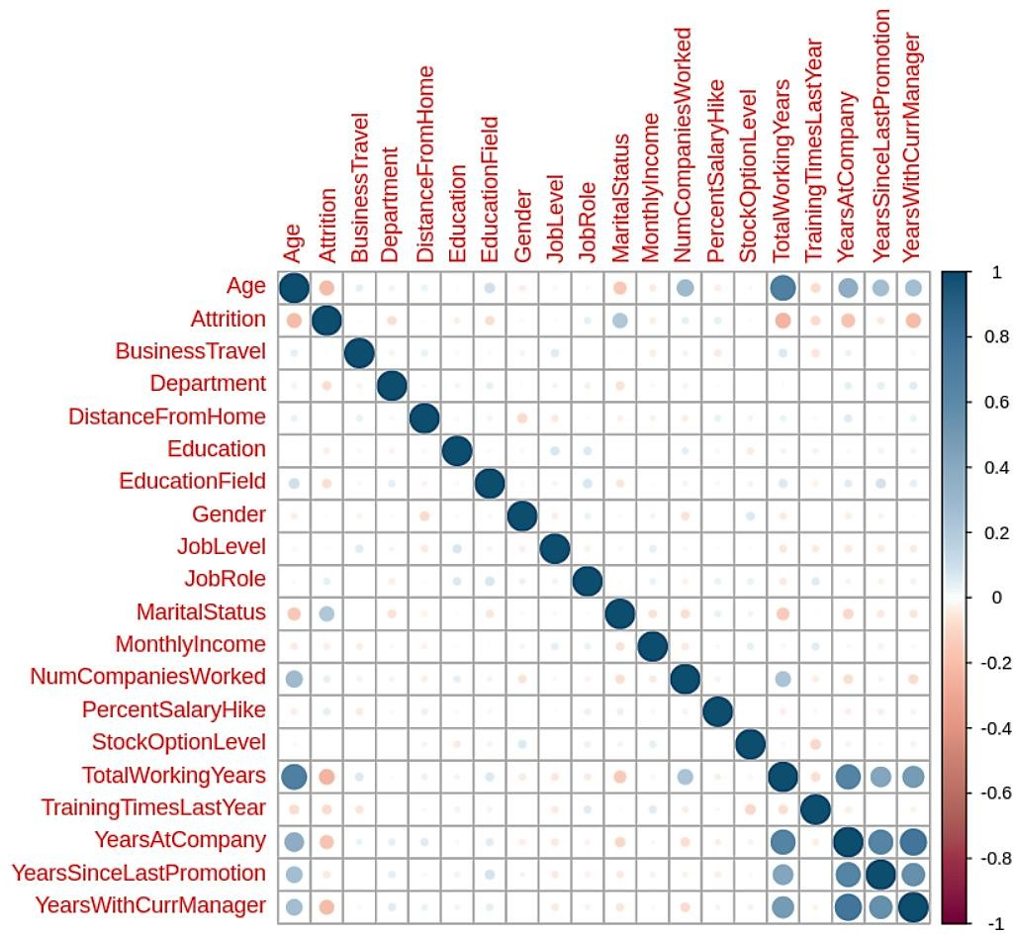

Figure 1. Matrix of correlation between ‘Attrition’ and other factors.

The matrix shows the general importance of different factors, but for proper analysis, it is important to create an individual chart for every factor. Without it, there is a chance that important information will be missed. It is even harder to calculate the possibility of burnout numerically. And this is a moment when we can turn to the help of AI.

The system that builds on the Neural model with a continuously updating database of employees’ status will allow to check regularly the possibility of attrition on a daily/weekly/monthly base. The neural model might be trained on mentioned in this article previously synthetical data and then applied to the company database of employees and their factors shape. The neural model developed for this paper consists

of the input layer with 19 neurons, 2 hidden layers with 8 and 5 neurons accordingly, and a single neuron layer output (Figure 2).

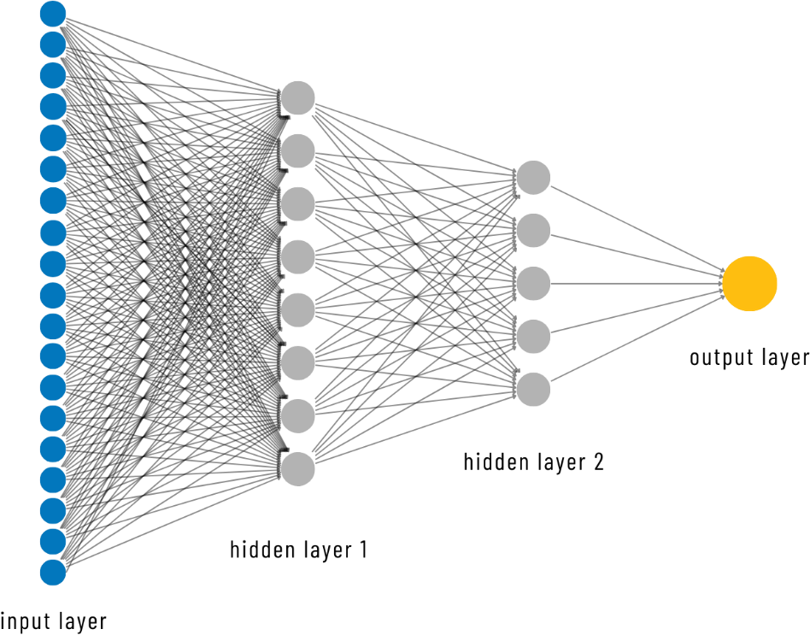

Figure 2. Neural Networks model.

The general accuracy of the model is 0.7, Precision is 0.6, Sensitivity is 0.7, and Specificity is 0.7 as well.

Accuracy (all correct / all) = (TP + TN) / (TP + TN + FP + FN) Precision (true positives / predicted positives) = TP / (TP + FP)

Sensitivity aka Recall (true positives / all actual positives) = TP / (TP + FN) Specificity (true negatives / all actual negatives) =TN / (TN + FP)

**Conclusions**: A neural network model can be used to enhance team management procedures and forecast the actual likelihood of staff attrition. By implementing it to ongoing data it is possible to predict how much the worker feel exhausted and which factor need to be reviewed. The use of artificial intelligence in managing IT project teams will help to mathematically determine the likelihood of employee burnout and the level of their motivation. This will reduce the risks of misunderstandings typical of the approach based on the intuition and feelings of the project manager or HR.

**References**:

1. Kucherenko, V. R., Markitan, O. S.. Project team management. In Project management in business structures. Retrieved from https://studfile.net/preview/5152720/page:55/.
2. IBM (2019) Employee-attrition-aif360 [Database]. <https://github.com/IBM/employee-attrition-aif360/blob/master/data/emp_attrition.csv>
3. Ragan, A. (2018, October 18). Taking the Confusion Out of Confusion Matrices. Towards Data Science. Retrieved October 28, 2022, from [https://towardsdatascience.com/taking-](https://towardsdatascience.com/taking-the-confusion-out-of-confusion-matrices-c1ce054b3d3e) [the-confusion-out-of-confusion-matrices-c1ce054b3d3e](https://towardsdatascience.com/taking-the-confusion-out-of-confusion-matrices-c1ce054b3d3e)

## 1 Oleksandr Vashchilin

Deputy Director Department of Information Technology

## 2 Olena Vashchilinа

Associate Professor Department of Applied Information Systems

## 3 Romanas Tumasonis

Dean of the Faculty of Electronics and Informatics

*1 State Employment Center of Ukraine*

*2 Taras Shevchenko National University of Kyiv, Ukraine*

*3 Vilniaus University of Applied Sciences, Lithuania*

# UNIFIED PORTAL OF VACANCIES

**Abstract**. Due to the armed military aggression in Ukraine, the problem of the population employment has become especially acute. Initiated by the Ministry of Economy and State Employment Service of Ukraine in corporation with leading jobs searching sites the “Unified Portal of Vacancies” - information environment for a job searching, was created. In this work are highlighted problematic questions that had to be solved at the start of this in-demand project. Features of aggregation of information from different sources and prospects of development are outlined.

**Keywords:** job vacancies search, “Unified Portal of Vacancies”, information exchange, unified directory, profession classifier.

Due to the war, many Ukrainians lost their works. So, looking for a job is a very urgent problem today. It is especially difficult for those who were forced to move to a different region of Ukraine due to the hostilities. At the same time, businesses that have changed their location because of the war, as well as enterprises that are opening or expanding, especially with the help of grant programs from the State for starting or developing a business [1], need labor. It is possible to provide Ukrainians with work in wartime only by combining the efforts of all interested parties - the State, business and job seekers. So, the State Employment Service with the participation of the Ministry of Economy of Ukraine, as the organizer, signed an agreement on cooperation and information interaction with leading work searching sites: work.ua, robota.ua, grc.ua, novarobota.ua, pidbir.com. As a result of such cooperation, the "Unified Portal of Vacancies" [2] was created, which began а work on September 20, 2022.

The "Unified Portal of Vacancies" allows you to find information about jobs based on the region (area, district, community), a field of work, expected salary level, and type of employment. Vacancies are updated on the portal several times a day. Brief information about the vacancy is displayed in an easy-to-view form, with subsequent redirection for additional information and contacts to the site that provided the vacancy (work.ua, robota.ua, grc.ua, novarobota.ua, pidbir.com, dcz.gov.ua). The portal is adapted to work from any mobile device. Currently, the portal contains more than 120 thousand vacancies. The portal is daily used by thousands of users that generate several tens of thousands of job search queries.

The portal technically is implemented using technologies: React, Node.js, Python. An object-relational database management system – PostgreSQL is used as a

database server. Information is exchanged through the API interface in json and xml formats.

At the start of the project development, we had to solve several problematic issues. Each of the leading Ukrainian sites for searching for a job has certain peculiarities in the business logic implementation of its software, specifically in the exchange of regulatory and reference information. First of all, the list of data on vacancies that all project participants are ready to provide was agreed upon. In this regard, at the first stage, a simplified algorithm for combining data is used to bring data to the state classifier of objects of the administrative-territorial structure of Ukraine [3] and a unified list of industries or areas of activity of enterprises.

Description of information aggregation from different sites:

1. first receiving directories (regions, settlements, branches of activity of enterprises, business entities) from leading job search sites. Bringing these directories to the unified directories.
2. repeatedly obtaining these directories, when changes were made. Bringing changes in these directories to the united unified directories.
3. daily receiving information about vacancies. Several times a day. Check for compliance of the provided vacancies with the unified directories. If there is such compliance - vacancies are added to the unified database of vacancies. If there is no match - manual processing is applied (reconciliation with sites, updating directories, etc.).

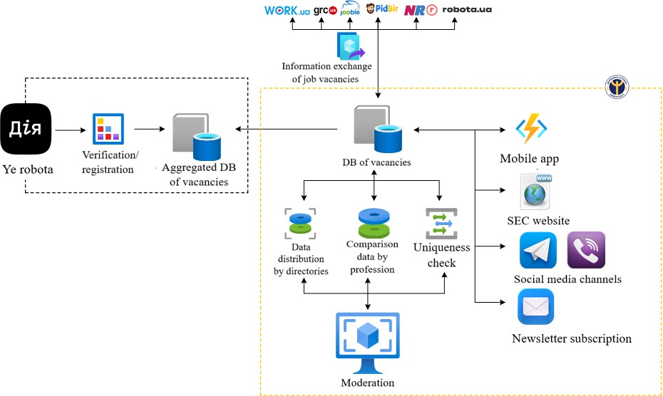

Figure 1 - Scheme of information exchange between project participants Development prospects:

1. unification of vacancies and possibly bringing them into line with the national classification of professions of Ukraine "DK 003:2010" [4], in particular with the use of artificial intelligence;
2. subscription for users for selection and distribution of vacancies;
3. application of artificial intelligence for searching and selecting vacancies;
4. implementation of a mobile application;
5. search and selection of vacancies via Viber and Telegram bot;
6. the possibility of searching and selecting vacancies using the portal and mobile application "Diya".

The scheme of information exchange between the project participants concerning future tasks is shown in Figure 1.

So, providing Ukrainians with jobs during the war is possible only through joint efforts of all interested parties - the State, business and job seekers. A powerful information environment for job search as the "Unified Portal of Vacancies" will help in overcoming unfavorable tendencies in the labor market by optimizing the process of legal job search. Proper provision of enterprises with employees will contribute to the recovery and future development of Ukraine's economy.

**References:**

* 1. Erobota: Grants from the state for starting or developing a business. *Ministry of Economy of Ukraine*: website. URL: [https://www.me.gov.ua/Documents/Detail?lang=uk-UA&id=94321ef8-](https://www.me.gov.ua/Documents/Detail?lang=uk-UA&id=94321ef8-1418-479c-a69f-f3d0fdb8b977&title=Robota-GrantiVidDerzhaviNaVidkrittiaChiRozvitokBiznesu) [1418-479c-a69f-f3d0fdb8b977&title=Robota-GrantiVidDerzhaviNaVidkrittiaChiRozvitokBiznesu](https://www.me.gov.ua/Documents/Detail?lang=uk-UA&id=94321ef8-1418-479c-a69f-f3d0fdb8b977&title=Robota-GrantiVidDerzhaviNaVidkrittiaChiRozvitokBiznesu).
  2. Unified Portal of Vacancies. *State Employment Center*: website. URL: <https://jobportal.dcz.gov.ua/>.
  3. State classifier of objects of the administrative and territorial system of Ukraine. URL: [https://dovidnyk.in.ua/directories/koatuu.](https://dovidnyk.in.ua/directories/koatuu)
  4. Classifier of professions DK 003:2010. *Verkhovna Rada of Ukraine*: website. URL: [https://zakon.rada.gov.ua/rada/show/va327609-10#Text.](https://zakon.rada.gov.ua/rada/show/va327609-10#Text)
  5. L.Yaremenko, A. Hevchuk, T. Vuzh, E. Vashchilina, M. Yermolaieva. [Information](https://www.koreascience.or.kr/article/JAKO202121055608991.view?orgId=anpor&hide=breadcrumb%2Cjournalinfo) [Technologies of Accounting and Analysis in Modern Companies](https://www.koreascience.or.kr/article/JAKO202121055608991.view?orgId=anpor&hide=breadcrumb%2Cjournalinfo)/ IJCSNS International Journal of Computer Science and Network Security, V.21 No.5, May 2021, p. 151-159.
  6. V. Pleskach, V. Krasnoshchok, M. Melnyk, S. Klymenko, R. Tumasonis. Current state and trends in the development of e-commerce software protection systems. *IT&I-2021 Information Technology and Interactions, December 01–03, 2021, KNU Taras Shevchenko, Kyiv, Ukraine*, p. 79- 88.

## 1 Anastasiia Vasylieva

Student at the Department of Software Engineering

## 2 Roman Melnyk

Professor at the Department of Software Engineering, Faculty of Information Technologies

*1,2 Lviv Polytechnic National University*

# CLASSIFICATION OF CLOUD TYPES ON SATELLITE IMAGES USING DEEP LEARNING

**Abstract.** Cloud types classification is a kind of image classification problem, which can be solved using supervised and unsupervised machine learning methods and artificial neural networks. In this research, the convolutional neural network was proposed to classify cloud images captured by the NOAA-20 Visible Infrared Imaging Radiometer Suite (VIIRS) satellite. CNN model successfully classifies four cloud types: Cirrus, Cumulonimbus, Cumulus, and Stratocumulus. Experiment results show that the proposed method has better accuracy of cloud classification than other machine learning methods, such as Random Forest, K-Nearest Neighbours and Decision Trees algorithms.

**Keywords:** satellite imagery, cloud classification, convolutional neural network.

**Introduction.** Today, cloud recognition and interpretation using satellite cloud imagery play a significant role in meteorological monitoring, climate, and weather forecasting. Manual cloud interpretation is used to solve the problem of classification of cloud images. But this method has certain disadvantages related to the quality of human recognition of cloud images and the complex and time-consuming processing of large data sets. Therefore, suitable approaches to solving this problem are supervised and unsupervised machine learning methods and artificial neural networks [1].

The purposes of the research are analyzing existing deep learning methods for image recognition and processing, creating an artificial neural network for cloud classification based on satellite images, and estimating its accuracy.

**Practical implementation.** The EarthData service [2] was chosen for uploading and processing satellite images of clouds, which allows you to receive an image captured by the NOAA-20 Visible Infrared Imaging Radiometer Suite (VIIRS) satellite, which collects data by combining visible and infrared spectral ranges.

To solve the problem of classification of cloud types on satellite images, a set of cloud images in RGB format of different sizes, belonging to the following four classes, was prepared: Cirrus, Cumulonimbus, Cumulus, and Stratocumulus.

A proposed convolutional neural network model accepts as input images of given classes with a size of 160 x 160 x 3, where 160 x 160 is the size of the image, and 3 is the number of channels (red, green, blue). The model consists of 4 combinations of convolutional and aggregating layers with the ReLU activation function and a fully connected layer with the Softmax activation function, which is usually used in the last levels of multiclass classification, because this function considers all the values from the previous network layer, which allows you to calculate the probability for each class [3].

During model training, the cross-entropy function, as a loss function, was used to calculate the difference between the value of the training data and the predicted

results. For optimization, the adaptive moment estimation (Adam) was chosen, which is a combination of the RMSprop algorithm and stochastic gradient descent [4].

The cloud image classification results, namely the actual cloud class and the predicted one, are shown in Figure 1.



Figure 1 - Cloud classification results

After evaluating the accuracy of the model on test images, the results of the proposed convolutional neural network were compared with other image classification methods (Table 1).

Table 1. Metrics comparison of the used algorithms

|  |  |  |  |  |  |
| --- | --- | --- | --- | --- | --- |
| Algorithm | Accuracy | Precision | Recall | F1-Score | Execution time, s |
| Random Forest | 0.585 | 0.72 | 0.84 | 0.72 | 17.7 |
| K-Nearest  Neighbours | 0.35 | 0.87 | 0.35 | 0.45 | 5.2 |
| Decision Tree | 0.54 | 0.63 | 0.54 | 0.53 | 59.2 |
| Proposed CNN | 0.7 | 0.79 | 0.7 | 0.712302 | 836.4 |

**Conclusions.** After analyzing common image classification methods, a convolutional neural network model was developed to solve the problem of cloud-type classification on satellite images. By comparing the accuracy of the proposed model with the existing algorithms, the better efficiency of the convolutional neural network was confirmed.

**References:**

1. Ball, John & Anderson, Derek & Chan, Chee Seng. (2017). A Comprehensive Survey of Deep Learning in Remote Sensing: Theories, Tools and Challenges for the Community. Journal of Applied Remote Sensing. doi: 10.1117/1.JRS.11.042609.
2. Earth Data Worldview. URL: <https://worldview.earthdata.nasa.gov/>
3. Afzali Gorooh, V.; Kalia, S.; Nguyen, P.; Hsu, K.-l.; Sorooshian, S.; Ganguly, S.; Nemani, R.R. Deep Neural Network Cloud-Type Classification (DeepCTC) Model and Its Application in Evaluating PERSIANN-CCS. Remote Sens. 2020, 12, 316. doi: 10.3390/rs12020316.
4. Yamashita, R., Nishio, M., Do, R.K.G. et al. Convolutional neural networks: an overview and application in radiology. Insights Imaging 9, 611–629 (2018). doi: 10.1007/s13244- 018-0639-9

## 1 Serhii Vedmid

Student of the master’s program

## 2 Oleksandr Timinskyi

PhD, Associate Professor

***1,2*** *Taras Shevchenko National University of Kyiv, Ukraine*

# А COLLABORATION MODEL FOR CREATING AN INNOVATIVE PEDAGOGICAL PRODUCT USING THE "INSCHOOL" WEB PLATFORM.

**Abstract.** In the real world, such qualities as a talented teacher-teacher, a scientist-professional in the development of educational and pedagogical product and a professional bearer of unique knowledge and skills are very rarely present together in one person. These are always different people and our goal is to make sure that they can meet and together create a unique innovative educational and pedagogical product that will help students to get modern, innovative, and unique knowledge and skills.

**Keywords:** Innovative pedagogical product, collaboration, web platform, concept, inSchool, out-of-school education.

## Introduction

Sixty five percent of children starting primary school today will enter into jobs that do not currently exist [1]. In an era of multiple labor market disruptions – wars, pandemics, supply chain changes, green transitions, technological transformation – the one type of investment that all governments and businesses can make is investing in education, reskilling, and upskilling. This is the best way to expand opportunities, increase social mobility and accelerate growth.

A single $1 investment in a child’s education yields as much as $5 in returns over a lifetime. An additional year of education on average translates to 9% higher lifetime earnings, and in some cases up to 15% higher. The returns in lower-income countries are even higher than those in higher-income countries [2].

That is why for Ukraine, investments in children's education have not only social but also economic significance. Undoubtedly, investments in innovative and unique education will bring a more tangible result from the point of view of the future. But when we talk about innovative education, we must understand that innovative education is the result of the development of science and technology, in which we as a country lag behind in many areas.

In the real world, such qualities as a talented teacher-teacher, a scientist- professional in the development of educational and pedagogical content, and a professional bearer of unique knowledge and skills are very rarely present together in one person. These are always different people and our goal is to make sure that they meet and together create a unique innovative educational and pedagogical product that will help students (primarily children) to get modern, innovative, and unique knowledge.

To solve this problem, an experimental solution for the creation of innovative and unique educational and pedagogical products is proposed - the collaboration module.

## Concept.

The main goal of the development of the collaboration module for the creation of an innovative pedagogical product is to offer a complex IT solution in the form of a separate web platform interface for the joint design, testing, and improvement of a pedagogical product by several participants.

The interface will offer the following roles and their functions:

**Teacher methodologist** is a carrier of knowledge, skills, and techniques for creating, monitoring, and improving educational and pedagogical products. A professional teacher is also a carrier of knowledge and skills for effective teaching and learning and monitoring the progress of students.

**Occupation professional** is a carrier and author of unique and innovative knowledge and skills in certain professional areas. He is not a teacher and does not have the skills to create an educational-pedagogical product, but he is a carrier of educational content and skills that, in the process of collaboration with a teacher, form the basis of an educational-pedagogical product.

The group of **student testers** is a number of students, users of the platform, who are interested in acquiring relevant skills or knowledge and voluntarily participate in the study (testing) of the educational and pedagogical context, which was created as a result of the collaboration of the "Methodist Pedagogue" and the "Professional". They give feedback in the form of passing tests or exams on the knowledge or skills they have learned.

A **teacher** is a carrier of effective methods of group and individual training, who has undergone preliminary training on teaching a new educational and pedagogical product and will teach and train students (platform users), collect feedback, and pass it on to the development team.

A **student** is a consumer of an educational product – a user, a student of an educational platform (a child or parent, an adult student) who undergoes training in acquiring knowledge and training in mastering skills according to a developed educational and pedagogical product.

**Stage 1** – product request. A potential "Learner" from the system's existing "skill tree" or "catalog of knowledge groups" chooses the one they would like to develop or explore. If the system does not find a suitable educational and pedagogical product and teacher - a request is generated, which the potential consumer approves. After that, the system sends an invitation to other potential consumers with similar interests to join the request. If, as a result of these invitations, a group of students with a number of at least 50 users will be formed, the system registers a "Passive product request". In order to activate this request, the system automatically generates a fundraising procedure.

**Stage 2** – the creation of a team for the development of an innovative educational and pedagogical product. After the successful completion of the fundraising procedure, the system sends an invitation to participate in the development of a new educational product to "Professionals" who have proven skills, as well as to "Methodologists" who are accordingly registered in the system. The team is considered created if an

agreement is reached and a corresponding smart contract is generated - the minimum number of members of the development team is three "Professionals" and three "Teacher methodologists".

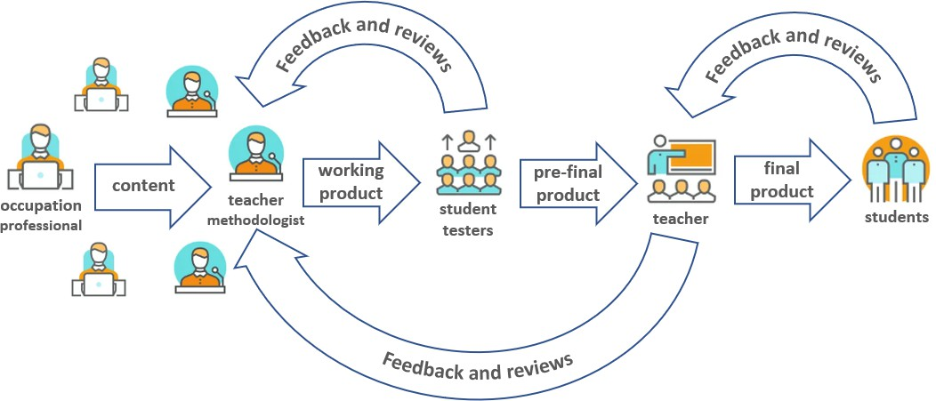

Pic.1. The process of collaboration to create an innovative pedagogical product.

**Stage 3** – development and testing. The development team begins to work on the creation of an educational and pedagogical product. At this time, the system creates a "Group of testers" by selecting "students" from among those who took part in fundraising and who already have experience or can perform the role of "testers" based on their set of skills. The process of development and testing takes place in a consistent iterative order - when, after the presentation of the educational content, the "Methodists-pedagogues" receive feedback from the "Group of testers" and process it

- they make appropriate changes to the pedagogical product together with the "Professionals"

**Stage 4** – training of "Teachers". After the completion of development and testing, the Development Team initiates the training procedure for "teachers". After receiving a corresponding request, the system selects teachers based on the geographical principle and criteria set by the development team and invites them to undergo training. According to the results of the training, "teachers" also have the opportunity to provide feedback to the team and influence the results.

**Stage 5** – finalization of the educational and pedagogical product. At this stage, the system sends a message to all "students" who participated in fundraising that the educational and pedagogical product they ordered is ready and they are invited to start studying and training. Also, in the process of this training, the "teachers" are expected to collect feedback and feedback from the students and pass it on to the development team. The product is considered finalized as a result of the successful training of more than 50% of students who participated in the fundraising

An important note - in the smart contract regarding the intellectual property of the educational and pedagogical product, the development team can, at its own request, specify who will be additionally entitled to a profit bonus (it can also be testers, teachers, and even students who participated in fundraising and final testing). The size of the "Teachers" bonus is also regulated by the smart contract. The system will distribute profits according to the smart contract and after confirmation of receipt of services by the "students".

## Conclusion.

As a result of the research, a theoretical model and a set of tools were proposed for establishing interaction between all participants in the development, testing, and improvement of an innovative educational and pedagogical product. This model is planned for implementation on the "inSchool" platform for the organization of children's out-of-school education.

It is expected that the successful implementation of both the model and the platform as a whole will allow the development of the after-school education market of Ukraine in the conditions of a pandemic, war, and forced migration, will create additional jobs and offer prospects to talented professionals, teachers, children, and adults.

**References:**

1. Sylvain Rochon, 2019, Preparing Our Children for the Future — A Futurist’s Education System [*https://medium.datadriveninvestor.com/preparing-our-children-for-the-future-a-futurists-*](https://medium.datadriveninvestor.com/preparing-our-children-for-the-future-a-futurists-education-system-a658b3dc83b9)[*education-system-a658b3dc83b9*](https://medium.datadriveninvestor.com/preparing-our-children-for-the-future-a-futurists-education-system-a658b3dc83b9)
2. Catalysing Education 4.0 Investing in the Future of Learning for a Human-Centric Recovery. World Economic Forum. Insight report, May 2022

<https://www3.weforum.org/docs/WEF_Catalysing_Education_4.0_2022.pdf>

1. Concept of development of out-of-school education/ Project, 2019, [https://nus.org.ua/wp-](https://nus.org.ua/wp-content/uploads/2019/10/kontseptsiya-rozvitku-pozashkilnoi-osviti.pdf) [content/uploads/2019/10/kontseptsiya-rozvitku-pozashkilnoi-osviti.pdf](https://nus.org.ua/wp-content/uploads/2019/10/kontseptsiya-rozvitku-pozashkilnoi-osviti.pdf)
2. Agile 101. Agile essentials. <https://www.agilealliance.org/agile101/>
3. PMBOK Guide. <https://www.pmi.org/pmbok-guide-standards/foundational/PMBOK>

## 1 Illia Zhylka

Master student

## 2 Tatjana Selivyorstova

Candidate of technical science, assistant professor

## 3 Yurij Kaliberda

Senior teacher

*1,2,3 Department of information technology and systems, Scientific and educational institute «Institute of industrial and business technologies», Ukrainian state university of science and technologies*

# A STUDY OF THE MODERN APPROACH TO THE DEVELOPMENT OF ANDROID APPLICATIONS IN THE KOTLIN LANGUAGE USING THE JETPACK COMPOSE FRAMEWORK

**Abstract.** The work is devoted to comparing the display speed of two UI interfaces, one of which was written using a new framework from Google - Jetpack Compose, and the other using xml files. Parameters such as Frozen Frames, Slow Frames, and full screen display speed were taken as the main metrics. according to the test results, it was determined that the new framework, in addition to its advantages, has a significant drawback that must be taken into account when switching to Jetpack Compose.

**Keywords:** Android, Kotlin, Jetpack Compose, Google, Rendering Research, UI Components, Imperative type of programming.

**Introduction.** Thanks to the rapid development of the mobile industry, every few years the world sees the emergence of new technical solutions designed to make life easier for developers. Declarative UI has probably become the main trend in mobile development over the past few years. Such a solution has long been successfully used in the Internet and cross-platform solutions, and finally began to be used in native development. For the implementation of which there is SwiftUI (presented at WWDC 2019) on iOS, and Jetpack Compose (presented a month earlier at Google I/O 2019) on Android.

Jetpack Compose is a modern toolkit from Google for creating Android applications using the Kotlin programming language. Jetpack Compose simplifies writing and updating an application's visual interface by providing a declarative approach [1].

It is known that declarative programming is a programming paradigm in which the programmer defines what the program should do without specifying how it should be implemented. In other words, the approach focuses on what needs to be achieved rather than teaching how to achieve it. In contrast to it, the imperative method is a method of authoritative prescriptions (orders), which is based on relations of

subordination (subordination) of some subjects to others [4]. A clear example of this approach is the description of the necessary graphic components in xml files.

Therefore, the task of studying and analyzing the modern approach to developing Android applications in the Kotlin language using the Jetpack Compose framework is relevant.

The purpose of the work is to study the display metrics of UI mobile applications by comparing the test results obtained using open APIs.

**Jetpack Compose Review**. The main feature of Jetpack Compose is the declarative style of creating UI. At the same time, the description of the interface looks like a set of componable functions - widgets that are not used under the hood of a view, but directly deal with the display on the canvas. It should be noted that at the moment the declarative style of UI development is not a widespread and popular business, but the number of projects using Jetpack Compose is constantly growing.

The main advantages of Jetpack Compose, in contrast to the existing Android UI framework, are the following [2]:

1. Unbundled toolkit: Jetpack Compose does not depend on specific platform releases;
2. You no longer need to switch between classes and xml files, all work with the UI takes place in one Kotlin file.
3. Composite approach: no inheritance. Each UI component performs an ordinary composable function, which is responsible for only limited functionality, i.e., without unnecessary logic.
4. Backward compatibility: You don't need to start a project from scratch to use Compose. It is possible to embed it (using ComposeView) into an existing XML layout, and vice versa.
5. Support by giant corporations.
6. Less code

Rendering test for UI display. The following parameters were selected as important metrics for displaying the UI of mobile applications:

* + Frozen Frames – interface objects whose visualization takes more than 700 ms;
  + Slow Frames – interface objects whose visualization takes more than 16 ms;
  + Page Load Duration – page display speed.

The study of the display parameters of the UI of mobile applications was carried out using the FrameMetricsAggregator API, taking into account the life cycles of the application. The "Flashlight" application was chosen as a test, the UI of which was developed using Jetpack Compose (Figure 1.1) and using the standard approach - through an xml page (Figure 1.2). Testing made it possible to compare the display speed of widgets written in different ways (Figure 1.3) [3].

|  |  |
| --- | --- |
|  |  |
| Figure 1.1 | Figure 1.2 |

Table 1 – Widget display metrics

|  |  |  |
| --- | --- | --- |
|  | XML Layout | Compose Layout |
| Frozen Frames, од % | 0,03 | 0,022 |
| Page Load Duration, од мс | 104 | 182 |
| Slow Frames, од % | 8,91 | 9,93 |

Looking at the results, we can draw the following conclusions that Jetpack Compose at this stage of its existence loses to the standard approach in terms of page load speed, this is due to the fact that most components used for XML-based layouts are compiled in advance, while Compose components, as well as the code, are compiled in Runtime mode. Because build components are ungrouped on the fly, rendering the layout can take a significant amount of time. But on the plus side, Jetpack Compose has its own performance benefits as more and more components are interpreted ahead of time. Not only focusing on productivity, Jetpack compose has also improved development acceleration by providing modular and intuitive declarative APIs.

**References:**

1. What is Jetpack Compose? [https://apptractor.ru/info/articles/kontseptsii-jetpack-](https://apptractor.ru/info/articles/kontseptsii-jetpack-composekotorye-dolzhen-znat-kazhdyy-razrabotchik.html) [composekotorye-dolzhen-znat-kazhdyy-razrabotchik.html](https://apptractor.ru/info/articles/kontseptsii-jetpack-composekotorye-dolzhen-znat-kazhdyy-razrabotchik.html)
2. Benefits of using Jetpack Compose https://medium.com/dvt-engineering/what-are- the-benefits-of-using-androids-jetpack-compose-9d962fed0109
3. Rendering Test [https://medium.com/okcredit/comparing-jetpack-compose-](https://medium.com/okcredit/comparing-jetpack-compose-performance-with-xml-9462a1282c6b) [performance-with-xml-9462a1282c6b](https://medium.com/okcredit/comparing-jetpack-compose-performance-with-xml-9462a1282c6b)
4. What is the difference between styles? Jetpack Compose Tutorial [Електронний ресурс] // Developer. – 2022. – Режим доступу до ресурсу: https://developer.android.com/jetpack/compose/tutorial.

# AUTHORS

Andrashko Yu. 11

Avramenko К. 7

Babenko T. 118

Bigdan A. 118

Biloshchytska S. 11

Biloshchytskyi A. 11

Bovsunovska M. 14

Buchyk S. 18, 21

Buzyurova A. 24

Cherevatov A. 28

Chernenko A. 158

Chychkan I. 28

Chyzhenko V. 30

Dakov S. 33, 35

Dolgikh S. 37

Dunaievskyi M. 44

Faizullin A. 11

Fedirko Yu. 41

Gaivoronski A. 44

Gamotska S. 55

Gavryliuk V. 46

Gorbachuk V. 44

Guzhva Yu. 50

Hazun H. 53

Hnatiienko H. 14, 55, 62,

107

Hnatiienko O. 59

Hnatiienko V. 62

Holubnycha A. 33

Hrytsun Ya. 134

Hudymenko M. 67

Ivanenko I. 90

Ivanov I. 69

Kaliberda Yu. 177

Kalinichenko N. 71

Khlevna Iu. 71, 74, 124

Khlevnyi A. 46, 76

Kiktev N. 24

Kolumbet A. 76

Kopp A. 79

Kostovetskyi Ye 84

Kravchenko O. 138

Kravets T. 84

Kruk N. 81

Kubiavka L. 30, 100, 151

Kuchansky A. 11, 105,

144

Laptiev S. 86

Laptieva T. 86

Latysheva Т. 7, 116

Liashenko O. 84

Lukova-Chuiko N. 86

Lutsenko V. 111

Lybak I. 93

Melnyk R. 171

Merkulova K. 90, 93

Minaeva Ju. 95

Mishchenko D. 98

Mohylevych V. 35

Morozov V. 50, 53, 100,

163

Mykhalchuk V. 103, 105

Myrutenko L. 116

Naberegniy A. 107

Nakonechnyj V. 111

Nesterenko Ye. 74

Nikolayev M. 113

Nizov Ya. 116

Onyshchenko A. 113

Orlovskyi D. 79

Paliy S. 136

Palko D. 118

Parkhomenko I. 35

Pikulsky R. 121

Pryidun M. 124

Pryshchepa V. 128

Rymchuk V. 131

Saiko V. 134

Sakharova S. 136

Saroka S. 18

Scherbak V. 81

Selivyorstova T. 177

Shabatska S. 67

Shats H. 138

Shcheblanin Yu. 140

Shestak Ya. 161

Shlapak O. 142

Shvydchenko A. 144

Shykhmat A. 146

Sokol-Chernilovska K. 149

Stepanov M. 81

Steshenko G. 156

Sukhina K. 151

Suleimanov Seit-Bekir 44

Surovtseva O. 154

Svoboda I. 156

Synelnyk K. 100

Timinskyi O. 165, 173

Tmienova N. 158

Toliupa S. 86, 161

Torchylo A. 161

Tsapro D. 21

Tsesliv O. 163

Tumasonis R. 168

Vakulenko O. 165

Vashchilin O. 168

Vashchilinа O. 168

Vasylieva A. 171

Vedmid S. 173

Veres Z. 146

Vlasenko O. 55

Yehorchenkov O. 41, 69,

128, 131, 142, 149, 154

Yeremenko B. 98

Yermak V. 62

Zahynei A. 140

Zhylka I. 177

Zozulia O. 62

**Partners of the Conference**



BIOSOL is based on more than 10 years of experience in the information technology market. Since the end of 2019, we have become the exclusive representative of the world’s leading manufacturer of products and solutions for security and biometric identification, Vendor Identytech Solutions.

Identytech Solutions is:

* 20 years of experience in the industry of personal identification systems;
* research center and production in Israel;
* central office in the USA;
* more than 20 regional offices around the world;
* more than 100 completed projects.

[www.biosol.com.ua](http://www.biosol.com.ua/)



Sigma Software University is an educational platform created by Sigma Software to share knowledge and develop the IT community in Ukraine.

Combining the company’s 19-year experience in various fields and a strong team of expert practitioners, the company helps to grow professionally and master new areas for both beginners and experienced professionals and contribute to the formation of an innovative IT community in the country.

https://university.sigma.software/



Huawei Technologies Co., Ltd. is a Chinese multinational technology corporation headquartered in Shenzhen, Guangdong, China. It designs, develops, produces and sells telecommunications equipment, consumer electronics and various smart devices.

Huawei is organized around three core business segments:

* Carrier Network Business Group – provides wireless networks, fixed networks, global services, carrier software, core networks and network energy solutions that are deployed by communications carriers
* Enterprise Business Group – Huawei’s industry sales team
* Consumer Business Group – the core of this group is “1 + 8 + N” where “1” represents mobile phones; “8” represents tablets, PCs, VR devices, wearables, smart screens, smart audio, smart speakers, and head units; and “N” represents ubiquitous Internet of Things (IoT) devices
* Cloud & AI Business Group – Huawei’s server, storage products and cloud services.

https://[www.huawei.com/ua/](http://www.huawei.com/ua/)



Syngenta is a leading science-based agtech company. They help millions of farmers around the world to grow safe and nutritious food, while taking care of the planet.

Syngenta is a global company with headquarters in Switzerland. 30,000 employees, in more than 90 countries are working to transform how crops are grown and protected.

Syngenta’s portfolio includes more than 80 plant protection products, as well as many hybrids and seed varieties of field and vegetable crops. More than 300 specialists work in the Ukrainian branch of the company, including many candidates in agricultural sciences. The goal of the Syngenta company in Ukraine is to offer comprehensive solutions for Ukrainian farmers and a partnership preferred by Ukrainian and international companies. The Syngenta company is distinguished by its high-quality products, an integrated approach to solving tasks and using the advantages of Ukrainian agriculture.

[www.syngenta.ua](http://www.syngenta.ua/)



KPMG is an international network of independent firms providing audit, tax and consulting services. They work closely with our customers to help them reduce risk and realize opportunities for their business.

KPMG network members include corporations, government agencies, and non-profit organizations. They provide clients with stable standards of quality of services, based on high professionalism, deep knowledge of industry specifics and local conditions.

The main goal of KPMG is to provide and improve the quality of professional services provided by its specialists. All the companies that are part of the international network strive to attract the best specialists to their staff.

The offices are represented in 144 countries, where more than 236 000 professionals work. In Ukraine, KPMG has been providing services to leading domestic and international companies and organizations since 1992. The company’s offices are located in Kyiv and Lviv.

https://home.kpmg/ua/uk/home.html



Skyglyph is a dynamic start-up consisting of creative and industry savvy aerial survey enthusiasts based in Sofia, Bulgaria encompassing an established business network in North America, Eastern Europe, and Southeast Asia.

Skyglyph renowned specialization is the development of cloud-based software and industrial surveillance solutions that transform drones into concise instruments for deployment in a wide range of business use cases.

Skyglyph’s cloud-based platform simplifies the scouting process and management of flight control, asset mapping, site monitoring, data transfer and visual result interpretation. We excel in the professional interpretation of images via the generation of comprehensive analytical and recommended actions reports that can be applied to a variety of survey use case requirements.

Our solutions are designed to bridge the gap between drone technologies and user requirements that deliver the master results that you expect.

Skyglyph eliminates the gap between the technical aspects of aerial surveying and the “plug and play” needs of its users. The results are simple and concise while at the same time providing an intrinsically valuable asset for site analysis.

https://skyglyph.com/ Telegram: Skyglyph

36 Vitosha Blvd., apt. 8, Sofia 1000, Bulgaria

Наукове видання

**Інформаційні технології та взаємодії (сателітна): Матеріали конференції, 1 грудня 2022 р., Київ, Україна**

Information Technology and Implementation (Satellite): Conference Proceedings, December 01, 2022, Kyiv, Ukraine

В авторській редакції

Редактор: Снитюк В.Є. Верстка: Гамоцька С.Л. Обкладинка: Дубницька А.С.

Підп. до друку 01.12.2022 р. Формат 60х84 1/16.

Папір офсетний. Друк офс. Гарнітура Times New Roman Умовн. друк. арк. 11,5. Обл.-вид. арк. 11,9

Зам. № 01\01-12-2022

Видавець ФО-П Піча Ю.В.

04080, Київ, вул. Новокостянтинівська, 1В

Свідоцтво

про внесення суб’єкта видавничої справи до Державного реєстру видавців,

виготівників і розповсюджувачів видавничої продукції:

ДК №822 від 27.02.2002 р.

Надруковано Видавцем ФО-П Піча Ю.В. 04080, Київ, вул. Новокостянтинівська, 1В Тел. (050) 355-77-75