**error: ‘JAVAEXP’ expected team: 이바딤 다랴 세르지바 리티스 바류카스**

[Location of the Forked Repository](https://github.com/r33tis/pdfbox): https://github.com/r33tis/pdfbox

Hash of the Last Commit: **to be updated to be updated to be updated**

[Commit Hash Before Changes](https://github.com/r33tis/pdfbox/commit/477ea0107bf298e6da5f043037c6256aef06b6ab): 77ea0107bf298e6da5f043037c6256aef06b6ab

**Justification for the selected classes**

We chose to write our unit tests for **COSFloat** and ***COSNumber*** classes because their methods appeared intuitive to understand, did not have many dependencies.

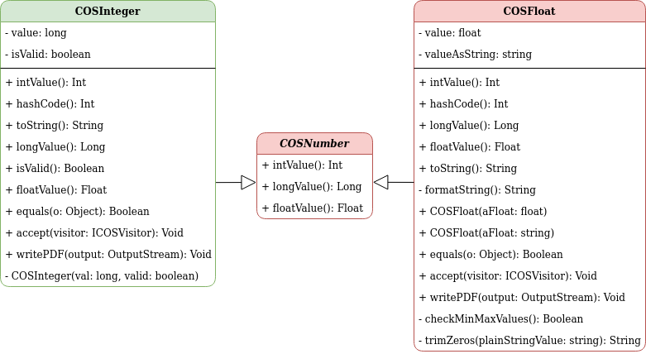

Figure 1 UML Diagram of COSInteger, *COSNumber* and COSFloat Classes

Both of these classes were chosen as test targets because each of them had less than three uncovered branches. Before forking the official repository, **COSFloat.java** and ***COSNumber.java*** had 97% and 83% covered lines, respectively.

**Description of why the classes are partially covered**

COSFloat.java was not completely covered as line 137 was not covered by test cases. Test case for checking the returning variable was added.

COSNumber.java was partially covered since lines 86, 92 and 93 were not covered by test cases. Tests were not checking whether giving string could be a number.

After covering lines we got 100% of coverage for each of target classes.

**Description of how our team have improved the test cases**

Uncovered lines were covered by adding tests