Class Program

1) To print class factorial of a given number

#include<iostream>

#include<conio.h>

using namespace std;

class factorial

{

private:

int i,num,fact;

public:

void getdata()

{

cout<<"Enter a Number to get its Factorial : ";

cin>>num;

}

int display()

{

fact=1;

for(i=1;i<=num;i++)

{

fact=fact*i;

}

cout<<"\n\nThe Factorial of "<<num<<" is : "<<fact;

}

};

int main()

{

factorial f;

f.getdata();

f.display();

getch();

return 0;

}

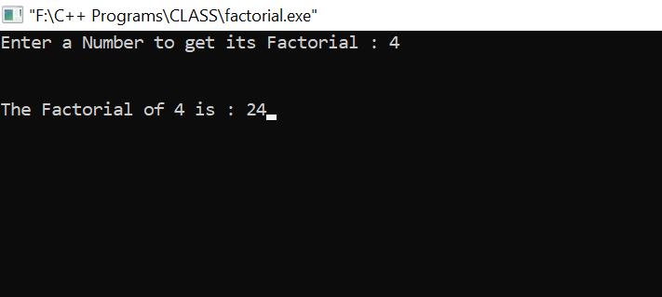

2) To print Fibonacci series of a given Number

#include <iostream>

#include <conio.h>

using namespace std;

class Fibo

{

int no,i,f1,f2,f3;

public:

void displayFibo();

};

void Fibo :: displayFibo()

{

f1=0;

f2=1;

cout<<"Enter number of terms for series : ";

cin>>no;

cout<<"\nFibonacci series are :";

for(i=0;i<no;i++)

{

cout<<"\t"<<f1;

f3=f1+f2;

f1=f2;

f2=f3;

}

}

int main()

{

Fibo FS;

FS.displayFibo();

getch();

return 0;

}

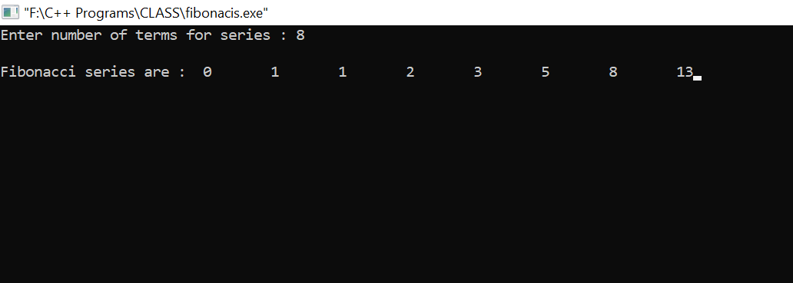

3) To print sum of first 100 odd numbers .

#include<iostream>

#include<conio.h>

using namespace std;

class test

{

private:

int i;

public :

void take()

{

for(i=1;i<=200;i++)

{

if(i%2==1)

cout<<i<<"\t ";

}

}

};

int main()

{

test t;

t.take();

getch();

return 0;

}

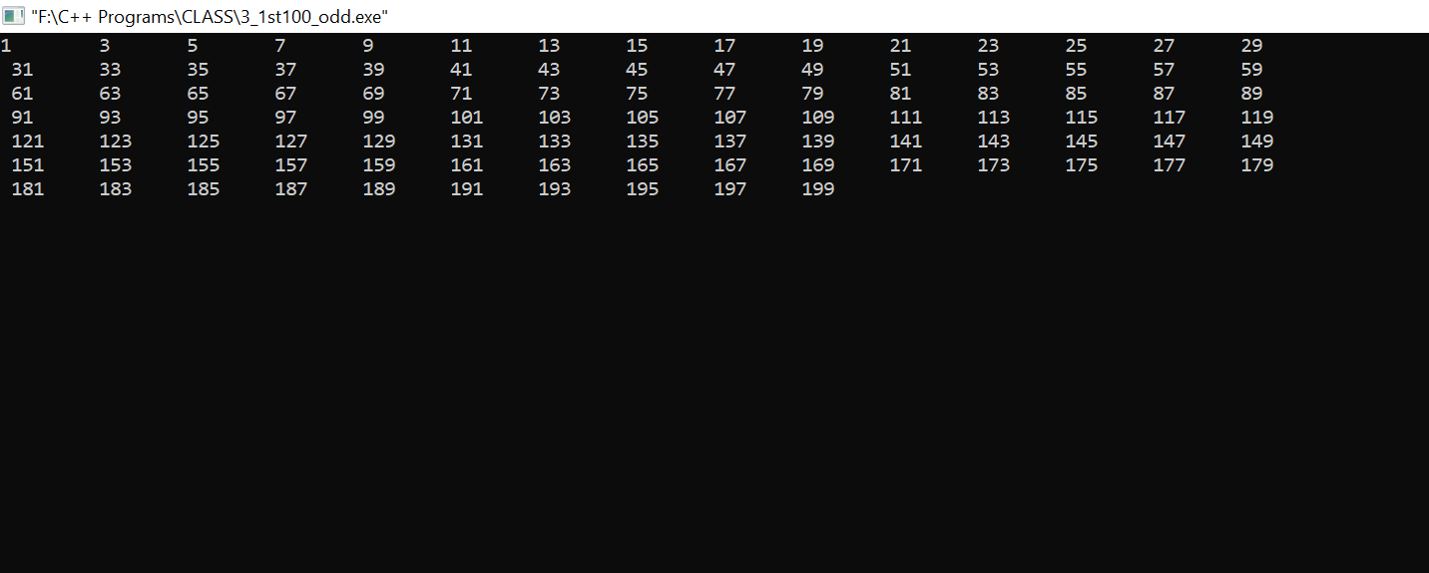

4) To check given number is Armstrong number or Not

#include <iostream>

#include <conio.h>

using namespace std;

class arm

{

private:

int no, r, sum, num;

public:

void getdata()

{

cout<<"Enter a number to check if its Armstrong or not : ";

cin>>no;

}

void display();

};

void arm::display()

{

sum = 0;

num=no;

while(no>0)

{

r = no % 10 ;

sum = sum + (r * r *r);

no = no/10;

}

if(num == sum)

cout<<"\n It is an Armstrong number";

else

cout<<"\n It is not an Armstrong number";

}

int main()

{

arm A;

A.getdata();

A.display();

getch();

return 0;

}

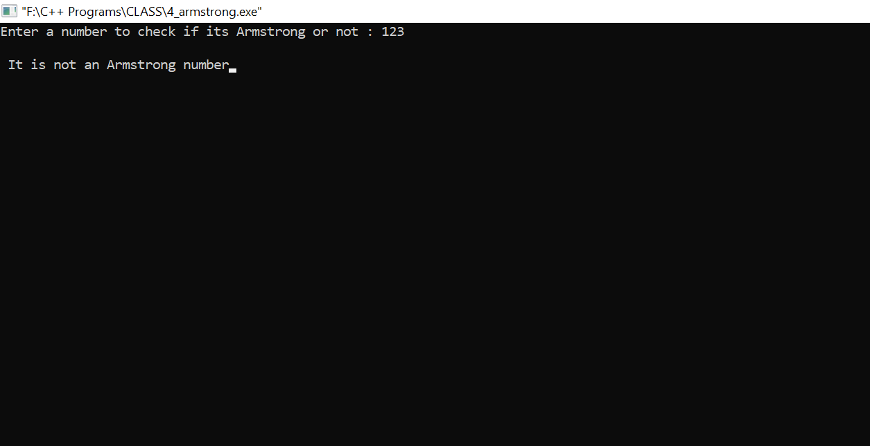

5) To calculate quotient and remainder

#include<iostream>

#include<conio.h>

using namespace std;

class test

{

private: int num1,num2,q,r;

public:

test()

{

cout<<"Enter First Number : ";

cin>>num1;

cout<<"Enter Second Number : ";

cin>>num2;

q=num1/num2;

cout<<"\n\nThe Quotient is = "<<q<<endl;

r=num1%num2;

cout<<"\nThe Remainder is = "<<r;

}

};

int main()

{

test t;

getch();

return 0;

}

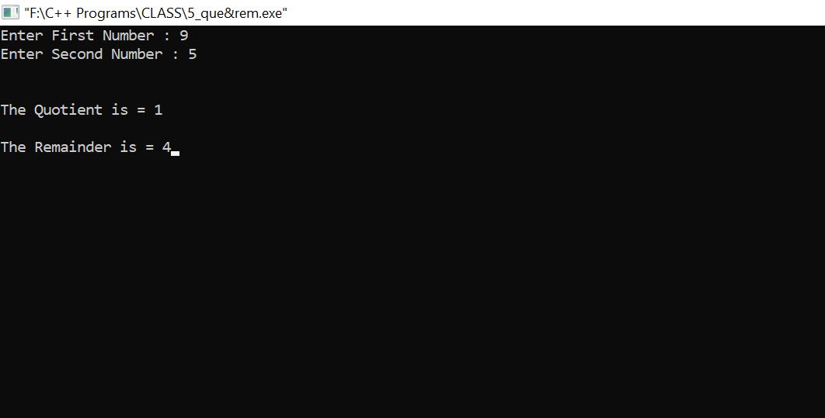

6) To check given character is consonant or vowel

#include <iostream>

#include <conio.h>

using namespace std;

class vowel

{

private:

char ch;

public:

void take()

{

cout<<"Enter a character : ";

cin>>ch;

}

void show()

{

if(ch=='a'||ch=='A'||ch=='e'||ch=='E'||ch=='i'||ch=='I'||ch=='o'||ch=='O'||ch=='u'||ch=='U')

cout<<endl<<endl<<ch<<" is Vowel";

else

cout<<endl<<endl<<ch<<" is Consonant";

}

};

int main()

{

vowel v;

v.take();

v.show();

getch();

return 0;

}

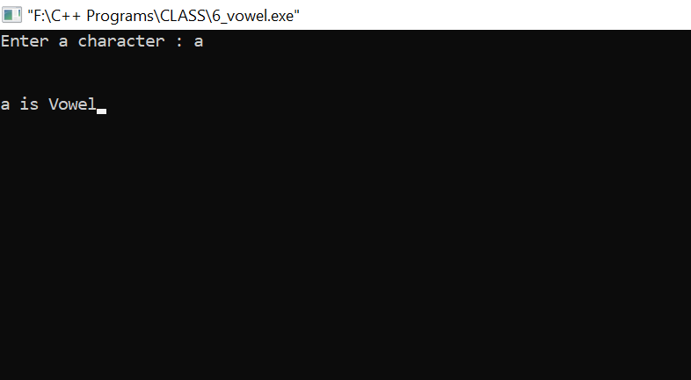

7) To swap the given number

#include<iostream>

#include<conio.h>

using namespace std;

class swp

{

private: int x,y,z;

public: void test()

{

cout<<"Enter First Number : ";

cin>>x;

cout<<"Enter Second Number : ";

cin>>y;

z=x;

x=y;

y=z;

cout<<"\n\nAfter swapping the number is : \n\nFirst Number is : "<<x<<"\nSecond Number is : "<<y;

}

};

int main()

{

swp s;

s.test();

getch();

return 0;

}

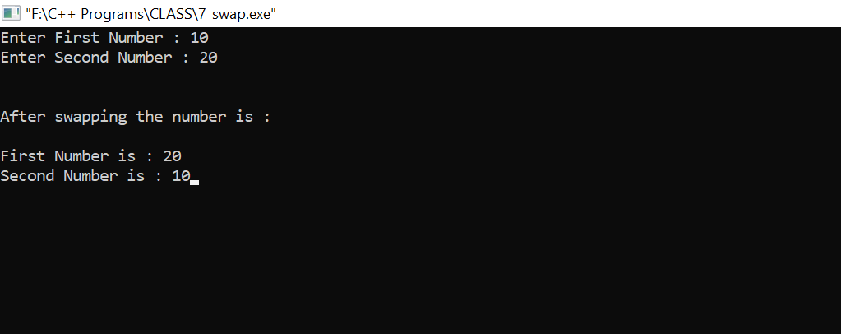

8) To check given number is prime number or not

#include<iostream>

#include<conio.h>

using namespace std;

class prime

{

private:

int i,n;

public:

int check()

{

cout<<"Enter a number to check whether its a prime number or not : ";

cin>>n;

i=2;

cout<<endl<<endl;

while(i<n)

{

if(n%i==0)

{

cout<<n<<" is not a prime number \n";

break;

}

else

{

cout<<n<<" is a prime number\n";

break;

}

i++;

}

}

};

int main()

{

prime p;

p.check();

getch();

return 0;

}

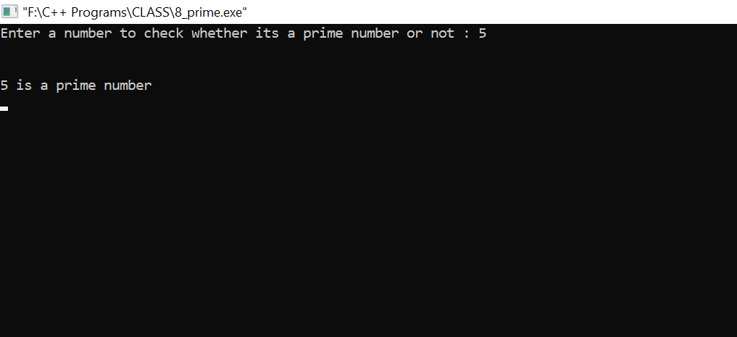

9) To check given number is even or odd and check the greater number #include<conio.h>

#include<iostream>

using namespace std;

class even_odd

{

private:

int a;

public:

void accept_value();

void calculate();

};

void even_odd :: accept_value()

{

cout<<"Enter a First Number : ";

cin>>a;

cout<<endl;

}

void even_odd :: calculate()

{

if(a%2==0)

cout<<a<<" is Even Number";

else

cout<<a<<" is Odd Number";

}

int main()

{

even_odd num;

num.accept_value();

num.calculate();

getch();

return 0;

}

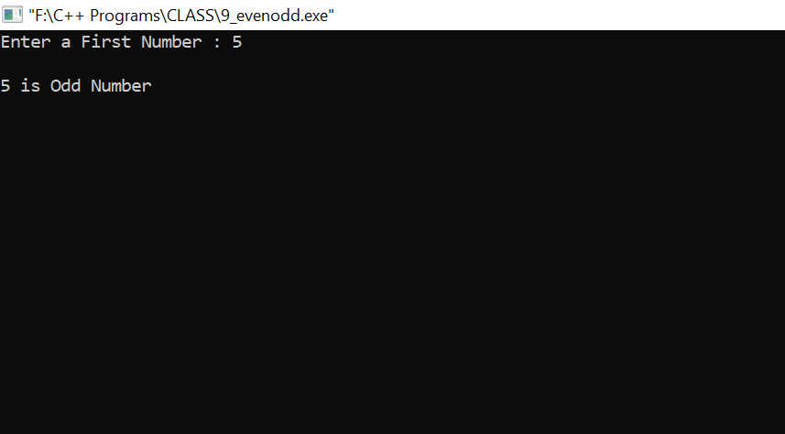

10) Draw this pattern

*

* *

* * *

* *

*

#include<iostream>

#include<conio.h>

using namespace std;

int main()

{

int n, c, k, space = 1;

cout<<"Enter number of rows : ";

cin>>n;

space = n - 1;

cout<<endl<<endl;

for (k = 1; k<=n; k++)

{

for (c = 1; c<=space; c++)

cout<<" ";

space--;

for (c = 1; c<= 2*k-1; c++)

cout<<"*";

cout<<"\n";

}

space = 1;

for (k = 1; k<= n - 1; k++)

{

for (c = 1; c<= space; c++)

cout<<" ";

space++;

for (c = 1 ; c<= 2*(n-k)-1; c++)

cout<<"*";

cout<<"\n";

}

getch();

return 0;

}

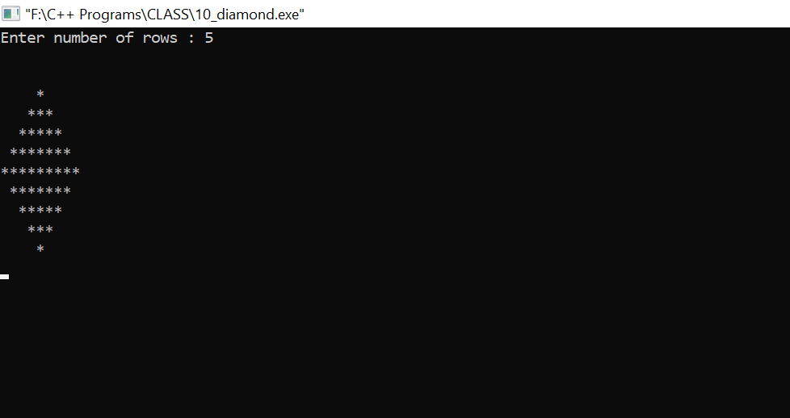

11) Draw this pattern

1

2 3

4 5 6

#include<iostream>

#include<conio.h>

using namespace std;

class star

{

int r,c,n=1;

public: void test()

{

for(r=1;r<=4;r++)

{

for(c=1;c<=r;c++)

{

cout<<n<<" ";

n++;

}

cout<<endl;

}

}

};

int main()

{

star obj;

obj.test();

getch();

return 0;

}

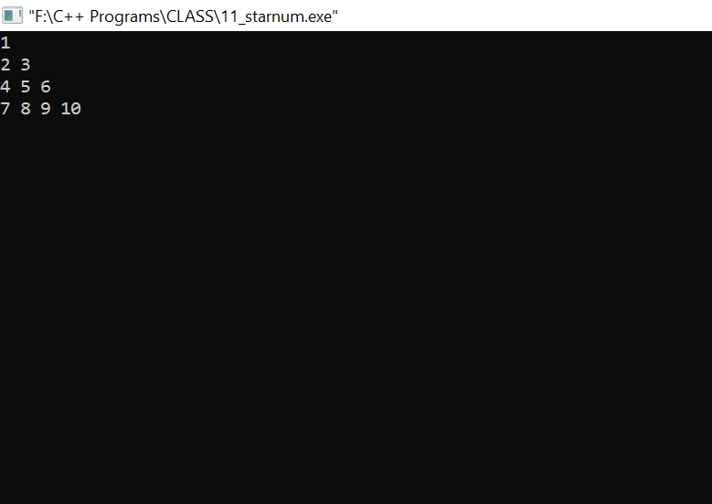

13) To print the sum of first 50 natural numbers

#include<iostream>

#include<conio.h>

using namespace std;

class sum

{

private : int i,sum;

public :

void add()

{

sum=0;

for(i=1;i<=50;i++)

{

sum=sum+i;

}

cout<<"Sum of First 50 Natural numbers are : "<<sum;

}

};

int main()

{

sum s;

s.add();

getch();

return 0;

}

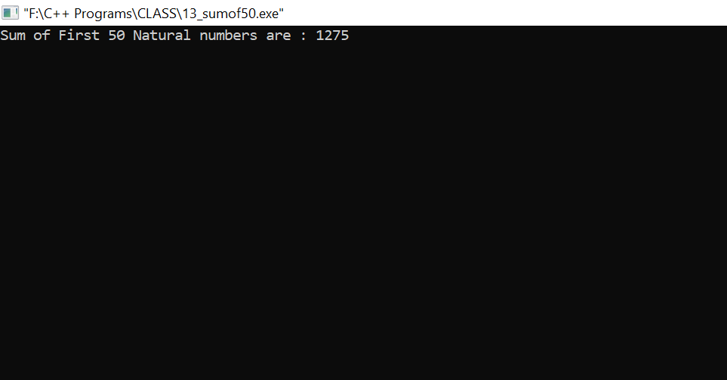

14) To accept the year and check it’s a leap year or not

#include<iostream>

#include<conio.h>

using namespace std ;

class leap

{

private: int year;

public:

void check()

{

cout<<"Enter the year to see whether its a leap year or not : ";

cin>>year;

if(year%400==0 && year%100==0 || year%4==0 && year%100!=0 )

{

cout<<endl<<year<<" is a Leap Year";

}

else {

cout<<endl<<year<<" is not a Leap Year";

}

}

};

int main()

{

leap c1;

c1.check();

getch();

return 0;

}

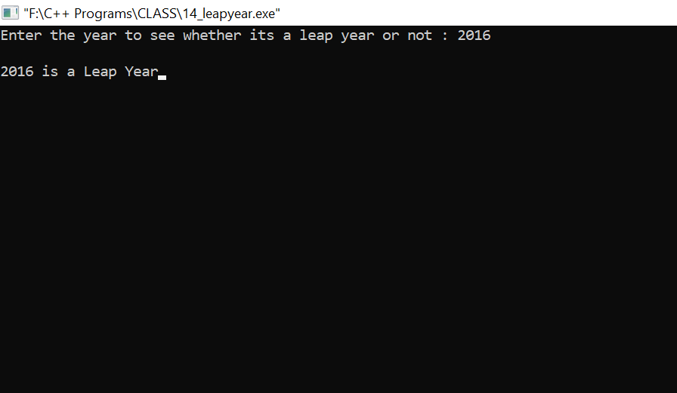

15) To find the string is palindrome or not

#include<iostream>

#include<conio.h>

#include<string.h>

using namespace std;

class palin

{

private: char str[10];

int len,i,mid,j;

public: void test()

{

cout<<"Enter a String : " ;

cin>>str;

cout<<endl<<endl;

len=strlen(str);

mid=len/2;

len--;

for(i=0;i<=mid;i++)

{

if(str[i]==str[len-i])

j=0;

else

j=1;

}

if(j==0)

cout<<"String is palindrome";

else

cout<<"String is not a palindrome";

}

};

int main()

{

palin p;

p.test();

getch();

return 0;

}

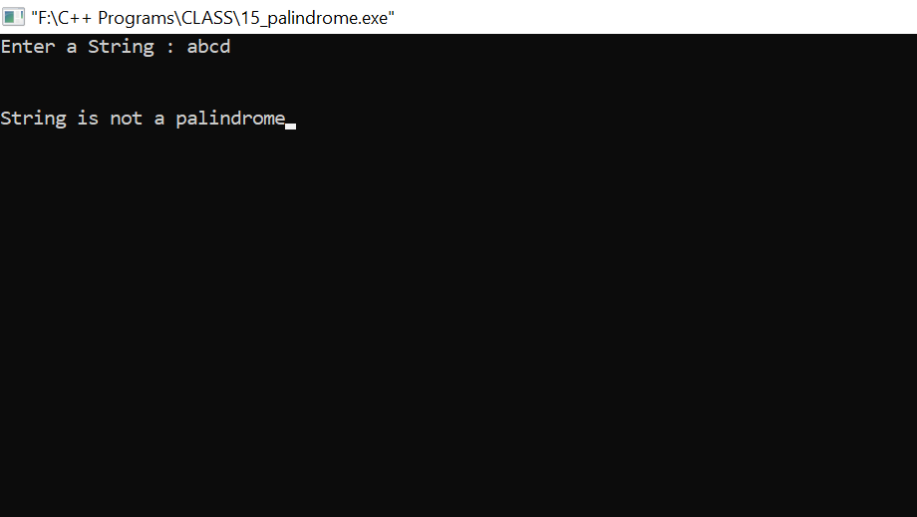

16) To print sum of array and square of array elements

#include<iostream>

#include<conio.h>

using namespace std;

class complex

{

private : int arr[5],sum=0;

public :

void accept()

{

cout<<"Enter Five Numbers : ";

for(int i=0;i<5;i++)

{

cin>>arr[i];

}

}

void addition()

{

for(int i=0;i<5;i++)

{

sum=sum+arr[i];

}

}

void print()

{

cout<<"\n\nSum Of Array Elements are : "<<sum;

cout<<endl<<endl;

for(int i=0;i<5;i++)

{

cout<<"\nSquare of "<<arr[i]<<" is "<<arr[i]*arr[i];

}

}

};

int main()

{

complex s1;

s1.accept();

s1.addition();

s1.print();

getch();

return 0;

}

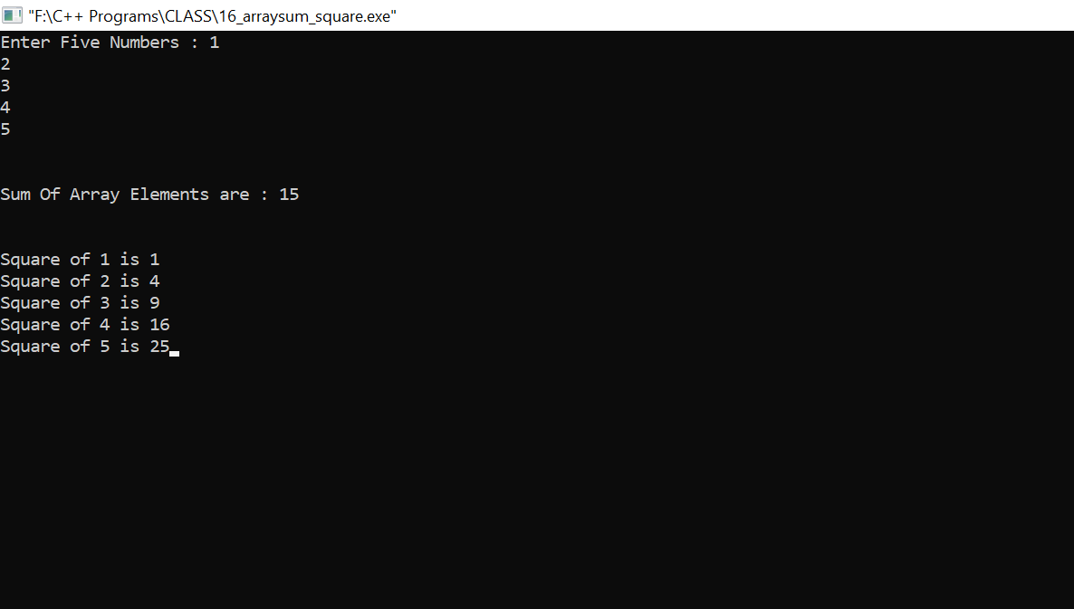

17) To print Table

#include<iostream>

#include<conio.h>

using namespace std;

class table

{

private: int i,num,ans;

public:

void creat()

{

cout<<"Enter a number to see its table : ";

cin>>num;

for(i=1; i<=10; i++ )

{

ans=num*i;

cout<<endl<<ans;

}

}

};

int main()

{

table t;

t.creat();

getch();

return 0;

}

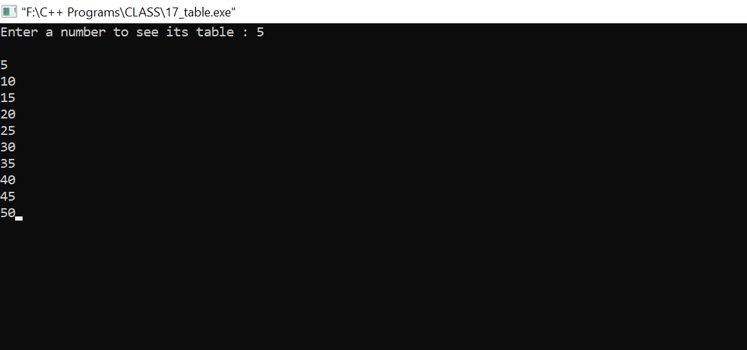

18) To accept the radius and calculate the area of circle

#include<iostream>

#include<conio.h>

using namespace std;

class aoc

{

private:

int r;

float pi,area;

public:

void check()

{

pi=3.14;

cout<<"Enter the radius of a circle : ";

cin>>r;

area=r*r*pi;

cout<<"\n\nThe Area of the circle is = "<<area;

}

};

int main()

{

aoc a1;

a1.check();

getch();

return 0;

}

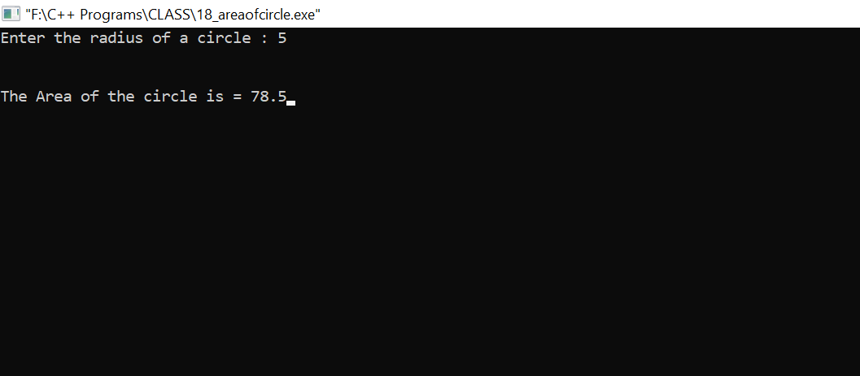

19) Draw this pattern

A

A B

A B C

A B C D

A B C D E

#include<iostream>

#include<conio.h>

using namespace std;

class star

{

int i;

unsigned char j;

public: void test()

{

for(i='A';i<='E';i++)

{

for(j='A';j<=i;j++)

{

cout<<j<<" ";

}

cout<<endl;

}

}

};

int main()

{

star obj;

obj.test();

getch();

return 0;

}

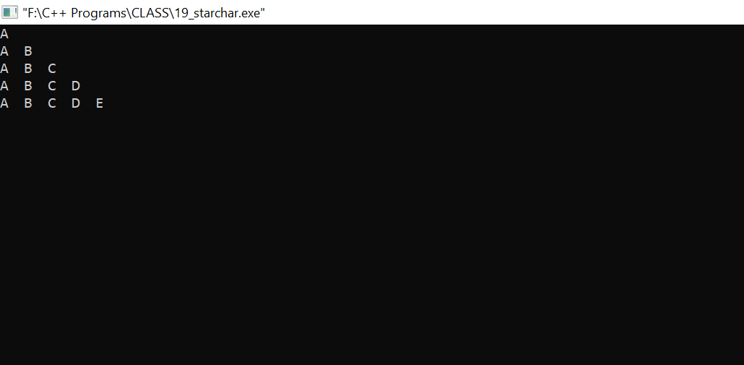

20) Sorting of array

#include<iostream>

#include<conio.h>

using namespace std;

class sorting

{

private : int no[5],i,j,temp;

public :

void getdata()

{

for(i=0;i<5;i++)

{

cin>>no[i];

}

}

void sor()

{

for (i=0;i<5;i++)

{

for(j=i+1;j<5;j++)

{

if (no[i]>no[j])

{

temp = no[i];

no[i]= no[j];

no[j] = temp;

}

}

}

for(i=0;i<5;i++)

{

cout<<no[i]<<" ";

}

}

};

int main()

{

sorting s;

cout<<"Enter Five Numbers : ";

s.getdata();

cout<<"\n\nSorted Array : ";

s.sor();

getch();

return 0;

}

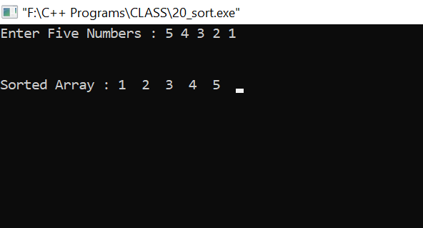

22) To display the factors of number

#include<iostream>

#include<conio.h>

using namespace std;

class fact

{

int fact=1,num,i;

public : void test()

{

cout<<"Enter a number to Find factorial : ";

cin>>num;

for(i=1;i<=num;i++)

fact=fact*i;

cout<<"\n\nThe Factorial is : "<<fact;

}

};

int main()

{

fact f1;

f1.test();

getch();

return 0;

}

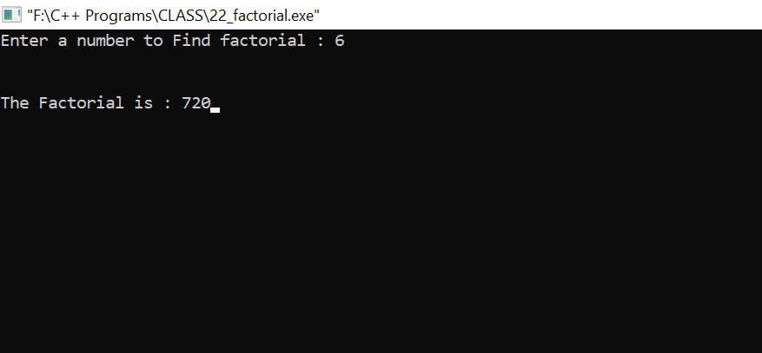

23) using While loop print first 15 odd numbers

#include<iostream>

#include<conio.h>

using namespace std;

class odd

{

int num=1;

public: void test()

{

cout<<"The First 15 Odd numbers are : ";

while(num<=30)

{

if(num%2!=0)

cout<<" "<<num;

num++;

}

}

};

int main()

{

odd obj;

obj.test();

getch();

return 0;

}

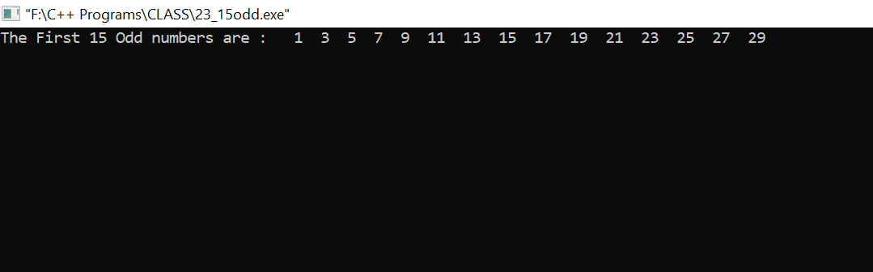

24) Find the length of string

#include<string.h>

#include<conio.h>

#include<iostream>

using namespace std;

class count

{

int len;

char name[50];

public : void test()

{

cout<<"Enter a string to count its Length : ";

cin>>name;

len=strlen(name);

cout<<"\n\nThe Length of the String is = "<<len;

}

};

int main()

{

count obj;

obj.test();

getch();

return 0;

}

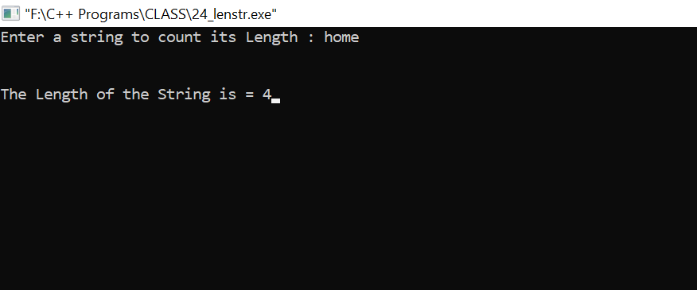

25) class to concatenate two string

#include<string.h>

#include<iostream>

#include<conio.h>

using namespace std;

class concat

{

char name[20],surname[20];

public : void test()

{

cout<<"Enter First string : ";

cin>>name;

cout<<"Enter Second string : ";

cin>>surname;

strcat(name,surname);

cout<<"\n\nThe Concatenate is : "<<name;

}

};

int main()

{

concat obj;

obj.test();

}

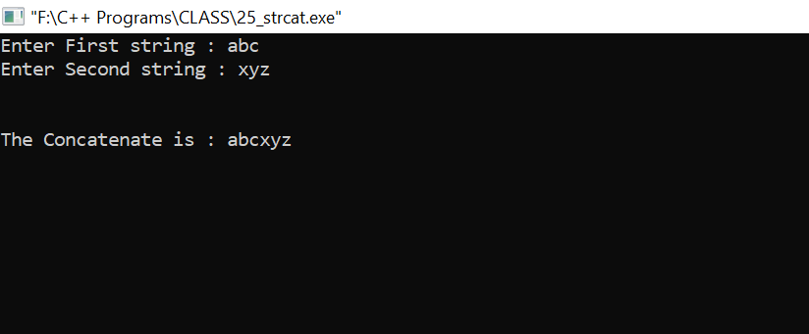

**Friend Function**

1. Accept two numbers to calculate addition,subtraction,multiplication and division

#include<iostream>

#include<conio.h>

using namespace std;

class arith

{

private : int n1,n2;

public :

void getdata()

{

cout<<"Enter First Number : ";

cin>>n1;

cout<<"Enter Second Number : ";

cin>>n2;

}

friend void arithmatic(arith &s);

};

void arithmatic(arith &s)

{

cout<<"\n\nAddition of "<<s.n1<<" & "<<s.n2<<" is "<<s.n1+s.n2<<endl;

cout<<"Subtraction of "<<s.n1<<" & "<<s.n2<<" is "<<s.n1-s.n2<<endl;

cout<<"Multiplication of "<<s.n1<<" & "<<s.n2<<" is "<<s.n1*s.n2<<endl;

cout<<"Division of "<<s.n1<<" & "<<s.n2<<" is "<<s.n1/s.n2<<endl;

}

int main()

{

arith a1;

a1.getdata();

arithmatic(a1);

getch();

return 0;

}

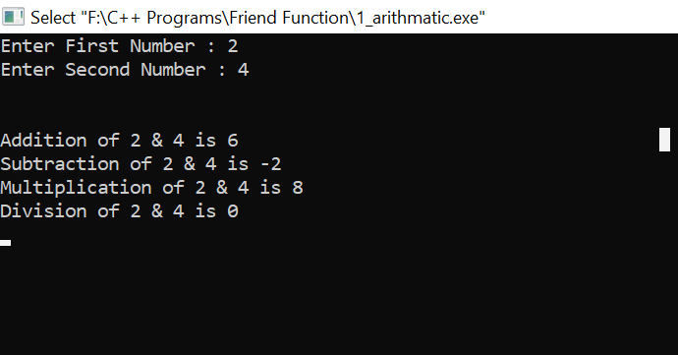

1. To check no is even or odd :-

#include<iostream>

#include<conio.h>

using namespace std;

class check

{

private : int a;

public :

void setdata(int num)

{

a=num;

}

friend void check_odd_even(check s);

};

void check_odd_even(check s)

{

if(s.a%2==0)

{

cout<<endl<<s.a<<" is Even Number";

}

else

{

cout<<endl<<s.a<<" is Odd Number";

}

}

int main()

{

int n1;

cout<<"Enter a Number : ";

cin>>n1;

check c;

c.setdata(n1);

check_odd_even(c);

getch();

return 0;

}

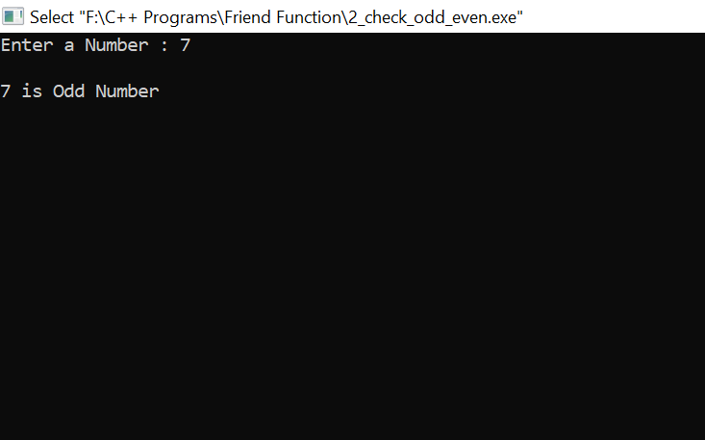

1. Accept number to calculate square and cube :-

#include<iostream>

#include<conio.h>

using namespace std;

class complex

{

private : int a;

public :

void setdata(int num)

{

a=num;

}

friend void square_cube(complex s);

};

void square_cube(complex s)

{

cout<<"\nSquare of "<<s.a<<" is "<<s.a*s.a<<endl;

cout<<"Cube of "<<s.a<<" is "<<s.a*s.a*s.a;

}

int main()

{

int n1;

cout<<"Enter a Number : ";

cin>>n1;

complex c;

c.setdata(n1);

square_cube(c);

getch();

return 0;

}

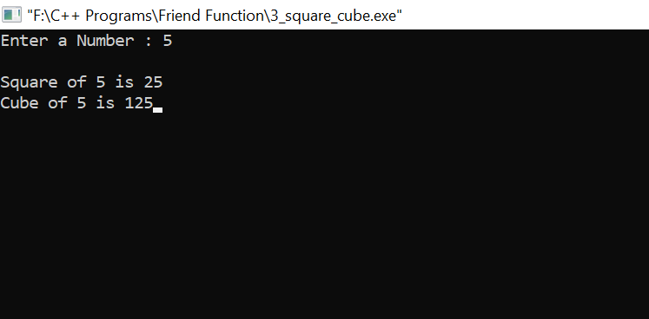

1. Accept radius and calculate area of circle :-

#include<iostream>

#include<conio.h>

using namespace std;

class complex

{

private : int r;

public :

void setdata(int num)

{

r=num;

}

friend void square_cube(complex s);

};

void square_cube(complex s)

{

cout<<"\nArea of Circle is : "<<3.14*s.r*s.r;

}

int main()

{

int radius;

cout<<"Enter a Radius of Circle : ";

cin>>radius;

complex c;

c.setdata(radius);

square_cube(c);

getch();

return 0;

}

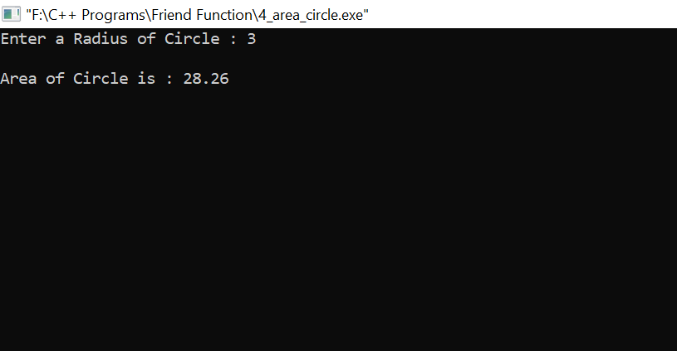

1. To check the year is leap or not ;-

#include<iostream>

#include<conio.h>

using namespace std;

class complex

{

private : int l;

public :

void setdata(int num)

{

l=num;

}

friend void square_cube(complex s);

};

void square_cube(complex s)

{

if(s.l%100==0 && s.l%100==0 || s.l%4==0 && s.l% 100!=0)

{

cout<<endl<<s.l<<" is Leap Year";

}

else

{

cout<<endl<<s.l<<" is Not Leap Year";

}

}

int main()

{

int year;

cout<<"Enter a Year : ";

cin>>year;

complex c;

c.setdata(year);

square_cube(c);

getch();

return 0;

}

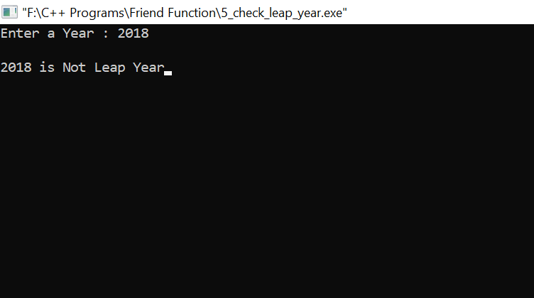

1. To find factorial of given number :-

#include<iostream>

#include<conio.h>

using namespace std;

class complex

{

private : int f;

public :

void setdata(int num)

{

f=num;

}

friend int factorial(complex s);

};

int factorial(complex s)

{

int fact=1;

for(int i=1;i<=s.f;i++)

{

fact=fact*i;

}

return(fact);

}

int main()

{

int facto;

cout<<"Enter a Number : ";

cin>>facto;

complex c;

c.setdata(facto);

cout<<"\nFactorial of "<<facto<<" is "<<factorial(c);

return 0;

}

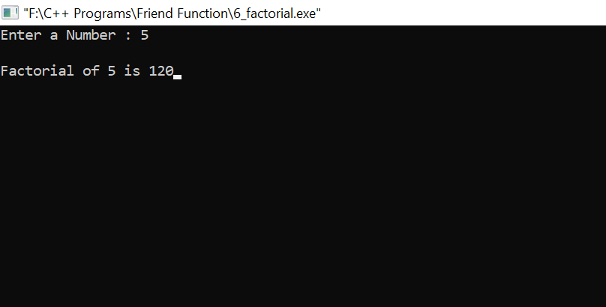

1. To check even odd and greater number :-

#include<iostream>

#include<conio.h>

using namespace std;

class check

{

private : int a,b;

public :

void setdata(int num1,int num2)

{

a=num1;

b=num2;

}

friend void check_odd_even(check s);

friend void large(check s);

};

void check_odd_even(check s)

{

if(s.a%2==0)

cout<<endl<<s.a<<" is Even Number";

else

cout<<endl<<s.a<<" is Odd Number";

if(s.b%2==0)

cout<<endl<<s.b<<" is Even Number";

else

cout<<endl<<s.b<<" is Odd Number";

}

void large(check s)

{

if(s.a>s.b)

cout<<s.a<<" is Greater than "<<s.b;

else

cout<<s.b<<" is Greater than "<<s.a;

}

int main()

{

int n1,n2;

cout<<"Enter First Number : ";

cin>>n1;

cout<<"Enter Second Number : ";

cin>>n2;

check c;

c.setdata(n1,n2);

check_odd_even(c);

cout<<endl<<endl;

large(c);

getch();

return 0;

}

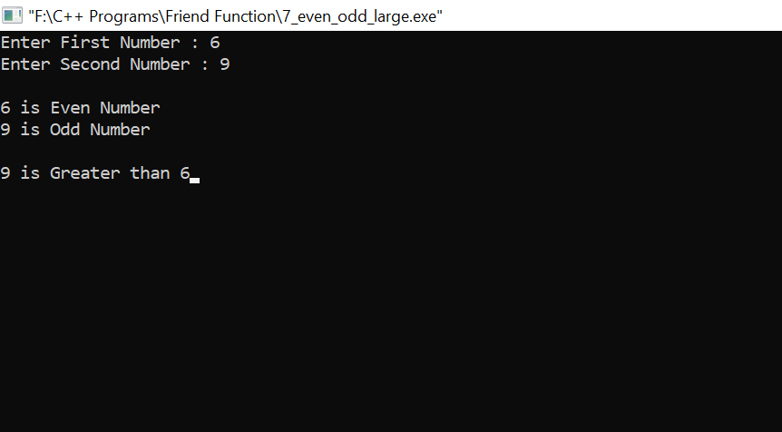

**Default function**

1. Accept two numbers to calculate addition,subtraction,multiplication,division,modulus

#include<iostream>

#include<conio.h>

using namespace std;

void arithmatic(int num1,int num2,int number=30);

int main()

{

int num1,num2;

cout<<"Enter First Number : ";

cin>>num1;

cout<<"Enter Second Number : ";

cin>>num2;

arithmatic(num1,num2);

getch();

return 0;

}

void arithmatic(int n1,int n2,int n)

{

cout<<endl<<endl;

for(int i=0;i<=n;i++)

{

cout<<"*";

}

cout<<"\n\nAddition of "<<n1<<" & "<<n2<<" is "<<n1+n2<<endl;

cout<<"Subtraction of "<<n1<<" & "<<n2<<" is "<<n1-n2<<endl;

cout<<"Multiplication of "<<n1<<" & "<<n2<<" is "<<n1*n2<<endl;

cout<<"Division of "<<n1<<" & "<<n2<<" is "<<n1/n2<<endl<<endl;

for(int i=0;i<=n;i++)

{

cout<<"*";

}

}

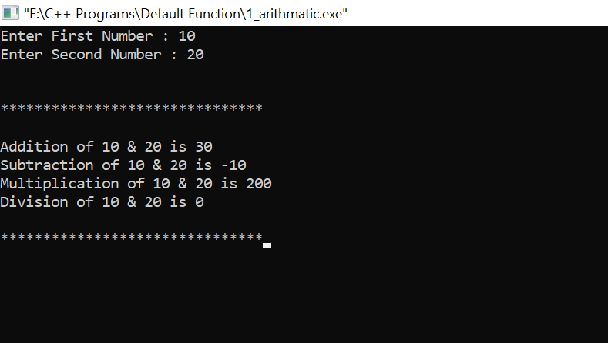

1. To check number is even or odd

#include<iostream>

#include<conio.h>

using namespace std;

void check_even_odd(int num1,int number=50);

int main()

{

int num1;

cout<<"Enter a Number : ";

cin>>num1;

check_even_odd(num1);

getch();

return 0;

}

void check_even_odd(int n1,int n)

{

cout<<endl<<endl;

for(int i=0;i<=n;i++)

{

cout<<"#";

}

if(n1%2==0)

{

cout<<endl<<endl<<n1<<" is Even Number";

}

else

{

cout<<endl<<endl<<n1<<" is Odd Number";

}

cout<<endl<<endl;

for(int i=0;i<=n;i++)

{

cout<<"#";

}

}

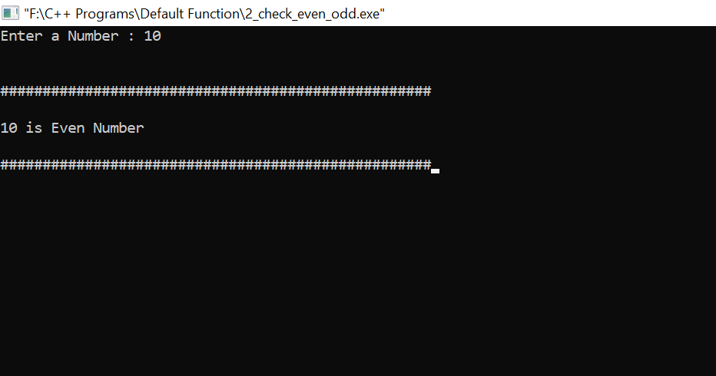

1. Accept a number to calculate square and cube

#include<iostream>

#include<conio.h>

using namespace std;

void square_cube(int num1,int number=20);

int main()

{

int num1;

cout<<"Enter a Number : ";

cin>>num1;

square_cube(num1);

getch();

return 0;

}

void square_cube(int n1,int n)

{

cout<<endl<<endl;;

for(int i=0;i<=n;i++)

{

cout<<"_";

}

cout<<endl<<endl;

cout<<"Square of "<<n1<<" is "<<n1*n1;

cout<<"\nCube of "<<n1<<" is "<<n1*n1*n1;

cout<<endl<<endl;

for(int i=0;i<=n;i++)

{

cout<<"_";

}

}

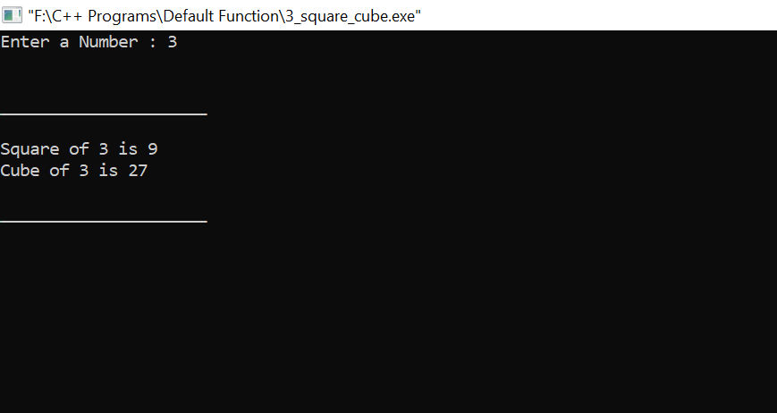

1. To accept radius and find the area of circle

#include<iostream>

#include<conio.h>

using namespace std;

void area(int num1,int number=40);

int main()

{

int radius;

cout<<"Enter a radius : ";

cin>>radius;

area(radius);

getch();

return 0;

}

void area(int r,int n)

{

cout<<endl<<endl;;

for(int i=0;i<=n;i++)

{

cout<<"%";

}

cout<<endl<<endl;

cout<<"Area of Circle is : "<<3.14*r*r;

cout<<endl<<endl;

for(int i=0;i<=n;i++)

{

cout<<"%";

}

}

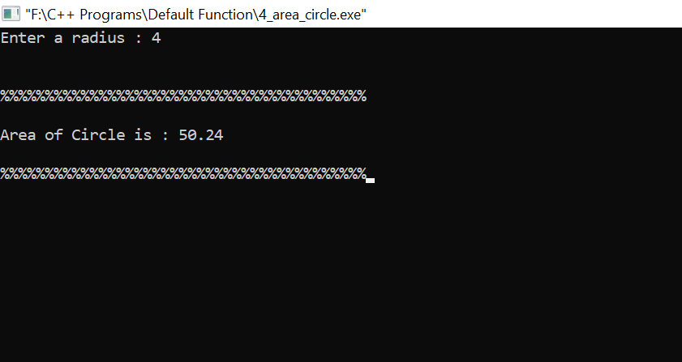

1. Accept a number to print factorial

#include<iostream>

#include<conio.h>

using namespace std;

void factorial(int f,int number=25);

int main()

{

int num;

cout<<"Enter a Number : ";

cin>>num;

factorial(num);

getch();

return 0;

}

void factorial(int f,int n)

{

int fact=1;

cout<<endl<<endl;;

for(int i=1;i<=n;i++)

{

cout<<"!";

}

cout<<endl<<endl;

for(int i=1;i<=f;i++)

{

fact=fact*i;

}

cout<<"Factorial of "<<f<<" is "<<fact;

cout<<endl<<endl;

for(int i=0;i<=n;i++)

{

cout<<"!";

}

}

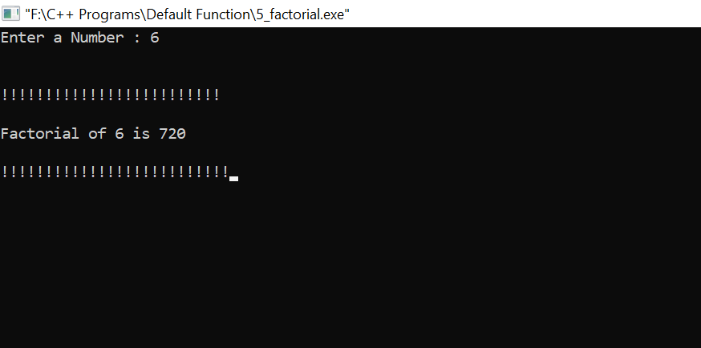

1. Accept a number to print multiplication table

#include<iostream>

#include<conio.h>

using namespace std;

void table(int t,int number=15);

int main()

{

int num;

cout<<"Enter a Number : ";

cin>>num;

table(num);

getch();

return 0;

}

void table(int t,int n)

{

cout<<endl<<endl;;

for(int i=1;i<=n;i++)

{

cout<<"*";

}

cout<<endl<<endl;

cout<<"Multiplication table of "<<t<<" is : \n\n";

int m=1;

for(int i=1;i<=10;i++)

{

m=t*i;

cout<<m<<endl;

}

cout<<endl<<endl;

for(int i=0;i<=n;i++)

{

cout<<"*";

}

}

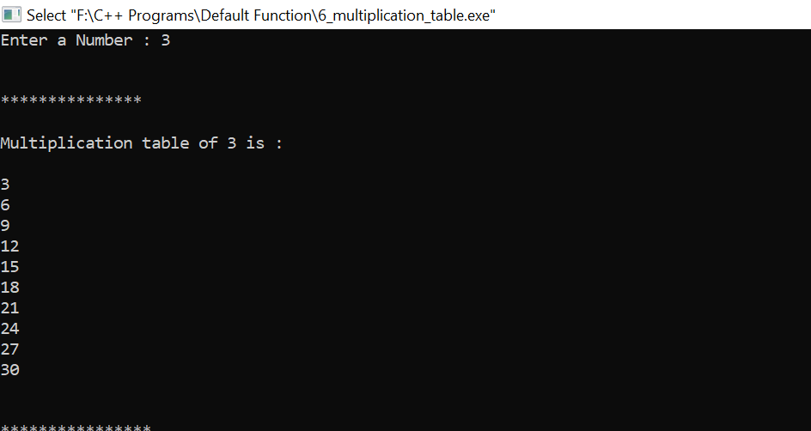

**Function Overloading**

1. Accept number multiply it and find the square

#include<iostream>

#include<conio.h>

using namespace std;

class check

{

public :

void function(int a,int b)

{

cout<<"\n\nMultiplication of "<<a<<" And "<<b<<" are : "<<a*b;

}

void function(int a)

{

cout<<"Square of "<<a<<" is "<<a*a;

}

};

int main()

{

int n1,n2;

cout<<"Enter First Number : ";

cin>>n1;

cout<<"Enter Second Number : ";

cin>>n2;

check c;

c.function(n1,n2);

cout<<endl<<endl;

c.function(n1);

getch();

return 0;

}

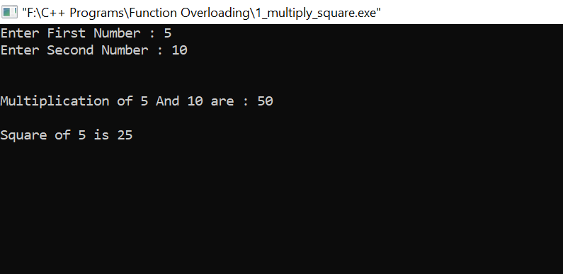

1. Find factorial and addition of two number

#include<iostream>

#include<conio.h>

using namespace std;

class complex

{

public :

void function(int a)

{

int fact=1;

for(int i=1;i<=a;i++)

{

fact=fact*i;

}

cout<<"\n\nFactorial of "<<a<<" is "<<fact;

}

void function(int a,int b)

{

cout<<"Addition of "<<a<<" And "<<b<<" are "<<a+b;

}

};

int main()

{

int n1,n2;

cout<<"Enter First Number : ";

cin>>n1;

cout<<"Enter Second Number : ";

cin>>n2;

complex c;

c.function(n1);

cout<<endl<<endl;

c.function(n1,n2);

getch();

return 0;

}

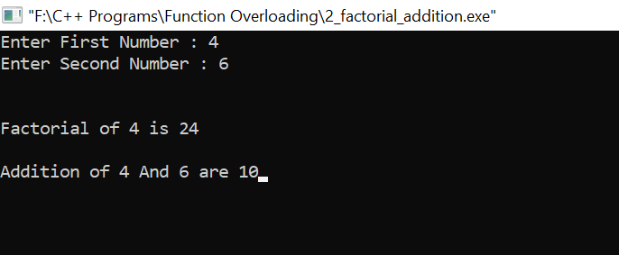

1. Find the number is Armstrong or not and addition of two number

#include<iostream>

#include<conio.h>

using namespace std;

class complex

{

public :

void function(int a)

{

int sum = 0,num,r;

num=a;

while(a>0)

{

r = a % 10 ;

sum = sum + (r * r *r);

a = a/10;

}

if(num == sum)

cout<<"\n"<<num<<" is an Armstrong number";

else

cout<<"\n"<<num<<" is not an Armstrong number";

}

void function(int a,int b)

{

cout<<"Addition of "<<a<<" And "<<b<<" are "<<a+b;

}

};

int main()

{

int n1,n2;

cout<<"Enter First Number : ";

cin>>n1;

cout<<"Enter Second Number : ";

cin>>n2;

complex c;

c.function(n1);

cout<<endl<<endl;

c.function(n1,n2);

getch();

return 0;

}

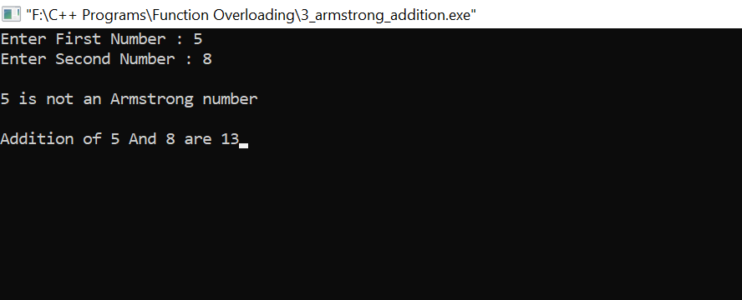

1. Find number is prime or not and find subtraction of two number

#include<iostream>

#include<conio.h>

using namespace std;

class complex

{

private : int flag=0;

public :

void function(int a)

{

for(int i=2;i<a;i++)

{

if(a%i==0)

{

flag=1;

break;

}

}

if(flag==1)

cout<<a<<" is Not Prime Number";

else

cout<<a<<" is Prime Number";

}

void function(int a,int b)

{

cout<<"Subtraction of "<<a<<" And "<<b<<" are "<<a-b;

}

};

int main()

{

int n1,n2;

cout<<"Enter First Number : ";

cin>>n1;

cout<<"Enter Second Number : ";

cin>>n2;

complex c;

cout<<endl;

c.function(n1);

cout<<endl<<endl;

c.function(n1,n2);

getch();

return 0;

}

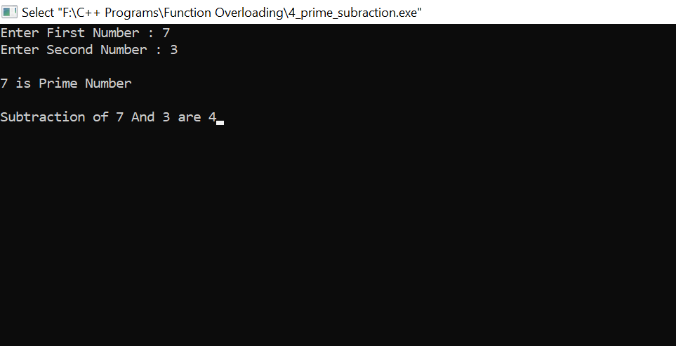

1. Check given character is vowel conconent and accept the number to swap them

#include<iostream>

#include<conio.h>

using namespace std;

class complex

{

private :

public :

void function(char c)

{

if(c=='a' || c=='A' || c=='e' || c=='E' || c=='i' || c=='I' || c=='o' || c=='O' || c=='u' || c=='U')

cout<<c<<" is Vowel";

else

cout<<c<<" is Consonent";

}

void function(int a,int b)

{

int temp;

temp=a;

a=b;

b=temp;

cout<<"\nFirst Number is : "<<a;

cout<<"\nSecond Number is : "<<b;

}

};

int main()

{

char ch;

int n1,n2;

cout<<"Enter a Character : ";

cin>>ch;

cout<<"Enter First Number : ";

cin>>n1;

cout<<"Enter Second Number : ";

cin>>n2;

complex c;

cout<<endl;

c.function(ch);

cout<<endl<<endl;

cout<<"After Swapping Numbers are : ";

c.function(n1,n2);

getch();

return 0;

}

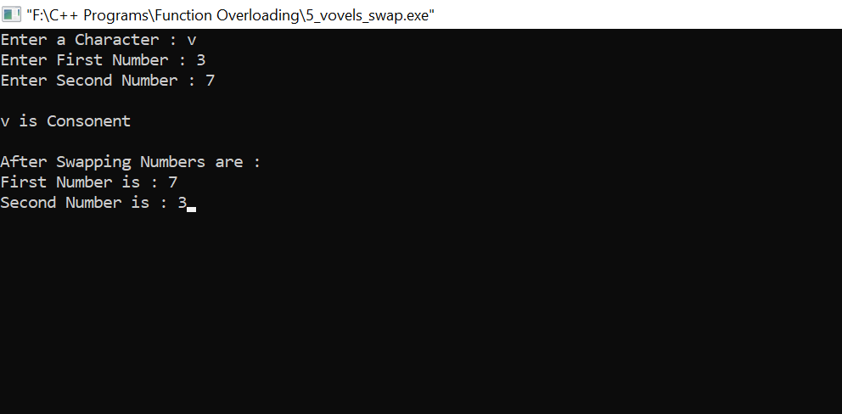

1. Accept radius and find area of circle and accept side and fine area of square

#include<iostream>

#include<conio.h>

using namespace std;

class complex

{

private : int r;

public :

void function()

{

cout<<"\nEnter Radius Of Circle : ";

cin>>r;

cout<<"\nArea of Circle is : "<<3.14*r*r;

}

void function(int s)

{

cout<<"Area of Square is : "<<s*s;

}

};

int main()

{

int side;

cout<<"Enter Side of Square : ";

cin>>side;

complex c;

cout<<endl;

c.function(side);

cout<<endl<<endl;

c.function();

getch();

return 0;

}

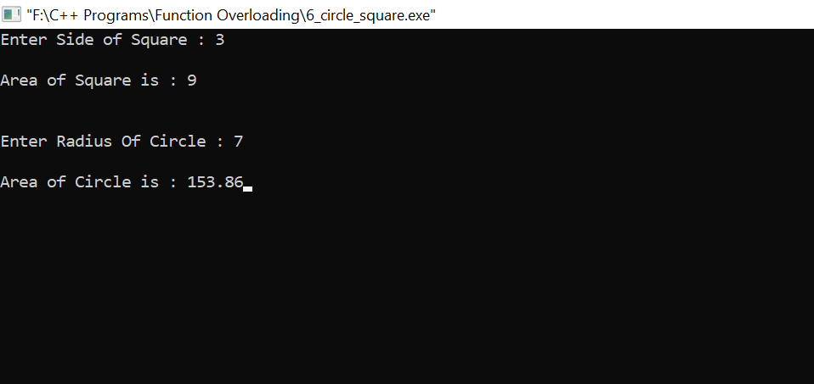

1. Print the multiplication table of given number and print Fibonacci series

#include<iostream>

#include<conio.h>

using namespace std;

class complex

{

private : int s=0,i,a=0,b=1,c=0;

public :

void function(int n)

{

for(i=1;i<=10;i++)

{

s=n*i;

cout<<s<<endl;

}

}

void function()

{

for(i=1;i<=10;i++)

{

c=a+b;

cout<<c<<" ";

a=b;

b=c;

}

}

};

int main()

{

int num;

cout<<"Enter a Number : ";

cin>>num;

complex c;

cout<<endl;

cout<<"Table of "<<num<<" is : \n\n";

c.function(num);

cout<<endl<<endl;

cout<<"Fibonacci Series of 10 Numbers are : ";

c.function();

getch();

return 0;

}

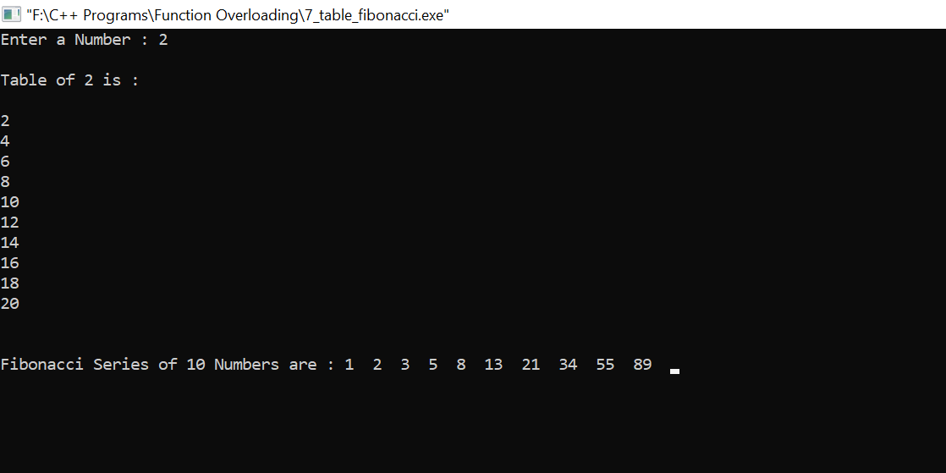

**Operator Overloading**

1. concatenate with two strings using + operator

#include <iostream>

#include <conio.h>

#include<string.h>

#include<stdlib.h>

using namespace std;

class concatination

{

private:

char str[50];

public:

concatination()

{

strcpy(str,"");

}

concatination(char s[])

{

strcpy(str,s);

}

void display()

{

cout<<str;

}

concatination operator +(concatination s)

{

concatination temp;

if(strlen(str)+strlen(s.str)<50)

{

strcpy(temp.str,str);

strcat(temp.str,s.str);

}

else

{

cout<<"\n String Length Exceeds !";

exit(1);

}

return(temp);

}

};

int main()

{

char str1[20],str2[20];

cout<<"Enter First String : ";

cin>>str1;

cout<<"Enter Second String : ";

cin>>str2;

concatination S1=str1;

concatination S2=str2;

concatination S3;

S3=S1+S2;

cout<<"\n\nConcatination String is : ";

S3.display();

getch();

return 0;

}

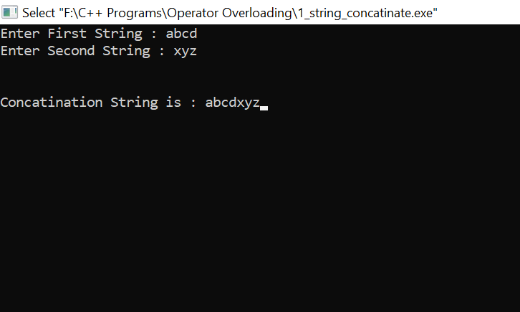

1. compare strings using ‘<’ ‘>’’==’ operator

#include<iostream>

#include<conio.h>

#include<string.h>

using namespace std;

class sample

{

private:

char str1[20];

int len;

public:

void getstr()

{

cout<<"Enter String: ";

cin>>str1;

len=strlen(str1);

}

friend int operator < (sample & s1,sample & s2);

friend int operator > (sample & s1,sample & s2);

friend int operator == (sample & s1,sample & s2);

};

int operator < (sample & s1,sample & s2)

{

if(s1.len < s2.len)

return 1;

else

return 0;

}

int operator > (sample & s1,sample & s2)

{

if(s1.len > s2.len)

return 1;

else

return 0;

}

int operator == (sample & s1,sample & s2)

{

if(s1.len == s2.len)

return 1;

else

return 0;

}

int main()

{

sample x,y;

x.getstr();

y.getstr();

cout<<endl<<endl;

if(x<y)

cout<<"string 1 is less than string 2";

if(x>y)

cout<<"string 1 is greater than string 2";

if(x==y)

cout<<"Both strings are equal";

getch();

return 0;

}

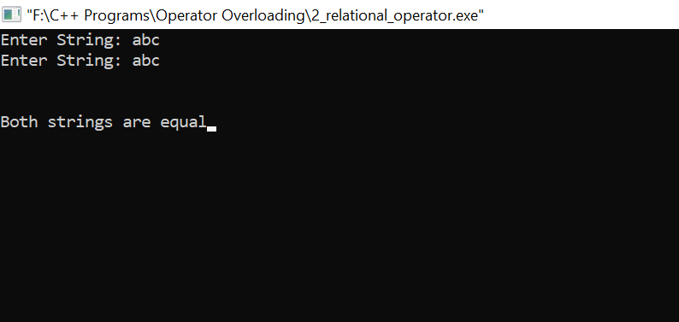

3] Accept two numbers and find addition,subtraction,multiplication,division using operator

#include<iostream>

#include<conio.h>

using namespace std;

class sample

{

private:

int a;

public:

void get()

{

cout<<"Enter Value: ";

cin>>a;

}

void friend operator + (sample & m,sample & n);

void friend operator - (sample & m,sample & n);

void friend operator * (sample & m,sample & n);

void friend operator / (sample & m,sample & n);

};

void operator +(sample & m,sample & n)

{

cout<<"\n\nAddition of "<<m.a<<" And "<<n.a<<" is "<<m.a + n.a;

}

void operator - (sample & m,sample & n)

{

cout<<"\nSubtraction of "<<m.a<<" And "<<n.a<<" is "<<m.a - n.a<<endl;

}

void operator * (sample & m,sample & n)

{

cout<<"Multiplication of "<<m.a<<" And "<<n.a<<" is "<<m.a * n.a<<endl;

}

void operator / (sample & m,sample & n)

{

cout<<"Division of "<<m.a<<" And "<<n.a<<" is "<<m.a / n.a<<endl;

}

int main()

{

sample s1,s2;

s1.get();

s2.get();

s1+s2;

s1-s2;

s1*s2;

s1/s2;

getch();

return 0;

}

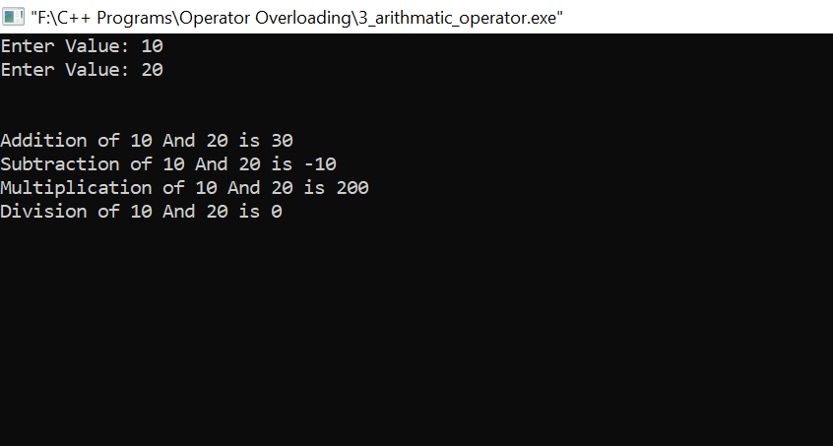

1. to print prefix and postfix using ‘++’ ‘--’

#include<iostream>

#include<conio.h>

using namespace std;

class sample

{

private:

int val1,val2;

public:

sample(int x,int y);

void operator ++(); //prefix of ++ operator

void operator ++(int x); //postfix of ++ operator

void operator --(); //prefix of -- operator

void operator --(int x); //postfix of -- operator

void display();

};

sample::sample(int x, int y)

{

val1=x;

val2=y;

}

void sample::operator ++()

{

++val1;

++val2;

}

void sample::operator ++(int x)

{

val1++;

val2++;

}

void sample::operator --()

{

--val1;

--val2;

}

void sample::operator --(int x)

{

val1--;

val2--;

}

void sample::display()

{

cout<<"value1 = "<<val1<<endl;

cout<<"value2 = "<<val2<<endl;

}

int main()

{

int n1,n2;

cout<<"Enter First Number : ";

cin>>n1;

cout<<"Enter Second Number : ";

cin>>n2;

sample e1(n1,n2),e2(n1,n2);

++e1;

cout<<endl;

cout<<"Prefix Form of ++ Operator : "<<endl;

e1.display();

e1++;

cout<<endl;

cout<<"Postfix Form of ++ Operator : "<<endl;

e1.display();

cout<<endl<<endl;

--e2;

cout<<endl;

cout<<"Prefix Form of -- Operator : "<<endl;

e2.display();

e2--;

cout<<endl;

cout<<"Postfix Form of -- Operator : "<<endl;

e2.display();

getch();

return 0;

}

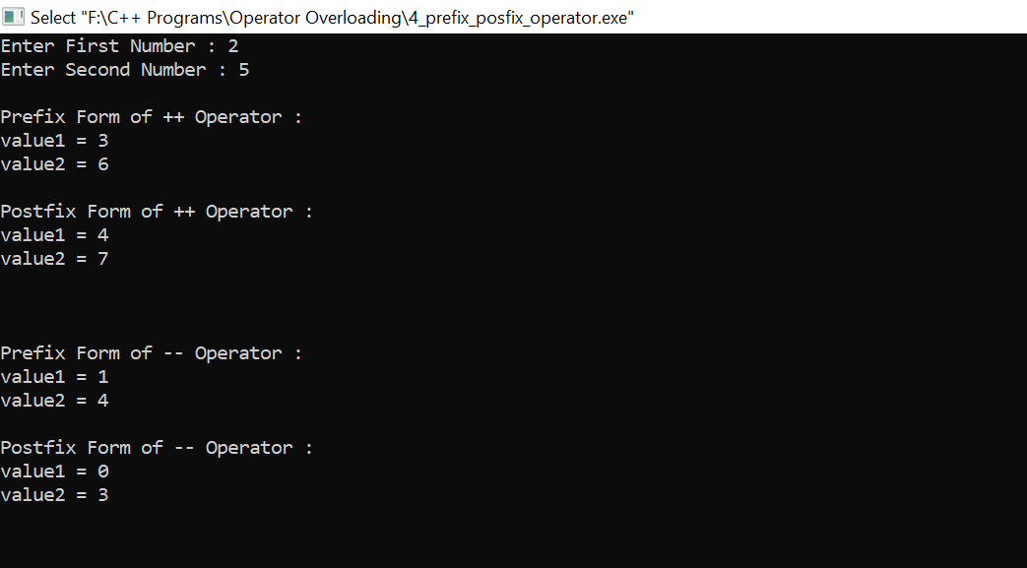

5) To show ‘<<’,’>>’ using operator overloading

#include<iostream>

#include<conio.h>

using namespace std;

class sample

{

private :

int a,b;

public :

void setdata(int x,int y)

{

a=x;

b=y;

}

void showdata()

{

cout<<"First Number is : "<<a<<"Second Number is : "<<b;

}

friend ostream& operator <<(ostream &,sample);

friend istream& operator >>(istream &,sample &);

};

ostream& operator <<(ostream &dout,sample s)

{

cout<<"First Number is : "<<s.a<<"\nSecond Number is : "<<s.b;

return(dout);

}

istream& operator >>(istream &din,sample &p)

{

cin>>p.a>>p.b;

return(din);

}

int main()

{

sample t1;

cout<<"Enter Two Number : ";

cin>>t1;

cout<<"\n\nNumber Entered are : \n";

cout<<t1;

getch();

return 0;

}

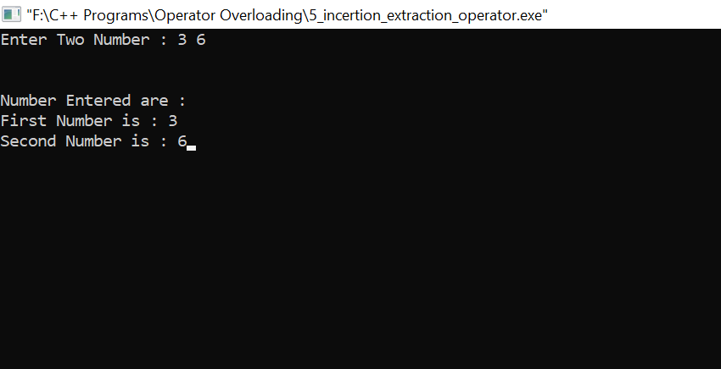

**pointer program**

1] Accept and print the number

#include<iostream>

#include<conio.h>

using namespace std;

class complex

{

private : int a,b;

public :

void set(int a,int b)

{

this->a=a;

this->b=b;

}

void print()

{

cout<<"\n\nFirst Number is : "<<a;

cout<<"\nSecond Number is : "<<b;

}

};

int main()

{

complex s1;

int n1,n2;

cout<<"Enter First Number : ";

cin>>n1;

cout<<"Enter Second Number :";

cin>>n2;

s1.set(n1,n2);

s1.print();

getch();

return 0;

}

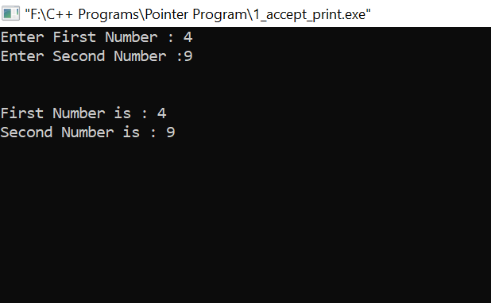

2] Accept book id, book price and print book id and price

#include<iostream>

#include<conio.h>

using namespace std;

class complex

{

private : int a,b;

public :

void set(int a,int b)

{

this->a=a;

this->b=b;

}

void print()

{

cout<<"\n\nBook ID is : "<<a;

cout<<"\nBook Price is : "<<b;

}

};

int main()

{

complex s1;

int id,price;

cout<<"Enter Book ID : ";

cin>>id;

cout<<"Enter Book Price :";

cin>>price;

s1.set(id,price);

s1.print();

getch();

return 0;

}

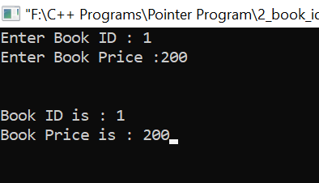

3] Accept person name and age and print the name and age

#include<iostream>

#include<conio.h>

using namespace std;

class complex

{

private : char name[20];

int age;

public :

void getdata()

{

cout<<"Enter Your Name : ";

cin>>name;

cout<<"Enter Your Age : ";

cin>>age;

}

void print()

{

cout<<"\n\nYour Name is : "<<name;

cout<<"\nYour Age is : "<<age;

}

};

int main()

{

complex *s1=new complex;

s1->getdata();

s1->print();

getch();

return 0;

}

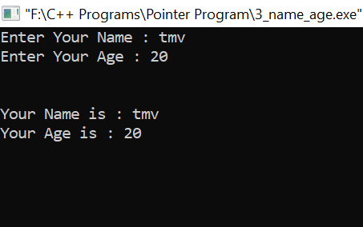

4] Accept two values and print subtraction, addition and multiplication

#include<iostream>

#include<conio.h>

using namespace std;

class complex

{

private : int a,b;

public :

void set(int x,int y)

{

this->a=x;

this->b=y;

}

void print()

{

cout<<"\n\nAddition of "<<a<<" And "<<b<<" is : "<<a+b;

cout<<"\nSubtraction of "<<a<<" And "<<b<<" is : "<<a-b;

cout<<"\nMultiplication of "<<a<<" And "<<b<<" is : "<<a*b;

}

};

int main()

{

complex s1;

int n1,n2;

cout<<"Enter First Number : ";

cin>>n1;

cout<<"Enter Second Number :";

cin>>n2;

s1.set(n1,n2);

s1.print();

getch();

return 0;

}

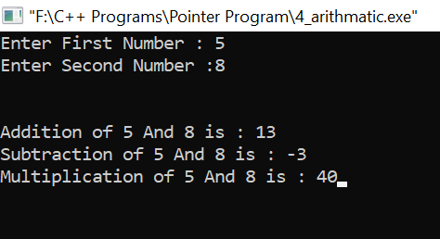

5] Swap the numbers

#include<iostream>

#include<conio.h>

using namespace std;

class complex

{

private : int n1,n2;

public :

void accept()

{

cout<<"Enter First Number : ";

cin>>n1;

cout<<"Enter Second Number :";

cin>>n2;

}

void swap()

{

int temp;

temp=n1;

n1=n2;

n2=temp;

}

void show()

{

cout<<"\n\nFirst Number is : "<<n1;

cout<<"\nSecond Number is : "<<n2;

}

};

int main()

{

complex s1;

complex *ptr=&s1;

s1.accept();

cout<<"\n\nAfter Swapping Numbers are : \n";

ptr->swap();

ptr->show();

getch();

return 0;

}

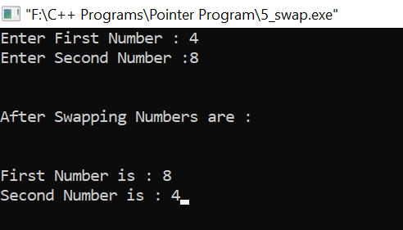

6] Print sum of array numbers

#include<iostream>

#include<conio.h>

using namespace std;

class complex

{

private : int arr[5],sum=0;

public :

void accept()

{

cout<<"Enter Five Numbers : ";

for(int i=0;i<5;i++)

{

cin>>arr[i];

}

}

void addition()

{

for(int i=0;i<5;i++)

{

sum=sum+arr[i];

}

}

void print()

{

cout<<"\n\nSum Of Array Elements are : "<<sum;

}

};

int main()

{

complex s1;

complex *ptr=&s1;

s1.accept();

ptr->addition();

ptr->print();

getch();

return 0;

}

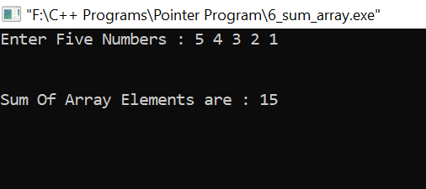

7] Print reverse of array and square of its elements

#include<iostream>

#include<conio.h>

using namespace std;

class complex

{

private : int arr[5],sum=0,i;

public :

void accept()

{

cout<<"Enter Five Numbers : ";

for(i=0;i<5;i++)

{

cin>>arr[i];

}

}

void reverse()

{

for(i=4;i>=0;i--)

{

cout<<arr[i]<<" ";

}

}

void square()

{

for(i=0;i<5;i++)

{

cout<<arr[i]*arr[i]<<" ";

}

}

};

int main()

{

complex s1;

complex *ptr=&s1;

s1.accept();

cout<<"\n\nReverse of Array is : ";

ptr->reverse();

cout<<"\n\nSquare of Array is : ";

ptr->square();

getch();

return 0;

}

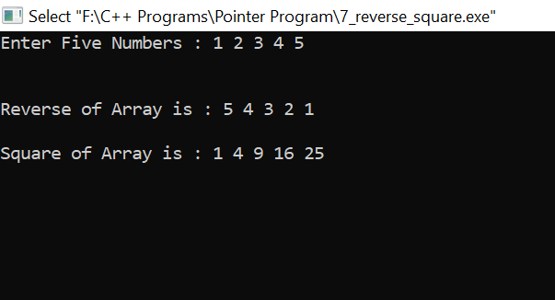

8] Find cube of array elements

#include<iostream>

#include<conio.h>

using namespace std;

class complex

{

private : int arr[5],sum=0,i;

public :

void accept()

{

cout<<"Enter Five Numbers : ";

for(i=0;i<5;i++)

{

cin>>arr[i];

}

}

void cube()

{

for(i=0;i<5;i++)

{

cout<<arr[i]*arr[i]*arr[i]<<" ";

}

}

};

int main()

{

complex s1;

complex *ptr=&s1;

s1.accept();

cout<<"\n\nCube of Array is : ";

ptr->cube();

getch();

return 0;

}

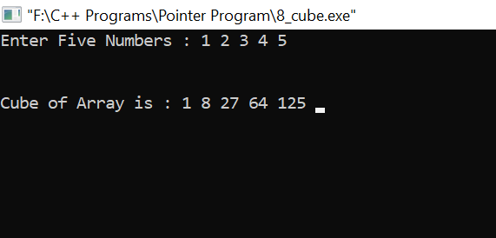

**Inheritance**

1. Accept person age,salary and name and print

#include<iostream>

#include<conio.h>

using namespace std;

class accept

{

public : int age;

long salary;

char name[20];

void getdata()

{

cout<<"Enter Person's Name : ";

cin>>name;

cout<<"Enter Person's Age : ";

cin>>age;

cout<<"Enter Person's Salary : ";

cin>>salary;

}

};

class print : public accept

{

public :

void show()

{

cout<<"\n\nPerson's Name is : "<<name;

cout<<"\nPerson's Age is : "<<age;

cout<<"\nPerson's Salary is : "<<salary;

}

};

int main()

{

print p;

p.getdata();

p.show();

getch();

return 0;

}

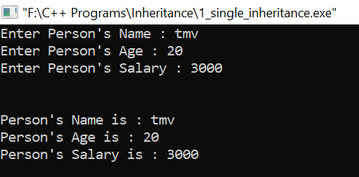

1. Accept student roll number and subject and print it

#include<iostream>

#include<conio.h>

using namespace std;

class accept

{

public : int rn;

int m1,m2,m3;

void getdata()

{

cout<<"Enter Student Roll Number : ";

cin>>rn;

cout<<"Enter Student Marks for First Subjects : ";

cin>>m1;

cout<<"Enter Student Marks for Second Subjects : ";

cin>>m2;

cout<<"Enter Student Marks for Third Subjects : ";

cin>>m3;

}

};

class print : public accept

{

public :

void show()

{

cout<<"\n\nStudent Roll Number is : "<<rn;

cout<<"\nStudent Marks for First Subjects is : "<<m1;

cout<<"\nStudent Marks for Second Subjects is : "<<m2;

cout<<"\nStudent Marks for Third Subjects is : "<<m3;

}

};

int main()

{

print p;

p.getdata();

p.show();

getch();

return 0;

}

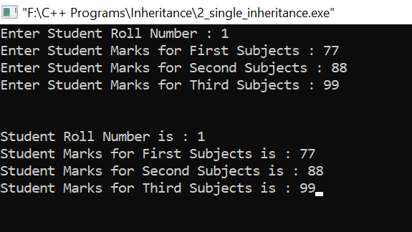

1. Accept student roll number and subject and print total marks using multi level inheritance

#include<iostream>

#include<conio.h>

using namespace std;

class accept

{

public : int rn;

int marks[3];

void getdata()

{

cout<<"Enter Student Roll Number : ";

cin>>rn;

cout<<"Enter Student Marks for Three Subjects : ";

for(int i=0;i<3;i++)

{

cin>>marks[i];

}

}

};

class calculation : public accept

{

public :

int sum=0;

void cal()

{

for(int i=0;i<3;i++)

{

sum=sum+marks[i];

}

}

};

class print : public calculation

{

public :

void show()

{

cout<<"\n\nStudent Roll Number is : "<<rn;

cout<<"\n\nTotal Marks Of Three Subjects are : "<<sum;

}

};

int main()

{

print p;

p.getdata();

p.cal();

p.show();

getch();

return 0;

}

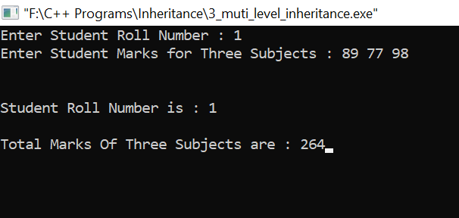

1. Accept two numbers and print addition,subtraction,multipilication and moduolus

#include<iostream>

#include<conio.h>

using namespace std;

class accept

{

public : int a,b;

void getdata()

{

cout<<"Enter First Number : ";

cin>>a;

cout<<"Enter Second Number : ";

cin>>b;

}

};

class arith_1 : public accept

{

public :

void sum_sub()

{

cout<<"\n\nAddition of "<<a<<" and "<<b<<" is "<<a+b;

cout<<"\nSubtraction of "<<a<<" and "<<b<<" is "<<a-b;

}

};

class arith_2 : public arith_1

{

public :

void mul_div_mod()

{

cout<<"\nMultiplication of "<<a<<" and "<<b<<" is "<<a*b;

cout<<"\nDivision of "<<a<<" and "<<b<<" is "<<a/b;

cout<<"\nModulus of "<<a<<" and "<<b<<" is "<<a%b;

}

};

int main()

{

arith_2 a;

a.getdata();

a.sum_sub();

a.mul_div_mod();

getch();

return 0;

}

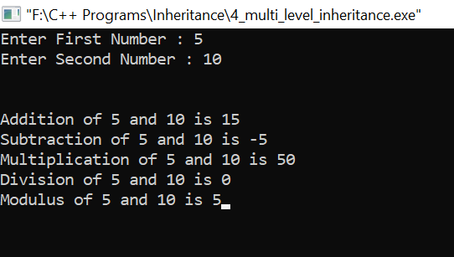

1. Accept student roll number and subject and print total marks using multiple inheritance

#include<iostream>

#include<conio.h>

using namespace std;

class accept

{

protected : int rn;

public :

void getdata()

{

cout<<"Enter Student Roll Number : ";

cin>>rn;

}

};

class calculation

{

protected : int sum,m1,m2,m3;

public :

void accept_mark()

{

cout<<"Enter Student Marks for First Subjects : ";

cin>>m1;

cout<<"Enter Student Marks for Second Subjects : ";

cin>>m2;

cout<<"Enter Student Marks for Third Subjects : ";

cin>>m3;

}

void cal()

{

sum=m1+m2+m3;

}

};

class print : public accept,public calculation

{

private :

public :

void show()

{

cout<<"\n\nStudent Roll Number is : "<<rn;

cout<<"\n\nTotal Marks Of Three Subjects are : "<<sum;

}

};

int main()

{

print p;

p.getdata();

p.accept_mark();

p.cal();

p.show();

getch();

return 0;

}

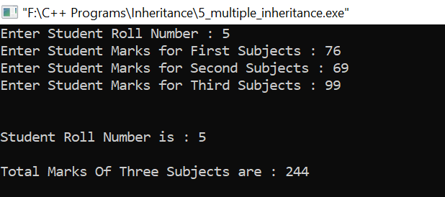

1. Accept two numbers and print square of first and cube of second number

#include<iostream>

#include<conio.h>

using namespace std;

class accept_1

{

protected : int a;

public :

void getdata_1()

{

cout<<"Enter First Number : ";

cin>>a;

}

};

class accept_2

{

protected : int b;

public :

void getdata_2()

{

cout<<"Enter Second Number : ";

cin>>b;

}

};

class print : public accept_1,public accept_2

{

public :

void show()

{

cout<<"\n\n\nSquare of "<<a<<" is : "<<a*a;

cout<<"\n\nCube of "<<b<<" is : "<<b*b*b;

}

};

int main()

{

print p;

p.getdata_1();

p.getdata_2();

p.show();

getch();

return 0;

}

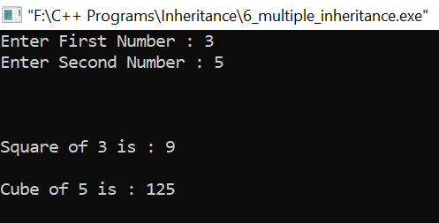

1. Accept student roll number and subject and print total marks using hybrid inheritance

#include<iostream>

#include<conio.h>

using namespace std;

class student

{

protected : int rn,m1,m2,m3,sum,per;

public :

void getdata()

{

cout<<"Enter Student Roll Number : ";

cin>>rn;

cout<<"Enter Student Marks for First Subjects : ";

cin>>m1;

cout<<"Enter Student Marks for Second Subjects : ";

cin>>m2;

cout<<"Enter Student Marks for Third Subjects : ";

cin>>m3;

}

void percentage()

{

cout<<"\n\nPercentage of Student is : "<<(m1+m2+m3)/3;

}

};

class test : public student

{

public :

void putdata()

{

getdata();

cout<<"\n\nStudent Roll Number is : "<<rn;

cout<<"\nStudent Marks for First Subject is : "<<m1;

cout<<"\nStudent Marks for Second Subject is : "<<m2;

cout<<"\nStudent Marks for Third Subject is : "<<m3;

}

void show()

{

cout<<"\n\nStudent Roll Number is : "<<rn;

cout<<"\nTotal Marks Of Three Subjects are : "<<m1+m2+m3;

}

};

class score : public student

{

public :

void percen()

{

percentage();

}

};

class result : public test , public score

{

public :

void display()

{

putdata();

show();

}

};

int main()

{

result r;

r.display();

getch();

return 0;

}

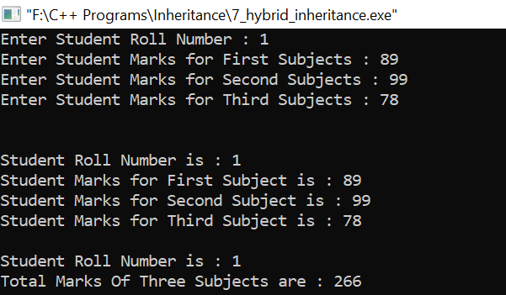

1. Accept 3 numbers and print addition subtraction multiplication using hybrid inheritance

#include<iostream>

#include<conio.h>

using namespace std;

class accept

{

public : int a,b;

void getdata()

{

cout<<"Enter First Number : ";

cin>>a;

cout<<"Enter Second Number : ";

cin>>b;

}

};

class addition : public accept

{

public :

int sum()

{

return(a+b);

}

int multi()

{

return(a*b);

}

};

class subtraction : public accept

{

public :

int sub()

{

return(a-b);

}

};

class multiplication : public accept

{

public :

void finally()

{

getdata();

cout<<"\n\nAddition of "<<a<<" and "<<b<<" is "<<a+b;

cout<<"\nSubtraction of "<<a<<" and "<<b<<" is "<<a-b;

cout<<"\nMultiplication of "<<a<<" and "<<b<<" is "<<a*b;

}

};

int main()

{

multiplication m;

m.finally();

getch();

return 0;

}

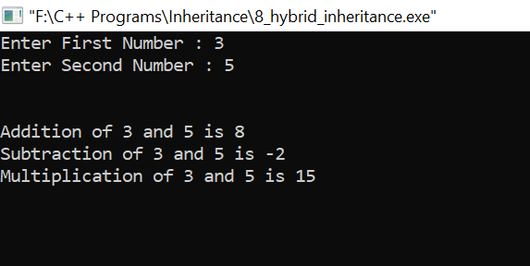

1. Accept manager and scientist data and print it

#include<iostream>

#include<conio.h>

using namespace std;

class emp

{

protected: int age;

char name[10];

public: void getdata()

{

cout<<"enter name";

cin>>name;

cout<<"enter age";

cin>>age;

}

void putdata()

{

cout<<"name="<<name;

cout<<"age="<<age;

}

};

class manager:public emp

{

private:int id,salary;

public:void getdata()

{

emp::getdata();

cout<<"enter id";

cin>>id;

cout<<"enter salary";

cin>>salary;

}

void putdata()

{

emp::putdata();

cout<<"id="<<id;

cout<<"salary"<<salary;

}

};

class scientist:public emp

{

private: int code;

char dept[10];

public:

void putdata()

{

emp::putdata();

cout<<"code"<<code;

cout<<"department"<<dept;

}

void getdata()

{

emp::getdata();

cout<<"enter code";

cin>>code;

cout<<"enter dept";

cin>>dept;

}

};

int main()

{

manager m1;

scientist s1;

cout<<"enter details of scientist";

s1.getdata();

m1.getdata();

cout<<"details for manager";

m1.putdata();

cout<<"dtails for scientist";

s1.putdata();

getch();

return 0;

}

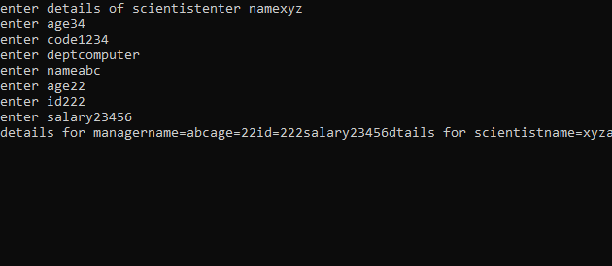

10) Print square and cube using hierarchical inheritance

#include<iostream>

#include<conio.h>

using namespace std;

class accept

{

public : int a,b;

void getdata()

{

cout<<"Enter a Number : ";

cin>>a;

}

};

class square : public accept

{

public :

void sq()

{

cout<<"Square of "<<a<<" is "<<a*a;

}

};

class cube : public accept

{

public :

void cu()

{

cout<<"Cube of "<<a<<" is "<<a*a*a;

}

};

int main()

{

square s;

cout<<"Square of Number : \n\n";

s.getdata();

s.sq();

cube c;

cout<<"\n\nCube of Number : \n\n";

c.getdata();

c.cu();

getch();

return 0;

}

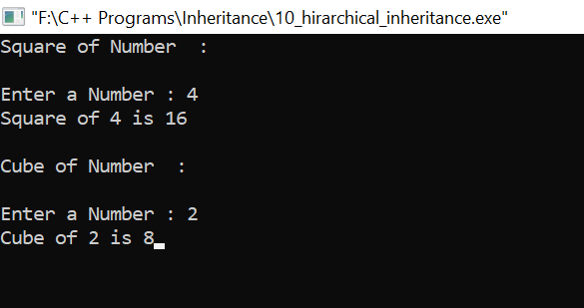

**Inline function**

1) Print factorial of given number

#include<iostream>

#include<conio.h>

using namespace std;

inline int fact(int x)

{

int i,facto=1;

for(i=1;i<=x;i++)

{

facto=facto*i;

}

cout<<"\nFactorial of : "<<x<<" is "<<facto;

}

int main()

{

int num;

cout<<"Enter a number : ";

cin>>num;

fact(num);

getch();

return 0;

}

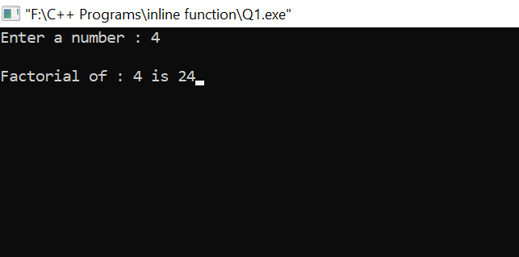

2) Check given number is a Armstrong or not

#include<iostream>

#include<conio.h>

using namespace std;

inline int arm(int a)

{

int n1,n2,n3,sum=0;

n1=a/100;

n2=(a%100)/10;

n3=a%10;

sum=n1*n1*n1+n2*n2*n2+n3*n3*n3;

if(a==sum)

cout<<a<<" is an Armstrong Number";

else

cout<<a<<" is Not an Armstrong Number";

}

int main()

{

int num;

cout<<"Enter a Number : ";

cin>>num;

cout<<endl;

arm(num);

getch();

return 0;

}

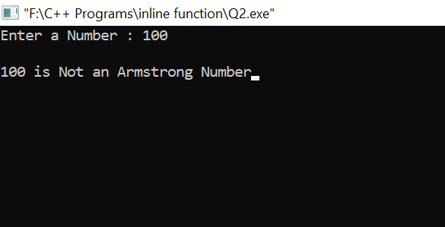

3) Check prime number between 50 to 100

#include<iostream>

#include<conio.h>

using namespace std;

inline int prime(int n)

{

int j, flag = 1;

for(j=2; j <= n/2; ++j)

{

if (n%j == 0)

{

flag =0;

break;

}

}

return flag;

}

int main()

{

int i, flag;

cout<<"Prime Number Between 50 to 100 are : \n\n";

for(i=50+1; i<100; ++i)

{

flag = prime(i);

if(flag == 1)

cout<<"\t"<<i;

}

getch();

return 0;

}

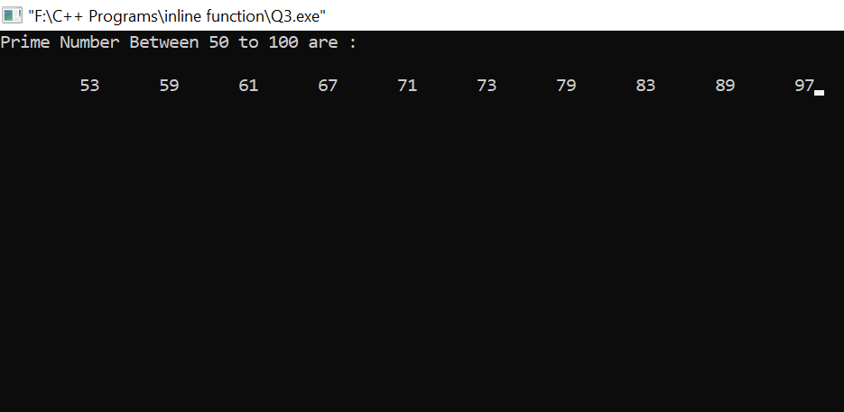

4) accept the array from user and calculate square and cube

#include<iostream>

#include<conio.h>

using namespace std;

inline int square_array()

{

int arr[5]={4,5,6,7,8};

cout<<"Given array is : \n";

for(int i=0;i<=4;i++)

{

cout<<arr[i];

cout<<"\t";

}

cout<<"\n\nSquare of the array is : \n";

for(int i=0;i<=4;i++)

{

cout<<arr[i]*arr[i];

cout<<"\t";

}

cout<<"\n\nCube of the array is : \n";

for(int i=0;i<=4;i++)

{

cout<<arr[i]*arr[i]*arr[i];

cout<<"\t";

}

}

int main()

{

square_array();

getch();

return 0;

}

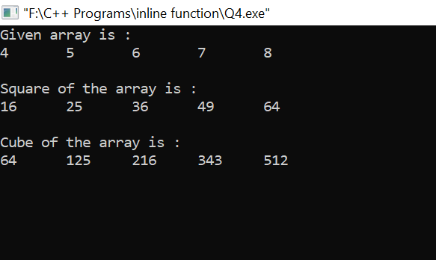

5) accept the array and print sum of its elements

#include<iostream>

#include<conio.h>

using namespace std;

inline int sum_array()

{

int arr[5],sum=0;

for(int i=1;i<=5;i++)

{

cout<<"Enter "<<i<<" Numbers : ";

cin>>arr[i];

}

cout<<"\n\nSum of the array is : ";

for(int i=1;i<=5;i++)

{

sum=sum+arr[i];

}

cout<<sum;

}

int main()

{

sum_array();

getch();

return 0;

}

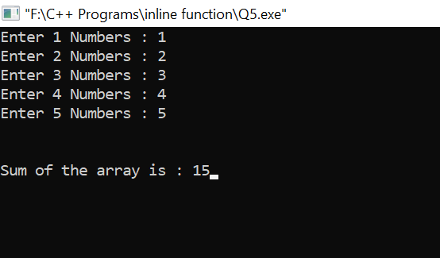

6)Accept two numbers and check it is even or odd

#include<iostream>

#include<conio.h>

using namespace std;

inline int check(int a,int b)

{

if(a%2==0 && b%2==0)

cout<<a<<" and "<<b<<" are Even numbers";

if(a%2==0 && b%2!=0)

cout<<a<<" is Even number and "<<b<" is Odd number";

if(a%b!=0 && b%2==0)

cout<<a<<" is Odd number and "<<b<<" is Even number";

if(a%2!=0 && b%2!=0)

cout<<a<<" and "<<b<<" both are Odd numbers";

}

int main()

{

int no1,no2;

cout<<"Enter First number : ";

cin>>no1;

cout<<"Enter Second number : ";

cin>>no2;

cout<<endl<<endl;

check(no1,no2);

getch();

return 0;

}

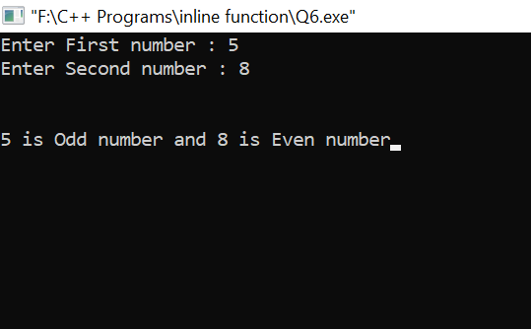

7) Find largest number in an array

#include<iostream>

#include<conio.h>

using namespace std;

inline largest_array()

{

int arr[4],i,maxi;

cout<<"Enter 4 elements in an array : ";

for(i=0;i<=3;i++)

cin>>arr[i];

maxi=arr[0];

for(i=0;i<=3;i++)

{

if(arr[i]>maxi)

maxi=arr[i];

}

cout<<endl<<endl<<maxi<<" is the Largest number";

}

int main()

{

largest_array();

getch();

return 0;

}

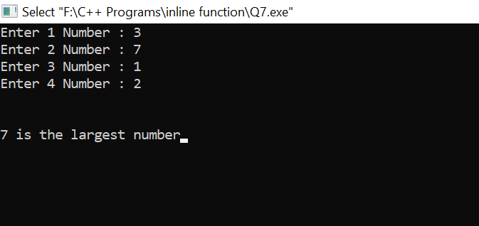

8) find smallest number in an array

#include<iostream>

#include<conio.h>

using namespace std;

inline smallest_array()

{

int arr[4],i,mini;

cout<<"Enter 4 Numbers in an array : ";

for(i=0;i<=3;i++)

cin>>arr[i];

mini=arr[0];

for(i=0;i<=3;i++)

{

if(arr[i]<mini)

mini=arr[i];

}

cout<<endl<<endl<<mini<<" is the Smallest Number";

}

int main()

{

smallest_array();

getch();

return 0;

}

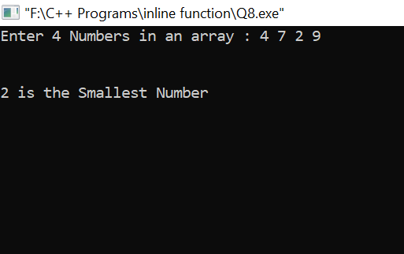

9) Find out string is palindrome or not

#include<iostream>

#include<conio.h>

#include<string.h>

using namespace std;

inline void test()

{

char str1[20],str2[20];

cout<<"Enter The String : ";

cin>>str1;

strcpy(str1,str2);

strrev(str1);

if(strcmp(str1,str2)==0)

cout<<"\n\nString is Palindrome";

else

cout<<"\n\nString is Not a Palindrome";

}

int main()

{

test();

getch();

return 0;

}

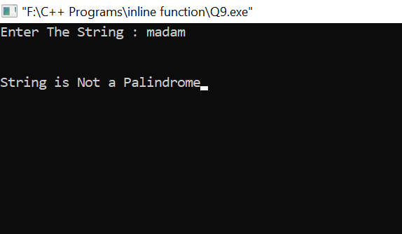

10) Check given character is consonant or vowel

#include <iostream>

#include<conio.h>

using namespace std;

inline char check_vowel(char c)

{

if (c == 'a' || c == 'e' || c == 'i' || c == 'o' || c == 'u' || c == 'A' || c == 'E' || c == 'I' || c == 'O' || c == 'U')

cout << c << " is a Vowel.";

else

cout << c << " is a Consonant.";

}

int main()

{

char ch;

cout<<"Enter an alphabet : ";

cin>>ch;

cout<<endl<<endl;

check_vowel(ch);

getch();

return 0;

}

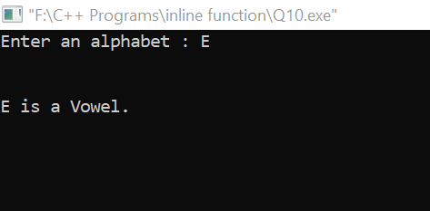

11) Accept a number and convert from decimal to binary using while loop

#include<iostream>

#include<conio.h>

using namespace std;

inline int deci_binary(int no)

{ int a[10],i,num;

num=no;

for(i=0; no!=0; i++)

{

a[i]=no%2;

no= no/2;

}

cout<<"\n\nBinary of the "<<num<<" is : ";

for(i--;i>=0;i--)

{

cout<<a[i];

}

}

int main()

{

int n;

cout<<"Enter the number to convert Binary : ";

cin>>n;

deci_binary(n);

getch();

return 0;

}

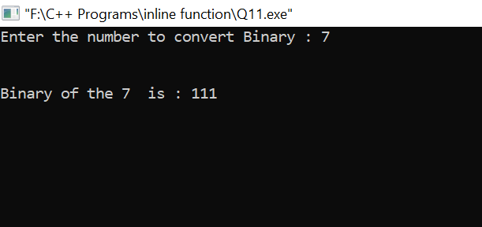

15) Accept a year and check it is leap or not

#include<iostream>

#include<conio.h>

using namespace std;

inline void square_cube(int y)

{

if(y%100==0 && y%100==0 || y%4==0 && y% 100!=0)

cout<<endl<<y<<" is Leap Year";

else

cout<<endl<<y<<" is Not Leap Year";

}

int main()

{

int year;

cout<<"Enter a Year : ";

cin>>year;

square_cube(year);

getch();

return 0;

}

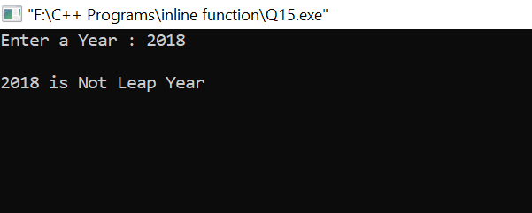

Constructor

1] To print sum of first 100 natural numbers.

#include<iostream>

#include<conio.h>

using namespace std;

class sum

{

private : int number,add=0;

public :

sum()

{

for(number =1; number <=100; number++)

{

add=add+number;

}

cout << add;

}

};

int main()

{

cout << "The sum of the first 100 Natural Numbers are : ";

sum s;

getch();

return 0;

}

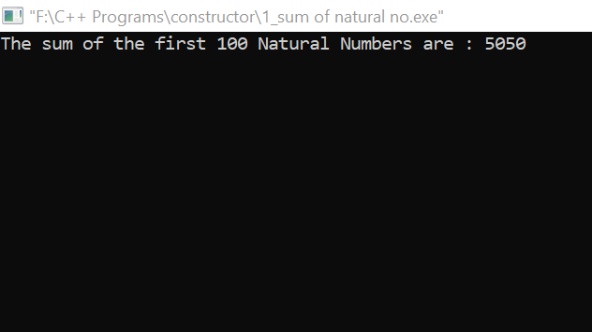

2] To check given number is prime number or not and as well even or odd.

#include<iostream>

#include<conio.h>

using namespace std;

class sample

{

private :

int no,i,flag=0;

public :

void display();

sample();

};

sample::sample()

{

cout << " Enter your number : ";

cin>> no;

}

void sample::display()

{

for(i=2;i<no;i++)

{

if(no%i==0)

{

flag=1;

break;

}

}

if(flag==1)

cout << no<<" Not a prime number \n" << endl;

else

cout << no<<" prime number \n" << endl;

if(no%2==1)

cout <<no<< " Odd number " << endl;

else

cout <<no<< " Even number " << endl;

}

int main()

{

sample s1;

cout<<endl<<endl;

s1.display();

getch();

return 0;

}

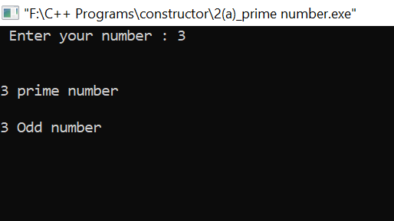

3] To check given number is Armstrong number or Not

#include<iostream>

#include<conio.h>

using namespace std;

class rmstrong

{

private: int no,r,sum,num;

public:

rmstrong()

{

cout<<”Enter a Number to check if its Armstrong or Not : “;

cin>>no;

sum=0;

num=no;

while(no>0)

{

r=no%10;

sum=sum+(r*r*r);

no=no/10;

}

cout<<endl<<endl;

if(num==sum)

cout<<num<<” is an Armstrong Number .”;

else

cout<<num<<” is Not an Armstrong Number .”;

}

};

int main()

{

rmstrong a;

getch();

return 0;

}

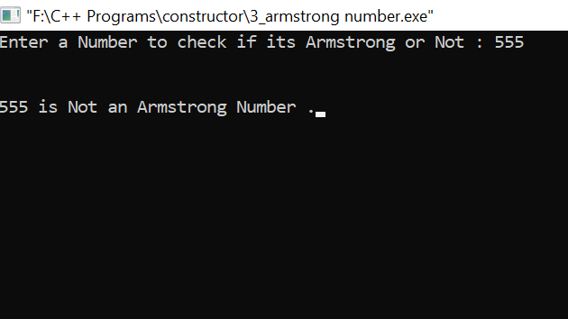

4] To print Fictorial of a given number.

#include <iostream>

#include<conio.h>

using namespace std;

class fibonacci

{

int k1,k2;

public:

fibonacci()

{

k1 = 0; k2 = 1;

}

void series(int n)

{

int i,next;

cout << k1 << " " << k2 << " " ;

for(i=1; i <= n-2; i++)

{

next = k1 + k2;

cout << next << " " ;

k1 = k2; k2 = next;

}

}

};

int main()

{

fibonacci ser;

int n;

cout << "How many numbers Do you want to see Fibonacci Series ? ";

cin >> n;

cout<<"\n\n";

ser.series(n);

getch();

return 0;

}

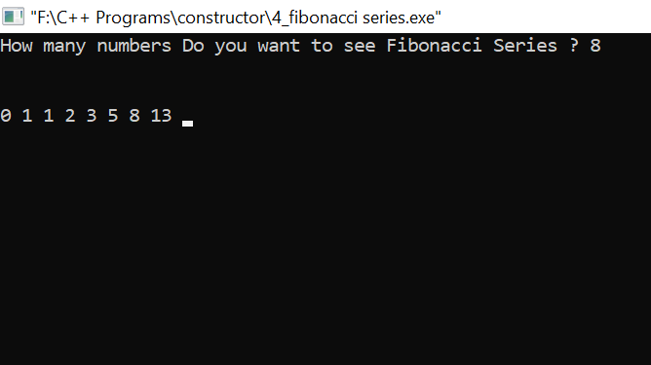

5] Parameterized Constructor of reversing the string.

#include<iostream>

#include<string.h>

#include<conio.h>

using namespace std;

class reverse

{

private : char str[20];

int len,i,j;

public :

reverse(char *s)

{

strcpy(str,s);

len=strlen(str);

cout<<"\n\nReverse of the string is : "<<strrev(str);

}

};

int main()

{

char a[20];

cout<<"Enter any string : ";

cin>>a;

reverse s(a);

getch();

return 0;

}

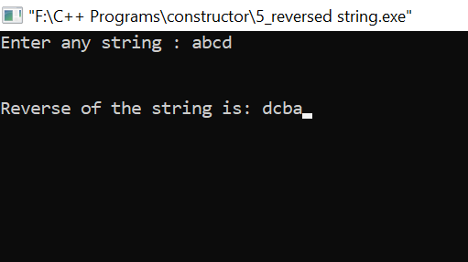

6] Default constructor of sorting he elements array in ascending and descending order.

#include<iostream>

#include<conio.h>

using namespace std;

class sort

{

private : int num[5],i,j,desc;

public :

sort()

{

cout<<"Enter Five Numbers : ";

for (i = 0; i < 5; ++i)

cin>>num[i];

for (i = 0; i < 5; ++i)

{

for (j = i + 1; j < 5; ++j)

{

if (num[i] > num[j])

{

desc = num[i];

num[i] = num[j];

num[j] = desc;

}

}

}

cout<<"\n Numbers in Ascending Order : \n";

for (i = 0; i < 5; ++i)

{

cout<<" ";

cout<<num[i];

cout<<" ";

}

//Decending Order

for (i = 0; i < 5; ++i)

{

for (j = i + 1; j < 5; ++j)

{

if (num[i] < num[j])

{

desc = num[i];

num[i] = num[j];

num[j] = desc;

}

}

}

cout<<"\n\n\n Numbers in Descending Order : \n";

for (i = 0; i < 5; ++i)

{

cout<<" ";

cout<<num[i];

cout<<" ";

}

}

};

int main ()

{

sort s;

getch();

return 0;

}

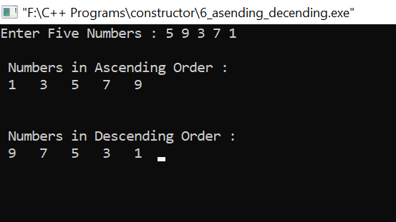

7] Parameterized Constructor To find the factors of given number.

#include<iostream>

#include<conio.h>

using namespace std;

class fact

{

int n, i, facti;

public:

fact(int x) //copy constructor

{

n=x;

facti=1;

}

fact(fact &x)

{

n=x.n;

facti=1;

}

void calculate()

{

for(i=1; i<=n; i++)

{

facti=facti*i;

}

}

void display()

{

cout<<”\n\nFactorial of “<<n<<” is : “<<facti;

}

};

int main()

{

int x;

cout<<”Enter a Number : “;

cin>>x;

fact f1(x);

f1.calculate();

f1.display();

getch();

return 0;

}

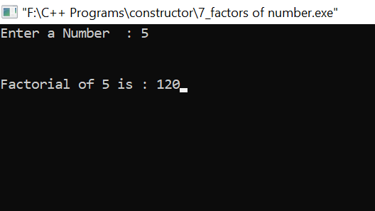

8] Parameterized Constructor To check given character is consonant or vowel.

#include<iostream>

#include<conio.h>

using namespace std;

class vowel

{

private: char ch;

public:

vowel(char ch)

{

if(ch=='A' || ch=='E' || ch=='I' || ch=='O' || ch=='U')

cout<<ch<<" is Vowel .";

else

cout<<ch<<" is Consonant .\n";

}

};

int main()

{

char ch;

cout<<"Enter a Character : ";

cin>>ch;

cout<<endl<<endl;

vowel v(ch);

getch();

return 0;

}

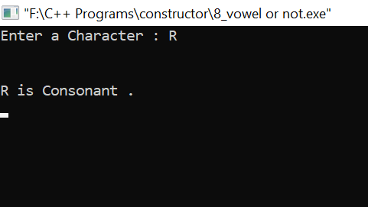

9] To print multiplication table of a given number.

#include<iostream>

#include<conio.h>

using namespace std;

class table

{

private : int i,no,t=1;

public :

table()

{

cout<<"Enter a Number : ";

cin>>no;

cout<<"\n\nMultiplication Table of "<<no<<" is ";

for(i=1;i<=10;i++)

{

t=no*i;

cout<<" \n"<<t;

cout<<"";

}

}

};

int main()

{

table t;

getch();

return 0;

}

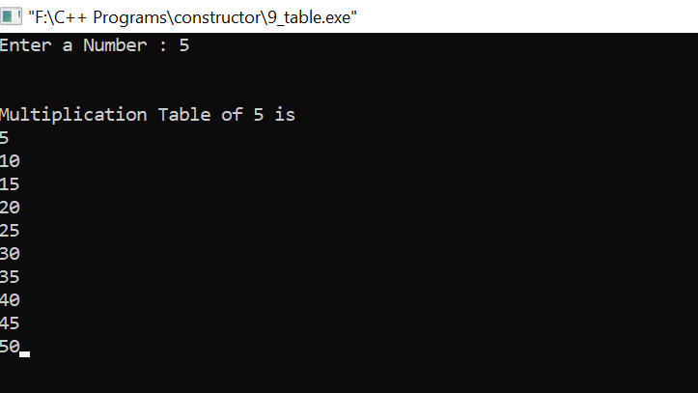

10] Parameterized Constructor To swap the number given by user.

#include<iostream>

#include<conio.h>

using namespace std;

class swaping

{

private : int n1,n2,temp;

public :

swaping(int n1,int n2)

{

n1=n1;

n2=n2;

int temp;

temp=n1;

n1=n2;

n2=temp;

cout<<"\n\nFirst Number is : "<<n1;

cout<<"\nSecond Number is : "<<n2;

}

};

int main()

{

int num1,num2;

cout<<"Enter First Number : ";

cin>>num1;

cout<<"Enter Second Number :";

cin>>num2;

cout<<"\n\nAfter Swapping Numbers are : \n";

swaping s1(num1,num2);

getch();

return 0;

}

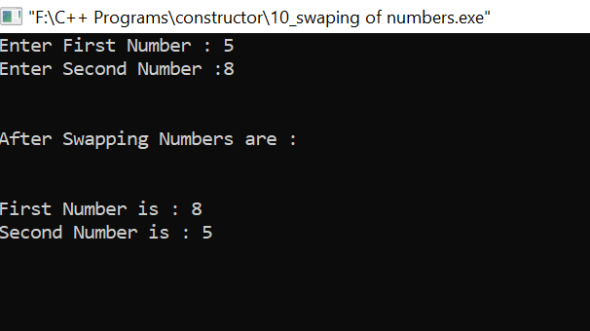

11] Parameterized Constructor To print the data of two student.

#include<iostream>

#include<conio.h>

using namespace std;

class student

{

private : int r,a;

public :

student(int rn,int age)

{

r=rn;

a=age;

cout<<"\n\nStudent Roll Number is : "<<r;

cout<<"\nStudent is : "<<a;

}

};

int main()

{

int rn,age;

cout<<"Enter Student Roll Number : ";

cin>>rn;

cout<<"Enter Student Age : ";

cin>>age;

student s(rn,age);

getch();

return 0;

}

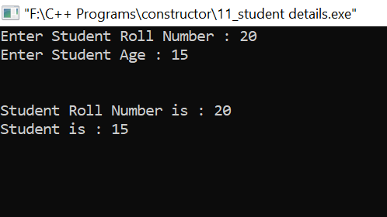

12] To check the number given by the user is palindrome or not.Ask User to Continne to Another Number .

#include<iostream>

#include<conio.h>

#include<stdlib.h>

using namespace std;

class palindrome

{

private: int n,rev,temp;

public:

palindrome()

{

rev=0;

cout<<"Enter the number : ";

cin>>n;

temp=n;

while(temp!=0)

{

rev=rev*10;

rev=rev+temp%10;

temp=temp/10;

}

if(n==rev)

cout<<n<<" is Palindrome";

else

cout<<n<<" is Not Palindrome";

}

};

int main()

{

char choice='y';

while(choice=='y')

{

palindrome p;

cout<<"\n\nDo You Want Continue [Y/n] : ";

cin>>choice;

}

getch();

return 0;

}

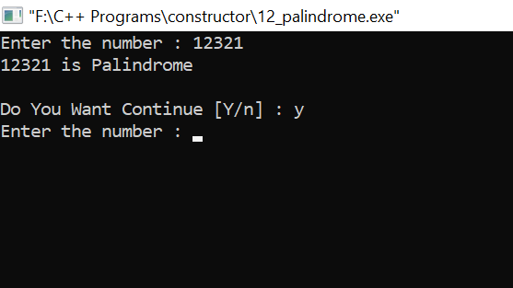

13] To accept array from user and calculate the summation of element.And Average also .

#include<iostream>

#include<conio.h>

using namespace std;

class sum

{

private : int arr[5],s=0;

public :

sum()

{

cout<<"Enter Five Numbers : ";

for(int i=0;i<5;i++)

{

cin>>arr[i];

}

for(int i=0;i<5;i++)

{

s=s+arr[i];

}

cout<<"\n\nSum Of Array Elements are : "<<s;

cout<<"\n\nAverage Of Array Elements are : "<<s/5;

}

};

int main()

{

sum s1;

getch();

return 0;

}

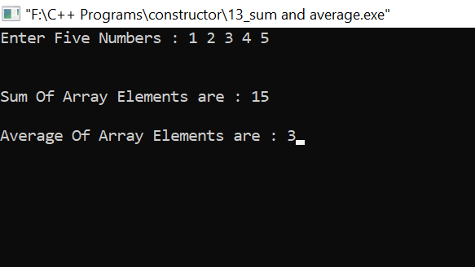

15] To find the quotient and remainder as well

#include<iostream>

#include<conio.h>

using namespace std;

class test

{

private: int num1,num2,q,r;

public:

test()

{

cout<<"Enter First Number : ";

cin>>num1;

cout<<"Enter Second Number : ";

cin>>num2;

q=num1/num2;

cout<<"\n\nThe Quotient is = "<<q<<endl;

r=num1%num2;

cout<<"\nThe Remainder is = "<<r;

}

};

int main()

{

test t;

getch();

return 0;

}

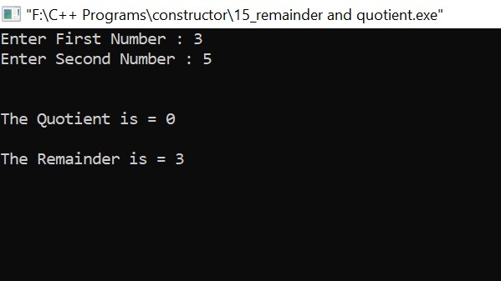

16] Overloaded constructor addition and subtraction.

#include<iostream>

#include<conio.h>

using namespace std;

class function

{

public :

function(int a,int b)

{

cout<<"\n\nAddition of "<<a<<" And "<<b<<" are : "<<a+b;

cout<<"\n\nSubtraction of 10 And 5 is "<<10-5;

}

function()

{

cout<<"\n\nSubtraction of 10 And 5 is "<<10-5;

}

}

int main()

{

int n1,n2;

cout<<"Enter First Number : ";

cin>>n1;

cout<<"Enter Second Number : ";

cin>>n2;

function c(n1,n2),;

cout<<endl<<endl;

function c();

getch();

return 0;

}

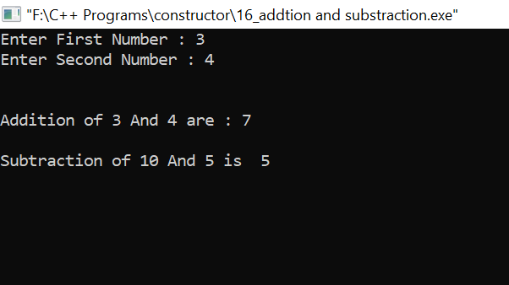

17] To calculate square and cube of first 10 numbers.

#include<iostream>

#include<conio.h>

using namespace std;

class sample

{

private :

int a,b;

public :

sample()

{

for(int i=0;i<10;i++)

cout<<"\nCube of "<<i<<" is "<<i*i*i;

}

sample(int x)

{

cout<<"\n\nSquare of "<<x<<" is "<<x*x<<endl<<endl;;

for(int i=1;i<=10;i++)

cout<<"\nCube of "<<i<<" is "<<i*i*i;

}

};

int main()

{

int a,b;

cout << " Enter a Number : ";

cin>> a ;

sample s1(a);

sample s2();

getch();

return 0;

}

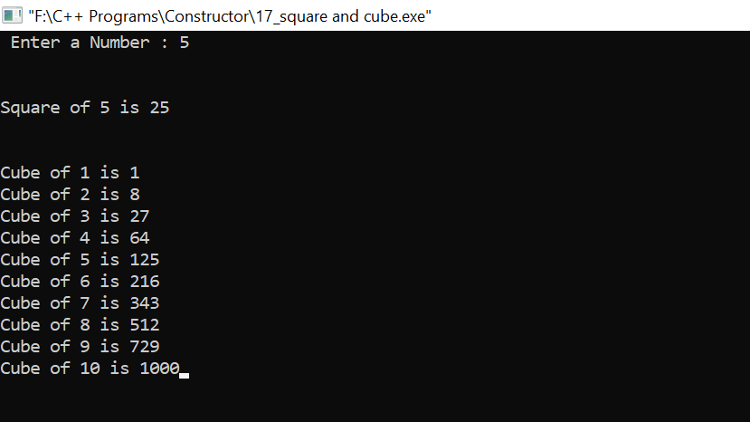

18 ] To print the data ( name,age,salary) of the manager and employee.

#include<iostream>

#include<conio.h>

using namespace std;

class data

{

public : int age;

long salary;

char name[20];

data()

{

cout<<"Enter Manager Name : ";

cin>>name;

cout<<"Enter Manager Age : ";

cin>>age;

cout<<"Enter Manager Salary : ";

cin>>salary;

cout<<"\n\nManager Name is : "<<name;

cout<<"\nManager Age is : "<<age;

cout<<"\nManager Salary is : "<<salary;

}

};

int main()

{

data d;

getch();

return 0;

}

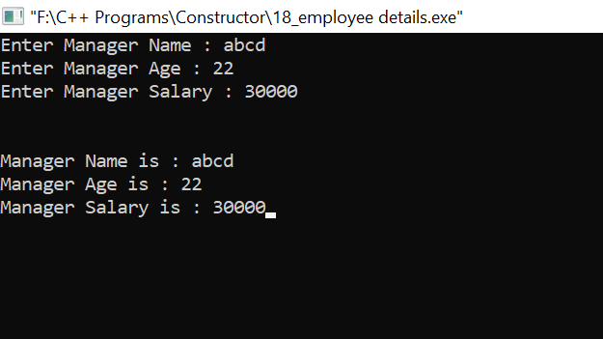

19] To accept array and print the repeated number from array.

#include <iostream>

#include<conio.h>

using namespace std;

class complex

{

private : int arr[5],i,j,count=1;

public :

complex()

{

int count=1;

cout<<"Enter Five Numbers : ";

for(i=0;i<5;i++)

{

cin>>arr[i];

}

for(i=0;i<5;i++)

{

for(j=i+1;j<5;j++)

{

if(arr[i]==arr[j])

{

cout<<"\n\nRepeated Number is :"<<arr[i];

count++;

cout<<endl<<arr[i]<<" is Repeated by "<<count<<" times .";

}

}

}

}

};

int main()

{

complex c;

getch();

return 0;

}

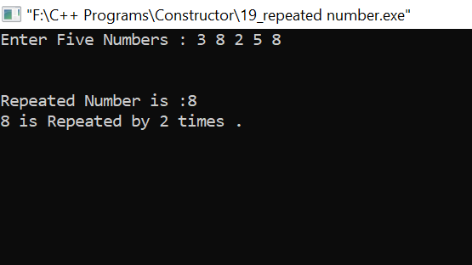

21] To print factorial of number.

#include<iostream>

#include<conio.h>

using namespace std;

class sample

{

private :

int n,f;

public :

sample(int a);

sample(sample & x);

void display();

void cal();

};

sample::sample(int a)

{

n=a;

f=1;

}

sample::sample(sample & x)

{

f=x.f;

n=x.n;

}

void sample::display()

{

cout << "\n\nFactorial is " << f <<endl;

}

void sample::cal()

{

while(n>0)

{

f=f*n;

n--;

}

}

int main()

{

int no;

cout << "Enter a number : " ;

cin>> no;

sample A(no);

A.cal();

sample B=A;

B.display();

getch();

return 0;

}

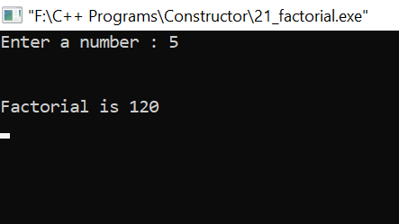

22] Copy constructor to check even or odd and find greater number

#include<iostream>

#include<conio.h>

using namespace std;

class sample

{

private :

int a,b;

public :

sample(int a,int b);

sample(sample & x);

void display();

void cal();

};

sample :: sample(int c,int d)

{

a=c;

b=d;

}

sample :: sample(sample & x)

{

a=x.a;

b=x.b;

}

void sample :: display()

{

if(a>b)

cout << a<<" is the greater than "<<b << endl;

else

cout << b<<" is the greater than "<<a << endl;

cout<<endl<<endl;

if(a%2==0 && b%2==0)

cout<<a<<" And "<<b<<" Both are Even Number .";

else

cout<<a<<" And "<<b<<" Both are Odd Number .";

}

int main()

{

int a,b;

cout << " Enter First number : ";

cin>> a ;

cout << " Enter First number : ";

cin>> b;

sample A(a,b);

sample B(A);

cout << "\n\nResult is : " ;

A.display();

//cout << " B = " ;

//B.display();

getch();

return 0;

}

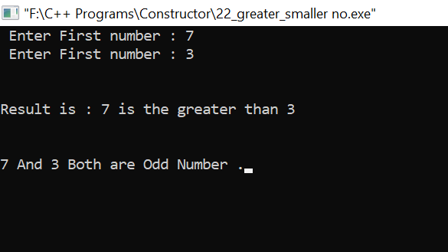

23] To check given number is Armstrong number or not

#include<iostream>

#include<conio.h>

using namespace std;

class sample

{

private :

int no,no1,no2,no3,sum;

public :

sample(int a);

sample(sample & x);

void display();

void cal();

};

sample :: sample(int b)

{

no=b;

}

sample :: sample(sample & x)

{

no=x.no;

}

void sample :: display()

{

no1=no/100;

no2=(no%100)/10;

no3=no%10;

sum=(no1*no1*no1)+(no2*no2*no2)+(no3*no3*no3);

cout<<endl<<endl;

if(no==sum)

cout << no<<" is Armstrong Number " << endl;

else

cout << no<<" is Not a Armstrong Number " << endl;

}

int main()

{

int no;

cout << "Enter your number : ";

cin >> no;

sample A(no);

sample B(A);

A.display();

getch();

return 0;

}

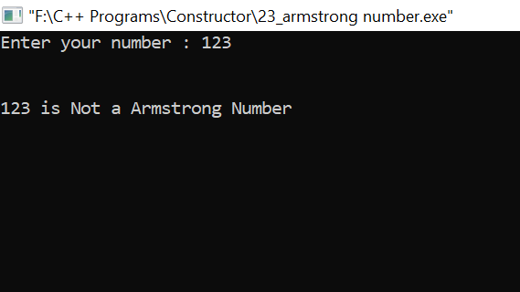

24] To print multiplication table of given number

#include<iostream>

#include<conio.h>

using namespace std;

class table

{

private : int i,no,t=1;

public :

table()

{

cout<<"Enter a Number : ";

cin>>no;

cout<<"\n\nMultiplication Table of "<<no<<" is ";

for(i=1;i<=10;i++)

{

t=no*i;

cout<<" \n"<<t;

cout<<"";

}

}

};

int main()

{

table t;

table a(t);

getch();

return 0;

}

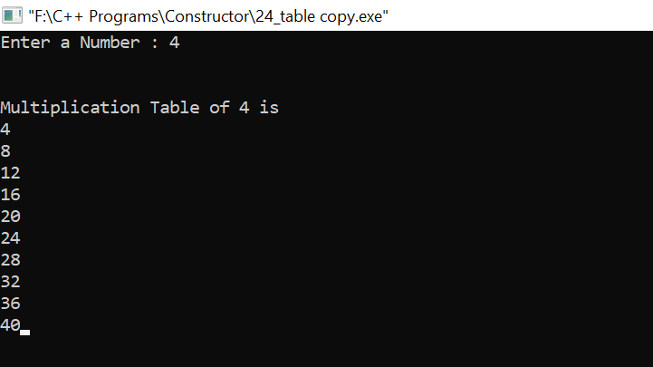

25] To print Fibonacci series

#include <iostream>

#include<conio.h>

using namespace std;

class fibonacci

{

int k1,k2;

public:

fibonacci()

{

k1 = 0; k2 = 1;

}

void series(int n)

{

int i,next;

cout << k1 << " " << k2 << " " ;

for(i=1; i <= n-2; i++)

{

next = k1 + k2;

cout << next << " " ;

k1 = k2; k2 = next;

}

}

};

int main()

{

fibonacci ser;

int n;

cout << "How many numbers Do you want to see Fibonacci Series ? ";

cin >> n;

cout<<"\n\n";

ser.series(n);

getch();

return 0;

}

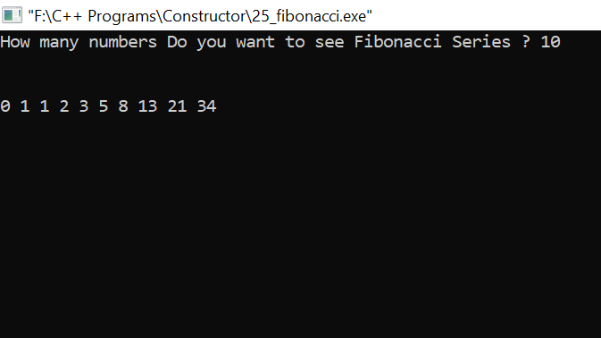

Destroctor

1) To print sum of first 100 natural numbers and destroy the object.

#include<iostream>

#include<conio.h>

using namespace std;

class sum

{

private:

int s=0,i;

public:

sum()

{

for(i=1;i<=100;i++)

s=s+i;

cout<<"\n";

}

void show()

{

cout<<"Sum of first 100 natural number is= "<<s;

}

~sum()

{

cout<<"Destructor is called ";

}

};

int main()

{

sum ob;

ob.show();

getch();

return 0;

}

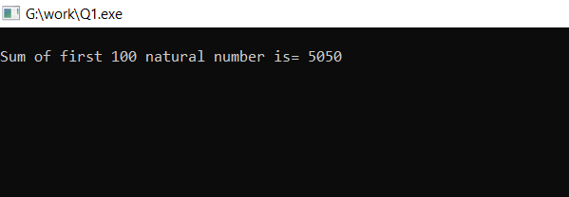

3) To create multiple objects and destroy these objects.

#include<iostream>

#include<conio.h>

using namespace std;

int count=0;

class alpha

{

public:

alpha()

{

count++;

cout<<"\nThe number of objects created are"<<count;

}

~alpha()

{

cout<<"\nThe number of object destroyed are= "<<count;

count--;

}

};

int main()

{

cout<<"\nEnter main= ";

alpha a1,a2,a3,a4;

{

cout<<"\n\nEnter block 1";

alpha a5;

}

{

cout<<"\n\nEnter block 2";

alpha a6;

}

cout<<"\n\nReenter main";

getch();

return 0;

}

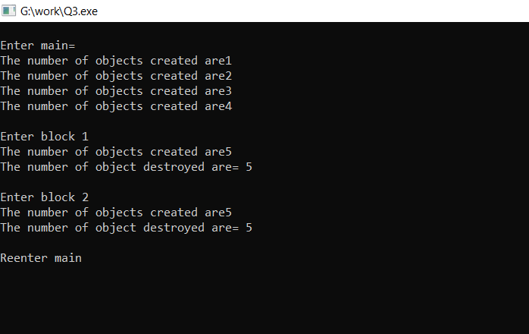

4) overloaded constructor To calculate the area of circle and rectangle and destroy the constructor.

#include<iostream>

#include<conio.h>

using namespace std;

class area

{

private:

int length,width;

float radius;

public:

area(int len,int wid)

{

length=len;

width=wid;

cout<<"\nArea of rectangle= "<<length*width;

}

area(float rad)

{

radius=rad;

cout<<"\nArea of Circle= "<<3.14*radius*radius;

}

~area()

{

cout<<"\nDestructor is called";

}

};

int main()

{

area a1(16,15);

area a2(4.6);

getch();

return 0;

}

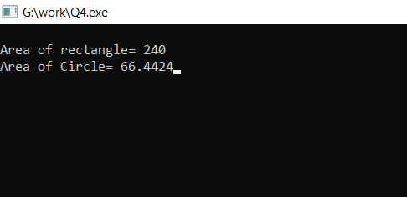

5) To print Fibonacci series and destroy the object.

#include<iostream>

#include<conio.h>

using namespace std;

class emp

{

int emp_id,age,salary;

public:

emp(int id,int a,int sal)

{

emp_id=id;

age=a;

salary=sal;

}

emp(emp &s)

{

emp_id=s.emp_id;

age=s.age;

salary=s.salary;

cout<<"copy constructor working";

}

void show()

{

cout<<"\nId of the employee= "<<emp_id;

cout<<"\nAge of the employee= "<<age;

cout<<"\nSalary of the employee= "<<salary;

}

~emp()

{

cout<<"\nDestructor function is called";

}

};

int main()

{

emp s1(171,25,15000);

emp s2=s1;

s2.show();

getch();

return 0;

}

