**HACK**

1. Clone Repository - git clone <https://github.com/sumitkute/blockchianhack.git>
2. Get to Transaction Node Connection String as shown below

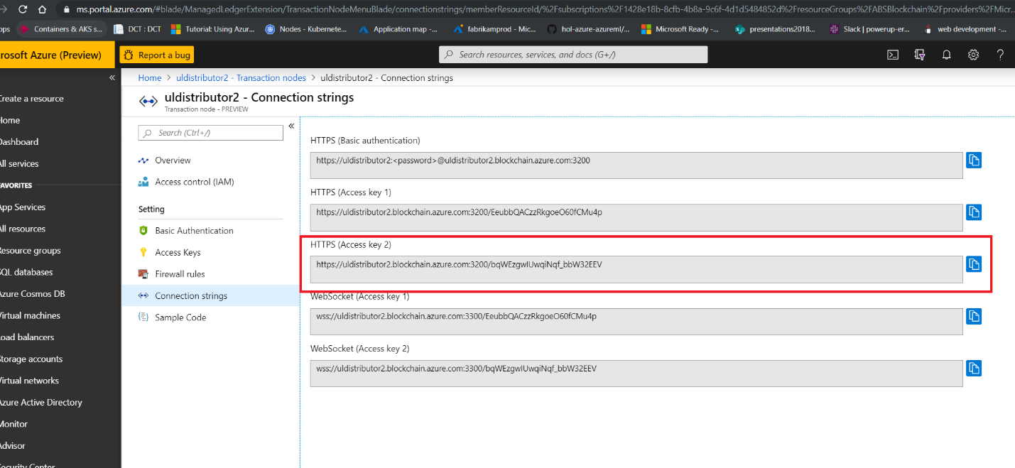

1. Open <https://remix.ethereum.org/#appVersion=0.7.7>
2. RUN - Environment - Web2 Provider - Enter Connection String
3. Create new SOL File and replace it with RetailerFinance.SOL downloaded earlier

1. 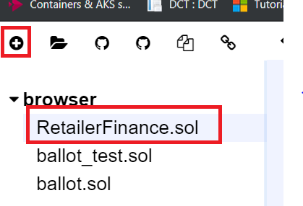
2. Compile and Deploy - You need to pass all four-account address - as shown by Proctor

1. Copy deployed Contract Address

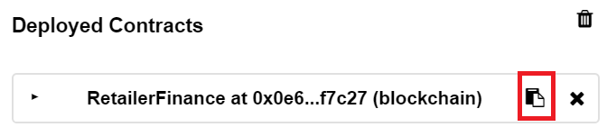

1. Run index_completed.html in browser
2. Past contract address and all account address and connection string in index_completed.html
3. Click on Save Config.